IEEE P802.11
Wireless LANs
LB 275 CR for EHT-SIG
Date: Aug 17, 2023
Author(s):
Name | Affiliation | Address | Phone | email
Ross Jian Yu | Huawei |  |  | ross.yujian@huawei.com
Ming Gan | Huawei
Edward Au | Huawei
Stephen McCann | Huawei

Abstract
This submission proposes resolutions for following 12 CIDs received for TGbe LB275:
CID 19020, 19021, 19022, 19023, 19024, 19025, 19081, 19093, 19172, 19447, 19536, 20118
Revisions:
- Rev 0: Initial version of the document.
- Rev1: updated during presentation.

CID 19020
CID | Page | Clause | Comment | Proposed Change | Resolution
19020 | 779.05 | 36.3.12.8 | "For OFDMA transmission that is wider than 80 MHz, RU Allocation subfields per 80 MHz frequency  subblock shall carry consistent RU or MRU size and placement information for the entire PPDU" different 80MHz can carry different RUA information. in the meanwhile, this rule is enforcing the RUA to be consistent for the PPDU...it's vague how to interprete the "consistent". | suggest to add some explanations in one of the example of annex Z. or remove this sentence | REVISED  An explanation is added in EHT-SIG example 3.  Instructions to the editor:  Please make the changes as shown in 11/23-1377r1 tagged with #CID19020.

TGbe editor, please make the following changes to P979, line 2 of P802.11be D4.0 as shown below:
(#19020) The EHT-SIG content channels per 80 MHz are allowed to carry different information when EHT MU PPDU is wider than 80 MHz and for OFDMA transmission to multiple users. In this example, STA 1441 and STA 1442 are operating on the primary 80 MHz channel, which is the lower 80 MHz in this example. The User field for STA 1441 is in content channel 1 while the User field for STA 1442 is in content channel 2 in the lower 80 MHz. No User field exists in the upper 80 MHz. The contents of the entire EHT-SIG field in the lower 80 MHz and higher 80 MHz for this example are shown in Table Z-20 (EHT-SIG content in the lower 80 MHz for example 3) and Table Z-21 (EHT-SIG content in the upper 80 MHz for example 3), respectively. The RU Allocation subfields in the lower and upper 80 MHz carry consistent RU or MRU size and placement information for the 160 MHz PPDU. The EHT-SIG content channels per 80 MHz can also be the same.

CID 19021
CID | Page | Clause | Comment | Proposed Change | Resolution
19021 | 784.60 | 36.3.12.8 | "the RU Allocation subfield other than the first one in the  EHT-SIG content channel encodes zero additional User fields per RU or MRU contributed to the User  Specific field in the same EHT-SIG content channel as the RU Allocation subfield" read like the 1st RUA has to encode larger than zero user fields contributes to the same CC as the RUA. e.g. E.g. 996 -> [80 30 30 30]. 1st RUA in CC2 also encodes 0 additional user fields. | suggest to refine the language to avoid confusion | REJECTED  The first RU Allocation subfield in each content channel can encode zero or more User fields in the same content channel.

CID 19022
CID | Page | Clause | Comment | Proposed Change | Resolution
19022 | 785.23 | 36.3.12.8 | "NOTE 5--The exact dynamic split of User fields between the two content channels, and ,  is not specified and might be used to reduce any disparity in the number of User fields between content channels." is duplicated with "For an MU-MIMO allocation of RU or MRU size greater than 242 tones in an OFDMA transmission, the  dynamic split of User fields between EHT-SIG content channel 1 and EHT-SIG content channel 2 is decided  by the AP (on a per case basis) and signaled by the AP using the RU Allocation subfields in each EHT-SIG  content channel. " | remove this note | REJECTED  NOTE 5 further describes the usage of dynamic split of the User fields. Hence, it is better to keep the NOTE.
Discussion
P.L 785.23
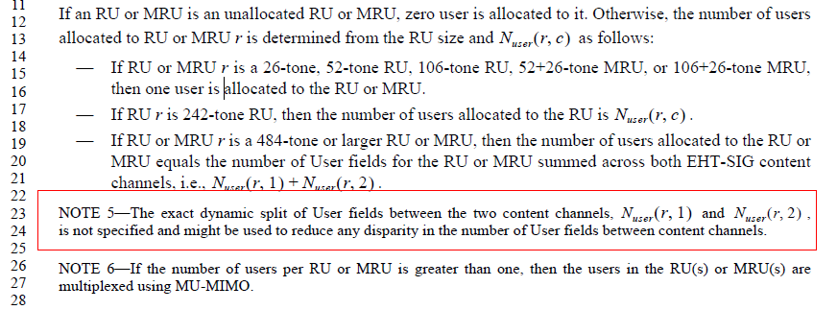
P.L 787.49
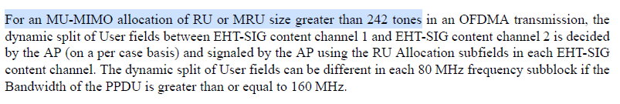
Discussion ends

CID 19023
CID | Page | Clause | Comment | Proposed Change | Resolution
19023 | 787.54 | 36.3.12.8 | "The dynamic split of User fields can be different in each 80 MHz frequency subblock if the  Bandwidth of the PPDU is greater than or equal to 160 MHz" if MUMIMO with 4STAs is conducted on 2x996 RU in 320MHz PPDU, is it mean the split can be different in different 80MHz? e.g. 1+1 in lower 80 and 2+0 in upper 80? | please clarify the intension. | REJECTED  For the example given by the commenter, the understanding is correct. Since the number of User fields may be varied in content channel 1 or 2 in each 80 MHz frequency subblock, different dynamic splits of the User fields in each 80 MHz frequency subblock may help to reduce the disparity in the number of User fields between content channels.  The commenter was asking a question for clarification and there is no change in the draft standards required.

CID 19024
CID | Page | Clause | Comment | Proposed Change | Resolution
19024 | 791.19 | 36.3.12.8 | "For a DL OFDMA transmission (in the U-SIG field, the UL/DL field is set to 0, and the PPDU Type And  Compression Mode field is set to 0), the number of user fields is indicated by the RU Allocation subfields." the number of user fields is not indicated but derived from the RUAs | change indicated by to derived from or implicitly indicated by | REJECTED  The RU Allocation subfields do indicate the number of User fields.  The detailed methods are shown in Page 785, lines 11-21, of D4.0.

Discussion
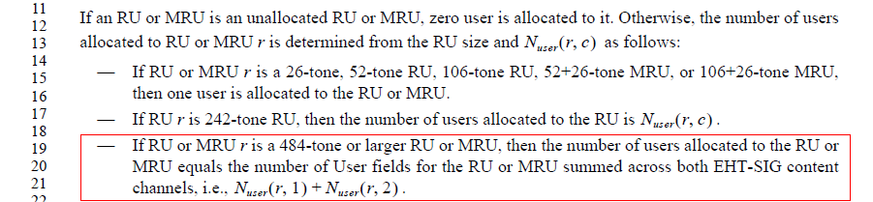
Discussion ends

CID 19025
CID | Page | Clause | Comment | Proposed Change | Resolution
19025 | 797.36 | 36.3.12.8 | 48 entries in total in 36-42, 6bits are sufficient to indicate a specific entry. So don't need to know N_user. | let's discuss.... | REJECTED  While other methods exist for indication. the consensus from the discussion during the previous and current comment resolution period is to keep the same format and parsing method when 9-16 SS entries are removed from the table.
Discussion
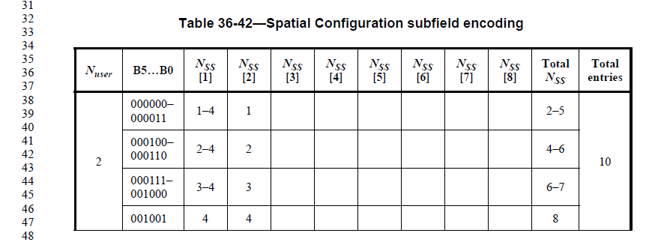
…
Discussion ends

CID 19172
CID | Page | Clause | Comment | Proposed Change | Resolution
19172 | 797.33 | 36.3.12.8.5 | In Table 36-42 Spatial Configuration subfield encoding, 4 bits are sufficient to represent all possible spatial configurations, as the maximum number of total entries is 13. | Please revise Table 36-42 and use only 4 bits to indicate all possible spatial configurations rather than 6 bits in Table 36-42 | REJECTED  While other methods exist for indication. the consensus from the discussion during the previous and current comment resolution period is to keep the same format and parsing method when 9-16 SS entries are removed from the table.

CID 19081
CID | Page | Clause | Comment | Proposed Change | Resolution
19081 | 775.50 | 36.3.12.8 | the 1st user encoding block must be present because this is for MU transmission | remove "if present" | REJECTED  There exists one User field in the common encoding block. Hence if the number of non-OFDMA Users is 2, one User field per content channel, then no user encoding block is present.
Discussion
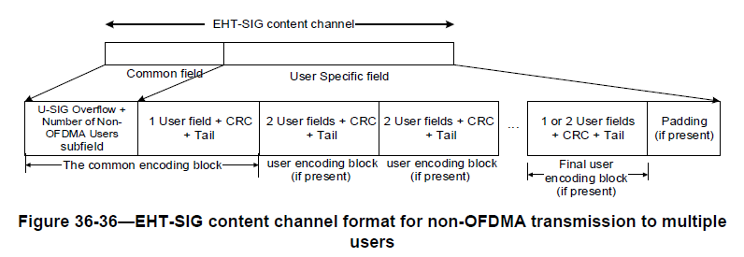
Discussion ends

CID 19093
CID | Page | Clause | Comment | Proposed Change | Resolution
19093 | 784.49 | 36.3.12.8.3 | 'is referred to by' -> 'is referred by' | remove 'to'  also in P784L59 | REJECTED  The current language is correct.

CID 19447
CID | Page | Clause | Comment | Proposed Change | Resolution
19447 | 785.32 | 36.3.12.8.3 | Regarding "80-303 (001010y2y1y0-100101y2y1y0 in binary representation."  No need to mention y2y1y0 because range 80-303 in binary representation is 001010000-100101111. Similar problem can be found on P784L14 | As in the comment. | REJECTED  The entries are grouped, as 8 entries per group, whose last 3 digits are from 000 to 111:  001010y2y1y0, 001011y2y1y0, 001100y2y1y0,…,100100y2y1y0, 100101y2y1y0.  The current description aims to point out that the last 3 bits are used to indicate the number of User fields signaled in the corresponding content channel.
Discussion
P785.L23:
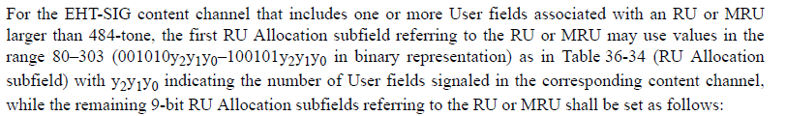
P784.L14:
Discussion ends

CID 19536
CID | Page | Clause | Comment | Proposed Change | Resolution
19536 | 784.45 | 36.3.12.8.3 | Typo: "contribute to different the number of User fields to the" | Change to "contribute different number of User fields to the" | ACCEPTED

CID 20118
CID | Page | Clause | Comment | Proposed Change | Resolution
20118 | 777.15 | 36.3.12.8.3 | In 160/320 MHz channel bandwidth OFDMA transmission, the STA-ID subfield in EHT-SIG user field is set to 2046 for RU/MRU with fewer than 242 tones when this RU/MRU is not allocated to a user. What is the benefit of using STA-ID 2046 to the receiving STA operating in the lower or upper 80 MHz subblock (in a 160 MHz channel for example).  The STA operating in the lower or upper 80 MHz subblock (in a 160 MHz channel), knows the distribution of users across the content channels over both the lower and upper 80 MHz subblocks. In this case the STA will process all user fields signaled in the lower or upper 80 MHz subblock (including the STA with STA-ID 2046) but it only decode the data field for the intended STA-ID. | Please clarify the benefit of using STA-ID 2046 for the receiving STA in an allocation which contains small size RU/MRU which are not allocated to a user.  Please clarify if allocation index 28 can be used to signal no user for an allocation index corresponding to an RU size < 242 for 160/320 MHz channel bandwidth in an OFDMA transmission. | REJECTED  On Page 785, lines 1-9, of D4.0, the paragraph has detailed explanations on how to indicate an RU or MRU that is not allocated to a user.  For RU/MRU fewer than 242-tones, there will be a corresponding User field. A STA-ID 2046 is chosen to prevent a STA to treat this User field as its own User field.  RU allocation index 28 is used to signal a 242-tone RU contributes to zero user field, and clearly cannot be used for an RU size < 242.

Discussion
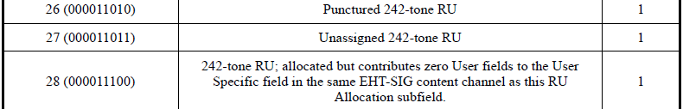
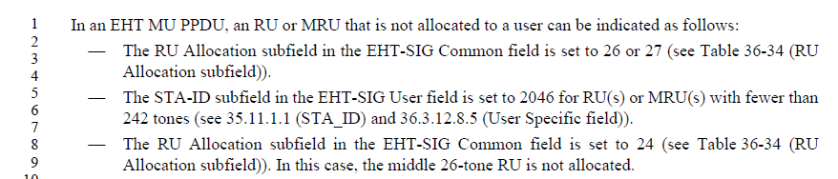
Discussion ends

