IEEE P802.11
Wireless LANs
LB272 DMG Sensing Instance CIDs: Part 3
Date: 2023-07-11
Author(s):
Name | Affiliation | Address | Phone | email
Pu (Perry) Wang | MERL | 201 Broadway, Cambridge, MA 02319, USA |  | pwang@merl.com
Abstract
This document proposes resolution to several LB272 DMG related CIDs.
The list of CIDs is: 1226, 1394, 1488, 2079, 2090.

R0: Initial document
R0: Add CID 1394

CID | Section | Page  Line | Comment | Proposed Change | Resolution
1488 | 11.55.3.6.5.1 | P212  L49 | Insert new paragraph: "The DMG Sensing Request frames shall be sent in the order of the STA ID value in the frame. Each frame shall be sent to the direction of the responder STA indicated by the RA of the frame." | As in the comment | Revise

Proposed changes in P212L49:
The DMG Sensing Request frames shall be sent in the order of the STA ID value in the frame. Each frame shall be sent to the direction of the responder STA.

CID | Section | Page  Line | Comment | Proposed Change | Resolution
1394 | 11.55.3.6.3 | P211  L45 | "First Beam Index of the BRP Sensing element" - the word "field" is missing | replace with "First Beam Index field of the BRP Sensing element" | Accept

CID | Section | Page  Line | Comment | Proposed Change | Resolution
2079 | 11.55.3.6.3 | P212  L31 | it should be 'Rx Beam List'  it should be 'transmit/receive beam combinations' | As in comment. | Accept

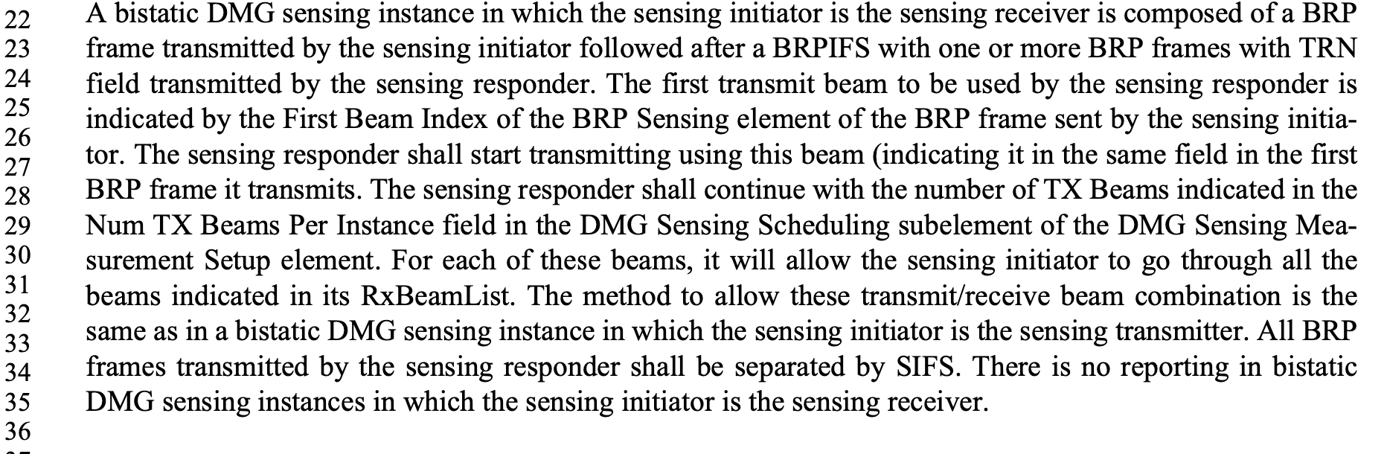

CID | Section | Page  Line | Comment | Proposed Change | Resolution
2090 | 11.55.4.3 | P219  L15 | ..., the SBP responder shall transmit all frames prepared...' | As in comment. | Accept

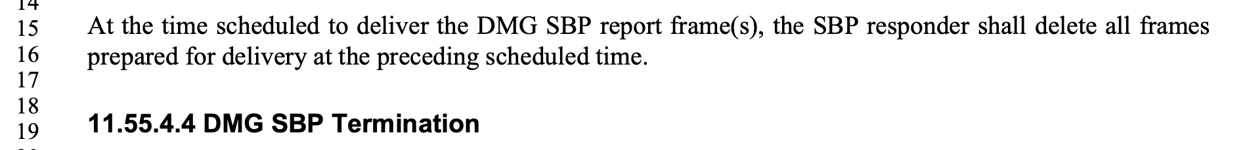

CID | Section | Page  Line | Comment | Proposed Change | Resolution
1226 | 11.55.3.6.5 | P212  L21 | Parameters defined in Table 8-4--(Vector descriptions) appear also in Table 28-1--(TXVECTOR and RXVECTOR parameters). The mentioned parameters belong to the receiver and the transmitter respectively. There is no definition in the normative text of 11.55.3.6.5 (Multistatic EDMG sensing instance) on how to manage those parameters. | Provide the rule(s) how to assert the parameters and the relevant timing for the recieving and transmitting. | Reject  Needs more specifics

Straw Poll:
Do you agree with the proposed resolutions for CIDs 1226, 1394, 1488, 2079 and 2090 in revision 2 of this document?
Y/N/A

