IEEE P802.11
Wireless LANs

CID 16341
Date: 2023-07-12
Author(s):
Name | Affiliation | Address | Phone | email
Yunbo Li | Huawei |  |  | liyunbo@huawei.com
Ming Gan
Yuchen Guo
Guogang Huang
Yousi Lin
Zhenguo Du
Stephen McCann
Edward Au

Abstract
This submission proposes comment resolution(s) for the following 1 CID(s) received in LB271 on TGbe D3.2

CIDs:
16341

Revisions:
- Rev 0: Initial version of the document.

CID | Clause | P.L | Comment | Proposed Change | Resolution
16341 | 35.8 | 0.00 | No mention of clear rules for when R-TWT SPs are duplicated. | Should prohibit APs from setting up multiple duplicate R-TWT SPs or add a rule for STAs in such cases | Revised  Due to different traffic interval that decided by the upper traffic pattern, some times AP can not schedule several non-overlapped R-TWT.  When the SP of two R-TWT overlapps, the current spec ask a TXOP holder to end current TXOP before a coming R-TWT SP even the TXOP holder is transmitting frame for another R-TWT.  It will decrease the efficiency, and increase the delay of pending low latency traffic in current TXOP.  In this reolution, a TXOP holder is allowed to continue to transmit low latency traffic of one RTWT even the SP of another R-TWT starts before the end of current TXOP.  TGbe editor, please make changes as shown in 11-23/1266r0 tagged 16341

Discussion:
Base on current spec text
- In all cases, a non-AP EHT STA shall end current TXOP before the start time of a coming R-TWT SP
- An EHT AP shall end current TXOP before the start time of a coming R-TWT SP except the remaning TXOP is used to transmit frames of R-TWT TID of the coming R-TWT
One important case that missed is that when current TXOP is used to transmit frames of one R-TWT, the TXOP holder doesn’t need to end current TXOP due to another coming R-TWT.
The missing case happens when two R-TWT SP overlaps. Overlapping R-TWT SPs may happen very frequently. Because as long as the TWT wake interval of one R-TWT is not an integer multiple of another R-TWT’s wake interval, partial SPs of these two R-TWT will overlaps. The wake interval is decided by the upper layer traffic pattern, AP or STA can not change it.
Below are three examples:
Figure 1: The TXOP holder terninate TXOP before SP of R-TWT2, because the transmitting frame belongs to TID1, while R-TWT TID is TID 0 for coming R-TWT SP.
Figure 2: The TXOP holder doesn’t terninate TXOP before SP of R-TWT2, because the transmitting frame belongs to TID0 which is the R-TWT TID of coming R-TWT SP. This case is supported by current spec.
Figure 3: The TXOP holder doesn’t terninate TXOP before SP of R-TWT2, because the transmitting frame belongs to TID1 which is the R-TWT TID of existing R-TWT SP. This case is NOT supported by current spec yet. we propose to capature this case by the resolution of CID 16341.

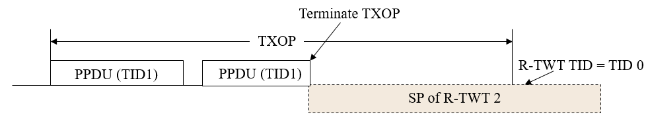
Figure 1
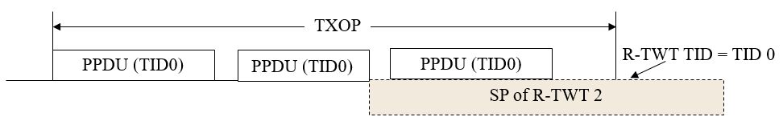
Figure 2
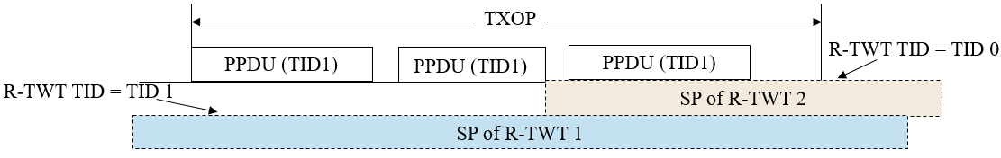
Figure 3

Proposed spec text

TGbe editor: Please make the following changes in subclause 35.8.4.1 (TXOP and backoff procedures rules for R-TWT SPs): (#16341)

35.8.4.1 TXOP and backoff procedures rules for R-TWT SPs

A non-AP EHT STA with dot11RestrictedTWTOptionImplemented set to true as a TXOP holder shall ensure the TXOP ends before the start time of any active R-TWT SPs that are advertised by its associated AP or the AP corresponding to the transmitted BSSID in a multiple BSSID set in which its associated AP belongs to, as specified in 35.8.3 (R-TWT announcement), except the non-AP EHT STA is a member of another R-TWT, the SP of another R-TWT overlaps with the start time of the active R-TWT SP and the remaining portion of TXOP is used for the delivery of UL frames of R-TWT UL TID(s) of another R-TWT. In addition, before starting transmission of any PPDU, the non-AP EHT STA with dot11RestrictedTWTOptionImplemented set to true shall check if there is enough time for the frame exchange to complete prior to the start of the R-TWT SP and, if there is not enough time, then the STA shall defer transmission by selecting a random backoff count using the present CW[AC] (without advancing to the next value of CW[AC]), except the non-AP EHT STA is a member of another R-TWT, the SP of another R-TWT overlaps with the start time of the active R-TWT SP and the TXOP is used for the delivery of UL frames of R-TWT UL TID(s) of another R-TWT. The QSRC[AC] for the MSDU or A-MSDU is not affected.

An EHT AP with dot11RestrictedTWTOptionImplemented set to true as a TXOP holder shall ensure the TXOP ends before the start time of any active R-TWT SP advertised by itself as specified in 35.8.3 (R-TWT announcement) unless one of following conditions are true:
- the remaining portion of TXOP fallen within the R-TWT SP is used for the delivery of DL frames of R-TWT DL TID(s) or to solicit the UL frames of R-TWT UL TID(s).
- the SP of another R-TWT overlaps with the start time of the active R-TWT SP, the remaining portion of TXOP fallen within the R-TWT SP is used for the delivery of DL frames of R-TWT DL TID(s) of another R-TWT or to solicit the UL frames of R-TWT UL TID(s) of another R-TWT.

