IEEE P802.11
Wireless LANs
LB272 CR for CID 2036
Date: 2023-07-11
Author(s):
Name | Company | Address | Phone | email
Dong Wei | NXP | 6501 W. William Cannon Dr, Austin, TX, U.S.A. |  | dong.wei@nxp.com
Abstract

This document aims to resolve the following LB272 comment: CID 2036.

R0: Initial version

CID 2036
CID | Clause | Page | Comment | Proposed Change
2036 | 11.55.1.5.2.5 | 182.19 | "In the SR2SR variant of a TF sounding phase, the AP transmits an SR2SR Sounding Trigger frame to solicit NDP transmission from one non-AP STA, ...". A figure would be nice to illustrate "TF sounding phase - SR2SR variant" | See comment
Proposed resolution: Revised

TGbf Editor: Please revise the second paragraph of 11.55.1.5.2.5 of D1.2 as follows.

Implementation of the SR2SR variant of the TF sounding phase is optional. When supported, the AP shall
transmit an SR2SR Sounding Trigger frame to one non-AP STA that is an SR2SR sensing transmitter and
one or more non-AP STAs that are SR2SR sensing receivers, and are not assigned to be polled or have responded in the polling phase of the TB sensing measurement instance to solicit SR2SR NDP transmission. The SR2SR Sounding Trigger frame shall allocate spatial resources for the SR2SR NDP transmission covering the full bandwidth. The SR2SR NDP may be transmitted with more than one spatial stream. The non-AP STA indicated as an SR2SR sensing transmitter by a Transmitter User Info field in an SR2SR Sounding Trigger frame shall transmit an SR2SR NDP a SIFS after receiving the SR2SR Sounding Trigger frame. Any non-AP STA indicated as an SR2SR sensing receiver by a Receiver User Info field in the SR2SR Sounding Trigger frame shall perform sensing measurement on the SR2SR NDP sent by the SR2SR sensing transmitter (see Figure 11-74x (Example of SR2SR variant of a TF sounding phase)).

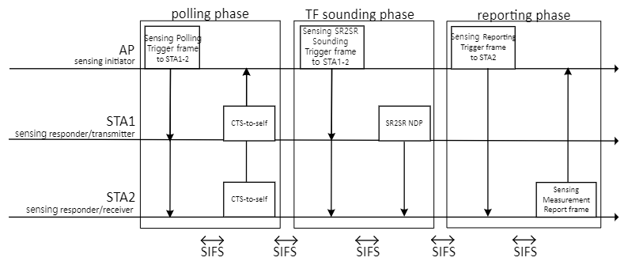

Figure 11-74x—Example of SR2SR variant of a TF sounding phase

SP: Do you agree to the resolution provided in the document 11-23/1265 for CID 2036?

