IEEE P802.11
Wireless LANs
LB271 CRs for Some General CIDs
Date: 2023-07-07
Author(s):
Name | Affiliation | Address | Phone | email
Zhi Mao | Huawei Technologies | F3 building, Huawei Base, Bantian, Longgang, Shenzhen, Guangdong, China, 518129 |  | maozhi3@huawei.com
Chenchen Liu
Mengshi Hu
Ross Jian Yu
Bo Gong
Ming Gan
Abstract
This submission includes the resolutions for the following 5 CIDs:

16900 16950 17056 17078 17101.

The baseline document is P802.11be D3.2.

Revision history:
R0 – Initial version.

CID: 16900
CID | Clause | Page | Line | Comment | Proposed Change | Proposed Resolution
16900 | / | / | / | "may not" is confusing (could mean "shall not" or could mean "is allowed not to") | Change to "shall not" at 471.16, 472.13, 560.30 | Revised.  Partly agree with the commenter. This commenter suggested 3 changes. One is accepted, the other two are not because they are both correspondent with previous sentences.  Instructions to TGbe editor:  Please make the changes as shown in 11/23-1255r0 tagged with #16900.

Proposed Text Change (#16900):
TGbe editor: Please update this clause as shown below:
35.3.16.8.1 General
When a non-AP MLD is operating in the EMLSR mode, a non-AP STA affiliated with a non-AP MLD that is operating on one of the EMLSR links is considered to have lost medium synchronization if it is not able to perform CCA during frame exchanges that includes the link switch delays between an AP affiliated with an AP MLD and one of the other non-AP STAs operating on the other EMLSR links, which are affiliated with the same non-AP MLD. The non-AP STA that has lost medium synchronization shall start a MediumSyncDelay timer and begin counting down immediately after returning to the listening operation if the duration of the loss of medium synchronization is longer than aMediumSyncThreshold; otherwise, the non-AP STA (#16900)shall not start the MediumSyncDelay timer.

Discussion:
The following two sentence “may not” are both correspondent with previous sentences. So, it is better to keep the currect description.
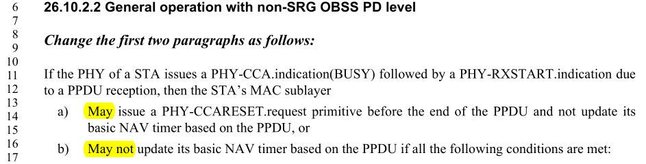

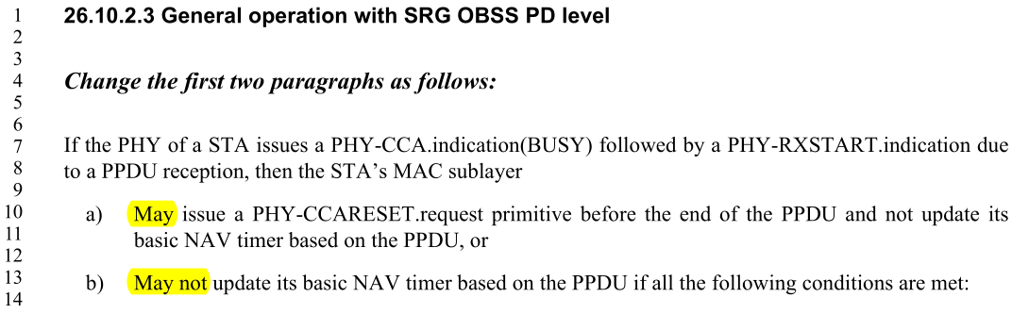
End of Discussion

CID: 16950
CID | Clause | Page | Line | Comment | Proposed Change | Proposed Resolution
16950 | / | / | / | Is it "Nss" or "NSS" or "N_SS"? | Be consistent with majority use in the baseline | Accepted.  Note to TGbe editor:  This comment has been addressed in the resolution of CID 15170 in document 802.11-23/689/r2.

CID: 17056
CID | Clause | Page | Line | Comment | Proposed Change | Proposed Resolution
17056 | / | / | / | "right after" is colloquial | Delete at 533.13; delete "right" at 611.53/54, 900.54/58 | Revised  Agree with the commenter, and reflect the detail changes.  Instructions to TGbe editor:  Please make the changes as shown in 11/23-1255r0 tagged with #17056.

Proposed Text Change (#17056):
TGbe editor: Please update these 2 clauses as shown below:
35.3.11 Multi-link procedures for (extended) channel switching and channel quieting(#15157)
P565L62
If an AP (#16522)(affected AP) affiliated with an AP MLD is switching channel, the Channel Switch Announcement element, or the Extended Channel Switch Announcement element with the Channel Switch Count field (#17834)set to a nonzero value, and the Max Channel Switch Time element shall be included in every Beacon and Probe Response frames on all links of the AP MLD from (#17056) the time the (#16522)affected AP includes the elements in the Beacon frame it transmits until the estimated (#18297)target switch time. After the estimated (#18298)target switch time, the Channel Switch Announcement element and the Extended Channel Switch Announcement element shall not be included in the per-STA profile (#16597)corresponding to the affected AP in the Beacon and Probe Response frames and the Max Channel Switch Time element shall be included in the per-STA profile of the affected AP in every Beacon and Probe Response frames on all links of the AP MLD(#16523), except the link corresponding to the affected AP, until the affected AP resumes BSS operation on the new channel. The value carried in the Switch Time field indicates the adjusted estimated time of the first Beacon frame in the new channel.

P630L53/54
Table 35-3—Summary of supported RU or MRU sizes for sounding feedback(#17055) (con-

Operating channel width of the EHT  beamformee (MHz) | Sounding feedback modes | Bandwidth of PPDU carrying the EHT NDP Announcement frame (MHz)
 |  | 20 | 40 | 80 | 160 | 320
320 | Mandatory for SU feedback (non-TB sounding) | 242 | 484 | 484+242 (F),  996 | 996+484 (F),  996+484+242 (F),  2×996 | 2x996+484 (F),  3x996 (F),  3×996+484 (F),  4×996
Optional for CQI feedback (non-TB sounding)
– NOTE 1
 | Mandatory for MU feedback (TB sounding) | 242 | 484 | 484+242 (F),  996 | 996+484 (F),  996+484+242 (F),  2×996 | 2×996+484 (F),  3×996 (F),  3×996+484 (F),  4×996
 | Optional for MU feedback (TB sounding) – NOTE 2 | N/A | 242 | 242, 484,  484+242 (P) | 242, 484, 996,  484+242,  996+484 (P) | 484, 996,  996+484, 2×996,  2×996+484 (P),  3×996+484 (P),  3×996 (P)
 | Optional for SU feedback (TB sounding) – NOTE 3 | 242 | 242,  484 | 242, 484,  484+242,  996 | 242, 484, 996,  484+242,  996+484,  996+484+242,  2×996 | 484, 996,  996+484, 2×996,  2×996+484,  3×996,  3×996+484,  4×996
 | Optional for CQI feedback (TB sounding) – NOTE 4
NOTE 1—Supported if the Non-Triggered CQI Feedback subfield in the EHT PHY Capabilities Information field in the EHT Capabilities element is set to 1.

NOTE 2—Supported if the Triggered MU Beamforming Partial bandwidth Feedback subfield in the EHT PHY Capabilities Information field in the EHT Capabilities element is set to 1.

NOTE 3—Supported if the Triggered SU Beamforming Feedback subfield in the EHT PHY Capabilities Information field in the EHT Capabilities element is set to 1.

NOTE 4—Supported if the Triggered CQI Feedback subfield in the EHT PHY Capabilities Information field in the EHT Capabilities element is set to 1.

NOTE 5—“(F)” (#17056) after the MRU indicates MRU sizes where the feedback represents full bandwidth feedback. “(P)” (#17056) after the MRU indicates MRU sizes where the feedback represents partial bandwidth feedback. If no explicit indication is added, both (F) and (P) are implied where possible.

NOTE 6—Each value in the table only indicates the size of a feedback RU or MRU, not the location of the RU or MRU. This includes all possible feedback RU(s) or MRU(s) of the same size within the beamformee’s operating bandwidth.

36.3.23 EHT receive procedure
If the received PPDU is EHT MU PPDU, the PHY entity shall begin receiving the EHT-SIG, EHT-STF, and EHT-LTF for EHT MU PPDU as shown in Figure 36-78 (PHY receive procedure for an EHT MU PPDU). The PHY entity shall check the CRC of the Common field of EHT-SIG.
- If the CRCs protecting the Common field of EHT-SIG are valid, for all supported modes, unsupported modes and Validate indication, the PHY entity shall maintain PHY- CCA.indication(BUSY, channellist) primitive for the predicted duration of the transmitted PPDU, as defined by RXTIME in Equation (36-109), unless it receives a PHY-CCARESET.request primitive before the end of the PPDU for instance during spatial reuse operation as described in 35.10 (EHT Spatial reuse operation). A Validate EHT-SIG indication is defined as a field value of a subfield either in the EHT-SIG common field or in the receiver’s own user field being set to a Validate state.
- If the UL/DL subfield of the U-SIG field is set to 0 and the CRCs protecting the Common field of the EHT-SIG are valid, the PHY entity shall search for intended STA-ID in each User field. If an intended STA-ID is detected in a user encoding block or in the common encoding block of EHT-SIG (STA-ID can be present in the common encoding block of EHT-SIG only if the PPDU type and compression mode and UL/DL indicate a DL non-OFDMA transmission) with valid CRC, and an unsupported mode or a Validate EHT-SIG indication is not indicated, the PHY entity shall continue receiving the EHT-STF (#17056) after the EHT-SIG.
- If the UL/DL subfield of the U-SIG field is set to 1 and the CRC protecting the common encoding block of the EHT-SIG is valid and an unsupported mode or a Validate EHT-SIG indication is not indicated, the PHY entity may continue receiving the EHT-STF (#17056) after the EHT-SIG without checking the STA-ID subfield.

CID: 17078
CID | Clause | Page | Line | Comment | Proposed Change | Proposed Resolution
17078 | / | / | / | "rules defined as"/"rules as defined" should be just "rules defined" (4x) | As it says in the comment | Revised.  Agree with the commenter, and reflect the detail changes.  Instructions to TGbe editor:  Please make the changes as shown in 11/23-1255r0 tagged with #17078.
Proposed Text Change (#17078):
TGbe editor: Please update these 4 clauses as shown below:
35.10 EHT Spatial reuse operation
35.10.1 General
P641L58
An EHT STA follows the rules defined in 26.10 (HE spatial reuse operation) and the additional rules defined(#17078) below.

35.3.8 Block ack procedures in Multi-link operation
P559L16
An MLD shall follow the mechanisms defined in 11.5 (Block ack operation) and 35.4 (EHT acknowledgment procedure) with additional rules(#17078) defined in this subclause for performing block ack operation.

35.3.21 TDLS procedure in multi-link operation
35.3.21.1 General
P601L32
A non-AP MLD that intends to establish a single link TDLS direct link with a peer STA on one of its links follows the procedures defined in 11.20 (Tunneled direct link setup), with additional rules(#17078) defined in 35.3.21.2 (TDLS direct link over a single link).

35.8 Restricted TWT (R-TWT)
35.8.1 General
P637L29
(#15830)(#16061)An R-TWT scheduled STA establishes membership for one or more R-TWT schedules with its associated EHT AP by following the rules defined in 26.8.3 (Broadcast TWT operation) with the additional rules defined in 35.8.2 (R-TWT membership setup). An R-TWT scheduling AP may announce one or more R-TWT SPs as described in 35.8.3 (R-TWT announcement(#16064)). EHT STAs that support R-TWT operation follow the rules(#17078) defined in 26.8.3 (Broadcast TWT operation) and the additional rules and restrictions that are defined in the subclauses below.

CID: 17101
CID | Clause | Page | Line | Comment | Proposed Change | Proposed Resolution
17101 | / | / | / | "in the range of" followed by a number should be "in the range" | As it says in the comment (10x) | Accepted.  Note to TGbe editor:  This comment has been addressed in the resolution of CID 17161 in document 23/0603r1

