IEEE P802.11
Wireless LANs
CR for Misc CIDs
Date: 2023-07-08
Author(s):
Name | Affiliation | Address | Phone | email
Dibakar Das | Intel |  |  | Dibakar.das@intel.com
Abstract
This submission proposes resolutions for following CIDs:

15444 17142 15489 18308 15940 16290 16295 16409 16411 16458 16717 16729 17232 17978 16730 16731 16734 17143 17899 17977

Revisions:
- Rev 0: Initial version. Discussion text for CID 15489 provided by Gaurang and Abhi.

The changes are relative to 11be draft 3.2

CID | Clause | Page | Comment | Proposed Change | Resolution
15444 | 35.18 | 655.15 | The sentence has "MSCS procedures" as the subject but uses singular verb. | Rephrase as "The MSCS procedures, including setting up, updating of parameters and termination of an MSCS, classification of MSDUs addressed to a non-AP EHT STA, and setting the UP of those MSDUs, as defined in 11.25.3 (MSCS procedures), are performed at the MLD level..." | Accept.
17142 | 35.18 | 655.17 | "is" should be "are" | As it says in the comment | Accept.
15489 | 35.3.16.8.2 | 561.29 | Can Medium Synchronization Delay be updated by Beacon frames? | Please clarify it | Revised.  The relevant text was accidentally deleted in last draft. We now bring it back.  TGbe editor: please implement changes as shown in doc 11-23/1202 tagged as #15489
18308 | 35.2.1.2.3 | 476.34 | If a non-AP EHT STA does not have data to transmit, it may still respond CTS frame to the received MU-RTS TXS trigger based on the rule "The first PPDU of the exchange shall carry a CTS  frame transmitted per the rules defined in 26.2.6.3 (CTS frame response to an MU-RTS Trigger frame)." However, it should be allowed to set Duration field to zero or less than the allocated time to return the allocated time to AP. | Suggest to add the text "The STA may set the Duration/ID field in the CTS frame with a value that indicates a time no later than the ending time of the PPDU carrying the MU-RTS TXS Trigger frame plus the allocated time duration in the Allocation Duration field of the soliciting MU-RTS TXS Trigger frame. | Reject.  The additional overhead of returning through a QoS Null frame containing Cas Cttrl + Ack field is expected to be relatively small.
15940 | 35.2.1.2.3 | 476.62 | A non-AP EHT STA that receives a MU-RTS TXS Trigger frame from its associated AP that contains a User Info field addressed to the STA shall update its CWmin[AC], CWmax[AC], AIFSN[AC], and MUEDCATimer[AC] state variables to the values contained in the dot11MUEDCATable, for all the ACs from which at least one QoS Data frame was transmitted successfully in a non-TB PPDU to the AP within time allocated in the TF. | Normative text is needed for the case when the QoS Data frame is transmitted to a peer STA (TXOP Sharing Mode = 2) and a BA received from that peer STA (and not an AP) - does the STA update its MUEDCATimer[AC] for this case? | Reject.  MU EDCA rules only apply for UL transmissions within the allocated time.
16290 | 35.17 | 654.53 | The sentence "If negotiated R-TWT SPs for the TID specified in the QoS Characteristics element are trigger-enabled R-TWT" is strange.  This is because the R-TWT setup procedure (35.8.2.2) requests the AP to set the Trigger field. | replace "if negotiated R-TWT SPs" by "As negotiated R-TWT SPs". | Reject.  R-TWT can be both “trigger-enabled” and non-trigger enabled. See P637L41 in draft 3.2:  “An R-TWT scheduling AP should set the Trigger field to 1 in the Restricted TWT Parameter Set field(s) it transmits.”
16295 | 35.3.24.3 | 586.26 | The transmission of direct link frames should  be enabled by using MU-RTS TXS Trigger frames in an r-TWT period. In that case, the EHT STA is an r-TWT scheduled STA having specified a QoS Characteristics element accordingly. Issue is that P2P recipient is not aware of such negociations, and may be in doze state for TWT SP it is not member of (initiating P2P STA is member of). There is high risk of lost TWT/TXS resource (not used) | Make the recipient P2P STA aware of the TWT membership. It thus can be awake for the service periods to come in this rTWT schedule, hence be available for P2P communication with the initiator peer STA. | Reject.  If the P2P STA is part of same BSS and is not legacy STA, then it can negotiate the same SP. Otherwise, they can negotiate a common SP among themselves that’s aligned to the r-TWT SP.
16409 | 35.17 | 654.49 | in "...there are negotiated R-TWT SPs for the TID specified in the QoS Characteristics element then the EHT AP..." direction is missing | Suggest to modify "for the TID specified in the QoS Characteristics element" as "for the TID and direction specified in the QoS Characteristics element" | Revised.  Agree in principle. This sentence has been revised in draft 3.2:  “If the EHT STA is an R-TWT scheduled STA (see 35.8 (Restricted TWT (R-TWT))) and there are negotiated R-TWT SPs for the TID specified in the QoS Characteristics element in the same direction (UL or DL) as indicated by the Direction subfield in the QoS Characteristics element, then the EHT AP should use these R-TWT SPs to serve traffic corresponding to the TID and specified direction in the QoS Characteristics element.”  TGbe editor: no further changes needed.
16411 | 35.17 | 654.54 | "the EHT AP should ensure that the trigger frames are scheduled at the start of the R-TWT SPs." seems to be confusing. | Please clarify how to ensure the traffic described by the QoS Characteristics element has arrived or is arriving when the trigger frames are scheduled at the start of the R-TWT SPs . | Reject.  Since the SCS Request containing the QoS Characteristics is sent by a non-AP STA, its expected that the traffic arrival at that non-AP STA would follow the parameter it describes itself. The mechnanism it applies to ensure this and receive correct allocation could be proprietary and not described in spec.
16458 | 35.2.1.2.1 | 473.59 | "The Triggered TXOP sharing procedure allows an AP to allocate a portion of an obtained TXOP to one associated non-AP EHT STA for transmitting one or more non-TB PPDUs."  If the obtained TXOP has enough time, it would be good to share to more associated non-AP EHT STAs. | The Triggered TXOP sharing procedure allows an AP to allocate a portion of an obtained TXOP to one or more associated non-AP EHT STA for transmitting one or more non-TB PPDUs. | Reject.  If there is sufficient time to allocate for multiple STAs, the AP may send multiple such Trigger frames back to back.
16717 | 35.2.1.1 | 473.58 | "Triggered TXOP sharing" should be lowercase: "triggered TXOP sharing" | Fix here and any other locations | Accept.
16729 | 35.2.1.2.3 | 477.23 | "Within the allocated time by an  MU-RTS TXS Trigger frame with Triggered TXOP Sharing Mode subfield equal to 2, the addressed STA by  the MU-RTS TXS Trigger frame may transmit QoS Data frames, Management frames and the frames that  assists the transmission of QoS Data frames and Management frames, e.g., RTS frame, the frames for  sounding." has wonky grammar | Change to "Within the time allocated by an MU-RTS TXS Trigger frame with TXOP Sharing Mode subfield equal to 2, the STA addressed by the MU-RTS TXS Trigger frame may transmit QoS Data frames, Management frames and frames that assists the transmission of these frames, e.g., RTS/CTS frames and sounding frames." | Revised.  Made changes along the lines suggested by commenter.  TGbe editor: please implement changes as shown in doc 11-23/1202 tagged as #16729
17232 | 35.2.1.2.3 | 477.22 | "the frames for sounding". Is this intended as an example of an allowed Management frame? In that case, use the correct frame name. | See comment | Revised.  Changed this to “sounding frames”.  TGbe editor: please implement changes as shown in doc 11-23/1202 tagged as #16729
17978 | 35.2.1.2 | 477.27 | "the frames for sounding" should be "frames for sounding" | as in comment | Revised.  Changed this to “sounding frames”.  TGbe editor: please implement changes as shown in doc 11-23/1202 tagged as #16729
16730 | 35.2.1.2.3 | 477.30 | "NOTE 2--With the Duration rule defined here, the basic NAV of any STA in the same BSS that receives these frames  might become zero only at the end of the allocated time if the basic NAV timer is set per the P2P transmission frames  during the allocated time period" has editorial issues | Change to "NOTE 2--With this Duration field rule, the basic NAV of a STA in the same BSS might become 0 only at the end of the allocated time if the basic NAV timer is set by the frames transmitted to peer non-AP STAs during the allocated time period" | Revised.  Made changes along the lines.  TGbe editor: please implement changes as shown in doc 11-23/1202 tagged as #16730
16731 | 35.2.1.2.3 | 477.32 | I can't understand "these STAs can transmit in the remaining TXOP after the allocated time period  due to a zero basic NAV value" -- which STAs? | "shall not  be used by the non-TB PPDU(s) that is transmitted during the time al | Revised.  Made changes along the lines.  TGbe editor: please implement changes as shown in doc 11-23/1202 tagged as #16730
16734 | 35.2.1.2.3 | 477.55 | "shall not  be used by the non-TB PPDU(s) that is transmitted during the time allocated by an associated AP" could be worded better, and this applies to all the PPDUs since they are required to be non-TB above | "shall not  be used by the non-TB PPDU(s) that is transmitted during the time al | Reject.  The suggested sentence seems to be same as original text.
17143 | 35.18 | 655.21 | " MSCS procedure" missing article | As it says in the comment | Revised.  Added “the” before “MSCS procedure”.  TGbe editor: please implement changes as shown in doc 11-23/1202 tagged as #17143
17899 | 35.3.16.8.2 | 561.30 | Change Multi-Link Probe Response to lowercase | As in comment | Accept.
17977 | 35.2.1.1 | 475.39 | Figure 35-1 is incorrect, if the last PPDU (BlockACK) ends less than PFS before the end of the allocated time, then the "Data to another non-AP STA" should be transmitted already outside of the allocated time since there is already a PIFS between the two frames. Should the "PIFS" be "SIFS" in the figure? | please correct the figure as well as the text describing it. | Revised.  Changed the text to clarify.  TGbe editor: please implement changes as shown in doc 11-23/1202 tagged as #17977

Discussion for CID 15489:

From D3.0 redline comparison with D2.3 (P536)
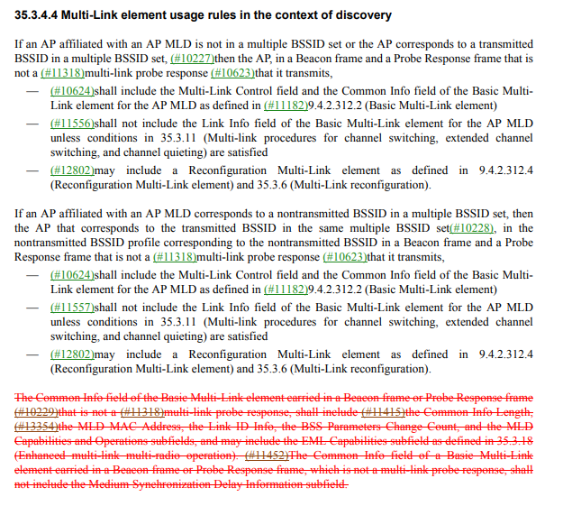
Deletion of the text was triggered by CID 10625 in CR document 11-23/1462r3 during LB266 comment resolutions (see below).
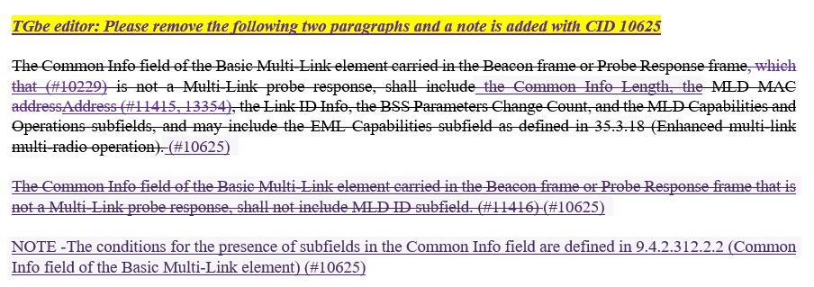
Instructions to delete the paragraph in document 1462r3 did not include the last statement – “The Common Info field of a Basic Multi-Link element carried in a Beacon frame or Probe Response frame, which is not a multi-link probe response, shall not include the Medium Synchronization Delay Information subfield”. This statement was added as a resolution for CID 11452 in CR document 11-23/1188r4 during LB266 comment resolutions (see below).
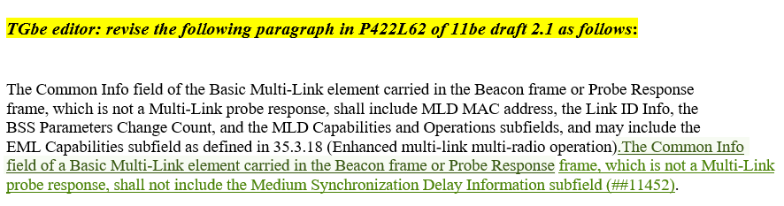
Since the last statement was accidentally deleted, it is added back.

TGbe editor: Please insert the following paragraph in P531L39 in draft 3.2 as follows):

35.3.4.4 Multi-Link element usage in the context of discovery

The Common Info field of a Basic Multi-Link element carried in a Beacon frame or Probe Response frame, which is not a multi-link probe response, shall not include the Medium Synchronization Delay Information subfield (#15489).

TGbe editor: Please revise P515L28 in draft 3.2 as follows):

Within the time allocated by an MU-RTS TXS Trigger frame with Triggered TXOP Sharing Mode subfield equal to 2, the STA addressed by the MU-RTS TXS Trigger frame may transmit QoS Data frames, Management frames and frames that
assists the transmission of QoS Data and Management frames, e.g., RTS/CTS frames, sounding frames (#16729).

TGbe editor: Please revise P515L34 in draft 3.2 as follows):

NOTE 2—With the Duration field rule defined here, the basic NAV of any STA in the same BSS might become 0 only at the end of the allocated time if the basic NAV timer is set by the frames transmitted to peer STAs during the allocated time period (#16730). Such (#16731) STAs can transmit in the remaining TXOP after the allocated time period due to a zero basic NAV value.

TGbe editor: Please revise P513L31 in draft 3.2 as follows):

Figure 35-1 (Example of an MU-RTS TXS Trigger frame with Triggered TXOP Sharing Mode subfield value equal to 1 soliciting UL PPDU(#16727)) shows an example of the exchange of (#16727)an MU-RTS TXS Trigger frame with Triggered TXOP Sharing Mode subfield value equal to 1 preceded by an optional CTS-to-self transmission and transmission of UL non-TB PPDUs by a scheduled STA within the allocated time. Additionally, the figure shows the case where the AP transmits to another non-AP STA within the allocated time signaled in (#16727)the MU-RTS TXS Trigger frame, since the CS mechanism indicates that the medium is idle at the TxPIFS slot boundary after the transmission of the last BlockAck frame to STA 1 (#17977).

TGbe editor: Please revise P674L25 in draft 3.2 as follows):

35.18 EHT MSCS procedure

An MLD that implements the (#17143) MSCS procedure shall have each STA affiliated with that MLD set dot11MSCSActivated to true, and shall indicate its capability by having each STA affiliated with that MLD set the Mirrored SCS field of the Extended Capabilities elements that the STA transmits to 1.

