IEEE P802.11
Wireless LANs
Bug fix contribution - DMG sensing procedure expiry timer
Date: 2023-6-xx
Author(s):
Name | Affiliation | Address | Phone | email
Zhuqing Tang | Huawei  Technologies | F3, Huawei Base, Shenzhen, Guangdong, China |  | tangzhuqing@huawei.com
Rui Du
Narengerile
Mengshi Hu
Yiyan Zhang

Abstract
This submission provides a contribution of a bug fix problem.

Rev 0: Initial document
Problem statement

In the DMG sensing part of the 11bf draft, although the DMG sensing procedure expiry timer and the DMG SBP procedure expiry timer have been described in Clause 11, there is no corresponding field indication of DMG Procedure Expiry Exponent nor DMG SBP procedure expiry timer in any frames in Clause 9.
Thus, this problem needs to be addressed.

Discussion

In sensing measurement parameters field, we have Measurement Setup Expiry Exponent to indicate a time after which the sensing measurement session is terminated, if there are no frame exchange sequences.

The same applies to SBP procedure. We have SBP Procedure Expiry Exponent.

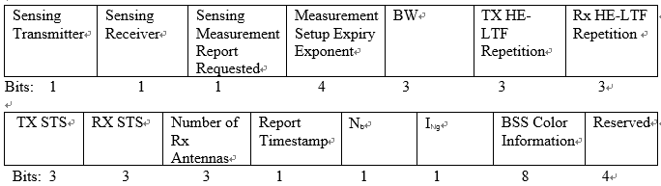

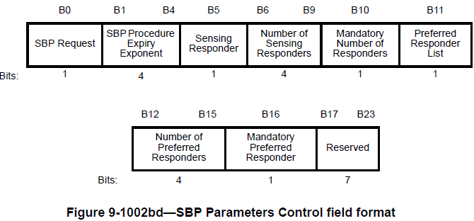

Thus, the DMG sensing procedure expiry exponent field and DMG SBP procedure expiry exponent field should be added in DMG Sensing Measurement Session element and DMG SBP Parameters Control field, respectively.

The value of the expiry timer needs further discussion.

In sub-7 sensing, the Measurement Session Expiry value is equal to $2^{( measurement session expiry exponent+8)}$ ms, this field has 4 bits, meaning that the expiry timer can be chosen from 256ms ($2^{8}$) to 2.3h ($2^{23}$).

In DMG sensing, what value should we choose? The value may not be the same as sub-7 sensing.

In Claudio’s contribution (0814r3), a time limit (10s) is given (see below Table X3), thus one possible solution for setting up the DMG sensing procedure Expiry value is equal to $2^{(DMG sensing procedure expiry exponent+7)}$ms, this field may include 3 bits, meaning that the expiry timer can be chosen from 128ms ($2^{7}$) to 16.3s ($2^{14}$). (Further discussion needed)

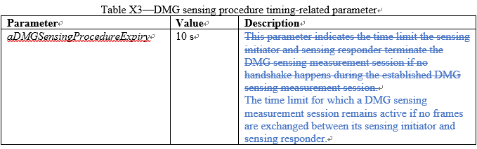

Proposed changes to Draft 1.1

Instructions to the editor: please modify the frame format in the subclause in P84L10 in 9.4.2.325 DMG Sensing Measurement Session element in D1.1 as shown below:

Instructions to the editor: please add the following sentence in the subclause in P86L27 in 9.4.2.325 DMG Sensing Measurement Session element in D1.1 as shown below:

The DMG Sensing Procedure Expiry Exponent field contains an unsigned integer. It is encoded according to
the conventions in 9.2.2 (Conventions). The DMG Sensing Procedure Expiry value is equal to $2^{(DMG sensing procedure expiry exponent+7)}$ ms. It is a time after which the DMG sensing procedure is terminated, if there are no frame exchange sequences (see 11.55.3.8 (DMG sensing measurement termination).

Instructions to the editor: please modify the frame format in the subclause in P103L40 in 9.4.2.334 DMG SBP Parameters element in D1.1 as shown below:

Instructions to the editor: please add the following sentence in the subclause in P105L17 in 9.4.2.334 DMG SBP Parameters element in D1.1 as shown below:

The DMG SBP Procedure Expiry Exponent field contains an unsigned integer. It is encoded according to
the conventions in 9.2.2 (Conventions). The DMG SBP Procedure Expiry Exponent value is equal to $2^{(DMG sensing procedure expiry exponent+7)}$ ms. It is a time after which the DMG SBP procedure is terminated, if there are no frame exchange sequences (see 11.55.4.3 (DMG SBP Termination)).

SP
Do you support the provided proposed change to be included in the latest 11bf draft?

Y/N/A

