IEEE P802.11
Wireless LANs
CIDs related to PHYCONFIG_VECTOR
Date: 6-Jul-23
Author(s):
Name | Affiliation | Address | Phone | email
Sigurd Schelstraete | MaxLinear |  |  | sschelstraete@maxlinear.com
Abstract
This document discusses and proposes resolutions for CIDs 4384, 4385, 4386

Introduction

CID | Page | Line | Comment | Proposed Change | Proposed resolution
4384 | 3240 | 37 | Section 19.2.3 only mentions two parameters in PHYCONFIG_VECTOR. Presumably, this is in addition to the parameters listed in Table 8-4. (Note BTW that both listed parameters are already in this Table.) | Add sentence to clarify that the full set of parameters in PHYCONFIG_VECTOR is obtained by also considering the parameters listed in Table 8-4.  A similar addition should be made to the "PHYCONFIG_VECTOR parameters" section of other PHYs: 20.2.3, 21.2.3, 22.2.5, 27.2.4 | REVISED  Apply changes proposed in doc.: IEEE 802.11-23/1179r1
4385 | 4192 | 9 | The HE receive procedure clause mentions the use of PHY-RXEND.indication(Filtered) with BSS Color as a condition (P4192L9 and P4193L49). "Filtered" is defined on P569L42 as "This value is used to indicate that during the reception of the PPDU, the PPDU was filtered out due to a condition set in the PHYCONFIG_VECTOR.". There currently is no indication of color or any support for color filtering in PHYCONFIG_VECTOR. | Add support for color filtering in PHYCONFIG_TXVECTOR of HE. | REVISED  Apply changes proposed in doc.: IEEE 802.11-23/1179r1
4386 | 4192 | 11 | The HE receive procedure clause uses the term "intended value" to decide on when to Filter out a PPDU. This term is not defined anywhere. | Clarify the use of the term "intended value" in the HE receive procedure.  (Note: the term appears three times in this section) | REVISED  Apply changes proposed in doc.: IEEE 802.11-23/1179r1

CIDs 4385, 4386

Discussion
Both CIDs refer to the same paragraph (P4192L9 of D3.0):
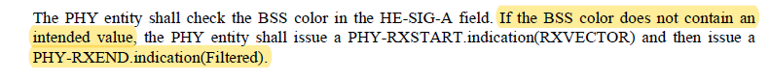

(Note: the exact same paragraph also appears at P4192L55 and P4193L49)

The first issue is that the use of PHY-RXEND.indication(Filtered) requires a filtering condition. This condition should be related to configurations set in the PHYCONFIG_VECTOR. See P569L42 in D3.0:

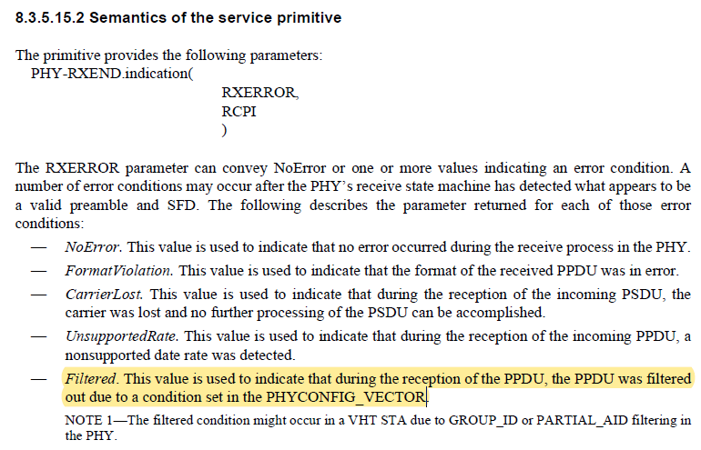

Currently, the PHYCONFIG_VECTOR (of HE PHY) does not contain such a variable.

In the same paragraph (P4192L9 of D3.0), the use of “intended value” is also unclear (CID 4386). Presumably, it means the color values that should not be filtered out by the PHY. Once CID 4385 is resolved and the mechanism to indicate these color values is specified, this can be used to clarify the meaning of “intended value”.

Proposal
PHYCONFIG_VECTOR parameters for an HE PHY are currently given in clause 27.2.4 (PHYCONFIG_VECTOR parameters).

The proposal is to add a parameter “BSS_COLOR_LIST” that contains the color values that can not be ignored by the receiver.

--- begin proposal ---

27.2.4 PHYCONFIG_VECTOR parameters
The PHYCONFIG_VECTOR carried in a PHY-CONFIG.request primitive for an HE PHY contains an OPERATING_CHANNEL parameter, which identifies the operating or primary channel. The PHY shall set dot11CurrentPrimaryChannel to the value of this parameter.

(…)

The PHYCONFIG_VECTOR carried in a PHY-CONFIG.request primitive for an HE PHY contains a CENTER_FREQUENCY_SEGMENT_1 parameter, which takes the value 0 if the CHANNEL_WIDTH parameter does not indicate 80+80 MHz, and otherwise identifies the center frequency of segment 1 and takes a value between 1 and 200. The PHY shall set dot11CurrentChannelCenterFrequencyIndex1 to the value of this parameter.

The PHYCONFIG_VECTOR carried in a PHY-CONFIG.request primitive for an HE PHY contains a BSS_COLOR_LIST parameter, which indicates a list of color values for which PPDUs have to be processed. Processing of PPDUs with color values not in BSS_COLOR_LIST can be terminated as soon as their color is determined.

--- end proposal ---

It is also proposed to update clause 8.3.5.15.2 to add the new filtering condition to the existing NOTE:

--- begin proposal ---

8.3.5.15.2 Semantics of the service primitive
The primitive provides the following parameters:
PHY-RXEND.indication(
RXERROR,
RCPI
)

The RXERROR parameter can convey NoError or one or more values indicating an error condition. A number of error conditions may occur after the PHY’s receive state machine has detected what appears to be a valid preamble and SFD. The following describes the parameter returned for each of those error conditions:
— NoError. This value is used to indicate that no error occurred during the receive process in the PHY.
— FormatViolation. This value is used to indicate that the format of the received PPDU was in error.
— CarrierLost. This value is used to indicate that during the reception of the incoming PSDU, the
carrier was lost and no further processing of the PSDU can be accomplished.
— UnsupportedRate. This value is used to indicate that during the reception of the incoming PPDU, a
nonsupported date rate was detected.
— Filtered. This value is used to indicate that during the reception of the PPDU, the PPDU was filtered out due to a condition set in the PHYCONFIG_VECTOR.
NOTE 1—The filtered condition might occur: in a VHT STA due to GROUP_ID or PARTIAL_AID filtering in the PHY.:
- in a VHT STA due to GROUP_ID or PARTIAL_AID filtering in the PHY.
- in an HE STA due to BSS color filtering in the PHY.

--- end proposal ---

To resolve CID 4386, the following change is proposed on P4192L9 (as well as P4192L55 and P4193L49):

--- begin proposal ---

The PHY entity shall check the BSS color in the HE-SIG-A field. If the BSS color does not contain an intended value (i.e., the color value is not contained in the PHYCONFIG_VECTOR parameter BSS_COLOR_LIST), the PHY entity shall issue a PHY-RXSTART.indication(RXVECTOR) and then issue a PHY-RXEND.indication(Filtered).

--- end proposal ---

CID 4384

Discussion
Table 8-4 is intended to define PHYCONFIG_VECTOR parameters that are common (Note: there are CIDs related to the clean-up of this Table).

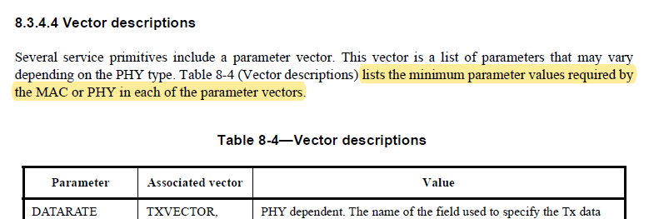

In addition to this, most PHY clauses have their own PHYCONFIG_VECTOR subclause, e.g.:

- DMG: 20.2.3 PHYCONFIG_VECTOR parameters
- VHT: 21.2.3 PHYCONFIG_VECTOR parameters
- TVHT: 22.2.5 PHYCONFIG_VECTOR parameters
- HE: 27.2.4 PHYCONFIG_VECTOR parameters
None of these clauses make reference to Table 8-4. Presumably, the full PHYCONFIG_VECTOR definition for a given PHY is obtained by combining the values in Table 8-4 with the ones that are specified for that PHY.

Proposal
Add the following sentence at the end of clause 20.2.3, 21.2.3, 22.2.5 and 27.2.4:

--- begin proposal ---

Additional PHYCONFIG_VECTOR parameters are defined in Table 8-4.

--- end proposal ---

