IEEE P802.11
Wireless LANs
LB272 comments DMG comment 2063 resolution
Date: 2023.06.xx
Author(s):
Name | Company | Address | Phone | email
Rui Du | Huawei Technologies |  |  | Ray.du@huawei.com
Yan Xin |  |  |  | Yan.Xin@huawei.com
Ning Gao | OPPO |  |  | Gaoning1@oppo.com
Abstract
This submission contains the proposed comment resolution for the CID 2063.

R0: initial document
R1: reference draft is updated to 11bf D1.2.
R2: the document has been further modified.
R3: extra padding indication is added to help the sensing responder understand the actual length of DMG Sensing Request frame.

CID 2063
CID | Page.  Line | Clause Number | Comment | Proposed Change | Resolution
2063 | 193.50 | 11.55.2.6.2.3 | Some of the sensing responder may not be able to fullfil the initiation of DMG sensing instance when DMG sensing type equals to coordianted monostatic, coordinated bistatic and multistati due to some reasons, e.g. blocked by the moving target during the DMG sensing instance. This case should be considered in DMG sensing. | Commenter will provide a contribution. | Revised.  TGbf Editor make changes specified in 1127r3.  (https://mentor.ieee.org/802.11/dcn/23/11-23-1172-03-00bf-lb272-comments-dmg-comment-2063-resolution.docx)

Discussion

In the coordinated DMG sensing, sensing initiator may not able to receive the DMG sensing response due to some reasons (e.g. blocked by the moving target, or sensing responder does not want to pariciapte in this DMG sensing exchange). In current draft 1.1 if the sensing initiator dose not receive a DMG Sensing Response frame within SIFS time, it shall not send the next DMG Sensing Request frame until the duration of a DMG Sensing Response frame plus 2×SIFS after the DMG Sensing Request frame.

In this case, no PPDU is transmitted within a duration of DMG Sensing Resposne + 2*SIFS. This may lead to the TXOP loss when SP field in Measurement Session Control field (within DMG Sensing Measurement Session element) equals to 0 (i.e. CBAP mode is adopted). To avoid TXOP loss, this transmitting rule could be slightly adjusted as follows.

Discussion end

Dicussion 2

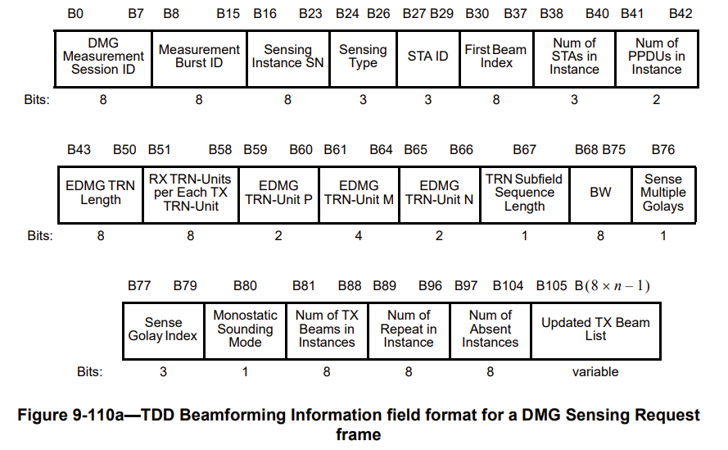

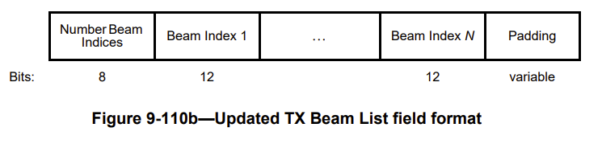
The Padding field length is set to make the length of the TDD Beamforming Information field an integer number of octets(#1357). If the Updated TX Beam List subfield is sent to different STAs in an instance does not have the same length across STAs participating in the instance, it is adapted to have the same length by adjusting the length of the Padding field (#1318).

In coordinated DMG monostatic sensing parallel sounding mode, sensing responder uses the NSTA, STA_ID and length/duration of DMG Sensing Request/Response to calculate the waiting time before transmitting DMG monostatic sensing PPDU. All the length/duration of DMG Sensing Request/Response frames used by the sensing responder (in the same DMG sensing exchange) to calculate the waiting time shall have the same length to ensure the alignment of transmitting DMG monostatic sensing PPDU.

In the above example, the duration of DMG Sensing Request frame received by STA 3 is extended with this extra padding. The padding duration is a DMG Sensing Response frame plus 2 × SIFS minus (SIFS+aCCATIME). This duration time is can be known by the sensing responder, so the only thing sensing responder needs to know is if the DMG Sensing Request frame is padded or not.

To help STA 3 understand the actual length of DMG Sensing Request frame, an indication shall be added to the TDD beamforming Information in DMG Sensing Request frame. When the sensing responder receives a DMG Sensing Request frame with the Extra Padding field equals to 1, sensing responder knows that the DMG Sensing Request frame is padded with an extra duration of DMG Sensing Response frame plus 2 × SIFS minus (SIFS+aCCATIME). Based on this, the sensing responder could calculate the actual length/duration of the actual DMG Sensing Request frame and further calculate the waiting time to transmit the monostatic PPDU to ensure the transmission alignment.

Discussion 2 end

Instructions to the editor: please make the following changes to Figure9-110a TDD Beamforming Information field format for a DMG Sensing Request frame in subclasue 9.3.1.25.5 DMG Sensing Request frame and insert the following paragraphes in P42L49 in 11bf D1.2 as follows.

Figure 9-110a TDD Beamforming Information field format for a DMG Sensing Request frame

The Extra Padding field indicates if the DMG Sensing Request frame is padded with a duration of a DMG Sensing Response frame plus 2 × SIFS minus (SIFS+aCCATIME) to ensure the alignment of simultaneously transmission of DMG monostatic sensing PPDUs in parallel coordinated monostatic DMG sensing instance. This field is set to 1 if the DMG Sensing Reqeust frame is padded and set to 0 if the DMG Sensing Request frame is not padded. This field is reserved otherwise (#2063).

Instructions to the editor: please make the following changes to paragraph from P172L39 to P172L49 in subclasue 11.55.3.6.2.3 Parallel coordinated monostatic DMG sensing instance in 11bf D1.2.

- In the initiation phase, the sensing initiator shall send a DMG Sensing Request frame to each intended sensing responder to request them to participate in the coordinated monostatic DMG sensing instance. The STA ID field of the DMG Setup Request frame shall indicate the order of DMG Sensing Request frames and the Monostatic Sounding Mode field shall be set to 0 to identify the parallel sounding mode. Each sensing responder shall respond with the DMG Sensing Response frame a SIFS after the request. When SP field in the DMG Sensing Measurement Request frame is set to 1, if the sensing initiator does not receive a response within the duration of a DMG Sensing Response frame plus a SIFS after a DMG Sensing Request frame, it shall send the next DMG Sensing Request frame the duration of a DMG Sensing Response frame plus 2 × SIFS after the DMG Sensing Request frame(#1304, #1305, #1391, #1392). When SP field in the DMG Sensing Measurement Reqeust frame is set to 0, if the sensing initiator does not receive a response within SIFS+aCCATIME after a DMG Sensing Request frame, it shall pad the next DMG Sensing Request frame to ensure the alignment of simultaneously transmission of DMG monostatic sensing PPDUs. The duration of the padding shall be euqal to a DMG Sensing Response frame plus 2 × SIFS minus (SIFS+aCCATIME) (#2063).

SP
Do you support resolution to the following CID and incorporate the text changes into the latest TGbf draft: 2063 in 11-23/1172r3?

Y/N/A

