IEEE P802.11
Wireless LANs
LB272 Comment resolution for CIDs related to Availability Window
Date: 2023-7-12
Author(s):
Name | Affiliation | Address | Phone | email
Zhuqing Tang | Huawei  Technologies | F3, Huawei Base, Shenzhen, Guangdong, China |  | tangzhuqing@huawei.com
Rui Du
Naren
Mengshi Hu
Yiyan Zhang

Abstract
This submission resolves the comments of the CID 1810 and 2107.

Rev 0: Initial document
Rev 1: url has been added
Rev 2: modified, added two more solutions based on ad-hoc meeting discussions in July 7th
Rev 3: for CID 2107, solution option 3 has been chosen by the group member, so this solution has been revised, and the rest options have been deleted

CID 1810
CID | Page.  Line | Clause Number | Comment | Proposed Change | Resolution
1810 | 174.52 | 11.55.1.4 | Need an example or description for how the availability window is assigned in a measurement setup | Add the following:  Figure 9-788edk (Example of a bitmap with 200 TU periodicity signalled in the ISTA Availability Window  element), 9-788edl (Example of mapping of ISTA's availability bitmap to RSTA's TSF) and 9-788edm  (Example of how an RSTA assigns an Availability Window to an ISTA) together also show an example of how an AP (sensing initiator) assigns an availability window from the received Availability Window element of a non-AP STA (sensing responder). | Accepted

Discussion

This proposed paragraph is also used when specifying the availability window assignment in SBP procedure, see below screenshot:

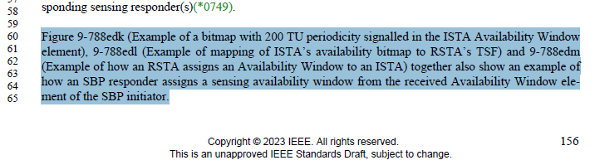

CID 2107
CID | Page.  Line | Clause Number | Comment | Proposed Change | Resolution
2107 | 174.40 | 11.55.1.4 | In the sensing measurement setup, AP directly assigns an availability window to an associated STA without knowing the associated STA's availability for TB sensing measurement. In this case, it is possible that the associated STA is not available during the assigned availability window. | The commenter will provide a contribution. | Revised  TGbf Editor make changes specified in 1169r3  (https://mentor.ieee.org/802.11/dcn/23/11-23-1169-02-00bf-lb272-comment-resolution-for-cids-related-to-availability-window.docx).

Discussion

Problem statement:

- In the current 802.11bf draft, for TB sensing measurement setup, AP directly assigns the availability window to the associated STA by transmitting Sensing Measurement Request frame. In this frame, the Availability window field indicates the assigned availability window to the sensing responders.
- If the AP assigns the availability window without acquiring the ISTA availability window element from the associated STA, it is possible that the associated STA is not available in the assigned availability window.
- Thus, the non-AP STA may not able to conduct the TB sensing measurement exchange, as all TB sensing measurement exchanges shall take place within a sensing availability window.
- This will cause
- Waste of resource.
- Measurement setup cannot be established.
That is, this is an existing flaw in the current 11bf draft.

For reference:3 examples of the other availability window assignments:

- Availability window assignment for unassociated STA in 11bf
- The unassociated STA transmit a Sensing Measurement Query frame to solicit a Sensing Measurement Request frame. The Sensing Measurement Query frame includes an ISTA Availability Window element to indicate its availability. 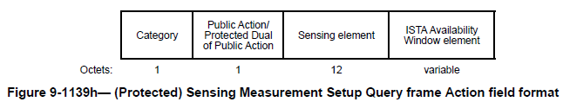
- The AP assigns an availability window to an unassociated STA based on the ISTA Availability Window. The assignment is indicated in the Availability Window field in a TB Sensing Specific subelement in a Sensing Measurement Request frame. 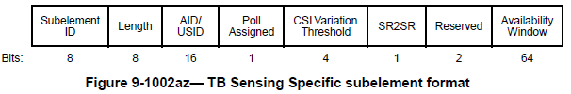

- Availability window assignment for SBP procedure in 11bf
- The non-AP STA transmits an SBP request frame which includes an ISTA Availability Window element to indicate its availability.
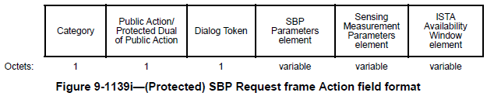
- The AP assigns the availability window in the RSTA availability window element of the SBP response frame.
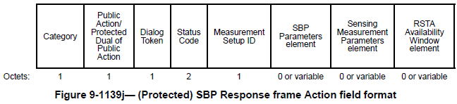
- Availability window assignment in 802.11az – TB ranging
- The non-AP STA transmits IFTMR frame which contains an ISTA availability window element in the Availability Window field to indicate its availability. (for both associated STA or unassociated STA)
- Based on the received IFTMR frame, the AP transmits the FTM frame which include the RSTA Availability Window element in the Availability Window field to assign availability windows.
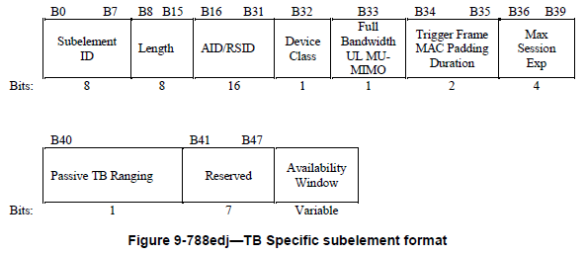
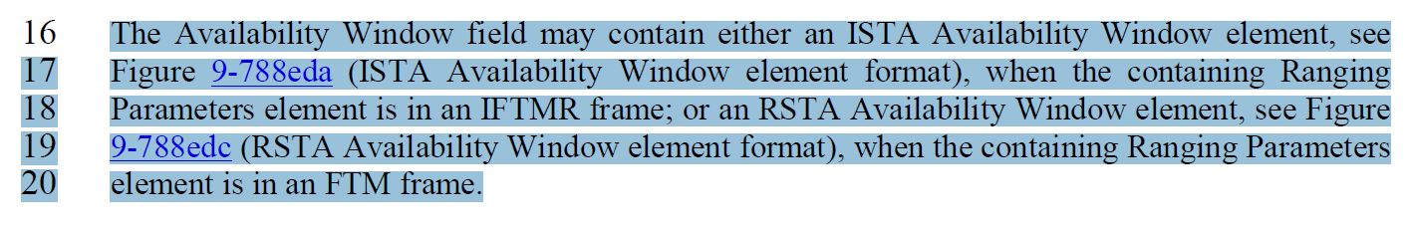

Proposed change

Therefore, to assign the availability window to the associated STAs, we can re-use the availability window assignment procedure in 11az.

(Three recommended options, the second and the third options are proposed in the ad-hoc meeting in July 7)

Recommended option – 1

The AP (sensing initiator) transmits a Sensing Measurement Request frame which contains one or more RSTA availability information subfields in the RSTA availability window elements in Availability Window field. Then, the non-AP STA (sensing responder) indicates its availability in the Assigned Availability Window field (bitmap) in the Sensing Measurement Response frame.
If the non-AP STA is not available in all of the assigned availability windows, the non-AP STA shall set the status code to REJECTED_WITH_SUGGESTED_CHANGES and indicate its preferred availability allocation by including an ISTA Availability Window element in the Availability Window field in the sensing Measurement Response frame.

Recommended option – 2

To give non-AP STA the mechanism to indicate its preferred availability and periodicity (similar as 11az), we can add ISTA availability window element in the sensing capabilities element in any association request frame, as the sensing capabilities element includes not only the sensing capabilities, but also the sensing operation information, see below the screenshot:

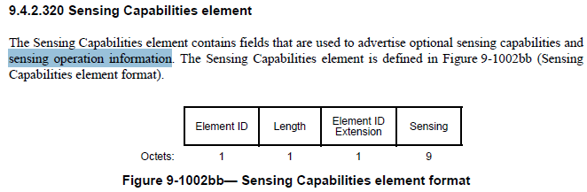

Recommended option – 3

If the non-AP STA is not available in the availability window allocated by the AP in the Sensing Measurement Request frame, the non-AP STA can set the status code to REJECTED_WITH_SUGGESTED_CHANGES, and includes the ISTA availability window element for the future measurement setup.

Two sub-options, option 3.1 and 3.2

(The ISTA availability window element can be directly included in the sensing measurement response frame, or it can be included in the TB sensing specific subelement in the sensing measurement parameters element in the sensing measurement response frame since the availability window is only used for TB sensing while we also have non-TB sensing which does not require availability window.)

(Option 3-2 has been chosen)

Discussion end

Resolution

Instructions to the editor: please modify Figure 9-1002az in the subclause in P72L7 in 9.4.2.319 Sensing Measurement Parameters element in D1.2 as shown below:

The Availability Window field contains an RSTA Availability Window element (see 9.4.2.297 (RSTA
Availability Window element)), when it is included in a Sensing Measurement Request frame; or an ISTA Availability Window element (see 9.4.2.296 (ISTA Availability Window element)), when it is included in a Sensing Measurement Response frame.

Instructions to the editor: please modify the paragraphs in the subclause in P135L28 in 11.55.1.4 Sensing Measurement Session in D1.2 as shown below:

- the RSTA Availability Information field in the RSTA Availability Window element containing exactly one Availability Window Information field. The Availability Window Broadcast Format subfield in the Header subfield in the RSTA Availability Information field in this RSTA Availability Window element shall be set to 0 (see 9.4.2.297 (RSTA Availability Window element)). If the sensing responder is not available in the sensing availability window provided by the AP, the sensing responder shall set the STATUS CODE to REJECTED_WITH_SUGGESTED_CHANGES and include a TB sensing specific subelement in the sensing measurement response frame, the TB sensing specific subelement shall include an ISTA availability window element (see 9.4.2.296 (ISTA Availability Window element)). The assigned availability window for the unassociated sensing responder shall overlap with a 10 TU interval signaled by the ISTA Availability Window element (see 9.4.2.296 (ISTA Availability Window element)) in the Sensing Measurement Setup Query frame.

SP
Do you support resolution to the following CID and incorporate the text changes into the latest TGbf draft: 1810 and 2107 in 11-23/1169r3?

Y

