IEEE P802.11
Wireless LANs
LB272 Comment resolution for CIDs related to Availability Window
Date: 2023-7-06
Author(s):
Name | Affiliation | Address | Phone | email
Zhuqing Tang | Huawei  Technologies | F3, Huawei Base, Shenzhen, Guangdong, China |  | tangzhuqing@huawei.com
Rui Du
Naren
Mengshi Hu
Yiyan Zhang

Abstract
This submission resolves the comments of the CID 1810 and 2107.

Rev 0: Initial document

CID 1810
CID | Page.  Line | Clause Number | Comment | Proposed Change | Resolution
1810 | 174.52 | 11.55.1.4 | Need an example or description for how the availability window is assigned in a measurement setup | Add the following:  Figure 9-788edk (Example of a bitmap with 200 TU periodicity signalled in the ISTA Availability Window  element), 9-788edl (Example of mapping of ISTA's availability bitmap to RSTA's TSF) and 9-788edm  (Example of how an RSTA assigns an Availability Window to an ISTA) together also show an example of how an AP (sensing initiator) assigns an availability window from the received Availability Window element of a non-AP STA (sensing responder). | Revised  Agree with the commenter. Add the proposed text as an example, and also add some description.  TGbf Editor make changes specified in xxxxr0.

Instructions to the editor: please add the following changes to P135L52 in the subclause 11.55.1.4 Sensing Measurement Session in D1.1 as shown below:

A non-AP STA shall transmit a Sensing Measurement Query frame which includes a bitmap in the ISTA Availability Information field of the ISTA Availability Window element to indicate its availability. Then, the AP assigns a sensing availability window to the non-AP STA in the RSTA availability window element of the Sensing Measurement Request frame. Figure 9-788edk (Example of a bitmap with 200 TU periodicity signaled in the ISTA Availability Window element), 9-788edl (Example of mapping of ISTA's availability bitmap to RSTA's TSF) and 9-788edm (Example of how an RSTA assigns an Availability Window to an ISTA) together also show an example of how an AP (sensing initiator) assigns an availability window from the received Availability Window element of a non-AP STA (sensing responder).

CID 2107
CID | Page.  Line | Clause Number | Comment | Proposed Change | Resolution
2107 | 174.40 | 11.55.1.4 | In the sensing measurement setup, AP directly assigns an availability window to an associated STA without knowing the associated STA's availability for TB sensing measurement. In this case, it is possible that the associated STA is not available during the assigned availability window. | The commenter will provide a contribution. | Revised  TGbf Editor make changes specified in xxxxr0.

Discussion

Problem statement:

- In the current 802.11bf draft, for TB sensing measurement setup, AP directly assigns the availability window to the associated STA by transmitting Sensing Measurement Request frame. In this frame, the Availability window field indicates the assigned availability window to the sensing responders.
- If the AP assigns the availability window without acquiring the ISTA availability window element from the associated STA, it is possible that the associated STA is not available in the assigned availability window.
- Thus, the non-AP STA may not able to conduct the TB sensing measurement instance, as all TB sensing measurement instances shall take place within a sensing availability window.
- This will cause
- Waste of resource.
- Measurement setup cannot be established.
That is, this is an existing flaw in the current 11bf draft.

For reference: examples of the other availability window assignments:

- Availability window assignment for unassociated STA in 11bf
- The unassociated STA transmit a Sensing Measurement Query frame to solicit a Sensing Measurement Request frame. The Sensing Measurement Query frame includes an ISTA Availability Window element to indicate its availability. 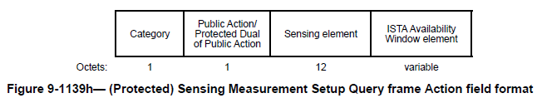
- The AP assigns an availability window to an unassociated STA based on the ISTA Availability Window. The assignment is indicated in the Availability Window field in a TB Sensing Specific subelement in a Sensing Measurement Request frame. 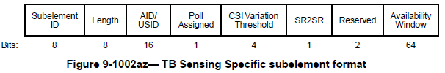

- Availability window assignment for SBP procedure in 11bf
- The non-AP STA transmits an SBP request frame which includes an ISTA Availability Window element to indicate its availability.
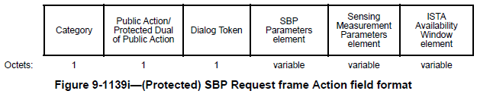
- The AP assigns the availability window in the RSTA availability window element of the SBP response frame.
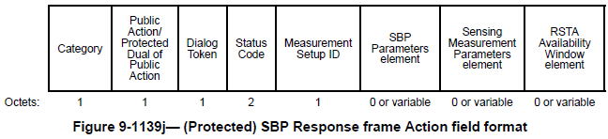
- Availability window assignment in 802.11az – TB ranging
- The non-AP STA transmits IFTMR frame which contains an ISTA availability window element in the Availability Window field to indicate its availability.
- Based on the received IFTMR frame, the AP transmits the FTM frame which include the RSTA Availability Window element in the Availability Window field to assign availability windows.
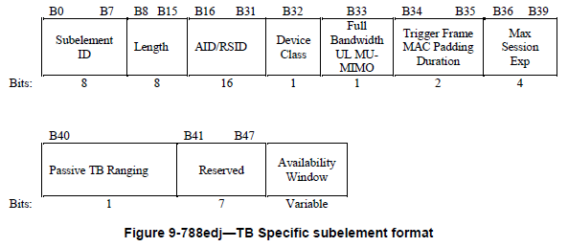

Proposed change

Therefore, to assign the availability window to the associated STAs, we can re-use the availability window assignment procedure in 11az.

The AP (sensing initiator) transmits a Sensing Measurement Request frame which contains one or more RSTA availability information subfields in the RSTA availability window elements in Availability Window field. Then, the non-AP STA (sensing responder) indicates its availability in the Assigned Availability Window field (bitmap) in the Sensing Measurement Response frame.
If the non-AP STA is not available in all of the assigned availability windows, the non-AP STA shall set the status code to REJECTED_WITH_SUGGESTED_CHANGES and indicate its preferred availability allocation by including an ISTA Availability Window element in the Availability Window field in the sensing Measurement Response frame.

Discussion end

Resolution

Instructions to the editor: please modify the paragraphs in the subclause in P135L39 to P135L50 in 11.55.1.4 Sensing Measurement Session in D1.1 as shown below:

If the sensing initiator includes a TB Sensing Specific subelement in a Sensing Measurement Request frame, the availability window field shall contain an RSTA Availability Window element, and if the sensing responder is an associated STA, then the RSTA Availability Information field in the RSTA Availability Window element shall contain exactly one one or more Availability Window Information field fields. The Availability Window Information field fields in a Sensing Measurement Request frame represents represent the availability window windows assigned by the sensing initiator. The sensing responder shall contain an assigned availability window field in the Sensing Measurement Response frame indicating which sensing availability windows provided by the sensing initiator is available for itself. If the sensing responder is not available in all of the sensing availability windows provided by the AP, the sensing responder shall set the STATUS CODE to REJECTED_WITH_SUGGESTED_CHANGES in the Sensing Measurement Response frame and the availability window field shall contain an ISTA availability window element in the Sensing Measurement Response frame. If the sensing responder is an unassociated STA, the RSTA Availability Information field in the RSTA Availability Window element shall contain exactly one Availability Window Information subfield.

If the sensing initiator includes a TB Sensing Specific subelement in a Sensing Measurement Request frame, the The Availability Window Broadcast Format subfield in the Header subfield in the RSTA Availability Information field in this RSTA Availability Window element shall be set to 0 (see 9.4.2.297 (RSTA Availability Window element)). A sensing initiator shall only request assign a sensing availability window from an unassociated sensing responder to a sensing responder that overlaps with a 10 TU interval in which the sensing responder is available as signaled by the ISTA Availability Window element (see 9.4.2.296 (ISTA Availability Window element)) in the Sensing Measurement Query frame or in the Sensing Measurement Response frame.

Instructions to the editor: please modify Figure 9-1002az in the subclause in P112L6 in 9.4.2.319 Sensing Measurement Parameters element in D1.1 as shown below:

The Availability Window field contains may contain either an RSTA Availability Window element, (see 9.4.2.297 (RSTA Availability Window element)), when the containing TB Sensing Specific subelement is in a Sensing Measurement Request frame; or an ISTA Availability Window element, (see 9.4.2.296 (ISTA Availability Window element)), when the containing TB Sensing Specific subelement is in a Sensing Measurement Response frame.

Instructions to the editor: please modify Figure 9-1139d in the subclause in P108L10 in 9.6.7.50 (Protected) Sensing Measurement Setup Response frame format in D1.1 as shown below:

The Assigned Availability Window is a bitmap indicating which sensing availability windows assigned by AP is available. A value of 1 indicates it is available, and a value of 0 indicates it is unavailable.

SP
Do you support resolution to the following CID and incorporate the text changes into the latest TGbf draft: 1810 and 2107 in 11-23/1169r0?

Y/N/A

