IEEE P802.11
Wireless LANs
Resolutions to CID 2283
Date: 2023-07-05
Author(s):
Name | Affiliation | Address | Phone | email
Cheng Chen | Intel |  |  | cheng.chen@intel.com
Abstract
This submission proposes resolutions to the following comments submitted in LB272 under Instance topic. The CIDs are referring to D1.0. The text used as reference is D1.1.

CIDs: 2283

Revision history:
R0: Original version
R1: Editorial fixes

CID | Clause | Page | Comment | Proposed change
2283 | 11.55.1.5.2.2 | 178.51 | It is not clear what is the PPDU format used by the responder in polling phase to send CTS-to-self.  Whether there is any requirement at AP sentting CS required=1? | CTS-to-self in polling phase is carried in HE-TB PPDU if UL BW<320  CTS-to-self in polling phase is carried in EHT-TB PPDU if UL BW=320  CS required is set to 1 by AP

Proposed resolution: Revised.

Discussion:
- Regarding the first topic, it depends on the corresponding User Info field variant for the STA in the Sensing Polling trigger frame. If the User Info field variant is HE variant, the CTS-to-self will be sent in HE TB PPDU. If the User Info field variant is EHT variant, the CTS-to-self will be sent in EHT TB PPDU.
  - In 11az, the CTS-to-self is sent in an S-MPDU. We can do the same for 11bf.
- Regarding the second topic, in 11az, we have the following rule:
  - An RSTA that transmits a Ranging Trigger frame shall set the CS Required subfield to 1 unless one of the following conditions is met:
— The Ranging Trigger frame is of subvariant Poll, Sounding, Secure Sounding or Passive
Sounding.
— The Ranging Trigger frame is of subvariant Report and the UL Length subfield in the
Common Info field of the Trigger frame is less than or equal to 418.
  - We can use the same rule for 11bf.
- We found that currently all the User Info fields in a Sensing Trigger frame are only inheriting the 11az ones, which are HE only. This should be corrected to allow EHT variant User Info field too so that a STA can send EHT TB PPDU as responses to the following variants of the Sensing Trigger frames.
  - Sensing Polling Trigger frame
  - Sensing Threshold-based Reporting Trigger frame
  - Sensing Reporting Trigger frame
- We also found that some fields in the Sensing Trigger frame need to be updated or corrected. Moreover, TGbk recently reviewed and passed SP for the following contribution regarding updates on Ranging Trigger frame
https://mentor.ieee.org/802.11/dcn/23/11-23-0887-02-00bk-pdt-tb-ranging.docx
Since most of Sensing Trigger frame formats are reusing Ranging Trigger frame formats, we tried to make some edits in 11bf D1.1 to keep the two Trigger frame formats consistent.
- See below for details.

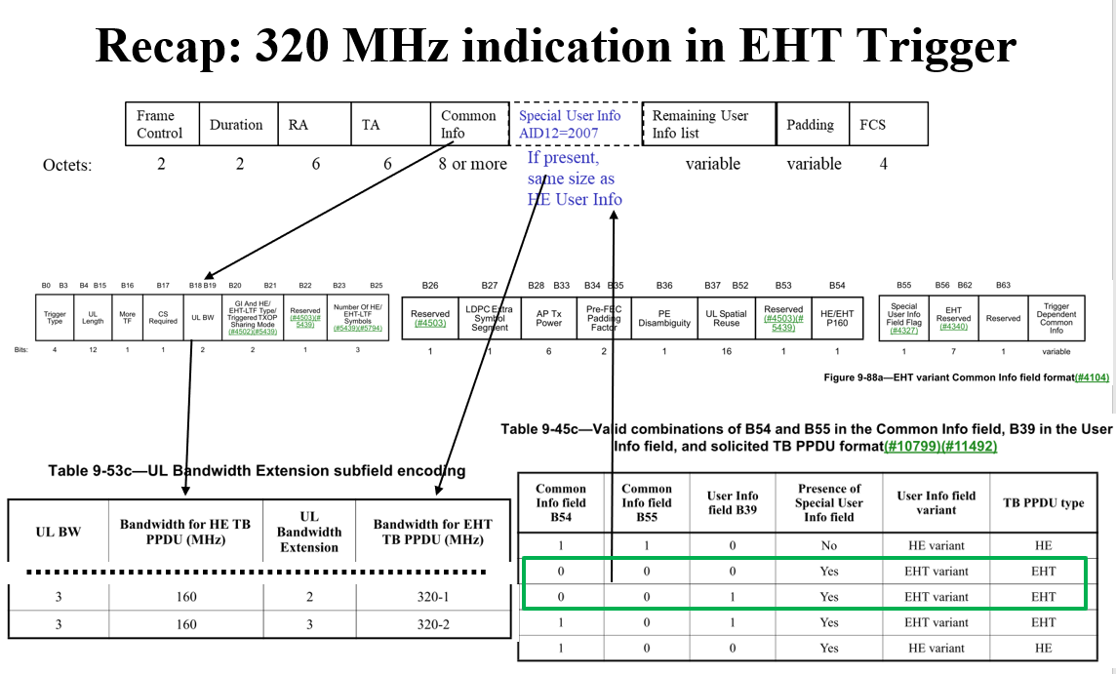

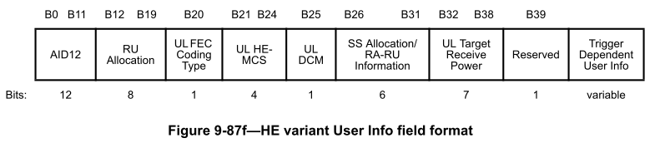

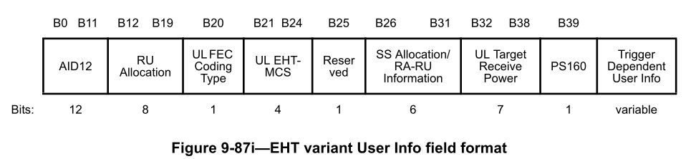

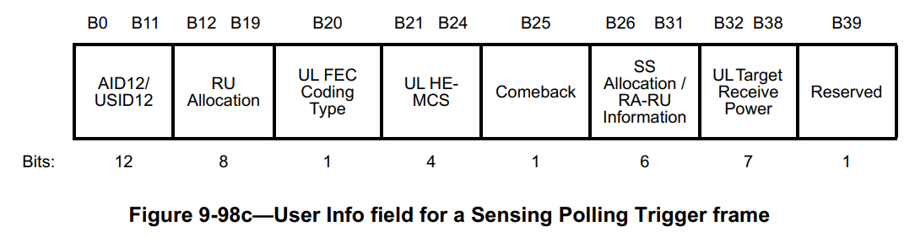

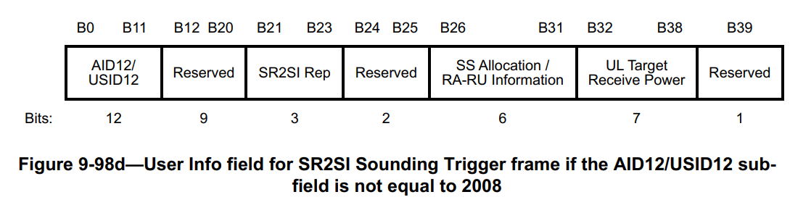

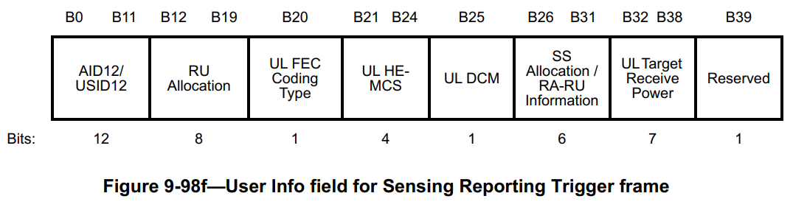

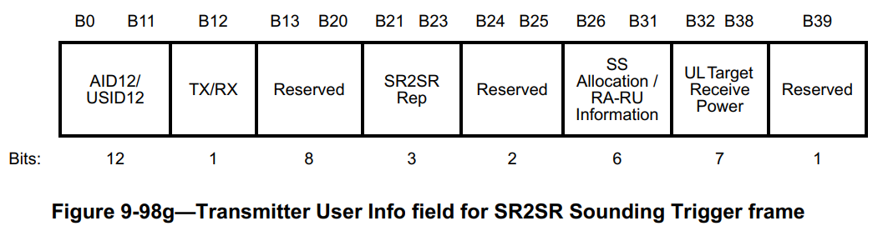

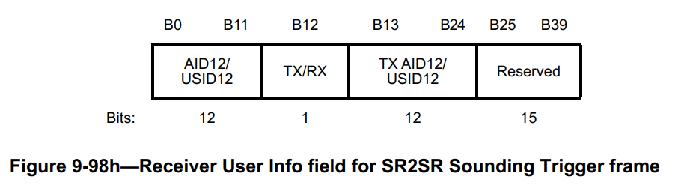
Currently, Sensing Polling Trigger frame, Sensing Reporting Trigger frame, and Sensing Threshold-based Reporting Trigger frame can be sent in a 320 MHz PPDU. Sensing SR2SI Sounding Trigger frame and Sensing SR2SR Trigger frame cannot be sent in a 320 MHz PPDU because 320 MHz sensing sounding is only allowed in NDPA sounding phase in a TB sensing measurement instance.

In 11be D3.2, 320 MHz for Trigger frame is handled mainly via the Special User Info field and EHT variant User Info field and EHT variant Common Info field.

The UL Bandwidth Extension subfield in the Special User Info field together with the UL BW field in the Common Info field of a Trigger frame is used to indicate a 320 MHz Trigger frame.
- Direction: if a Trigger frame is sent in a 320 MHz PPDU, we’ll need rules for the STA to encode/decode the bandwith based on both these two subfields.

By identifying an EHT variant User Info field based on table 9-45c above, a non-AP STA can use the RU Allocation subfield and the PS160 subfield to identify an RU/MRU allocated by a 320 MHz Trigger frame.
- Direction: to identify an RU allocated by a 320 MHz Trigger frame, we’ll need rules for the STA to encode/decode a corresponding EHT variant User Info field.

The B39 in the User Info field of a Sensing Polling Trigger frame, Sensing Reporting Trigger frame, and Sensing Threshold-based Trigger fame is currently Reserved in D1.1. However, they should be changed to PS160 field as defined in 11be D3.2.

The UL HE-MCS field in the User Info field of a Sensing Polling Trigger frame, Sensing Reporting Trigger frame, and Sensing Threshold-based Trigger fame should be changed to “UL MCS” field to accommodate the scenario where the User Info field is an EHT variant.

TGbf editor, make the following change in D1.1:
9.3.1.22.14 Sensing Trigger frame format
9.3.1.22.14.1 General
The RA field and the CS Required, UL BW fields in the Common Info field of the Sensing Trigger frame
are identical to the Basic Trigger frame described in 26.5.2 (UL MU operation), 35.5.2 (EHT UL MU operation) and 9.3.1.22 (Trigger frame format), except that the RA field in a Sensing Trigger frame with only one User Info field that is not a Special User Info field (see 9.3.1.22.3) can be either unicast or broadcast.

9.3.1.22.14.2 Sensing Polling Trigger frame
The format of the User Info field in the Sensing Polling Trigger frame is defined in Figure 9-98c (User Info field for a Sensing Polling Trigger frame).

 | B0 B11 | B12 B19 | B20 | B21 B24 | B25 | B26 B31 | B32 B38 | B39
 | AID12/USID12 | RU Allocation | UL FEC Coding Type | UL HE-MCS | Comeback | SS Allocation/RA-RU Information | UL Target Receive Power | Reserved PS160
Bits | 12 | 8 | 1 | 4 | 1 | 6 | 7 | 1
Figure 9-98c—User Info field for a Sensing Polling Trigger frame

The AID12/USID12 field carries either the 12 LSBs of the AID for an associated STA or the 12 LSBs of the USID for an unassociated STA. The RU Allocation, UL FEC Coding Type, UL HE-MCS, SS Allocation/RA-RU Information, UL Target Receive Power fields are identical to the corresponding fields in the Basic Trigger frame; see 9.3.1.22 (Trigger frame format).

If the Sensing Polling Trigger frame is soliciting an HE TB PPDU:
- The RU Allocation and SS Allocation/RA-RU Information fields are identical to the corresponding fields in the HE variant User Infor field (9.3.1.22.4 (HE variant User Info field)).
- The UL MCS field is identical to the UL HE-MCS field in the HE variant User Info field.
- The PS160 field is reserved.

If the Sensing Polling Trigger frame is soliciting an EHT TB PPDU:
- The RU Allocation, SS Allocation/RA-RU Information, and PS160 fields are identical to the corresponding fields in the EHT variant User Infor field (9.3.1.22.5 (EHT variant User Info field)).
- The UL MCS field is identical to the UL EHT MCS field in the EHT variant User Info field.

The Comeback field indicates performing a new sensing measurement session for an unassociated non-AP STA. The Comeback field is set to 1 to indicate that the AP intends to perform a new sensing measurement session with this unassociated non-AP STA. The Comeback field is set to 0 for unassociated STAs and is reserved for associated STAs(#1558).

The Trigger Dependent User Info field is not present in the Sensing Polling Trigger frame.

9.3.1.22.14.2 Sensing Reporting Trigger frame
The format of the User Info field in the Sensing Reporting Trigger frame is defined in Figure 9-98f (User
Info field for Sensing Reporting Trigger frame).

 | B0 B11 | B12 B19 | B20 | B21 B24 | B25 | B26 B31 | B32 B38 | B39
 | AID12/USID12 | RU Allocation | UL FEC Coding Type | UL HE-MCS | UL DCM | SS Allocation/RA-RU Information | UL Target Receive Power | Reserved PS160
Bits | 12 | 8 | 1 | 4 | 1 | 6 | 7 | 1
Figure 9-98f—User Info field for Sensing Reporting Trigger frame

The AID12/USID12 field is identical to the corresponding subfield in the Sensing Polling Trigger
Frame (#1869). The RU Allocation, UL FEC Coding Type, UL HE-MCS, UL DCM, SS Allocation/RA-RU Information, and UL Target Receive Power fields are identical to the corresponding fields in the Basic Trigger frame; see 9.3.1.22 (Trigger frame format)(#1645).

If the Sensing Reporting Trigger frame is soliciting an HE TB PPDU
- The RU Allocation, UL DCM, and SS Allocation/RA-RU Information fields are identical to the corresponding fields in the HE variant User Infor field (9.3.1.22.4 (HE variant User Info field).
- The UL MCS field is identical to the UL HE MCS field in the HE variant User Info field.
- The PS160 field is reserved.

If the Sensing Reporting Trigger frame is soliciting an EHT TB PPDU
- The RU Allocation, SS Allocation/RA-RU Information, and PS160 fields are identical to the corresponding fields in the EHT variant User Infor field (9.3.1.22.5 (EHT variant User Info field).
- The UL MCS field is identical to the UL EHT MCS subfield in the EHT variant User Info field.
- The UL DCM field is reserved.

The Trigger Dependent User Info field is not present in the Sensing Reporting Trigger frame.

2nd paragraph of 11.55.1.5.2.2
The AP shall send a Sensing Polling Trigger frame to one or more STAs and shall allocate each RU indicated in the Polling Trigger frame to only one STA. Any STA addressed by a User Info field in a Sensing Polling Trigger frame that intends to participate in the TB sensing measurement instance shall respond with a CTS-to-self frame in its designated RU allocation as identified in the Sensing Polling Trigger frame; otherwise, the STA shall not send a response to avoid unnecessary resource allocation and the AP shall not include the STA in this TB sensing measurement exchange(#1041, #1130, #2027). The CTS-to-self shall be sent in an S-MPDU within in its designated RU allocation as identified in the Sensing Polling Trigger frame and shall be within an HE TB PPDU if the corresponding User Info field variant is an HE variant, or within an EHT TB PPDU if the corresponding User Info field is an EHT variant.

26.5.2.5 UL MU CS mechanism
An AP that transmits a Sensing Trigger frame shall set the CS Required subfield to 1 unless one of the following conditions is met:
— The Sensing Trigger frame is of subvariant Sensing Polling, SR2SI Sounding, or SR2SR Sounding.
— The Sensing Trigger frame is of subvariant Sensing Reporting or Sensing Threshold-based Reporting and the UL Length subfield in the Common Info field of the Trigger frame is less than or equal to 418.

SP

Do you support the proposed resolutions to the CIDs and incorporate the text changes into the latest TGbf draft?

Y/N/A

