IEEE P802.11  
Wireless LANs

|  |
| --- |
| **LB 272 CR for CID 1798** |
| **Date:** 2023-07-04 |
| **Author(s):** |

|  |  |  |  |  |
| --- | --- | --- | --- | --- |
| **Name** | **Affiliation** | **Address** | **Phone** | **Email** |
| Dongguk Lim | LG Electronics | 19, Yangjae-daero 11gil, Seocho-gu, Seoul 137-130, Korea |  | dongguk.lim@lge.com |
| Sanggook Kim |  | sanggook.kim@lge.com |
| Jinsoo Choi |  | js.choi@lge.com |

Abstract

This submission proposes the resolutions for following 1 CID

* 1798

Revisions:

* Rev 0: Initial version of the document.

Interpretation of a Motion to Adopt

A motion to approve this submission means that the editing instructions and any changed or added material are actioned in the TGbf D1.0 Draft. This introduction is not part of the adopted material.

***Editing instructions formatted like this are intended to be copied into the TGbf D1.0 Draft (i.e. they are instructions to the 802.11 editor on how to merge the text with the baseline documents).***

***TGbf Editor: Editing instructions preceded by “TGbf Editor” are instructions to the TGbf editor to modify existing material in the TGbf draft. As a result of adopting the changes, the TGbf editor will execute the instructions rather than copy them to the TGbf Draft.***

#### *CID 1798*

|  |  |  |  |  |  |
| --- | --- | --- | --- | --- | --- |
| **CID** | **Clause** | **PP.LL** | **Comment** | **Proposed Change** | **Resolution** |
| 1798 | 9.4.2.320 | 113.46 | Ng = 16 is specified as "The subfield is set to 1 to indicate that subcarrier grouping of 16 is supported in  the Sensing Measurement Report frame; and it is set to 0 otherwise." The  same specification exists as INg in Sensing measurement parameter on line 17, page 111. | Remove Ng=16 from Figure 9-1002bb--Sensing field format and related text in this subclause. | Rejected.  Ng = 16 was defined as an optional feature and it means that all non-AP STAs do not necessarily have to support it.  So, to inform whether this feature is supported or not between an AP and a non-AP STA, it should be included in the sensing element. Please refer to 9.4.2.320 Sensing Capabilities element.  After an exchange of this capability, an AP can know if a non-AP STA supports Ng = 16. After then, to use this value in the sensing measurement, it shall be contained in the Sensing measurement parameter. |

Discussion:

P113L46

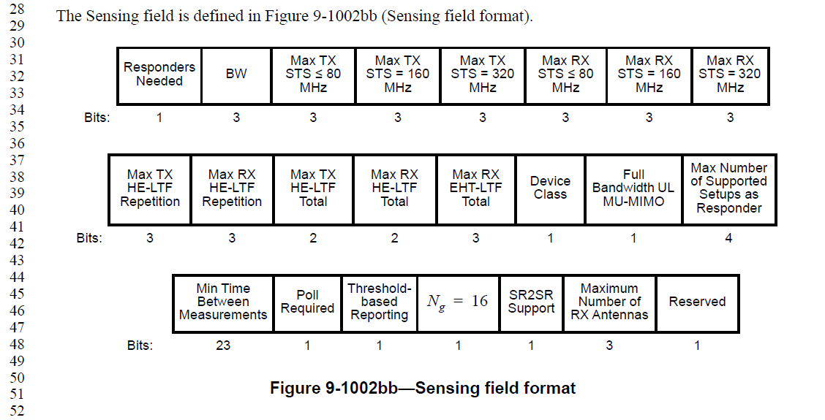



P111L17

