IEEE P802.11
Wireless LANs
LB271 CR for MISC MAC CIDs
Date: June 30, 2023
Author(s):
Name | Affiliation | Address | Phone | email
Jason Yuchen Guo | Huawei |  |  | guoyuchen@huawei.com
Ming Gan | Huawei
Yunbo Li | Huawei
Guogang Huang | Huawei
Mengyao Ma | Huawei
Hongjia Su | Huawei
Yousi Lin | Huawei

Abstract
This submission proposes resolutions for following 3 CIDs received for TGbe LB271:
15284 15664 17952
Revisions:
- Rev 0: Initial version of the document.

Interpretation of a Motion to Adopt

A motion to approve this submission means that the editing instructions and any changed or added material are actioned in the TGbe Draft. This introduction is not part of the adopted material.

Editing instructions formatted like this are intended to be copied into the TGbe Draft (i.e. they are instructions to the 802.11 editor on how to merge the text with the baseline documents).

TGbe Editor: Editing instructions preceded by “TGbe Editor” are instructions to the TGbe editor to modify existing material in the TGbe draft. As a result of adopting the changes, the TGbe editor will execute the instructions rather than copy them to the TGbe Draft.

CID | Commenter | Page | Clause | Comment | Proposed Change | Resolution
15284 | Mengshi Hu | 469.64 | 26.5.2.2.1a | "an 160 MHz ..." should be "a 160 MHz ..." | As in the comment | Accepted.
15664 | Geonjung Ko | 630.13 | 35.12 | A STA can utilize intra-PPDU power save based on the PHY Version Identifier field in the U-SIG field.  When a STA receives the U-SIG field with the BSS Color field set to its own BSS color value and the PHY Version Identifier set to a value that the STA does not support, the STA can enter the doze state during the PPDU. This is beneficial when there is a future generation STA in the same BSS.  According to the receive procedure in 36.3.23, when a STA receives the PHY Version Identifier field not set to an intended value, a PHY-RXEND.indicated(Filtered) is issued (p.g. 899, line 54), so the current conditions for intra-PPDU power save do not cover the above case. | Please add a condition for the case described in the comment. | Revised –  Agree in principle with the commenter.  TGbe editor:  Please implement the changes in this document tagged as #15664.
17952 | Yuchen Guo | 0.00 |  | If a buffer BU is a individually addressed link-specific MMPDU without including a MLO Link Information element, there is no way to command the non-AP MLD should wake up on the intended link to retrieve it. Please fix it. | Please define a Wakeup Request A-control field to address this case | Reject-  This topic has been discussed in 11/22-1201r6 (https://mentor.ieee.org/802.11/dcn/22/11-22-1201-06-00be-ml-traffic-indication-using-a-control.docx). Following the discussion, the group could not reach a consensus solution that would satisfy the commenter.

CID 15284 (P469)
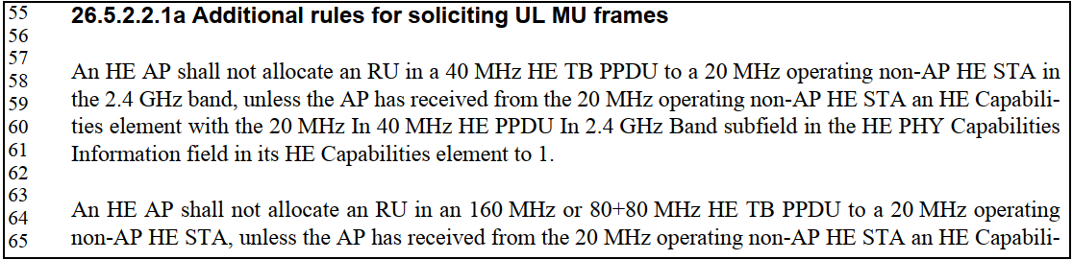

CID 15664
35.12 Intra-PPDU power save for non-AP EHT STAs
TGbe Editor: please update the subclause as follows:
A non-AP EHT STA that operates in intra-PPDU power save mode shall follow the rules defined in 26.14.1 (Intra-PPDU power save for non-AP HE STAs) and with the following additions:
— The conditions that apply to an HE MU PPDU shall also apply to an EHT MU PPDU, and
— The conditions that apply to an HE TB PPDU shall also apply to an EHT TB PPDU.
(#15664)A non-AP EHT STA that operates in intra-PPDU power save mode may enter the doze state or become unavailable until the end of a PPDU currently being received if the following condition is met:
— The RXVECTOR parameter BSS_COLOR is the BSS color of the BSS in which the STA is associated, a PHY-RXEND.indication(Filtered) primitive was received, and the BSS Color Disabled subfield is equal to 0 in the most recently received HE Operation element from the AP with which it is associated.

