IEEE P802.11
Wireless LANs
AIML methodology for dynamic spectrum sharing and coexistence
Date: 2023-06-27
Authors:
Name | Affiliation | Address | Phone | Email
Marco Hernandez | YRP-IAI | Japan |  | Marco.Hernandez@ieee.org
 | CWC Oulu Univ. | Finland
Abstract
High level AIML methodology for dynamic spectrum sharing and coexistence.
Revision History

Revision | Date | Notes
0 | 6/26/2023 | Initial release.
1 | 7/5/2023 | Minor edits.

1. Use case: dynamic spectrum sharing and coexistence

1.1 Introduction

The wireless spectrum is getting ever more crowded with an increasing number of devices and services. In the unlicensed spectrum case, the situation is more challenging with the incorporation of IoT, unlicensed cellular network, and new transmission requirements in 802.11 applications for example 802.11be. The situation requires efficient utilization of the spectrum in a shared ecosystem, where devices from different vendors and with different priority levels share a common set of spectrum bands.

Wi-Fi 6 introduces several technologies to improve spectral efficiency in dense user environments with some forms of interference avoidance and congestion control assuming inter- and intra-interference.
Enhancements at the PHY level: beamforming to focus energy on the direction of users, multi-user operation (MU-MIMO and OFDMA) for the allocation of resources in different Resource Blocks or frequency bands.

Enhancements at the MAC level includes mitigation strategies against OBSS. Overlapping Basic Service Set (OBSS) refers to the situation in which multiple access points (APs) have coverage areas that overlap with each other, leading to interference and degradation of performance in the wireless network. Mitigation the effects of OBSS, includes:

- BSS Coloring: This enhancement uses a specific color to identify each BSS (Basic Service Set) in a given channel. This helps the APs and client devices to differentiate between their own BSS and other BSSs in the same channel. This differentiation can help reduce interference and improve overall network performance.

- Spatial Reuse: This enhancement enables multiple APs to share the same channel and still operate without causing interference. Spatial Reuse works by using different spatial streams in different areas of the channel, allowing multiple APs to use the same channel without interfering with each other.

- Transmit Power Control: This enhancement enables APs to adjust their transmit power based on the proximity of other APs in the same channel. By reducing the transmit power when other APs are detected in the same channel, the interference caused by OBSS can be minimized.

- Dynamic Frequency Selection: This enhancement enables APs to select the least congested channel in a given frequency band. By selecting the least congested channel, the interference caused by OBSS can be minimized.

Another extension to Wi-Fi 6 to mitigate interference is called multiple network allocation vector (M-NAV). With M-NAV, multiple NAV timers can be set for a single transmission, which can help to improve network performance in environments with a high number of devices. For example, in a network with multiple access points, M-NAV can be used to coordinate the transmissions between different access points, reducing collisions and improving overall network throughput. However, M-NAV can also lead to increased overhead and complexity in network management, as multiple timers must be coordinated and managed by devices within the network.

M-NAV can be used to mitigate interference by coordinating transmissions between multiple devices and access points. Interference occurs when two or more devices attempt to transmit data on the same wireless channel at the same time, leading to collisions and reduced network performance. M-NAV allows for multiple Network Allocation Vectors (NAVs) to be set for a single transmission, which reserves the wireless channel for the duration of each transmission. By coordinating transmissions between multiple devices and access points, M-NAV can help to reduce collisions and improve overall network performance in environments with a high number of competing devices.
For example, in a wireless network with multiple access points, M-NAV can be used to coordinate transmissions between the different access points. This can help to reduce interference and collisions by ensuring that each access point has a reserved time slot during which it can transmit data, without interfering with the transmissions of other access points.

In addition, M-NAV can be used to manage interference between devices within the same network. By setting multiple NAV timers for a single transmission, devices can transmit data in shorter bursts, reducing the time that the wireless channel is reserved. This can help to reduce collisions and improve overall network performance by allowing multiple devices to transmit data without interfering with each other.
However, it is important to note that M-NAV adds complexity and overhead to network management, and not all devices support it. In addition, M-NAV may not be effective in all network environments, as the optimal use of M-NAV depends on the specific network topology and traffic patterns.

In a nutshell, Wi-Fi 6 enhancements help APs and STAs identify traffic and tune out interference from other Wi-Fi networks.

Figure 1⸺ Illustration of Wi-Fi 6 enhancements.

1.1.1 Co-channel interference

Co-channel interference is the interference caused by transmitting at the same frequency by two or more wireless systems. In the unlicensed spectrum case, the situation is more challenging with the incorporation of IoT, unlicensed cellular network. The situation requires efficient utilization of the spectrum in a shared ecosystem, where devices from different vendors and with different priority levels share a common set of spectrum bands.

In this coexistence scenario, detecting other signals of interest, or at least recognizing the presence of signals of a specific modulation type, is significant for dynamic spectrum-sharing techniques.

Spectrum sensing techniques have been developed to achieve spectrum awareness for some years. They have found widespread applications in the 3.5 GHz citizens broadband radio service band, the 6 GHz unlicensed band, the Industrial, Scientific, and Medical (ISM) frequency bands, and the 60 GHz mm-wave bands, among others.

Currently, a diversity of coexisting devices is unable to demodulate each other’s signals, and in the best case, may only have a beacon-length sensing duration to infer such information to minimize any outage for a higher-priority transmission. Hence, lightweight, and fast signal classification techniques are needed.
AIML techniques support efficient spectrum sensing and signal detection. A potential 802.11 specification could specify the framework under which implementation dependent AIML solutions will work by specifying dataset generation, storage, and processing procedures to support the development and evaluation of AIML-based spectrum awareness techniques.

AIML spectrum sensing, and signal classification infer the presence of other wireless systems sharing the same spectrum, reacting by manipulating system parameters according to a given policy under a collaborative or uncollaborative scheme for interference mitigation and avoidance. The use case will improve performance and coexistence of 802.11 deployments in the presence of inter-interference and intra-interference with the power of AIML. Something that current specifications are lacking.

1.1.2 AIML in 802.11

AIML in the context of a future 802.11 specification will fit in Wi-Fi 7.

Key Wi-Fi 7 features include:

- Continuous user experience in terms of throughput and lower latency and jitter.
- Spectrum Efficiency
- Network Energy Efficiency
- Connection density in terms of high-density scenarios and cellular offload traffic
- Improvements to worst-case latency & jitter

Key enhancements, among others, include:

- Multi-link operation
- Multi-AP operation
- Bridging with TSN

The increased in complexity operations of Wi-Fi 7 requires dynamic automation of operations. AIML-based solution at the PHY and MAC level is strong candidate to achieve this goal, while supporting autonomy and scalability.

1.2 Use case high level description

Dynamic spectrum sharing will be described by two AIML-based approaches. Namely, signal or protocol classification, and dynamic interference management using the technologies already in Wi-Fi 6, propose for Wi-Fi 7 and signal or protocol classification.
The example with signal or protocol classification may be used for the TIG AIML report, while the example of dynamic interference management shows the synergies with current Wi-Fi standards, where AIML models automate and optimise performance under interference constrains.

1.2.1 Signal or protocol clasification
The motivation for AIML-based signal classification is to facilitate spectrum sharing (SS) of heterogenous wireless systems for coexistence.

Figure 2 shows an example of spectrum sharing over the 5 GHz band, illustrating the coexistence of different radio access technologies (RAT), protocols, bandwidth usage, etc. The situation is more critical in dense scenarios where interference cannot be handled with a single 802.11 specification. Moreover, there is a similar for the 6 GHz band, where future Wi-Fi standards will be sharing the spectrum with unlicensed 5G.
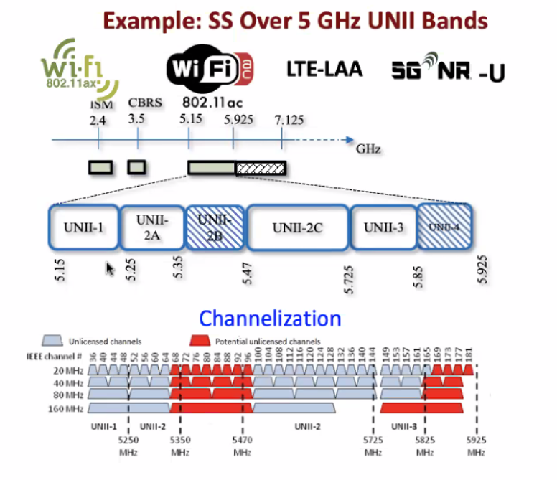
Figure 2⸺Spectrum sharing over the 5 GHz band.

Figure 3 shows examples of spectrum sharing models known as horizontal coexistence.

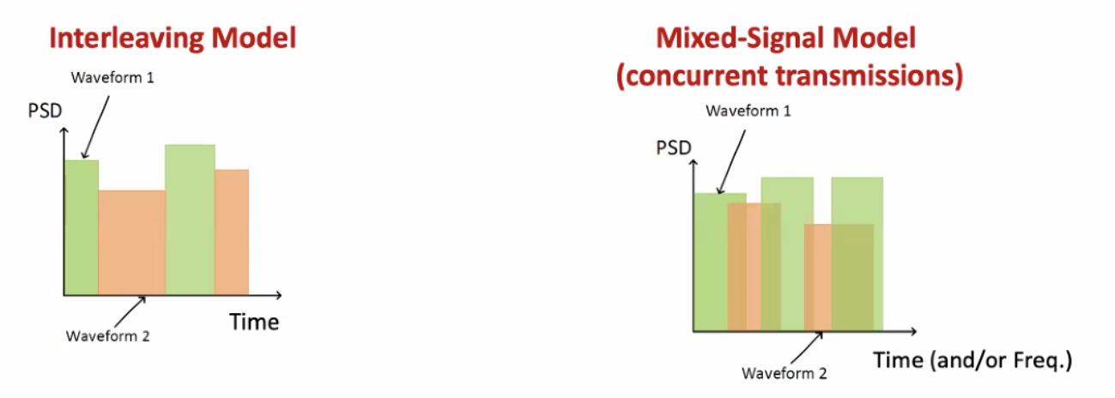
Figure 3⸺ Spectrum sharing models.

Another example is vertical or hierarchy coexistence. The best example is Citizens Broadband Radio Service (CBRS) based on a three-tiered spectrum authorization framework to accommodate a variety of commercial uses on a shared basis without requiring an exclusive spectrum license neither license-exempt.

The three tiers are: incumbent access, priority access, and general authorized access. The idea is that wireless systems subscribe to a dynamic spectrum access system (SAS), such that such wireless systems share spectrum based on access, geographic location, demand, and interference resilience, all managed by the SAS.

Signal classification is a technology that helps identify what wireless system produces the most harmful interference for a given scenario and act upon by the SAS.

Another way to see signal classification is to detect and classify adversarial (interference) transmissions and anomalies without decoding.

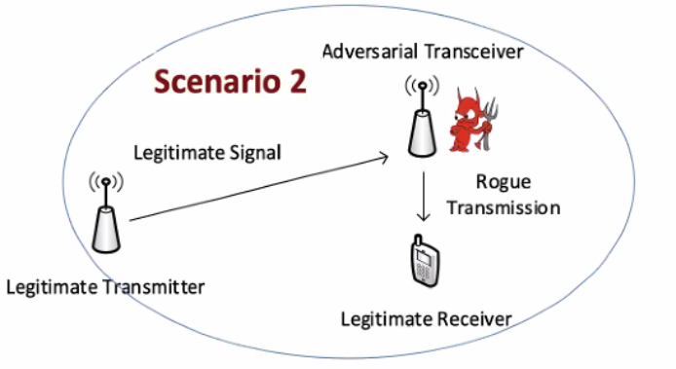
Figure 4⸺Example of coexistence with AIML.

The legitime Wi-Fi reciver does not need to have an adversarial 5G or (or other BSS) front-end. An AIML model will identify the rogue transmission protocol (or signal type) and use it in an AIML-based dynamic spectrum access system.

Example of modulation classifier using a cascade of convolutional neural networks (CNN). It can be extended to a Deeep Neural Network (DNN) and consequently no need for retraining.

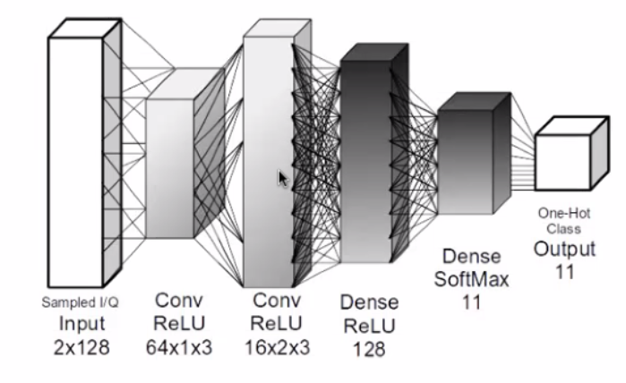
Figure 5⸺modulation clasiffier using CNN.

Another example using bidirectional recurrent neural network (BRNN). The training phase allow the RNN to receive information backwards (past) and forward (future), connecting hidden layers of oppostite directions. Bidirrectional long-short term memery (BiLSTM) RNN.

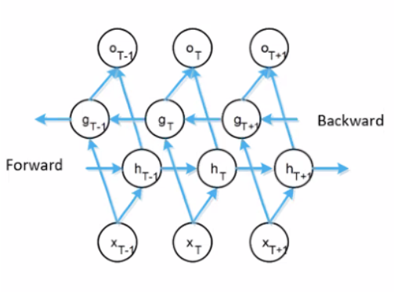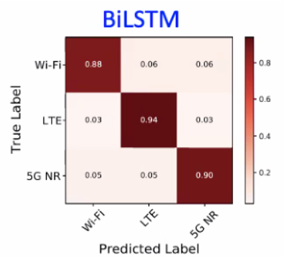

Figure 6⸺protocol classifier with BiLSTM.

Another example combined time/frequency domain classification.

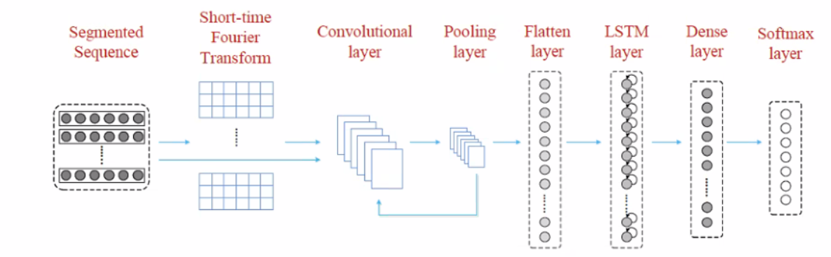

Figure 7⸺time, frequency domain classification.

Another example: automatic optimization of classfier parameters:

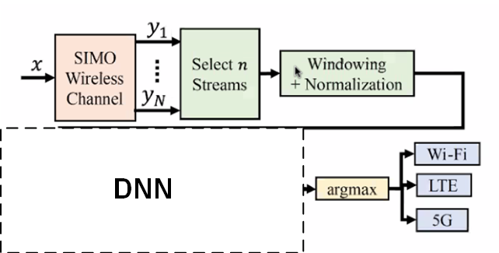

Figure 8⸺Deep learning optimizer of classifier parameters.

- Preprocessing parameters: RF chains (I/Q streams), window size.
- Learning parameters: choice of optimizer, batch size, learning rate, etc.
- Data collection parameters: filter size, etc.

1.2.2 Dynamic interference management Wi-Fi tecnologies

OBSS refers to the situation where multiple APs have overlapping coverage areas, leading to interference and degraded network performance. M-NAV, on the other hand, enables multiple APs to use the same channel by dividing the channel into several virtual sub-channels, with each sub-channel allocated to a specific AP.
These mechanisms are used in the 802.11 standards to address the issue of co-channel interference.

To combine these mechanisms, a coordinated approach is required. One approach is to use M-NAV to allocate virtual sub-channels to each AP in an OBSS. Each AP would then operate on its assigned sub-channel, reducing interference with other APs in the same OBSS.
However, this approach requires coordination among the APs in the same OBSS to ensure that they use the same M-NAV configuration. This coordination can be achieved using a centralized controller or by using a distributed protocol that enables the APs to exchange information and synchronize their M-NAV configurations.

Another approach is to use OBSS-aware MNAV, which considers the OBSS information when allocating virtual sub-channels to each AP. This approach ensures that the APs in the same OBSS are allocated sub-channels that are least likely to interfere with each other.
AIML proposed solution for either a centralized controller or distributed protocol:

- Enable OBSS and M-NAV in the network: Configure the APs to use OBSS detection and mitigation techniques, such as BSS Coloring, Spatial Reuse, Transmit Power Control, and Dynamic Frequency Selection. Configure the client devices to support M-NAV, which enables them to communicate with multiple APs using different channels.

- Collect data: Collect data on the network environment, such as the number of client devices, the traffic load, and the signal strength of each AP. As previously stated, AIML spectrum sensing, and signal classification infer the presence of other wireless systems sharing the same spectrum, reacting by manipulating system parameters according to a given policy under a collaborative or uncollaborative scheme for interference mitigation and avoidance

- Train an AI model: Use the collected data to train an AI model that can optimize channel allocation and reduce interference. The AI model can be trained using machine learning techniques such as supervised learning, unsupervised learning, or reinforcement learning.

- Deploy the AI model: Deploy the AI model on the network to optimize the channel allocation and reduce interference in real time. The AI model can communicate with the APs and client devices to allocate channels based on the current network environment.

- Continuously monitor and update the AI model: Continuously monitor the performance of the network and update the AI model as necessary to improve its accuracy and effectiveness.

By combining OBSS, MNAV, spectrum sensing, signal classification and AIML, wireless networks can achieve better performance by optimizing channel allocation and reducing interference in real time. However, it is important to note that this technique requires expertise in AI and wireless networking and may not be suitable for all network environments.

1.3 KPIs
The requirement to enable an AIML model is the availability of performance metrics (KPIs) along with historical data as inputs to the AIML model.

- Continuous throughput, low latency and jitter measured at the MAC-SAP in high density scenarios.

- Network energy efficiency

1.4 Potential features analysis
Study of the KPIs mentioned above under high density scenarios. Study of required computation complexity.

1.5 Standard impact

The introduction of AIML requires the specification of the required signaling and data format of inputs and outputs of the AIML functionality, even if the Inference Models are not specified themself.

Such signaling includes the Data Collection, Model Training, Inference Model Actor flow of information.

The Model Management and monitoring requires the specification of KPIs measurement depending on target use case and not specified in the current Std.

1.6 Technical feasibility
- The AIML model may be deployed in a STA or AP (one-sided).
- The AIML model may be deployed in both STA and AP (two-sided).

In both cases with the possibility that the Inference Model may be running in the cloud.

Another important aspect is the deployment of an Inference Model: via firmware from vendors or from the cloud.

Enforced by vendors only, or user’s choice.

Still, there is uncertainty of the impact on computational requirements.

2 Requirements for a AIML

AIML algorithms and models are implementation specific and out of the scope of an 802.11 specification. The requirements are on enabling AIML functionality and corresponding types of inputs and outputs, data collection, and the signalling required to support AIML solutions.

A potential standard should specify the required signalling and data format to and from the AIML Model as illustrated in Figure 2.

Figure 9⸺ Required signalling for AIML implementations.

Figure 2 shows the flows of information for AIML solutions and it is shown only to facilitate discussions. Some inference models require training, some other semi-training, while others do not require training. Data collection is required for inference, training, deployment, refreshment, and overall management. Inference functionality means the action at the PHY and MAC by supervised learning, unsupervised learning, self-supervised learning, etc.

The output of an AIML model, or Action in Figure 2, may be for example, beam steering and will be applied to the beam management. This part of the information flow of AIML solutions

The flow of information is the required signalling in a potential specification, and it should accommodate a wide class of inference models.

Data collection (DC) signalling:
- DC for Model Training
- DC for Model Inference
- DC for Model management & monitoring

Model training (MT) signalling:
- Training, validation, testing, deployment (transfer)

Model Inference (MI) signalling:
- Environment input from DC
- Model management control
- Model training deployment, update, and feedback.
- Actions from MI’s output

Model Management (MM) signalling:
- Environment input and Actor’s actions from DC
- Request and management of Model generation, update, activation, selection, monitor, fallback.

AIML technologies are continuously evolving. Hence, a specification cannot get hooked to a given way of doing training, inference, and so on. In fact, how to implement those blocks is the innovation from companies.

