IEEE P802.11
Wireless LANs
LB271 CR for 16118
Date: 2023-07-11
Author(s):
Name | Affiliation | Address | Phone | email
Shawn (Sanghyun) Kim | WILUS Inc. | 216 Hwangsaeul-ro, Seongnam-si, Gyeonggi-do, Korea |  | shawn.kim@wilusgroup.com
Greg Geonjung Ko |  |  |  | greg.ko@wilusgroup.com
John  (Ju-Hyung) Son |  |  |  | john.son@wilusgroup.com
Jin Sam Kwak |  |  |  | jinsam.kwak@wilusgroup.com
This document proposes resolution to the following LB271 CID (changes relative to draft 3.2):
16118

Revisions:
- Rev0: Initial version of the document.
- Rev1: EMLMR delay => EMLMR transition delay, EMLMR Delay subfield => EMLMR Transition Delay subfield

CID | Page | Line | Clause | Comment | Proposed Change | Resolution
16118 | 620 | 45 | 35.8.5.1 | The point at which a non-AP STA in EMLSR mode begins switching back operation is at the end of the frame exchange. Since the end of frame exchange for a non-AP STA in EMLSR mode is TXOP end time + aSIFSTime + aSlotTime + aRxPHYStartDelay, we need to verify whether the 'T' for EMLSR should be EMLSR transition delay + aSIFSTime + aSlotTime + aRxPHYStartDelay. | As in comment | Revised  Agree with the commenter.  The "T" for the AP (now T1) has been modified to enable the STA operating on the EMLSR link to support listening operation at the start of the R-TWT SP.  TGbe editor, please apply the changes as shown in 11-23/1060r2 tagged with 16118.

Details about the changes:
The end of the frame exchanges is defined in 35.3.17 (Enhanced multi-link single radio operation).
(D3.2_Page 593_line 33)
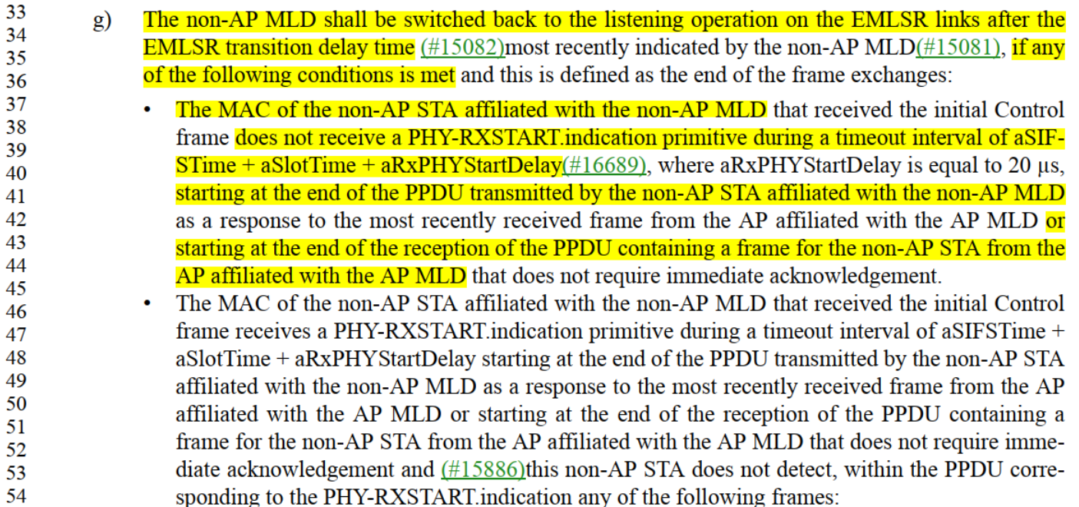

Illustration of the non-AP MLD in EMLSR mode
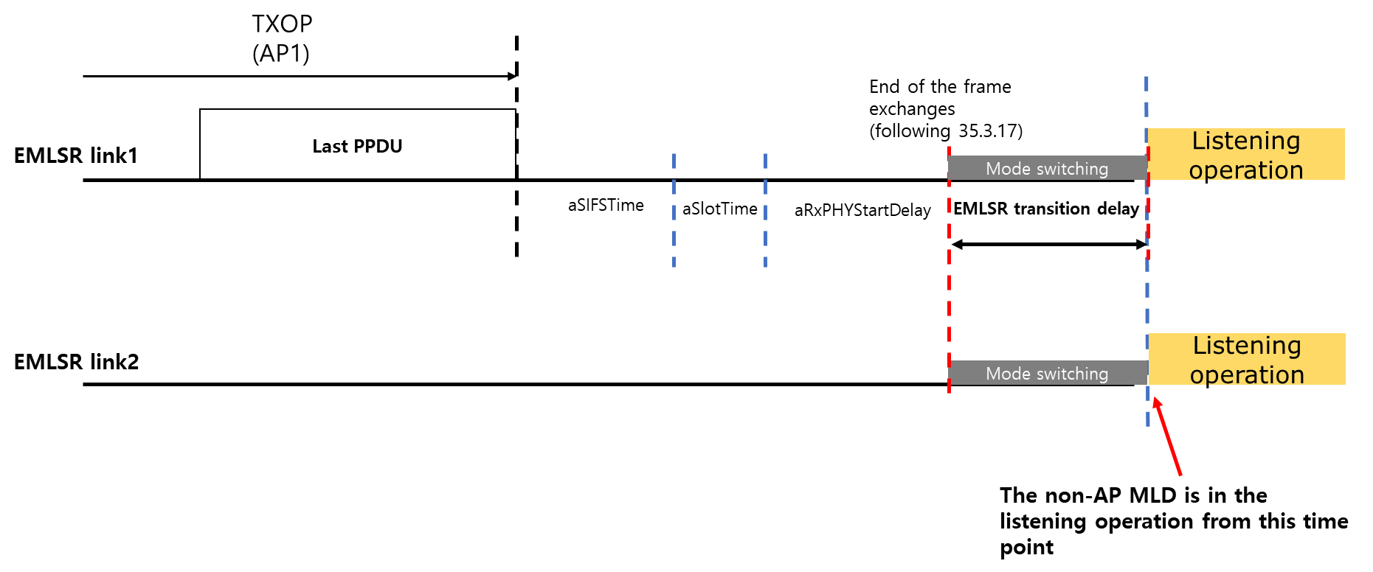
Following 35.3.17, a non-AP MLD switches back to the listening operation on the EMLSR links after the end of the last PPDU + aSIFSTime + aSlotTime + aRxPHYStartDelay + EMLSR transition delay.

TXOP management rules are defined in 35.8.4 (Channel access rules for R-TWT SPs) to ensure that the non-AP STAs in EMLSR mode can listen their operating channel at the start of the R-TWT SP.
(D3.2_Page 639_line 32)
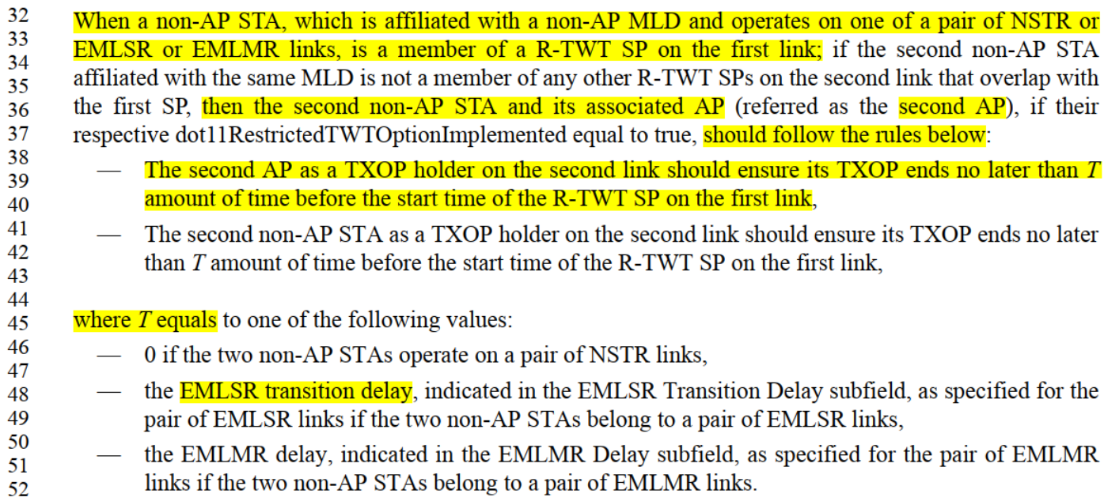

If an AP MLD ends TXOP on EMLSR link1 considering only the EMLSR transition delay of the non-AP MLD, the non-AP MLD cannot listen the EMLSR link2 at the start of the R-TWT SP.
Illustration of the problem the comment raised
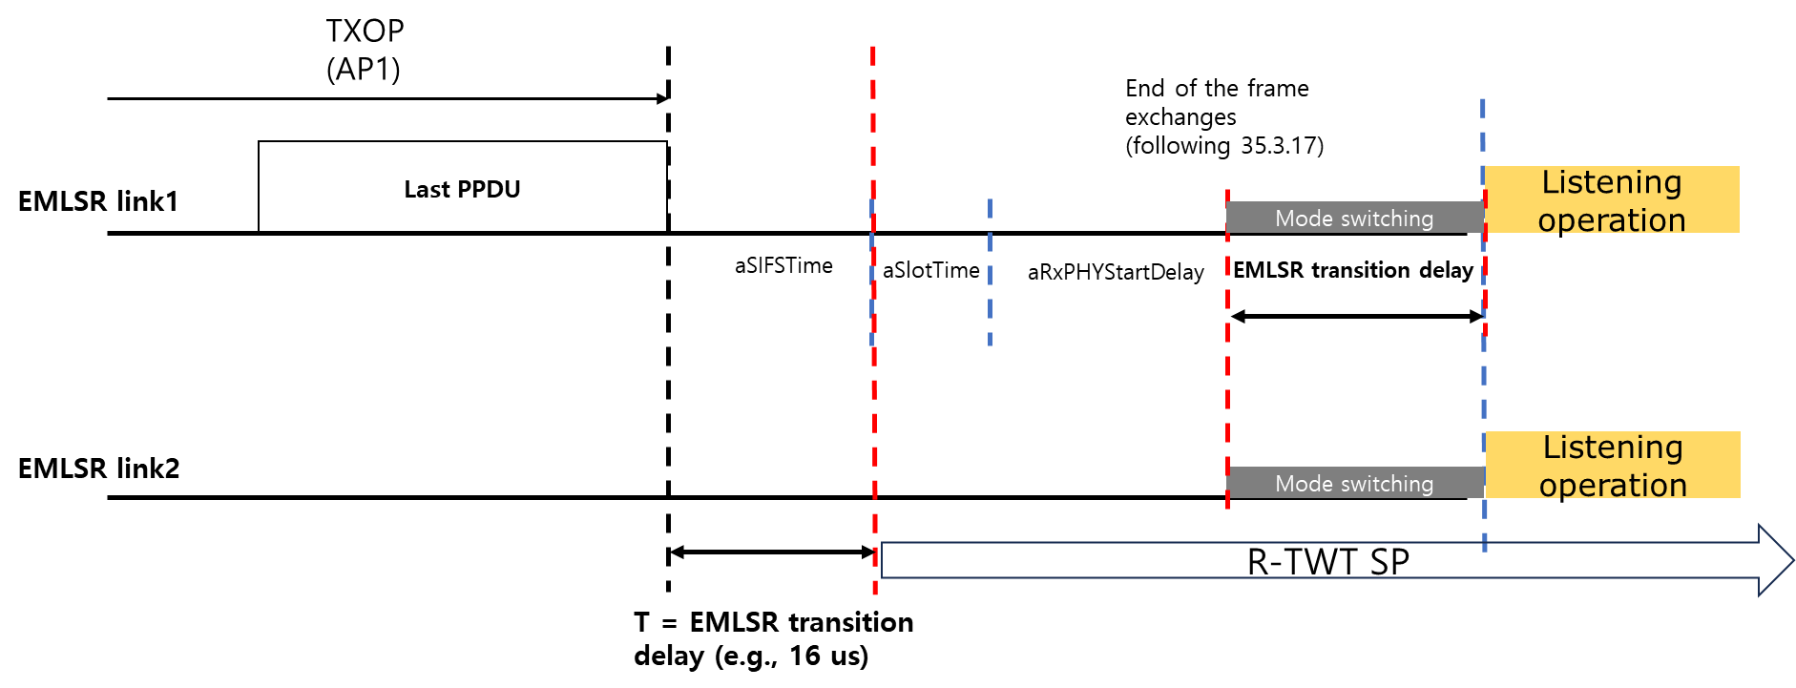

To resolve the problem, the T should be modified to include whole the time parameters from the end of the TXOP(the last PPDU) to the start of the R-TWT SP. Since T for EMLMR has the same problem, we can solve the problem in the same way.

Proposed resolution:
TGbe editor: Please modify the subclause 35.8.4.1 (TXOP and backoff procedures rules for R-TWT SPs) as following:

35.8.4.1 TXOP and backoff procedures rules for R-TWT SPs
…
When a non-AP STA, which is affiliated with a non-AP MLD and operates on one of a pair of NSTR or EMLSR or EMLMR links, is a member of a R-TWT SP on the first link; if the second non-AP STA affiliated with the same MLD is not a member of any other R-TWT SPs on the second link that overlap with the first SP, then the second non-AP STA and its associated AP (referred as the second AP), if their respective dot11RestrictedTWTOptionImplemented equal to true, should follow the rules below:
— The second AP as a TXOP holder on the second link should ensure its TXOP ends no later than T1
amount of time before the start time of the R-TWT SP on the first link,
— The second non-AP STA as a TXOP holder on the second link should ensure its TXOP ends no later
than T2 amount of time before the start time of the R-TWT SP on the first link,
where T1 equals to one of the following values:
— 0 if the two non-AP STAs operate on a pair of NSTR links,
— aSIFSTime + aSlotTime + aRxPHYStartDelay + EMLSR transition delay, where the aRxPHYStartDelay is 20 us and the EMLSR transition delay is indicated in the EMLSR Transition Delay subfield, as specified for the pair of EMLSR links if the two non-AP STAs belong to a pair of EMLSR links,
— aSIFSTime + aSlotTime + aRxPHYStartDelay + EMLMR transition delay, where the aRxPHYStartDelay is 20 us and the EMLMR transition delay is indicated in the EMLMR Transition Delay subfield, as specified for the pair of EMLMR links if the two non-AP STAs belong to a pair of EMLMR links.
where T2 equals to one of the following values:
— 0 if the two non-AP STAs operate on a pair of NSTR links,
— the EMLSR transition delay, indicated in the EMLSR Transition Delay subfield, as specified for the pair of EMLSR links if the two non-AP STAs belong to a pair of EMLSR links,
— the EMLMR transition delay, indicated in the EMLMR Transition Delay subfield, as specified for the pair of EMLMR links if the two non-AP STAs belong to a pair of EMLMR links.

