IEEE P802.11
Wireless LANs
REVme CIDs 4270, 4107, 4114, 4122
Date: 2023-07-09
Author(s):
Name | Affiliation | Address | Phone | Email
Mark Hamilton | Ruckus/CommScope | 350 W Java Dr  Sunnyvale, CA, 94089 | +1 303 818 8472 | Mark.hamilton@commscope.com

Abstract
This document contains discussion and proposed resolutions for the following comments from TGme LB273 on IEEE P802.11-REVme/D3.0:

4270, 4107, 4114, 4122

All references are to D3.0 numbering.

Revision Notes

R0 – initial version
R1 – Added specific changes for CID 4122

CIDs 4270, 4107:

CID | Clause | Page/Line | Comment | Proposed Change
4270 | 5.1.1.4 | 339.57 | "-- QoSNoAck, if the frame is a QoS Data frame with an ack policy of No Ack. This service class is  also used when the DA parameter is a group address unless the frame was delivered via DMS or the  GCR block ack retransmission policy." -- also not for a DA broadcast (but RA unicast) received by an AP | Change to "-- QoSNoAck, if the frame is a QoS Data frame with an ack policy of No Ack. This service class is  also used when the DA parameter is a group address unless the frame is received by an AP or was delivered via DMS or the  GCR block ack retransmission policy."
4107 | 5.1.1.4 | 339.55 | A frame received at an AP, from a non-AP STA, with group addressed DA will have an individual address RA and will be Acked. So, the service class in the MA-UNITDATA.indication should indicate QoSAck (the first bullet in this list, not the second). | Add to the second bullet second sentence (the exceptions), ", or the frame is received at an AP from a non-AP STA (with an individual RA)."

Discussion:

P339.52:
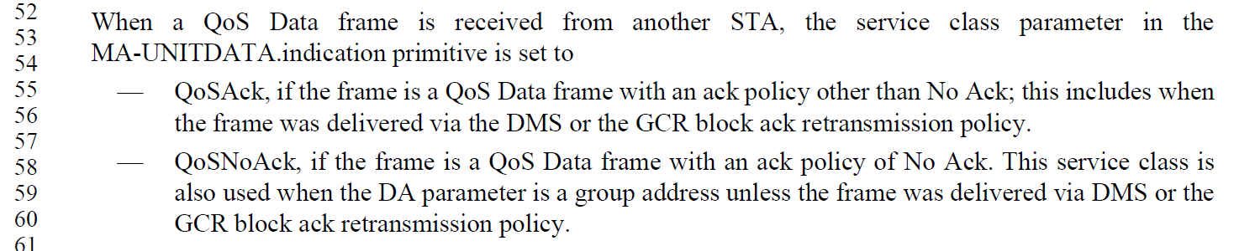

The concerns raised both cover the point that a group addressed DA is still transmitted unicast (and should use QoSAck policy) when transmitted from a non-AP STA to an AP. The first suggestion seems to be the more succinct.

Proposed Resolution:

CID 4270: Accepted.

CID 4107: Revised.
At P339.57 , change the second bullet to, “-- QoSNoAck, if the frame is a QoS Data frame with an ack policy of No Ack. This service class is also used when the DA parameter is a group address unless the frame is received by an AP or was delivered via DMS or the GCR block ack retransmission policy”.

CID 4114:

CID | Clause | Page/Line | Comment | Proposed Change
4114 | 4.9.1 | 322.35 | The PHY is a complete layer, not a sublayer. | Change "PHY Sublayer" to "PHY Layer" in Figure 4-24 (2x), and also in Figure 4-25 (2x).

Discussion:

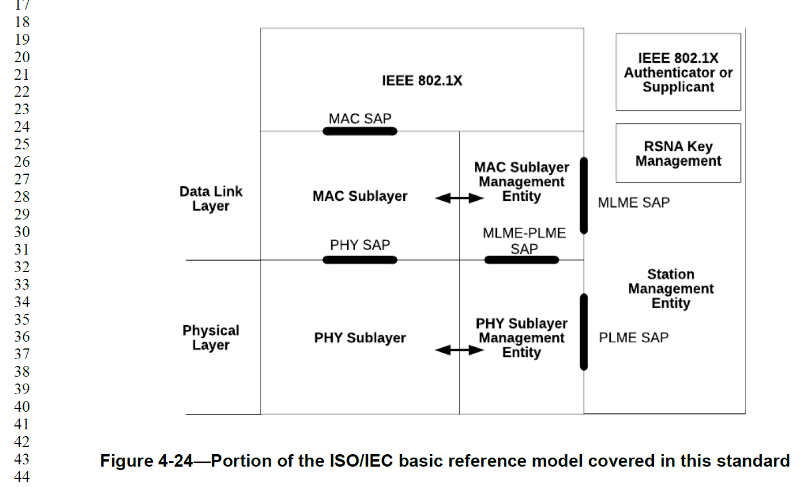

(Figure 4-25 is similar.)

Both “PHY Sublayer” and “PHY Sublayer Management Entity” should be corrected to just say “Layer” instead of “Sublayer”.

This also applies to text in situations similar to:
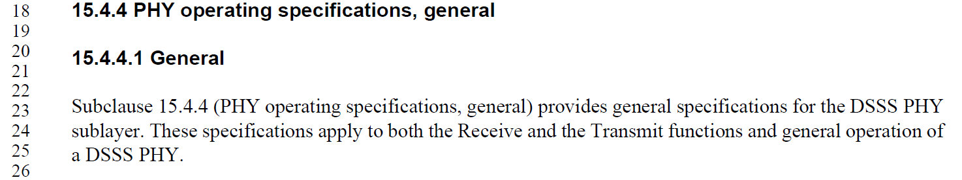

and

These occur at: P3130.23, P3132.39, P3137.37, P3156.33, P3161.12, P3166.12, P3195.56, P3198.28, P3203.34, P3221.28, P3225.53, P3532.1, P3585.20, P4677.38, P4693.29.

Proposed Resolution:

CID 4114: Revised.

Change "PHY Sublayer" to "PHY Layer" in Figure 4-24 (2x), and in Figure 4-25 (2x), and also in text at locations: P3130.23, P3132.39, P3137.37, P3156.33, P3161.12, P3166.12, P3195.56, P3198.28, P3203.34, P3221.28, P3225.53, P3532.1, P3585.20, P4677.38, P4693.29.

CID 4122:

CID | Clause | Page/Line | Comment | Proposed Change
4122 | 9.4.2.231.1 | 1348.42 | Missing ".". Also, should there be a space? Misc other related typos. | P1348.42 has "PHY-CCA indication (IDLE)" (no ".", and a space). Add the dot, for sure. (Same thing at P1349.41.) The space seems to be inconsistent: P568.15 has space, P568.63 does not. Which should it be? (This applies to all the primitive types, "request, indication, response, confirm", which are all inconsistent.) Another issue: P2366.10 has "busy" instead of "BUSY". And, finally, P2768.30 has "PHY-CCA.INDICATION" ("indication" should be lower case).

Discussion:

P1348.41:

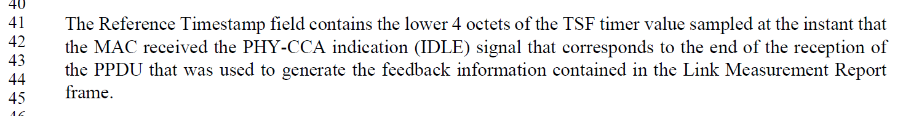

It has been suggested that in some cases, the reference to a PHY-CCA.indication might be used in more “English-language” sense, rather than to the specific technical term, and thus the dot (“.”) would not be required.

This seems incorrect/inappropriate when the phrasing is referring explicitly to the primitive itself. But, in the case above, it is a reference to the “signal” that the primitive is delivering, and this could be a valid argument.

In such a case, however, it seems that the “signal” being delivered is that the CCA-PHY is signaling that the medium is idle, and this should also be phrased as an English-language construct, such as “PHY-CCA indication idle signal”, without the parenthesis or upper-case IDLE.

As a separate issue, when the primitive is being referenced explicitly, should we try to align the spacing (before and after the parentheses, the upper-case BUSY | IDLE, and the lower-case “indication”)? For example:

P2366.10:

REVme task group: Any direction/opinions on the above?

Based on direction from the group, consider the usages at: P1348.41, 1349.41, P1917.25, P1920.24, P2358.33, 2366.10, P2768.30, P3138.56, P3210.14 (Figure 17-19), P3318.8 (Figure 19-25), P3318.25 (Figure 19-26), P3491.8 (Figure 21-36), P4187.14 (Figure 27-60, and Figures 27-61, 27-62 and 27-63), P4194.34,

Proposed Resolution:

CID 4122: Revised.

At P1348.42, replace “the MAC received the PHY-CCA indication (IDLE) signal” with “the MAC received the PHY-CCA.indication(IDLE) primitive”
Editor: note, change “signal” to “primitive”, insert the “.”, and remove the space before “(IDLE)”

At P1349.41, replace “the MAC received the PHY-CCA indication (IDLE) signal” with “the MAC received the PHY-CCA.indication(IDLE) primitive”
Editor: note, change “signal” to “primitive”, insert the “.”, and remove the space before “(IDLE)”

At P1917.25, replace “and no PHY-CCA.indication (BUSY)” with “and no PHY-CCA.indication(BUSY)”
Editor: note, remove the space before “(BUSY)”

At 2358.33, replace “and no PHY-CCA.indication (BUSY)” with “and no PHY-CCA.indication(BUSY)”
Editor: note, remove the space before “(BUSY)”

At P2366.10, replace “PHY-CCA.indication (busy)” with “PHY-CCA.indication(BUSY)”
Editor: note, upper-case “BUSY”, and remove the space before “(BUSY)”

At P2768.30, replace “PHY-CCA.INDICATION primitive” with “PHY-CCA.indication primitive”
Editor: Note, lower-case “indication”

At P3138.56, replace “PHY-CCA.indication (IDLE) primitive” with “PHY-CCA.indication(IDLE) primitive”
Editor: Note, remove the space before “(IDLE)”

At P3210.14 (Figure 17-19), replace “PHY-CCA.indication(STATE=busy)” with “PHY-CCA.indication(BUSY)”
Editor: Note, remove “STATE=” and upper-case “BUSY”

At P3318.9 (Figure 19-25), replace “PHY-CCA.indication(STATE=busy)” with “PHY-CCA.indication(BUSY)”
Editor: Note, remove “STATE=” and upper-case “BUSY”

At P3318.37 (Figure 19-26), replace “PHY-CCA.indication(STATE=busy)” with “PHY-CCA.indication(BUSY)”
Editor: Note, remove “STATE=” and upper-case “BUSY”

At P3491.11 (Figure 21-36), replace “PHY-CCA.indication(Busy,primary)” with “PHY-CCA.indication(BUSY,primary)”
Editor: Note, upper-case “BUSY”

At P4187.19 (Figure 27-60), replace “PHY-CCA.indication(busy,primary)” with “PHY-CCA.indication(BUSY,primary)”. Same thing in Figures 27-61, 27-62 and 27-63.
Editor: Note, upper-case “BUSY”

At P4194.34, replace “PHY-CCA.indication (IDLE) primitive” with “PHY-CCA.indication(IDLE) primitive”
Editor: Note, remove the space before “(IDLE)”

