IEEE P802.11
Wireless LANs
11bk Spec text for TB ranging sequence
Date: 2023-07-07
Author(s):
Name | Affiliation | Address | Phone | Email
Yanjun Sun | Qualcomm
Ali Raissinia
Steve Shellhammer
George Cherian

Abstract
We propose the draft specification skeleton for TB ranging to help the creation of TGbk draft.

Revisions:

- Rev 0: Initial version of the document.
- Rev 1: Update spec text based on feedbacks from the call.

Interpretation of a Motion to Adopt

A motion to approve this submission means that the editing instructions and any changed or added material are actioned in the TGbk Draft. This introduction is not part of the adopted material.

Editing instructions formatted like this are intended to be copied into the TGbk Draft (i.e. they are instructions to the 802.11 editor on how to merge the text with the baseline documents).

TGbk Editor: Editing instructions preceded by “TGbk Editor” are instructions to the TGbk editor to modify existing material in the TGbk draft. As a result of adopting the changes, the TGbk editor will execute the instructions rather than copy them to the TGbk Draft.

Discussion:
The text is prepared for the following motion:
Motion (202301-13) :
Move to include in the SFD that:
“The Ranging Trigger frame in 802.11bk sets the Trigger Type subfield in the Common Info field to 8 as in 802.11az and includes the Special User Info field immediately after the Common Info field as defined in 802.11be”.

Discussion: in 11be D3.2, 320 MHz for Trigger frame is handled mainly via the Special User Info field and EHT variant User Info field and EHT variant Common Info field
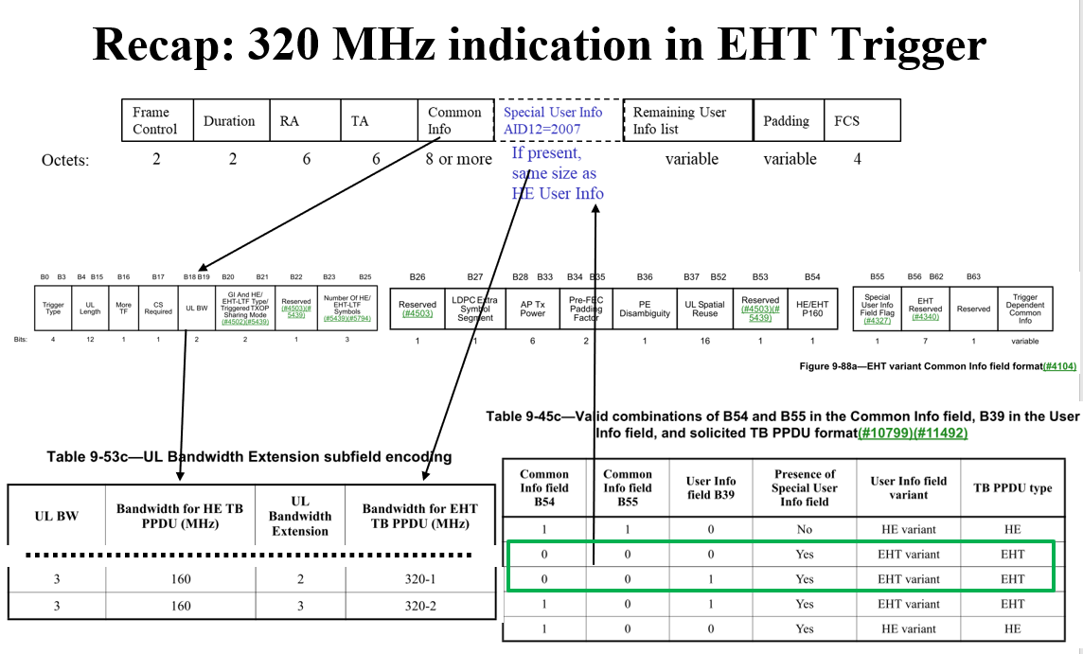
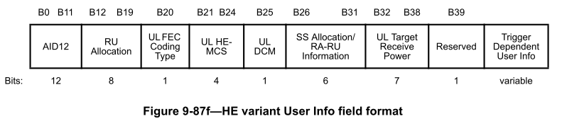
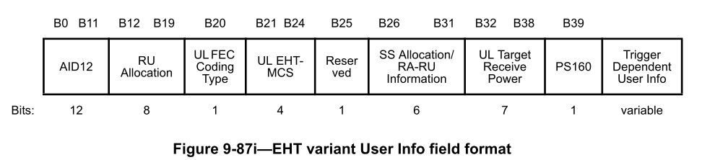
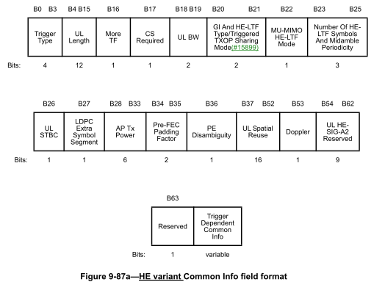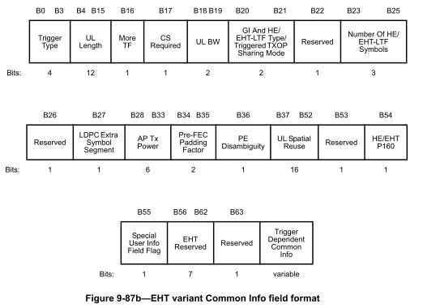
The UL Bandwidth Extension subfield in the Special User Info field together with the UL BW field in the Common Info field of a Trigger frame is used to indicate a 320 MHz Trigger frame.
- Direction: if a Trigger frame is sent in a 320 MHz PPDU, we’ll need rules for the STA to encode/decode the bandwith based on both these two subfields.
By identifying an EHT variant User Info field based on table 9-45c above, a non-AP STA can use the RU Allocation subfield and the PS160 subfield to identify an RU/MRU allocated by a 320 MHz Trigger frame.
- Direction: to identify an RU allocated by a 320 MHz Trigger frame, we’ll need rules for the STA to encode/decode a corresponding EHT variant User Info field

Proposed spec text:
TGbk editor: Please note Baseline is 11bkD0.1, REVme_D3.0, IEEE 802.11az-2022, IEEE 802.11be D3.2.

TGbk editor: Please update 11.21.6.4 as follows (track changes enabled):

11.21.6.4 Measurement exchange

11.21.6.4.3 TB ranging measurement exchange

11.21.6.4.3.1 General
TB ranging is the dynamic trigger-based variant of the FTM procedure. The TB ranging measurement exchange consists of one or more scheduled availability windows. The TB ranging measurement exchange is dynamic, as the actual number of ISTAs participating in the measurement exchange can vary across availability windows. Each ISTA that is assigned to the scheduled availability window may participate in or skip the corresponding measurement exchange. The availability windows are scheduled periodic time windows assigned to ISTAs during negotiation (see 11.21.6.3.3 Negotiation for TB ranging measurement exchange).
Within each availability window the RSTA and ISTAs shall not transmit or trigger transmission of any Data frames; they shall only perform ranging activities related to Polling, Measurement Sounding and Measurement Reporting phases, as well as signaling of modification of availability window parameters; see 11.21.6.5.1 (Availability window parameter modification), and TB ranging session termination, see 11.21.6.6.2 (TB ranging and non-TB ranging session termination) . Each availability window by default consists of a single TXOP and may be extended to multiple TXOPs by announcement, if a single TXOP is insufficient to accommodate all ISTAs that responded to the poll; see 11.21.6.4.3.2 (Polling phase of TB ranging), and 11.21.6.4.3.3 (Measurement sounding phase of TB ranging). Each availability window of the TB ranging measurement exchange consists of one or more triplets of sequential phases: Polling phase, Measurement Sounding phase and Measurement Reporting phase. Figure 11-37a (TB ranging availability windows each with one instance of a polling/sounding/reporting triplet) shows an example of two availability windows, each composed of a single triplet of Polling, Measurement Sounding and Measurement Reporting phases. An RSTA and ISTA participating in TB ranging shall perform any Polling, Measurement Sounding, and Measurement Reporting phases only within the availability windows.
Figure 11-37a—TB ranging availability windows each with one instance of a polling/sounding/reporting triplet

Each availability window typically contains a single poll, where the RSTA should poll all the ISTAs assigned to that availability window. If the available bandwidth is insufficient to allow for the polling of all ISTAs assigned to the availability window with one poll, the RSTA shall indicate that one or more extra polling/sounding/reporting triplets can be expected within the availability window (see example in Figure 11-37b (TB ranging availability window with two instances of polling/sounding/reporting triplets within a single TXOP), and Figure 11-37c (TB ranging availability window with two instances of polling/sounding/reporting triplets in separate TXOPs). All instances of polling/sounding/reporting triplets shall be completed before the end of the availability window.
During the availability window, measurement resources and results shall be made available to each ISTA whose poll response was received at the RSTA; see 11.21.6.4.3.3 (Measurement Sounding phase of TB ranging) and 11.21.6.4.3.4 (Reporting Phase of TB ranging Measurement). This may also lead to extra instances of polling/sounding/reporting triplets, even if all ISTAs assigned to this availability window were polled in the first Polling phase instance (e.g., if the RSTA is not able to accommodate all ISTAs that responded in a single measurement sounding phase instance; see 11.21.6.4.3.3 (Measurement sounding phase of TB ranging).
The timestamps reported within each measurement sounding phase shall be derived from a clock that runs continuously during the measurement sounding phase.
If there is a discontinuity in the clock for the FTM timestamping between two reported TOD timestamps, then the TOD Not Continuous subfield in the TOD Error field of LMR frame shall be set to 1. Otherwise it shall be set to 0.
NOTE - In some use cases it is of interest to have a clock that runs continuously across subsequent ranging availability windows. For this reason it is desirable for the clock for the FTM timestamping to run continuously.
Within each availability window, an RSTA shall use an AID or Ranging Session ID (RSID) to identify an associated or unassociated ISTA respectively. The AID and RSID assignment shall be nonconflicting and shall have the same size and valid address space (as defined in 9.4.1.8 and 26.17.4). The RSID usage shall follow the same rules as that of AIDs for HE operations. The RSIDs are assigned to unassociated ISTAs during the FTM negotiation; see 11.21.6.3 (FTM procedure negotiation).
An RSTA shall follow the rules defined in 26.5.2 (UL MU Operation) or 35.5.2 (EHT UL MU operation) when transmitting any Trigger frames of variant Location for TB ranging with the following rules:
- A Ranging Trigger frame shall be carried in an S-MPDU if the Ranging Trigger frame is carried in a VHT PPDU or, HE PPDU, or EHT PPDU.
- An RSTA shall not transmit a Ranging Trigger frame in a VHT MU PPDU or, HE MU PPDU, or EHT MU PPDU that is not an EHT SU transmission.
An RSTA shall not transmit a Sounding Ranging Trigger frame soliciting an HE TB Ranging NDP or an EHT TB Ranging NDP that uses UL MU-MIMO, i.e., where the same RU is allocated to multiple ISTAs, to any ISTA from which it has not received a TB specific subelement in the Ranging Parameters element with the Full Bandwidth UL MU-MIMO field equal to 1.

If required, an ISTA shall transmit any FTM Request frames outside of Availability Windows allocated to itself. Inside Availability Windows allocated to itself, an ISTA shall not transmit any frame except when assigned UL resources by a TF transmitted by the RSTA.

An RSTA, in which dot11MultiBSSIDImplemented is true, and that transmits a Ranging Trigger frame or a Ranging NDP Announcement frame to a set of ISTAs, in which at least two ISTAs have a TB ranging measurement exchange with different BSSIDs in the Multiple BSSID set of the RSTA shall set the TA field of these frames to the transmitted BSSID. Any ISTA that negotiates a TB ranging measurement exchange session with a nontransmitted BSSID of an RSTA shall support the reception of a Control frame with TA equal to the transmitted BSSID.
An ISTA shall follow the rules defined in Subclause 26.5.2 (UL MU Operation) or 35.5.2 (EHT UL MU operation) when transmitting any HE TB PPDUs for TB ranging with the exceptions defined in 11.21.6.4.3.2 (Polling Phase of TB ranging), 11.21.6.4.3.3 (Measurement Sounding phase of TB ranging) and 11.21.6.4.3.4 (Reporting phase of TB ranging measurement).

Figure 11-37b—TB ranging availability window with two instances of polling/sounding/reporting triplets within a single TXOP
Figure 11-37c—TB ranging availability window with two instances of polling/sounding/reporting triplets in separate TXOPs

11.21.6.4.3.2 Polling phase of TB ranging
The Polling phase is the first phase of each polling/sounding/reporting triplet.
Each Polling phase instance includes at least one Poll Ranging Trigger frame, see 9.3.1.22.10 (Ranging Trigger variant), and no more than one which it receives a response from at least one ISTA ; The Ranging variant Trigger frame of poll is called the TF Ranging Poll frame . The RSTA shall allocate each RU in the TF Ranging poll to only one ISTA. Any ISTA addressed by a User Info field in a TF Ranging Poll frame that intends to participate in the measurement sequence within this availability window shall send a CTS-to-self in an S-MPDU within an HE TB PPDU in its designated RU allocation as identified in the TF Ranging Poll frame, otherwise shall not send a CTS-to-self to avoid resource allocation in this measurement sequence; see Figure 11-37c (TB ranging availability window with two instances of polling/sounding/reporting triplets in separate TXOPs).
If the available bandwidth does not allow for the polling of all ISTAs assigned to this availability window using a single TF Ranging Poll frame, the RSTA shall attempt to schedule one or more extra polling/sounding/reporting triplets within the availability window. The RSTA shall indicate the extra polling/sounding/reporting triplets by setting the More TF subfield in the Common Info field to 1 and the RA field to the broadcast address in the TF Ranging Poll frame, and in TFs in subsequent Polling, Measurement Sounding and Measurement Reporting phases in the same availability window. If the RSTA had set the More TF subfield to 1 in the preceding Ranging Trigger frame, and if there are no additional polling/sounding/reporting triplets in the same availability window, the RSTA shall set the More TF subfield in the Common Info field to 0 and the RA field to the broadcast address in the next Ranging Trigger frame within that availability window. On receipt of such a frame, an ISTA that has not been addressed by a User Info field in the TF, may enter doze state, if no other condition requires this STA to remain awake. Any extra polling/sounding/reporting triplets can either be transmitted in the same TXOP: see example in Figure 11-37b (TB ranging availability window with two instances of polling/sounding/reporting triplets within a single TXOP); or a new TXOP, see example in Figure 11-37c (TB ranging availability window with two instances of polling/sounding/reporting triplets in separate TXOPs) depending on the maximum allowed TXOP duration and the predicted length of the extra instances of polling/sounding/reporting triplets.

Figure 11-37d—TB ranging availability window with two ISTAs

11.21.6.4.3.3 Measurement sounding phase of TB ranging
The measurement-sounding phase commences SIFS time after the Polling phase and is the second phase of each polling/sounding/reporting triplet; see Figure 11-37d (TB ranging availability window with two ISTAs). The measurement sounding phase consists of one or more Sounding Ranging Trigger frames; see 9.3.1.22.10 (Ranging Trigger variant) allocating uplink resources to one or more ISTAs; see Figure 11-37a (TB ranging availability windows each with one instance of a polling/sounding/reporting triplet), and Figure 11-37c (TB ranging availability window with two instances of polling/sounding/reporting triplets in separate TXOPs). The Ranging variant Trigger frame of sounding subvariant is called the TF Ranging Sounding frame. Each TF Ranging Sounding frame shall allocate uplink resources for one or more ISTAs’ I2R NDP multiplexed in the spatial stream domain covering the full bandwidth. The format of the I2R NDP is either an HE TB Ranging NDP; see 27.3.18a.2 (HE TB Ranging NDP) or an EHT TB Ranging NDP; see TBD (EHT TB Ranging NDP). SIFS time after receiving the last I2R NDP, the RSTA shall transmit an NDP Announcement frame followed by a R2I NDP ; the Ranging NDP Announcement frame is described in 9.3.1.19 and the R2I NDP is an HE Ranging NDP as described in 27.3.18a.1 (HE Ranging NDP) or an EHT Ranging NDP as described in TBD (EHT Ranging NDP). Figure 11-37d shows an availability window with an RSTA and two ISTAs (ISTA 1 and ISTA 4) responding to the poll. The Ranging NDP Announcement frame’s STA Info fields specify all the ISTAs that will use the R2I NDP, which shall include the ISTAs that were allocated uplink resources in the measurement sounding phase.
NOTE--The 320 MHz bandwidth of the Ranging NDP Announcement frame is indicated based on rules in 17.3.5.2 (SERVICE field) if the frame is transmitted in a non-HT Duplicate PPDU or based on rules in Table 36-28 (U-SIG field of an EHT MU PPDU) if the frame is transmitted in an EHT MU PPDU.
The RSTA shall select a bandwidth value for the measurement sounding phase that is less than or equal to the RSTA Assigned Max Bandwidth of each of the ISTAs that are being allocated resources during this measurement instance. It may be different from the bandwidth used in the Polling phase, but shall adhere to the rules of multiple frame transmission in an EDCA TXOP; see 10.23.2.8 (Multiple frame transmission in an EDCA TXOP).
If the Trigger frame Ranging Sounding is soliciting an HE TB Ranging NDP, tThe RSTA shall set the TXVECTOR parameter CH_BANDWIDTH of the Trigger frame Ranging Sounding to that same bandwidth and use the same value for the UL BW subfield of the Common Info field of said Trigger frame. Otherwise, the RSTA shall set the TXVECTOR parameter CH_BANDWIDTH of the Trigger frame Ranging Sounding to CBW320. When transmitting the Ranging NDP Announcement frame and R2I NDP, the RSTA shall set the TXVECTOR parameter CH_BANDWIDTH to that same bandwidth.
If the TF Ranging Sounding frame is transmitted in a 320 MHz PPDU, the I2R NDP shall be an EHT TB Ranging NDP. If the TF Ranging Sounding frame is transmitted in a PPDU of 160 MHz or less, the I2R NDP shall be an HE TB Ranging NDP. In the TF Ranging Sounding, the RSTA shall set the SS Allocation subfield and the I2R Rep subfield of the User Info fields corresponding to each of the ISTAs triggered by the Trigger frame in the following way:
- The Number of Spatial Streams in each SS Allocation subfield shall not exceed the RSTA Assigned I2R STS ≤ 80 MHz for the corresponding ISTA, if the UL BW subfield in the Common Info field indicated a bandwidth less than or equal to 80 MHz, and not exceed the RSTA Assigned I2R STS > 80 MHz for the corresponding ISTA otherwise
- All the I2R Rep subfields in the User Info fields of the TF Ranging Sounding shall be set to the same value. This value indicates the number of LTF repetitions in the I2R NDP preamble and shall not exceed any of the RSTA Assigned I2R Rep corresponding to the ISTA triggered by this Trigger frame.
- The product of the number of LTF repetitions, indicated in each of the I2R Rep subfields of the User Info fields, and the number of HE-LTF symbols, indicated in the Number Of HE-LTF Symbols And Midamble Periodicity subfield in the Common Info field, shall not exceed the RSTA Assigned I2R LTF Total for any of the ISTA triggered by this Trigger frame.

After transmission of the TF Ranging Sounding, the RSTA’s MAC sublayer shall issue a PHY-RXLTFSEQUENCE.request primitive with an LTFVECTOR containing the following parameters:
- the SECURE_LTF_FLAG parameter set to 0, and
- the LTF_NSTS and LTF_REP parameter vectors set to the same values as indicated, respectively, by the SS Allocation and I2R Rep subfields of all the User Info fields
Similarly, in the Ranging NDP Announcement frame, the RSTA shall set the R2I NSTS subfield and R2I Rep subfield of the STA Info fields corresponding to each of the ISTAs, addressed by that frame in the following way
- The R2I NSTS subfield value shall not exceed the RSTA assigned R2I STS ≤ 80 MHz for the corresponding ISTA, if the TXVECTOR parameter CH_BANDWIDTH for this Ranging NDP Announcement frame is less than or equal to 80 MH, and not exceed RSTA assigned R2I STS > 80 MHz for the corresponding ISTA otherwise.
- The number of LTF repetitions in the R2I Rep subfield shall be set to a value not to exceed the RSTA Assigned R2I Rep, for the corresponding ISTA.
- The combination of the values of the R2I NSTS and the R2I Rep shall not lead to a total number of LTF that exceeds the RSTA Assigned R2I LTF Total for each corresponding ISTA.
After reception of the Ranging NDP Announcement frame, the ISTAs’ MAC sublayer shall issue a PHY-RXLTFSEQUENCE.request primitive with an LTFVECTOR containing the following parameters:
- the SECURE_LTF_FLAG parameter set to 0, and
- the LTF_NSTS and LTF_REP parameters set to the same values as indicated, respectively, by the R2I NSTS and R2I Rep subfields of the STA Info field addressed to it.
The RSTA shall set a different value than the previous transmission in the Sounding Dialog Token Number field in its transmitted Ranging NDP Announcement frame as part of each Measurement Sounding phase. Measurement instances are associated with the Sounding Dialog Token Number field value.

The R2I NDP is transmitted SIFS after the Ranging NDP Announcement frame; if the bandwidth is equal to 320 MHz, the R2I NDP shall be an EHT Ranging NDP, as described in TBD (EHT Ranging NDP), otherwise the R2I NDP shall be an HE Ranging NDP.
Figure 11-37e—TB ranging availability window with multiple TF Ranging Sounding frames

The RSTA may schedule some ISTAs that replied during the Polling phase to the first measurement sounding phase instance and other ISTAs to one of possibly multiple extra measurement sounding phase instances; see Figure 11-37b (TB ranging availability window with two instances of polling/sounding/reporting triplets within a single TXOP), and Figure 11-37c (TB ranging availability window with two instances of polling/sounding/reporting triplets in separate TXOPs). The RSTA shall only schedule measurement sounding resources to an ISTA in a measurement sounding instance, if a valid poll response was received from that ISTA in the corresponding Polling phase instance. This may require an RSTA to poll an ISTA multiple times. This is necessary, for example, if different ISTAs have varying, incompatible RSTA Assigned Max Bandwidth values or if the RSTA wants to limit the time duration of each range measurement sounding instance. If the RSTA intends to initiate a TB ranging measurement exchange soliciting both an EHT (TB) Ranging NDP and an HE (TB) Ranging NDP in a same TXOP, the RSTA shall:
- Begin with TB ranging measurement exchange that solicits EHT (TB) Ranging NDP, that uses non-HT duplicate PPDU for the Ranging Trigger frames, and that sets the More TF subfield to 1 in the Ranging Trigger frames.
- After all the TB ranging measurement exchanges that solicit EHT (TB) Ranging NDP are completed, then perform TB ranging measurement exchange that solicits HE (TB) Ranging NDP

Both RSTA and ISTA perform RTT measurements by capturing the timestamps of the NDP. The ISTA shall record the time at which the I2R NDP is transmitted (t1). The RSTA shall then capture the time at which the I2R NDP arrives (t2) and shall record the time at which the R2I NDP is transmitted (t3). The ISTA shall finally captures the time at which the R2I NDP arrives (t4); see Figure 11-37f (Timing diagram of a Measurement Sounding phase in TB ranging). The timestamp values t2 and t3 shall be measured according to the RSTA’s clock (i.e., without applying any frequency offset correction to the time basis).
Figure 11-37f—Timing diagram of a measurement sounding phase in TB ranging

The Round Trip Time (RTT_ISTA) observed by ISTA is defined as:
RTT_{ISTA} = [(t4-t1) – (t3’-t2’)]
where t3’ and t2’ are the time at which the R2I NDP was transmitted and the time at which the I2R NDP was received, respectively, as converted by the ISTA from the RSTA’s time basis to its own time basis.
The mechanism by which the ISTA derives t3’ and t2’ from the TOD and TOA fields of the relevant R2I LMR; (see 11.21.6.4.3.4 (Reporting phase of TB ranging measurement) are implementation dependent.
When the I2R LMR Feedback is negotiated, the RSTA can compute the RTT as:
RTT_{RSTA} = [(t4’-t1’) – (t3-t2)]
where t1’ and t4’ are the time at which the I2R NDP was transmitted and the time at which the R2I NDP was received, respectively, as converted by the RSTA from the ISTA’s time basis to its own time basis. The mechanism by which the RSTA derives t4’ and t1’ from the TOD and TOA fields of the relevant I2R LMR are implementation dependent; see 11.21.6.4.3.4 (Reporting phase of TB ranging measurement).
NOTE—When using CFO in the conversion from the ISTA’s time basis to the RSTA’s, the RSTA uses the CFO reported in the CFO Parameter field of the I2R LMR.

NOTE—Refer to Subclause 27.3.15.3 (Precorrection accuracy requirements for carrier frequency offset (CFO) correction requirement for HE TB PPDU transmission).

In an LMR, the TOA field contains a timestamp that represents the time, with respect to a time base, at which the start of the preamble of the corresponding NDP arrived at the receive antenna connector. The TOD field contains a timestamp that represents the time, with respect to the same time base, at which the start of the preamble of the corresponding NDP appeared at the transmit antenna connector.
If the measurement sounding phase includes more than a single TF Ranging Sounding frame, see Figure 11-37e (TB ranging availability window with multiple TF Ranging Sounding frames), each ISTA and RSTA pair shall refer to the t1 and t2 of the I2R NDP transmitted by that ISTA, while t3 and t4 shall be based on the single R2I NDP received by all ISTAs; see Figure 11-37g (Measurement Sounding phase with I2R time-division multiplexing). )
If due to retransmission an ISTA receives multiple TF Ranging Sounding frames and transmits multiple I2R NDPs, the ISTA and RSTA shall refer to the t1 and t2 of the I2R NDP last transmitted.
Figure 11-37g—Measurement sounding phase with I2R time-division multiplexing

The uplink power control, timing and frequency synchronization requirements of unassociated STAs performing TB ranging shall follow the same rules as those of associated HE STAs.
To aid in synchronizing the TSF time at the ISTAs, the RSTA maintains a trigger poll counter. Before transmitting a TF Ranging Poll, the RSTA shall increase the trigger poll counter by one (modulo 8) and set the Token subfield of the Trigger Dependent Common Info subfield to the value of the trigger poll counter.

When transmitting a Ranging NDP Announcement frame as part of the TB ranging measurement exchange, an RSTA shall include a value in the Partial TSF subfield in the STA Info field with the AID11 subfield equal to 2044, that is equal to the RSTA’s TSF[21:6] at the time of transmission of the preceding TF Ranging Poll. Specifically the time that the first data symbol of the PSDU of said frame was transmitted to the PHY plus the RSTA’s delays through its local PHY from the MAC-PHY interface to its interface with the WM.

Additionally, the RSTA shall set the Token subfield in the STA Info field with the AID11 subfield equal to 2044 to the same trigger poll counter value as the Token subfield in the TF Ranging Poll whose partial TSF time is carried in the Ranging NDP Announcement frame.

NOTE—An ISTA that tries to synchronize to the RSTA’s TSF time will need to keep track of the difference between its local TSF[63:22] and the RSTA’s TSF[63:22] when updating the TSF[21:6]. When receiving a partial TSF value in a received Ranging NDP Announcement frame from the RSTA, to synchronize its TSF time with the RSTA’s TSF time in order to determine the start of a subsequent TB ranging availability window:
- The ISTA should check if its TSF[21:6] at the reception of a TF Ranging Poll was larger than the received Partial TSF and the absolute difference is more than 2¹⁶⁻¹, then the ISTA should increase the RSTA’s tracked TSF [53:32] value by 1.
- If the ISTA’s TSF [21:6] at the reception of the TF Ranging Poll is less than the Partial TSF and the absolute difference is more than 2¹⁶⁻¹, the ISTA should decrease the RSTA’s tracked TSF [63:22] value by 1.

11.21.6.4.3.4 Reporting phase of TB ranging measurement
The last phase of each polling/sounding/reporting triplet is the measurement reporting phase, which is transmitted a SIFS time after the measurement sounding phase; see Figure 11-37c (TB ranging availability window with two instances of polling/sounding/reporting triplets in separate TXOPs). The measurement results shall be carried in LMR frames; see 9.6.7.49 (LMR frame format). LMR frames shall carry measurement results from the RSTA to the ISTA, and if negotiated also from the ISTA to the RSTA; see Figure 11-37h (TB ranging measurement reporting phase with Bidirectional LMR Feedback for n ISTAs). If the Range Reporting is performed in the context of a Secure FTM Session, see 11.21.6.3 (FTM procedure negotiation), the corresponding LMR and FTM; see 11.21.6.5.1 (Availability Window parameter modification); frames shall be transmitted using Protected Fine Timing Action frames, and see 9.6.34 (Protected Fine Timing Frame details).
The feedback type of the I2R and R2I LMRs may be either immediate (i.e., from the current availability window) or delayed (i.e., from the last availability window in which the ISTA responded to the TF Ranging Poll frame and the RSTA allocated resources to that ISTA during the measurement sounding phase). The LMR feedback (immediate/delayed) is indicated by the RSTA during the negotiation (see 11.21.6.3.3 Negotiation for TB and Non-TB ranging measurement exchange).
The Dialog Token field in the LMR frame shall be identical to the Sounding Dialog Token field in the corresponding Ranging NDP Announcement frame in the Measurement Sounding phase from which the reported TOA and TOD values were measured; see 11.21.6.4.3.3 (Measurement sounding phase of TB ranging).
NOTE—LMR feedback is carried in Action No-Ack frames and is therefore neither acknowledged nor retransmitted; see 9.6.7.49 (Location Measurement Report (LMR) frame format).
The RSTA shall transmit an R2I LMR to all ISTAs that were allocated resources in the preceding measurement sounding phase. All the R2I LMR frames shall be carried in one HE MU PPDU or one EHT MU PPDU, where each RU contains only one user. If there is only one R2I LMR it may be carried instead in an HE SU PPDU. If the R2I LMR is transmitted in a bandwidth of 160 MHz or less, the PPDU shall be an HE MU PPDU or an HE SU PPDU.
NOTE--if there is only one R2I LMR, the frame is carried in an HE SU PPDU, HE MU PPDU or EHT MU PPDU (including EHT SU transmission) and this does not include VHT/HT/non-HT PPDUs.
If I2R LMR was negotiated, the RSTA shall assign uplink resources to the ISTAs using a Report Ranging Trigger frame; see 9.3.1.22.10 (Ranging Trigger variant). The Ranging variant Trigger frame of report subvariant is called the TF Ranging LMR.
A TB ranging measurement reporting phase including the optional I2R LMR is illustrated in Figure 11-37h (TB ranging measurement reporting phase with Bidirectional LMR Feedback for n ISTAs). If the I2R LMR was negotiated by one or more ISTAs, then SIFS time after transmitting out the R2I LMR, the RSTA transmits a TF Ranging LMR to solicit the I2R LMR frame(s). This TF shall allocate uplink resources to ISTAs that negotiated I2R LMR and were allocated resources in the preceding measurement sounding phase. The RSTA shall allocate each RU in the TF Ranging LMR to only one ISTA. In response to the TF Ranging LMR, each addressed ISTA shall respond by transmitting an I2R LMR frame.

If an ISTA negotiated delayed I2R LMR reporting, and if the TOA measurement for the previous availability window is not ready, then the ISTA shall not respond to the TF Ranging Poll frame in the Polling phase of any availability window until the I2R LMR is ready.
For delayed reporting, the first instance of the R2I LMR and the optional I2R LMR do not have valid TOA/TOD timestamps to include, in this case the RSTA and the ISTA shall set the Invalid Measurement subfield in the TOA Error field of the respective LMR to 1.

Figure 11-37h—TB ranging measurement reporting phase with bidirectional LMR feedback for n ISTAs

In TB ranging, the PHY shall issue the PHY-RXEND.indication primitive with error condition IntegrityCheckError, if the PHY detects the integrity check error in the reception of the corresponding HE Ranging NDP or HE TB Ranging NDP. If the PHY of an RSTA issues a PHY-RXEND.indication primitive with error condition IntegrityCheckError, the RSTA shall set the Invalid Measurement field in the R2I LMR frame carrying the TOA measured from the I2R NDP to 1. Correspondingly, if I2R LMR was negotiated between the ISTA and RSTA and the PHY of the ISTA issues a PHY-RXEND.indication primitive with error condition IntegrityCheckError, the ISTA shall set the Invalid Measurement field in the I2R LMR carrying the TOA measured from the R2I NDP to 1.
NOTE—When a STA detects that the transmit center frequency offset (CFO) between the ISTA and the RSTA exceeds the allowed tolerance from the values specified in 27.3.19.3 and 27.3.15.3, this can be an indication of a security attack.
If I2R LMR reporting was negotiated, then the ISTA shall include a CFO parameter in the I2R LMR; see 9.6.7.49 (Location Measurement Report (LMR) frame format). The ISTA shall estimate the CFO parameter based on the PPDU carrying the TF Ranging Sounding frame that solicits the I2R NDP from the ISTA. The RSTA may account for clock rate differences between ISTA and RSTA based on the CFO parameter included in the received I2R LMR. The mechanism by which t4 and t1 are adjusted by the RSTA is implementation specific. The CFO parameter refers to the t1 and t4 indicated in the same I2R LMR.
If the Invalid Measurement field in an R2I LMR or I2R LMR is equal to 1, the RSTA or ISTA receiving the LMR should discard the TOA carried in the LMR.
In TB ranging measurement reporting phase, if R2I LMR reporting or I2R LMR reporting carries phase shift feedback, then the R2I LMR reporting or the I2R LMR reporting shall be immediate feedback.
In TB ranging measurement reporting phase, if R2I AOA feedback was negotiated the RSTA shall include the optional AOA feedback subfield in the R2I LMR frame and if I2R LMR reporting was negotiated in addition to I2R AOA Feedback reporting then the ISTA shall include the optional AOA feedback subfield in the I2R LMR frame. The AOA field contains the Direction Measurement Results element described in 9.4.2.300.

Straw Poll: Do you support to incorporate the proposed draft text in this document 11-23/1052 to the TGbk Draft?
Result: Yes/No/Abstain

