IEEE P802.11  
Wireless LANs

|  |  |  |  |  |
| --- | --- | --- | --- | --- |
| LB272 Reporting CID Resolution Part 3. | | | | |
| Date: 2023-07-06 | | | | |
| Author(s): | | | | |
| Name | Affiliation | Address | Phone | email |
| Chris Beg | Cognitive Systems |  |  | chris.beg@cognitivesystems.com |
|  |  |  |  |  |
|  |  |  |  |  |
|  |  |  |  |  |
|  |  |  |  |  |

Abstract

This submission addresses the following 18 LB272 CIDs: 2019 2272 2218 1451 1452 1658 1659 1883 1940 1941 1782 1797 1003 1489 1490 1491 2045 2046.

Revision history:

R0 – initial version

R1 – Revisions made to CIDs as follows:

Change resolution to reject to the following: 1451 1452 1940 1941 2045 2046

Revised wording in resolution for: 1003 1489 1490 1491

| **CID** | **Clause** | **Page** | **Comment** | **Proposed Change** | **Resolution** |
| --- | --- | --- | --- | --- | --- |
| 2019 | 9.4.1.75.2.1 | 91.59 | "The measured CSI for the t^th transmit antenna, the r^th receive antenna, and the k^th subcarrier is the complex value indicated by H(t,r,k)". Strictly speaking, CSI is between mapper output (spatial streams) and RX antennas input (antennas). The dimensions of the channel are N_RX x N_SS. In cases where not all antennas are used, what does N_TX refer to? Even if one stream is mapped to each antenna, the true number is still N_SS. | Refer to "transmit streams" instead of "transmit antennas" in the appropriate places | Revised  Existing Q matrix constraints all sensing NDPs results in one to one mapping of TX antenna to spatial stream. Note added to section 9.4.1.75.2.1 to clarify.  TGbf editor to make changes to section 9.4.1.75.2.1 as shown in 11-23/1042r1. |
| 2272 | 9.4.1.75.3 | 93.27 | NTX should be the total NSTS-1 of the received NDP instead of number of transmit antennas -1 | as in comment | Revised  Existing Q matrix constraints all sensing NDPs results in one to one mapping of TX antenna to spatial stream. Note added to section 9.4.1.75.2.1 to clarify.  TGbf editor to make changes to section 9.4.1.75.2.1 as shown in 11-23/1042r1. |

**Discussion:**

* In 802.11az, we have the following description of transmit configuration for an HE Ranging NDP and HE TB Ranging NDP (section 27.3.18a.1, 27.3.18a.2)

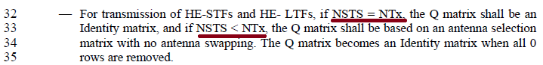

* A similar constraint is defined for the 320 MHz EHT Sounding NDP in section 11.55.1.5.2.3

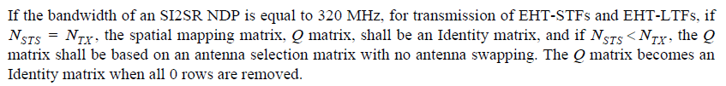

* The constraints on the Q matrix results in mapping one transmit antenna per spatial stream, or the number of spatial streams being equal to the number of transmit antennas.
* In the latest 802.11bf draft, the Sensing field and Sensing Measurement Parameter field identifies capabilities / parameters in terms of STS (e.g., Max TX STS<=80MHZ)

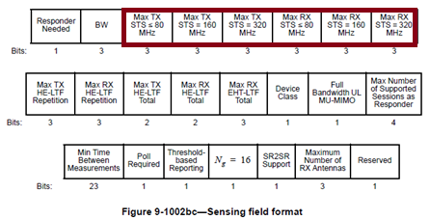

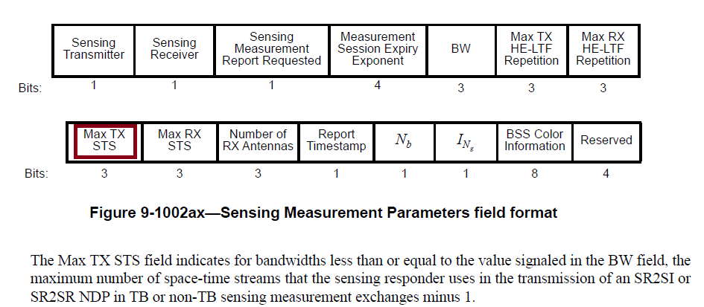

* When referring to capabilities or transmit configuration, using STS is closer to the existing baseline.
* From the reporting prespective, which is new for Sensing, the desire is to keep the report in terms of transmit antenna to receive antenna.
* To help reduce confusion, a note should be added to section 9.4.1.75.2.1 (General) highlight the constraints on the Q matrix used for all current Sensing NDPs will result in a one-to-one mapping of spatial stream to transmit antenna.

| **CID** | **Clause** | **Page** | **Comment** | **Proposed Change** | **Resolution** |
| --- | --- | --- | --- | --- | --- |
| 2218 | 27.2.2, 36.2.2 | 0.00 | The CSI format in the Sensing Measurement Report Container has the dimension Ntx x Nrx x Nsc. This is not consistent with the dimension in CSI_ESTIMATE in RXVECTOR. Please make it consistent. | As in the comment | Revised  Agree in principle.  A change to both the CSI_ESTIMATE RXVECTOR in clause 27 and 36, as well as the CSI encoding and report container descriptions in section 9 have been made.  TGbf editor to make changes to Table 27-1, Table 36-1, and sections 9.4.1.75.2.2, 9.4.1.57.2.3, 9.4.1.75.4 as shown in 11-23/1042r1. |

**Discussion:**

* Issue was also raised in contribution 11-23-1007r0, and proposed resolution.
* Changes to CSI_ESTIMATE RXVECTOR parameters in clause 27 and 36 is required.
  + Table 27-1 and Table 36-1 modified as per TGbf Editor instructions below.
* Changes to required to section 9 text as per TGbf Editor instructions for the following:
  + 9.4.1.75.2.2 CSI encoding procedure
  + 9.4.1.75.2.3 CSI decoding procedure
  + Table 9-127j in section 9.4.1.75.4 Sensing Measurement Report information

|  |  |  |  |  |  |
| --- | --- | --- | --- | --- | --- |
| **CID** | **Clause** | **Page** | **Comment** | **Proposed Change** | **Resolution** |
| 1451 | 36.2.2 | 231.23 | "based on the channel measured during the training symbols of the received EHT sounding NDP..." is not clear. The training preamble is a vague conception depending on the implementation. | Replace "training symbols" with specific subfields measured, e.g. EHT-LTFs, L-LTFs, RL-LTFs, etc. | Rejected  The terminology “measured during the training symbols” is used throughout many RXVECTOR and TXVECTOR parameters defined in Table 27-1 and should be maintained to ensure consistency. Parameters such as EXPANSION_MAT and CHAN_MAT, and DELTA_SNR are examples. |
| 1452 | 27.2.2 | 223.23 | "based on the channel measured during the training symbols of the received EHT sounding NDP..." is not clear. The training preamble is a vague conception depending on the implementation. | Replace "training symbols" with specific subfields measured, e.g. L-LTFs, HE-LTFs, etc. | Rejected  The terminology “measured during the training symbols” is used throughout many RXVECTOR and TXVECTOR parameters defined in Table 36-1, and should be maintained to ensure consistency. Parameters such as EXPANSION_MAT and CHAN_MAT, and DELTA_SNR are examples. |
| 1658 | 36.2.2 | 223.22 | The referenced sub-clause 11.55.1 is too generic and doesn't provide direct information about the format of the CSI array. | Provide a more suitable reference for the format of the array of CSI, e.g., 9.4.1.75.2 (CSI encoding and decoding), or define a new sub-clause for the format and provide the reference to it. | Revised  Agree in principle.  Changed reference to section 9.4.1.75.2 as suggested.  TGbf editor to make changes to Table 27-1 as shown in 11-23/1042r1. |
| 1659 | 36.2.2 | 231.22 | The referenced sub-clause 11.55.1 is too generic and doesn't provide direct information about the format of the CSI array. | Provide a more suitable reference for the format of the array of CSI, e.g., 9.4.1.75.2 (CSI encoding and decoding), or define a new sub-clause for the format and provide the reference to it. | Revised  Agree in principle.  Changed reference to section 9.4.1.75.2 as suggested.  TGbf editor to make changes to Table 36-1 as shown in 11-23/1042r1. |
| 1883 | 36.2.2 | 231.25 | Possible values, or the range of values, for N_SC, N_TX and N_RX should be specified or referenced. Table 36-19 of 802.11be_D3.0 may be used as the reference. | As in comment. | Revised  Section 9.4.1.75.2 contains the requested information. Reference in CSI_ESTIMATE changed from 11.55.1 to 9.4.1.75.2.  TGbf editor to make changes to Table 27-1 and Table 36-1 as shown in 11-23/1042r1. |
| **CID** | **Clause** | **Page** | **Comment** | **Proposed Change** | **Resolution** |
| 1940 | 27.2.2 | 223.22 | HE CSI_ESTIMATE description does not define what should be returned in case of repeated LTF. Dimension of CSI_ESTIMATE is currently defined as Nsc X Ntx X Nrx, however dimension of channel estimation in case of repeated LTF is Nsc X Ntx X Nrx X Nrep_ltf. | Define dimension of CSI_ESTIMATE to be Nsc X Ntx X Nrx X Nrep_ltf, to allow all the raw estimates to be provided to the SME. | Reject  The commenter has withdrawn the comment |
| 1941 | 36.2.2 | 231.22 | EHT CSI_ESTIMATE description does not define what should be returned in case of repeated LTF. Dimension of CSI_ESTIMATE is currently defined as Nsc X Ntx X Nrx, however dimension of channel estimation in case of repeated LTF is Nsc X Ntx X Nrx X Nrep_ltf. | Define dimension of CSI_ESTIMATE to be Nsc X Ntx X Nrx X Nrep_ltf, to allow all the raw estimates to be provided to the SME. | Reject  The commenter has withdrawn the comment |

**Discussion:**

* LTF repetitions feature allows transmission of multiple LTF symbols, and is controllable via Sensing Measurement Parameters field (Max TX HE-LTF Repetition and Max RX HE-LTF Repetition fields).

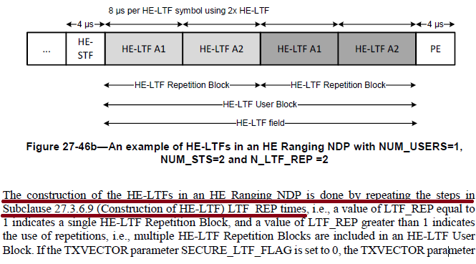

* The repeated LTFs allow multiple measurements of the channel to be performed with highly deterministic timing.
* Similar to the DMG sensing burst, these repeated measurements can be used to improve the quality of measurement (e.g., averaging or combining), or can be used by the application to help estimate a higher frequency doppler.
* The current report format only supports a single “combined” measurement per exchange.
  + The “combining” is done in the PHY (e.g., delivered as a single dimension CSI_ESTIMATE).

***TGbf Editor: Modify Table 27-1 in D1.1 as follows:***

|  |  |  |  |  |
| --- | --- | --- | --- | --- |
| Parameter | Condition | Value | TXVECTOR | RXVECTOR |
| CSI_ESTIMATE | FORMAT is either HE_SU  or HE_TB, and  PSDU_LENGTH is 0 | Contains an array of CSI values based on the channel measured during the training symbols of the received HE Ranging NDP or HE TB Ranging NDP (see 9.4.1.75.2 (CSI encoding and decoding)(#1658,#1883)). The number of complex elements is where is the number of receive antennas, $N_{TX }$ is the number of transmit antennas, and is the total number of subcarriers (see table Table 9-127k)(#2218). | N | Y |
| Otherwise | Not present | N | N |

***TGbf Editor: Modify Table 36-1 in D1.1 as follows:***

|  |  |  |  |  |
| --- | --- | --- | --- | --- |
| Parameter | Condition | Value | TXVECTOR | RXVECTOR |
| CSI_ESTIMATE | FORMAT is EHT_MU,  PSDU_LENGTH is 0, and  CH_BANDWIDTH is  either CBW320-1 or  CBW320-2 | Contains an array of CSI values based on the channel measured during the training symbols of the received EHT sounding NDP (see 9.4.1.75.2 (CSI encoding and decoding))(#1659, #1883). The number of complex elements is where is thenumber ofreceive antennas, $N_{TX }$ is the number of transmit antennas, and is the total number of subcarriers (see table Table 9-127k)(#2218). | N | Y |
| Otherwise | Not present | N | N |

***TGbf Editor: Modify the section 9.4.1.75.2.1 text in D1.1 as follows:***

Subclause 9.4.1.75.2.2 (CSI encoding procedure) describes the encoding of the measured CSI, which involves scaling and quantizing the measured CSI, for inclusion in the Sensing Measurement Report field. Subclause 9.4.1.75.2.3 (CSI decoding procedure) describes the decoding of the scaled and quantized CSI that is received in the Sensing Measurement Report field.

The measured CSI for the *rth* receive antenna *, the tth* transmit antenna, and the *kth* subcarrier is the complex value indicated by *H(r, t, k).* The real part of the CSI is indicated by *H(R)(r, t, k),* and the imaginary part of the CSI is indicated by *H(I)(r, t, k)*. The real and imaginary parts of the CSI are represented as 2s complement binary integers(#2218,#2019,#2272).

NOTE – Transmission constraints imposed on the Q matrix for the HE Ranging NDP (see section (27.3.18a.1 (HE Ranging NDP)), HE TB Ranging NDP (see section 27.3.18a.2 (HE TB Ranging NDP)) result in a one to one mapping of transmit antenna to space-time stream. Transmission constraints imposed on the Q matrix for the EHT Sounding NDP (see section 11.55.1.5.2.3 (NDPA sounding phase)) result in a one to one mapping of transmit antenna to spatial stream (#2019,#2272).

The encoded CSI is denoted as *He(r, t, k)* and the decoded CSI is denoted as  *He(r, t, k)* (#2218).

***TGbf Editor: Modify the section 9.4.1.75.2.2 text in D1.1 as follows:***

9.4.1.75.2.2 CSI encoding procedure

The number receive antennas is indicated by *NRX* and the number of transmit antennas is indicated by *NTX*(#2218).

* For a given tuple of receive and transmit antennas, *(r, t)*, the maximum of the absolute value of the real and imaginary parts of the CSI for all subcarriers is calculated using Equation (9-5b).
* *m(r, t) =* max*k={1,3,…,Nsc}{*max*{ |H(R)(r, t, k)|, |H(I)(r, t, k)|}}*  (9-5b)
* The number of subcarriers, *NSC*, is specified in Table 9-127k (Number of subcarriers as a function of bandwidth, puncturing, and Ng). This calculation is performed for each tuple of receive and transmit antennas, *(r, t)*, with *r = 1, 2, …, NRX* and *t = 1, 2, …, NTX*.
* For a given tuple of receive and transmit antennas, *(r, t)*, the positive scaling factor γ*(r, t)* is selected to avoid overflow when scaling and quantizing the measured CSI using Equation (9-5c) and Equation (9-5d). The value of *m(r, t)* may be used in the selection of the *γ(r, t)* to avoid an overflow. The sensing receiver selects the exact value of the scaling factor.

 (9-5c)

 (9-5d)

* This calculation is performed for each tuple of receive and transmit antennas, *(r, t)*.
* Each real and imaginary part of the CSI is scaled and quantized to *Nb* bits using Equation (9-5c) and Equation (9-5d), respectively. The value of *Nb* is signaled in the Sensing Measurement Report Control field, and may have a value of 8 or 10 bits.

***TGbf Editor: Modify the section 9.4.1.75.2.3 text in D1.1 as follows:***

9.4.1.75.2.3 CSI decoding procedure

The received encoded CSI is decoded as follows(#2218):

* The received real and imaginary parts of the scaled and quantized CSI are decoded as a pair of 2s complement numbers and are combined to form the complex CSI, *He(r, t, k)*.
* Each CSI value is rescaled according to Equation (9-5e).

*Hd(r, t, k) = γ(r, t) He(r, t, k)* (9-5e)

***TGbf Editor: Modify the section 9.4.1.75.4 text in D1.1 as follows:***

|  |  |  |
| --- | --- | --- |
| * Sensing Measurement Report information (#2218) | | |
| Field | Size (bits) | Meaning |
| γ*(1, 1)* | 12 | Scaling factor for receive antenna 1 and transmit antenna 1. |
| γ*(1, 2)* | 12 | Scaling factor for receive antenna 1 and transmit antenna 2. |
| … | … | … |
| γ*(1, NTX)* | 12 | Scaling factor for receive antenna 1 and transmit antenna *NTX*. |
| γ*(2, 1)* | 12 | Scaling factor for receive antenna 2 and transmit antenna 1. |
| γ*(2, 2)* | 12 | Scaling factor for receive antenna 2 and transmit antenna 2. |
| … | ... | … |
| γ*(2, NTX)* | 12 | Scaling factor for receive antenna 2 and transmit antenna *NTX*. |
| … | ... | … |
| γ*(NRX, 1)* | 12 | Scaling factor for receive antenna *NRX* and transmit antenna 1. |
| γ*(NRX, 2)* | 12 | Scaling factor for receive antenna *NRX* and transmit antenna 2. |
| … | ... | … |
| γ*(NRX, NTX)* | 12 | Scaling factor for receive antenna *NRX* and transmit antenna *NTX*. |
| Padding | 0 or 4 | The Padding field is used so that the next field is aligned on an octet boundary. |
| *He(1, 1, k)* |  | CSI for receive antenna 1 and transmit antenna 1, for subcarrier *k in {1, 2, …, NSC}* |
| *He(1, 2, k)* |  | CSI for receive antenna 1 and transmit antenna 2, for subcarrier *k in {1, 2, …, NSC}* |
| … | … | … |
| *He(1, NTX, k)* |  | CSI for receive antenna 1 and transmit antenna *NTX*, for subcarrier *k in {1, 2, …, NSC}* |
| *He(2, 1, k)* |  | CSI for receive antenna 2 and transmit antenna 1, for subcarrier *k in {1, 2, …, NSC}* |
| *He(2, 2, k)* |  | CSI for receive antenna 2 and transmit antenna 2, for subcarrier *k in {1, 2, …, NSC}* |
| … | … | … |
| *He(2, NTX, k)* |  | CSI for receive antenna 2 and transmit antenna *NTX*, for subcarrier *k in {1, 2, …, NSC}* |
| … | … | … |
| *He(NRX, 1, k)* |  | CSI for receive antenna  *NRX* and transmit antenna space-time stream 1, for subcarrier *k in {1, 2, …, NSC}* |
| *He(NRX, 2, k)* |  | CSI for receive antenna  *NRX* and transmit antenna 2, for subcarrier *k in {1, 2, …, NSC}* |
| *He(NRX, NTX, k)* |  | CSI for receive antenna  *NRX* and transmit antenna *NTX*, for subcarrier *k in {1, 2, …, NSC}* |
|  | 8 | RSSI at receive antenna 1 |
|  | 8 | RSSI at receive antenna 2 |
| … | … | … |
|  | 8 | RSSI at receive antenna *NRX* |
| Rx_OP_Gain_Index(1) | 8 | If the Rx_OP_Gain_Type field is 1, the Rx_OP_Gain_Index(1) field contains the Rx OP index for receive antenna 1.  If the Rx_OP_Gain_Type field is 2, the Rx_OP_Gain_Index(1) field contains the Rx gain index for receive antenna 1.  If the Rx_OP_Gain_Type field is 0 or 3, the Rx_OP_Gain_Index(1) field is reserved(#1160). |
| Rx_OP_Gain_Index(2) | 8 | If the Rx_OP_Gain_Type field is 1, the Rx_OP_Gain_Index(2) field contains the Rx OP index for receive antenna 2.  If the Rx_OP_Gain_Type field is 2, the Rx_OP_Gain_Index(2) field contains the Rx gain index for receive antenna 2.  If the Rx_OP_Gain_Type field is 0 or 3, the Rx_OP_Gain_Index(2) field is reserved(#1160). |
| … | … | … |
| Rx_OP_Gain_Index*(NRX)* | 8 | If the Rx_OP_Gain_Type field is 1, the Rx_OP_Gain_Index(*NRX* ) field contains the Rx OP index for receive antenna.  If the Rx_OP_Gain_Type field is 2, the Rx_OP_Gain_Index(*NRX*) field contains the Rx gain index for receive antenna.  If the Rx_OP_Gain_Type field is 0 or 3, the Rx_OP_Gain_Index(*NRX*) field is reserved(#1160). |

Since the scaling and quantization is performed for each RX/TX antenna pair, the scaled and quantized CSI values are ordered by RX/TX pair. The Sensing Measurement field begins with the set of scaling factors for each RX/TX antenna pair. For each RX/TX antenna pair there is a 12-bit positive scaling factor. If there is an odd number of scaling factors, then the set of scaling factors is followed by a 4-bit padding field(#2218).

For each RX/TX antenna pair the in-phase (real) component of the CSI is entered first and followed by the quadrature (imaginary) component of the CSI. This begins with the lowest frequency subcarrier (*NSC*), and is repeated for each subcarrier. The number of subcarriers included in the Sensing Measurement Report information is defined in Table 9-127k (Number of subcarriers as a function of bandwidth, puncturing, and Ng)(#2218).

|  |  |  |  |  |  |
| --- | --- | --- | --- | --- | --- |
| **CID** | **Clause** | **Page** | **Comment** | **Proposed Change** | **Resolution** |
| 1782 | 36.2 | 231.24 | General EHT sounding NDP its number of LTF is related to Nss_total instead of N_TX. Need to add rules in PHY section that when EHT sounding NDP is used for sensing, Q matrix shall be identical matrix and Nss_toal shall be N_Tx, i.e., similar rules from ranging NDP. Also may want to cut down the number of LTF/GI combiniation to be supported in sounding EHT NDP for sensing. Add some texts to 36.3.18 | as in the comment | Rejected  The requested changes are listed in section 11.55.1.5.2.3, along with the conditions for selecting the NDP. |
| 1797 | 36.2.2 | 231.24 | Format EHT_TB is missing in Table 36-1 while format HE_TB is included in table 27-1. | Add FORMAT is EHT_TB in the condition column in the table. | Rejected  The EHT Sounding NDP may only be used as a SI2SR NDP during the NDPA sounding phase (11.55.1.5.2.3). In this scenario, the EHT_MU PPDU format is used.  As a result, there is currently no defined scenario where an EHT_TB PPDU format is required. |

**Discussion:**

* The only valid scenario where the EHT Sounding NDP is used is as a SI2SR NDP during the NDPA sounding phase (as described in section 11.55.1.5.2.3).
* The requested constraints are listed in section 11.55.1.5.2.3 as follows:

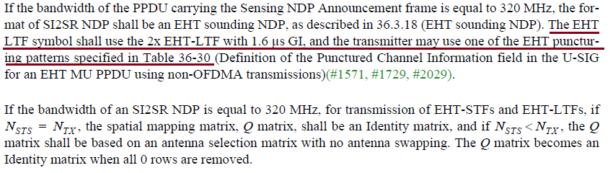

|  |  |  |  |  |  |
| --- | --- | --- | --- | --- | --- |
| **CID** | **Clause** | **Page** | **Comment** | **Proposed Change** | **Resolution** |
| 1003 | 11.55.1.2 | 170.17 | The phrase "A STA with four or less transmit antennas..." should be "A STA with four or fewer transmit antennas..." | As in comment | Revised  Agree in principle.  Replacing “four or less” with “up to four”.  TGbf editor to make changes to P130.62-65 as shown in 11-23/1042r1. |
| 1489 | 11.55.1.2 | 170.17 | This capability for a STA should have been written in terms of the number of supported receive spatial streams, but was written incorrectly in terms of transmit antennas. The number of transmit antennas is on the transmitting device, which is the source of the confusion, I believe. | Change "A STA with four or less transmit antennas shall support an N_g value of 4 and may optionally support an N_g value of 16 in the Sensing Measurement Report frame." To "A STA that can support reception of up to four spatial streams shall support an N_g value of 4 and may optionally support an N_g value of 16 in the Sensing Measurement Report frame." | Revised  Update wording to make clear this requirement is intended for the receiving STA, not the transmitting STA.  TGbf editor to make changes to P130.62-65 as shown in 11-23/1042r1. |

**Notes:**

* This statement is intended for the STA which is the sensing receiver since it is the sensing receiver who generates the measurement report.
* The wording “A STA with for or less transmit antennas shall” suggests that this requirement is for the sensing transmitter, which is not intended.
* The constraint should be re-worded such that it is clear this requirement is intended for the sensing receiver.
* Given discussion above, spatial streams should be used instead of antennas.

***TGbf Editor: Modify the text in D1.2 130.17-20 as follows:***

A sensing STA that supports receiving up to four spatial streams shall support an Ng (see Table 9-127h (Sensing Measurement Report Control field definition)) value of 4 and may optionally support an Ng value of 16 in the Sensing Measurement Report frame(#1002, #1077, #1003, #1489).

|  |  |  |  |  |  |
| --- | --- | --- | --- | --- | --- |
| **CID** | **Clause** | **Page** | **Comment** | **Proposed Change** | **Resolution** |
| 1490 | 11.55.1.2 | 170.20 | This capability for a STA should have been written in terms of the number of supported receive spatial streams, but was written incorrectly in terms of transmit antennas. The number of transmit antennas is on the transmitting device, which is the source of the confusion, I believe. | Change “A STA with five or more transmit antennas and a bandwidth of 80 MHz shall support an N_g value of 4 and may optionally support an N_g value of 16 in the Sensing Measurement Report frame.” To “A STA that can support reception of five or more spatial streams and a bandwidth of 80 MHz shall support an N_g value of 4 and may optionally support an N_g value of 16 in the Sensing Measurement Report frame.” | Revised  Agree with commenter that the requirement is intended for the receiver not transmitter. Applied changes to clarify requirement is for the sensing receiver.  TGbf editor to make changes to P131.1-4 as shown in 11-23/1042r1. |

**Notes:**

* This statement is intended for the STA which is the sensing receiver since it is the sensing receiver who generates the measurement report.
* The wording “A STA with for or less transmit antennas shall” suggests that this requirement is for the sensing transmitter, which is not intended.
* The constraint should be re-worded such that it is clear this requirement is intended for the sensing receiver.
* Given discussion above, spatial streams should be used instead of antennas.

***TGbf Editor: Modify the text in D1.2 130.22-25 as follows:***

A sensing STA that supports receiving five or more spatial streams shall support an *Ng* value of 4 and may optionally support an *Ng* value of 16 in the Sensing Measurement Report frame if the bandwidth of the SI2SR, SR2SI, or SR2SR NDP used to obtain the reported sensing measurement is less than or equal to 80 MHz(#1002, #1077, #1792, #1490).

|  |  |  |  |  |  |
| --- | --- | --- | --- | --- | --- |
| **CID** | **Clause** | **Page** | **Comment** | **Proposed Change** | **Resolution** |
| 1491 | 11.55.1.2 | 170.24 | This capability for a STA should have been written in terms of the number of supported receive spatial streams, but was written incorrectly in terms of transmit antennas. The number of transmit antennas is on the transmitting device, which is the source of the confusion, I believe. | Change "A STA with five or more transmit antennas and a bandwidth greater than or equal to 160 MHz shall support an N_g value of 4 and may optionally support an N_g value of 16 in the Sensing Measurement Report frame." To "A STA that can support reception of five or more spatial streams and a bandwidth of greater or equal to 160 MHz shall support an N_g value of 8 and may optionally support an N_g value of 16 in the Sensing Measurement Report frame." | Revised  Agree with commenter that the requirement is intended for the receiver not transmitter. Applied changes to clarify requirement is for the sensing receiver.  TGbf editor to make changes to P130.6-10 as shown in 11-23/1042r1. |

**Notes:**

* This statement is intended for the STA which is the sensing receiver since it is the sensing receiver who generates the measurement report.
* The wording “A STA with for or less transmit antennas shall” suggests that this requirement is intended for the sensing transmitter, which is not intended.
* The constraint should be re-worded such that it is clear this requirement is intended for the sensing receiver.
* Given discussion above, space-time streams should be used instead of antennas.

***TGbf Editor: Modify the text in D1.1 130.27-31 as follows:***

A sensing STA with that supports receiving five or more spatial streams shall support an *Ng* value of 8 and may optionally support an *Ng* value of 16 in the Sensing Measurement Report frame if the bandwidth of the SI2SR, SR2SI, or SR2SR NDP used to obtain the reported sensing measurement is greater than or equal to 160 MHz(#1002, #1077, #1792, #1491).

|  |  |  |  |  |  |
| --- | --- | --- | --- | --- | --- |
| **CID** | **Clause** | **Page** | **Comment** | **Proposed Change** | **Resolution** |
| 2045 | 11.55.1.5.4 | 188.15 | "The sensing transmitter shall use the same ordered set of antennas with no antenna swapping" is not very precise (antennas are not ordered, swapping is not defined, ...). | Change to e.g. "The sensing transmitter shall use same set of tx antennas with the same spatial mapping matrix" | Rejected  The terminology used was taken from text in P802.11az, section 27.3.18a.1 and 27.3.18a.2. This was discussed within the group, and the decision was to maintain the same terminology used in P802.11az. |
| 2046 | 11.55.1.5.4 | 188.15 | "The sensing transmitter shall use the same ordered set of antennas with no antenna swapping". Not clear if this allows for a generic Q matrix, or only allows mapping each stream to a single antenna. | Clarify. Consider that using all antennas (and hence allowing for a generic Q matrix) has its benefits. | Rejected  Constraints on the Q matrix for the HE Ranging NDP and HE TB Ranging NDP are defined in P802.11az, section 27.3.18a.1 and 27.3.18a.2. Constraints on the Q matrix for the EHT Sounding NDP is defined in D1.2 (section 11.55.1.5.2.3). |

**Notes:**

* Initial text was derived from P802.11az, section 27.3.18a.1 and 27.3.18a.2, which describe the HE Ranging NDP and HE TB Ranging NDP:

* Text describing similar constraints for the EHT Sounding NDP is defined in P802.11bf D1.2 in section 11.55.1.5.2.3.

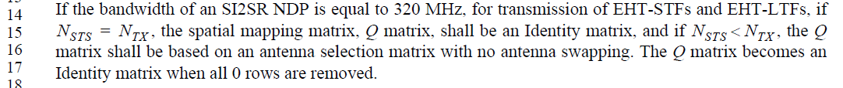

**SP:**

Do you support the resolution to CIDs 2019 2272 2218 1451 1452 1658 1659 1883 1940 1941 1782 1797 1003 1489 1490 1491 2045 2046 11-23/1042r1 and incorporating the changes into the latest TGbf draft?

Y/N/A