IEEE P802.11  
Wireless LANs

|  |  |  |  |  |
| --- | --- | --- | --- | --- |
| LB272 Reporting CID Resolution Part 3. | | | | |
| Date: 2023-07-06 | | | | |
| Author(s): | | | | |
| Name | Affiliation | Address | Phone | email |
| Chris Beg | Cognitive Systems |  |  | chris.beg@cognitivesystems.com |
|  |  |  |  |  |
|  |  |  |  |  |
|  |  |  |  |  |
|  |  |  |  |  |

Abstract

This submission addresses the following 18 LB272 CIDs: 2019 2272 2218 1451 1452 1658 1659 1883 1940 1941 1782 1797 1003 1489 1490 1491 2045 2046.

Revision history:

R0 – initial version

| **CID** | **Clause** | **Page** | **Comment** | **Proposed Change** | **Resolution** |
| --- | --- | --- | --- | --- | --- |
| 2019 | 9.4.1.75.2.1 | 91.59 | "The measured CSI for the t^th transmit antenna, the r^th receive antenna, and the k^th subcarrier is the complex value indicated by H(t,r,k)". Strictly speaking, CSI is between mapper output (spatial streams) and RX antennas input (antennas). The dimensions of the channel are N_RX x N_SS. In cases where not all antennas are used, what does N_TX refer to? Even if one stream is mapped to each antenna, the true number is still N_SS. | Refer to "transmit streams" instead of "transmit antennas" in the appropriate places | Revised  Existing Q matrix constraints all sensing NDPs results in one to one mapping of TX antenna to spatial stream. Note added to section 9.4.1.75.2.1 to clarify.  TGbf editor to make changes to section 9.4.1.75.2.1 as shown in 11-23/1042r0. |
| 2272 | 9.4.1.75.3 | 93.27 | NTX should be the total NSTS-1 of the received NDP instead of number of transmit antennas -1 | as in comment | Revised  Existing Q matrix constraints all sensing NDPs results in one to one mapping of TX antenna to spatial stream. Note added to section 9.4.1.75.2.1 to clarify.  TGbf editor to make changes to section 9.4.1.75.2.1 as shown in 11-23/1042r0. |

**Discussion:**

* In 802.11az, we have the following description of transmit configuration for an HE Ranging NDP and HE TB Ranging NDP (section 27.3.18a.1, 27.3.18a.2)

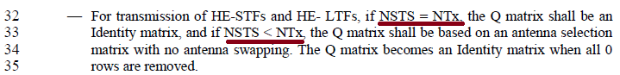

* A similar constraint is defined for the 320 MHz EHT Sounding NDP in section 11.55.1.5.2.3

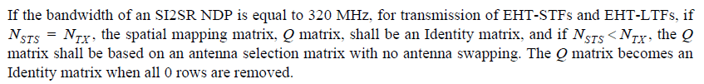

* The constraints on the Q matrix results in mapping one transmit antenna per spatial stream, or the number of spatial streams being equal to the number of transmit antennas.
* In the latest 802.11bf draft, the Sensing field and Sensing Measurement Parameter field identifies capabilities / parameters in terms of STS (e.g., Max TX STS<=80MHZ)

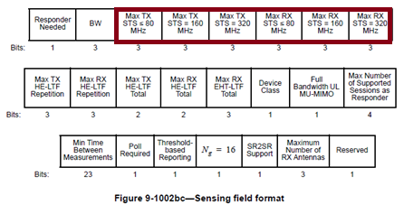

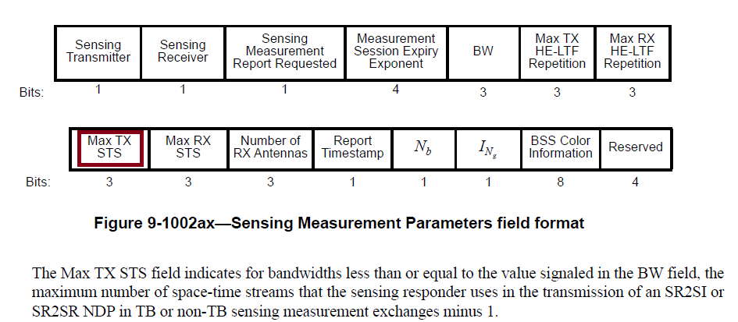

* When referring to capabilities or transmit configuration, using STS is closer to the existing baseline.
* From the reporting prespective, which is new for Sensing, the desire is to keep the report in terms of transmit antenna to receive antenna.
* To help reduce confusion, a note should be added to section 9.4.1.75.2.1 (General) highlight the constraints on the Q matrix used for all current Sensing NDPs will result in a one-to-one mapping of spatial stream to transmit antenna.

| **CID** | **Clause** | **Page** | **Comment** | **Proposed Change** | **Resolution** |
| --- | --- | --- | --- | --- | --- |
| 2218 | 27.2.2, 36.2.2 | 0.00 | The CSI format in the Sensing Measurement Report Container has the dimension Ntx x Nrx x Nsc. This is not consistent with the dimension in CSI_ESTIMATE in RXVECTOR. Please make it consistent. | As in the comment | Revised  Agree in principle.  A change to both the CSI_ESTIMATE RXVECTOR in clause 27 and 36, as well as the CSI encoding and report container descriptions in section 9 have been made.  TGbf editor to make changes to Table 27-1, Table 36-1, and sections 9.4.1.75.2.2, 9.4.1.57.2.3, 9.4.1.75.3, 9.4.1.75.4 as shown in 11-23/1042r0. |

**Discussion:**

* Issue was also raised in contribution 11-23-1007r0, and proposed resolution.
* Changes to CSI_ESTIMATE RXVECTOR parameters in clause 27 and 36 is required.
  + Table 27-1 and Table 36-1 modified as per TGbf Editor instructions below.
* Changes to required to section 9 text as per TGbf Editor instructions for the following:
  + 9.4.1.75.2.2 CSI encoding procedure
  + 9.4.1.75.2.3 CSI decoding procedure
  + 9.4.1.75.3 Sensing Measurement Report Control field
  + Table 9-127j in section 9.4.1.75.4 Sensing Measurement Report information

Questions:

* Do we want to change the order of Ntx and Nrx in Measurement Control Field?

|  |  |  |  |  |  |
| --- | --- | --- | --- | --- | --- |
| **CID** | **Clause** | **Page** | **Comment** | **Proposed Change** | **Resolution** |
| 1451 | 36.2.2 | 231.23 | "based on the channel measured during the training symbols of the received EHT sounding NDP..." is not clear. The training preamble is a vague conception depending on the implementation. | Replace "training symbols" with specific subfields measured, e.g. EHT-LTFs, L-LTFs, RL-LTFs, etc. | Revised  Agree in principle.  Replaced “during the training symbols” with “from the EHT-LTF field(s)”.  TGbf editor to make changes to Table 36-1 as shown in 11-23/1042r0. |
| 1452 | 27.2.2 | 223.23 | "based on the channel measured during the training symbols of the received EHT sounding NDP..." is not clear. The training preamble is a vague conception depending on the implementation. | Replace "training symbols" with specific subfields measured, e.g. L-LTFs, HE-LTFs, etc. | Revised  Agree in principle.  Replaced “during the training symbols” with “from the HE-LTF field(s)”.  TGbf editor to make changes to Table 27-1 as shown in 11-23/1042r0. |
| 1658 | 36.2.2 | 223.22 | The referenced sub-clause 11.55.1 is too generic and doesn't provide direct information about the format of the CSI array. | Provide a more suitable reference for the format of the array of CSI, e.g., 9.4.1.75.2 (CSI encoding and decoding), or define a new sub-clause for the format and provide the reference to it. | Revised  Agree in principle.  Changed reference to section 9.4.1.75.2 as suggested.  TGbf editor to make changes to Table 27-1 as shown in 11-23/1042r0. |
| 1659 | 36.2.2 | 231.22 | The referenced sub-clause 11.55.1 is too generic and doesn't provide direct information about the format of the CSI array. | Provide a more suitable reference for the format of the array of CSI, e.g., 9.4.1.75.2 (CSI encoding and decoding), or define a new sub-clause for the format and provide the reference to it. | Revised  Agree in principle.  Changed reference to section 9.4.1.75.2 as suggested.  TGbf editor to make changes to Table 36-1 as shown in 11-23/1042r0. |
| 1883 | 36.2.2 | 231.25 | Possible values, or the range of values, for N_SC, N_TX and N_RX should be specified or referenced. Table 36-19 of 802.11be_D3.0 may be used as the reference. | As in comment. | Revised  Section 9.4.1.75.2 contains the requested information. Reference in CSI_ESTIMATE changed from 11.55.1 to 9.4.1.75.2.  TGbf editor to make changes to Table 27-1 and Table 36-1 as shown in 11-23/1042r0. |

**Discussion:**

|  |  |  |  |  |  |
| --- | --- | --- | --- | --- | --- |
| **CID** | **Clause** | **Page** | **Comment** | **Proposed Change** | **Resolution** |
| 1940 | 27.2.2 | 223.22 | HE CSI_ESTIMATE description does not define what should be returned in case of repeated LTF. Dimension of CSI_ESTIMATE is currently defined as Nsc X Ntx X Nrx, however dimension of channel estimation in case of repeated LTF is Nsc X Ntx X Nrx X Nrep_ltf. | Define dimension of CSI_ESTIMATE to be Nsc X Ntx X Nrx X Nrep_ltf, to allow all the raw estimates to be provided to the SME. | Revised  Optional CSI_ESTIMATE has been added for allowing all raw estimates being returned to the SME. Additional text added to section 9 and section 11 describing combining multiple measurements for reporting.  TGbf editor to make changes to Table 27-1, section 9.4.1.75.2.1, and section 11.55.1.5.1 as shown in 11-23/1042r0. |
| 1941 | 36.2.2 | 231.22 | EHT CSI_ESTIMATE description does not define what should be returned in case of repeated LTF. Dimension of CSI_ESTIMATE is currently defined as Nsc X Ntx X Nrx, however dimension of channel estimation in case of repeated LTF is Nsc X Ntx X Nrx X Nrep_ltf. | Define dimension of CSI_ESTIMATE to be Nsc X Ntx X Nrx X Nrep_ltf, to allow all the raw estimates to be provided to the SME. | Revised  Optional CSI_ESTIMATE has been added for allowing all raw estimates being returned to the SME. Additional text added to section 9 and section 11 describing combining multiple measurements for reporting.  TGbf editor to make changes to Table 27-1, section 9.4.1.75.2.1, and section 11.55.1.5.1 as shown in 11-23/1042r0. |

**Discussion:**

* LTF repetitions feature allows transmission of multiple LTF symbols, and is controllable via Sensing Measurement Parameters field (Max TX HE-LTF Repetition and Max RX HE-LTF Repetition fields).

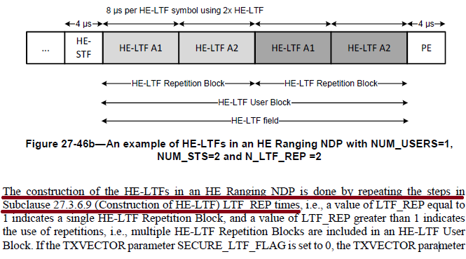

* The repeated LTFs allow multiple measurements of the channel to be performed with highly deterministic timing.
* Similar to the DMG sensing burst, these repeated measurements can be used to improve the quality of measurement (e.g., averaging or combining), or can be used by the application to help estimate a higher frequency doppler.
* The current report format only supports a single “combined” measurement per exchange.
  + The “combining” may be done in the PHY (e.g., delivered as a single dimension CSI_ESTIMATE).
  + The “combining” may also be done by the SME (e.g., delivered as a multi dimension CSI_ESTIMATE).
  + The application should optionally be able to access these multiple measurements.
* As a result, proposed additions:
  + An optional CSI_ESTIMATE format that allows extraction of the raw measurement from the multiple LTF symbols to the SME.
  + Normative text describing the combining of all measurements into a single matrix in either the PHY or SME for the purpose of reporting or application delivery.
* Additions have been made to Table 27-1 and Table 36-1 as per TGbf editor instructions below.
* Clearification has been added as per TGbf editor instructions below to the following:
  + 9.4.1.75.2.1 General
  + 11.55.1.5.1 General

***TGbf Editor: Modify Table 27-1 in D1.1 as follows:***

|  |  |  |  |  |
| --- | --- | --- | --- | --- |
| Parameter | Condition | Value | TXVECTOR | RXVECTOR |
| CSI_ESTIMATE | FORMAT is either HE_SU  or HE_TB, PSDU_LENGTH is 0, and a single estimate is combined from all LTF symbols in the HE-LTF repetition block(#1940). | Contains an array of CSI values based on the channel measured from the HE-LTF field(s)(#1452) of the received HE Ranging NDP or HE TB Ranging NDP (see 9.4.1.75.2 (CSI encoding and decoding)(#1658,#1883)). The number of complex elements is where is the number of receive antennas, $N_{TX }$ is the number of transmit antennas, and is the number of subcarriers(#2218). | N | Y |
| FORMAT is either HE_SU  or HE_TB,  PSDU_LENGTH is 0, and an estimate from multiple LTF symbols in the HE-LTF repetition block is available(#1940). | Contains an array of CSI values based on the channel measured from the HE-LTF field(s) of the received HE Ranging NDP or HE TB Ranging NDP (see 9.4.1.75.2 (CSI encoding and decoding)). The number of complex elements is where is the number of receive antennas, is the number of transmit antennas, is the number of LTF symbols in the HE-LTF repition block, and is the number of subcarriers. | N | O |
| Otherwise | Not present | N | N |

***TGbf Editor: Modify Table 36-1 in D1.1 as follows:***

|  |  |  |  |  |
| --- | --- | --- | --- | --- |
| Parameter | Condition | Value | TXVECTOR | RXVECTOR |
| CSI_ESTIMATE | FORMAT is EHT_MU,  PSDU_LENGTH is 0,  CH_BANDWIDTH is  either CBW320-1 or  CBW320-2, and a single estimate is combined from all EHT-LTF symbols(#1941). | Contains an array of CSI values based on the channel measured from the EHT-LTF field(s)(#1451) of the received EHT sounding NDP (see 9.4.1.75.2 (CSI encoding and decoding)(#1659, #1883)). The number of complex elements is where is the total number ofreceive antennas, $N_{TX }$ is the number of transmit antennas, and is the number of subcarriers(#2218). | N | Y |
| FORMAT is EHT_MU,  PSDU_LENGTH is 0, and  CH_BANDWIDTH is  either CBW320-1 or  CBW320-2, an estimate from multiple EHT-LTF symbols is available(#1941). | Contains an array of CSI values based on the channel measured from the EHT-LTF field(s) of the received EHT sounding NDP (see 9.4.1.75.2 (CSI encoding and decoding)). The number of complex elements is where is the total number of receive antennas, is the number of transmit antennas, is the number of EHT-LTF symbols, and is the number of subcarriers. | N | O |
| Otherwise | Not present | N | N |

***TGbf Editor: Modify the section 9.4.1.75.2.1 text in D1.1 as follows:***

Subclause 9.4.1.75.2.2 (CSI encoding procedure) describes the encoding of the measured CSI, which involves scaling and quantizing the measured CSI, for inclusion in the Sensing Measurement Report field. Subclause 9.4.1.75.2.3 (CSI decoding procedure) describes the decoding of the scaled and quantized CSI that is received in the Sensing Measurement Report field.

The measured CSI for the *rth* receive antenna *, the tth* transmit antenna, and the *kth* subcarrier is the complex value indicated by *H(r, t, k).* The real part of the CSI is indicated by *H(R)(r, t, k),* and the imaginary part of the CSI is indicated by *H(I)(r, t, k)*. The real and imaginary parts of the CSI are represented as 2s complement binary integers(#2218,#2019,#2272).

NOTE – Transmission constraints imposed on the Q matrix for the HE Ranging NDP (see section (27.3.18a.1 (HE Ranging NDP)), HE TB Ranging NDP (see section 27.3.18a.2 (HE TB Ranging NDP)), and EHT Sounding NDP (see section 11.55.1.5.2.3 (NDPA sounding phase)) result in a one to one mapping of transmit antenna to space-time stream (#2019,#2272).

The measured CSI is obtained from the RXVECTOR parameter CSI_ESTIMATE. If the NDP used in the measurement exchange was transmitted with LTF_REP or NUM_EHT_LTF greater than 0, for the purpose of generating a Sensing Measurement Report field, the value *H(r, t, k)* used in the encoding procedure will be a combination of the CSI obtained from each LTF symbol. The combination may be done by either the PHY or SME depending on implementation(#1940,#1941).

The encoded CSI is denoted as *He(r, t, k)* and the decoded CSI is denoted as  *He(r, t, k)* (#2218).

***TGbf Editor: Modify the section 9.4.1.75.2.2 text in D1.1 as follows:***

9.4.1.75.2.2 CSI encoding procedure

The number receive antennas is indicated by *NRX* and the number of transmit antennas is indicated by *NTX*(#2218).

* For a given tuple of receive and transmit antennas, *(r, t)*, the maximum of the absolute value of the real and imaginary parts of the CSI for all subcarriers is calculated using Equation (9-5b).
* *m(r, t) =* max*k={1,3,…,Nsc}{*max*{ |H(R)(r, t, k)|, |H(I)(r, t, k)|}}*  (9-5b)
* The number of subcarriers, *NSC*, is specified in Table 9-127k (Number of subcarriers as a function of bandwidth, puncturing, and Ng). This calculation is performed for each tuple of receive and transmit antennas, *(r, t)*, with *r = 1, 2, …, NRX* and *t = 1, 2, …, NTX*.
* For a given tuple of receive and transmit antennas, *(r, t)*, the positive scaling factor γ*(r, t)* is selected to avoid overflow when scaling and quantizing the measured CSI using Equation (9-5c) and Equation (9-5d). The value of *m(r, t)* may be used in the selection of the *γ(r, t)* to avoid an overflow. The sensing receiver selects the exact value of the scaling factor.

 (9-5c)

 (9-5d)

* This calculation is performed for each tuple of receive and transmit antennas, *(r, t)*.
* Each real and imaginary part of the CSI is scaled and quantized to *Nb* bits using Equation (9-5c) and Equation (9-5d), respectively. The value of *Nb* is signaled in the Sensing Measurement Report Control field, and may have a value of 8 or 10 bits.

***TGbf Editor: Modify the section 9.4.1.75.2.3 text in D1.1 as follows:***

9.4.1.75.2.3 CSI decoding procedure

The received encoded CSI is decoded as follows(#2218):

* The received real and imaginary parts of the scaled and quantized CSI are decoded as a pair of 2s complement numbers and are combined to form the complex CSI, *He(r, t, k)*.
* Each CSI value is rescaled according to Equation (9-5e).

*Hd(r, t, k) = γ(r, t) He(r, t, k)* (9-5e)

***TGbf Editor: Modify the section 9.4.1.75.3 text in D1.1 as follows:***

**9.4.1.75.3 Sensing Measurement Report Control field**

The Sensing Measurement Report Control field provides the information needed to process the Sensing

Measurement Report field. The Sensing Measurement Report Control field signals the bandwidth (BW), the number of transmit antennas (*NTX*), the number of receive antennas (*NRX*), the number of bits (*Nb*) used for each encoded CSI value, an indicator (*INg*) of the subcarrier grouping, an indicator of reporting receiver operating point (OP) index or gain index (Rx_OP_Gain_Type), and an optional reference timestamp. The fields of the Sensing Measurement Report Control field are specified in Table 9-127h (Sensing Measurement Report Control field definition).

***TGbf Editor: Modify the section 9.4.1.75.4 text in D1.1 as follows:***

|  |  |  |
| --- | --- | --- |
| * Sensing Measurement Report information (#2218) | | |
| Field | Size (bits) | Meaning |
| γ*(1, 1)* | 12 | Scaling factor for receive antenna 1 and transmit antenna 1. |
| γ*(1, 2)* | 12 | Scaling factor for receive antenna 1 and transmit antenna 2. |
| … | … | … |
| γ*(1, NTX)* | 12 | Scaling factor for receive antenna 1 and transmit antenna *NTX*. |
| γ*(2, 1)* | 12 | Scaling factor for receive antenna 2 and transmit antenna 1. |
| γ*(2, 2)* | 12 | Scaling factor for receive antenna 2 and transmit antenna 2. |
| … | ... | … |
| γ*(2, NTX)* | 12 | Scaling factor for receive antenna 2 and transmit antenna *NTX*. |
| … | ... | … |
| γ*(NRX, 1)* | 12 | Scaling factor for receive antenna *NRX* and transmit antenna 1. |
| γ*(NRX, 2)* | 12 | Scaling factor for receive antenna *NRX* and transmit antenna 2. |
| … | ... | … |
| γ*(NRX, NTX)* | 12 | Scaling factor for receive antenna *NRX* and transmit antenna *NTX*. |
| Padding | 0 or 4 | The Padding field is used so that the next field is aligned on an octet boundary. |
| *He(1, 1, k)* |  | CSI for receive antenna 1 and transmit antenna 1, for subcarrier *k in {1, 2, …, NSC}* |
| *He(1, 2, k)* |  | CSI for receive antenna 1 and transmit antenna 2, for subcarrier *k in {1, 2, …, NSC}* |
| … | … | … |
| *He(1, NTX, k)* |  | CSI for receive antenna 1 and transmit antenna *NTX*, for subcarrier *k in {1, 2, …, NSC}* |
| *He(2, 1, k)* |  | CSI for receive antenna 2 and transmit antenna 1, for subcarrier *k in {1, 2, …, NSC}* |
| *He(2, 2, k)* |  | CSI for receive antenna 2 and transmit antenna 2, for subcarrier *k in {1, 2, …, NSC}* |
| … | … | … |
| *He(2, NTX, k)* |  | CSI for receive antenna 2 and transmit antenna *NTX*, for subcarrier *k in {1, 2, …, NSC}* |
| … | … | … |
| *He(NRX, 1, k)* |  | CSI for receive antenna  *NRX* and transmit antenna space-time stream 1, for subcarrier *k in {1, 2, …, NSC}* |
| *He(NRX, 2, k)* |  | CSI for receive antenna  *NRX* and transmit antenna 2, for subcarrier *k in {1, 2, …, NSC}* |
| *He(NRX, NTX, k)* |  | CSI for receive antenna  *NRX* and transmit antenna *NTX*, for subcarrier *k in {1, 2, …, NSC}* |
|  | 8 | RSSI at receive antenna 1 |
|  | 8 | RSSI at receive antenna 2 |
| … | … | … |
|  | 8 | RSSI at receive antenna *NRX* |
| Rx_OP_Gain_Index(1) | 8 | If the Rx_OP_Gain_Type field is 1, the Rx_OP_Gain_Index(1) field contains the Rx OP index for receive antenna 1.  If the Rx_OP_Gain_Type field is 2, the Rx_OP_Gain_Index(1) field contains the Rx gain index for receive antenna 1.  If the Rx_OP_Gain_Type field is 0 or 3, the Rx_OP_Gain_Index(1) field is reserved(#1160). |
| Rx_OP_Gain_Index(2) | 8 | If the Rx_OP_Gain_Type field is 1, the Rx_OP_Gain_Index(2) field contains the Rx OP index for receive antenna 2.  If the Rx_OP_Gain_Type field is 2, the Rx_OP_Gain_Index(2) field contains the Rx gain index for receive antenna 2.  If the Rx_OP_Gain_Type field is 0 or 3, the Rx_OP_Gain_Index(2) field is reserved(#1160). |
| … | … | … |
| Rx_OP_Gain_Index*(NRX)* | 8 | If the Rx_OP_Gain_Type field is 1, the Rx_OP_Gain_Index(*NRX* ) field contains the Rx OP index for receive antenna.  If the Rx_OP_Gain_Type field is 2, the Rx_OP_Gain_Index(*NRX*) field contains the Rx gain index for receive antenna.  If the Rx_OP_Gain_Type field is 0 or 3, the Rx_OP_Gain_Index(*NRX*) field is reserved(#1160). |

Since the scaling and quantization is performed for each RX/TX antenna pair, the scaled and quantized CSI values are ordered by RX/TX pair. The Sensing Measurement field begins with the set of scaling factors for each RX/TX antenna pair. For each RX/TX antenna pair there is a 12-bit positive scaling factor. If there is an odd number of scaling factors, then the set of scaling factors is followed by a 4-bit padding field(#2218).

For each RX/TX antenna pair the in-phase (real) component of the CSI is entered first and followed by the quadrature (imaginary) component of the CSI. This begins with the lowest frequency subcarrier (*NSC*), and is repeated for each subcarrier. The number of subcarriers included in the Sensing Measurement Report information is defined in Table 9-127k (Number of subcarriers as a function of bandwidth, puncturing, and Ng)(#2218).

***TGbf Editor: Append the section 11.55.1.5.1 text in D1.1 as follows:***

Upon receiving an SI2SR, SR2SI or SR2SR NDP, the sensing receiver’s MAC shall issue a SENSREPORT.indication primitive(#1627).

The measured CSI is obtained from the RXVECTOR parameter CSI_ESTIMATE. If the NDP used in the measurement exchange was transmitted with LTF_REP or NUM_EHT_LTF greater than 0, then the CSI_ESTIMATE shall be either(#1940,#1941):

* An array of dimention containing a single estimate combined from all present LTF symbols, or

An array of dimention providing the SME implementation or application an estimate from multiple LTF symbols in the NDP.

NOTE—The SENSREPORT.indication primitive includes sensing measurements. If the NDP is preceded by a Sensing NDP Announcement frame, the SENSREPORT.indication primitive also includes operational parameters carried in the Sensing NDP Announcement frame. If the NDP is triggered by a SR2SI Sounding Trigger frame or SR2SR Sounding Trigger frame, the SENSREPORT.indication primitive also includes operational parameters carried in the SR2SI Sounding Trigger frame or SR2SR Sounding Trigger frame(#1627).

|  |  |  |  |  |  |
| --- | --- | --- | --- | --- | --- |
| **CID** | **Clause** | **Page** | **Comment** | **Proposed Change** | **Resolution** |
| 1782 | 36.2 | 231.24 | General EHT sounding NDP its number of LTF is related to Nss_total instead of N_TX. Need to add rules in PHY section that when EHT sounding NDP is used for sensing, Q matrix shall be identical matrix and Nss_toal shall be N_Tx, i.e., similar rules from ranging NDP. Also may want to cut down the number of LTF/GI combiniation to be supported in sounding EHT NDP for sensing. Add some texts to 36.3.18 | as in the comment | Rejected  The requested changes are listed in section 11.55.1.5.2.3, along with the conditions for selecting the NDP. |
| 1797 | 36.2.2 | 231.24 | Format EHT_TB is missing in Table 36-1 while format HE_TB is included in table 27-1. | Add FORMAT is EHT_TB in the condition column in the table. | Rejected  The EHT Sounding NDP may only be used as a SI2SR NDP during the NDPA sounding phase (11.55.1.5.2.3). In this scenario, the EHT_MU PPDU format is used.  As a result, there is currently no defined scenario where an EHT_TB PPDU format is required. |

**Discussion:**

* The only valid scenario where the EHT Sounding NDP is used is as a SI2SR NDP during the NDPA sounding phase (as described in section 11.55.1.5.2.3).
* The requested constraints are listed in section 11.55.1.5.2.3 as follows:

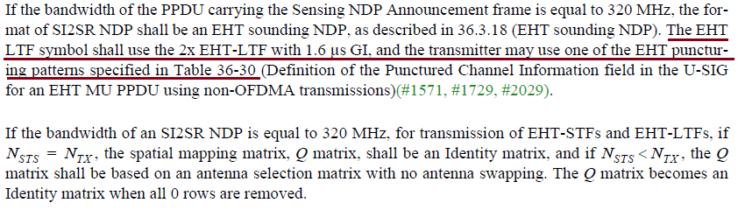

|  |  |  |  |  |  |
| --- | --- | --- | --- | --- | --- |
| **CID** | **Clause** | **Page** | **Comment** | **Proposed Change** | **Resolution** |
| 1003 | 11.55.1.2 | 170.17 | The phrase "A STA with four or less transmit antennas..." should be "A STA with four or fewer transmit antennas..." | As in comment | Revised  Agree in principle.  Replacing “four or less” with “up to four”.  TGbf editor to make changes to P130.62-65 as shown in 11-23/1042r0. |
| 1489 | 11.55.1.2 | 170.17 | This capability for a STA should have been written in terms of the number of supported receive spatial streams, but was written incorrectly in terms of transmit antennas. The number of transmit antennas is on the transmitting device, which is the source of the confusion, I believe. | Change "A STA with four or less transmit antennas shall support an N_g value of 4 and may optionally support an N_g value of 16 in the Sensing Measurement Report frame." To "A STA that can support reception of up to four spatial streams shall support an N_g value of 4 and may optionally support an N_g value of 16 in the Sensing Measurement Report frame." | Revised  Update wording to make clear this requirement is intended for the receiving STA, not the transmitting STA.  TGbf editor to make changes to P130.62-65 as shown in 11-23/1042r0. |

**Notes:**

* This statement is intended for the STA which is the sensing receiver since it is the sensing receiver who generates the measurement report.
* The wording “A STA with for or less transmit antennas shall” suggests that this requirement is for the sensing transmitter, which is not intended.
* The constraint should be re-worded such that it is clear this requirement is intended for the sensing receiver.
* Given discussion above, space-time streams should be used instead of antennas.

***TGbf Editor: Modify the text in D1.1 130.62-65 as follows:***

A sensing STA capable of receiving up to four space-time streams shall support an (see Table 9-127h (Sensing Measurement Report Control field definition)) value of 4 and may optionally support an value of 16 in the Sensing Measurement Report frame(#1002, #1077, #1003, #1489).

|  |  |  |  |  |  |
| --- | --- | --- | --- | --- | --- |
| **CID** | **Clause** | **Page** | **Comment** | **Proposed Change** | **Resolution** |
| 1490 | 11.55.1.2 | 170.20 | This capability for a STA should have been written in terms of the number of supported receive spatial streams, but was written incorrectly in terms of transmit antennas. The number of transmit antennas is on the transmitting device, which is the source of the confusion, I believe. | Change “A STA with five or more transmit antennas and a bandwidth of 80 MHz shall support an N_g value of 4 and may optionally support an N_g value of 16 in the Sensing Measurement Report frame.” To “A STA that can support reception of five or more spatial streams and a bandwidth of 80 MHz shall support an N_g value of 4 and may optionally support an N_g value of 16 in the Sensing Measurement Report frame.” | Revised  Agree with commenter that the requirement is intended for the receiver not transmitter. Applied changes to clarify requirement is for the sensing receiver.  TGbf editor to make changes to P131.1-4 as shown in 11-23/1042r0. |

**Notes:**

* This statement is intended for the STA which is the sensing receiver since it is the sensing receiver who generates the measurement report.
* The wording “A STA with for or less transmit antennas shall” suggests that this requirement is for the sensing transmitter, which is not intended.
* The constraint should be re-worded such that it is clear this requirement is intended for the sensing receiver.
* Given discussion above, space-time streams should be used instead of antennas.

***TGbf Editor: Modify the text in D1.1 131.1-4 as follows:***

A sensing STA capable of receiving five or more space-time streams shall support an *Ng* value of 4 and may optionally support an *Ng* value of 16 in the Sensing Measurement Report frame if the bandwidth of the SI2SR, SR2SI, or SR2SR NDP used to obtain the reported sensing measurement is less than or equal to 80 MHz(#1002, #1077, #1792, #1490).

|  |  |  |  |  |  |
| --- | --- | --- | --- | --- | --- |
| **CID** | **Clause** | **Page** | **Comment** | **Proposed Change** | **Resolution** |
| 1491 | 11.55.1.2 | 170.24 | This capability for a STA should have been written in terms of the number of supported receive spatial streams, but was written incorrectly in terms of transmit antennas. The number of transmit antennas is on the transmitting device, which is the source of the confusion, I believe. | Change "A STA with five or more transmit antennas and a bandwidth greater than or equal to 160 MHz shall support an N_g value of 4 and may optionally support an N_g value of 16 in the Sensing Measurement Report frame." To "A STA that can support reception of five or more spatial streams and a bandwidth of greater or equal to 160 MHz shall support an N_g value of 8 and may optionally support an N_g value of 16 in the Sensing Measurement Report frame." | Revised  Agree with commenter that the requirement is intended for the receiver not transmitter. Applied changes to clarify requirement is for the sensing receiver.  TGbf editor to make changes to P130.6-10 as shown in 11-23/1042r0. |

**Notes:**

* This statement is intended for the STA which is the sensing receiver since it is the sensing receiver who generates the measurement report.
* The wording “A STA with for or less transmit antennas shall” suggests that this requirement is intended for the sensing transmitter, which is not intended.
* The constraint should be re-worded such that it is clear this requirement is intended for the sensing receiver.
* Given discussion above, space-time streams should be used instead of antennas.

***TGbf Editor: Modify the text in D1.1 131.6-10 as follows:***

A sensing STA with capable of receiving five or more space-time streams shall support an *Ng* value of 8 and may optionally support an *Ng* value of 16 in the Sensing Measurement Report frame if the bandwidth of the SI2SR, SR2SI, or SR2SR NDP used to obtain the reported sensing measurement is greater than or equal to 160 MHz(#1002, #1077, #1792, #1491).

|  |  |  |  |  |  |
| --- | --- | --- | --- | --- | --- |
| **CID** | **Clause** | **Page** | **Comment** | **Proposed Change** | **Resolution** |
| 2045 | 11.55.1.5.4 | 188.15 | "The sensing transmitter shall use the same ordered set of antennas with no antenna swapping" is not very precise (antennas are not ordered, swapping is not defined, ...). | Change to e.g. "The sensing transmitter shall use same set of tx antennas with the same spatial mapping matrix" | Revised  Agree with commenter in principle. Additional clarifications added.  TGbf editor to make changes to D1.1 P150.39-51 as shown in 11-23/1042r0. |
| 2046 | 11.55.1.5.4 | 188.15 | "The sensing transmitter shall use the same ordered set of antennas with no antenna swapping". Not clear if this allows for a generic Q matrix, or only allows mapping each stream to a single antenna. | Clarify. Consider that using all antennas (and hence allowing for a generic Q matrix) has its benefits. | Revised  Agree with commenter in principle. Additional clarifications added.  TGbf editor to make changes to D1.1 P150.39-51 as shown in 11-23/1042r0. |

**Notes:**

* Initial text was derived from P802.11az, section 27.3.18a.1 and 27.3.18a.2, which describe the HE Ranging NDP and HE TB Ranging NDP:

* Additional constraint in the UL MU case (TB instance) can be clarified. In this case, the AP may allocate different space-time-streams to the participating STAs using the SS Allocation field.

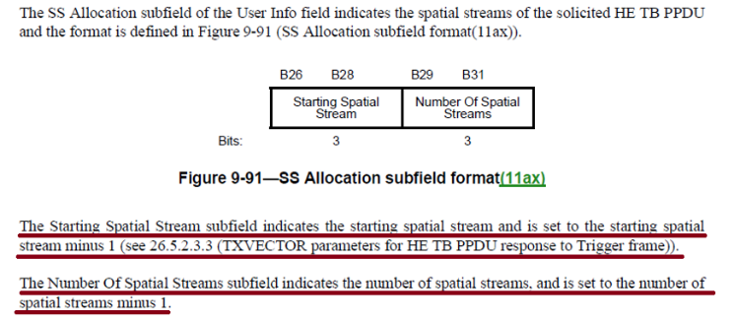

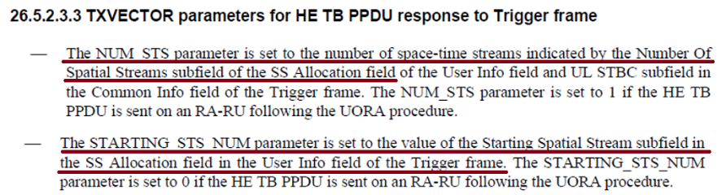

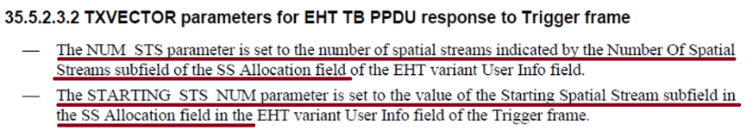

* The result is the antennas used by each responder/transmitter when sending the SR2SI or SR2SR NDP shall ensure the first antenna in the ordered subset always maps to the Starting Spatial Stream (STARTING_STS_NUM).



**Proposed Resolutions**: Revise

***TGbf Editor: Modify the text in D1.1 150.39-51 as follows:***

The sensing transmitter shall use the same ordered set of antennas with no antenna swapping for transmission of an SI2SR, SR2SI or SR2SR NDP in all sensing measurement instances associated with that sensing measurement session to ensure the sensing receiver computes the CSI from a consistent transmit configuration. In the SR2SI or SR2SR variant of the TF sounding phase, the sensing transmitter shall always map the first antenna in the ordered set to the Starting Spatial Stream indicated by the SS Allocation field and maintain ordering for the remaining space-time streams regardless of the UL resource assignment(#2045,#2046). If any of the transmit antennas is not available, the sensing transmitter shall not transmit the SI2SR, SR2SI or SR2SR NDP for that sensing measurement instance.

NOTE—The sensing transmitter needs to terminate the sensing measurement session if any of its transmit antennas is no longer available for sensing measurements. If all transmit antennas of the sensing transmitter are no longer available for sensing measurements, then the sensing measurement session is implicitly terminated(#1156).

**SP:**

Do you support the resolution to CIDs 2019 2272 2218 1451 1452 1658 1659 1883 1940 1941 1782 1797 1003 1489 1490 1491 2045 2046 11-23/1042r0 and incorporating the changes into the latest TGbf draft?

Y/N/A