IEEE P802.11
Wireless LANs
LB271 CR for subclause 9.2.4 EHT link adaptation
Date: 2023.06.05
Author(s):
Name | Company | Address | Phone | email
Bo Gong | Huawei Technologies | H3, Huawei Base, Bantian, Longgang, Shenzhen, Guangdong, China, 518129 |  | gongbo8@huawei.com
Ming Gan |  |  |  | ming.gan@huawei.com
Ross (Jian Yu) |  |  |  | ross.yujian@huawei.com
Abstract
This submission contains proposed comment resolutions to comments on P802.11be D3.0.
The changes are based on P802.11be D3.0.

This submission provides a resolution to the following CIDs:
- 15246, 15896, 16238, 17308, 17380, 17393,17394, 17395, 17396, 17397, 17398, 17399, 17400, 17401, 17402, 17403, 17404, 17405, 17406, 17407, 17684
Note: CID 15246 has been withdrawn by the commenter.

Revisions:
- Rev 0: Initial version of the document.

CID 15896
Page.  Line | Clause Number | Comment | Proposed Change | Resolution
150.27 | 9.2.4.7.11 | The concept of "Validate" is not specified here and needs to be clearly defined and referenced here for readers to understand its meaning. | define the value "Validate" and reference here. | Revised.  Agreed in principle. Reflect the detailed explanation.  Instructions to the editor:  Please make the changes as shown in 11/23-1022r1 under CID 16238.  Note that the resolutions for CID 15896 and CID 16238 are the same.

CID 16238
Page.  Line | Clause Number | Comment | Proposed Change | Resolution
150.27 | 9.2.4.7.11 | The term "Validate" doesn't appear to make sense. In the baseline "validate" is used as part of a (security) integrity check on MSDUs or MPDUs. I think the correct term is "reserved" or "rejected"? I also note that the term "validate" is used in clause 11.52 P394L6 and this appears to be a similar usage to that of the baseline. | Change "Validate" to "Reserved" | Accepted.  Note that the resolutions for CID 15896 and CID 16238 are the same.

Discussion:

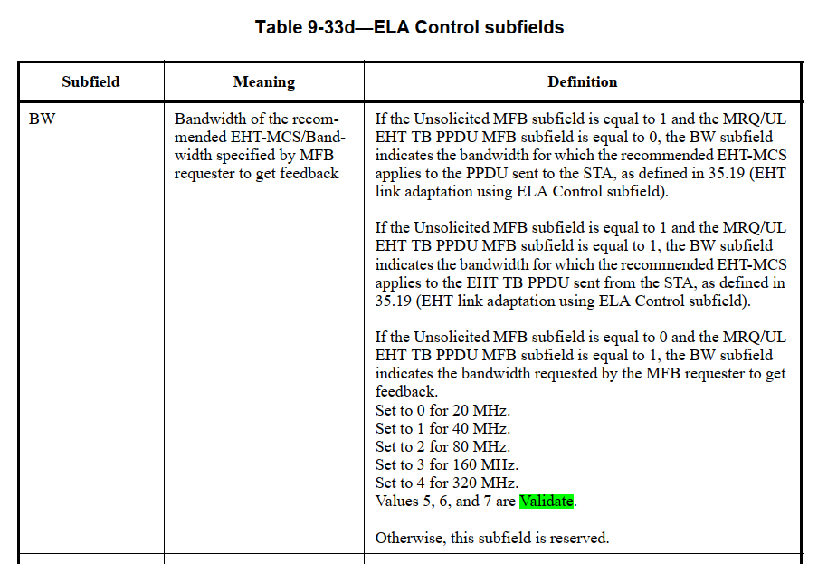

CID 17308
Page.  Line | Clause Number | Comment | Proposed Change | Resolution
146.01 | 9.2.4.7.11 | There is a lot of repetitive defintions in ELA, and I take the same applies to the normative behavior. Please merge the two fields ELA and HLA, and by relying on the EHT/HE bit differentiation add the different text. That way we can save 5-10 pages of repetitive text. Suggest doing the same for 35.19 as well. | As in comment. | Rejected.  The commenter fails to identify a technical issue. It fails to identify specific changes that would satisfy the comment. Please note the following:  - Describing ELA and HLA separately is more intuitive and easier to understand.  - Major changes at this stage, such as merging two sub-clauses, will incur more comments and unnecessary work on resolving and reviewing them.

CID 17380
Page.  Line | Clause Number | Comment | Proposed Change | Resolution
140.18 | 9.2.4.6.4 | "HE link adaptation (HLA)/EHT link adaptation (ELA)" - Under which circumstances is this HLA vs ELA? Certainly section 9.2.4.7.3 provides no information! | Either create a single named parameter described in a single section (with 2 subsections for HLA/ELA) for this OR add a second column in this table for the HLA/ELA field and split this row into two. | Rejected.  For B25 of the Control Information Subfield, it is set to 1 if the Control Information subfield is an ELA control  Subfield. And it is set to 0 if the Control Information subfield is an HLA control Subfield. The illustration can be referred to in 9.2.4.7.11 ELA Control in Line 59, Page 150 of TGbe Draft D3.0.

CID 17393
Page.  Line | Clause Number | Comment | Proposed Change | Resolution
148.06 | 9.2.4.7.11 | "ELA control" should be "ELA Control subfield" | Change to "ELA Control subfield" x2 at P148L6/7 | Accepted.

Discussion:

The following changes should be made in Line 6, Page 148 in TGbe Draft D3.0:

Table 9-33d—ELA Control subfields

 | Subfield |  | Meaning |  | Definition
Unsolicited MFB |  | Unsolicited MFB indicator |  | Set to 1 if the ELA control subfield is an unsolicited MFB.  Set to 0 if the ELA control subfield is an MRQ or a solicited MFB.

CID 17394
Page.  Line | Clause Number | Comment | Proposed Change | Resolution
148.09 | 9.2.4.7.11 | Procedural language is creeping into clause 9 within "Set to 1 and set Unsolicited MFB subfield to 0 to request an  ELA feedback" | Try "Set to 1 with the Unsolicited MFB subfield set to 0 to indicate a request for ELA feedback ... Set to 0 and with Unsolicited MFB subfield set to 0 to indicate a response to an ELA request" | Revised.  Agreed in principle. Reflect the detailed explanation.  Instructions to the editor:  Please make the changes as shown in 11/23-1022r1 under CID 17394.

Instructions to the Editor:

Please make the following changes in Line 9, Page 148 in TGbe Draft D3.0:
Table 9-33d—ELA Control subfields
Subfield | Meaning | Definition
Unsolicited MFB | Unsolicited MFB indicator | Set to 1 if the ELA control is an unsolicited MFB.  Set to 0 if the ELA control is an MRQ or a solicited MFB.
MRQ/UL EHT TB PPDU MFB | ELA feedback request indicator/UL EHT TB PPDU MFB indication | Set to 1 with the Unsolicited MFB subfield set to 0 to indicate a request for ELA feedback.  Set to 0 with the Unsolicited MFB subfield set to 0 to indicate a respond to an ELA request.  If the Unsolicited MFB subfield is equal to 1, a value of 1 in this subfield indicates that the NSS, EHT-MCS, BW, PS160, and RU Allocation fields represent the recommended MFB for the EHT TB PPDU sent from the STA as defined in 35.19 (EHT link adaptation using ELA Control subfield).  If the Unsolicited MFB subfield is 1 and MRQ/UL EHT TB PPDU MFB = 0, then NSS, EHT-MCS, PS160, RU Allocation,  and BW fields represent the recommended values for the PPDU sent to the STA.

CID 17395
Page.  Line | Clause Number | Comment | Proposed Change | Resolution
148.15 | 9.2.4.7.11 | Column header is "subfield" but text calls them "fields" | Try " NSS, EHT-MCS, BW, PS160, and RU Allocation subfields" x2 | Revised.  Agreed in principle. Reflect the detailed explanation.  Instructions to the editor:  Please make the changes as shown in 11/23-1022r1 under CID 17395.

Instructions to the Editor:

Please make the following changes in Line 15, Page 148 in TGbe Draft D3.0:

Table 9-33d—ELA Control subfields

Subfield | Meaning | Definition
Unsolicited MFB | Unsolicited MFB indicator | Set to 1 if the ELA control is an unsolicited MFB.  Set to 0 if the ELA control is an MRQ or a solicited MFB.
MRQ/UL EHT TB PPDU MFB | ELA feedback request indicator/UL EHT TB PPDU MFB indication | Set to 1 and set Unsolicited MFB subfield to 0 to request an ELA feedback.  Set to 0 and set Unsolicited MFB subfield to 0 to respond to an ELA request.  If the Unsolicited MFB subfield is equal to 1, a value of 1 in this subfield indicates that the NSS, EHT-MCS, BW, PS160, and RU Allocation subfields represent the recommended MFB for the EHT TB PPDU sent from the STA as defined in 35.19 (EHT link adaptation using ELA Control subfield).  If the Unsolicited MFB subfield is 1 and MRQ/UL EHT TB PPDU MFB = 0, then NSS, EHT-MCS, PS160, RU Allocation,  and BW subfields represent the recommended values for the PPDU sent to the STA.

CID 17396
Page.  Line | Clause Number | Comment | Proposed Change | Resolution
148.21 | 9.2.4.7.11 | Using "=". Also missing article | Try "the MRQ/UL EHT TB PPDU MFB field is equal to 0, then *the* NSS" | Revised.  Agreed in principle. Reflect the detailed explanation.  Instructions to the editor:  Please make the changes as shown in 11/23-1022r1 under CID 17396.

Instructions to the Editor:

Please make the following changes in Line 21, Page 148 in TGbe Draft D3.0:

Table 9-33d—ELA Control subfields

Subfield | Meaning | Definition
Unsolicited MFB | Unsolicited MFB indicator | Set to 1 if the ELA control is an unsolicited MFB.  Set to 0 if the ELA control is an MRQ or a solicited MFB.
MRQ/UL EHT TB PPDU MFB | ELA feedback request indicator/UL EHT TB PPDU MFB indication | Set to 1 and set Unsolicited MFB subfield to 0 to request an ELA feedback.  Set to 0 and set Unsolicited MFB subfield to 0 to respond to an ELA request.  If the Unsolicited MFB subfield is equal to 1, a value of 1 in this subfield indicates that the NSS, EHT-MCS, BW, PS160, and RU Allocation fields represent the recommended MFB for the EHT TB PPDU sent from the STA as defined in 35.19 (EHT link adaptation using ELA Control subfield).  If the Unsolicited MFB subfield is 1 and MRQ/UL EHT TB PPDU MFB is equal to 0, then the NSS, EHT-MCS, PS160, RU Allocation,  and BW fields represent the recommended values for the PPDU sent to the STA.

CID 17397
Page.  Line | Clause Number | Comment | Proposed Change | Resolution
148.29 | 9.2.4.7.11 | N_{SS} is not italicised | Italicise N_{SS}, 4x in this cell | Accepted.

Discussion:

The following changes should be made in Line 29, Page 148 in TGbe Draft D3.0:

NSS | Recommended number of spatial streams | If the Unsolicited MFB subfield is equal to 1 and the MRQ/UL EHT TB PPDU MFB subfield is equal to 0 or if the Unsolicited MFB subfield is equal to 0 and the MRQ/UL EHT TB PPDU MFB subfield is equal to 0, the NSS subfield indicates the rec- ommended number of spatial streams to the PPDU sent to the STA, NSS, and is set to NSS – 1.  If the Unsolicited MFB subfield is equal to 1 and the MRQ/UL EHT TB PPDU MFB subfield is equal to 1, the NSS subfield indicates the recommended number of spatial streams to the EHT TB PPDU sent from the STA, NSS, and is set to NSS– 1.  Otherwise, this subfield is reserved.

CID 17398
Page.  Line | Clause Number | Comment | Proposed Change | Resolution
148.50 | 9.2.4.7.11 | Rogue linefeed | Remove rogue linefeed | Accepted.

Discussion:

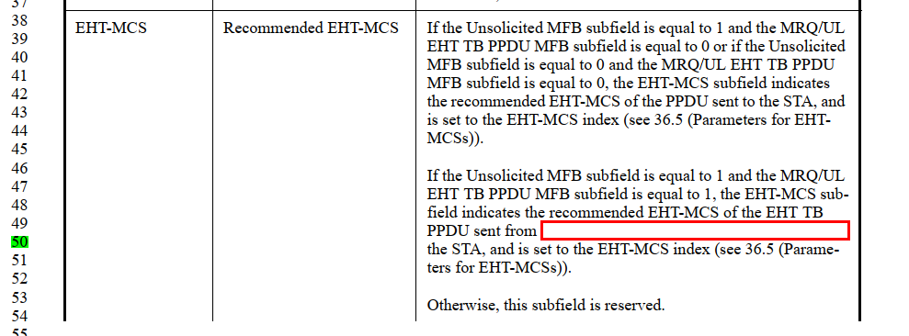

CID 17399
Page.  Line | Clause Number | Comment | Proposed Change | Resolution
149.12 | 9.2.4.7.11 | Bad article; also "tone" is singular x2 | Try "for an RU or MRU size smaller than or equal to 2x996 tones" x2 in this cell. | Revised.  Agreed in principle. Reflect the detailed explanation.  Instructions to the editor:  Please make the changes as shown in 11/23-1022r1 under CID 17399.

Instructions to the Editor:

Please make the following changes in Line 12, Page 149 in TGbe Draft D3.0:

Subfield | Meaning | Definition
PS160 | Indication of primary 160 MHz channel or sec-  ond 160 MHz channel that the RU or MRU allocation applies to if the size of RU or MRU is smaller than or equal to 2×996 tones. Oth- erwise, the PS160 subfield is used to indicate the  RU or MRU index along with the RU Allocation subfield. | If the Unsolicited MFB subfield is equal to 1, or the Unsolicited MFB subfield is equal to 0 and the MRQ/UL EHT TB PPDU MFB subfield is equal to 1, the PS160 subfield is set to 0 to indicate the RU or MRU allocation applies to the primary  160 MHz channel and set to 1 to indicate the RU or MRU allo- cation applies to the secondary 160 MHz channel for an RU or MRU size smaller than or equal to 2x996 tones; the PS160 subfield is used to indicate the RU or MRU index along with the RU Allocation subfield for an RU or MRU size smaller than or equal to 2x996 tones. Please refer to RU Allocation subfield defini- tion in Table 9-53a (Encoding of PS160 and RU Allocation subfields in an EHT variant User Info field).  Otherwise, this subfield is reserved.

CID 17400
Page.  Line | Clause Number | Comment | Proposed Change | Resolution
149.15 | 9.2.4.7.11 | Spurious "Please", missing article | Delete "Please"; try "Refer to *the* RU Allocation subfield ..." | Accepted.

Discussion:

The following changes should be made in Line 15, Page 149 in TGbe Draft D3.0:

Table 9-33d—ELA Control subfields

Subfield | Meaning | Definition
PS160 | Indication of primary 160 MHz channel or sec-  ond 160 MHz channel that the RU or MRU allocation applies to if the size of RU or MRU is smaller than or equal to 2×996 tones. Oth- erwise, the PS160 subfield is used to indicate the  RU or MRU index along with the RU Allocation subfield. | If the Unsolicited MFB subfield is equal to 1, or the Unsolicited MFB subfield is equal to 0 and the MRQ/UL EHT TB PPDU MFB subfield is equal to 1, the PS160 subfield is set to 0 to indicate the RU or MRU allocation applies to the primary  160 MHz channel and set to 1 to indicate the RU or MRU allo- cation applies to the secondary 160 MHz channel for the size of RU or MRU smaller than or equal to 2×996 tone; the PS160 subfield is used to indicate the RU or MRU index along with the RU Allocation subfield for the size of RU or MRU larger than 2×996 tone. Referto the RU Allocation subfield defini- tion in Table 9-53a (Encoding of PS160 and RU Allocation subfields in an EHT variant User Info field).  Otherwise, this subfield is reserved.

CID 17401
Page.  Line | Clause Number | Comment | Proposed Change | Resolution
148.17 | 9.2.4.7.11 | Wrong article, since the MFB applies to one or more near-future PPDUs so there not a particular PPDU. Also, who is "the STA"? | Try " the recommended EHT-MCS applies to future EHT TB PPDU(s) sent by the STA that is issuing this recommendation" Ditto L22 "the recommended values for future PPDU(s)  sent to the STA that is issuing this recommendation". And either 1) similar changes at L29, L35,L45 ... until the end of this table or 2) treating these entities at L17/22 as antecedents for the rest of this table (weak style though!), *maybe* it could be OK to refer to "the [EHT TB]. PPDU(s)" and "the STA" thereafter. | Revised.  Agreed in principle. Reflect the detailed explanation.  Instructions to the editor:  Please make the changes as shown in 11/23-1022r1 under CID 17404.  Note that the resolutions for CID 17401 and CID 17404 are the same.

CID 17404

Page.  Line | Clause Number | Comment | Proposed Change | Resolution
149.36 | 9.2.4.7.11 | Strange wording "the RU or MRU for which the recommended EHT-MCS applies to the EHT TB PPDU sent from the STA, as defined in 35.19 (EHT link adaptation using ELA Control subfield)." In what sense is this "*to* the EHT PPDU"? | Try "the RU or MRU in future EHT TB PPDU(s) sent from the STA for which the recommended EHT-MCS applies, as defined in 35.19 (EHT link adaptation using ELA Control subfield).". Ditto P150L7, try " the BW subfield indicates the bandwidth of future PPDU(s) sent to the STA for which the recommended EHT-MCS applies, as defined in 35.19 (EHT link adaptation using ELA Control subfield)." Ditto P150L14, try "the BW subfield indicates the bandwidth of future EHT TB PPDU(s) sent from the STA for which the recommended EHT-MCS applies, as defined in 35.19 (EHT link adaptation using ELA Control subfield)." | Revised.  Agreed in principle. Reflect the detailed explanation.  Instructions to the editor:  Please make the changes as shown in 11/23-1022r1 under CID 17404.  Note that the resolutions for CID 17401 and CID 17404 are the same.

Instructions to the Editor:

- Please make the following changes in Line 17, Page 148 in TGbe Draft D3.0:

If the Unsolicited MFB subfield is equal to 1, a value of 1 in this subfield indicates that the NSS, EHT-MCS, BW, PS160, and RU Allocation fields represent the recommended MFB for future EHT TB PPDU(s) sent by the STA that is issuing this recommendation as defined in 35.19 (EHT link adaptation using ELA Control subfield).

- Please make the following changes in Line 22, Page 148 in TGbe Draft D3.0:

If the Unsolicited MFB subfield is 1 and MRQ/UL EHT TB PPDU MFB = 0, then NSS, EHT-MCS, PS160, RU Allocation, and BW fields represent the recommended values for future PPDU(s) sent to the STA that is issuing this recommendation.

- Please make the following changes in Line 29, Page 148 in TGbe Draft D3.0:

If the Unsolicited MFB subfield is equal to 1 and the MRQ/UL EHT TB PPDU MFB subfield is equal to 0 or if the Unsolicited MFB subfield is equal to 0 and the MRQ/UL EHT TB PPDU MFB subfield is equal to 0, the NSS subfield indicates the recommended number of spatial streams for future PPDU(s) sent to the STA that is issuing this recommendation, N_{SS}, and is set to N_{SS} – 1.

- Please make the following changes in Line 34, Page 148 in TGbe Draft D3.0:

If the Unsolicited MFB subfield is equal to 1 and the MRQ/UL EHT TB PPDU MFB subfield is equal to 1, the NSS subfield indicates the recommended number of spatial streams for future EHT TB PPDU(s) sent by the STA that is issuing this recommendation, N_{SS}, and is set to N_{SS} – 1.

- Please make the following changes in Line 42, Page 148 in TGbe Draft D3.0:

If the Unsolicited MFB subfield is equal to 1 and the MRQ/UL EHT TB PPDU MFB subfield is equal to 0 or if the Unsolicited MFB subfield is equal to 0 and the MRQ/UL EHT TB PPDU MFB subfield is equal to 0, the EHT-MCS subfield indicates the recommended EHT-MCS for future PPDU(s) sent to the STA that is issuing this recommendation, and is set to the EHT-MCS index (see 36.5 (Parameters for EHT MCSs)).

- Please make the following changes in Line 50, Page 148 in TGbe Draft D3.0:

If the Unsolicited MFB subfield is equal to 1 and the MRQ/UL EHT TB PPDU MFB subfield is equal to 1, the EHT-MCS subfield indicates the recommended EHT-MCS for future EHT TB PPDU(s) sent by the STA that is issuing this recommendation, and is set to the EHT-MCS index (see 36.5 (Parameters for EHT-MCSs)).

- Please make the following changes in Line 24, Page 149 in TGbe Draft D3.0:

If the Unsolicited MFB subfield is equal to 1 and the MRQ/UL EHT TB PPDU MFB subfield is equal to 0, the RU Allocation subfield and the PS160 jointly indicate the RU or MRU which the recommended EHT-MCS applies to, as defined in 35.19 (EHT link adaptation using ELA Control subfield).

- Please make the following changes in Line 36, Page 149 in TGbe Draft D3.0:

If the Unsolicited MFB subfield is equal to 1 and the MRQ/UL EHT TB PPDU MFB subfield is equal to 1, the RU Allocation subfield and the PS160 jointly indicate the RU or MRU which the recommended EHT-MCS applies to, as defined in 35.19 (EHT link adaptation using ELA Control subfield).

- Please make the following changes in Line 9, Page 150 in TGbe Draft D3.0:

If the Unsolicited MFB subfield is equal to 1 and the MRQ/UL EHT TB PPDU MFB subfield is equal to 0, the BW subfield indicates the bandwidth which the recommended EHT-MCS applies to, as defined in 35.19 (EHT link adaptation using ELA Control subfield).

- Please make the following changes in Line 15, Page 150 in TGbe Draft D3.0:

If the Unsolicited MFB subfield is equal to 1 and the MRQ/UL EHT TB PPDU MFB subfield is equal to 1, the BW subfield indicates the bandwidth which the recommended EHT-MCS applies to, as defined in 35.19 (EHT link adaptation using ELA Control subfield).

- Please make the following changes in Line 17, Page 657 in TGbe Draft D3.0:

A non-AP EHT STA may set the Unsolicited MFB subfield to 0 and the MRQ/UL EHT TB PPDU MFB to 1 in the ELA Control field it transmits to the AP to indicate that the NSS, EHT-MCS, bandwidth, and RU allocation in the ELA Control field represent the recommended MFB for future EHT TB PPDU(s) sent by the STA that is issuing this recommendation. The AP should not exceed the recommended RU or MRU size indicated in the most recently received RU Allocation and PS160 subfield of the ELA Control field when it sends a triggering frame addressed to the STA.

CID 17402
Page.  Line | Clause Number | Comment | Proposed Change | Resolution
149.31 | 9.2.4.7.11 | 1) Misleading wording: " the RU or MRU requested by the MFB requester to get feedback" The MFB requester doesn't request an RU/MRU, they request feedback about the RU/MRU. 2) This smacks of precedure: the request is copied into the response, but that doesn't belong in clause 9. | Try "If the Unsolicited MFB subfield is equal to 0 and the MRQ/UL EHT TB PPDU MFB subfield is equal to 1, the RU Allocation subfield and the PS160 jointly indicate the RU or MRU  for which feedback is provided. NOTE - As defined in <xref>, these fields indicate the same RU or MRU for which the MFB requester requested feedback." | Revised.  Agreed in principle. Reflect the detailed explanation.  Instructions to the editor:  Please make the changes as shown in 11/23-1022r1 under CID 17402.

Instructions to the Editor:

Please make the following changes in Line 31, Page 149 in TGbe Draft D3.0:

RU Allocation | RU or MRU of the recommended EHT-MCS/RU or MRU specified by MFB requester to get feedback | If the Unsolicited MFB subfield is equal to 1 and the MRQ/UL EHT TB PPDU MFB subfield is equal to 0, the RU Allocation subfield and the PS160 jointly indicate the RU or MRU for which the recommended EHT-MCS applies to the PPDU sent to the STA, as defined in 35.19 (EHT link adaptation using ELA Control subfield).  If the Unsolicited MFB subfield is equal to 0 and the MRQ/UL EHT TB PPDU MFB subfield is equal to 1, the RU Allocation subfield and the PS160 jointly indicate the RU or MRU for which feedback is requested by the MFB requester.  If the Unsolicited MFB subfield is equal to 1 and the MRQ/UL EHT TB PPDU MFB subfield is equal to 1, the RU Allocation subfield and the PS160 jointly indicate the RU or MRU for which the recommended EHT-MCS applies to the EHT TB PPDU sent from the STA, as defined in 35.19 (EHT link adap- tation using ELA Control subfield).  The RU Allocation subfield and the PS160 subfield are inter- preted with the BW subfield to specify the RU or MRU. The RU or MRU index encoding is as defined in Table 9-53a (Encoding of PS160 and RU Allocation subfields in an EHT variant User Info field).  Otherwise, this subfield is reserved.

CID 17403

Page.  Line | Clause Number | Comment | Proposed Change | Resolution
149.22 | 9.2.4.7.11 | "to get feedback" is vague, since it is feedback specifically for the specified RU or MRU | Try "RU or MRU for which the MFB requester solicits feedback". Ditto P150L7, try and replace "Bandwidth specified by MFB requester to get feedback" by "Bandwidth for which the MFB requester solicits feedback". Ditto P150L20, try "the BW subfield indicates the PPDU bandwidth for which the MFB requester solicits feedback." | Revised.  Agreed in principle. Reflect the detailed explanation.  Instructions to the editor:  Please make the changes as shown in 11/23-1022r1 under CID 17403.

Instructions to the Editor:

- Please make the following changes in Line 22, Page 149 in TGbe Draft D3.0:

RU Allocation | RU or MRU of the recommended EHT-MCS/RU or MRU for which the MFB requester solicits feedback. | If the Unsolicited MFB subfield is equal to 1 and the MRQ/UL EHT TB PPDU MFB subfield is equal to 0, the RU Allocation subfield and the PS160 jointly indicate the RU or MRU for which the recommended EHT-MCS applies to the PPDU sent to the STA, as defined in 35.19 (EHT link adaptation using ELA Control subfield).  If the Unsolicited MFB subfield is equal to 0 and the MRQ/UL EHT TB PPDU MFB subfield is equal to 1, the RU Allocation subfield and the PS160 jointly indicate the RU or MRU requested by the MFB requester to get feedback.  If the Unsolicited MFB subfield is equal to 1 and the MRQ/UL EHT TB PPDU MFB subfield is equal to 1, the RU Allocation subfield and the PS160 jointly indicate the RU or MRU for which the recommended EHT-MCS applies to the EHT TB PPDU sent from the STA, as defined in 35.19 (EHT link adap- tation using ELA Control subfield).  The RU Allocation subfield and the PS160 subfield are inter- preted with the BW subfield to specify the RU or MRU. The RU or MRU index encoding is as defined in Table 9-53a (Encoding of PS160 and RU Allocation subfields in an EHT variant User Info field).  Otherwise, this subfield is reserved.

- The following changes should be made in Line 9, Page 150 in TGbe Draft D3.0:

BW | Bandwidth of the recommended EHT-MCS/Bandwidth for which the MFB requester solicits feedback | If the Unsolicited MFB subfield is equal to 1 and the MRQ/UL EHT TB PPDU MFB subfield is equal to 0, the BW subfield indicates the bandwidth for which the recommended EHT-MCS applies to the PPDU sent to the STA, as defined in 35.19 (EHT link adaptation using ELA Control subfield).  If the Unsolicited MFB subfield is equal to 1 and the MRQ/UL EHT TB PPDU MFB subfield is equal to 1, the BW subfield indicates the bandwidth for which the recommended EHT-MCS applies to the EHT TB PPDU sent from the STA, as defined in  35.19 (EHT link adaptation using ELA Control subfield).  If the Unsolicited MFB subfield is equal to 0 and the MRQ/UL EHT TB PPDU MFB subfield is equal to 1, the BW subfield indicates the PPDU bandwidth for which the MFB requester solicits feedback.  Set to 0 for 20 MHz.  Set to 1 for 40 MHz.  Set to 2 for 80 MHz.  Set to 3 for 160 MHz.  Set to 4 for 320 MHz.  Values 5, 6, and 7 are Validate.  Otherwise, this subfield is reserved.

CID 17405

Page.  Line | Clause Number | Comment | Proposed Change | Resolution
149.36 | 9.2.4.7.11 | "Bandwidth of the recommended EHT-MCS" - but MCSs aren't normally regarded as having a bandwith. | Try "Bandwidth associated with the recommended EHT-MCS" | Revised.  Agreed in principle. Reflect the detailed explanation.  Instructions to the editor:  Please make the changes as shown in 11/23-1022r1 under CID 17405.

Instructions to the Editor:

- Please make the following changes in Line 21, Page 149 in TGbe Draft D3.0:

RU Allocation | RU or MRU associated with the recommended EHT-MCS/RU or MRU specified by MFB requester to get feedback | If the Unsolicited MFB subfield is equal to 1 and the MRQ/UL EHT TB PPDU MFB subfield is equal to 0, the RU Allocation subfield and the PS160 jointly indicate the RU or MRU for which the recommended EHT-MCS applies to the PPDU sent to the STA, as defined in 35.19 (EHT link adaptation using ELA Control subfield).  If the Unsolicited MFB subfield is equal to 0 and the MRQ/UL EHT TB PPDU MFB subfield is equal to 1, the RU Allocation subfield and the PS160 jointly indicate the RU or MRU requested by the MFB requester to get feedback.  If the Unsolicited MFB subfield is equal to 1 and the MRQ/UL EHT TB PPDU MFB subfield is equal to 1, the RU Allocation subfield and the PS160 jointly indicate the RU or MRU for which the recommended EHT-MCS applies to the EHT TB PPDU sent from the STA, as defined in 35.19 (EHT link adap- tation using ELA Control subfield).  The RU Allocation subfield and the PS160 subfield are inter- preted with the BW subfield to specify the RU or MRU. The RU or MRU index encoding is as defined in Table 9-53a (Encoding of PS160 and RU Allocation subfields in an EHT variant User Info field).  Otherwise, this subfield is reserved.

- Please make the following changes in Line 7, Page 150 in TGbe Draft D3.0:

BW | Bandwidth associated with the recom- mended EHT-MCS/Band- width specified by MFB requester to get feedback | If the Unsolicited MFB subfield is equal to 1 and the MRQ/UL EHT TB PPDU MFB subfield is equal to 0, the BW subfield indicates the bandwidth for which the recommended EHT-MCS applies to the PPDU sent to the STA, as defined in 35.19 (EHT link adaptation using ELA Control subfield).  If the Unsolicited MFB subfield is equal to 1 and the MRQ/UL EHT TB PPDU MFB subfield is equal to 1, the BW subfield indicates the bandwidth for which the recommended EHT-MCS applies to the EHT TB PPDU sent from the STA, as defined in  35.19 (EHT link adaptation using ELA Control subfield).  If the Unsolicited MFB subfield is equal to 0 and the MRQ/UL EHT TB PPDU MFB subfield is equal to 1, the BW subfield indicates the bandwidth requested by the MFB requester to get feedback.  Set to 0 for 20 MHz.  Set to 1 for 40 MHz.  Set to 2 for 80 MHz.  Set to 3 for 160 MHz.  Set to 4 for 320 MHz.  Values 5, 6, and 7 are Validate.  Otherwise, this subfield is reserved.

CID 17406

Page.  Line | Clause Number | Comment | Proposed Change | Resolution
150.54 | 9.2.4.7.11 | Missing article x2 | Try "Set to 0 for a non-beamformed PPDU. Set to 1 for a beamformed PPDU." | Accepted.

Discussions:

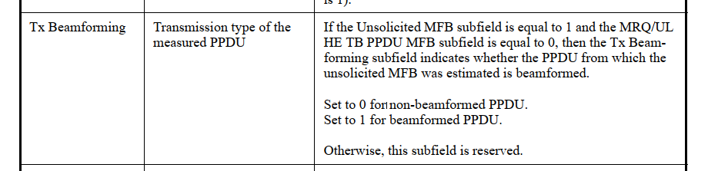

CID 17407

Page.  Line | Clause Number | Comment | Proposed Change | Resolution
150.59 | 9.2.4.7.11 | Missing capitalization x2 | Try "Set to 1 if the Control Information subfield is an ELA Control subfield. Set to 0 if the Control Information subfield is an HLA Control subfield." | Accepted.

Discussion:

The following changes should be made in Line 59, Page 150 in TGbe Draft D3.0:

HLA/ELA | HE/EHT link adaptation indication | Set to 1 if the Control Information subfield is an ELA Control subfield.  Set to 0 if the Control Information subfield is an HLA Control subfield.

CID 17684

Page.  Line | Clause Number | Comment | Proposed Change | Resolution
274.40 | 9.4.2.313.2 | "EHT MFB and EHT MRQ are MFB and MRQ using ELA Control subfield, respectively." seems out of place and also the intent here is unclear. | Try "MFB and MRQ using the ELA Control subfield are called EHT MFB and EHT MFQ, respectively." Also check with editor if these definitions belong here or as text after the end of the table, etc. | Revised.  Agreed in principle. Reflect the detailed explanation.  Instructions to the editor:  Please make the changes as shown in 11/23-1022r1 under CID 17468.

Instructions to the Editor:

Please make the following changes in Line 40, Page 274 in TGbe Draft D3.0:

EHT Link Adaptation Support | Indicates support for link adaptation using the ELA Control subfield. | If the +HTC-HE Support subfield in HE MAC Capabilities Information field in HE Capabili- ties element is equal to 1:  Set to 0 (No feedback) if the STA does not provide EHT MFB.  Set to 2 (Unsolicited) if the STA can receive and provide only unsolicited EHT MFB.  Set to 3 (Solicited and unsolicited) if the STA is capable of receiving and providing EHT MFB in response to EHT MRQ and if the STA can receive and provide unsolic- ited EHT MFB.  The value 1 is reserved.  NOTE: MFB and MRQ using ELA Control subfield are referred to as EHT MFB and EHT MRQ, respectively.  Reserved if the +HTC-HE Support subfield in HE MAC Capabilities Information field in HE Capabilities element is 0.

