IEEE P802.11
Wireless LANs
LB271 CR for subclause 35.19 EHT link adaptation
Date: 2023.06.05
Author(s):
Name | Company | Address | Phone | email
Bo Gong | Huawei Technologies | H3, Huawei Base, Bantian, Longgang, Shenzhen, Guangdong, China, 518129 |  | gongbo8@huawei.com
Ming Gan |  |  |  | ming.gan@huawei.com
Ross (Jian Yu) |  |  |  | ross.yujian@huawei.com
Abstract
This submission contains proposed comment resolutions to comments on P802.11be D3.0.
The changes are based on P802.11be D3.0.

This submission provides a resolution to the following CIDs:
- 15445, 15446, 15487, 15588, 15589, 17376

Revisions:
- Rev 0: Initial version of the document.

CID 15445
Page.  Line | Clause Number | Comment | Proposed Change | Resolution
655.36 | 35.19 | The requirement at line 36 seems redundant, given the requirement at line 32. If the intention is for the sentence on line 36 to provide clarification, it would be clearer if it did not use normative language | Revise sentence to eliminate "shall" and move the first sentence to the previous paragraph. | Rejected.  - The paragraph at Line 32 illustrates that the EHT Link Adaptation Support subfield is set according to PHY implementation parameter dot11EHTMCSFeedbackOptionImplemented.  - The paragraph at Line 36 illustrates the usage of EHT Link Adaptation Support subfield with different settings. The description is inherited from 11ax in 26.13 Link adaptation using the HLA Control subfield.

Discussion:

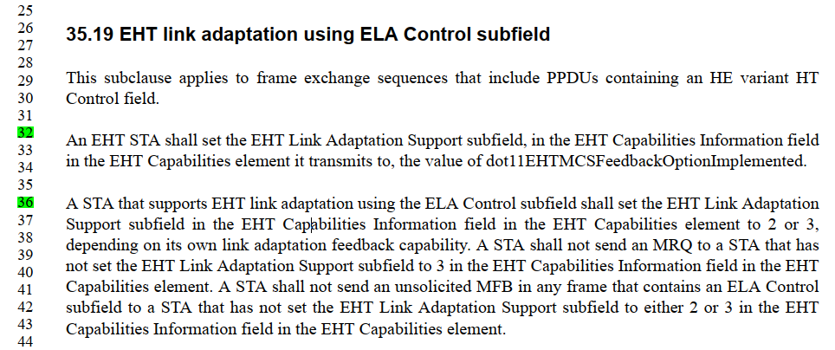

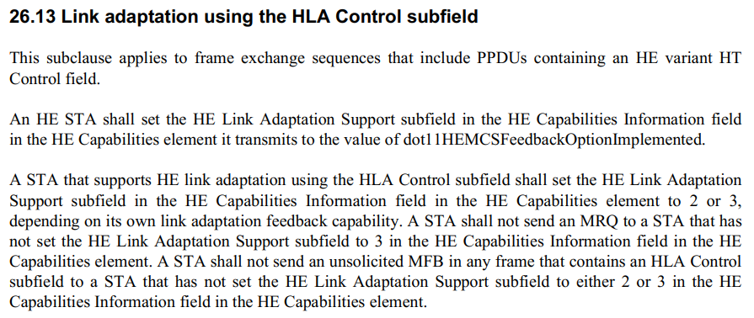

CID 15446
Page.  Line | Clause Number | Comment | Proposed Change | Resolution
655.45 | 35.19 | The sentence "The HLA/ELA subfield should be set to 1 in the ELA Control subfield of a frame to indicate the ELA Control subfield." is not clear. How can a field within a field "indicate" the outer field? | Rephrase to clarify the intention. | Revised.  Agreed in principle. Reflect the detailed explanation.  Instructions to the editor:  Please make the changes as shown in 11/23-1021r2 under CID 15446.

Instructions to the Editor:

Please make the following changes in Line 45, Page 655 in TGbe Draft D3.0:

The HLA/ELA subfield shall be set to 1 to indicate that the Control Information subfield is an ELA Control subfield and shall be set to 0 to indicate that the Control Information subfield is an HLA Control subfield.

CID 15487
Page.  Line | Clause Number | Comment | Proposed Change | Resolution
655.33 | 35.19 | "EHT Capabilities Information field" should be "EHT MAC Capabilities Information field", and the same typos exists in the next paragragh. | As in comment | Accepted.

Discussion:

The following changes should be made in Line 32, Page 655 in TGbe Draft D3.0:

An EHT STA shall set the EHT Link Adaptation Support subfield, in the EHT MAC Capabilities Information field
in the EHT Capabilities element it transmits to, the value of dot11EHTMCSFeedbackOptionImplemented.
A STA that supports EHT link adaptation using the ELA Control subfield shall set the EHT Link Adaptation Support subfield in the EHT MAC Capabilities Information field in the EHT Capabilities element to 2 or 3, depending on its own link adaptation feedback capability. A STA shall not send an MRQ to a STA that has not set the EHT Link Adaptation Support subfield to 3 in the EHT MAC Capabilities Information field in the EHT Capabilities element. A STA shall not send an unsolicited MFB in any frame that contains an ELA Control subfield to a STA that has not set the EHT Link Adaptation Support subfield to either 2 or 3 in the EHT MAC Capabilities Information field in the EHT Capabilities element

CID 15588
Page.  Line | Clause Number | Comment | Proposed Change | Resolution
655.38 | 35.19 | MRQ is a subfield in the baseline, the sentence needs to be refined to reflect the actual meaning. | Change to: A STA shall not send an ELA feedback request indicated by an ELA Control subfield in any frame to a STA ... | Rejected.  - MRQ subfield is a subfield, whilst MRQ indicates an ELA feedback request.  - The description is inherited from 11ax in 26.13 Link adaptation using the HLA Control subfield.
Discussion:

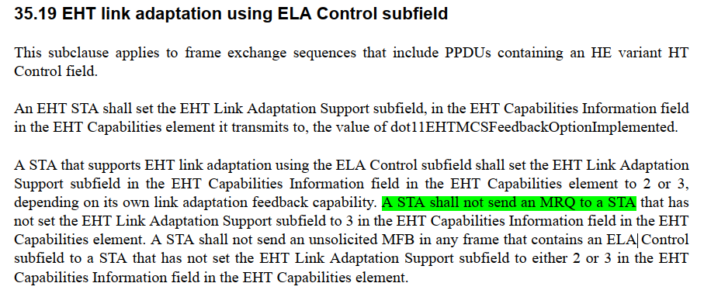

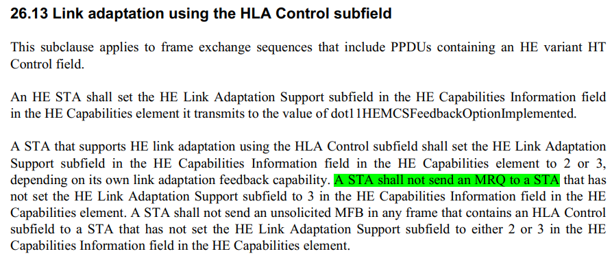

CID 15589
Page.  Line | Clause Number | Comment | Proposed Change | Resolution
657.14 | 35.19 | set the Unsolicited MFB subfield to 0' does not match with the text in 9.2.4.7.11 (ELA Control) | Change to: A non-AP EHT STA may set the Unsolicited MFB subfield to 1 ... | Accepted.

Discussion:

The following changes should be made in Line 14, Page 657 in TGbe Draft D3.0:

A non-AP EHT STA may set the Unsolicited MFB subfield to 1 and the MRQ/UL EHT TB PPDU MFB to 1 in the ELA Control field it transmits to the AP to indicate that the NSS, EHT-MCS, bandwidth, and RU allocation in the ELA Control field represent the recommended MFB for the EHT TB PPDU sent from the non-AP EHT STA. The AP should not exceed the recommended RU or MRU size indicated in the most recently received RU Allocation and PS160 subfield of the ELA Control field when it sends a triggering frame addressed to the STA.

CID 17376
Page.  Line | Clause Number | Comment | Proposed Change | Resolution
655.26 | 35.19 | Several functionalities are inherited from HLA in this case. Please call out only the new additions in this subclause and for the rest cite the HLA subclause to avoid redundancy. Also note that the contents of HT control throughout a PPDU are already the same so no need to call out here as well, and that other restrictions apply which are defined in 10.8 and 10.9. | As in comment. | Rejected.  The commenter fails to identify a technical issue. It fails to identify specific changes that would satisfy the comment. Please note the following:  - Describing ELA and HLA separately is more intuitive and easier to understand.  - Major changes at this stage, such as merging two sub-clauses, will incur more comments and unnecessary work on resolving and reviewing them.

