IEEE P802.11
Wireless LANs
LB272 CR for MLME CID – Part 3
Date: 2023-06-xx
Author(s):
Name | Affiliation | Address | Phone | email
Narengerile | Huawei | Shenzhen, China |  | narengerile@huawei.com
Rui Du
Mengshi Hu
Zhuqing Tang
Yiyan Zhang

Abstract
This document proposes the comment resolutions for 18 MLME CIDs. The resolutions are proposed based on 11bf D1.1.

CIDs: 1216, 1217, 1218, 1219, 1225, 1466, 1467, 1468, 1469, 1470, 1471, 1472, 1473, 1474, 1475, 1476, 1778 and 2162.

R0: initial version on June 16, 2023.

CID: 1216, 1217, 1218, 1219, 1225
CID | Clause | Page | Comment | Proposed change
1216 | 6.3.137.3.4 | 45.35 | "On the receipt of this primitive, the SME should operate according to the procedure in 11.55.2 (SBP procedure)..." Provide more accurate reference. | Replace the reference with "11.55.2.2 (Setup)"
1217 | 6.3.137.5.4 | 48.08 | On the receipt of this primitive, the SME should operate according to the procedure in 11.55.2 (SBP procedure). Provide more accurate reference. | Replace the reference with "11.55.2.3 (Reporting)"
1218 | 6.3.137.7.4 | 49.10 | On the receipt of this primitive, the SME should operate according to the procedure in 11.55.2 (SBP procedure). Provide more accurate reference. | Replace the reference with "11.55.2.3 (Reporting)"
1219 | 6.3.137.10.4 | 50.55 | On the receipt of this primitive, the SME should operate according to the procedure in 11.55.2 (SBP procedure). Provide more accurate reference. | Replace the reference with "11.55.2.4 (Termination)"
1225 | 6.3.139.2.4 | 62.14 | "...according to the procedure in 11.55.4 (DMG SBP procedure)" Provide more accurate reference | Replace the reference with "11.55.4.2 (DMG SBP Setup)"
Proposed resolution: REVISED to all. Please incorporate the modifications specified in 23/1016r0 https://mentor.ieee.org/802.11/dcn/23/11-23-1016-00-00bf-lb272-cr-for-mlme-cid-part-3.docx) for CIDs 1216, 1217, 1218, 1219, 1225.
Discussions:
Agree with the commenter in principle. These 5 comments are suggesting provide accurate references for the primitives used in the SBP procedure and the DMG SBP procedure. Given the latest draft D1.1, all primitives in clause 6 are summarized into Table 6-1, while the references (given in the ‘Comments’ column) in the table are very general – 11.55.2 SBP procedure and 11.55.4 DMG SBP procedure. The following modifications are proposed.
Modifications:
To TGbf editor: Please modify Table 6-1 in D1.1 as follows.
Service Name | MLME-xxx | Type | References | Comments
SBP procedure | SBP | 1 | 9.6.7.54 ((Protected) SBP Request frame format),  9.6.7.55 ((Protected) SBP Response frame format) | See 11.55.2.2 (Setup exchange)
 | SBPREPORT | 2 | 9.6.7.57 (SBP Report frame format),  9.6.36.7 (Protected SBP Report frame) | See 11.55.2.3 (Reporting)
 | SBPTERMINATION | 2 | 9.6.7.56 ((Protected) SBP Termination frame format) | See 11.55.2.4 (Termination)

Service Name | MLME-xxx | Type | References | Comments
DMG SBP procedure | DMG-SBP | 1 | 9.6.19.26 (Protected DMG SBP Request frame format),  9.6.19.27 (Protected DMG SBP Response frame format),  9.6.21.12 (DMG SBP Request frame format),  9.6.21.13 (DMG SBP Response frame format) | See 11.55.4.2 (DMG SBP Setup exchange)
 | DMG-SBPREPORT | 2 | 9.6.19.28 (Protected DMG SBP Report frame format),  9.6.21.14 (DMG SBP Report frame format) | See 11.55.4.3 (DMG SBP Reporting)
 | DMG-SBPTERMINATION | 2 | 9.6.21.15 (DMG SBP Termination frame format),  9.6.36.6 (Protected DMG SBP Termination frame) | See 11.55.4.4 (DMG SBP Termination)

CID: 1466, 1467, 1468, 1469, 1470, 1471, 1472, 1473, 1474, 1475, 1476
CID | Clause | Page | Comment | Proposed change
1466 | 6.3.136.2.2 | 29.14 | Figure 9-1139c doesn't specify/define valid values for this field. | Change reference to point to the clause where the valid values are actually listed/defined.
1467 | 6.3.136.3.2 | 30.01
1468 | 6.3.136.6.2 | 32.36
1469 | 6.3.136.7.2 | 33.41
1470 | 6.3.136.8.2 | 35.01
1471 | 6.3.136.9.2 | 36.10
1472 | 6.3.136.13.2 | 39.07
1473 | 6.3.136.14.2 | 39.61
1474 | 6.3.136.18.2 | 42.51
1475 | 6.3.137.4.2 | 46.11
1476 | 6.3.137.5.2 | 47.34
Proposed resolution: REJECTED to all.
Reason: Figure 9-1139c shows the Measurement Session ID Indication field, which is the correct reference for Measurement Session ID. The value of the Measurement Session ID is set in an implementation-dependent manner. The spec does not need to list or define its actual values.
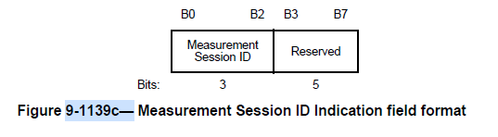

CID: 1778, 2162
CID | Clause | Page | Comment | Proposed change
1778 | 6.3.136.1 | 25.14 | There is to much procedure defined in clause 6. This should be in subclause 11.55. The material with cross-frame/inter-frame procedure, role assignments of the participants, etc. (which is all, or almost all of subclause 6.3.136.1) should all be moved to ubclause 11.55. Really only the first paragraph of 6.3.136.1 is appropriate in clause 6, which makes it seem that perhaps a General introduction subclause isn’t needed at all (I’ll leave that for the TG to consider). | Move everything after the first paragraph of 6.3.136.1 to be a new subclause “11.55.1 General” before 11.55.2 (renumbered) WLAN sensing procedure.
2162 | 6.3.136.18.2 | 42.52 | MLME-SENSNTBREPORTRQ.confirm is sent after the transmission of the sensing measurement report frame at the sensing responder, according to Figure 6-29b. This is not consistent with the text in 6.3.136.18.2. | Change “Identifies the sensing measurement setup for the received Sensing Measurement Report frame.” To “Identifies the sensing measurement setup for the transmitted Sensing Measurement Report frame.”  Resolved by 625
Proposed resolution: REIVSED to all.
Discussions for CID 1778:
Agree with the commenter in principle. Given the latest draft D1.1, the technical procedures mentioned in this comment are already removed from clause 6. So, this issue no longer exists. And no extra modifications are needed.
Discussions for CID 2162
This .confirm primitive is issued at the sensing responder after sending the report frame. The original text in D1.0 was written from the sensing initiator’s perspective, which is incorrect (see the snapshot below). Given the latest draft D1.1, the last two rows are replaced with SensingMeasurementReportContainer parameter, along with the related texts. So, this issue no longer exists. And no extra changes are needed.
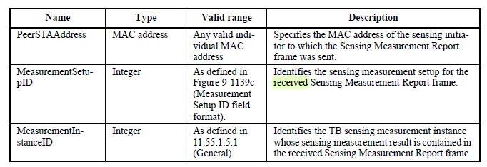

SP:
Do you agree to include the resolutions provided for CIDs 1216, 1217, 1218, 1219, 1225, 1466, 1467, 1468, 1469, 1470, 1471, 1472, 1473, 1474, 1475, 1476, 1778 and 2162 in the latest 11bf Draft?
Y/N/A

