IEEE P802.11
Wireless LANs
LB271 CR related to DCM in EHT PPE Thresholds field
Date: 2023.06.16
Author(s):
Name | Company | Address | Phone | email
Mengshi Hu | Huawei Technologies | F3, Huawei Base, Bantian, Longgang, Shenzhen, Guangdong, China, 518129 |  | humengshi@huawei.com
Ming Gan
Abstract
This submission contains the proposed comment resolutions of CIDs in 23/0272 IEEE 802.11be LB271 comments.

2 comments related to the DCM in subclause 9.4.2.313.5 (EHT PPE Thresholds field) and 35.13 (Nominal packet padding values selection rules) are resolved.

Resolved CIDs: 17728 and 15272.
Revision Notes
R0 | Initial revision

CID 17728
CID | Page.  Line | Clause Number | Comment | Proposed Change | Resolution
17728 | 292.04 | 9.4.2.313.5 | This sentence is confusing since I could strike-out "initial" and "using EHT-MCS 14" and the sentence is still perfectly valid. What special thing is going on here? BTW, in 35.13, there is no instance of "initial" so that doesn't help, and in fact no usage of "initial RU allocation ind" anywhere outside this paragraph. | Use the same term here as in 35.13 (e.g. "initial RU allocation index/indices") | REVISED.  Agree with the commenter in principle. The corresponding sentences are updated.  Instructions to the editor:  Please make the changes as shown under CID 17728 in 11-23/1015r0.

Discussion (CID 17728):
The text in 802.11 D3.0:

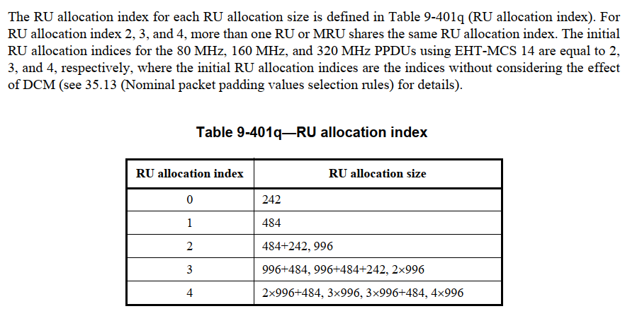

To some extend I agree with the commenter that the wording “initial” is a little bit confusing if someone only reads subclause 9.4.2.313.5 and does not read subclause 35.13 carefully. Furthermore, although a reference is given in the above text (see 35.13 (Nominal packet padding values selection rules) for details), as the commenter says, there is no “initial” in subclause 35.13, too.

The “initial” here indicates the following:
According to 35.13, the RU allocation index used to get the PPET value is equal to (b + DCM), where “b” is the actual RU size, and the DCM is equal to 0 or 1. The wording “initial” is used to describe the actual RU size “b”.

To make it clear, the usage of “initial” is avoided and the corresponding sentence is updated.

Instructions to the editor: please make the following changes to Page 316, Line 31 in the subclause 9.4.2.313.5 (EHT PPE Thresholds field) in D3.2 as shown below:
The RU allocation index for each RU allocation size is defined in Table 9-404q (RU allocation index). For an RU allocation index equal to 2, 3, and 4, more than one RU or MRU shares the same RU allocation index. The RU allocation indices for 80 MHz, 160 MHz, and 320 MHz PPDUs using EHT-MCS 14 are equal to 2, 3, and 4, respectively, before considering the effect of DCM on these RU allocation indices (see 35.13 (Nominal packet padding values selection rules) for details). (#17728)

CID 15272
CID | Page.  Line | Clause Number | Comment | Proposed Change | Resolution
15272 | 632.49 | 35.13.3 | Although the text is clear, the wording in the table is confusing. HE-MCS 0 + DCM may be interpreted as HE-MCS 1 (because some places use the wording b + DCM to describe the RU size index). | Change "HE-MCS 0 + DCM" into "HE-MCS 0 with DCM" | REVISED.  Agree with the commenter. Table 35-5 is updated accordingly.  Instructions to the editor:  Please make the changes as shown under CID 15272 in 11-23/1015r1.

Discussion (15272):
Suggest avoiding using “HE-MCS 0 + DCM” here, because “+ DCM” has a totally different meaning in the case that an RU Allocation index = b + DCM, and both of these descriptions are used in the same subclause.

Instructions to the editor: please make the following changes to Page 651, Line 46 in the subclause 35.13.3 (PPET not present in EHT but present in HE) in D3.2 as shown below:
Table 35-5—EHT nominal packet padding indication for NSS ≤ NSTS+1 when the PPE Thresholds Present subfield is set to 0 in the EHT Capabilities element and 1 in the HE Capabilities element

EHT-MCS | RU or MRU size  < 106 tones | 106-tone RU and 106+26-tone MRU | 242 tones  ≤ RU or MRU size  ≤ 2996 tones | RU or MRU size  > 2996 tones
0–11 | 0 µs (see NOTE 1) | 0 µs (see NOTE 1) | HE nominal packet padding value | EHT common nominal packet padding value
12 and 13 | EHT common nominal packet padding value | EHT common nominal packet padding value | EHT nominal packet padding value | EHT common nominal packet padding value
14 | — | — | HE nominal packet padding value for HE-MCS 0 with DCM (see NOTE 4) | EHT common nominal packet padding value (see NOTE 4)
15 | 0 µs (see NOTE 1) | HE nominal packet padding value for HE-MCS 0 with DCM | HE nominal packet padding value for HE-MCS 0 with DCM | EHT common nominal packet padding value
NOTE 1—The nominal packet padding value conveyed by the PPE Thresholds field in the HE Capabilities element is 0 µs in these cases.

NOTE 2—The HE nominal packet padding value is the value conveyed by the PPE Thresholds field in the HE Capabilities element.

NOTE 3—The EHT common nominal packet padding value is the value conveyed by the Common Nominal Packet Padding subfield in the EHT PHY Capabilities Information field in the EHT Capabilities element.

NOTE 4—EHT-MCS 14 only applies to 80 MHz, 160 MHz, and 320 MHz EHT MU PPDUs, and the nominal packet padding value can be taken from the values for 996-, 2×996-, and 4×996-tone RUs, respectively.

