IEEE P802.11
Wireless LANs
LB272 CR for Threshold-based Reporting – Part 3
Date: 2023.07.01
Author(s):
Name | Company | Address | Phone | email
Mengshi Hu | Huawei Technologies | F3, Huawei Base, Bantian, Longgang, Shenzhen, Guangdong, China, 518129 |  | humengshi@huawei.com
Rui Du
Narengerile
Zhuqing Tang
Yiyan Zhang
Abstract
This submission contains the proposed comment resolutions of CIDs in 23/0314 LB272 comments and approved resolutions.

9 comments related to the threshold-based reporting are resolved.

Resolved CIDs: 1055, 1737, 1738, 1783, 1982, 1984, 1985, 2039, and 2040.
Revision Notes
R0 | Initial revision

CID 1055
CID | Page.  Line | Clause Number | Comment | Proposed Change | Resolution
1055 | 183.54 | 11.55.1.5.2.6.2 | Threshold-based reporting does not work and is not necessary. It is complicated and can be implementation specific. | Delete "11.55.1.5.2.6.2 Threshold-based reporting phase" from 11bf spec. | REJECTED.  This is an optional feature used to save the overhead of CSI feedback. If a STA is unable to support this procedure, it can choose not to use it.

CIDs 1737, 1738, 1783, 1982, 1984, 1985, 2039, and 2040
CID | Page.  Line | Clause Number | Comment | Proposed Change | Resolution
1737 | 184.25 | 11.55.1.5.2.6.2 | Delete the text"-- The CSI variation value equal to 0 indicates the cases that the CSI variations are smaller than a certain degree which is kept unchanged throughout all the subsequent measurement instances corresponding to the same measurement setup" needs further clarification/cleanup as it implies to many measurements as oppose to a single measure of CSI Variation value 0 | As per comment  Since it adds no informative nor normative as a bullet list | REVISED.  According to the discussions in the task group, the corresponding sentence is updated.  Instructions to the editor:  Please make the changes as shown under CID 2040 in 11-23/1014r2.
1738 | 184.29 | 11.55.1.5.2.6.2 | Delete the text "-- The CSI variation value equal to 1 indicates the cases that the CSI variations are larger than a certain degree which is kept unchanged throughout all the subsequent measurement instances corresponding to the same measurement setup" needs further clarification/cleanup as it implies to many measurements as oppose to a single measure of CSI Variation value 1 | As per comment  Since it adds no informative nor normative as a bullet list | REVISED.  According to the discussions in the task group, the corresponding sentence is updated.  Instructions to the editor:  Please make the changes as shown under CID 2040 in 11-23/1014r2.
1783 | 90.38 | 9.4.1.75.1 | The computation of CSI variation is not defined. How can this threaholding scheme be used? | as in the comment | REVISED.  Not to add formulas or detailed implementation method is an agreement in the task group according to previous discussions. To make it clear, the corresponding sentence is updated.  Instructions to the editor:  Please make the changes as shown under CID 2040 in 11-23/1014r2.
1982 | 184.34 | 11.55.1.5 | "How" asks a question. | Change to "NOTE--The conditions for a larger CSI variation are determined by the implementation." | REVISED.  Agree in principle. The corresponding sentence is updated.  Instructions to the editor:  Please make the changes as shown under CID 2040 in 11-23/1014r2.
1984 | 184.17 | 11.55.1.5 | The relationship between the terms "CSI variation value" and "CSI variation threshold" is not clear. | Clarify the relationship between CSI variation value and CSI variation threshold. | REVISED.  The difference of CSI variation value and the CSI variation threshold is clarified in many places. The CSI variation value is obtained by the sensing responder, and the CSI variation threshold is set by the sensing initiator. To make it clear, the corresponding sentence is updated.  Instructions to the editor:  Please make the changes as shown under CID 2040 in 11-23/1014r2.
1985 | 184.22 | 11.55.1.5 | Saying "A larger CSI variation value shall reflect a larger CSI variation" is like saying "A black bear shall be black" -- completely meaningless -- adds no information. | Remove this statement | REJECTED.  This is different from the example that the commenter gave. The corresponding sentence is used to avoid the ambiguous case in which a value of 0 indicates the largest CSI variation.
2039 | 184.17 | 11.55.1.5.2.6.2 | "The selection method of the CSI variation value is implementation specific, but it shall follow the following rules: (...)". The definition of CSI variation is extremely open-ended. At the minimum, an example (e.g. in an appendix) could help clarify this. | See comment | REVISED.  Not to add formulas or detailed implementation method is an agreement in the task group according to previous discussions. To make it clear, the corresponding sentence is updated.  Instructions to the editor:  Please make the changes as shown under CID 2040 in 11-23/1014r2.
2040 | 184.34 | 11.55.1.5.2.6.2 | "NOTE--How to define the larger CSI variation, and which case corresponds to the CSI variation value equal to 0 or 1, are implementation specific." and "Different sensing responders may have different threshold values set by the sensing  initiator." (P184L40). Without a more precise definition, the reporting of CSI variation may not be very useful. | Improve definition of CSI variation. | REVISED.  Agree in principle. The corresponding sentences are updated.  Instructions to the editor:  Please make the changes as shown under CID 2040 in 11-23/1014r2.

Discussion (Text in 802.11bf D1.0):
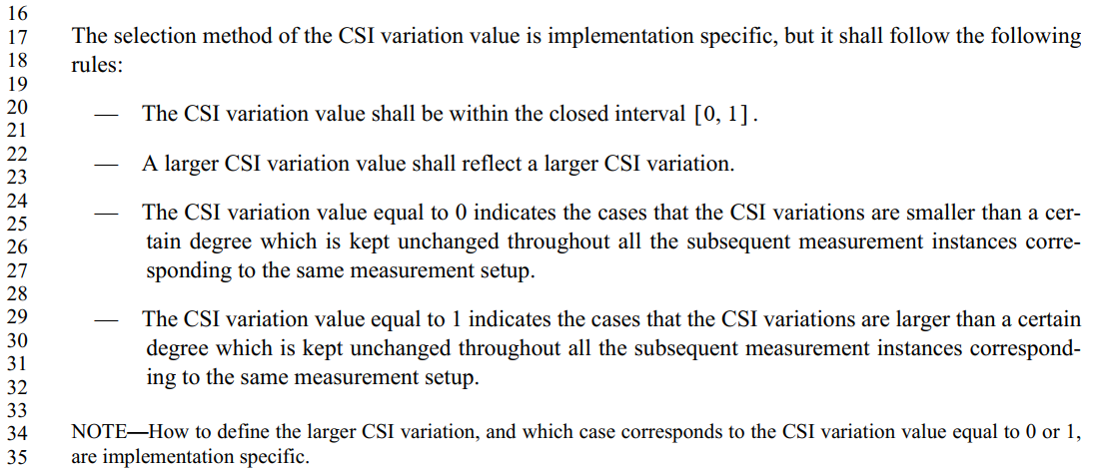

Instructions to the editor: please make the following changes to Page 146, Line 7 in the subclause 11.55.1.5.2.6.2 Threshold-based reporting phase in D1.1 as shown below:

The selection method of the CSI variation value at the sensing responder (#1984) is implementation specific, but the following apply:
— The CSI variation value shall be within the closed interval [0, 1].
— A larger CSI variation value shall reflect a larger CSI variation.
— A CSI variation value equal to 0 should indicate that the CSI variation is smaller than an implementation-dependent reference value. (#1737)
— A CSI variation value equal to 1 should indicate that the CSI variation is larger than a second implementation-dependent reference value. (#1738)
— The above reference values should be the same in all sensing measurement exchanges of a sensing measurement session for a given sensing responder.
NOTE—The CSI variation value depicts the amplitude and phase variations of the channel between a sensing initiator and a sensing responder. (#1783, #1982, #2039, #2040)

SP
Do you support resolutions to the following CIDs and incorporate the text changes into the latest TGbf draft: 1055, 1737, 1738, 1783, 1982, 1984, 1985, 2039, and 2040, in 11-23/1014r2.

Y/N/A

