IEEE P802.11
Wireless LANs
CID 4383
Date: 2023-06-12
Author(s):
Name | Affiliation | Address | Phone | email
Sigurd Schelstraete | MaxLinear |  |  | sschelstraete@maxlinear.com
Abstract
This document discusses and proposes a resolution for CID 4383

Introduction

4383 | 8.3.4.4 | 552 | 50 | P552L45 states "Table 8-4 (Vector descriptions) lists the minimum parameter values required by the MAC or PHY in each of the parameter vectors.". However, some of the parameters in Table 8-4 are PHY specific. For instance "GROUP_ID_MANAGEMENT", "PARTIAL_AID_LIST_GID00", ... apply to VHT only. Since Table 8-4 claims to be the minimal list, PHY specific parameters should be moved to the respective clauses. (Each clause already has a subclause "PHYCONFIG_VECTOR parameters") | Move PHY-specific parameters in Table 8-4 (specifically PHYCONFIG_VECTOR parameters) to the "PHYCONFIG_VECTOR parameters" clause of the appropriate PHY.

Discussion
Section 8.3.4.4 describes Table 8-4 as containing the set of parameter values for each of the parameter vectors TXVECTOR, RXVECTOR and PHYCONFIG_VECTOR. As highlighted below, these sets are described as “the minimum parameters required by the MAC or PHY” – presumably to be interpreted as the parameters that are common to all PHY and MAC variants.
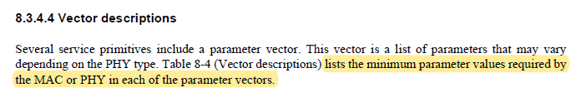

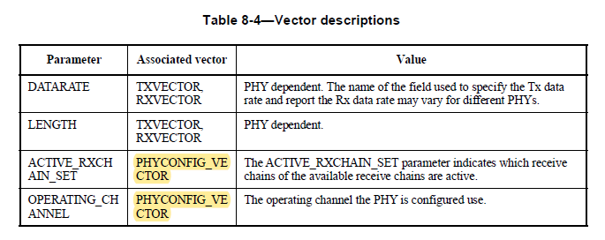

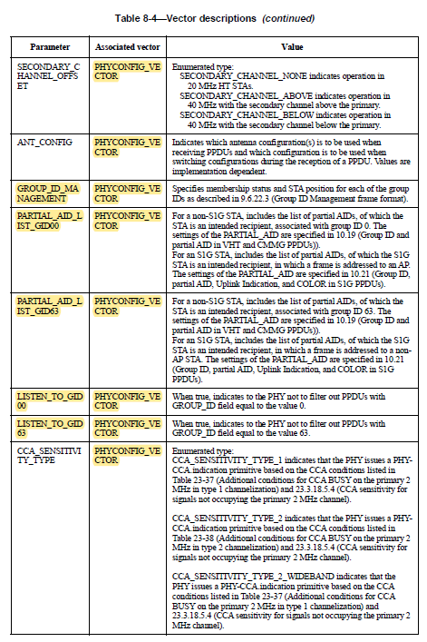

However, some of these parameters are not shared by all PHYs. Specifically, the use of GROUP_ID for MU-MIMO and related management messages is exclusive to VHT. HE (and EHT) no longer uses the GROUP_ID concept. All parameters that depend on the definition of GROUP_ID are only relevant for VHT and for PHYs directly derived from VHT (such as S1G and TVHT).

The list of affected parameters is:
- GROUP_ID_MANAGEMENT
- PARTIAL_AID_LIST_GID00
- PARTIAL_AID_LIST_GID63
- LISTEN_TO_GID00
- LISTEN_TO_GID63
If Table 8-4 indeed lists the minimum parameter values required by the MAC or PHY in each of the parameter vectors, strictly speaking the parameters listed above do not belong in Table 8-4.

In addition to Table 8-4, each PHY has its own description of PHYCONFIG_VECTOR parameters. These PHY-specific parameters exist in addition to the “common” ones defined in Table 8-4.

A typical “PHY-specific” PHYCONFIG_VECTOR looks as follows:
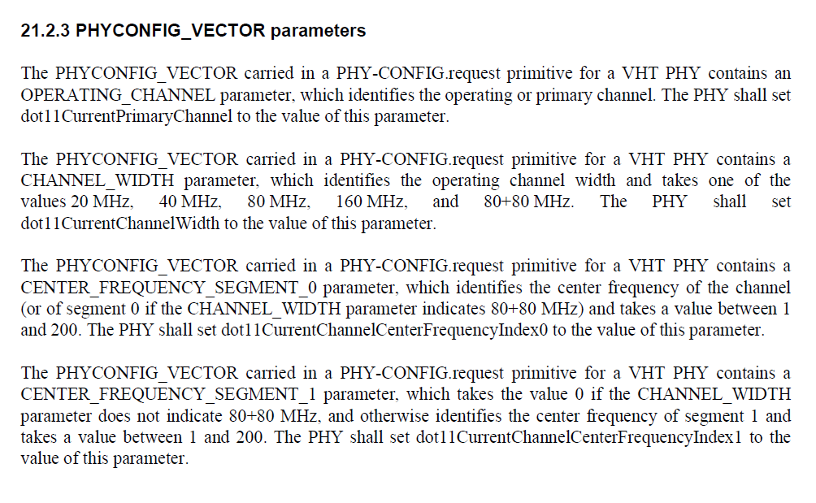

Proposal
For the PHYCONFIG_VECTOR parameters identified above, the proposal is to remove the parameters from Table 8-4 and add them to the PHYCONFIG_VECTOR clauses for those PHYs that use these parameters – i.e., VHT, S1G and TVHT.

The proposed changes are detailed below.

Make the following changes
Modify Table 8-4 as follows:

Parameter | Associated vector | Value
DATARATE | TXVECTOR, RXVECTOR | PHY dependent. The name of the field used to specify the Tx data rate and report the Rx data rate may vary for different PHYs.
LENGTH | TXVECTOR, RXVECTOR | PHY dependent.
ACTIVE_RXCHAIN_SET | PHYCONFIG_VECTOR | The ACTIVE_RXCHAIN_SET parameter indicates which receive chains of the available receive chains are active.
OPERATING_CHANNEL | PHYCONFIG_VECTOR | The operating channel the PHY is configured use.
SECONDARY_CHANNEL_OFFSET | PHYCONFIG_VECTOR | Enumerated type:  SECONDARY_CHANNEL_NONE indicates operation in 20 MHz HT STAs.  SECONDARY_CHANNEL_ABOVE indicates operation in 40 MHz with the secondary channel above the primary.  SECONDARY_CHANNEL_BELOW indicates operation in 40 MHz with the secondary channel below the primary.
ANT_CONFIG | PHYCONFIG_VECTOR | Indicates which antenna configuration(s) is to be used when receiving PPDUs and which configuration is to be used when switching configurations during the reception of a PPDU. Values are implementation dependent.
GROUP_ID_MANAGEMENT | PHYCONFIG_VECTOR | Specifies membership status and STA position for each of the groupIDs as described in 9.6.22.3 (Group ID Management frame format).
PARTIAL_AID_LIST_GID00 | PHYCONFIG_VECTOR | For a non-S1G STA, includes the list of partial AIDs, of which the STA is an intended recipient, associated with group ID 0. The settings of the PARTIAL_AID are specified in 10.19 (Group ID and partial AID in VHT and CMMG PPDUs)).  For an S1G STA, includes the list of partial AIDs, of which the S1G STA is an intended recipient, in which a frame is addressed to an AP. The settings of the PARTIAL_AID are specified in 10.21 (Group ID, partial AID, Uplink Indication, and COLOR in S1G PPDUs).
PARTIAL_AID_LIST_GID63 | PHYCONFIG_VECTOR | For a non-S1G STA, includes the list of partial AIDs, of which the STA is an intended recipient, associated with group ID 63. The settings of the PARTIAL_AID are specified in 10.19 (Group ID and partial AID in VHT and CMMG PPDUs)).  For an S1G STA, includes the list of partial AIDs, of which the S1G STA is an intended recipient, in which a frame is addressed to a non-AP STA. The settings of the PARTIAL_AID are specified in 10.21 (Group ID, partial AID, Uplink Indication, and COLOR in S1G PPDUs).
LISTEN_TO_GID00 | PHYCONFIG_VECTOR | When true, indicates to the PHY not to filter out PPDUs with GROUP_ID field equal to the value 0.
LISTEN_TO_GID63 | PHYCONFIG_VECTOR | When true, indicates to the PHY not to filter out PPDUs with GROUP_ID field equal to the value 63.
CCA_SENSITIVITY_TYPE | PHYCONFIG_VECTOR | Enumerated type:  CCA_SENSITIVITY_TYPE_1 indicates that the PHY issues a PHYCCA. indication primitive based on the CCA conditions listed in Table 23-37 (Additional conditions for CCA BUSY on the primary 2 MHz in type 1 channelization) and 23.3.18.5.4 (CCA sensitivity for signals not occupying the primary 2 MHz channel).  CCA_SENSITIVITY_TYPE_2 indicates that the PHY issues a PHYCCA. indication primitive based on the CCA conditions listed in Table 23-38 (Additional conditions for CCA BUSY on the primary 2 MHz in type 2 channelization) and 23.3.18.5.4 (CCA sensitivity for signals not occupying the primary 2 MHz channel).  CCA_SENSITIVITY_TYPE_2_WIDEBAND indicates that the PHY issues a PHY-CCA.indication primitive based on the CCA conditions listed in Table 23-37 (Additional conditions for CCA BUSY on the primary 2 MHz in type 1 channelization) and 23.3.18.5.4 (CCA sensitivity for signals not occupying the primary 2 MHz channel).

Add the following text to 21.2.3 (VHT PHYCONFIG_VECTOR parameters):

The PHYCONFIG_VECTOR carried in a PHY-CONFIG.request primitive for a VHT PHY contains a GROUP_ID_MANAGEMENT parameter, which specifies membership status and STA position for each of the group IDs as described in 9.6.22.3 (Group ID Management frame format).

The PHYCONFIG_VECTOR carried in a PHY-CONFIG.request primitive for a VHT PHY contains a PARTIAL_AID_LIST_GID00 parameter, which includes the list of partial AIDs, of which the STA is an intended recipient, associated with group ID 0. The settings of the PARTIAL_AID are specified in 10.19 (Group ID and partial AID in VHT and CMMG PPDUs)).

The PHYCONFIG_VECTOR carried in a PHY-CONFIG.request primitive for a VHT PHY contains a PARTIAL_AID_LIST_GID63 parameter, which includes the list of partial AIDs, of which the STA is an intended recipient, associated with group ID 63. The settings of the PARTIAL_AID are specified in 10.19 (Group ID and partial AID in VHT and CMMG PPDUs)).

The PHYCONFIG_VECTOR carried in a PHY-CONFIG.request primitive for a VHT PHY contains a LISTEN_TO_GID00 parameter, which, when true, indicates to the PHY not to filter out PPDUs with GROUP_ID field equal to the value 0.

The PHYCONFIG_VECTOR carried in a PHY-CONFIG.request primitive for a VHT PHY contains a LISTEN_TO_GID63 parameter, which, when true, indicates to the PHY not to filter out PPDUs with GROUP_ID field equal to the value 63.

Add the following text to 22.2.5 (TVHT PHYCONFIG_VECTOR parameters):

The PHYCONFIG_VECTOR carried in a PHY-CONFIG.request primitive for a TVHT PHY contains a GROUP_ID_MANAGEMENT parameter, which specifies membership status and STA position for each of the group IDs as described in 9.6.22.3 (Group ID Management frame format).

The PHYCONFIG_VECTOR carried in a PHY-CONFIG.request primitive for a TVHT PHY contains a PARTIAL_AID_LIST_GID00 parameter, which includes the list of partial AIDs, of which the STA is an intended recipient, associated with group ID 0. The settings of the PARTIAL_AID are specified in 10.19 (Group ID and partial AID in VHT and CMMG PPDUs)).

The PHYCONFIG_VECTOR carried in a PHY-CONFIG.request primitive for a TVHT PHY contains a PARTIAL_AID_LIST_GID63 parameter, which includes the list of partial AIDs, of which the STA is an intended recipient, associated with group ID 63. The settings of the PARTIAL_AID are specified in 10.19 (Group ID and partial AID in VHT and CMMG PPDUs)).

The PHYCONFIG_VECTOR carried in a PHY-CONFIG.request primitive for a TVHT PHY contains a LISTEN_TO_GID00 parameter, which, when true, indicates to the PHY not to filter out PPDUs with GROUP_ID field equal to the value 0.

The PHYCONFIG_VECTOR carried in a PHY-CONFIG.request primitive for a TVHT PHY contains a LISTEN_TO_GID63 parameter, which, when true, indicates to the PHY not to filter out PPDUs with GROUP_ID field equal to the value 63.

(NOTE: S1G does not currently have a section “PHYCONFIG_VECTOR parameters”)
Add new section 23.2.5:

23.2.5 PHYCONFIG_VECTOR parameters
The PHYCONFIG_VECTOR carried in a PHY-CONFIG.request primitive for a S1G PHY contains a GROUP_ID_MANAGEMENT parameter, which specifies membership status and STA position for each of the group IDs as described in 9.6.22.3 (Group ID Management frame format).

The PHYCONFIG_VECTOR carried in a PHY-CONFIG.request primitive for a S1G PHY contains a PARTIAL_AID_LIST_GID00 parameter, which includes the list of partial AIDs, of which the S1G STA is an intended recipient, in which a frame is addressed to an AP. The settings of the PARTIAL_AID are specified in 10.21 (Group ID, partial AID, Uplink Indication, and COLOR in S1G PPDUs).

The PHYCONFIG_VECTOR carried in a PHY-CONFIG.request primitive for a S1G PHY contains a PARTIAL_AID_LIST_GID63 parameter, which includes the list of partial AIDs, of which the S1G STA is an intended recipient, in which a frame is addressed to a non- AP STA. The settings of the PARTIAL_AID are specified in 10.21 (Group ID, partial AID, Uplink Indication, and COLOR in S1G PPDUs).

The PHYCONFIG_VECTOR carried in a PHY-CONFIG.request primitive for a S1G PHY contains a LISTEN_TO_GID00 parameter, which, when true, indicates to the PHY not to filter out PPDUs with GROUP_ID field equal to the value 0.

The PHYCONFIG_VECTOR carried in a PHY-CONFIG.request primitive for a S1G PHY contains a LISTEN_TO_GID63 parameter, which, when true, indicates to the PHY not to filter out PPDUs with GROUP_ID field equal to the value 63.

Additional changes
There appears to be an editorial mistake in Table 9-581.
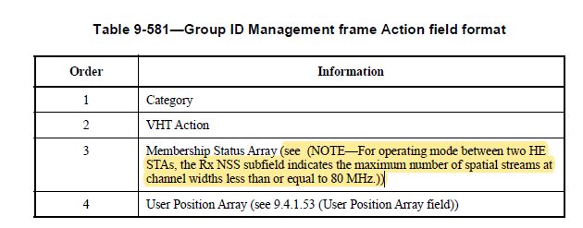
The hyperlink behind the highlighted text points to the correct location (9.4.1.52), but the text is unrelated and appears to be the result of a copy/paste mishap.

Proposed change:
Modify Table 9-581 as follows:

Table 9-581—Group ID Management frame Action field format
Order | Information
1 | Category
2 | VHT Action
3 | Membership Status Array (see (NOTE— For operating mode between two HE  STAs, the Rx NSS subfield indicates the maximum number of spatial streams at  channel widths less than or equal to 80 MHz.) 9.4.1.52)
4 | User Position Array (see 9.4.1.53 (User Position Array field))

