IEEE P802.11
Wireless LANs
Proposed IEEE 802.11 AIML TIG Technical Report Text for the CSI Compression Use Case
Date: 2023-06
Author(s):
Name | Affiliation | Address | Phone | Email
Zinan Lin | InterDigital | 111 West 33rd Street  New York, NY 10120  USA |  | Zinan.lin@gmail.com
Rui Yang | InterDigital
Xiaofei Wang | InterDigital Inc. |  | +1-607-592-2727 | Xiaofei.wang@interdigital.com
Liangxiao Xin | Zeku
Ziming He | Samsung Cambridge Solution Centre |  |  | Ziming.he@samsung.com
Eunsung Jeon | Samsung | 1-1, Samsungjeonja-ro, Hwaseong-si, Gyeonggi-do 18448 Korea | +82-10-2317-5808 | eunsung.jeon@samsung.com
Ziyang Guo | Huawei Technologies |  |  | guoziyang@huawei.com
Abstract
This document contains the proposed technical report text of the IEEE 802.11 AIML TIG, especially for the CSI compression use case.

Revision history:
r0: Copied from 802.11-23/0991r0, and add VQVAE based CSI compression in Section 2.1.2, model generalization requirement in Section 2.1.4, and standard impact discussion in Section 2.1.5. All the modifications are highlighted in yellow.

Table of Contents

- Introduction
  - Terminologies
  - Background information

- AIML Use cases for IEEE 802.11
Note: use cases potentially can be organized into different categories
Note: use cases potentially can identify KPIs

Use case 1: CSI feedback compression

Use case description (Index-based CSI Feedback)

In 802.11ax [1] and the draft of 802.11be [2], the AP initiates the sounding sequence by transmitting the NDPA frame followed by an NDP which is used for the generation of V matrix at the beamformee. Upon the receipt of the NDP from the beamformer, the beamformee applies a compression scheme (i.e., Givens rotations) on the V matrix and feeds back the angels in the beamforming report frame.

It is indicated in [3] that higher number of spatial streams has been an inevitable trend in WiFi for more than a decade. The preliminary results [3] [4] [5] show that MIMO with a large number transmitter antennas and a large number of spatial streams (e.g., 16 spatial streams) offer remarkable system performance gains on both SU-MIMO and MU-MIMO cases. Multi AP (MAP) may be one potential feature in the next 802.11 generation, e.g. UHR [6] - [9] . Large number of spatial streams combined with MAP feature may further increase the sounding feedback airtime overhead if coordination between APs (e.g., joint transmission/reception, coordinated beamforming) is applied. Large amount of overhead or prolonged sounding procedures may negatively impact the latency and limit the system performance. Therefore, there is a need to reduce the CSI overhead especially when the number of transmitter antennas goes higher or multiple APs perform joint or coordinated transmission.

Some studies (e.g., [10] [11] [12] [13] [19]) have shown that AI/ML can efficiently reduce the CSI feedback and improve the system throughput. For example, motivated by the nature that the CSI may fall into different clusters due to the channel similarity of nearby STAs, iFOR algorithm [10] applies the unsupervised learning, K-means, to the CSI compression to classify the angle vectors which are derived from V matrix. Simulation results show that for an 8x2 SU-MIMO, iFOR uses around 8% of the number of bits required by the existing feedback mechanism (802.11ax) and boosts the system throughput by up to 52%. In [11] , another unsupervised learning, Deep Neural Network Autoencoder (DNN-AE) is applied to CSI angle vectors and further compresses the derived angles (LB-SciFi) by leveraging the compression capability of DNNs. Experimental results show that LB-SciFi reduces the feedback overhead by 73% and increases the network throughput by 69% on average. In [19], a vector quantized variational autoencoder (VQVAE) is applied to compress the V matrix. Simulation results show that the implementation of VQVAE can significantly increase the system throughput by up to 223%, and reduce the feedback overhead by 97%. On the other hand, study in [20] has shown that AI/ML can significantly reduce the computational complexity of the CSI feedback without degrading the system throughput.

This use case proposes to apply AI/ML technique to CSI feedback schemes to reduce the CSI overhead with minimum loss of PER performance, or/and to reduce the computational complexity of the CSI feedback without loss of the system throughput.

Use case description (Dual CSI Feedback)

A beamforming is a technique of multiple antennas for steering a beam of an antenna array only to a corresponding STA. The channel state information (CSI) feedback should be preceded for a beamforming transmission. In order to reduce CSI feedback overhead, numerous CSI compression techniques have been developled so far. This can be categorized into two groups: one is based on the vector quantization using the codebook (CB) and the other is using the Givens rotation (GV).

The CB-based compression can reduce the feedback overhead significantly by feeding back an index of the predefined codebook, which has been used in 3GPP LTE systems. However, the selected codebook is not necessarily the optimal beamforming feedback matrix due to the limited cardinality of the codebook, showing poor PER performance compared with the GV-based compression. On the other hand, the GV-based compression has been adopted in WLAN systems such as 802.11n/ac/ax/be [1], [2]. The beamforming feedback matrix, which is a unitary matrix, is compressed by a series of GV matrices and each of the GV matrices is exprssed in the angular form. However, GV-based compression is known to incur huge feedback overhead, especially for the systems using a large bandwidth and/or a large number of antennas. This problem was addressed by the IEEE 802.11 standardization and a new designs for CSI compression may be needed to support higher number of spatial streams (e.g., 16 spatial streams) MIMO and/or wider bandwidth (e.g., 640 MHz).

The dual CSI compression combines CB and GV to maximize the advantages of both techniques. The basic idea is to decompose a large size CSI into a subband CSI and a subcarrier CSI, giving lower feedback rate for the slow-varying subband CSI using the CB while allocating higher feeback rate for the frequency-selective subcarrier CSI using the GV. Without loss of generality, a unitary matrix V can be expressed as the multiplication of two unitary matrices, i.e., V = V₁ V₂. Using this fact, a unitary matrix V is decomposed by multiplication of two unitary matrices, i.e., V₁ and V₂ as shown in Fig.1. Here, V₁ consists of K eigenvectors corresponding to the K largest eigenvalues which maximizes the channel capacity averaged over one subband. Since only K eigenvectors are chosen from the full dimensional matrix, the dimension reduced V₁ can reduce the overall feedback overhead. More detail algorithms for the dimension reduction are shown in [21], [22].

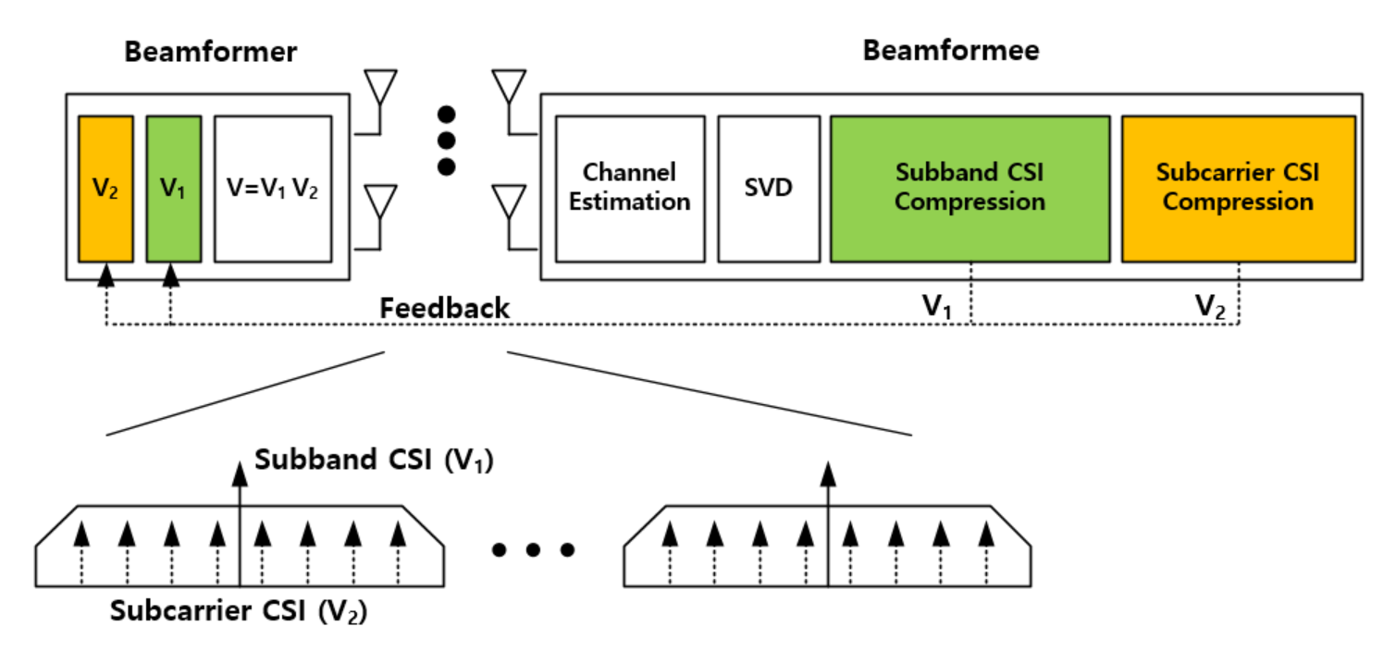
Figure 1. Illustration of WLAN systems with the dual CSI feedback.

Furthermore, in order to improve the reliability for subband CSI, the AIML technique based on the K-means algorithm is exploited in the codebook generation [23]. As shown in Fig.2, it finds a predefined number of centroids of data samples in an iterative manner. This process continues by updating the centroid in each cluster until the average Euclidean distance (ED) between the centroid and the data samples is minimized. The converged centroids are selected as the final codebook. The difference to the conventional K-means algorithm is that the proposed one finds a new centroid in terms of the minimum ED in each cluster, while the conventional K-means algorithm computes the mean of the data samples in each cluster to obtain the centroid. For fast convergence, the DFT-codebook is used for the initial centroid of the algorithm.

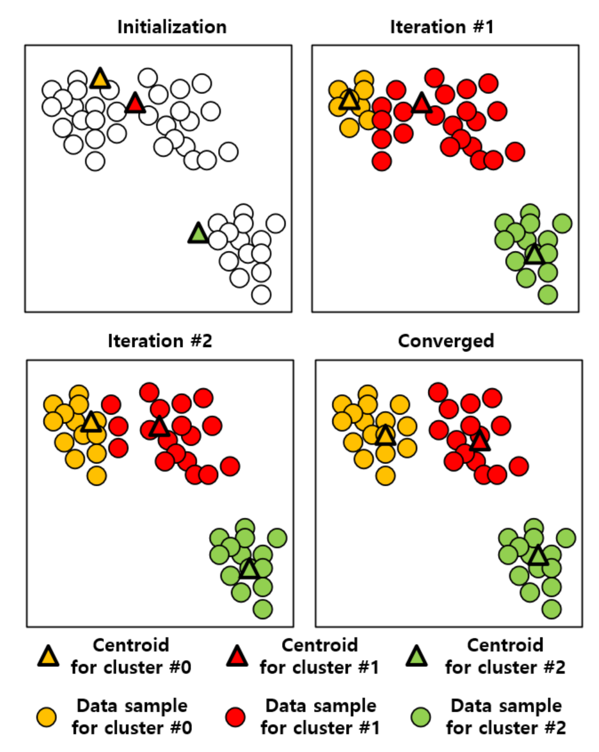
Figure 2. An example of the K-means algorithm iteration.

The simulation is performed extensively using an IEEE 802.11be link-level simulator. For a 8x2 SU-MIMO, the results shows that the AIML aided dual CSI compression can reduce the feedback overhead more than 50% compared with the conventional GV-based scheme. In addition, the throughput improvement from the reduced overhead is about 20% [18].

2.1.3. KPIs
KPIs considered in this use case are proposed as follows:
- Number of feedback bits per subcarrier group
- Achieved PER
  - Both SU-MIMO and MU-MIMO cases need to be considered
- Additional AIML overhead compared with compression saving
  - One example is the ratio between the number of additional bits required by AIML process (including data used for model training/inference [14] , the model parameters, the additional signaling) and the number of bits saved by the CSI feedback scheme. In this example, if the data used for model training that is performed by the AP fully relies on the legacy CSI report, then the additional AIML overhead used for model training/inference may be negligible.
  - Another aspect of the overhead is the additional storage required by AIML. For example, the K-means based schemes (e.g., [10], [17], [18]) require the codebook storage, and the autoencoder based schemes (e.g., [11], [19], [20]) require the storage of neural network models.
- Computation complexity/Latency:
  - Additional delay or computation is introduced by AIML processing.
Evaluation methodology needs to be established.

Requirements
- Backward compatibility with legacy 802.11
  - Support backward compatibility and coexistence with legacy 802.11 CSI report schemes
- Performance should follow the guidance below:
  - CSI airtime reduction: achieve airtime reduction of CSI feedback over 802.11be for a given Nr x Nc MIMO, where Nr is the number of rows in the compressed beamforming feedback matrix, Nc is the number of columns in the compressed beamforming feedback matrix.
  - Additional AIML overhead: minimize the additional overhead used for AIML process. Additional AIML overhead may include the data used for AIML model training/inference [14], the model parameters and additional signaling. The data used for AIML model training/inference [14] can reuse the legacy CSI report data.
  - Packet Error rate (PER): guarantee minimum SNR loss compared with 802.11be to achieve the target PER (e.g., 1% and/or 10%) at a given MCS in all types of channels [15] .
  - Computation complexity/Latency: minimize the additional computation complexity or latency required by AIML process
  - Additional storage for AIML: minimize the additional storage used for AIML process. Additional AIML storage may include the storage required for AIML model training data and the model parameters. For example, the STAs performing training may need storage for the training data or/and the model parameters, the STAs performing inference needs storage for the model parameters [17]. The model parameters could be the codebook used in the K-means based schemes (e.g., [10], [17], [18]), or the neural network coefficients in the autoencoder based schemes (e.g., [11], [20]), or both the codebook and neural network coefficients in the autoencoder based scheme in [19].
  - AIML model generalization: improve the generalization capability of AIML models. Generalization refers to the ability of an AIML model to be used in various scenarios, such as different bandwidths, number of transmit antennas, or number of spatial streams. For example, a single codebook can be used in different scenarios for K-means based CSI feedback schemes (e.g., [10], [17], [18]); a single neural network model (including both architecture and parameters) can be used in different scenarios for autoencoder based CSI feedback schemes (e.g., [11], [19], [20]).

Technical Feasibility Analysis

Standard Impart
The standard impact may include:
- Additional signaling (e.g., between AP and non-AP STAs) required by AIML process.
For example, a signaling scheme is introduced for VQVAE based CSI compression between AP and non-AP STA, as illustrated in Fig. 3. This scheme consists of two stages: training and model sharing, as well as inference. During training and model sharing stage, the AP receives beamforming reports from the STA, trains the AIML models, and sends the encoder (and codebook) to the STA (according to Use Case 3 Model Sharing). Then, during inference stage, STA utilizes the encoder (and codebook) to perform CSI compression.
AP
STA
NDP
V or$ϕ,ψ$
encoder and codebook
Train the encoder, codebook and decoder
NDP
Channel estimation, SVD
Encoder,
codebook
V
Index
Decoder,
codebook
$$\tilde{V}$$
beamforming
Data
AP
STA
Training and model sharing
Channel estimation, SVD, Givens rotation
Figure 3: Illustration of signaling between AP and non-AP STA for VQVAE based CSI compression

Technical feasibility

The following metrics will be studied:

- Backward compatibility: The STAs that supports AIML enabled CSI feedback compression shall support the legacy 802.11 CSI report scheme. This compatibility is expected to be supported since AIML capable STAs are expected to support legacy CSI report scheme.

- Data availability and accessibility: There are some STAs that are able to use the data to perform AIML model training and/or inference[14] . The data used for model training and/or inference shall be accessible for these STAs.
      - AP/edge computing based AIML: Data may be collected from non-AP STAs. The legacy 802.11 CSI reports may be used as training data.
      - Device computing based AIML: Data should be available at all STAs that support AIML process.

- Hardware/software capability: The STAs that use AIML to generate the AIML enabled CSI feedback compression shall have the hardware and software capability to support AIML algorithm(s).
      - AP/edge computing based AIML [16] : Extra data and model (e.g., model parameters) exchange may be required to support AP/edge computing based AIML. However, computation is not expected to be located at AP or edge computing resources for which higher computation capabilities is expected.
      - Device computing based AIML [16] : STAs that support AIML may be required to have extra computation capability. Extra data and model (e.g., model parameters) exchange between STAs may also be required to support device computing based AIML.

  - Use case 2
  - Use case N

- Summary
- References
- IEEE 802.11-REVme D2.0, October 2022
- IEEE P802.11be D2.2, October 2022
- 802.11-18/0818r3, 16 Spatial Stream Support in Next Generation WLAN
- 802.11-20/1877r1, 16 Spatial Stream Support
- 802.11-20/1535r66, Compendium of straw polls and potential changes to the Specification Framework Document Part 2
- 802.11-22/1515, A candidate feature: Multi-AP
- 802.11-22/1394, Virtual BSS And Multi AP Transmissions
- 802.11-22/1516 Considerations on Multi-AP Coordination
- 802.11-22/1512 Multi-AP Coordination for UHR
- M. Deshmukh, Z. Lin, H. Lou, M. Kamel, R. Yang, I. Güvenç, “Intelligent Feedback Overhead Reduction (iFOR) in Wi-Fi 7 and Beyond,” in Proceedings of 2022 VTC-Spring
- P. K. Sangdeh, H. Pirayesh, A. Mobiny, H. Zeng, “LB-SciFi: Online Learning-Based Channel Feedback for MU-MIMO in Wireless LANs, ” in Proceedings of 2020 IEEE 28th ICNP
- P. K. Sangdeh and H. Zeng, “DeepMux: Deep-Learning-Based Channel Sounding and Resource Allocation for IEEE 802.11ax,” IEEE Journal on Selected Areas in Communications, Vol. 39, No. 9, Aug. 2021
- S. Szott, K. Kosek-Szott, P. Gawłoicz, J. T. Gómez, B. Bellalta, A. Zubow, F. Dressler, “WiFi Meets ML: A Survey on Improving IEEE 802.11 Performance with Machine Learning,” IEEE Communication Surveys & Tutorials, Vol.24, Issue 3, Juen 2022
- 802.11-22/0723r1, Further discussion on next generation WLAN
- 802.11-19/0719r1, IEEE 802.11be Channel Model Document
- 802.11-22/1443r0, Wi-Fi Meets ML: Re-thinking Next-generation Wi-Fi Networks
- 802.11-23/0275r2, Improved AIML Enabled Index Based Beamforming CSI Feedback Schemes
- 802.11-23/0280r0, ML aided Dual CSI Feedback for Next Generation WLANs
- 802.11-23/0290r2, Study on AI CSI Compression
- 802.11-23/0755r0, AIML Assisted Complexity Reduction For Beamforming CSI Feedback Using Autoencoder
- 802.11-19/1018r0, Feedback Overhead Reduction
- 802.11-19/1115r1, Reduced Beamforming Feedback for 802.11be
- 802.11-22/950r2 Discussion on Interaction between AI/ML & Wireless LAN

