IEEE P802.11
Wireless LANs
Proposed resolutions for technical and editorial comments on D1.0
Date: 2022-06-09
Author(s):
Name | Affiliation | Address | Phone | email
Claudio da Silva | Meta Platforms, Inc |  |  | claudiodasilva@meta.com
Abstract
This document contains proposed resolutions for technical and editorial comments on D1.0 (LB272). The text used as reference is D1.0.

CIDs: 2224, 2061, 1422, 1557, 1618, 1620, 1493, 2261, 2262, 2264, 1977, 1262, 1794, 2023, 2191, 1239, 1335, 1780, 1781

CID | Clause | Page | Comment | Proposed change
2224 | 11.55.1.5.2.3 | 180.53 | The sentence lacks a verb. Suggest to revise the sentence: "Specifically, the time that the first data symbol of the PSDU of the frame was transmitted to the PHY plus the AP's delays through its local PHY from the MAC-PHY interface to its interface with the WM." | As in the comment

Proposed resolution: Revised

Discussion: Text referred to by the commenter is:
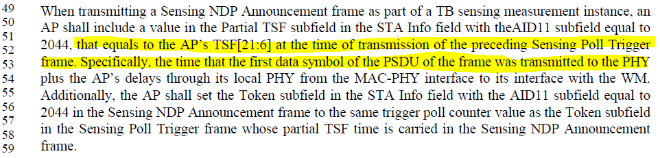

Modifications: TGbf Editor – Change 180.53-54 as follows:

Specifically, the time of transmission is defined as when that the first data symbol of the PSDU of the frame was transmitted to the PHY plus the AP’s delays through its local PHY from the MAC-PHY interface to its interface with the WM.

CID | Clause | Page | Comment | Proposed change
2061 | 9.3.1.19.1 | 63.48 | Special AID Info field with AID11 subfields equal to 2045 is used in both non-TB ranging measurement exchange and non-TB sensing measurement exchange. If used in ranging, it carries the I2R NDP Tx Power and R2I NDP Target RSSI; if used in sensing, it carries the SI2SR NDP Tx Power and SR2SI NDP Target RSSI. | Adding the descriptions for ranging and sensing, respectively.

Proposed resolution: Revised

Discussion: Text referred to by the commenter is:
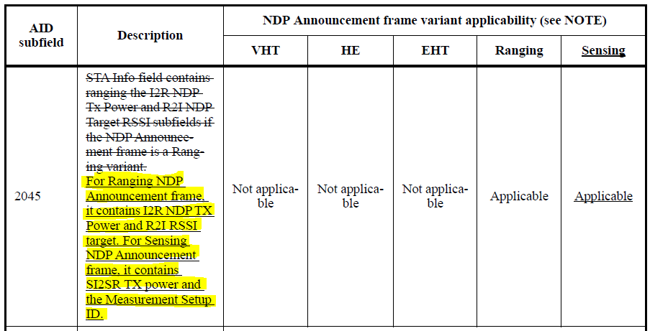

For reference,
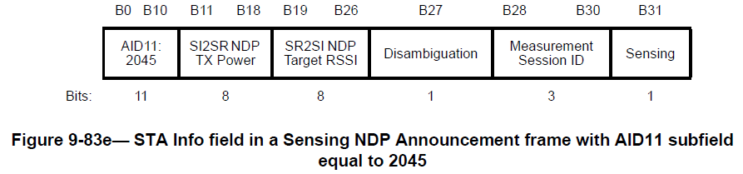

Note:

Modifications: TGbf Editor – Change the description of AID subfield equal to 2045 as follows:

For Ranging NDP Announcement frame, it contains I2R NDP TX Power and R2I RSSI target. For Sensing NDP Announcement frame, it contains the SI2SR TX power and the Measurement Setup ID, and it may contain the SR2SI NDP Target RSSI.

CID | Clause | Page | Comment | Proposed change
1422 | 9.4.1.75.4 | 96.47 | "Number of subcarriers" in Table 9-127k needs to be represented with Nsc in a consistent manner as in the rest of the subclause. | Change "Number of subcarriers" to "Number of subcarriers Nsc" on line 47 and 50

Proposed resolution: Accepted

Discussion: For reference,
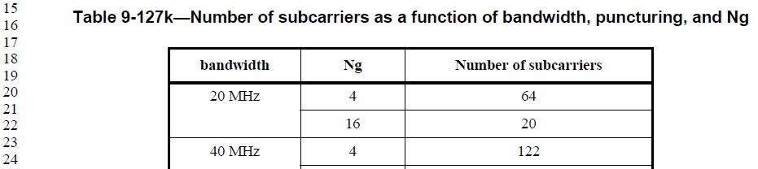

CID | Clause | Page | Comment | Proposed change
1557 | 9.6.7.49 | 146.33 | Should we use Element or element in Sensing Measurement Parameters element? | Unify the use of the word element when used for the Sensing Measurement Parameters element

Proposed resolution: Revised

Discussion: TGbf Editor – Rename “Sensing Measurement Parameters Element” in Figure 9-1139a with “Sensing Measurement Parameters”.

CID | Clause | Page | Comment | Proposed change
1618 | 11.55.1.5.2.5 | 182.54 | Upper case letters in the sentence are confusing, it looks like a subfield name! | Change the text to "- The number of spatial streams in the ... "
1620 | 11.55.1.5.2.4 | 181.46 | Upper case letters in the sentence are confusing, it looks like a subfield name! | Change the text to "- The number of spatial streams in the ... "

Proposed resolution: Revised

Discussion: Comments refer to:
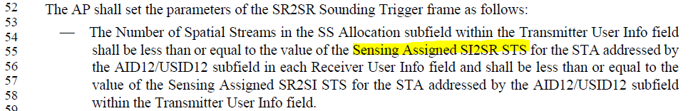

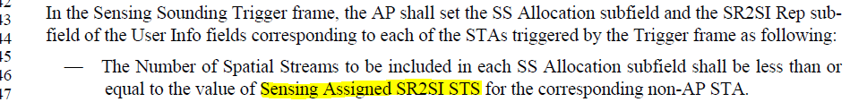

The “Assigned…” values/variables are defined in page 175 (D1.0):
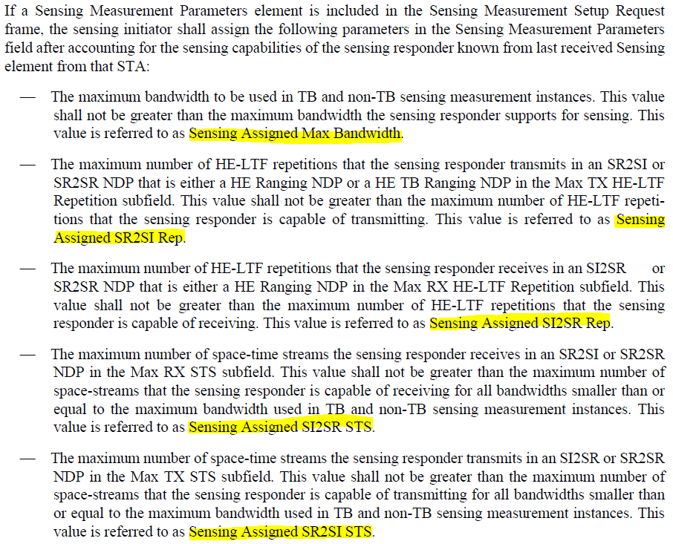

I propose to rename these 5 “assigned” variables as local variables (for example, aSensingSI2SRSTS), in such a way that, in page 175 (D1.0), we would have:

“…used in TB and non-TB sensing measurement instances. This value is referred to as Sensing Assigned SI2SR STS aSensingSI2SRSTS.”

and when this variable is referred to, such as in page 182.54 (D1.0), we would have:

The Number of Spatial Streams in the SS Allocation subfield within the Transmitter User Info field shall be less than or equal to the value of the Sensing Assigned SI2SR STS aSensingSI2SRSTS for the STA addressed by the AID12/USID12 subfield in each Receiver User Info field

Modifications: TGbf Editor – Please replace
- Sensing Assigned Max Bandwidth
- Sensing Assigned SR2SI Rep
- Sensing Assigned SI2SR Rep
- Sensing Assigned SI2SR STS
- Sensing Assigned SR2SI STS
with
- aSensingMaxBandwidth
- aSensingSR2SIRep
- aSensingSI2SRRep
- aSensingSI2SRSTS
- aSensingSR2SISTS
respectively, and make editorial changes necessary to support this change (as exemplified in the Discussions above).

CID | Clause | Page | Comment | Proposed change
1493 | 2 | 1 | The reference documents on page 1 should be based on IEEEP802.11REVme D2.1 and IEEE 802.11be D3.0 (the latest drafts) | As commented
2261 |  |  | The base line needs to be updated to the latest drafts of 802.11-REVme and 802.11be. | Update the baselines
2262 | 12.5.3.4.4 | 221.30 | This clause has changed in the 802.11REVme D2.0 - this clause seems to be from the 802.11az amendment, but .11az is not listed as an amendment. Please correct and align the base line text. | Fix the base line.
2264 | 12.5.5.4.4 | 221.49 | This clause has changed in the 802.11REVme D2.0 - this clause seems to be from the 802.11az amendment, but .11az is not listed as an amendment. Please correct and align the base line text. | Fix the base line.

Proposed resolution: Revised

Discussion: IEEE 802.11 TGme expects to roll in the 802.11az amendment after its initial SA ballot. By the time of its publication, the 802.11bf baseline will be 802.11-2025 as amended by the 802.11be amendment, as it is currently shown in the 802.11bf amendment.

Modifications: TGbf Editor – Update the baseline text to Draft P802.11REVme D3.0 and Draft P802.11be D3.2.

CID | Clause | Page | Comment | Proposed change
1977 | 11.55 | 172.50 | The so called sensing measurement setup seems to be simple request/response exchange the establishes operational parameters for sensing measurement instances. If so, state that right up front. It would greatly help in the undestanding of the procedure. Also, it might be better to not call it a "setup", but rather something closer to its real purpose -- the establishement of operational parameters for sensing measurement instances. | Change the name to "Sensing measurement parameter exchange". As the intorductory paragraph say "The sensing measurement parameter exchange establishes operational parameters for sensing measurement intances. The sensing measurement parameter exchange begins with the sensing initiator sending a Sensing Measurement Setup Request frame and ends when the sensing responder sends a Sensing Measurement Setup Response frame or a timeout occurs."

Proposed resolution: Revised

Modifications: TGbf Editor – Change the first paragraph of 11.55.1.4 as follows:

11.55.1.4 Sensing measurement session
Sensing measurement session is an agreement between a sensing initiator and a sensing responder on operational parameters associated with sensing measurement exchanges of a given Measurement Session ID. The process of establishing a sensing measurement session begins with the sensing initiator sending a Sensing Measurement Request frame and ends when the sensing responder sends a Sensing Measurement Response frame.

CID | Page | Comment | Proposed change | Proposed resolution
1262 | 5.67 | Some subclauses within 11.55 are written in terms of MLME primitives. Others are written in terms of (MAC) frames. | Seek guidance from IEEE802 Editor on whther Clause 11 subclauses shall be written in terms of MLME primitives. If yes, several 11.55 subclauses will have to be re-written. If not, make text to be consistent. | REJECTED  The commenter has withdrawn the comment.

CID | Page | Comment | Proposed change | Proposed resolution
1794 | 85.14 | The assignment of the "<Last assigned + 1>" number is editorial | Look at your baseline and choose a number | REJECTED  The draft follows the same format/notation adopted by multiple 802.11 amendment drafts. The assignment of the "<Last assigned + 1>" number is expected to be completed as part of the MDR process. The MDR for the P802.11bf draft is expected to be conducted after the publication of D3.0.

CID | Page | Comment | Proposed change | Proposed resolution
2023 | 145.14 | Why "(Protected)" in front of "Sensing Measurement Setup Request frame format". This makes the name different from the entry in Table 9-447. This is not done for similar existing frames. The fact that these frames are protected is mentioned later (9.6.10). | Remove the word "(Protected)". Similarly for 9.6.7.51-9.6.7.56 | REJECTED  “(Protected)” was included in the title of certain public action frames to indicate, as the commenter currently pointed out, that such frames can be protected. While we agree that such convention is not used in the baseline text, the group believes that it doesn’t violate the style guide and it improves the draft’s writing.

CID | Page | Comment | Proposed change | Proposed resolution
2191 | 170.05 | TGbf needs to specify what it means that a STA supports WLAN sensing. For example, a STA that supports WLAN sensing shall support the role of a sensing initaitor/responder. | As in the comment | REVISED  It is defined in 11.55.1.2 (D1.1) that “A STA with dot11SensingImplemented equal to true is referred to as a sensing STA and supports the sensing procedure both as a sensing initiator and as a sensing responder”.  Optional sensing capabilities are defined in 9.4.2.320 (Sensing Capabilities element). Further information on capabilities can be found in Annex B.  No further changes to the draft text are necessary.  Editor – Change the second sentence of 11.55.1.2 as follows:  A STA with dot11SensingImplemented equal to true is referred to as a sensing STA and supports shall support the sensing procedure both as a sensing initiator and as a sensing responder

CID | Clause | Page | Comment | Proposed change
1239 |  | 0.00 | There are many capabilities not covered by the MIB attributes | Provide MIB attributes for the not-covered capabilities
1335 | C.3 | 0.00 | The entries of dot11WLANSensingImplemented, dot11SBPImplemend, dot11DMGSensingMsmtImplemented, and dot11DMGSBPImplemented are shown but there are no definitions for them. | Define those MIB attributes.

Proposed resolution: Revised

Modifications: TGbf Editor – Insert the following tribute definitions into Annex C:

dot11SensingImplemented OBJECT-TYPE
SYNTAX TruthValue
MAX-ACCESS read-only
STATUS current
DESCRIPTION
"This is a capability variable. Its value is determined by device capabilities.

This attribute, when true, indicates that the STA is a sensing STA. This attribute, when false, indicates the STA is not a sensing STA. The default value of this attribute is false."
DEFVAL { false }
::= { dot11SENSStationConfigEntry 1 }

dot11SBPImplemented OBJECT-TYPE
SYNTAX TruthValue
MAX-ACCESS read-only
STATUS current
DESCRIPTION
"This is a capability variable. Its value is determined by device capabilities.

This attribute, when true, indicates that the STA supports SBP. This attribute, when false, indicates the STA does not support SBP. The default value of this attribute is false."
DEFVAL { false }
::= { dot11SENSStationConfigEntry 2 }

dot11DMGSensingMsmtImplemented OBJECT-TYPE
SYNTAX TruthValue
MAX-ACCESS read-only
STATUS current
DESCRIPTION
"This is a capability variable. Its value is determined by device capabilities.

This attribute, when true, indicates that the STA supports DMG sensing. This attribute, when false, indicates the STA does not support DMG sensing. The default value of this attribute is false."
DEFVAL { false }
::= { dot11SENSStationConfigEntry 3 }
dot11DMGSBPImplemented OBJECT-TYPE
SYNTAX TruthValue
MAX-ACCESS read-only
STATUS current
DESCRIPTION
"This is a capability variable. Its value is determined by device capabilities.

This attribute, when true, indicates that the STA supports DMG SBP. This attribute, when false, indicates the STA does not support DMG SBP. The default value of this attribute is false."
DEFVAL { false }
::= { dot11SENSStationConfigEntry 4 }

CID | Clause | Page | Comment | Proposed change
1780 | C.3 | 243.8 | The MIB attributes in the Dot11WirelessMgmtOptionsEntry sequence need to be defined objects. Define the attibutes listed within this SEQUENCE. | Define the attibutes listed within this SEQUENCE.
1781 | C.3 | 243.8 | The attrbites added to the Dot11WirelessMgmtOptionsEntry are probably meant to be in a compliance group. Define (or add to an existing) compliance group that references these new attributes of Dot11WirelessMgmtOptionsEntry. | Define (or add to an existing) compliance group that references these new attributes of Dot11WirelessMgmtOptionsEntry.

Proposed resolution: Rejected. 802.11 TGbf reviewed the comment and agreed that a submission was required with more detailed or updated editing instructions, or such that could reach consensus in discussion. No updated submission has been received and reviewed by 802.11 TGbf.

