IEEE P802.11
Wireless LANs
LB272 comments measurement setup comments resolution part 3
Date: 2023.06.xx
Author(s):
Name | Company | Address | Phone | email
Rui Du | Huawei Technologies |  |  | Ray.du@huawei.com
Claudio da Silva | Meta Platforms |  |  | claudiodasilva@meta.com
Abstract
This submission contains the proposed comment resolutions for the CIDs 2101, 1102, 1037, 2104, 1649 and 2105.

R0: initial document
R1: based on the discussion in ad-hoc meeting, the CR document is revised with some ideas borrowed from Table 9-319—Status Indication subfield values in REVme_D3.0.

CID 2101, 1102, 1037, 2104 and 1649

CID | Page.  Line | Clause Number | Comment | Proposed Change | Resolution
2101 | 173.10 | 11.55.1.4 | When the Status Code in Sensing Measurement Setup Response frame is REQUEST_DECLINED, is the sensing initiator allowed to try again immediately? When the sensing initiator try again, what parameters should be used ?  If the Status Code is REJECTED_WITH_SUGGESTED_CHANGES, the sensing initiator may try again with suggested parameters. When should the sensing initiator come back and try again (with suggested parameters) ? | Sensing Comeback Info field (used in 11bf to guide the behaviors of USTA's transmission of Sensing Measurement Query frame) can be reused to guide the behaviors of sensing initiator after its request has been declined or rejected. Commenter will provide a contribution. | Revised.  TGbf Editor make changes specified in 0976r1  (https://mentor.ieee.org/802.11/dcn/23/11-23-0976-01-00bf-lb272-comments-measurement-setup-comments-resolution-part-3.docx).
1102 | 173.25 | 11.55.1.4 | "... the measurement setup of the granted Measurement Setup ID shall not be resumed..." Meaning of "shall not be resumed" is unclear (for example, does this imply that the sensing initiator shall not send any other SM Setup Request frames to the intended sensing responder?). | Define a timer/"comeback time" that the recipient of an unsuccessful SM Setup Response may send another SM Setup Request. | Revised.  TGbf Editor make changes specified in 0976r1  (https://mentor.ieee.org/802.11/dcn/23/11-23-0976-01-00bf-lb272-comments-measurement-setup-comments-resolution-part-3.docx).
1037 | 173.26 | 11.55.1.4 | What happens if a Sensing Measurement Setup Response frame is received with a status code EJECTED_WITH_SUGGESTED_CHANGES? The current text in lin 26 page 173 says it is considered as unsuccessful for the measurement setup of the granted Measurement Setup ID. Then what's the difference between the status code EJECTED_WITH_SUGGESTED_CHANGES and REQUEST_DECLINED? | Suggest adding text to sepcify what happens if a Sensing Measurement Setup Response frame is received with a status code EJECTED_WITH_SUGGESTED_CHANGES. | Revised.  TGbf Editor make changes specified in 0976r1  (https://mentor.ieee.org/802.11/dcn/23/11-23-0976-01-00bf-lb272-comments-measurement-setup-comments-resolution-part-3.docx).
2104 | 146.01 | 9.6.7.49 | What is the reference time point for the USTA to calculate the actual USTA comeback after time and USTA comeback before time? Is that the starting or finishing point when USTA receives the Sensing Measurement Setup Request frame (with Comeback subfield equals to 1)? | Add description about the reference time point USTA used to caculate the USTA comeback after time and USTA comeback before time. | Rejected.  ‘Both sides start a corresponding unassociated STA comeback timer when the exchange of the Sensing Measurement Setup Query frame and the Sensing Measurement Setup Request frame with the Comeback subfield of the Sensing Comeback Info field set to 1 completes.’ The above sentence in P173L41 provides a general description of the reference time point to calculate comeback after time and comeback before time.
1649 | 146.52 | 9.6.7.50 | Dialog Token in the Sensing Measurement Setup Response frame can be used to identify the sensing measurement setup transaction. As a result, it is unnecessary to include the Measurement Setup ID field | remove the Measurement Setup ID field from the Sensing Measurement Setup Response frame. | Revised.  MSID shall be included in the Sensing Measurement Response frame, and normative text shall be added.  TGbf Editor make changes specified in 0976r2  (https://mentor.ieee.org/802.11/dcn/23/11-23-0976-02-00bf-lb272-comments-measurement-setup-comments-resolution-part-3.docx).

Discussion 1

These CIDs mainly focus on the behaviour of the sensing initiator after it received a Sensing Measurement Response frame with a Status Code other than SUCCESS. The sensing responder may reject or decline the Sensing Measurement Request due to different reasons, e.g. inappropriate parameters, out of resouces (i.e. reach the maximum measurement sessions it can support), et al.
Based on some relevant discussions, sensing initiator shall be allowed to send the Sensing Measurement Request frame again after its request has been rejected or declined. The rejection or decline only means the station (sensing responder) dose not want to be a sensing responder at the moment, and the station may accept to be a sensing responder in the future time.
Sensing application should have different priorites at different times, e.g. once set up, fall detection shall has higher priority than some other applications such as present detection when resource is limited. Due to limited resource of the sensing device, sensing responder should be allowed to terminate some low priority applications (sensing sessions) and allocate resource for other high priority applications (sensing sessions). In this case, the sensing responder need time to terminate some of the existing sensing sessions and finishing relevant report. So, it will be efficient if the sensing responder could provide a time for sensing sensing initiator to transmit Sensing Measurement Request frame again. And the sensing responder be ready (i.e. terminate some measurement sessions and allocate resources) for the new session(s) by the time.

Based on all the possibilities, a few cases have been summarized as follows.

- Case 1: The Status Code in Sensing Measurement Response frame equals to REJECTED_WITH_SUGGESTED_CHANGES.

The sensing responder wants the sensing initiator comeback to try again (by sending Sensing Measurement Request frame). Sensing initiator is expected to comeback to send a Sensing Measurement Request frame again with suggested parameters. Since the Sensing initiator is expected to comeback, it will be good to reuse the Sensing Comeback Info field to also provide a suggested comeback time for the sensing intiator. If the sensing intiator plans to send the Sensing Measurement Request frame again, it shall send the Sensing Measurement Request frame with the suggested parameters within the suggested comeback time.

- Case 2: The Status Code in Sensing Measurement Response frame equals to REQUEST_DECLINED. There are 2 subcases in case 2.

Subcase 2.1 Sensing responder cannot accept more sensing measurement session (e.g. reach the maximum measurement sessions it can support) but want the sensing initiator comeback to try later. Sensing Comeback Info field can be reused to contain the come back time information. The sensing initiator may try again (i.e. transmitting Sensing Measurement Request frame) with same or different sensing parameters by itself.

Subcase 2.2 Sensing responder cannot accept more sensing measurement session (e.g. reach the maximum measurement sessions it can support) and does not want the sensing initiator comeback to try later. As discussed above on, even the request has been declined. Sensing initator shall be allowed to try again some time later. In this case, a timer shall be set.

Discussion end

Discussion 2

MSID field Sensing Measurement Response frame is redundant. Sensing responder could use dialog token to identify the pairwise Sensing Measurement Request and Sensing Measurement Response exchange. Upon receiving a Sensing Measurement Response frame, sensing initiator could understand the reaction of the sensing responder to the Sensing Measurement Request frame by reading the Dialog Token field in the Sensing Measurement Response frame.

Discussion end

Instructions to the editor: please make the following changes to Figure 9-1139b – Sensing Comeback Info field format and corresponding paragraphs from P107L18 to P107L39 in the subclause 9.6.7.49 (Protected) Sensing Measurement Request frame format in D1.1 as shown below:

Figure 9-1139b – Sensing Comeback info field format

The Comeback subfield is set to 1 in a (Protected) Sensing Measurement Request frame addressed to an unassociated non-AP STA by an AP to indicate that the AP is not currently able to perform a new sensing measurement session with this non-AP STA. Otherwise, the Comeback subfield is set to 0.

The STA Comeback After Exponent subfield contains an unsigned integer. It is encoded according to the conventions in 9.2.2 (Conventions). The STA Comeback After value is equal to $2^{(Comeback After Exponent + 4)}$ms (giving it a value from 16 ms to 2048 ms). It is a time after which the unassociated non-AP STA is expected to transmit a Sensing Measurement Query frame to the AP (see 11.55.1.4 (Sensing measurement session)). The STA Comeback After Exponent subfield is reserved if the Comeback subfield is set to 0.

The STA Comeback Before Exponent subfield contains an unsigned integer. It is encoded according to the conventions in 9.2.2 (Conventions). The STA Comeback Before value is equal to $2^{(Comeback Before Exponent + 12)}$ ms (giving it a value from 4096 ms to 65536 ms). It is a time before which the unassociated non-AP STA is expected to transmit a Sensing Measurement Query frame to the AP (see 11.55.1.4 (Sensing measurement session)). The STA Comeback Before Exponent subfield is reserved if the Comeback subfield is set to 0.

Instructions to the editor: please make the following changes to Figure 9-1139d in the subclause 9.6.7.50 (Protected) Sensing Measurement Response frame format in D1.1 as shown below:

Figure 9-1139d – (Protected) Sensing Measurement Response frame Action field format

Instructions to the editor: please make the following changes to paragraphs from P108L26 to P108L35 in the subclause 9.6.7.50 (Protected) Sensing Measurement Response frame format in D1.1 as shown below:

The Dialog Token field is defined in 9.4.1.12 (Dialog Token field) and set to the value in the corresponding Sensing Measurement Request frame.

The Status Code field is defined in 9.4.1.9 (Status Code field). The status codes SUCCESS, REQUEST_DECLINED, and REJECTED_WITH_SUGGESTED_CHANGES are used in the frame.

The Sensing Comback Info field is reserved if the Status Code is set to SUCCESS and it is present if the Status Code is set to REJECTED_WITH_SUGGESTED_CHANGES or REQUEST_DECLINED. The Sensing Comeback Info field is shown in Figure 9-1139b (Sensing Comeback Info field format).

If the Status Code is set to REJECTED_WITH_SUGGESTED_CHANGES in a (Protected) Sensing Measurement Response frame addressed to a sensing initiator by a sensing responder, the Comeback field shall be set to 1 to indicate that the sensing responder wants the sensing initiator to initiate a new sensing measurement session with suggested parameters.

If the Status Code is set to REQUEST_DECLINED in a (Protected) Sensing Measurement Response frame addressed to a sensing initiator by a sensing responder, the Comeback field is set to 1 to indicate that the sensing responde is not currently able to participate a new sensing measurement session with this sensing initiator. Otherwise, the Comeback field is set to 0.

The STA Comeback After Exponent subfield contains an unsigned integer. It is encoded according to the conventions in 9.2.2 (Conventions). The STA Comeback After value is equal to $2^{(Comeback After Exponent + 4)}$ms (giving it a value from 16 ms to 2048 ms). It is a time after which the sensing initiator is expected to transmit a Sensing Measurement Request frame to the sensing responder upon it finish the reception of a Sensing Measurement Request frame with Comeback subfield set to 1. The STA Comeback After Exponent subfield is reserved if the Comeback subfield is set to 0.

The STA Comeback Before Exponent subfield contains an unsigned integer. It is encoded according to the conventions in 9.2.2 (Conventions). The STA Comeback Before value is equal to $2^{(Comeback Before Exponent + 12)}$ ms (giving it a value from 4096 ms to 65536 ms). It is a time before which the sensing initiator is expected to transmit a Sensing Measurement Request frame to the sensing responder upon it finish the reception of a Sensing Measurement Request frame with Comeback subfield set to 1. The STA Comeback Before Exponent subfield is reserved if the Comeback subfield is set to 0.

Instructions to the editor: please make the following changes to P134L12 in the subclause 11.55.1.4 Sensing measurement session in D1.1 as shown below:

The sensing responder should transmit the Sensing Measurement Response frame within a Sensing Frame Exchange Timeout (see Table 11-29a (Sensing timeout values)) in response to the Sensing Measurement Request frame. If no Sensing Measurement Response frame is received within this time period, or if a Sensing Measurement Response frame is received with a status code other than SUCCESS, the measurement session of the granted Measurement Session ID shall not be resumed and is considered unsuccessful. Opon reception of a Sensing Measurement Response frame with a Status Code other than SUCCESS, if the sensing initiator wants to transmit a Sensing Measurement Request frame to the same sensing responder, it shall transmit the frame according to the following rules:
- If the Status Code and the Comeback field within the received Sensing Measurement Response frame equal to REQUEST_DECLINED and 1, respectively, the sensing initiator shall transmit the Sensing Measurement Request frame to the same sensing responder after the time specified as STA Comeback After Value (see Table 11-29a (Sensing timeout values)) and before the time specified as STA Comeback Before Value (see Table 11-29a (Sensing timeout values)).

- If the Status Code and the Comeback field within the received Sensing Measurement Response frame are REQUEST_DECLINED and 0, respectively, the sensing initator shall not transmit the Sensing Measurement Request frame to the same sensing responder within 65536 ms.

- If the Status Code and the Comeback field within the received Sensing Measurement Response frame are REJECTED_WITH_SUGGESTED_CHANGES and 1, respectively, the sensing initiator shall transmit the Sensing Measurement Request frame with suggested sensing parameters to the same sensing responder after the time specified as STA Comeback After Value (see Table 11-29a (Sensing timeout values)) and before the time specified as STA Comeback Before Value (see Table 11-29a (Sensing timeout values)).

Discussion 3

Based on the discussions during the Adhoc meeting on July 8th at Lund. The group suggests to borrow some ideas from 11az to resolve CID 2101, 1102 and 1037. REVme_D3.0 is used as the reference for all the following discussions.

In Subclause 9.4.2.166 Fine Timing Measurement Parameters element, the format of Fine Timing Measurement Parameters element and Fine Timing Measurement Parameters field are shown as follows.

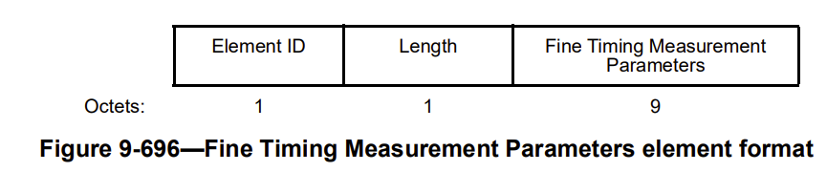

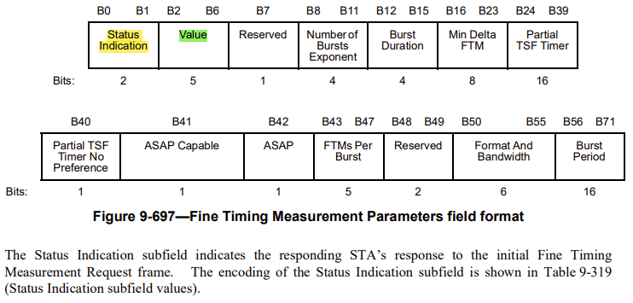
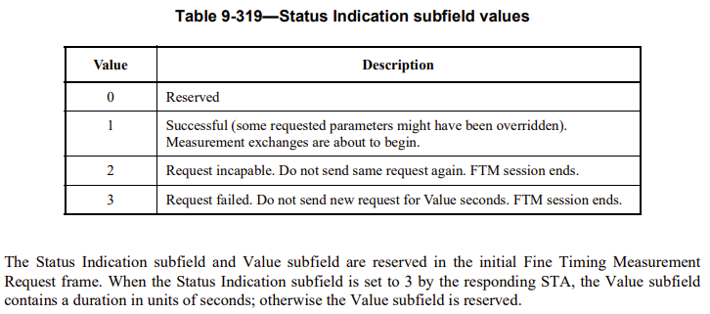
Within the Status Indication subfield in Table 9-319.
Value 1 indicates success. This is something like the Status Code ‘SUCCESS’. Some of the parameters may be overridden.
Value 2 indicates request incapable, do not send same request again, kind of REJECTED_WITH_SUGGESTED_CHANGES.
Value 3 indicates request failed, do not send new request for ceratin time, kind of REQUEST_DECLINED.
In Page 2585 under subclause 11.21.6.3.2 Negotiation for EDCA based ranging measurement exchange, there are some normative text about the Status Indication other than success.
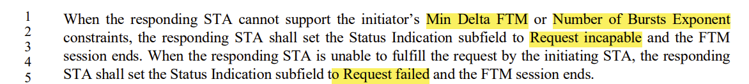

Value 3 is something like the Status Code ‘REQUEST_DECLINED’ in 11bf, so we can just focus on the function of Value 3. Compared with the current Sensing Measurement Response, one more thing is needed. When Status Code equals to REQUEST_DECLINED, Sensing Measurement Response frame shall carry a time duration to indicate the sensing intiator do not send a new request.

When Status Code equals to REQUEST_DECLINED, the Decline Duration field within Decline Duration Indication field is used to indicate the time within which the sensing intiator is requested not to send a new Sensing Measurement Request frame.

Discussion 2 end

Instructions to the editor: please make the following changes to Figure 9-1139d—(Protected) Sensing Measurement Response frame Action field format in 11bf D1.2:

Instructions to the editor: please make the following changes to paragraph from P108L8 to P108L10 and insert the following Table to P108L11 in the subclause 9.6.7.50 (Protected) Sensing Measurement Response frame format in 11bf D1.2:

The Status Code field is defined in 9.4.1.9 (Status Code field). The status codes SUCCESS, REQUEST_DECLINED, and REJECTED_WITH_SUGGESTED_CHANGES are used in the frame.

If the Status Code is set to 0 (SUCCESS), it means the sensing measurement session setup is success.

If the Status Code is set to 37 (REQEUST_DECLINED), it means the request has been declined and do not send a new Sensing Measurement Request frame for Decline Duration seconds. The sensing session setup is unsuccessful.

If the Status Code is seet to 39 (REJECTED_WITH_SUGGESTED_CHANGES), it means the request has been rejected and suggested parameters are provided. The sensing session setup is unsuccessful.

Decline Duration Indication field indicates a time duration within which sensing initiator is requested not to send a new Sensing Measurment Request frame after its request has been declined. The Decline Duration Indication field is present in the Sensing Measurement Reponse frame with Status Code set to REQEUST_DECLINED. This field is reserved otherwise. The Decline Duration Indication field is defined in Figure 9-1139e (Decline Duration Indication field format). The Decline Duration field contains a duration in units of seconds.

Figure 9-1139e— Decline Duration Indication field format

Instructions to the editor: please insert the following paragraph into P136L50 in the subclause 11.55.1.4 Sensing measurement session in 11bf D1.2 as shown below:

Upon reception of a Sensing Measurement Response frame with the Status Code equals to REQUEST_DECLINED, the sensing initiator should not transmit a new Sensing Measurement Request frame within the time Decline Duraiton field indicates.

Instructions to the editor: please make the following changes to P133L54 to P133L60 in the subclause 11.55.1.4 Sensing measurement session in 11bf D1.2 as shown below:

The sensing responder should transmit the Sensing Measurement Response frame within aSensingFrameExchangeExpiry (see Table 11-29a (Sensing procedure timing-related parameters)) timeout period in response to the Sensing Measurement Request frame. The sensing responder shall set the Measurement Session ID field in the Sensing Measurement Response frame to the value set in this field in the Sensing Measurement Request frame sent by the sensing initiator (#1649). If the sensing initiator does not receive the Sensing Measurement Response frame within this timeout period, or if a Sensing Measurement Response frame is received with a status code other than SUCCESS, the sensing measurement session shall be considered unsuccessful (#1103, *0718).

CID 2105

CID | Page.  Line | Clause Number | Comment | Proposed Change | Resolution
2105 | 173.10 | 11.55.1.4 | When AP (sensing responder) rejects USTA(sensing initiator)'s Sensing Measurement Setup Request and the Status Code in Sensing Measurement Setup Response frame is REJECTED_WITH_SUGGESTED_CHANGES, AP will provide suggested sensing parameters for the USTA. Since AP doesn't know USTA's sensing capabilities, it is better to add some rules to ensure the suggested sensing parameters can be compatible with USTA's sensing capabilities. | As in comment. | Rejected.  AP suggests sensing parameters based on its own sensing capabilities. AP does not necessarily to know USTA’s sensing capabilities before the suggestion.

SP
Do you support resolutions to the following CIDs and incorporate the text changes into the latest TGbf draft: 2101, 1102, 1037, 2104, 1649 and 2105 in 11-23/0976r2 ？

Y/N/A

