IEEE P802.11
Wireless LANs
LB272 CR for Threshold-based Reporting – Part 2
Date: 2023.06.02
Author(s):
Name | Company | Address | Phone | email
Mengshi Hu | Huawei Technologies | F3, Huawei Base, Bantian, Longgang, Shenzhen, Guangdong, China, 518129 |  | humengshi@huawei.com
Rui Du
Narengerile
Zhuqing Tang
Yiyan Zhang
Abstract
This submission contains the proposed comment resolutions of CIDs in 23/0314 LB272 comments and approved resolutions.

9 comments related to the threshold-based reporting are resolved.

Resolved CIDs: 1440, 1441, 1442, 1666, 1667, 1723, 1892, 1936, 1948.
Revision Notes
R0 | Initial revision

CIDs 1440, 1441, 1442, 1723
CID | Page.  Line | Clause Number | Comment | Proposed Change | Resolution
1440 | 185.06 | 11.55.1.5.2.6.2 | in Page 177 there is a note saying that "In the case that both basic reporting phase and threshold-based reporting phase exist, the basic reporting phase is present as the measurement reporting phase of the threshold-based reporting  phase." It's better to have the description on basic reporting phase in this figure. | To make it clear, in Figure 11-74h, "(basic reporting phase)" could be added after the "measurement reporting subphase". | REJECTED.  Since the case that both basic reporting phase and threshold-based reporting phase exist is not allowed any more (according to the resolutions to CIDs 1442 and 1723), to avoid confusion, there is no need to mention the measurement reporting subphase is equal to the basic one in the figure.
1441 | 177.48 | 11.55.1.5.2.1 | "the measurement reporting phase" should be "the measurement reporting subphase" | Change the "phase" into "subphase". | REVISED.  The corresponding sentence has been deleted according to the resolutions to CIDs 1442 and 1723.  Instructions to the editor:  Please make the changes as shown under CID 1723 in 11-23/952r1.
1442 | 177.48 | 11.55.1.5.2.1 | It is not clear if all the STAs support this hybrid reporting or only the STAs supporting threshold-based reporting support this hybrid reporting. | Add some descriptions on the STAs attending the hybrid reporting. | REVISED.  Although the responders supporting threshold-based reporting may support the hybrid reporting, according to some discussions, the hybrid reporting is not allowed for simplicity.  Instructions to the editor:  Please make the changes as shown under CID 1723 in 11-23/952r1.
1723 | 177.46 | 11.55.1.5.2.1 | Delete NOTE text between line 46-50 as it doesn't seem to apply since Threshold- based reporting trigger frame is not intended to retrieve basic reporting frames | As per comment | REVISED.  Agree in principle. The text is revised to indicate that the hybrid case is not allowed.  Instructions to the editor:  Please make the changes as shown under CID 1723 in 11-23/952r1.

Discussion:
Figure 11-74b (D1.1):
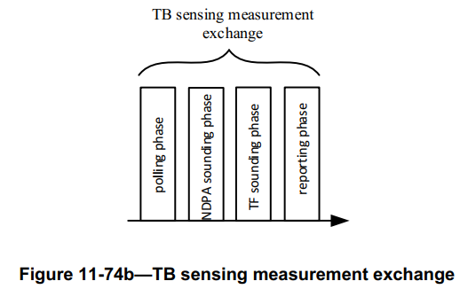
Text in Page 177 (D1.0):

The reporting phase of a TB sensing measurement instance has two variants: The basic reporting phase (see 11.55.1.5.2.6.1 (Basic reporting phase)), and the threshold-based reporting phase (see 11.55.1.5.2.6.2 (Threshold-based reporting phase)).

NOTE—The reporting phase in Figure 11-74c (TB sensing measurement instance) can be a basic reporting phase, a threshold-based reporting phase, or both of them. In the case that both basic reporting phase and threshold-based reporting phase exist, the basic reporting phase is present as the measurement reporting phase of the threshold-based reporting phase.

Figure 11-74g (D1.1):
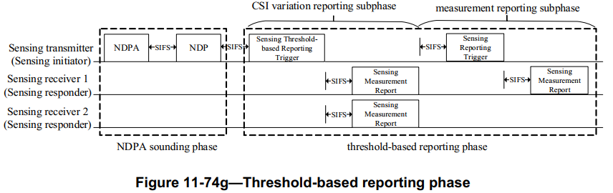
Instructions to the editor: please make the following changes to Page 138, Line 57 in the subclause 11.55.1.5.2.1 General in D1.1 as shown below:
The reporting phase of a TB sensing measurement exchange has two variants: The basic reporting phase (see 11.55.1.5.2.6.1 (Basic reporting phase)), and the threshold-based reporting phase (see 11.55.1.5.2.6.2 (Threshold-based reporting phase)).

NOTE—The reporting phase in Figure 11-74b (TB sensing measurement exchange) can be either a basic reporting phase or a threshold-based reporting phase. (#1441, 1442, 1723).

CIDs 1666, 1667
CID | Page.  Line | Clause Number | Comment | Proposed Change | Resolution
1666 | 112.25 | 9.4.2.319 | The CSI Variation Threshold subfield is reserved if Sensing Receiver subfield is set to 0. | Add text as in comment. | REVISED.  Agree with the commentor that the text needs to be updated.  Instructions to the editor:  Please make the changes as shown under CID 1667 in 11-23/952r1.
1667 | 112.59 | 9.4.2.319 | The meaning of this field should not have a dependency with Sensing element, since Sensing element is not included in the same frame. And of which of the both ends the Sensing element is refering to? | Remove "If the Threshold-based Reporting subfield is set to 1 in the Sensing element (see 9.4.2.320 (Sensing element))," And add normative text in clause 11 about how to set the value of this field. | REVISED.  Agree in Principle. The Threshold-based Reporting subfield in the Sensing element talks about the capability of the threshold-based reporting, and the CSI Variation Threshold subfield here in the Sensing Measurement Parameter element indicates whether the threshold-based reporting is used. There is no need to mention the capability here.  Instructions to the editor:  Please make the changes as shown under CID 1667 in 11-23/952r1.

Discussion:
Sensing Measurement Parameters element format:
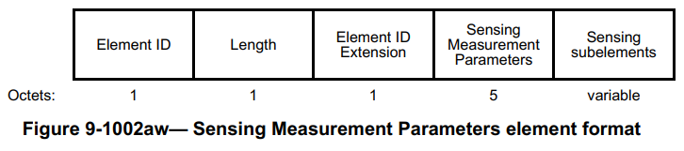
Sensing Transmitter field & Sensing Receiver field:

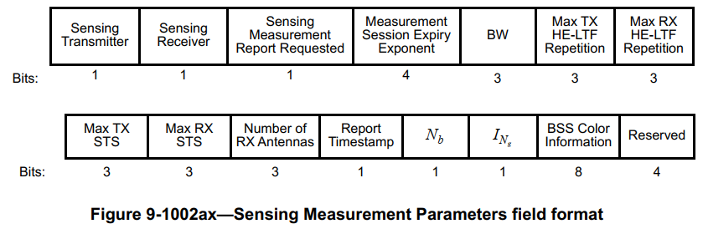
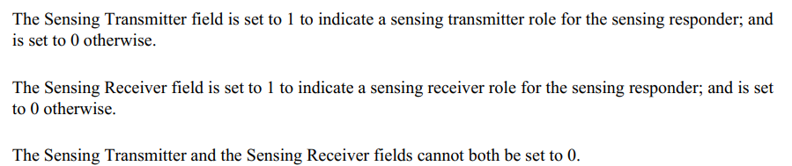

Instructions to the editor: please make the following changes to Page 74, Line 1 in the subclause 11.55.1.5.2.1 General in D1.1 as shown below:
The CSI Variation Threshold field is Reserved if the Sensing Receiver field in the Sensing Measurement Parameters field of the same frame is set to 0. Otherwise, the CSI Variation Threshold field values are defined in Table 9-401s (CSI Variation Threshold field definition). (#1666)

- CSI Variation Threshold field definition
Value | Meaning
0 | CSI variation threshold = 0
1 | CSI variation threshold = 0.1
2 | CSI variation threshold = 0.2
3 | CSI variation threshold = 0.3
4 | CSI variation threshold = 0.4
5 | CSI variation threshold = 0.5
6 | CSI variation threshold = 0.6
7 | CSI variation threshold = 0.7
8 | CSI variation threshold = 0.8
9 | CSI variation threshold = 0.9
10 | CSI variation threshold = 1
11-14 | Reserved
15 | Basic reporting

In the case that the Sensing Receiver field in the Sensing Measurement Parameters field of the same frame is set to 1, the CSI Variation Threshold field value between 0 and 10 indicates that threshold-based reporting is used in the corresponding TB sensing measurement exchanges, and indicates the corresponding CSI variation threshold value. The CSI Variation Threshold field value equal to 15 indicates that basic reporting (see 11.55.1.5.2.6.1 (Basic reporting phase)) is used in the corresponding TB sensing measurement exchanges(#1666, #1667).

CID 1892
CID | Page.  Line | Clause Number | Comment | Proposed Change | Resolution
1892 | 90.38 | 9.4.1.75.1 | The description for CSI Variation Feedback is confusing and cumbersome. For example, in the case of the Invalid Indication field set to 1, the value in 0 to 10 doesn't indicate anything. Suggest simplify the description. | Change the description as the following:  The value between 0 and 10 reflects the CSI variation value obtained by the sensing receiver if the Invalid Indication field set to 0; otherwise, the value of this field is not used. The above values are used for the feedback of CSI variation triggered by the Sensing Threshold-Based Report Trigger frame.  The value equal to 15 indicates that the CSI variation feedback is not used and the corresponding frame is used for the feedback of sensing measurement result transmitted in in the basic reporting phase. See Table 9-127g (CSI Variation Feedback subfield).  " | REJECTED.  The suggested wording “otherwise, the value of this field is not used” is inaccurate. Actually, in the case of the Invalid Indication field set to 1, a value between 0 and 10 is used to indicates an invalid CSI variation feedback.  In addition, the commentor suggests deleting the sentence related to the Remaining Report Segments field, which should also be kept because it describes the value that the Remaining Report Segments field shall choose.

Discussion:
- Segmentation Control field
Field | Size (bits) | Definition
… | … | …
Invalid Indication | 1 | The Invalid Indication subfield indicates whether the reported measurement result is invalid in the case of the CSI Variation Feedback field set to 15, and indicates whether the CSI variation feedback value is invalid in the case of the CSI Variation Feedback field set to a value between 0 and 10. An Invalid Indication field value of 1 indicates that the reported measurement result or the reported CSI variation feedback value is invalid. A value of 0 indicates that the reported measurement result or the reported CSI variation feedback value is valid.
CSI Variation Feedback | 4 | The value between 0 and 10 reflects the CSI variation value obtained by the sensing receiver in the case of the Invalid Indication field set to 0, and indicates an invalid CSI variation feedback in the case of the Invalid Indication field set to 1. The above values are used for the feedback of CSI variation triggered by the Sensing Threshold-Based Report Trigger frame. In this case, the Remaining Report Segments field is set to 0 to indicate this is the last segment with no Sensing Measurement Report Control and Sensing Measurement Report fields in the frame.  The value equal to 15 indicates that the CSI variation feedback is not used and the corresponding frame is used for the feedback of sensing measurement result transmitted in the measurement reporting phase of the threshold-based reporting phase or in the basic reporting phase.  See Table 9-127g (CSI Variation Feedback subfield).
… | … | …

CIDs 1936, 1948
CID | Page.  Line | Clause Number | Comment | Proposed Change | Resolution
1936 | 186.31 | 11.55.1.5.3.3 | Threshold-based reporting phase is not supported for the Non-TB measurement instance Reporting phase, however it is possible given all the frame definations. | To add threshold based reporting for the non-TB measurement instance, the easiest way would be to define the contents of the Sensing Measurement Report for the case where the CSI variation is below and above the threshold.  If the CSI variation is below the threshold, then the Sensing Measurement Report should be equivilant to what is reported in the TB threshold based reporting - CSI variation reporting sub-phase (e.g., the variation).  If the CSI variation is above the threshold, then the Sensing Measurement Report should be equivilant to what is reported in the TB threshold based reporting - measurement reporting sub-phase (e.g., the full report).  This would save the responder transmitting the full report over the air in cases where the variation is below the threshold. | REJECTED.  Although the threshold-based reporting can be extended to the non-TB case. According to the previous discussions within the task group, the threshold-based reporting is not allowed in the Non-TB case and the SBP case for simplicity. Thus, the resolution is rejected.
1948 | 184.56 | 11.55.1.5.2.6.2 | The responder as currently described does not do anything with the threhold. The threshold-based measurement reporting subphase requires the initiator to first perform the threshold check from all responders, and only send a Sensing Trigger frame to a responder "if the reported CSI variation feedback value is greater than or equal to the CSI variation threshold". This seems necessary to optimize spectrum usage, however a flow should also be defined where the responder applies the threshold information when generating the report. | Add a flow where the responder performs the following (perhaps to the non-TB instance):  If the CSI variation is below the threshold, then the Sensing Measurement Report should be equivilant to what is currently reported in the TB threshold based reporting - CSI variation reporting sub-phase (e.g., the variation).  If the CSI variation is above the threshold, then the Sensing Measurement Report should be equivilant to what is currently reported in the TB threshold based reporting - measurement reporting sub-phase (e.g., the full report). | REJECTED.  Similar to the resolution to CID 1936, since the threshold-based reporting is not allowed in the non-TB case, there is no need to add this flow for the non-TB case. Regarding the threshold, it helps save power, clear buffer, and adjust CSI variation at the responder, which has been discussed before within the task group.

SP
Do you support resolutions to the following CIDs and incorporate the text changes into the latest TGbf draft: 1440, 1441, 1442, 1666, 1667, 1723, 1892, 1936, and 1948, in 11-23/0952r0.

Y/N/A

