IEEE P802.11
Wireless LANs
LB272 Resolutions for DMG CIDs
Date: June 2, 2023
Author(s):
Name | Affiliation | Address | Phone | Email
Ning Gao | OPPO |  |  | gaoning1@oppo.com

Abstract
This submission proposes resolutions to the following CIDs:
- 1318, 1357
The text used as reference is 802.11bf D1.0.

Revisions:
- Rev 0: Initial version of the document.

Comments:
CID | Clause | Page | Comment | Proposed Change | Resolution
1318 | 9.3.1.25.5 | 82.31 | The length of the Updated TX Beam List subfield is variable, which can cause a synchronization issue in parallel coordinated monostatic DMG sensing instances. | Change the length of this subfield to be fixed. | Revised.  Agree with the commenter in principle.  TGbf Editor make changes as in doc.: 11-23/0948r0 under the tag 1318.
1357 | 9.3.1.25.5 | 83.48 | The padding field of the "Updated TX Beam List subfield" is not described. | Add the following text at the end of P83LL48: "The Padding fileld length is set to make the length of the TDD Beamforming Information field an integer number of octets" | Revised.  Agree with the commenter in principle.  TGbf Editor make changes as in doc.: 11-23/0948r0 under the tag 1357.

Discussion
In D1.0, the Updated TX Beam List subfield in the DMG Sensing Request frame is used to update the TX Beam List in Coordinated Monostatic DMG Sensing only, which is shown in the following figure.
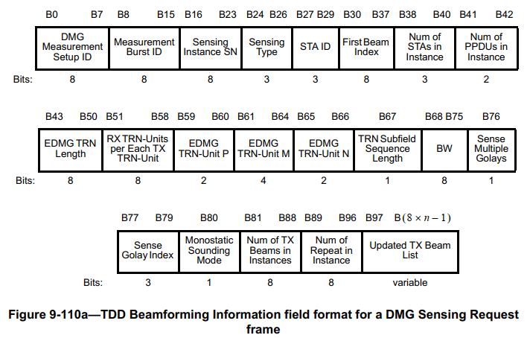

The length of a DMG Sensing Request frame is variable for the length of the Updated TX Beam List subfield is variable. This may result in a synchronization problem in a parallel coordinated monostatic DMG sensing instance shown in the follow figure.

The STA A need to wait for a period of time before transmitting the first monostatic sensing PPDU. Currently, the waiting time of STA A is calculated by the STA ID, Number of STAs in Instance and the length of the DMG Sensing Request frame and the DMG Sensing Response frame of STA A. In another word, the length of the DMG Sensing Request frame and the DMG Sensing Response frame of STA A and STA B are supposed to be the same.
However, the variation of the Updated TX Beam List subfield breaks this assumption and may cause an unnecessary interference between STAs.

A promising way to solve this synchronization problem is to force the DMG Sensing Request frames sent to different STAs have the same length in an instance.

9.3.1.25 TDD Beamforming frame format
9.3.1.25.5 DMG Sensing Request
TGbf Editor: Please modify the following paragraph and the Figure 9-110b as bellow.

The Updated TX Beam List subfield contains a list of transmit beam indices. The beam indices represent indices in the Beam Descriptors list sent within the DMG Sensing Beam Descriptor element (see 9.4.2.323 (DMG Sensing Beam Descriptor element)) with the TX Flag field set to 1. The Updated TX Beam List subfield is defined in Figure 9-110b (Updated TX Beam List subfield format). If the Number Beam Indices subfield equals to zero, none of the Beam Index subfield are present. (#1357) The Padding field length is set to make the length of the TDD Beamforming Information field an integer number of octets. (#1318) The Updated TX Beam List subfield sent to different STAs in an instance shall have the same length by adjusting the length of the Padding field.

Figure 9-110b—Updated TX Beam List subfield format

SP: Move to approve resolutions to CID 1318, 1357 as specified in doc.: 11-23/0948r0 and incorporate the text changes into the latest TGbf draft.

