IEEE P802.11  
Wireless LANs

|  |  |  |  |  |
| --- | --- | --- | --- | --- |
| 11be D3.0 CR for CID 17559 | | | | |
| Date: 2023-05-30 | | | | |
| Author(s): | | | | |
| Name | Affiliation | Address | Phone | email |
| Po-Kai Huang | Intel |  |  |  |
| Johannes Berg |  |  |  |  |

Abstract

This submission proposes resolutions for the following CIDs:

17559

Revisions:

* Rev 0: Initial version of the document.

Interpretation of a Motion to Adopt

A motion to approve this submission means that the editing instructions and any changed or added material are actioned in the TGbe D3.0 Draft. This introduction is not part of the adopted material.

***Editing instructions formatted like this are intended to be copied into the TGbe D3.0 Draft. (i.e. they are instructions to the 802.11 editor on how to merge the text with the baseline documents).***

***TGbe Editor: Editing instructions preceded by “TGbe Editor” are instructions to the TGbe editor to modify existing material in the TGbe draft. As a result of adopting the changes, the TGbe editor will execute the instructions rather than copy them to the TGbe Draft.***

|  |  |  |  |  |  |  |
| --- | --- | --- | --- | --- | --- | --- |
| **CID** | **Commenter** | **Clause** | **P.L** | **Comment** | **Proposed Change** | **Resolution** |
| 17559 | Brian Hart | 9.4.2.160 | 237.15 | Missing article | "indicates the 5 GHz band". Similar at L21 ("the 6 GHz band") and L28 (reuse "an S1G band"?) | Revised –  The proposed change in 9.4.2.160 creates backward compatibility issues to existing non-EHT STAs.  Propose to delete all the proposed changes in 9.4.2.160.  TGbe editor to make the changes shown in 11-23/0947r0 under all headings that include CID 17559 |

**Discussion:**

There are existing non-EHT STAs that interpreats the Channel Width field based on VHT operation information as described in the baseline shown below.

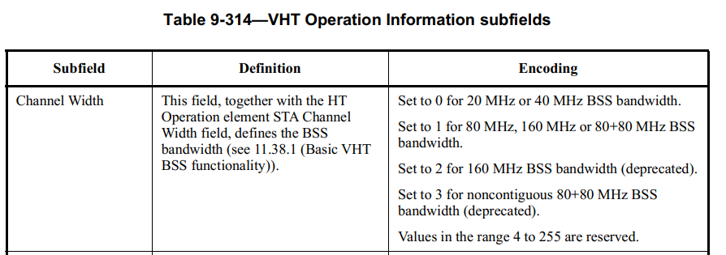

However, the change in 11be forces the existing non-EHT STAs to change the interpretation to the following, which is not compatibile with above. Since it is impossible to change the existing implementation in the field, the only correct way to address the issue is to remove all the proposed change in 9.4.2.160 Wide Bandwidth Channel Switch element

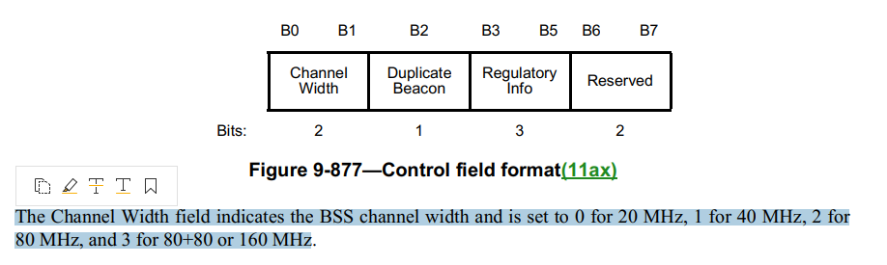

*TGbe editor: Modify Clause 9.4.2.160 as follows (track change on):*

**9.4.2.160 Wide Bandwidth Channel Switch element**

***Change the third paragraph (including to split it into three paragraphs) as follows:***

If the New Operating Class field in the frame that contains this element does not indicate an S1G band, the subfields New Channel Width, New Channel Center Frequency Segment 0, and New Channel Center Frequency Segment 1 have the same definition, respectively, as Channel Width, Channel Center Frequency Segment 0, and Channel Center Frequency Segment 1 in the VHT Operation Information field, described in Table 9-313 (VHT Operation Information subfields).

Otherwise, the subfields New Channel Width and New Channel Center Frequency Segment 0 have the same definition, respectively, as the Channel Width and the Channel Center Frequency in the S1G Operation Information field, described in Table 9-353 (S1G Operation Information field). The New Channel Center Frequency Segment 1 subfield is reserved.