IEEE P802.11 Wireless LANs
LB273 Security Adhoc Comment Resolutions Part 1
Date: 2023-07-12
Author(s):
Name | Affiliation | Address | Phone | email
Michael Montemurro | Huawei |  |  | montemurro.michael@gmail.com
Background
This contribution proposes comment resolutions to selected REVme SEC adhoc comments from LB273.

Remaining CIDs: 4109 and 4397

R0 – Initial version.
R1 – Incorporate changes based on offline comments from Mark Rison
R2 – Incorporate changes as a result on additional offline comments.
R3 – Revised based on TG review on the 2023-06-16 teleconference
R4 – TG review changes

Comment
CID | Page | Clause | Duplicate of CID | Resn Status | Comment | Proposed Change
4175 |  | 12 |  |  | " See 12.3.4.6  (TKIP replay protection procedures) and 12.5.2.4.4 (PN and replay detection)" should also refer to the GCMP subclause | At 979.5/24 change "and 12.5.2.4.4" to ", 12.5.2.4.4 and 12.5.4.4.4". In the middle cell for PC34.1.10 in B.4 add "12.5.4.3.6  (GCM originator  processing),  12.5.4.4.2 (GCM  recipient  processing),  12.5.4.4.4 (PN  and replay  detection)"

Discussion:
- The locations of the proposed resolution appear to be in these places:

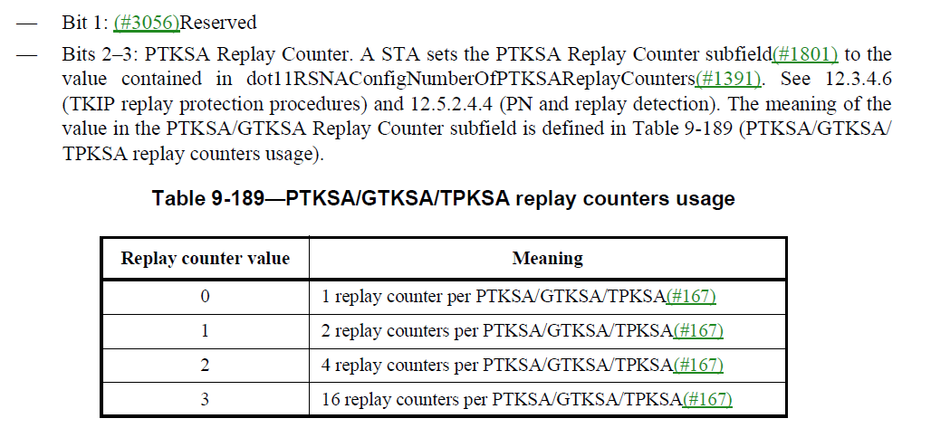

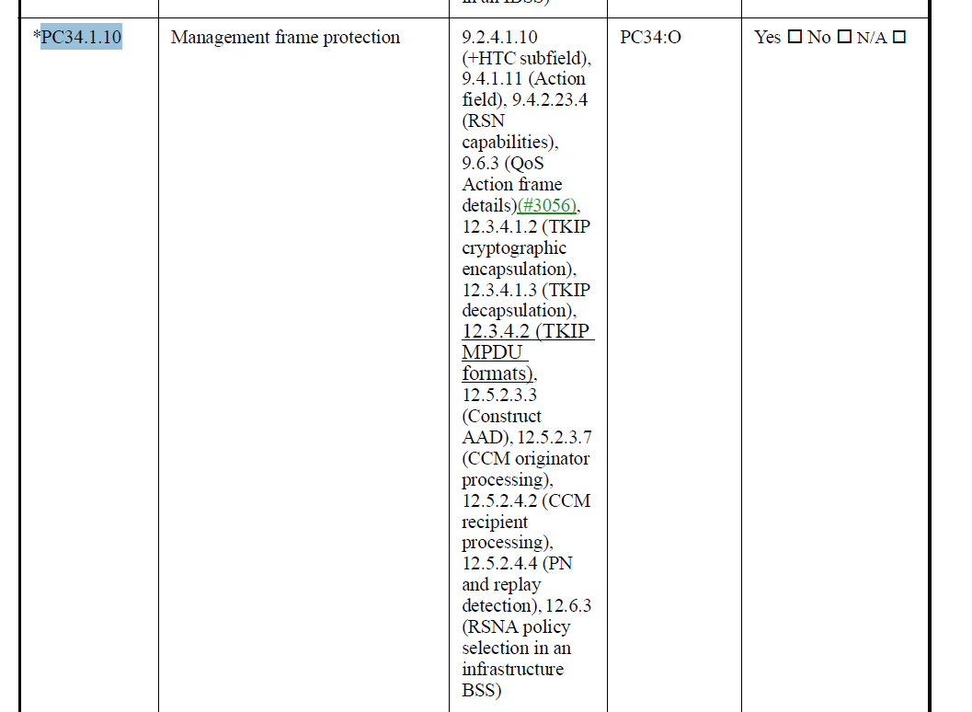
- The commenter is asking to update the description of bits 2 and 3, and the PICS PC34.1.10 with GCM clause references, which looks to be correct.

Proposed Resolution: (4175)
ACCEPTED

Comment
CID | Page | Clause | Duplicate of CID | Resn Status | Comment | Proposed Change
4300 |  | 12.5 |  |  | "use the reply counter corresponding to MSDU priority 0" -- but replay counters are based on MPDUs not MSDUs. Also typo in "reply" | At 2843.58 and 2853.52 change "the reply counter corresponding to MSDU priority 0" to "the replay counter corresponding to MPDU priority 0"

Discussion:
- The text referred to in the Proposed Change is
and

- The Proposed Change replaces MSDU with MPDU, and reply with replay in the notes

Proposed Resolution: (4300)
ACCEPTED

Comment
CID | Page | Clause | Duplicate of CID | Resn Status | Comment | Proposed Change
4117 | 2948.00 | 12.11.2.2 |  |  | Shouldn't 12.11 have mentioned somewhere the use of MIB attribute dot11AuthenticationAlgorithm set to filesSharedKey* or files PrivateKey? | Add to 12.11.2.2 first paragraph, "An AP _with dot11AuthenticationAlgorithmsTable including an entry with dot11AuthenticationAlgorithm equal to filsSharedKeyWithoutPFS, filsSharedKeyWithPFS, or filsPublicKey_ indicates support ...". Add to 12.11.2.3.1 second paragraph, "A STA _with dot11AuthenticationAlgorithmsTable including an entry with dot11AuthenticationAlgorithm equal to filsSharedKeyWithoutPFS, filsSharedKeyWithPFS, or filsPublicKe_ may initiate ...".

Discussion:
- The cited text where the proposed text changes are:
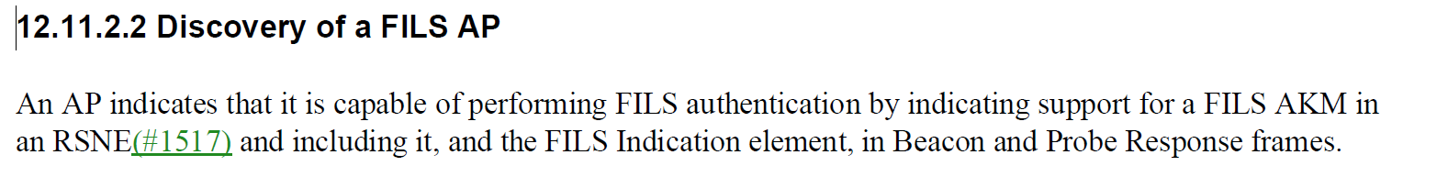
and
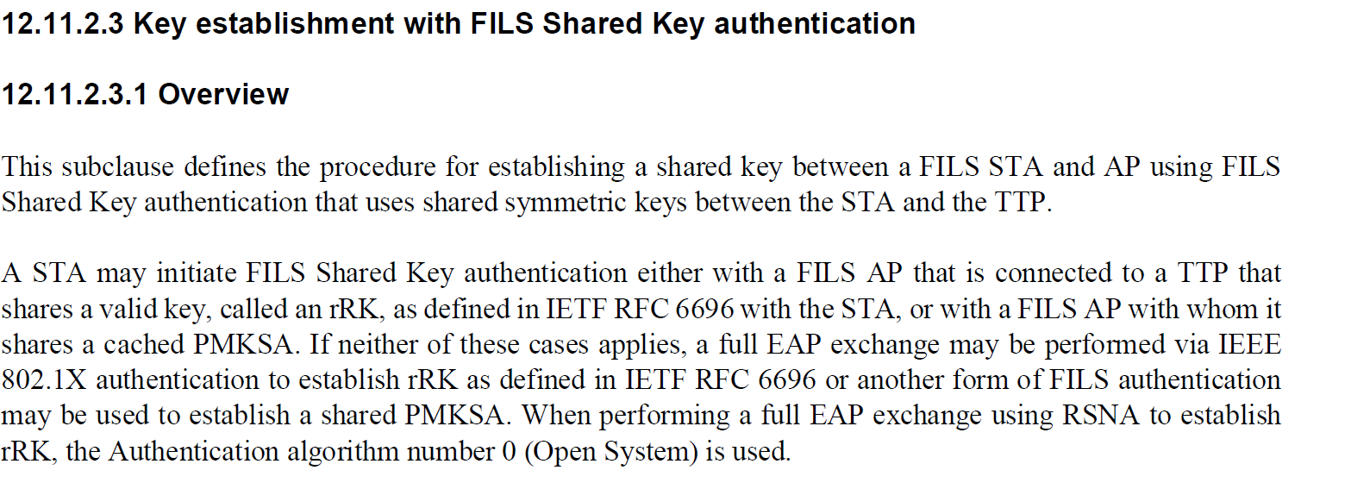
- The the current text is correct in both cases. The STA indicates support for FILS authentication by including the FILS AKM in the RSNE. The STA uses FILS Shared Key authentication when is shares a valid key with the AP.”
- We can add a note in both locations.The first note would apply to an AP and the second would apply to a STA.

Proposed Resolution: (4117)
REVISED. The current cited text is correct in terms of FILS behavior. A note is added to tie that behaviour to the MIB variable for authentication.
At 2948.45, insert the following note:
“NOTE – An AP with dot11AuthenticationAlgorithmsTable including an entry with dot11AuthenticationAlgorithm equal to filsSharedKeyWithoutPFS, filsSharedKeyWithPFS, or filsPublicKey is capable of performing FILS authentication.”

At 2949.23, insert the following note:
“NOTE – A STA with dot11AuthenticationAlgorithmsTable including an entry with dot11AuthenticationAlgorithm equal to filsSharedKeyWithoutPFS, filsSharedKeyWithPFS, or filsPublicKey is capable of performing FILS authentication.”

Comment
CID | Page | Clause | Duplicate of CID | Resn Status | Comment | Proposed Change
4293 | 2831.00 | 12.4.8.6.4 |  |  | "BadID shall be set" -- not clear by whom. If by protocol instance, then move to the "the protocol instance shall" list | Change "BadID shall be set, the protocol instance shall send a  Del event to the parent process and transition back to Nothing state" to "the protocol instance shall set BadID, send a Del event to the parent process, and transition back to Nothing state". At 2830.49 change "the  protocol instance shall set BadID and construct and transmit an (#3328)SAE Authentication  frame with (#3326)status code UNKNOWN_PASSWORD_IDENTIFIER(#3327), and a Del  event shall be sent to the parent process." to "the  protocol instance shall set BadID and construct and transmit an (#3328)SAE Authentication  frame with (#3326)status code UNKNOWN_PASSWORD_IDENTIFIER(#3327), and send a Del  event to the parent process."

Discussion:
- The cited text on page 2830 is:
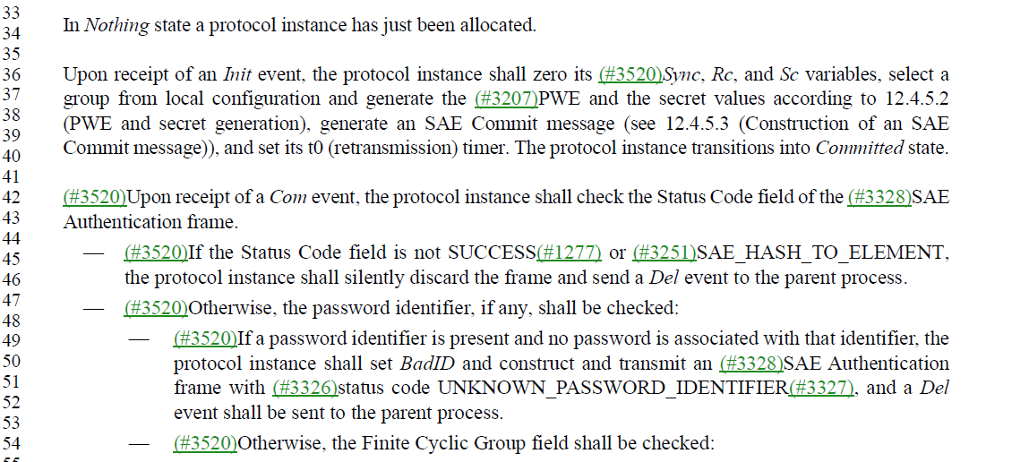
And on page 2831 is:
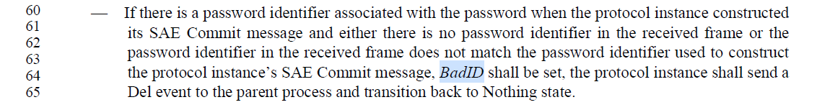
- The changes are:
At 2830.49, change
“BadID shall be set, the protocol instance shall send a Del event to the parent process and transition back to Nothing state"
to
“the protocol instance shall set BadID, send a Del event to the parent process, and transition back to Nothing state".

At 2831.64 change
"the protocol instance shall set BadID and construct and transmit an SAE Authentication frame with status code UNKNOWN_PASSWORD_IDENTIFIER, and a Del
event shall be sent to the parent process."
to
"the protocol instance shall set BadID and construct and transmit an SAE Authentication
frame with status code UNKNOWN_PASSWORD_IDENTIFIER, and send a Del
event to the parent process."

Proposed Resolution: (4293)
ACCEPTED

Comment:
CID | Page | Clause | Duplicate of CID | Resn Status | Comment | Proposed Change
4166 | 2844.00 | 12.5.2.4.4 |  |  | "If the receiver set the MFPC bit on a given link to 1, it shall  discard any individually addressed robust Management frame that is received with its PN less than  or equal to the value of the replay counter"  -- even if the peer didn't set the MFPC bit on the link? Ditto in equivalent GCMP subclause | Change to refer to whether MFP was negotiated, as in other locations. Ditto at line 1 and ditto (2x) in 12.5.4.4.4 [confirm direction]

Discussion:
- The cited text in the comment is:
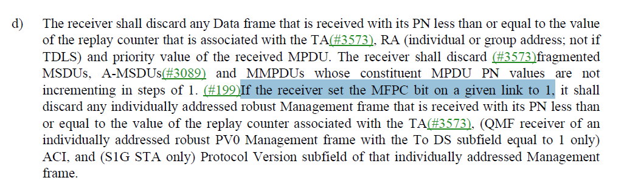

- Agree with the commenter that the requirement is dependent on MFP being negotiated.
- There are two locations that use “if the receiver …”: 2844.18 and 2854.6
- There are two locations that use “if the recipient …”: 2844.1 and 2853.54
- All four location could be updated with the format:
“If management frame protection is negotiated for a given link, the receiver shall”
- Besides those four locations, There is one additional location that uses “MFPC bit to 1” to indicate MFP being negotiated:
2537.61 “If a STA and its peer on a given link both set the MFPC bit to 1(#199), then the STA shall support the SA Query procedure.”

Proposed Resolution: (4166)
Revised. Update the text at 5 locations indicating that the condition is “If MFP is negotiated …”

At 2844.18 and 2854.6, change
“If the receiver set the MFPC bit on a given link to 1, it shall”
to
“If management frame protection is negotiated, the receiver shall”

At 2844.1 and 2853.54, change
“If the recipient set the MFPC bit on a given link to 1, it shall”
to
“If management frame protection is negotiated, the receiver shall”

At 2537.61, change
“If a STA and its peer on a given link both set the MFPC bit to 1, the STA…”
to
“If a STA and its peer negotiate management frame protection, the STA…”

Comment
CID | Page | Clause | Duplicate of CID | Resn Status | Comment | Proposed Change
4319 | 2846.00 | 12.5.3.4 |  |  | "robust GQMFs within an AC that are transmitted to the same RA." -- can a group-addressed Management frame be anything other than broadcast? | Delete "that are transmitted to the same RA" at lines 31 and 32

Discussion:
- The cited text is the following:
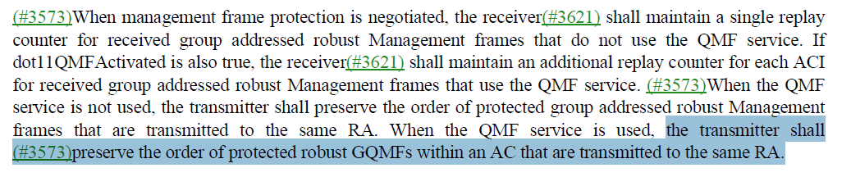
- In this case, it’s a group-addressed robust management frame so in this case its OK to leave out “that are transmitted to the same RA”
- An UL group-addressed management frame can be sent as a GQMF.
- P802.11bc introduces UL multicast management frames so it might be good to leave this text.

Proposed Resolution: (4319)
REJECTED. When P802.11bc is rolled-in to the baseline, a group-addressed management frame can be transmitted to a multicast RA.

Comment
CID | Page | Clause | Duplicate of CID | Resn Status | Comment | Proposed Change
4322 |  | 12.5.3.5 |  |  | The stuff in 12.5.3.5 about "should" not use the old key when IGTK rekeying should be promoted to a "shall", as for GTK and BIGTK | Change "Once a STA transmits a protected group addressed robust  Management frame using a new IGTK, the STA should not transmit protected group addressed  robust Management frames using the previously used IGTK" to "Once a STA transmits a protected group addressed robust  Management frame using a new IGTK, the STA shall not transmit protected group addressed  robust Management frames using the previously used IGTK"

Discussion:
- The cited text in context is:
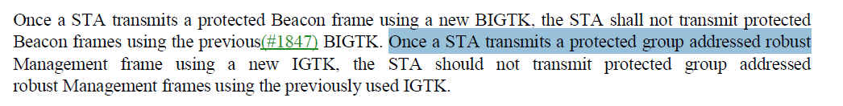

- The proposed change is as follows:
Change
“Once a STA transmits a protected group addressed robust Management frame using a new IGTK, the STA should not transmit protected group addressed robust Management frames using the previously used IGTK"
to
"Once a STA transmits a protected group addressed robust Management frame using a new IGTK, the STA shall not transmit protected group addressed robust Management frames using the previously used IGTK"
- The IGTK behaviour should follow the same behaviour as the BIGTK.

Proposed Resolution: (4322)
ACCEPTED.

Comment
CID | Page | Clause | Duplicate of CID | Resn Status | Comment | Proposed Change
4299 | 2847.00 | 12.5.3.6 |  |  | "If no  such IGTK exists, silently discard(#187) the frame and terminate BIP processing for this recep-  tion." should be "If the frame is a robust Management frame and no  such IGTK exists, silently discard(#187) the frame and terminate BIP processing for this recep-  tion." since the next sentence is about protected beacons | As it says in the comment

Discussion:
- The cited text in context is:
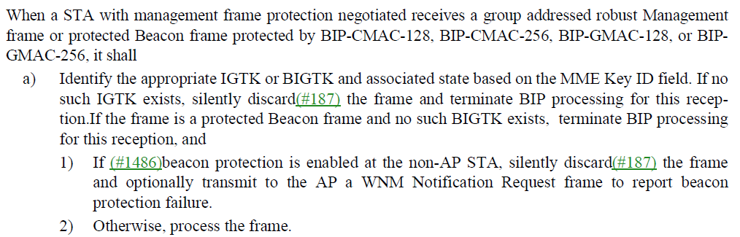

- The proposed change is:
At 2847.26, change
“If no such IGTK exists, silently discard(#187) the frame and terminate BIP processing for this reception.”
to
“If the frame is a robust Management frame and no such IGTK exists, silently discard(#187) the frame and terminate BIP processing for this reception”

Proposed Resolution: (4299)
ACCEPTED.

Comment
CID | Page | Clause | Duplicate of CID | Resn Status | Comment | Proposed Change
4108 | 2857.00 | 12.6.1.1.6 |  |  | "AKM suite" was changed to "AKMP" for CID 3266 (throughout, many locations), but CID 3266 says it was rejected. So, is this change correct and agreed? | Confirm this change, or revert it.

Discussion:
- Text at cited location:
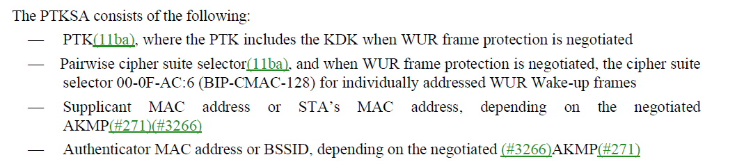
- Resolution to CID 3266:
REVISED (EDITOR: 2023-04-04 23:04:24Z) - Make the changes shown under “Proposed changes” for CID 3266 in https://mentor.ieee.org/802.11/dcn/22/11-22-2069-09-000m-resolutions-for-some-comments-on-11me-d2-0-lb270.docx, which make “AKM 00-0F-AC:<n>” an acceptable shorthand for the AKMP identified by that AKM suite selector value. In the cited text, PN and RSC describe the same counter.

Proposed Resolution: (4108)
REJECTED. The resolution approved by the TG was REVISED and adopted the changes in doc 11-22/2069r9 in D3.0.

Comment
CID | Page | Clause | Duplicate of CID | Resn Status | Comment | Proposed Change
4109 | 2857.00 | 12.6.1.1.6 |  |  | Here, it says "Supplicant MAC address or STA's MAC address ..." But, at P2884.32, it says, "In an infrastructure BSS, the IEEE 802.1X Authenticator MAC address (AA) and the AP's MAC address are  the same, and the Supplicant's MAC address (SPA) and the STA's MAC address are equal." So, is there some subtle distinction being made in 12.6.1.1.6 for non-infrastructure cases, and if so that should be explained or it won't be understood. Or, is the distinction in 12.6.1.1.6 unnecessary, and it should just say "Supplicant MAC" or "Authenticator MAC" (or "STA's MAC" or "BSSID")? | Clarify this subtlety if it is real, remove it if it is not real.

Discussion:
- The cited text in context is
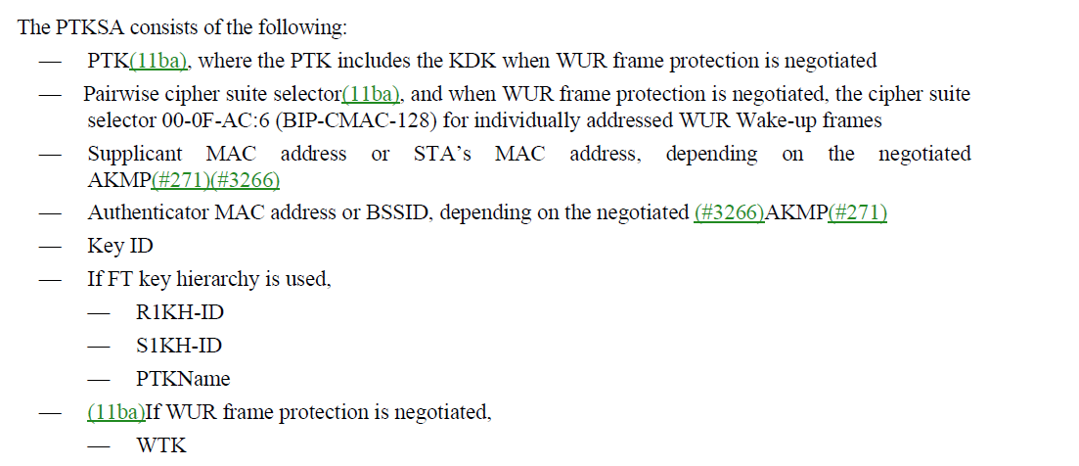

- Other cited text in the comment:
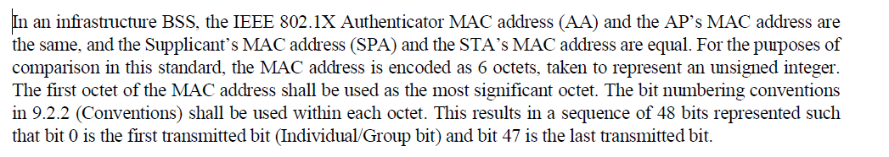

- Text describing addresses in SAE (12.4.1 p2809.5)
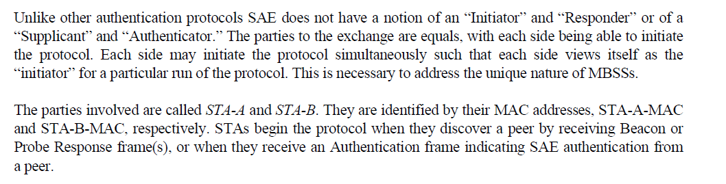

Proposed Resolution: (4109)
REVISED. Clarify MAC address that are part of the PTKSA
At 2857.24, Change
“Supplicant MAC address or STA’s MAC address” to “Supplicant MAC address”

At 2857.26, Change
“Authenticator MAC address or BSSID” to “Authenticator MAC address”

Comment
CID | Page | Clause | Duplicate of CID | Resn Status | Comment | Proposed Change
4230 | 2898.00 | 12.7.2 |  |  | "The IEEE 802.11 Key Descriptor maps to the IEEE 802.1X Key Descriptor as described in this subclause." is not saying anything clear or useful | Delete the cited sentence

Discussion:
- The cited text in context is:

- This is the only usage in the subclause for IEEE 802.1X Key Descriptor. Therefore the sentence could be deleted.

Proposed Resolution: (4230)
ACCEPTED

Comment
CID | Page | Clause | Duplicate of CID | Resn Status | Comment | Proposed Change
4144 | 2911.00 | 12.7.6.1 |  |  | "The MIC is computed over the body of the (#1836)EAPOL-Key PDU (with the Key MIC field first  zeroed before the computation) using the KCK defined in 12.7.1.3 (Pairwise key hierarchy) for PTK  generation." -- it is not clear what the last 3 words mean. They don't appear for the GKH | Delete " for PTK generation" in the cited text

Discussion:
- This is the cited text that is tied to the footnote:

- Agree with the comment that “for PTK generation” can be deleted in this sentence.

Proposed Resolution: (4144)
ACCEPTED

Comment
CID | Page | Clause | Duplicate of CID | Resn Status | Comment | Proposed Change
4165 | 2926.00 | 12.7.8.2 |  |  | "PairwiseCipherSuite field of the RSNE " -- no such field | Change the para at the referenced location to "Pairwise Cipher Suite List field of the RSNE  identifies the cipher suite(s) that can be or are used to protect the Data frames sent over the  (#2152)TDLS direct link". At line 41 change "TimeoutIntervalType" to "Timeout Interval Type". At line 47 change "AKM suite list" to "AKM Suite List"

Discussion:
- This is the cited text in context:
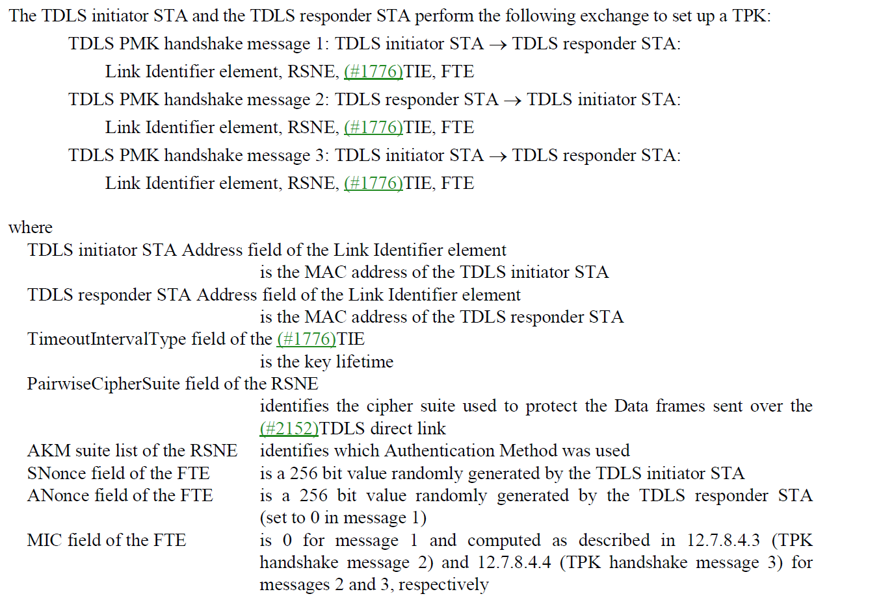

- The changes proposed by the commenter are:
At cited location, change “PairwiseCipherSuite field of the RSNE identifies the cipher suite used to protect the Data frames sent over the TDLS direct link”
to
“Pairwise Cipher Suite List field of the RSNE identifies the cipher suite(s) that can be or are used to protect the Data frames sent over the TDLS direct link”

At line 41, Change "TimeoutIntervalType" to "Timeout Interval Type"

At line 47 change "AKM suite list" to "AKM Suite List", but should be “AKM Suite List field”
- The changes look to be mostly aligning field names and capitalization.

Proposed Resolution: (4165)
REVISED.
At cited location, change “PairwiseCipherSuite field of the RSNE identifies the cipher suite used to protect the Data frames sent over the TDLS direct link”
to
“Pairwise Cipher Suite List field of the RSNE identifies the cipher suite used to protect the Data frames sent over the TDLS direct link”

At line 41, Change "TimeoutIntervalType" to "Timeout Interval Type"

At line 47 change "AKM suite list" to "AKM Suite List", but should be “AKM Suite List field”

Comment
CID | Page | Clause | Duplicate of CID | Resn Status | Comment | Proposed Change
4229 | 2929.00 | 12.7.8.4.3 |  |  | "All other RSNE fields shall be same as those received in message 1." -- not the RSN Capabilities field | Change to "All other RSNE fields, apart from the RSN Capabilities field if present, shall be same as those received in message 1." (but what about existing devices?) [needs discussion]

Discussion:
- This is the cited text in context:
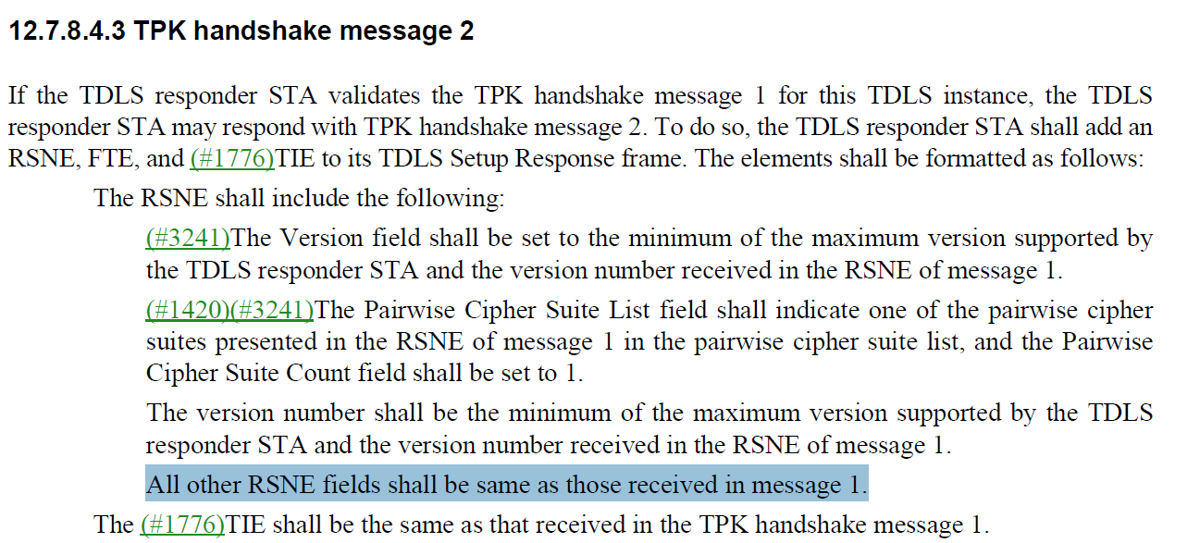

- The comment proposed changing the highlighted text above to to "All other RSNE fields, apart from the RSN Capabilities field if present, shall be same as those received in message 1."
- The RSN Capabilities is defined as follows:
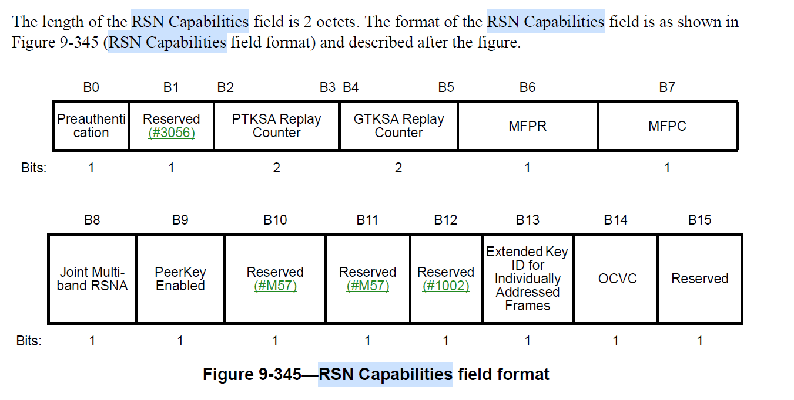
- In the requirements for TPK handshake message 1 on p2929.5, the TDLS responder STA is required to evaluate the value of the RSN Capabilities field:

Proposed Resolution: (4229)
REJECTED. Although the current text does not allow the initiatorto receive the responder's RSN capailities (e.g. MFP, RCs), this is baked into existing devices so cannot be changed. A new mechanism would be needed to allow this.

Comment
CID | Page | Clause | Duplicate of CID | Resn Status | Comment | Proposed Change
4143 | 2934.00 | 12.7.9.4 |  |  | PreANonce is not defined | Change PreANonce to PrevANonce (2x) and add "PrevANonce<-0" at 2933.46, where <- is the left arrow glyph

Discussion:
- This is the cited text at 2934.4:

- This is the cited text at 2933.46 where the initialization of PrevANonce should be added:
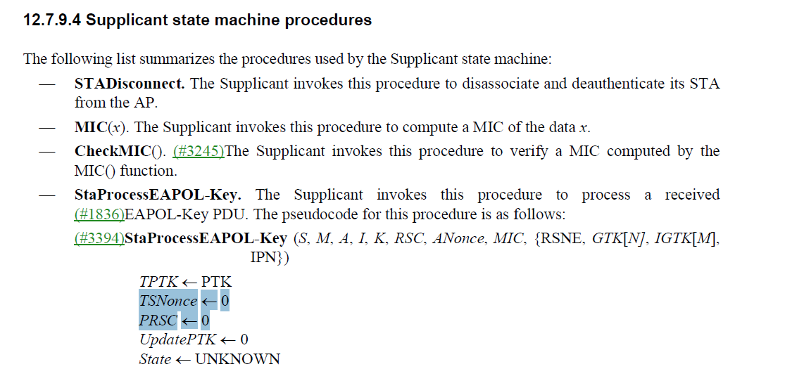
- The previous ANonce may or may not be zero, so initialization to 0 is not correct.

Proposed Resolution: (4143)
REVISED. Change “PreANonce” to “PrevANonce” at cited locations.

At 2933.44, add
“# Global initialization
PrevANonce ← 0”

At 2933.50, add
“# Frame specific processing”

Comment
CID | Page | Clause | Duplicate of CID | Resn Status | Comment | Proposed Change
4396 | 2970.00 | 13.4.2 |  |  | This sentence says that FT initial mobility association is initiated using Open System authentication in non-DMG case. However that is not true when an SAE over FT AKM is used (without PMK caching). | Insert "or SAE algorithm" after "Open System authentication algorithm" on lines 61, 63 and 64.  In Figure 13-2, insert "or SAE" after "Open" in the annotations for the top two arrows.  In Figure 13-2, insert "or SAE" after "bypassed if PSK" in the annotation for the 5th arrow.

Discussion:
- This is the cited text that is tied to the footnote:
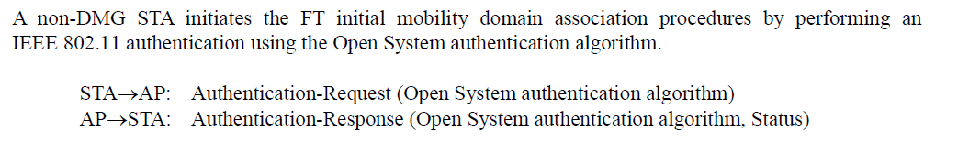
- Note that the next paragraph on p2971.32 is the following:
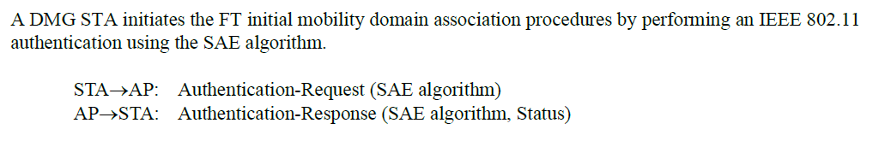
- Given that FT with SAE is covered in the next paragraph, it might be more reasonable to rename Fig 13-2 to “FT initial mobility domain association in an RSN using Open System authentication”

Proposed Resolution: (4396)
REVISED. The use of FT with SAE is covered in the next paragraph. See p2971.32.
Change the caption of Figure 13.2 to the following:
“FT initial mobility domain association in an RSN using Open System authentication”

Comment
CID | Page | Clause | Duplicate of CID | Resn Status | Comment | Proposed Change
4397 | 978.00 | 9.4.2.23.3 |  |  | There are various missing references to the new SAE AKMs.  e.g. the referenced sentence should also refer to AKM 24 (and the SAE-FT AKMs too?)  NOTE 5 (line 20) also seems outdated/incomplete.  Also 12.12.2 p2963 line 14 refers to AKMs 8/9 for SAE but not the other SAE AKMs | Per comment, either update the references or remove them and just refer to "SAE" pointing to the AKM suite selector table for details

Discussion:
- This is the cited text in context:
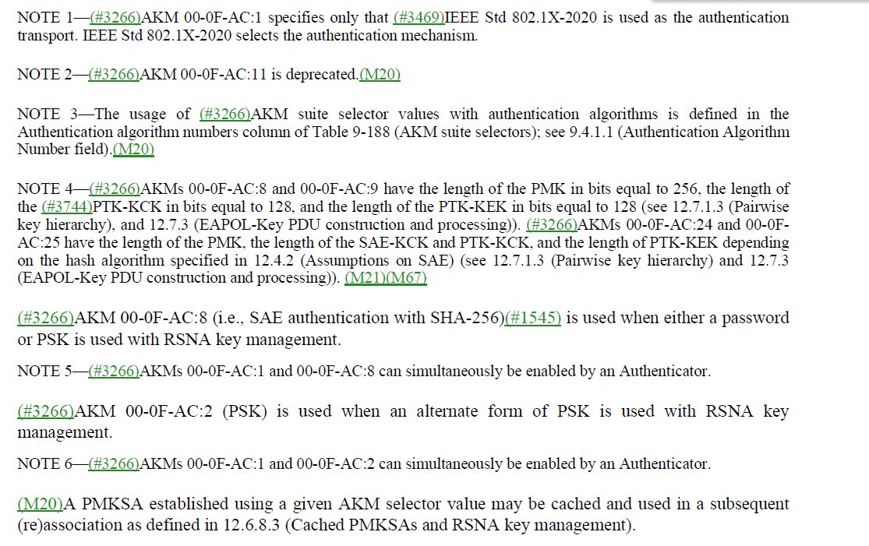
- The other referenced clause (12.12.2 – Security Constraints in the 6 GHz band)
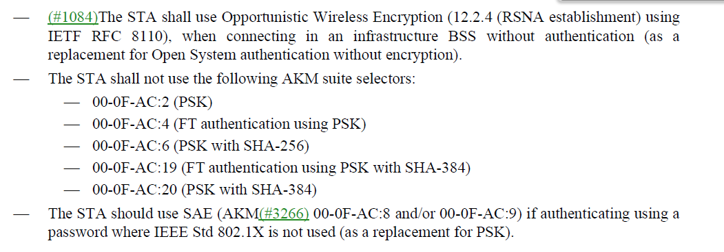
- It would be good to update the text at 978.18 to include AKM 24.
- Similarly, in 12.12.2, It would be good to update the last bullet to include AKMs 24 and 25.

Proposed Resolution: (4397)
REVISED. Update the cited text to include AKM 24 and 25 where appropriate.

At 978.18, change:
“AKM 00-0F-AC:8 (i.e., SAE authentication with SHA-256) is used when either a password or PSK is used with RSNA key management.”
to
“SAE authentication (AKM 00-0F-AC:8 or 00-0F-AC:24) is used when either a password or PSK is used with RSNA key management.”

At 978.20, change:
“NOTE 5— AKMs 00-0F-AC:1 and 00-0F-AC:8 can simultaneously be enabled by an Authenticator.”
to
“NOTE 5— AKM 00-0F-AC:1 can simultaneously be enabled with AKM 00-0F-AC:8 or 00-0F-AC:24 or both by an Authenticator.”

At 2963.14, change:
“The STA should use SAE (AKM 00-0F-AC:8 and/or 00-0F-AC:9) if authenticating using a password …”
To
“The STA should use SAE (AKM 00-0F-AC:8, 00-0F-AC:9, 00-0F-AC:24, or 00-0F-AC:25) if authenticating using a password …”

Comment
CID | Page | Clause | Duplicate of CID | Resn Status | Comment | Proposed Change
4350 |  | 12 |  |  | "GNoStations--" in Figure 12-53--Authenticator state machines, part 2 at 2938.13 should be "GNoStations--". Ditto "GKeyDoneStation--". Ditto "GKeyDoneStations -" | At 2938.13 change "GNoStations--" to "GNoStations--". At 2938.22 change "GKeyDoneStation--" to "GKeyDoneStations--" (2 fixes). At 2940.34 change "GKeyDoneStations --" to "GKeyDoneStations--". At 2934.14 and 2938.20 change "Keycount" to "keycount"

Discussion:
- Addressed in Mark Rison document 11-23/0933

Proposed Resolution: (4350)

Comment
CID | Page | Clause | Duplicate of CID | Resn Status | Comment | Proposed Change
4225 | 2928.00 | 12.7.8.4.2 |  |  | "indicate (#3266)AKM 00-0F-AC:7(TPK handshake)" -- what if it includes >1 AKM? Ditto "indicate a negotiated AKM" for FT (but maybe that's OK because it's in the assoc req where you can only have a single AKM -- but is that specified anywhere and what about 2975.42, 2977.54, 2980.9?) | Change the former to "indicate the single (#3266)AKM 00-0F-AC:7(TPK handshake)".

Discussion:
- Addressed in Mark Rison document 11-23/0933

Proposed Resolution: (4225)

