IEEE P802.11
Wireless LANs
LB272 Reporting CID Resolution Part 2.
Date: 2023-05-31
Author(s):
Name | Affiliation | Address | Phone | email
Chris Beg | Cognitive Systems |  |  | chris.beg@cognitivesystems.com
Abstract
This submission addresses the following 7 LB272 CIDs: 1231 1403 1454 1623 1805 1890, and 1893
.

Revision history:
R0 – initial version
R1 – comments added from 11bf discussion

CID | Clause | Page | Comment | Proposed Change | Resolution
1231 | 11.55.1.5.2.6.2 | 183.57 | "Threshold-based reporting is optional and may be present in.." The feature is optional, but it is not defined how to know if it is supported | Define the related capabilities and rules for the negotiation. Refer to the definition. | Revised  Agree with commentor in principle. New descriptions added to sections 11.55.1.3 and 11.55.1.4.  TGbf editor to make changes shown in 11-23/0941r1.

Discussion:

- Section 9.4.2.320 describes the Sensing Capabilities element, used for capability exchange. However, as commentor points out, there is no normative text describing the usage of the Threshold-based Reporting bit in Section 11.55.1.3 – Sensing capabilities exchange.
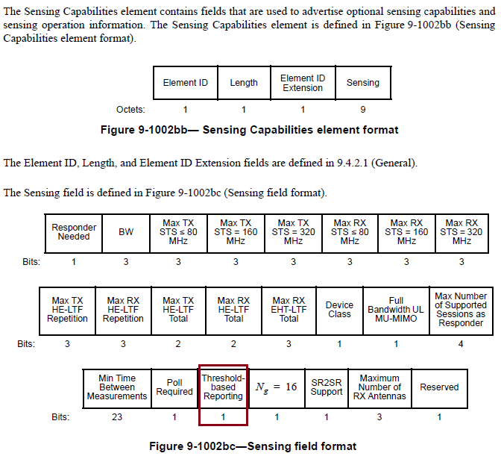
- Section 9.4.2.319 describes the Sensing Measurement Parameters element, used for the Measurement Session setup. However, as commentor points out, there is no normative text describing the usage of the CSI Variation Threshold field in Section 11.55.1.4 – Sensing measurement session.
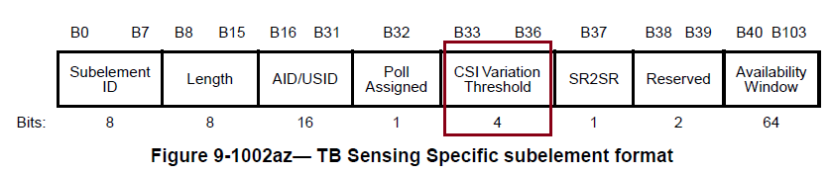

TGbf Editor: Insert the text into section 11.55.1.3 of D1.1 as follows:

If the Sensing Capabilities element is included in the Probe Request frame, a non-AP STA shall set the Poll Required subfield in the Sensing Capabilities element to 1 if it intends to be polled in TB sensing measurement exchanges(#1448, #1690).

If a Sensing Capabilities element is included in a frame, the Threshold-based Reporting field in the Sensing field shall be set to 1 to indicate that the STA supports threshold-based reporting. Otherwise, the Threshold-based Reporting field shall be set to 0(#1231).

TGbf Editor: Insert the text into section 11.55.1.4 of D1.1 as follows:

If the sensing initiator includes a TB Sensing Specific subelement in a Sensing Measurement Request frame, the Poll Assigned field shall be(#1119) set to 1 if the Poll Required field within the Sensing field(#1599) in the last Sensing Capabilities element received from the sensing responder is set to 1.

If the sensing initiator includes a TB Sensing Specific subelement in a Sensing Measurement Request frame, the CSI Variation Threshold field shall be set according to the following:
- If the Sensing Receiver field or the Sensing Measurement Report Requested field of the Sensing Measurement Parameters is set to 0, then the CSI Variation Threshold field is reserved.
- If the last Sensing Capabilities element received from the STA addressed by the AID/USID field has the Threshold-based Reporting field set to 1, and the sensing initiator intends to use threshold-based reporting in the corresponding TB sensing measurement exchanges, then the CSI Variation Threshold field shall be set to a value in the range of 0 to 10 to indicate the CSI variation threshold (see Table 9-401s (CSI Variation Threshold field definition)). Otherwise, the CSI Variation Threshold field shall be set to 15 to indicate basic reporting is used in the corresponding TB sensing measurement exchanges(#1231).

TGbf Editor: Modify the text in D1.1 145.44-52 as follows:

Threshold-based reporting is optional and mayshall be present in a TB sensing measurement exchange in which the sensing responder is in the role of sensing receiver for measurement sessions established with the CSI Variation Threshold field in the TB Sensing Specific subelement set to a value in the range of 0 to 10. A sensing initiator may implement the thresholdbased reporting for the purpose of finding out the sensing responder(s) with their CSI variation values greater than or equal to the CSI variation threshold values assigned to them in the corresponding Sensing Measurement Request frame(s), and then transmit a Sensing Reporting Trigger frame to obtain Sensing Measurement Report frame(s) containing the measurement result(s) from those sensing responder(s)(#1736).

CID | Clause | Page | Comment | Proposed Change | Resolution
1403 | 27.2.2 | 223.22 | The CSI_ESTIMATE RXVECTOR parameter should be a part of all OFDM PHY | Add the CSI_ESTIMATE to clauses 17, 19, 21 | Rejected  Amendments to the PHY service interface of clause 17 are out of scope of the PAR.  With the decision to only support HE and EHT PHYs and the CSI_ESTIMATE definition being based on specific NDPs, adding a CSI_ESTIMATE to the RXVECTOR of clauses 19 and 21 would require first defining the conditions for which it would be used.

Discussion:

- As per P802.11bf PAR description, amendments to the PHY service interface of the HT (clause 19), VHT (clause 21), HE (clause 27), and EHT (clause 36) PHYs are supported.
- In contribution 11-23/0633r2, as the response to CID 2053, it was decided by the group that the only STAs operating in frequency range of 1 – 7.125 GHz supported by the 11bf amendment would be HE and EHT (Motion 297).
- Amendments to the PHY service interface of clause 17 are out of scope of the PAR.
- With the decision to only support HE and EHT PHYs and the CSI_ESTIMATE definition being based for specific NDPs, adding a CSI_ESTIMATE to the RXVECTOR of clauses 19 and 21 would require first defining the conditions for which it would be used.

CID | Clause | Page | Comment | Proposed Change | Resolution
1454 | 11.55.1.5.2.6.1 | 183.41 | In the following paragraph, "In the basic reporting phase, the sensing initiator shall send a Sensing Report Trigger frame assigning RUs to one or more sensing receivers in order to obtain a Sensing Measurement Report frame containing sensing measurement results.", "assigning RUs" should be "assigning resources", because the scheduling in the Trigger Frame may take place in either RU, Spatial domain, or in both RU and Spatial Streams. We should not limit the Resource for scheduling only to the RUs. | "In the basic reporting phase, the sensing initiator shall send a Sensing Report Trigger frame assigning RUs to one or more sensing receivers in order to obtain a Sensing Measurement Report frame containing sensing measurement results." should be " In the basic reporting phase, the sensing initiator shall send a Sensing Report Trigger frame assigning resources to one or more sensing receivers in order to obtain a Sensing Measurement Report frame containing sensing measurement results." | Revised  Agree with commenter that the term “RUs” is focused on the frequency domain and does not consider the usage of the spatial domain.  To align with language used in the baseline, “assigning RUs” is changed to “allocating UL resources”.  TGbf editor to make changes shown in 11-23/0941r1.

Notes:
- Section 11.55.1.5.2.6.1 has been moved to page 145 in D1.1. Relevant text is on lines 25-28.

TGbf Editor: Modify the text in D1.1 145.25-28 as follows:

In the basic reporting phase, the sensing initiator shall send a Sensing Report Trigger frame assigning RUs allocating UL resources(#1454) to one or more sensing receivers in order to obtain a Sensing Measurement Report frame containing sensing measurement results.

CID | Clause | Page | Comment | Proposed Change | Resolution
1805 | 11.55.1.5.2.6.1 | 183.41 | It is better to descibe why sensing measurement report frame is not protected even if other sensing measurement related frames are protected. | Please add description why sensing measurement report frame is unprotected even if other frames are protected. | Rejected  A protected version of the sensing measurement report frame is described in section 9.6.36.2, which is based on an Action or an Action No Ack frame, of category Protected Sensing (38).

Discussion:
- A similar comment (CID 1804) was discussed in 11-23/0748 with respect to the SBP measurement report frames.
- A protected version of the sensing measurement report frame is described in section 9.6.36.2, which is based on an Action or an Action No Ack frame, of category Protected Sensing (38).

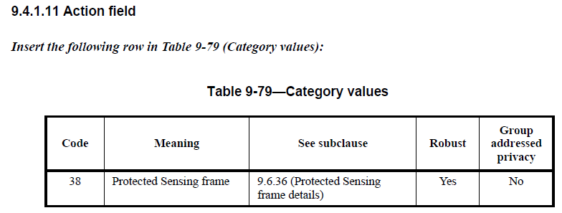
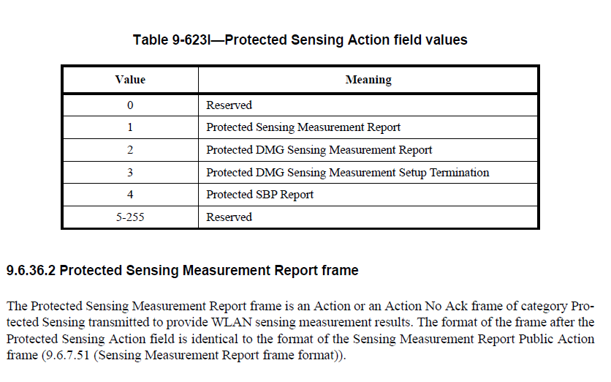

CID | Clause | Page | Comment | Proposed Change | Resolution
1623 | 11.55.1.5.2.6.1 | 183.37 | What does it mean for the sensing measurement report to remain consistent?? consistent in what sense? | Specify in the text what shall remain consistent, is it that the sensing measurement report may correspond to the current or previous TB sensing measurement instance? If so, specify this clear in the text. | Revised  The sentence indicated by commenter was deleted as per resolution of CID 1917 and implemented in D1.1.  No further changes required.
1893 | 11.55.1.5.2.6.1 | 183.37 | The information in this sentence appears the same as the one in the paragraph starting in Line 45 of the same page. Suggest remove this sentence (i.e., "The sensing measurement report may corresponding to ... with the same measurement setup"). | As in comment. If the assignee of this comment chooses keeping this sentence, "and shall" should be changed to "which shall". | Revised  The sentence indicated by commenter was deleted as per resolution of CID 1917 and implemented in D1.1.  No further changes required.

Discussion:

- As discussed in contribution 11-23/0727r1, in response to CID 1917, the text identified by CID 1623 and 1893 was deleted.
- This change has been implemented in D1.1.

For reference the following modifications have been suggested by 11-23/0727r1:

For a sensing responder which is a sensing receiver, the reporting phase shall be present in a TB sensing measurement instance if the Sensing Measurement Report Requested subfield within the Sensing Measurement Setup Request frame is set to 1. In this case, sensing measurement results obtained in a TB sensing measurement instance shall be reported during the reporting phase and the transmission of Sensing Measurement Report frame shall be conveyed to the STA by the MLME primitive MLME-SENSTBREPORTRQ. request. The sensing measurement report may correspond to either the current or previous TB sensing measurement instance, and shall remain consistent throughout all the subsequent TB sensing measurement instances associated with the same measurement setup.

The SME of a sensing receiver shall request the transmission of a Sensing Measurement Report frame to the sensing initiator by generating an MLME-SENSREPORTRQ.request primitive. During a TB sensing measurement instance, the sensing responder uUpon receiving the Sensing Report Trigger frame shall transmit either a measurement report frame corresponding to the sensing measurement result of the SI2SR NDP for the current measurement instance or the previous measurement instance consistently throughout all the subsequent TB measurement instances corresponding to the same measurement setup.

CID | Clause | Page | Comment | Proposed Change | Resolution
1890 | 11.55.1.2 | 170.28 | RSSI is measured in PHY, which is passed to MAC via RXVECTOR. In 11ax, the allowed values for the RSSI parameter in RXVECTOR are in the range from 0 to 255 inclusive. So, there is an inconsistency between the RSSIs defined in 11ax and 11bf. | Add a new parameter, e.g., SENS_RSSI, in RXVECTOR in 36.2 with the RSSI value range specified for 11bf. | Revised  An additional RXVECTOR parameter is not necessary since the Per-RX-antenna RSSI field value is derived from the existing RSSI parameter as per Table 9-127q.  To improve clarity, a reference to Table 9-127q is added to the text in 11.55.1.2.  TGbf editor to make changes shown in 11-23/0941r1.

Discussion:
- From the RXVECTOR definition for the 11ax PHY (table 27-1), there is the following definition:

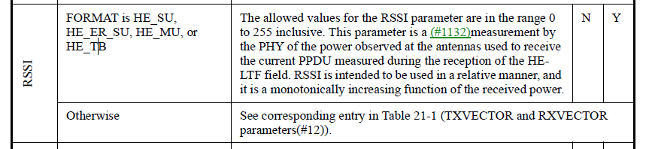

- The encoding and interpretation of the RSSI values for the purpose of the sensing measurement report can be found in the P802.11bf D1.1 in Table 9-127q as follows:
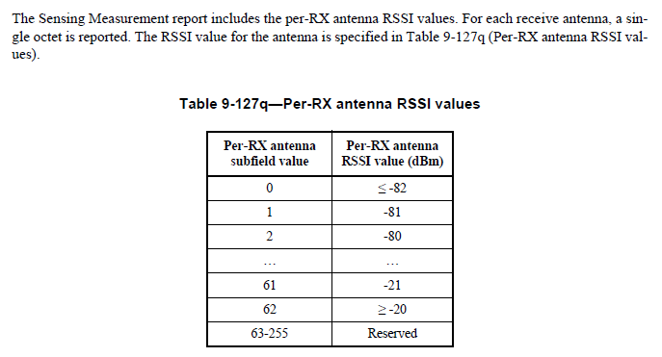

TGbf Editor: Modify the text in D1.0 170.28-29 as follows:

The per-RX antenna RSSI reported in the Sensing Measurement Report frame shall be in the range of 0 to 62 (see Table 9-127q (Per-RX antenna RSSI values))(#1971, #1890).

SP:
Do you support the resolution to CIDs 1231 1403 1454 1623 1805 1890, and 1893
as proposed in 11-23/0941r1 and incorporating the changes into the latest TGbf draft?

Y/N/A

