IEEE P802.11
Wireless LANs
LB272 Comment resolution for SBP procedure CID 1625
Date: 2023-6-01
Author(s):
Name | Affiliation | Address | Phone | email
Zhuqing Tang | Huawei  Technologies | F3, Huawei Base, Shenzhen, Guangdong, China |  | tangzhuqing@huawei.com
Rui Du
Narengerile
Mengshi Hu
Yiyan Zhang

Abstract
This submission resolves the comments of the CID 1625

Rev 0: Initial document

CID 1625
CID | Page.  Line | Clause Number | Comment | Proposed Change | Resolution
1625 | 191.55 | 11.55.2.2 | If the SensingMeasurementParameters will be identical to the one requested by the SBP Initiator, then all the TB sensing measurement setups will use the same exact parameters and the AP as Initiator will not be able to choose the sensing parameters according to the current capabilities of the sensing responders involved in the TB sensing used to satisfy the SBP sensing request. This would mean that all responders may be transmitters or all may be receivers or all may be transmitters and receivers. | Specify what in the Sensing Measurement Parameters field of the Sensing Measurement Parameters element in the SBP Request frame may be suggested by the SBP initiator and what should be left for the SBP responder to decide itself according to the capabilities of the sensing responders | Revised  Agree with the commenter in principle.  TGbf Editor make changes specified in 11-23/0938r0.

Discussion

1. For the proposed change, the fields that can be suggested by SBP initiator: BW, TX HE-LTF Repetition, RX HE-LTF Repetition, TX STS, RX STS, Number of RX Antennas, Report Timestamp. This is because the SBP initiator may have the requirement of the quality of the sensing measurement results in the report and these parameters determine the performance of the sensing measurement results.

Sensing measurement parameters field:
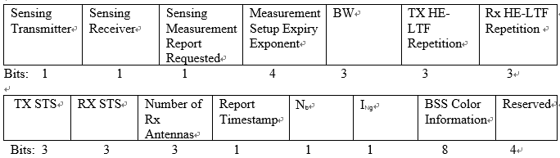

2. Delete the indicated sentence: The SensingMeasurementParameters parameter within the MLME-SENSMSMTSESSION.request primitive issued to initiate a sensing procedure used to satisfy an SBP request shall be identical to the SensingMeasurementParameters parameter within the corresponding MLME-SBP.request primitive.

Reason:
The sensing measurement parameters element contained in the SBP request frame should not be identical to that is used in sensing measurement request frame in sensing procedure. Some fields in the sensing measurement parameters element need to be clarified. In specific, the AID/USID field and the Availability Window field in the TB Sensing Specific subelement shall be reserved, as they should be assigned by AP.
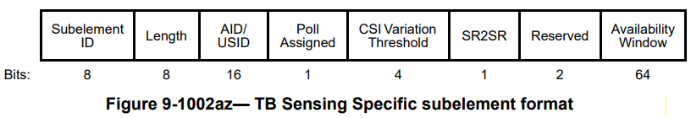

Resolution

Instructions to the editor: please modify the following sentence in the paragraph in the subclause in P154L5 in 11.55.2.2 Sensing Measurement parameters element in D1.1 as shown below:

The SensingMeasurementParameter parameter within the MLME-SENSMSMTSETUP.request primitive issued to initiate a WLAN sensing procedure used to satisfy an SBP request shall be identical to the SensingMeasurementParameter parameter within the corresponding MLME-SBP.request primitive.

If the SensingMeasurementParameters parameter is within a MLME-SBP.request primitive, the BW field, TX HE-LTF Repetition field, RX HE-LTF Repetition field, TX STS field, RX STS field, Number of Rx Antennas field, and the Report Timestamp field within the SensingMeasurementParameters parameter within a MLME-SBP.request primitive shall be suggested by the SBP initiator, and the remaining fields within the SensingMeasurementParameters parameter shall be determined by the SBP responder according to the capabilities of the sensing responders.

Instructions to the editor: please add the following sentence in the paragraph in the subclause in P73L62 in 9.4.2.319 Sensing Measurement parameters element in D1.1 as shown below:

The AID/USID field is reserved if a TB sensing specific subelement is included in the sensing measurement parameters element in the SBP request frame

Instructions to the editor: please add the following sentence in the paragraph in the subclause in P74L49 in 9.4.2.319 Sensing Measurement parameters element in D1.1 as shown below:

The Availability Window field is reserved if a TB sensing specific subelement is included in the sensing measurement parameters element in the SBP request frame

SP
Do you support the comment resolutions provided for the CIDs 1625 to be included in the latest 11bf draft?

Y/N/A

