IEEE P802.11
Wireless LANs
Proposed Resolution for REVme LB273 Editor1 ad-hoc Comments
Date: 2023-06-01
Author:
Name | Affiliation | Address | Phone | Email
Emily Qi | Intel Corporation | 2111 NE 25th Ave.  Hillsboro OR 97124 |  | Emily.h.qi@intel.com

This submission present proposed resolutions for comments in the Editor1 ad-hoc group.

The proposed changes are based on REVme/D3.0.

Revision history:

R0 – initial version
R1: incorporated feedback from the discussion on
R2: added 8 more new comments at the end of doc for review.

4013 | 621.01 | 9.2.4.8.1 |  | Table 9-34expresses units in the title of the table, which is non-traditional (i.e., easy to miss) and not as precise as could be | Dete "(octets)" and "in microseconds" from table header, and instead add these as labels to each row (i.e. all rows are octets except the last which is microseconds)

Discussion:

Cited text:
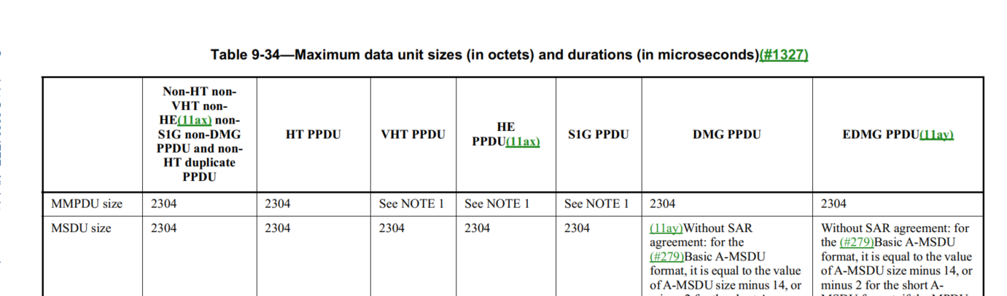

Proposed changes:

Proposed resolution:
Revised.

Change the table title to “Maximum data unit sizes and durations”
Change “size” in the first column to “size (in octets)”
Change “duration” in the first column to “duration (in microseconds)”.

4025 | 1871.00 | 10.11 | A | Since the term RSNA has been defined, it's better to use 'non-RSNA' instead of 'non-RSN association' | as in comment.

Discussion:

Cited text:
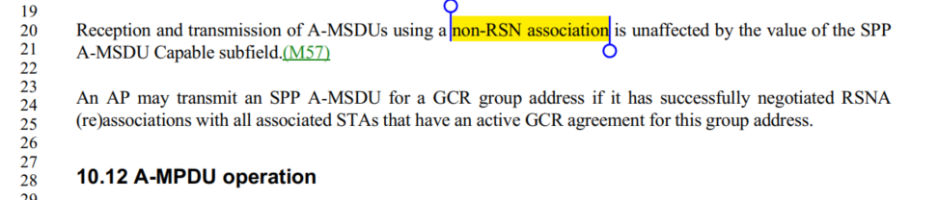

Change “non-RSN association” to “non-RSNA”

At 2864.24, change “RSN association” to “RSNA”.
At 1871.23, change “RSNA (re)association” to “RSNA”.

Proposed Resolution:

Revised.

At 1871.20, Change “non-RSN association” to “non-RSNA”
At 2864.24, change “RSN association” to “RSNA”.
At 1871.23, change “RSNA (re)association” to “RSNA”.

4096 | 725.50 | 9.3.3.10 |  | I think the sentence "The TVHT Operation element is present for a TVHT STA whendot11TVHTOptionImplemented is true; otherwise it is not present"should just say:"The TVHT Operation element is present for a STA whendot11TVHTOptionImplemented is true; otherwise it is not present" | delete 'TVHT' before STA in the sentence so it reads:"The TVHT Operation element is present for a STA whendot11TVHTOptionImplemented is true; otherwise it is not present"

Discussion:

Cited text:

Proposed change:

"The TVHT Operation element is present for a TVHT STA when dot11TVHTOptionImplemented is true; otherwise it is not present.”

Proposed Resolution:
Accepted.

4106 | 202.22 | 3.2 |  | "nonenhanced" (EDMG) does not have a hyphen, but in the 2.16+2.16 PPDU definition, and 4.32+4.32 PPDU definition, there is a hyphen. | replace "non-enhanced" with "nonenhanced"

Discussion:
Cited text:
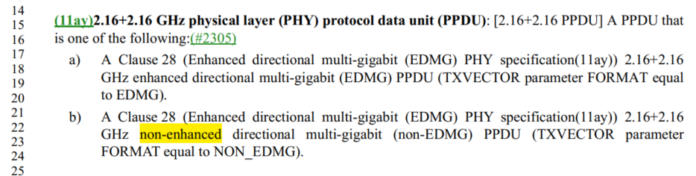

2 instances of “non-enhanced”.

6 instances of “nonenhanced”.

Proposed Resolution:

Accepted.
Note to editor: locations are: 202.22 and 202.56.

4114 | 322.00 | 4.9.1 |  | The PHY is a complete layer, not a sublayer. | Change "PHY Sublayer" to "PHY Layer" in Figure 4-24 (2x), and also in Figure 4-25 (2x).

Discussion:
Cited text:
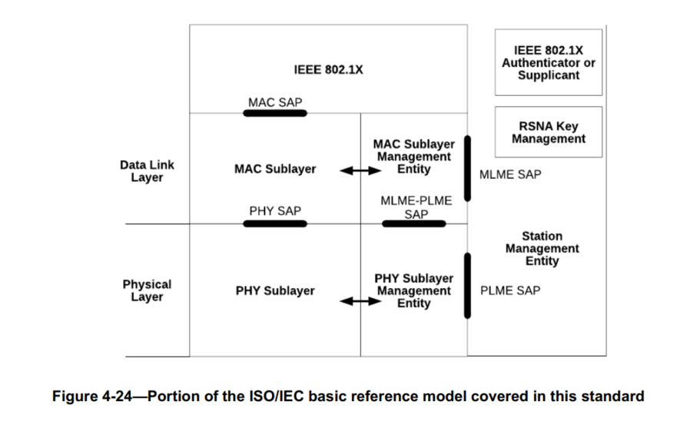
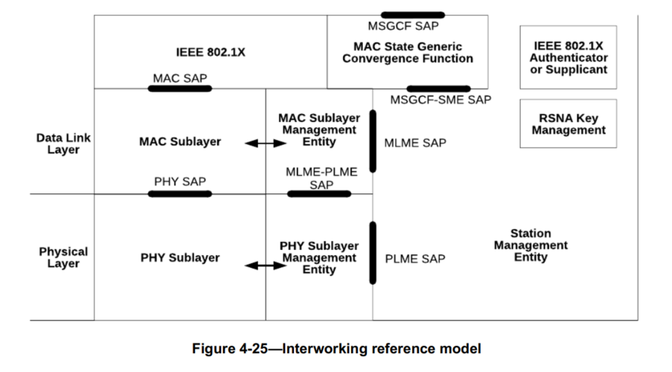

However, I found 20 instances of PHY sublayer in D3.0.

Should we review them one by one?

Note that both figures are editable. Commenter doesn’t need to provide visio source files.

Assigned to Mark H for a submission. – more work required.

Proposed Resolution:

?

4122 | 1348.42 | 9.4.2.231.1 |  | Missing ".". Also, should there be a space? Misc other related typos. | P1348.42 has "PHY-CCA indication (IDLE)" (no ".", and a space). Add the dot, for sure. (Same thing at P1349.41.) The space seems to be inconsistent: P568.15 has space, P568.63 does not. Which should it be? (This applies to all the primitive types, "request, indication, response, confirm", which are all inconsistent.) Another issue: P2366.10 has "busy" instead of "BUSY". And, finally, P2768.30 has "PHY-CCA.INDICATION" ("indication" should be lower case).

Discussion:

At 1348.42 and 1349.31, instances with a space:
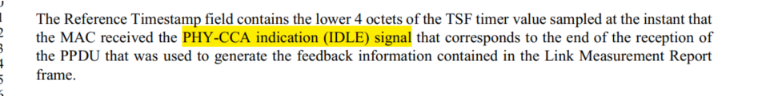

“MAC received the PHY-CCA indication (IDLE) signal”.

At 568.15/63. Instances with “.”:

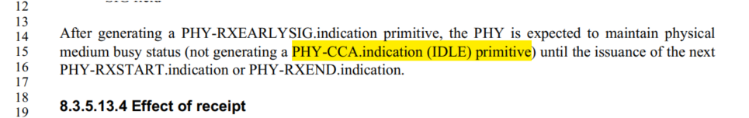

“PHY-CCA.indication (IDLE) primitive”

When it is a primitive, it shall be PHY-CCA.indication.

In other instances, we need to evaluate each of them.

Agreed with the following changes:
P2366.10 has "busy" instead of "BUSY". And, finally, P2768.30 has "PHY-CCA.INDICATION" ("indication

Assigned to Mark H. More work required.

Proposed Resolution

Option 1:
Revised.
At 2366.10, change “PHY-CCA.indication (busy) primitive” to “PHY-CCA.indication (BUSY) primitive”.
At 2768.30, change “PHY-CCA.INDICATION" to “PHY-CCA.indication"

Option 2: the Commenter to provide a submission.
4125 | 1868.00 | 10.11 |  | We don't refer to fields so informally | Change "SAs are all the same" to "SA fields are all the same". Same thing for DAs on that same line.
Discussion:

Cited text:
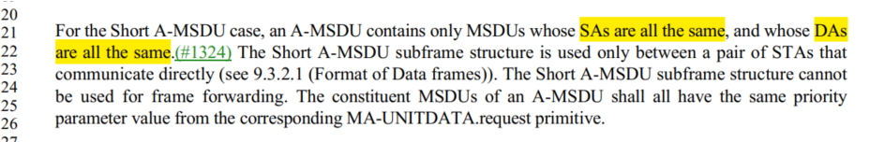

Proposed Resolutions
Rejected.
Reject reason: The SA and DA are associated with an MSDU, but are not fields (rather they are parameters in the MA-UNITDATA.request (where they are called "source/destination address")). The current text is accurate.

4170 |  | 9.4 |  | Saying in text that a field "is 2 octets" duplicates the figure | Delete "The length of theAuthentication Algorithm Number field is 2 octets." in 9.4.1.1, "The length of the Authentication Transaction Sequence Number field is 2 octets." in 9.4.1.2, "The length of the Beacon Interval field is 2 octets." in 9.4.1.3, "The length of the Capability Information field is 2 octets." in 9.4.1.4, "The length of the Listen Interval field is 2 octets." in 9.4.1.6, "The length of the Reason Code field is 2 octets." in 9.4.1.7, "The length of the AID field is 2 octets." in 9.4.1.8, "The length of the Block Ack Parameter Set field is 2 octets." in 9.4.1.13, "Thelength of the Block Ack Timeout Value field is 2 octets." in 9.4.1.14, "The length of the Originator Preferred MCS fieldis 2 octets." in 9.4.1.15, "The length of the DELBA Parameter Set field is 2 octets." in 9.4.1.16, "The length of the RSN Capabilities field is 2 octets." in 9.4.2.23.4, "is 2 octets and" in 9.4.2.46,

Discussion

All instances are in clause 9 and after figures.

Proposed Resolution:
Accepted.

4209 | 572.44 | 9.2.2 |  | "A field or subfield within the figure depiction of a frame format that includes a decimal value withinparentheses indicates that this field or subfield is set to the indicated value upon transmission." -- doesn't account for textual cases, e.g. "(Control)" in Figure 9-37--Frame Control field subfield values within Control framescarried in a non-S1G PPDU and Figure 9-1212--Frame Control field subfield values within PV1 Control frames (are there any parentheticals that are actually part of the field name?) | Delete "decimal" in the cited text

Discussion:

Cited text:

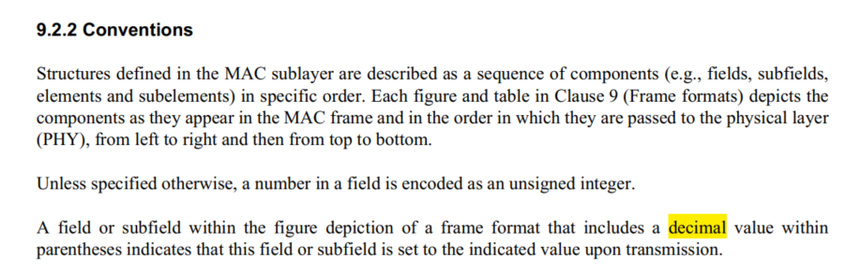

Listed example:
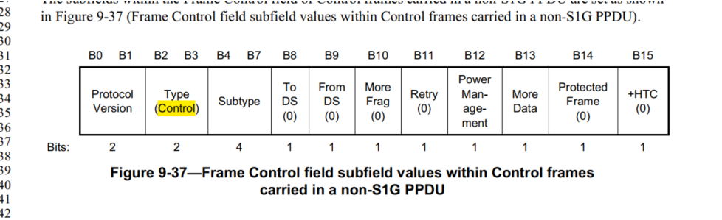

Proposed Changes:
Revised.

Replace "includes a decimal value" with "includes a value (decimal, if numeric)"

4238 | 370.34 | 6.4 |  | "TDLS peer U-APSD" in Table 6-1 should be "TDLS peer U-APSD (TPU)" | As it says in the comment

Discussion:
Cited text:
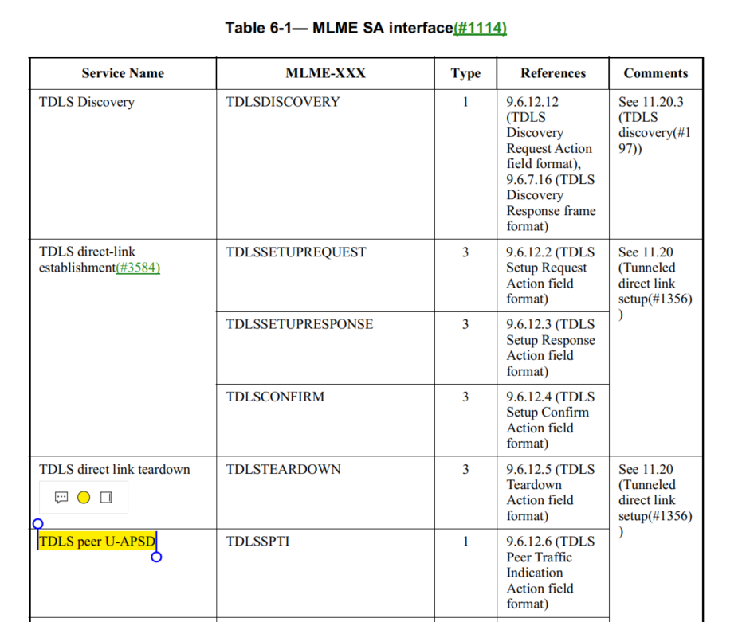

Proposed Resolution:
Accepted.

4296 | 580.01 | 9.2.4.1.4 |  | "QMF Management frame" in Table 9-4--Combinations of To DS and From DS subfields in Management frames is weird because "QMF" stands for "QoS Management frame" | In that table change "QMF Management frames" to "QMFs" and "Non-QMF Management frames" to "Management frames that are not QMFs"

Discussion:

Cited text:
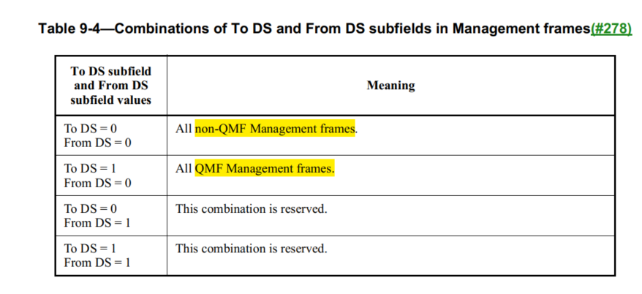

Proposed Resolution:
- Accepted.

4301 | 650.48 | 9.3.1.8.9 |  | "one EDMG Multi-TIDBlockAck" should be "one EDMG Multi-TIDBlockAck frame" | As it says in the comment
Discussion:

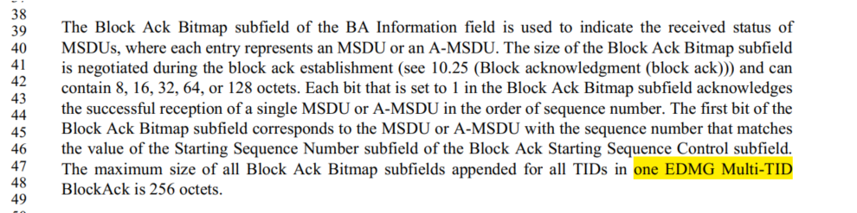

Proposed change: “The maximum size of all Block Ack Bitmap subfields appended for all TIDs in one EDMG Multi-TID BlockAck frame is 256 octets”.

Proposed Resolution:
Accepted.

4310 | 1357.12 | 9.4.2.240 |  | "SAE hash-to-element field" should be "SAE Hash-to-element field". Also, at 2817.61 change " SAE hash-to-element bit" to " SAE Hash-to-element bit" and at 2811.44 change "SAE Hash-to-element(#3178) method" to "SAE hash-to-element(#3178) method" | As it says in the comment
Discussion:

Cited texts:
At 1357.12:
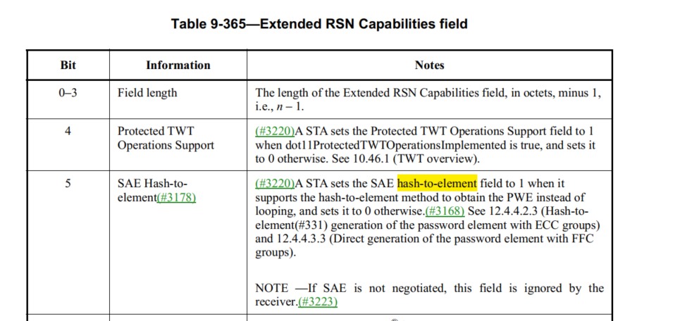

At 2817.61

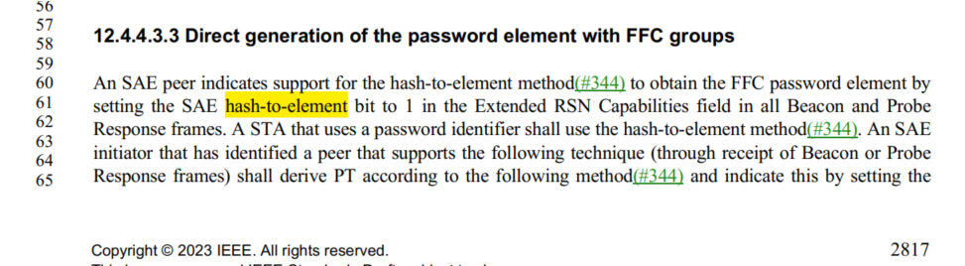
At 2811.44
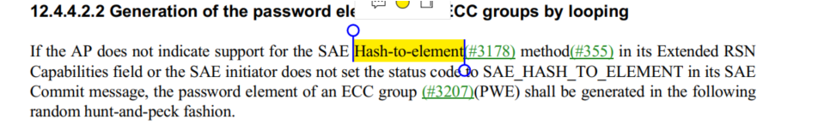

Proposed Resolution:
Accepted.
4333 | 854.53 | 9 |  | There should be no "element" (except in the xref caption) in the non-heading cells of the first column of Table 9-128--Element IDs | Change "AKM Suite Selector element (See" to "AKM Suite Selector (see"

Discussion:
Cited text:
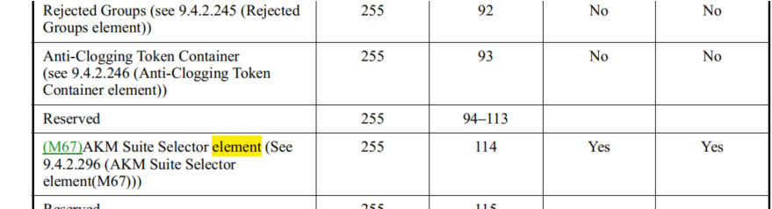

Proposed Resolution:
Accepted.

Note to editor: also change “See” to “see”.

4334 |  | 9.6.5 |  | Change "9.6.5 Vendor-specific Action frame details" to "9.6.5 Vendor-specific frame details", since VS frames are not a family of frames identified by an Action field, unlike other Action frames | As it says in the comment

Discussion:
Cited text:
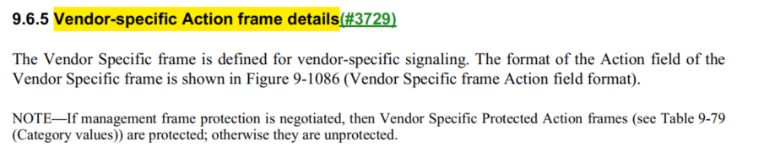
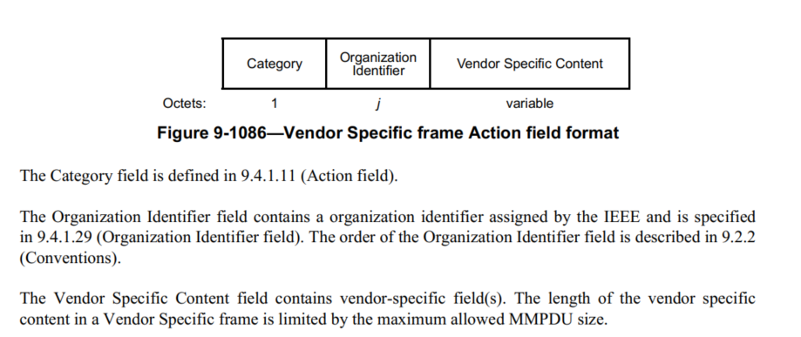

Let’s look at the action field definition:

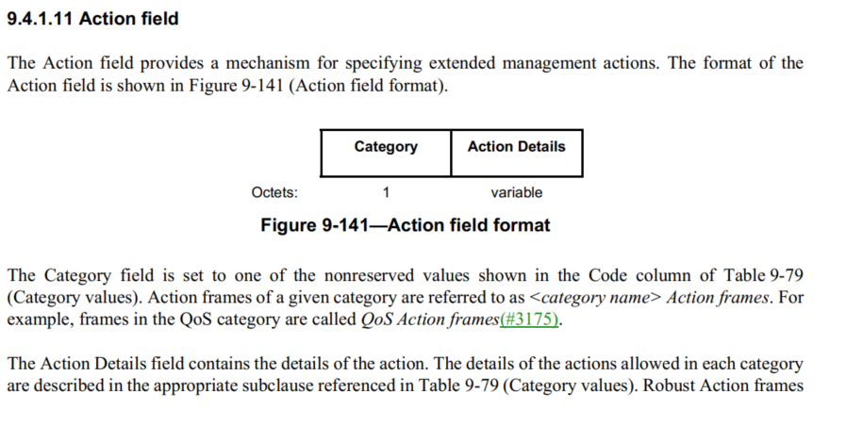
The VS action frame format includes the Category field and Action Details field. The Action Details field includes the Organization Identifier field and the Vendor Specific Content field. Therefore, VS action frame is an Action frame.

Assigned to Jouni. More work required.
Transferred to GEN.

Proposed Resolution:
Rejected.
Reject reason: The VS action frame format includes the Category field and Action Details field. The Action Details field includes the Organization Identifier field and the Vendor Specific Content field. Therefore, VS action frame is an Action frame.

4361 | 1870.08 | 10.11 |  | "The length of an A-MSDU transmitted in a VHT PPDU or HE PPDU(11ax) is limited by the maximumMPDU size supported by the recipient STA (see 10.12.5 (Transport of A-MPDU by the PHY data service))." looks like a stale xref | Put in the correct xref

Discussion:

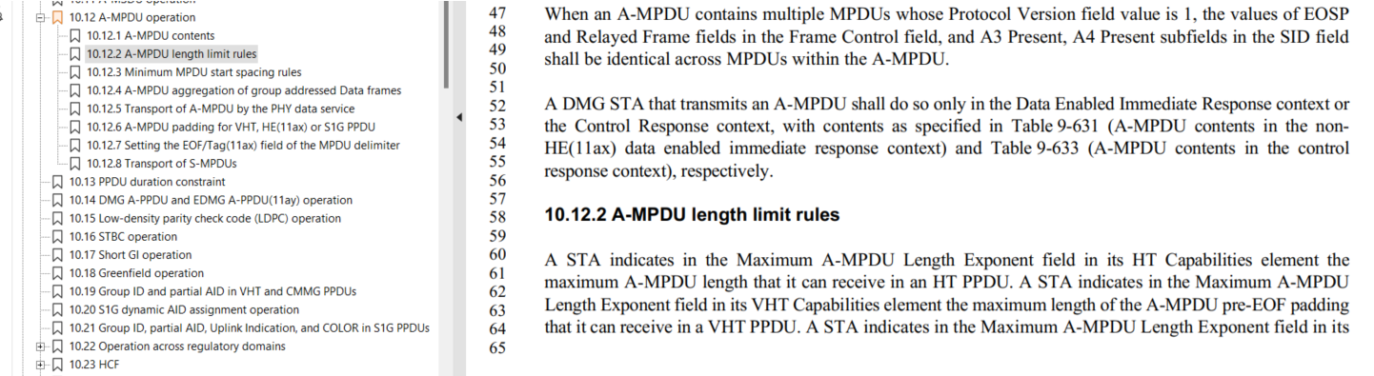

The correct xref is 10.12.2.

Assinged to Steve M. More work required.
Transferred to MAC.

Proposed Resolution:
Revised.
Change “10.12.5 (Transport of A-MPDU by the PHY data service))." to “10.12.2 (A-MPDU length limit rules)”.

4387 | 308.24 | 4.5.3.3 |  | "To deliver an MSDU within an ESS via the DS, the DS needs to know which AP within the ESS to deliver the MSDU, ". Looks like "to" is missing after "the MSDU" | Change sentence to "(...) needs to know which AP within the ESS to deliver the MSDU to, "

Discussion:
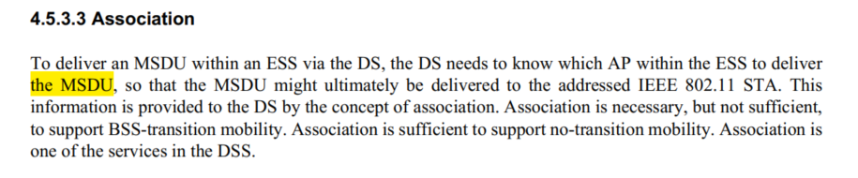
Proposed change:
“To deliver an MSDU within an ESS via the DS, the DS needs to know which AP within the ESS to deliver the MSDU to, so that the MSDU might ultimately be delivered to the addressed IEEE 802.11 STA.”

Proposed Resolution
Accepted.

4156 |  | 9 |  | The Greek letters in Table 9-114--Order of... are different from those in Table 9-89--Order of..., which makes it hard to search for references to the angles | Use the same Greek letter glyphs everywhere. Specifically, use the Unicode Greek letter glyphs (9-89 and 9-114 seems to use some proprietary horror; 9-99 seems to use some proprietary horror for phi but not for psi!)

Discussion:

At 819.23
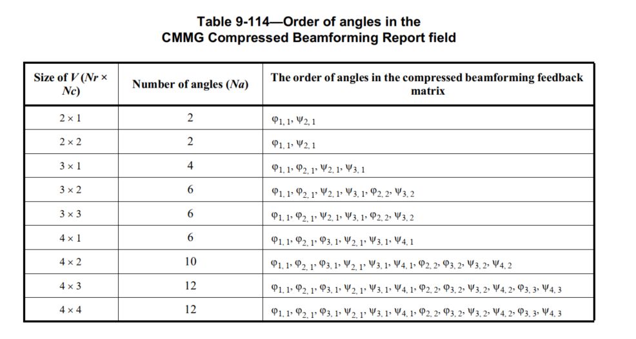

At 776.21:
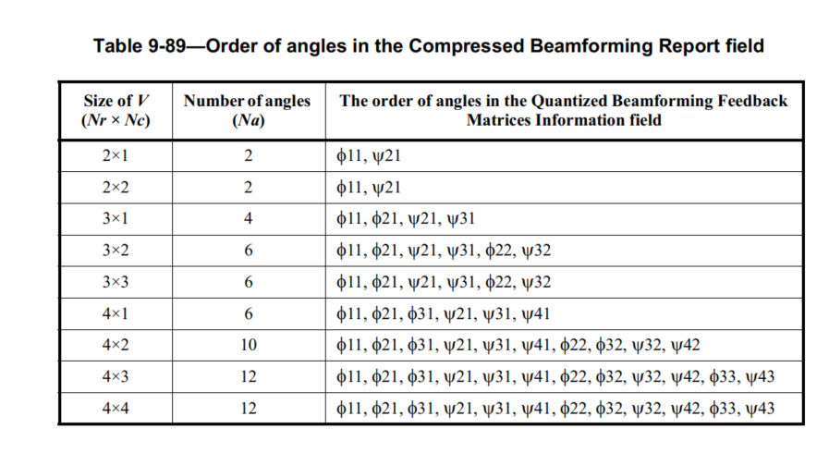

In IEEE SA Standards Style Manual, there is no recommendation on what type of Greek letter glyphs shall be used.

My recommendation is rejected, or if someone want to own this comment.

Reject Reason: The cited text does not affect an implementation. The meaning of the cited text is clear.

Proposed Resolution: ?

4169 |  | 9.8 |  | "an SID" should be "a SID" (12x) | As it says in the comment [I can provide locations if needed; confirm direction]

Discussion:

SID stands for “short identifier”.
Found 12 instances of “an SID”.

Need group direction: How do we pronounce “SID”?

Proposed Resolutions:

4181 |  | 9 |  | "[see" should be "(see" and similarly for closing ] (~18x) | As it says in the comment [I can provide locations if needed; confirm direction]

Discussion:

I found 18 instances.

Proposed Resolution:
Accepted

4210 |  | 9 |  | "A field or subfield within the figure depiction of a frame format that includes a decimal value withinparentheses indicates that this field or subfield is set to the indicated value upon transmission." -- in the teleconf on 2023-01-06 it was stated by the Editor that figures should not have numeric field values | Delete all such parentheticals [big item]

Discussion:

CID 4209 commented on the same sentence.

4209 | 572.44 | 9.2.2 |  | "A field or subfield within the figure depiction of a frame format that includes a decimal value withinparentheses indicates that this field or subfield is set to the indicated value upon transmission." -- doesn't account for textual cases, e.g. "(Control)" in Figure 9-37--Frame Control field subfield values within Control framescarried in a non-S1G PPDU and Figure 9-1212--Frame Control field subfield values within PV1 Control frames (are there any parentheticals that are actually part of the field name?) | Delete "decimal" in the cited text

The resolution for CID 4209 is:

Revised. Replace "includes a decimal value" with "includes a value (decimal, if numeric)".

CID 4210 should have the same resolution as CID 4209.

Proposed Resolutions:’
Revised.
Replace "includes a decimal value" with "includes a value (decimal, if numeric)".

Note to Editor: same resolution as CID 4209.

4336 |  | 9 |  | "Operating Class and Channel field" sounds like two fields, not one field, so is very confusing | Change "and" to "And" throughout (in 9.4.1.22 Operating Class and Channel field, 9.4.2.69.3 Location Indication Channels subelement, 9.4.2.84 Channel Usage element, 9.9.3.3 WUR Discovery frame format, 11.21.15 Channel usage procedures)

Discussion:

We talked about this issue in TGmd.

The conclusion is to include the following paragraph in the Editorial Style Guide:

For proper names, all words in the name (excluding acronyms) should be capitalized, including prepositions and conjunctions. This is to avoid ambiguity where the preposition or conjuction might be misinterpreted as part of the sentence. For example, “HT And VHT Trigger Frame RX Support subfield.” This rule may not apply to legacy text; these remain unchanged since the effort involved in changing all instances is substantial and no harm has been demonstrated.

See: https://mentor.ieee.org/802.11/dcn/09/11-09-1034-20-0000-802-11-editorial-style-guide.docx

Proposed Resolution:

Rejected.
Reject Reason: “Operating Class and Channel field" is legacy text and remains unchanged. For any new field name definition, all words in the name (excluding acronyms) should be capitalized, including prepositions and conjunctions, as it stated in https://mentor.ieee.org/802.11/dcn/09/11-09-1034-20-0000-802-11-editorial-style-guide.docx

4357 |  | 3.2 |  | Incorporation of the CID 1948 resolution intoD2.0 wasn't done correctly:REVISED (GEN: 2022-06-15 14:29:50Z) Add the following definition in Clause 3.2:non-high-efficiency (non-HE) physical layer (PHY) protocol data unit (PPDU): A PPDU that is transmitted by a Clause 15 (DSSS PHY specification for the 2.4 GHz band designated for ISM applications), Clause 16 (High rate direct sequence spread spectrum (HR/DSSS) PHY specification), Clause 17 (Orthogonal frequency division multiplexing (OFDM) PHY specification), or Clause 18 (Extended Rate PHY (ERP) specification) PHY, or not using a TXVECTOR FORMAT parameter equal to HE.And change non-high-thought (non-HT) physical layer (PHY) protocol data unit (PPDU): non-high-throughput (non-HT) physical layer (PHY) protocol data unit (PPDU): A PPDU that is transmitted by a Clause 15 (DSSS PHY specification for the 2.4 GHz band designated for ISM applications), Clause 16 (High rate direct sequence spread spectrum (HR/DSSS) PHY specification), Clause 17 (Orthogonal frequency division multiplexing (OFDM) PHY specification), or Clause 18 (Extended Rate PHY (ERP) specification) PHY, or not using a TXVECTOR FORMAT parameter equal to HT_MF, HT_GF, VHT. or HE | Implement the CID 1948 resolution as directed

Discussion

Resolution of CID 1948:
Add the following definition in Clause 3.2:
non-high-efficiency (non-HE) physical layer (PHY) protocol data unit (PPDU): A PPDU that is transmitted by a Clause 15 (DSSS PHY specification for the 2.4 GHz band designated for ISM applications), Clause 16 (High rate direct sequence spread spectrum (HR/DSSS) PHY specification), Clause 17 (Orthogonal frequency division multiplexing (OFDM) PHY specification), or Clause 18 (Extended Rate PHY (ERP) specification) PHY, or not using a TXVECTOR FORMAT parameter equal to HE.

And change non-high-thought (non-HT) physical layer (PHY) protocol data unit (PPDU):
non-high-throughput (non-HT) physical layer (PHY) protocol data unit (PPDU): A PPDU that is transmitted by a Clause 15 (DSSS PHY specification for the 2.4 GHz band designated for ISM applications), Clause 16 (High rate direct sequence spread spectrum (HR/DSSS) PHY specification), Clause 17 (Orthogonal frequency division multiplexing (OFDM) PHY specification), or Clause 18 (Extended Rate PHY (ERP) specification) PHY, or not using a TXVECTOR FORMAT parameter equal to HT_MF, HT_GF, VHT. or HE

The first change was made correctly correct. see: at 220.31 of D3.0

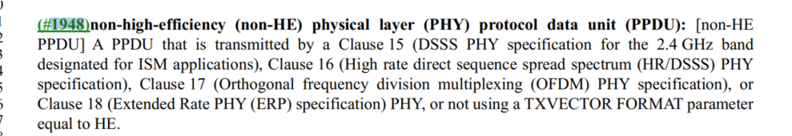

The second change was made to a wrong definition “... duplicate ...”. see: 221.21 of D3.0
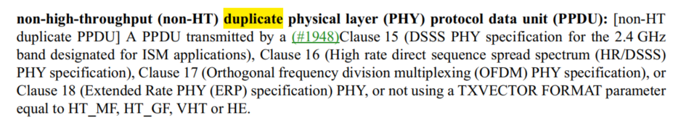

However. The definition that was supposed for the second change has already been updated based CID 3330, see 221.36:
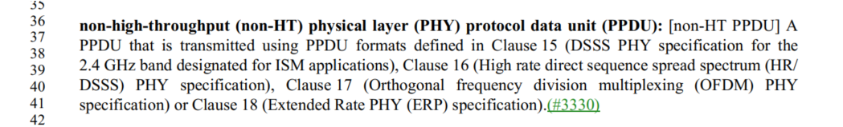

Therefore, the correction we should made is to reverse the change of the definition at 221.21 of D3.0.
Note that CID 1948 was implemented in D1.4.

Proposed Resolution:

Revised.
At 221.21,
Change:
“non-high-throughput (non-HT) duplicate physical layer (PHY) protocol data unit (PPDU): [non-HT
duplicate PPDU] A PPDU transmitted by a (#1948)Clause 15 (DSSS PHY specification for the 2.4 GHz
band designated for ISM applications), Clause 16 (High rate direct sequence spread spectrum (HR/DSSS)
PHY specification), Clause 17 (Orthogonal frequency division multiplexing (OFDM) PHY specification), or
Clause 18 (Extended Rate PHY (ERP) specification) PHY, or not using a TXVECTOR FORMAT parameter
equal to HT_MF, HT_GF, VHT or HE. “

To
“non-high-throughput (non-HT) duplicate physical layer (PHY) protocol data unit (PPDU): A PPDU
transmitted by a Clause 19 (High-throughput (HT) PHY specification) or Clause 21 (Very high throughput
(VHT) PHY specification) PHY with the TXVECTOR FORMAT parameter equal to NON_HT and the
CH_BANDWIDTH parameter equal to NON_HT_CBW40, CBW40, CBW80, CBW160, or CBW80+80.”

4359 | 1297.08 | 9.4.2.199.2 |  | Sometimes the N in N_STS,total is italicised, sometimes not | Italicised is far more popular, so fix in Table 9-343--Subfields of the S1G Capabilities Information field

Discussion

Cited text:
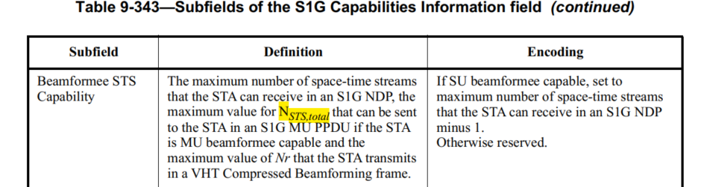

Proposed Resolution:

Accepted.
At 1297.8, Italicised N in N_STS,total.

4406 | 1283.13 | 9.4.2.198 |  | The location of this paragraph is not appropriate because the NDP Paging field exists only in the Individual TWT Parameter Set field explained in the next page. | Put the definition of NDP Paging Indicator field instead of the paragraph. For example, "The NDP Paging Indicator field is set to 1 to indicate that the NDP Paging field exists in the Individual TWT Parameter Set field; otherwise it is set to 0." Alternatively, the definition applies only when the Broadcast field is set to 0; and the NDP Paging Indicator field is reserved when the Broadcast field is set to 1. Further, move the current paragraph to P1291L62, after the paragraph of "The TWT Channel field ..." with a slight changes. For example, "The NDP Paging field is present in the Individual TWT Parameter Set field if the NDP Paging Indicator subfield in the Control field is equal to 1; otherwise, the NDP Paging field is not present.

Discussion

Cited text:
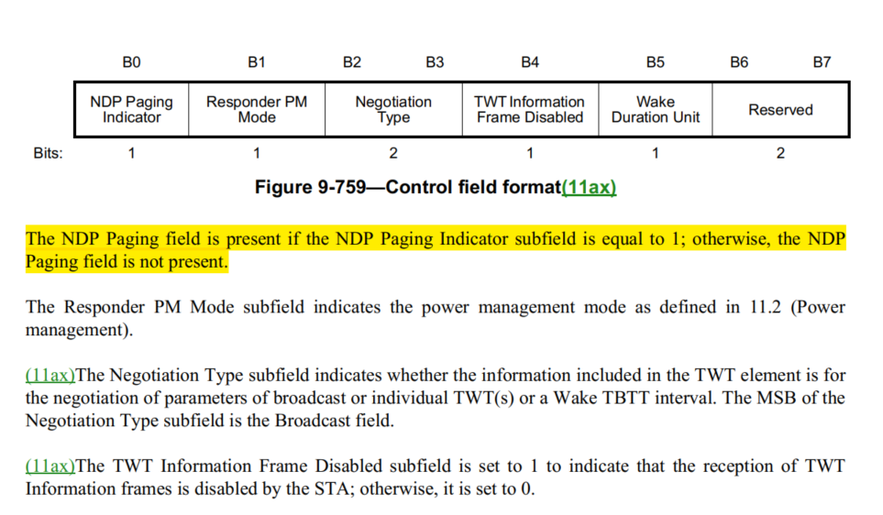
The cited text is for the definition of NDP Paging Indicator subfield, not for the NDP Paging Indiator field.

The format of the NDP Paging Indiator field is defined at 1292.23:
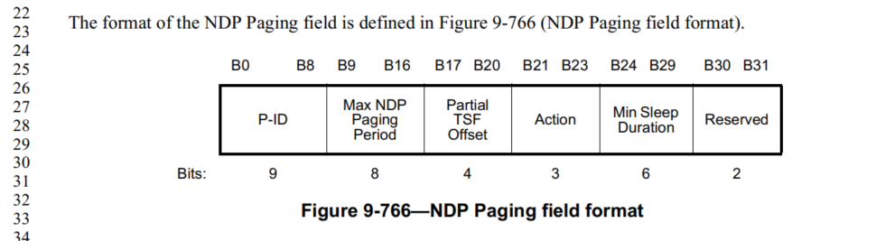

Proposed Resolution
Revised:
At 1283.13,
Change “The NDP Paging field is present if the NDP Paging Indicator subfield is equal to 1; otherwise, the NDP Paging field is not present.”
To
“The NDP Paging Indicator subfield is set to 1 to indicate that the NDP Paging field is present; otherwise, the NDP Paging field is not present.”

