IEEE P802.11
Wireless LANs
Proposed Resolution for REVme LB273 Editor1 ad-hoc Comments
Date: 2023-05-25
Author:
Name | Affiliation | Address | Phone | Email
Emily Qi | Intel Corporation | 2111 NE 25th Ave.  Hillsboro OR 97124 |  | Emily.h.qi@intel.com

This submission present proposed resolutions for comments in the Editor1 ad-hoc group.

The proposed changes are based on REVme/D3.0.

Revision history:

R0 – initial version

4013 | 621.01 | 9.2.4.8.1 |  | Table 9-34expresses units in the title of the table, which is non-traditional (i.e., easy to miss) and not as precise as could be | Dete "(octets)" and "in microseconds" from table header, and instead add these as labels to each row (i.e. all rows are octets except the last which is microseconds)

Discussion:

Cited text:
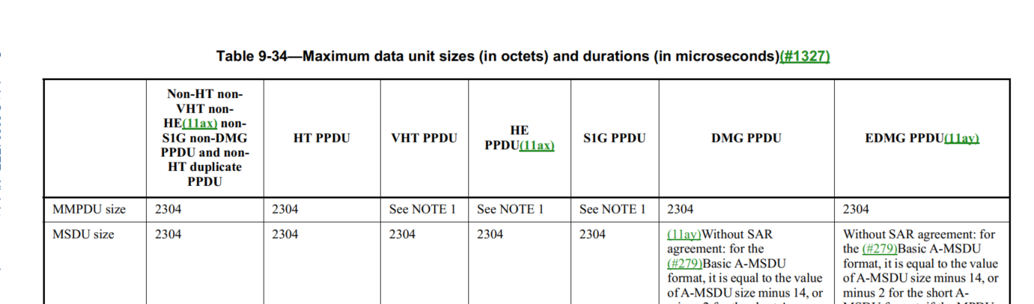

Proposed changes:
Change the table title to “Maximum data unit sizes and durations”
Change “size” of the first row to “size (in octets)”
Change “duration” of the first column to “duration (in microseconds)”.

Proposed resolution:
Accepted.

4025 | 1871.00 | 10.11 | A | Since the term RSNA has been defined, it's better to use 'non-RSNA' instead of 'non-RSN association' | as in comment.

Discussion:

Cited text:
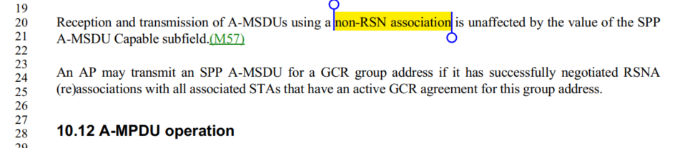

Change “non-RSN association” to “non-RSNA”

Proposed Resolution:

Accepted.
4096 | 725.50 | 9.3.3.10 |  | I think the sentence "The TVHT Operation element is present for a TVHT STA whendot11TVHTOptionImplemented is true; otherwise it is not present"should just say:"The TVHT Operation element is present for a STA whendot11TVHTOptionImplemented is true; otherwise it is not present" | delete 'TVHT' before STA in the sentence so it reads:"The TVHT Operation element is present for a STA whendot11TVHTOptionImplemented is true; otherwise it is not present"

Discussion:

Cited text:

Proposed change:

"The TVHT Operation element is present for a TVHT STA when dot11TVHTOptionImplemented is true; otherwise it is not present.”

Proposed Resolution:
Accepted.

4106 | 202.22 | 3.2 |  | "nonenhanced" (EDMG) does not have a hyphen, but in the 2.16+2.16 PPDU definition, and 4.32+4.32 PPDU definition, there is a hyphen. | replace "non-enhanced" with "nonenhanced"

Discussion:
Cited text:
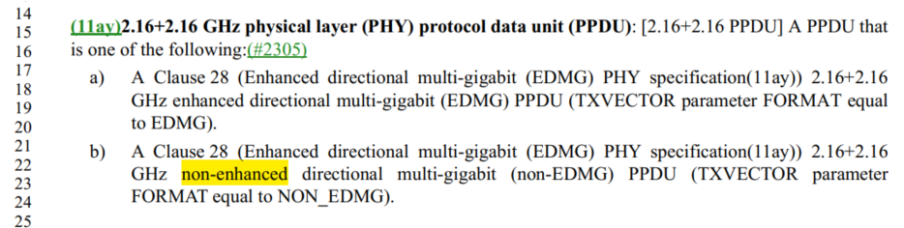

2 instances of “non-enhanced”.

6 instances of “nonenhanced”.

Proposed Resolution:

Accepted.
Note to editor: locations are: 202.22 and 202.56.

4114 | 322.00 | 4.9.1 |  | The PHY is a complete layer, not a sublayer. | Change "PHY Sublayer" to "PHY Layer" in Figure 4-24 (2x), and also in Figure 4-25 (2x).

Discussion:
Cited text:
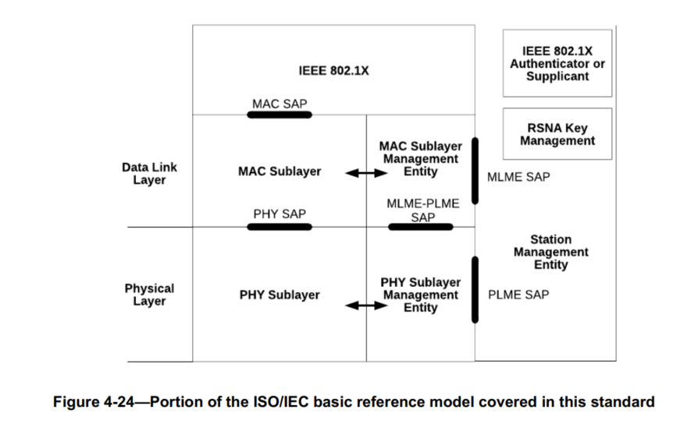
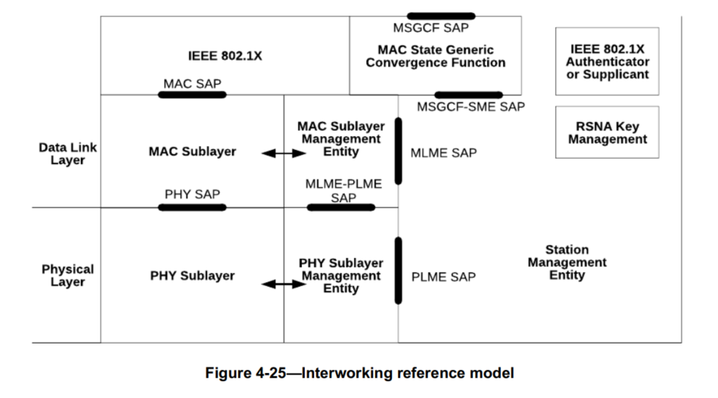

However, I found 20 instances of PHY sublayer in D3.0.

Should we review them one by one?

Note that both figures are editable. Commenter doesn’t need to provide visio source files.

Proposed Resolution:

?

4122 | 1348.42 | 9.4.2.231.1 |  | Missing ".". Also, should there be a space? Misc other related typos. | P1348.42 has "PHY-CCA indication (IDLE)" (no ".", and a space). Add the dot, for sure. (Same thing at P1349.41.) The space seems to be inconsistent: P568.15 has space, P568.63 does not. Which should it be? (This applies to all the primitive types, "request, indication, response, confirm", which are all inconsistent.) Another issue: P2366.10 has "busy" instead of "BUSY". And, finally, P2768.30 has "PHY-CCA.INDICATION" ("indication" should be lower case).

Discussion:

At 1348.42 and 1349.31, instances with a space:
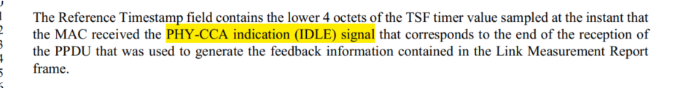

“MAC received the PHY-CCA indication (IDLE) signal”.

At 568.15/63. Instances with “.”:

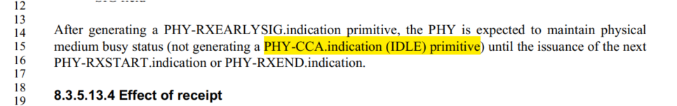

“PHY-CCA.indication (IDLE) primitive”

When it is a primitive, it shall be PHY-CCA.indication.

In other instances, we need to evaluate each of them.

Agreed with the following changes:
P2366.10 has "busy" instead of "BUSY". And, finally, P2768.30 has "PHY-CCA.INDICATION" ("indication

Proposed Resolution

Option 1:
Revised.
At 2366.10, change “PHY-CCA.indication (busy) primitive” to “PHY-CCA.indication (BUSY) primitive”.
At 2768.30, change “PHY-CCA.INDICATION" to “PHY-CCA.indication"

Option 2: the Commenter to provide a submission.
4125 | 1868.00 | 10.11 |  | We don't refer to fields so informally | Change "SAs are all the same" to "SA fields are all the same". Same thing for DAs on that same line.
Discussion:

Cited text:
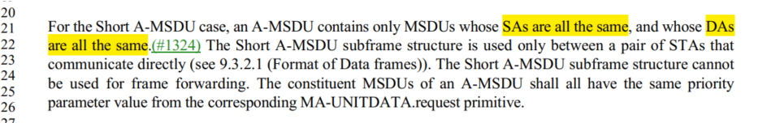

Agreed.

Proposed Resolutions
Accepted

4170 |  | 9.4 |  | Saying in text that a field "is 2 octets" duplicates the figure | Delete "The length of theAuthentication Algorithm Number field is 2 octets." in 9.4.1.1, "The length of the Authentication Transaction Sequence Number field is 2 octets." in 9.4.1.2, "The length of the Beacon Interval field is 2 octets." in 9.4.1.3, "The length of the Capability Information field is 2 octets." in 9.4.1.4, "The length of the Listen Interval field is 2 octets." in 9.4.1.6, "The length of the Reason Code field is 2 octets." in 9.4.1.7, "The length of the AID field is 2 octets." in 9.4.1.8, "The length of the Block Ack Parameter Set field is 2 octets." in 9.4.1.13, "Thelength of the Block Ack Timeout Value field is 2 octets." in 9.4.1.14, "The length of the Originator Preferred MCS fieldis 2 octets." in 9.4.1.15, "The length of the DELBA Parameter Set field is 2 octets." in 9.4.1.16, "The length of the RSN Capabilities field is 2 octets." in 9.4.2.23.4, "is 2 octets and" in 9.4.2.46,

Discussion

All instances are in clause 9 and after figures.

Proposed Resolution:
Accepted.

4209 | 572.44 | 9.2.2 |  | "A field or subfield within the figure depiction of a frame format that includes a decimal value withinparentheses indicates that this field or subfield is set to the indicated value upon transmission." -- doesn't account for textual cases, e.g. "(Control)" in Figure 9-37--Frame Control field subfield values within Control framescarried in a non-S1G PPDU and Figure 9-1212--Frame Control field subfield values within PV1 Control frames (are there any parentheticals that are actually part of the field name?) | Delete "decimal" in the cited text

Discussion:

Cited text:

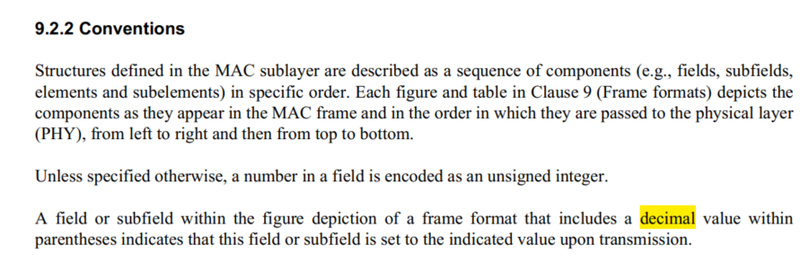

Listed example:
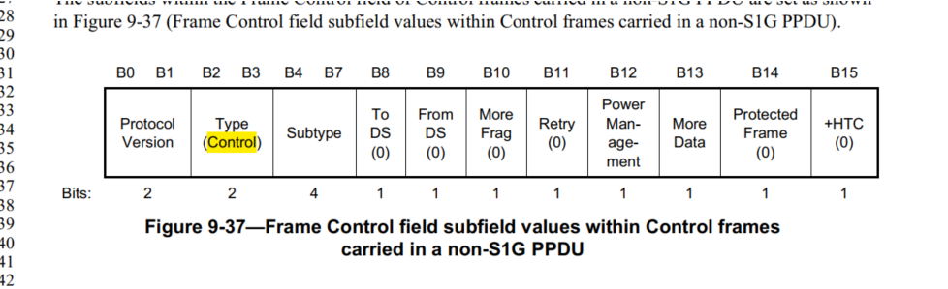

Proposed Changes:
Accepted.

4238 | 370.34 | 6.4 |  | "TDLS peer U-APSD" in Table 6-1 should be "TDLS peer U-APSD (TPU)" | As it says in the comment

Discussion:
Cited text:
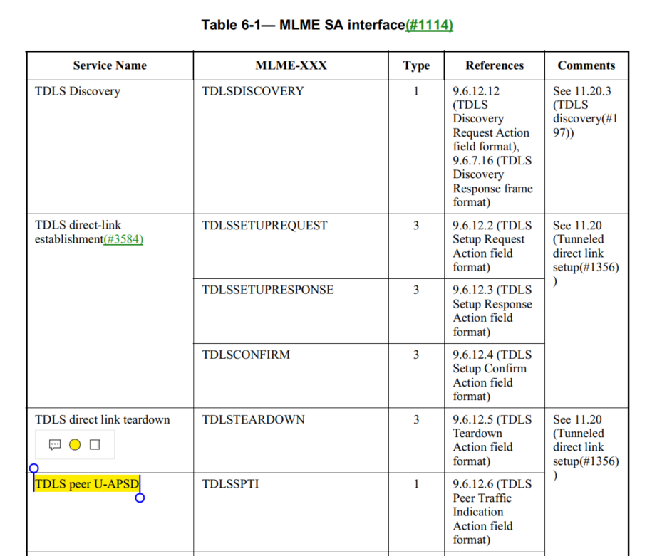

Proposed Resolution:
Accepted.

4296 | 580.01 | 9.2.4.1.4 |  | "QMF Management frame" in Table 9-4--Combinations of To DS and From DS subfields in Management frames is weird because "QMF" stands for "QoS Management frame" | In that table change "QMF Management frames" to "QMFs" and "Non-QMF Management frames" to "Management frames that are not QMFs"

Discussion:

Cited text:
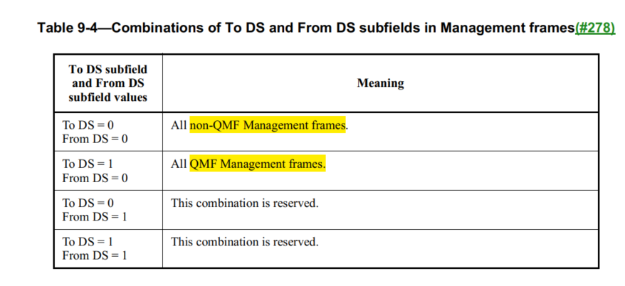

Proposed Resolution:
Accepted.

4301 | 650.48 | 9.3.1.8.9 |  | "one EDMG Multi-TIDBlockAck" should be "one EDMG Multi-TIDBlockAck frame" | As it says in the comment
Discussion:

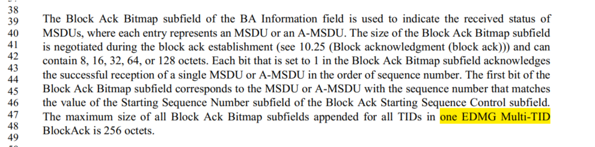

Proposed change: “The maximum size of all Block Ack Bitmap subfields appended for all TIDs in one EDMG Multi-TID BlockAck frame is 256 octets”.

Proposed Resolution:
Accepted.

4310 | 1357.12 | 9.4.2.240 |  | "SAE hash-to-element field" should be "SAE Hash-to-element field". Also, at 2817.61 change " SAE hash-to-element bit" to " SAE Hash-to-element bit" and at 2811.44 change "SAE Hash-to-element(#3178) method" to "SAE hash-to-element(#3178) method" | As it says in the comment
Discussion:

Cited texts:
At 1357.12:
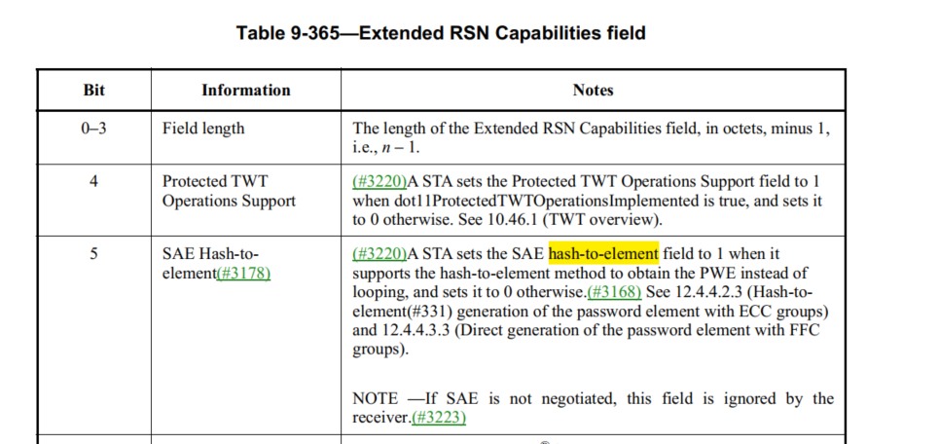

At 2817.61

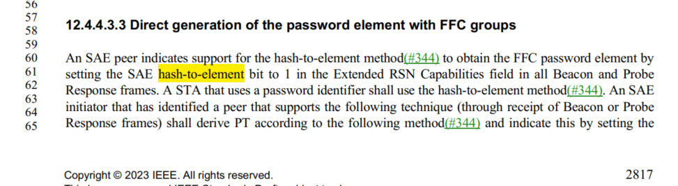
At 2811.44
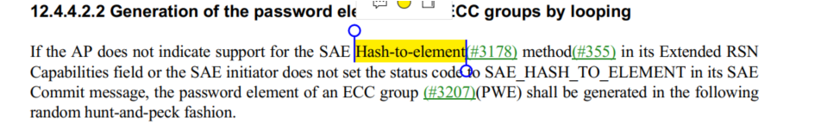

Proposed Resolution:
Accepted.
4333 | 854.53 | 9 |  | There should be no "element" (except in the xref caption) in the non-heading cells of the first column of Table 9-128--Element IDs | Change "AKM Suite Selector element (See" to "AKM Suite Selector (see"

Discussion:
Cited text:
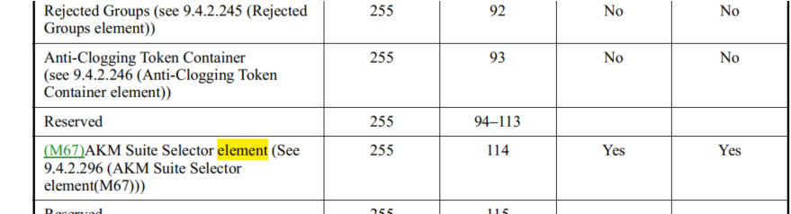

Proposed Resolution:
Accepted.

4334 |  | 9.6.5 |  | Change "9.6.5 Vendor-specific Action frame details" to "9.6.5 Vendor-specific frame details", since VS frames are not a family of frames identified by an Action field, unlike other Action frames | As it says in the comment

Discussion:
Cited text:
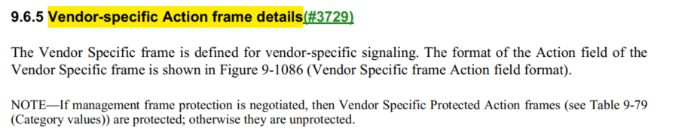
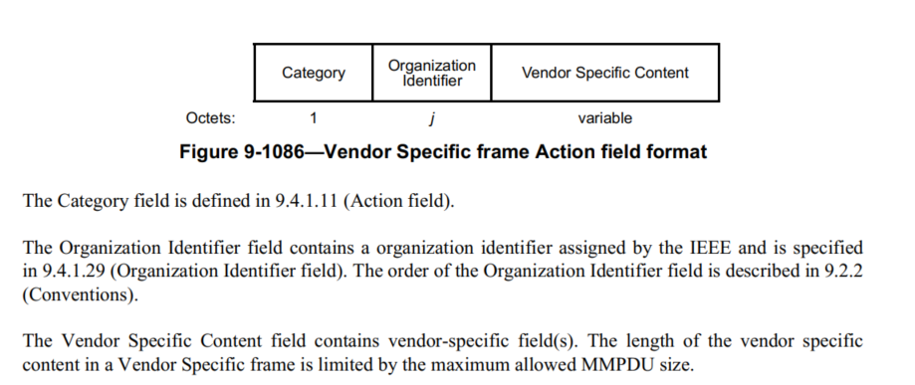

Let’s look at the action field definition:

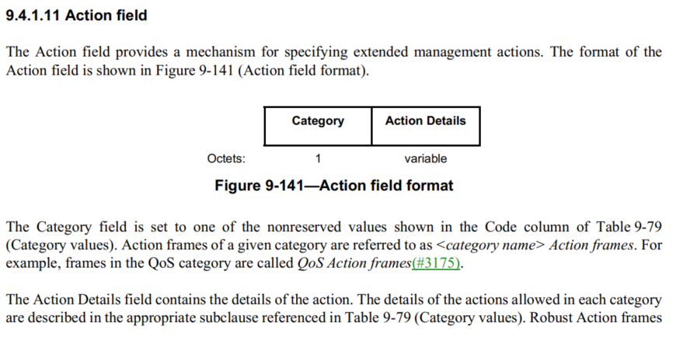
The VS action frame format includes the Category field and Action Details field. The Action Details field includes the Organization Identifier field and the Vendor Specific Content field. Therefore, VS action frame is an Action frame.

Proposed Resolution:
Rejected.
Reject reason: The VS action frame format includes the Category field and Action Details field. The Action Details field includes the Organization Identifier field and the Vendor Specific Content field. Therefore, VS action frame is an Action frame.

4361 | 1870.08 | 10.11 |  | "The length of an A-MSDU transmitted in a VHT PPDU or HE PPDU(11ax) is limited by the maximumMPDU size supported by the recipient STA (see 10.12.5 (Transport of A-MPDU by the PHY data service))." looks like a stale xref | Put in the correct xref

Discussion:

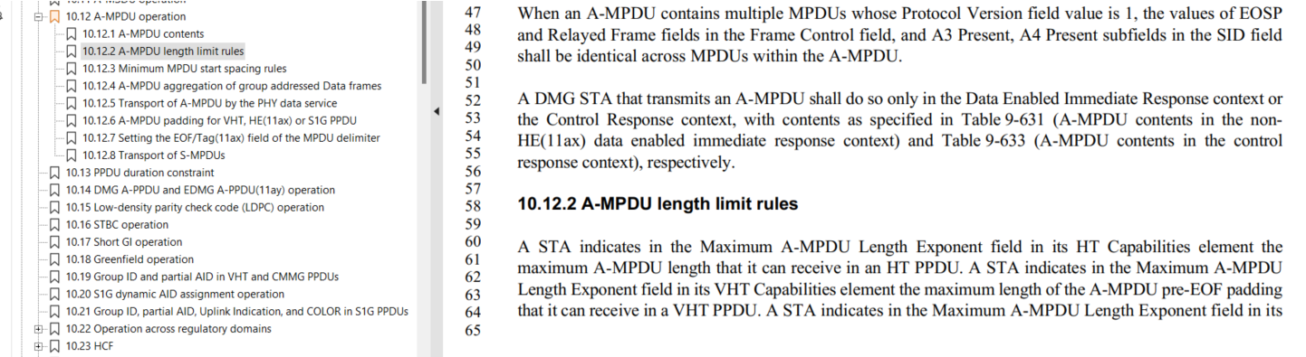

The correct xref is 10.12.2.

Proposed Resolution:
Revised.
Change “10.12.5 (Transport of A-MPDU by the PHY data service))." to “10.12.2 (A-MPDU length limit rules)”.

4387 | 308.24 | 4.5.3.3 |  | "To deliver an MSDU within an ESS via the DS, the DS needs to know which AP within the ESS to deliver the MSDU, ". Looks like "to" is missing after "the MSDU" | Change sentence to "(...) needs to know which AP within the ESS to deliver the MSDU to, "

Discussion:
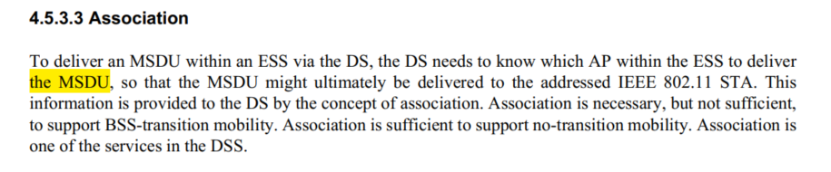
Proposed change:
“To deliver an MSDU within an ESS via the DS, the DS needs to know which AP within the ESS to deliver the MSDU to, so that the MSDU might ultimately be delivered to the addressed IEEE 802.11 STA.”

Proposed Resolution
Accepted.

