IEEE P802.11
Wireless LANs
LB272 DMG Sensing Instance CIDs: Part 2
Date: 2023-07-11
Author(s):
Name | Affiliation | Address | Phone | email
Pu (Perry) Wang | MERL |  |  | pwang@merl.com
Abstract
This document proposes resolution to several LB272 DMG related CIDs.
The list of CIDs is: 1048, 1049, 1050, 1051, 1233, 1234, 1236, 1393, 1394, 1395, 1396, 1397, 1398, 1399, 1400, 1401, 1402, 1404, 1405, 1406, 1487, 1488, 2097, 2298, 2299, 2301.

R0: Initial document
R1: Add CIDs
R2: Add and consolidate CIDs

CID | Section | Page  Line | Comment | Proposed Change | Resolution
2097 | 11.55.3.6.3 | P211  L52 | The 'Report Delay = 0' in the first sensing instance in Figure 11-74p. It should be 'Report Delay = 1'. | As in comment. | Reject
1048 | 11.55.3.6.3 | P211  L44 | inconsistent Report Delay codes in the text and Figure 11-74p for the first instance. Based on Report Delay code specificaiton in Table 9-401z, "no report in this instance" shoud be Report Delay =0. | In line 44 page 211, change "Report Delay =1" to "Report Delay =0". | Accept
1395 | 11.55.3.6.3 | P211  L44 | "In the first instance there is no report (Report Delay=1)" - It is actually Report Delay = 0 | replace with "In the first instance there is no report (Report Delay=0)" | Accept

Discussion:
According to the definition of Report Delay code specification in Table 9-410z, the Report Delay code for no report in the first instance should be Report Delay = 0.
Proposed changes in P211L44:
In the first instance there is no report (Report Delay=1 0).
Proposed changes between P211L45 and P211L56:
Update “Report BRP Frame Report Delay=0” in Figure 11-74p.
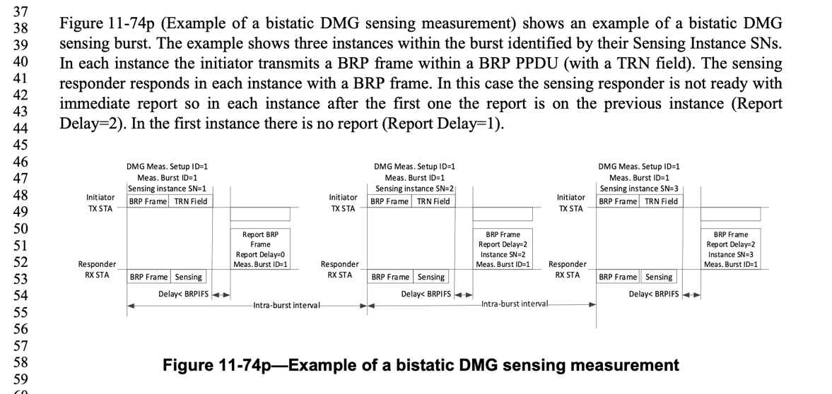
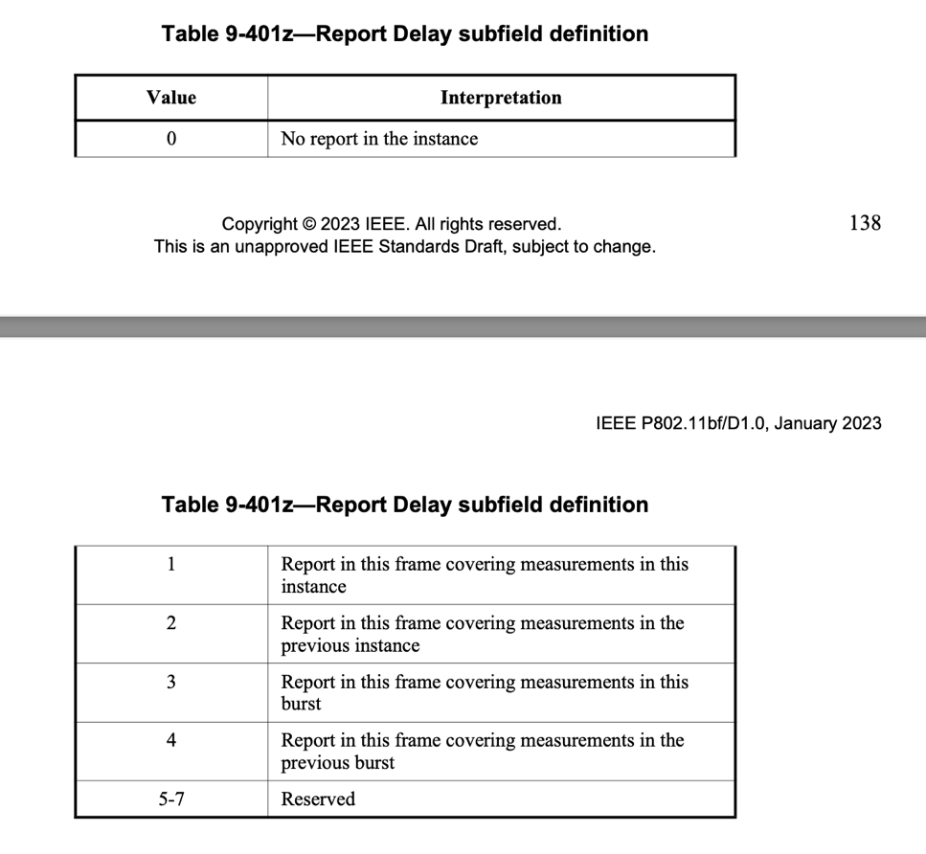

CID | Section | Page  Line | Comment | Proposed Change | Resolution
1393 | 11.55.3.6.3 | P211  L9 | " the First Beam Index field indicates" - First Beam Index field of what? It is not a field of the BRP frame | replace with " the First Beam Index field of the BRP Sensing element indicates" | Accept
The BRP Sensing element:
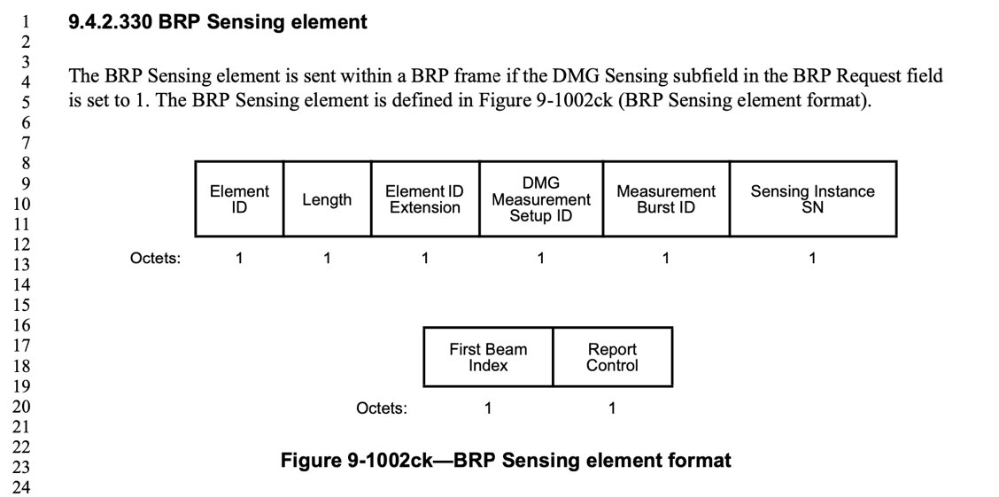
Proposed changes in P211L9:
In each BRP frame, the First Beam Index field of the BRP Sensing element indicates which is the first beam that is used in the TRN field of the PPDU.
CID | Section | Page  Line | Comment | Proposed Change | Resolution
1236 | 11.55.3.6.5.1 | P212  L45 | "The sensing initiator sets the Start of #N PPDU subfields to..." There is no such subfield. | Provide a comprehensive definition of the rule. | Revise  See CID 2084;
1400 | 11.55.3.6.5.1 | P212  L46 | "The sensing initiator sets the Start of #N PPDU subfields to the time, in microseconds, from the end of the DMG Sensing Request to the beginning of the EDMG multistatic sensing PPDU in the multistatic EDMG  sensing instance." - the Start of #N PPDU is not a part of the DMG sensing request frame | delete the sentence | Revise  See CID 2084;

CID | Section | Page  Line | Comment | Proposed Change | Resolution
1398 | 11.55.3.6.5.1 | P212  L31 | "is initiated by several DMG Sensing Measurement Setup Request frames and  responses to the DMG Sensing Requests frames" - wrong frame names | replace with "is initiated by several DMG Sensing Request frames responded by DMG Sensing Response frames" | Accept
1399 | 11.55.3.6.5.1 | P212  L35 | Throughout the paragraph in P212L35-48 replace "DMG Sensing Measurement Setup Request " with "DMG Sensing Request" | As in comment | Accept
1487 | 11.55.3.6.5.1 | P212  L35 | "The sensing initiator initiates the multistatic EDMG sensing instance by sending DMG Sensing Measurement  Setup Request frames to each of the intended sensing responders.The DMG Measurement Setup ID and the Sensing Instance SN subfields shall have the same value in all DMG Sensing Measurement Setup  Request frames." Wrong frame name | Replace the frame name with "DMG Sensing Request" | Accept

Discussion: the Start of #N PPDU is not a part of the DMG sensing request frame.

In the subclause 11.55.3.6.5 Multistatic EDMG sensing instance,
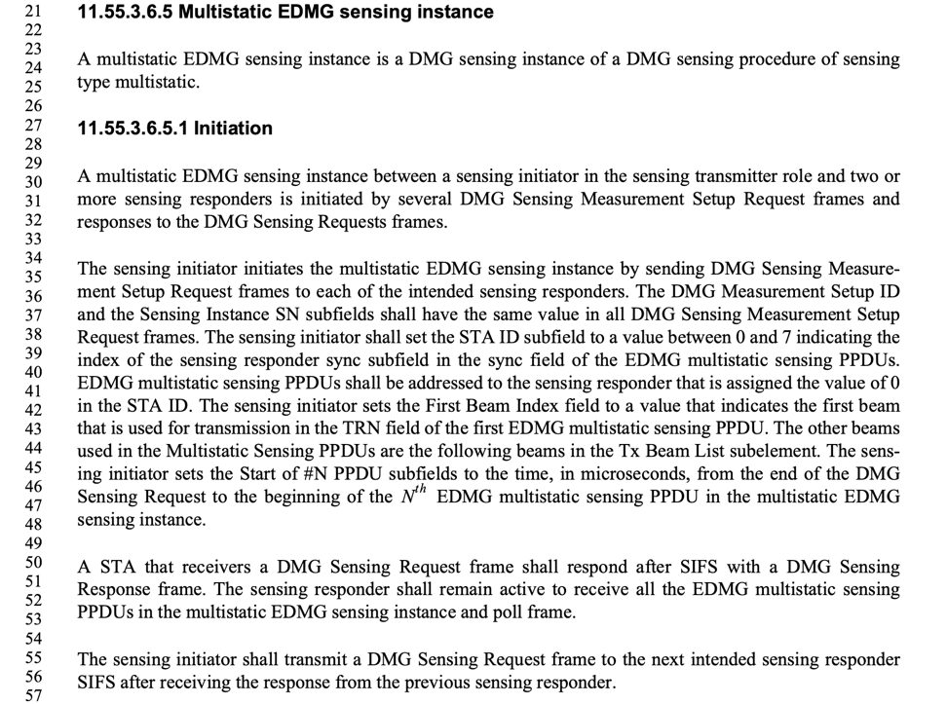
Proposed changes in P212L31-L38:
A multistatic EDMG sensing instance between a sensing initiator in the sensing transmitter role and two or more sensing responders is initiated by several DMG Sensing Measurement Setup Request frames and responses to the responded by DMG Sensing Requests Response frames.
The sensing initiator initiates the multistatic EDMG sensing instance by sending DMG Sensing Measurement Setup Request frames to each of the intended sensing responders. The DMG Measurement Setup ID, Measurement Burst ID (#2084) and the Sensing Instance SN subfields shall have the same value in all DMG Sensing Measurement Setup Request frames. The sensing initiator shall set the STA ID subfield to a value between 0 and 7 indicating the index of the sensing responder sync subfield in the sync field of the EDMG multistatic sensing PPDUs. EDMG multistatic sensing PPDUs shall be addressed to the sensing responder that is assigned the value of 0 in the STA ID. The sensing initiator sets the First Beam Index field to a value that indicates the first beam that is used for transmission in the TRN field of the first EDMG multistatic sensing PPDU. The other beams used in the Multistatic Sensing PPDUs are the following beams in the Tx Beam List subelement. The sensing initiator sets the Start of #N the N^{th} (#2119) PPDU subfields to the time, in microseconds, from the end of the DMG Sensing Request to the beginning of the Nth EDMG multistatic sensing PPDU in the multistatic EDMG sensing instance. The set of beams in the instance is repeated according to the Num of Repeat in Instance field. (#2084)

CID | Section | Page  Line | Comment | Proposed Change | Resolution
1233 | 11.55.3.6.4 | P212  L2 | "It is then followed by a set of DMG bistatic sensing instances"- not a precise definition | Replace with: "The initiation phase shall be followed by a sounding phase comprised of set of DMG bistatic sensing instances." | Revise
1049 | 11.55.3.6.4 | P212  L9 | What is "DMG Measurement Setup Request frame"? Searched the entire 11bf/D1.0 spec, only found 1 occurrence. Is it actually "DMG Sensing Measurement Setup Request frame format"? | Please clarify what "DMG Measurement Setup Request frame" is. | Revise  Change it to DMG Sensing Request frame
1396 | 11.55.3.6.4 | P212  L9 | "The sensing initiator shall send a DMG Measurement Setup Request frame to each sensing responder  it invites to participate in the sensing instance" - wrong frame name - it should be DMG Sensing Request frame | replace with "The sensing initiator shall send a DMG Sensing Request frame to each sensing responder it invites to participate in the sensing instance" | Accept
1050 | 11.55.3.6.4 | P212  L12 | After receiving "DMG Measurement Setup Request frame", should the sensing responder respond with "DMG Measurement Setup Response frame" or "DMG Sensing Response frame"? | Suggest Changing "DMG Sensing Response frame" to "DMG Measurement Setup Response frame". | Reject
1397 | 11.55.3.6.4 | P212  L15 | "The sensing responder that responded to the sensing initiator shall remain active to receive the BRP PPDU" - there may be multiple PPDUs present | replace with "A Sensing respodner that responded to the sensing initiator shall remain active to receiver BRP PPDUs from the initiator" | Revise
1234 | 11.55.3.6.4 | P212  L15 | "-- The sensing responder that responded to the sensing initiator shall remain active to receive the BRP PPDU.  -- The order of sounding is indicated in the STA ID field within the DMG Sensing Measurement Setup  Request frame"  The definition is incomplete. The sensing responder shall be active at the time of the sounding addressed to it. It happens after the completion of the initiation among the Num_of_STAs_in _Instance - STA_ID responders, plus the sounding of the STA_ID-1 responders. | Provide complete definition. | Revise

Original text in D1.0

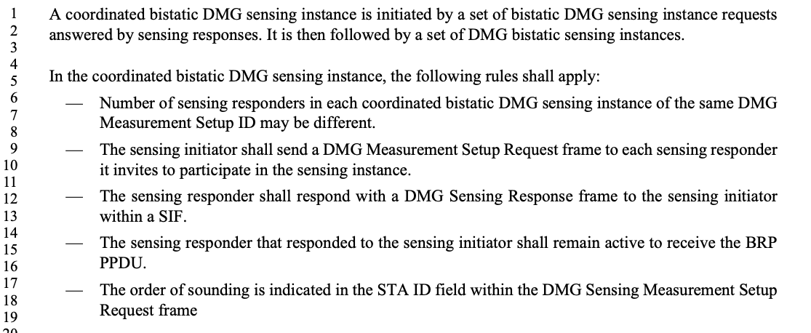

Proposed changes in P212L2-L19:
A coordinated bistatic DMG sensing instance is initiated by a set of bistatic DMG sensing instance requests answered by sensing responses. It is then followed by a set of DMG bistatic sensing instances. The initiation phase shall be followed by a sounding phase comprised of a set of DMG bistatic sensing instances.
In the coordinated bistatic DMG sensing instance, the following rules shall apply:
- Number of sensing responders in each coordinated bistatic DMG sensing instance of the same DMG Measurement Setup ID may be different.
- The sensing initiator shall send a DMG Sensing Measurement Setup Request frame to each sensing responder it invites to participate in the sensing instance.
- The sensing responder shall respond with a DMG Sensing Response frame to the sensing initiator within a SIF.
- The sensing responder that responded to the sensing initiator shall remain active to receive the BRP PPDU PPDUs. It happens after the completion of the initiation among the (the Num of STAs in Instance value – the STA ID value) responders, plus the sounding of (the STA ID value – 1) responders.
- The order of sounding is indicated in the STA ID field within the DMG Sensing Measurement Setup Request frame.
The parameters are defined in the DMG Sensing Request frame (P202L29-L52)
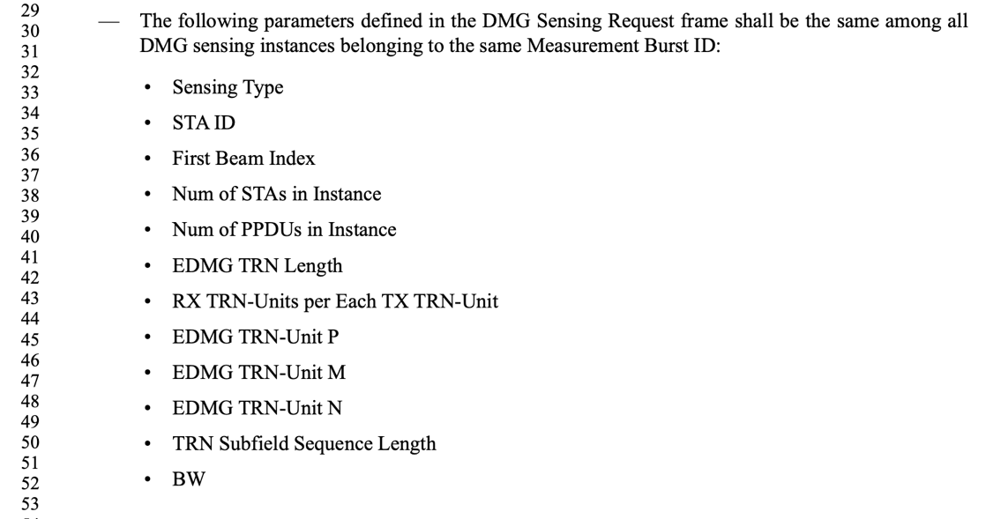

CID | Section | Page  Line | Comment | Proposed Change | Resolution
1488 | 11.55.3.6.5.1 | P212  L49 | Insert new paragraph: "The DMG Sensing Request frames shall be sent in the order of the STA ID value in the frame. Each frame shall be sent to the direction of the responder STA indicated by the RA of the frame." | As in the comment | Revise
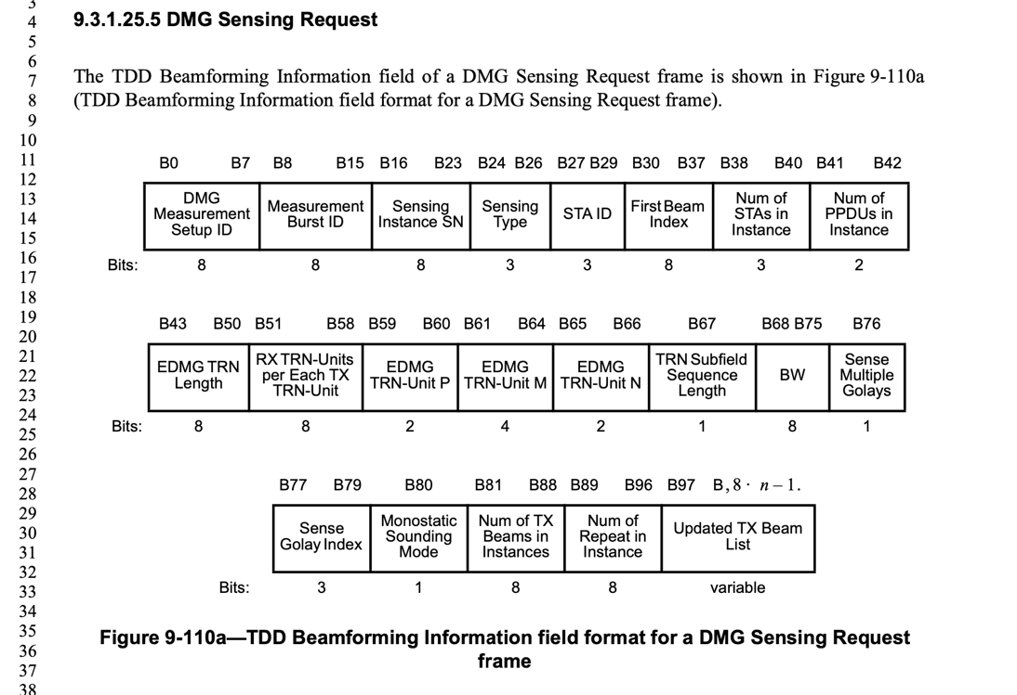
Proposed changes in P212L49:
The DMG Sensing Request frames shall be sent in the order of the STA ID value in the frame. Each frame shall be sent to the direction of the responder STA indicated by the updated Tx Beam List subelement.

CID | Section | Page  Line | Comment | Proposed Change | Resolution
1401 | 11.55.3.6.5.2 | P213  L5 | "The EDMG multistatic sensing PPDUs may be followed by up to three EDMG multistatic sensing PPDUs with the same parameters from the sensing transmitter. " - confusing text | replace with "The first EDMG multistatic sensing PPDU may be followed by up to three EDMG multistatic sensing PPDUs with the same parameters from the sensing transmitter. " | Accept

Proposed changes in P213L5-L8:
The first EDMG multistatic sensing PPDUs may be followed by up to three EDMG multistatic sensing PPDUs with the same parameters from the sensing transmitter. All the EDMG multistatic sensing PPDUs in a multistatic EDMG sensing instance shall have the same PPDU length and TRN field format.
CID | Section | Page  Line | Comment | Proposed Change | Resolution
1402 | 11.55.3.6.5.3 | P213  L24 | "to initiate the burst" - its an instance | replace with "to initiate the instance" | Accept
Proposed changes in P213L23-L27:
The instance starts with the sensing initiator sending a DMG Sensing Request frame to each of the sensing responders to initiate the burst instance and indicate the parameters that will be used in the TRN fields of the EDMG multistatic sensing PPDUs in the instance.

CID | Section | Page  Line | Comment | Proposed Change | Resolution
1051 | 11.55.3.8 | P214  L23 | inconsistency in the sentence in line 23 page 214: the reference is to "DMG Sensing Session Setup", while the 2nd half of the sentence and the section is talking about DMG Sensing Measurement Setup. | please fix the inconsistency. | Revise.  Change 11.55.3.3 (DMG sensing session setup) to 11.55.3.4 (DMG sensing measurement setup)

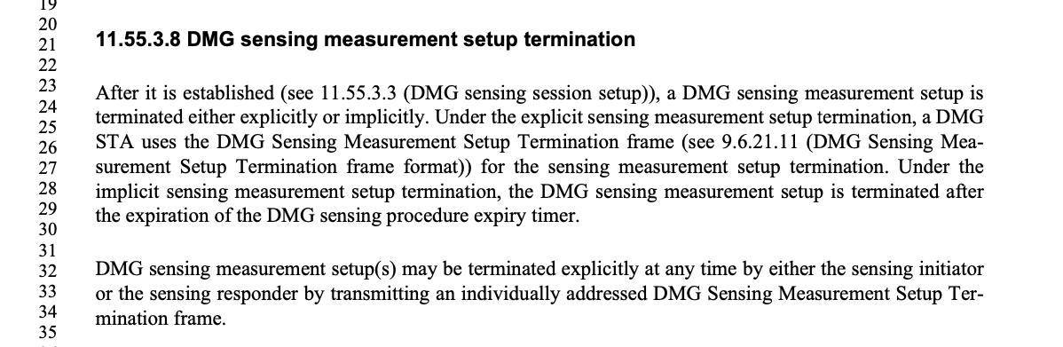
Proposed changes in P213L23:
11.55.3.8 DMG sensing measurement setup termination
After it is established (see 11.55.3.3 (DMG sensing session setup) 11.55.3.4 (DMG sensing measurement setup)), a DMG sensing measurement setup is terminated either explicitly or implicitly. Under the explicit sensing measurement setup termination, a DMG STA uses the DMG Sensing Measurement Setup Termination frame (see 9.6.21.11 (DMG Sensing Measurement Setup Termination frame format)) for the sensing measurement setup termination. Under the implicit sensing measurement setup termination, the DMG sensing measurement setup is terminated after the expiration of the DMG sensing procedure expiry timer.

CID | Section | Page  Line | Comment | Proposed Change | Resolution
1404 | 28.9.3.3 | P227  L53 | "However, the (NSTA-1)xP subfields " - better to specify it is TRN subfields | replace with "However, the (NSTA-1)xP TRN subfields " | Accept
Proposed changes in P227L23-L27 (28.9.3.3 EDMG multistatic sensing PPDU header fields):
However, the ( NSTA – 1) × P TRN subfields which are of the EDMG TRN-Unit M are used in a different way, as defined in 28.9.3.5 (TRN field for EDMG multistatic sensing PPDU), where NSTA and P have the values in the Multistatic Sensing NSTA and EDMG TRN-Unit P fields within the EDMG-Header-A, respectively.

CID | Section | Page  Line | Comment | Proposed Change | Resolution
1405 | 28.9.3.4.2 | P228  L22 | "The index r indicates the STA ID" - STA ID is not mentioned in clause 28, a clarification is warranted | replace with "The index r corresponds to the STA ID each STA is assigned in the DMG Sensing Request at the beginning of the DMG multistatic sensing instance" | Revise
Proposed changes in P228L19-L22 (28.9.3.4.2 Sync subfield definition):
28.9.3.4.2 Sync subfield definition
Each Sync subfield is composed of 18 Golay sequences. Sync subfields intended to be used by different STAs use different rows from the matrix defined in Table 28-74a (Coefficient matrix for EDMG multistatic sensing Sync field). The index r indicates corresponds to the STA ID with which each STA is assigned in the DMG Sensing Request frame at the beginning of the DMG multistatic sensing instance.

CID | Section | Page  Line | Comment | Proposed Change | Resolution
1406 | 28.9.3.5 | P229  L36 | "M-(NSTA×P)" it is incorrect, it should be "M-(NSTA-1)×P | Fix as in comment | Accept

Proposed changes in P229L31-L38 (28.9.3.5 TRN field for EDMG multistatic sensing PPDU):
The TRN field of an EDMG multistatic sensing PPDU is identical to the TRN field of an EDMG BRP-TX or BRP-RX/TX PPDU, as defined in 28.9.2.2.5 (TRN field definition), with the exception that instead of P TRN subfields transmitted with the AWV used to transmit the data field of the PPDU, we have N_{STA} x P TRN subfields in which the k^{th} set of P TRN subfields are transmitted with an AWV used to transmit the k^{th} Sync subfield. M – (N_{STA} -1) x P) TRN subfields are transmitted using AWV selected by the sensing transmitter to represent its TX beams.

CID | Section | Page  Line | Comment | Proposed Change | Resolution
2298 | 11.55.4.2 | P217  L13 | A non-AP/non-PCP sensing responder does not know whether a sensing measurement setup is initiated by the AP/PCP or by a non-AP/non-PCP STA in the form of a SBP procedure. | Include a bit in the sensing measurement parameter field that indicates whether the setup is on behalf of a DMG SBP session. | Reject
2299 | 11.55.4.2 | P217  L13 | In a DMG sensing measurement setup that is part of a DMG SBP procedure, a non-AP/non-PCP sensing responder can't determine the identity of the DMG SBP initiator. | Include a new field in the DMG measurement setup request frame to indicate the DMG SBP initiator's identity. Additionally, include a parameter in the DMG SBP Parameters element to indicate whether the DMG SBP responder is allowed to share the identity of the DMG SBP initiator with the sensing responder(s). | Reject
2301 | 11.55.4.2 | P217  L13 | DMG sensing responder is unable to know the identity of the actual DMG sensing initiator in DMG SBP procedure.  The DMG sensing measurement setup in SBP does not contain any information on the identity of the DMG sensing inititor. In fact, from the sensing responder perspective, the sensing measurement setup for SBP, which is initiated by a non-AP STA, and DMG sensing request, which originates from the AP, are identical. Due to various concerns, including privacy, DMG sensing measurement setup must contain information which enables the DMG sensing responder to identify the true DMG sensing initiator, so that the DMG responder can decide whether or not to accept the setup request. | Add a new field to the DMG measurement setup request frame to enable the DMG sensing responder to identify the identity of the actual DMG sensing initiator. | Reject

11.55.4.2 DMG SBP Setup
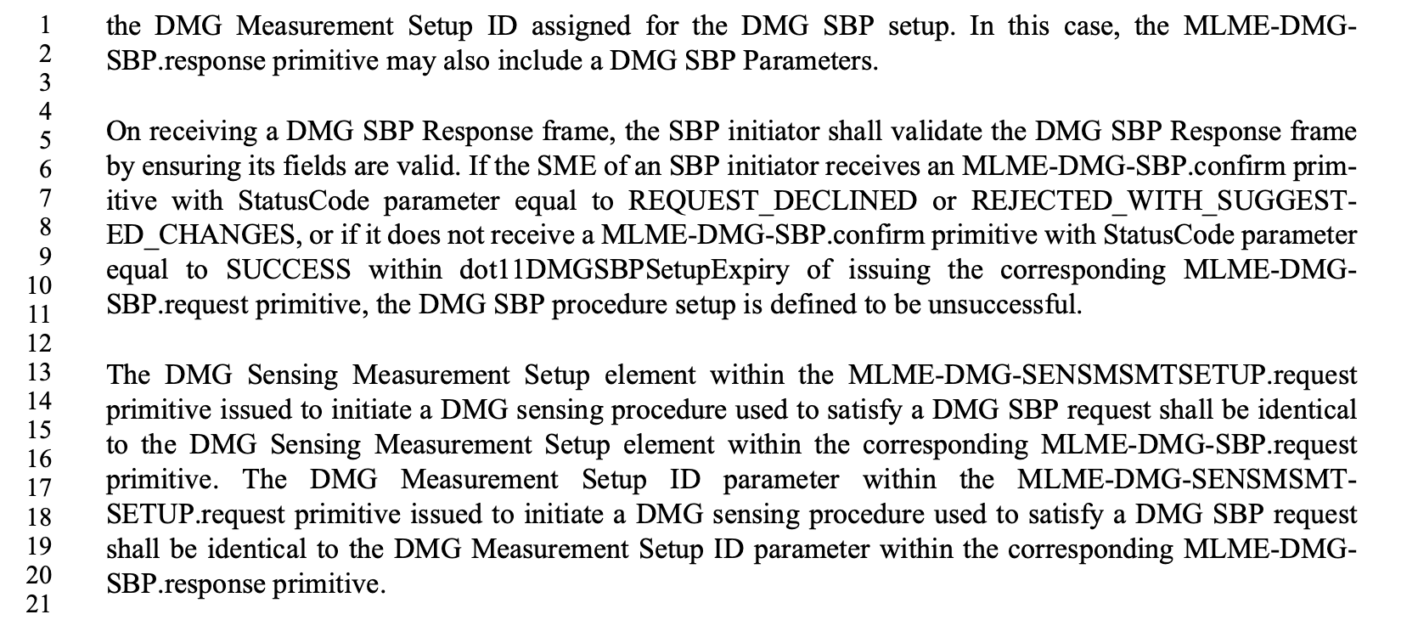

Straw Poll:
Do you agree with the proposed resolutions for CIDs 1048, 1049, 1050, 1051, 1233, 1234, 1236, 1393, 1394, 1395, 1396, 1397, 1398, 1399, 1400, 1401, 1402, 1404, 1405, 1406, 1487, 1488, 2097, 2298, 2299, and 2301 in revision 2 of this document?

Y/N/A

