IEEE P802.11
Wireless LANs
LB272 DMG Sensing Instance CIDs: Part 2
Date: 2023-07-11
Author(s):
Name | Affiliation | Address | Phone | email
Pu (Perry) Wang | MERL |  |  | pwang@merl.com
Abstract
This document proposes resolution to several LB272 DMG related CIDs.
The list of CIDs is: 1048, 1049, 1050, 1051, 1236, 2097.

R0: Initial document
R1: Add CIDs

CID | Section | Page  Line | Comment | Proposed Change | Resolution
2097 | 11.55.3.6.3 | P211  L52 | The 'Report Delay = 0' in the first sensing instance in Figure 11-74p. It should be 'Report Delay = 1'. | As in comment. | Rejected
1048 | 11.55.3.6.3 | P211  L44 | inconsistent Report Delay codes in the text and Figure 11-74p for the first instance. Based on Report Delay code specificaiton in Table 9-401z, "no report in this instance" shoud be Report Delay =0. | In line 44 page 211, change "Report Delay =1" to "Report Delay =0". | Accepted

Discussion:
According to the definition of Report Delay code specification in Table 9-410z, the Report Delay code for no report in the first instance should be Report Delay = 0.
Proposed changes in P211L44:
In the first instance there is no report (Report Delay=1 0).
Proposed changes between P211L45 and P211L56:
Update “Report BRP Frame Report Delay=0” in Figure 11-74p.
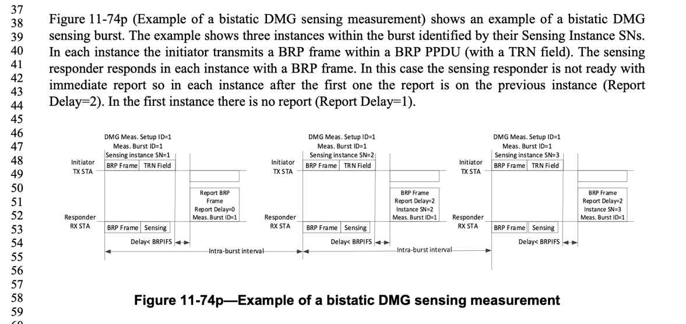
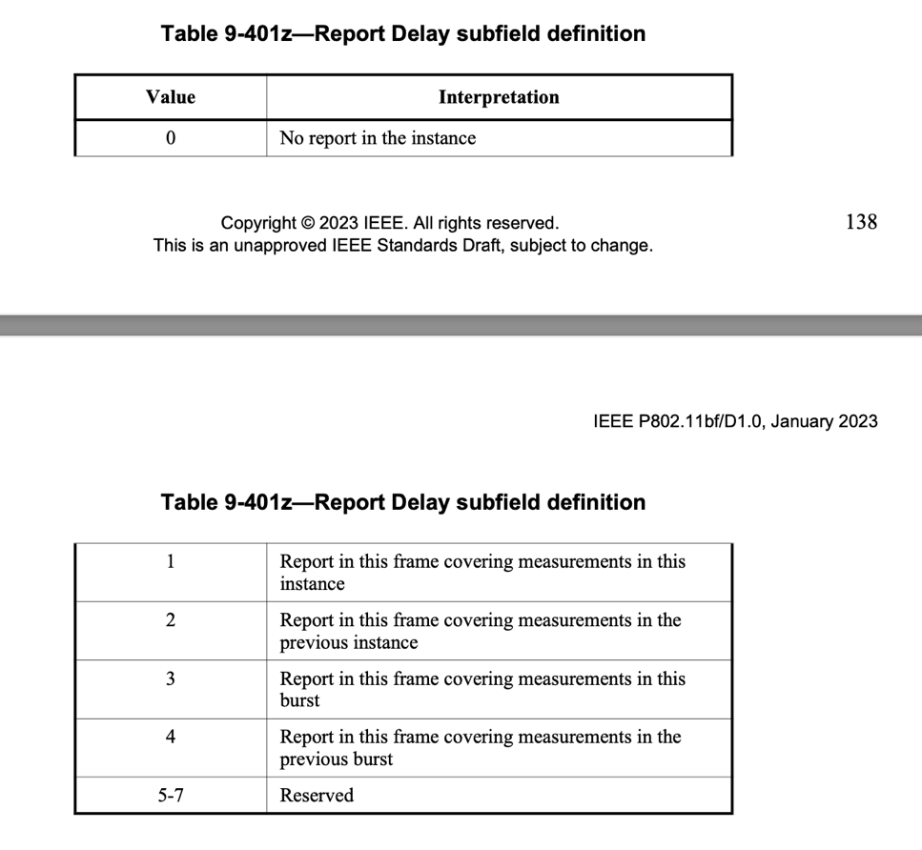
CID | Section | Page  Line | Comment | Proposed Change | Resolution
1236 | 11.55.3.6.5.1 | P212  L45 | "The sensing initiator sets the Start of #N PPDU subfields to..." There is no such subfield. | Provide a comprehensive definition of the rule. | Reject  The sentence is removed according to CID 1481.

Discussion: This is related to CID 1481.
In the subclause 11.55.3.6.5 Multistatic EDMG sensing instance,
The sensing initiator initiates the multistatic EDMG sensing instance by sending DMG Sensing Measurement Setup Request frames to each of the intended sensing responders. The DMG Measurement Setup ID, Measurement Burst ID (#2084) and the Sensing Instance SN subfields shall have the same value in all DMG Sensing Measurement Setup Request frames. The sensing initiator shall set the STA ID subfield to a value between 0 and 7 indicating the index of the sensing responder sync subfield in the sync field of the EDMG multistatic sensing PPDUs. EDMG multistatic sensing PPDUs shall be addressed to the sensing responder that is assigned the value of 0 in the STA ID. The sensing initiator sets the First Beam Index field to a value that indicates the first beam that is used for transmission in the TRN field of the first EDMG multistatic sensing PPDU. The other beams used in the Multistatic Sensing PPDUs are the following beams in the Tx Beam List subelement. The sensing initiator sets the Start of #N the N^{th} (#2119) PPDU subfields to the time, in microseconds, from the end of the DMG Sensing Request to the beginning of the Nth EDMG multistatic sensing PPDU in the multistatic EDMG sensing instance.
Proposed changes in P211L44:
The sensing initiator initiates the multistatic EDMG sensing instance by sending DMG Sensing Measurement Setup Request frames to each of the intended sensing responders. The DMG Measurement Setup ID, Measurement Burst ID (#2084) and the Sensing Instance SN subfields shall have the same value in all DMG Sensing Measurement Setup Request frames. The sensing initiator shall set the STA ID subfield to a value between 0 and 7 indicating the index of the sensing responder sync subfield in the sync field of the EDMG multistatic sensing PPDUs. EDMG multistatic sensing PPDUs shall be addressed to the sensing responder that is assigned the value of 0 in the STA ID. The sensing initiator sets the First Beam Index field to a value that indicates the first beam that is used for transmission in the TRN field of the first EDMG multistatic sensing PPDU. The other beams used in the Multistatic Sensing PPDUs are the following beams in the Tx Beam List subelement. The sensing initiator sets the Start of #N the N^{th} (#2119) PPDU subfields to the time, in microseconds, from the end of the DMG Sensing Request to the beginning of the Nth EDMG multistatic sensing PPDU in the multistatic EDMG sensing instance. The set of beams in the instance is repeated according to the Num of Repeat in Instance field. (#2084)

CID | Section | Page  Line | Comment | Proposed Change | Resolution
1049 | 11.55.3.6.4 | P212  L9 | What is "DMG Measurement Setup Request frame"? Searched the entire 11bf/D1.0 spec, only found 1 occurrence. Is it actually "DMG Sensing Measurement Setup Request frame format"? | Please clarify what "DMG Measurement Setup Request frame" is. | Revise  Change it to DMG Sensing Measurement Setup Request frame
1050 | 11.55.3.6.4 | P212  L12 | After receiving "DMG Measurement Setup Request frame", should the sensing responder respond with "DMG Measurement Setup Response frame" or "DMG Sensing Response frame"? | Suggest Changing "DMG Sensing Response frame" to "DMG Measurement Setup Response frame". | Revise  Change it to DMG Sensing Measurement Setup Request frame
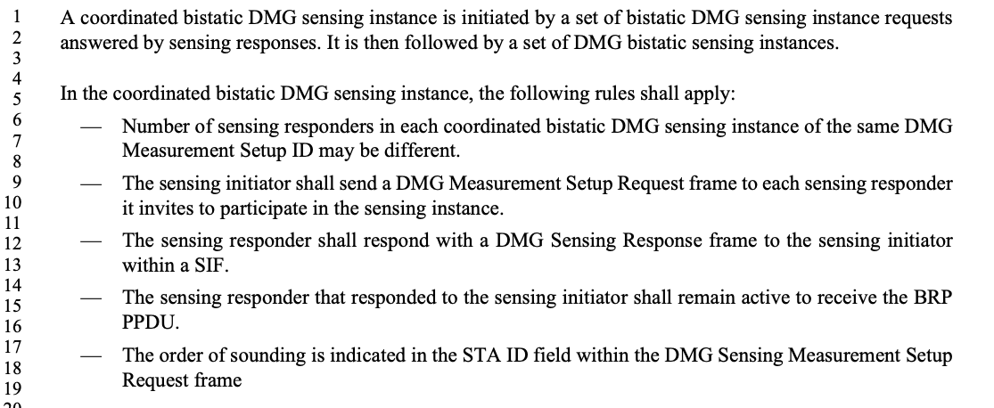

Proposed changes in P212L9-L12:
A coordinated bistatic DMG sensing instance is initiated by a set of bistatic DMG sensing instance requests answered by sensing responses. It is then followed by a set of DMG bistatic sensing instances.
In the coordinated bistatic DMG sensing instance, the following rules shall apply:
- Number of sensing responders in each coordinated bistatic DMG sensing instance of the same DMG Measurement Setup ID may be different.
- The sensing initiator shall send a DMG Sensing Measurement Setup Request frame to each sensing responder it invites to participate in the sensing instance.
- The sensing responder shall respond with a DMG Sensing Measurement Setup Response frame to the sensing initiator within a SIF.
- The sensing responder that responded to the sensing initiator shall remain active to receive the BRP PPDU.
- The order of sounding is indicated in the STA ID field within the DMG Sensing Measurement Setup Request frame.

CID | Section | Page  Line | Comment | Proposed Change | Resolution
1051 | 11.55.3.8 | P214  L23 | inconsistency in the sentence in line 23 page 214: the reference is to "DMG Sensing Session Setup", while the 2nd half of the sentence and the section is talking about DMG Sensing Measurement Setup. | please fix the inconsistency. | Revise.  Change 11.55.3.3 (DMG sensing session setup) to 11.55.3.4 (DMG sensing measurement setup)

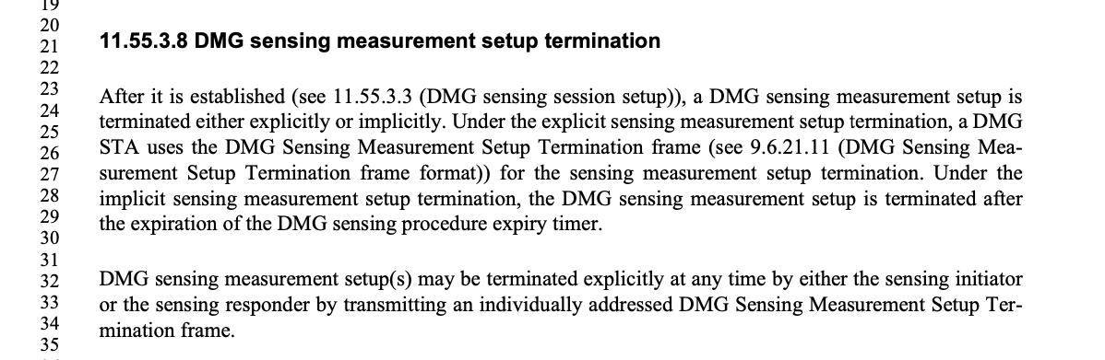
Proposed changes in P213L23:
11.55.3.8 DMG sensing measurement setup termination
After it is established (see 11.55.3.3 (DMG sensing session setup) 11.55.3.4 (DMG sensing measurement setup)), a DMG sensing measurement setup is terminated either explicitly or implicitly. Under the explicit sensing measurement setup termination, a DMG STA uses the DMG Sensing Measurement Setup Termination frame (see 9.6.21.11 (DMG Sensing Measurement Setup Termination frame format)) for the sensing measurement setup termination. Under the implicit sensing measurement setup termination, the DMG sensing measurement setup is terminated after the expiration of the DMG sensing procedure expiry timer.

Straw Poll:
Do you agree with the proposed resolutions for CIDs 1048, 1049, 1050, 1051, 1236, 2097 in revision 1 of this document?
Y/N/A

