IEEE P802.11
Wireless LANs
LB272 DMG Sensing Instance CIDs: Part 2
Date: 2023-05-15
Author(s):
Name | Affiliation | Address | Phone | email
Pu (Perry) Wang | MERL |  |  | pwang@merl.com
Abstract
This document proposes resolution to several LB272 DMG related CIDs.
The list of CIDs is: 1048, 2097.

R0: Initial document

CID | Section | Page  Line | Comment | Proposed Change | Resolution
2097 | 11.55.3.6.3 | P211  L52 | The 'Report Delay = 0' in the first sensing instance in Figure 11-74p. It should be 'Report Delay = 1'. | As in comment. | Rejected
1048 | 11.55.3.6.3 | P211  L44 | inconsistent Report Delay codes in the text and Figure 11-74p for the first instance. Based on Report Delay code specificaiton in Table 9-401z, "no report in this instance" shoud be Report Delay =0. | In line 44 page 211, change "Report Delay =1" to "Report Delay =0". | Accepted

Discussion:
According to the definition of Report Delay code specification in Table 9-410z, the Report Delay code for no report in the first instance should be Report Delay = 0.
Proposed changes in P211L44:
In the first instance there is no report (Report Delay=1 0).
Proposed changes between P211L45 and P211L56:
Update “Report BRP Frame Report Delay=0” in Figure 11-74p.
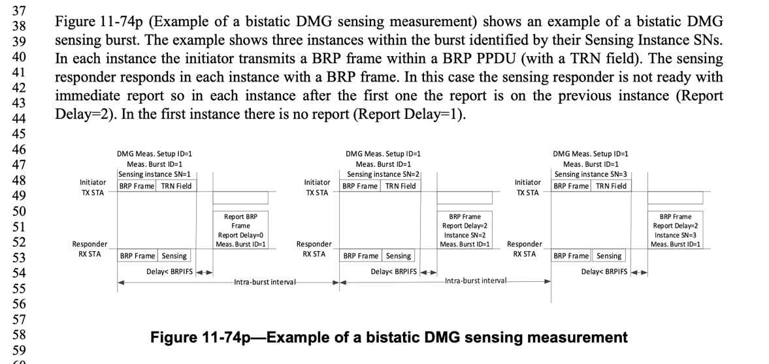
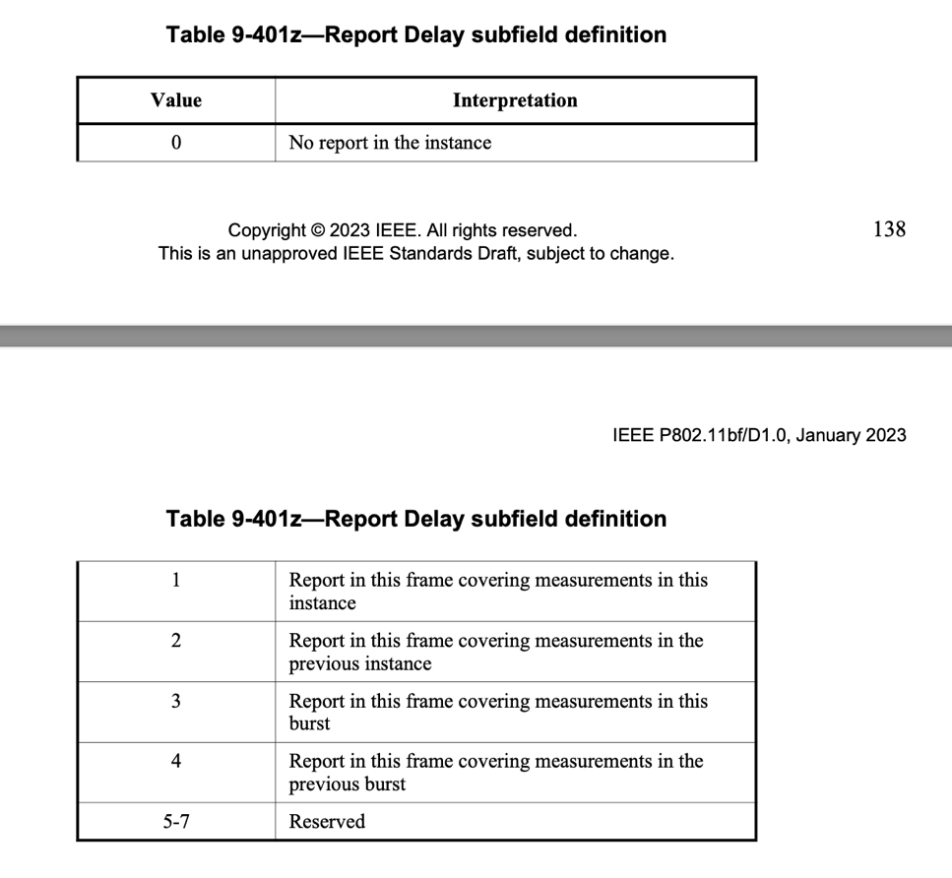

Straw Poll:
Do you agree with the proposed resolutions for CIDs 1048, and 2097 in revision 0 of this document?
Y/N/A

