IEEE P802.11
Wireless LANs
11bk Spec text for TB ranging
Date: 2023-06-01
Author(s):
Name | Affiliation | Address | Phone | Email
Yanjun Sun | Qualcomm
Ali Raissinia
Steve Shellhammer
George Cherian
Christian Berger | NXP

Abstract
We propose the draft specification skeleton for TB ranging to help the creation of TGbk draft D0.1.

Revisions:

- Rev 0: Initial version of the document.

Interpretation of a Motion to Adopt

A motion to approve this submission means that the editing instructions and any changed or added material are actioned in the TGbk 0.1 Draft. This introduction is not part of the adopted material.

Editing instructions formatted like this are intended to be copied into the TGbk Draft (i.e. they are instructions to the 802.11 editor on how to merge the text with the baseline documents).

TGbk Editor: Editing instructions preceded by “TGbk Editor” are instructions to the TGbk editor to modify existing material in the TGbk draft. As a result of adopting the changes, the TGbk editor will execute the instructions rather than copy them to the TGbk Draft.

Discussion:
The text is prepared for the following motion:
Motion (202301-13) :
Move to include in the SFD that:
“The Ranging Trigger frame in 802.11bk sets the Trigger Type subfield in the Common Info field to 8 as in 802.11az and includes the Special User Info field immediately after the Common Info field as defined in 802.11be”.

Discussion: in 11be D3.2, 320 MHz for Trigger frame is handled mainly via the Special User Info field and EHT variant User Info field and EHT variant Common Info field
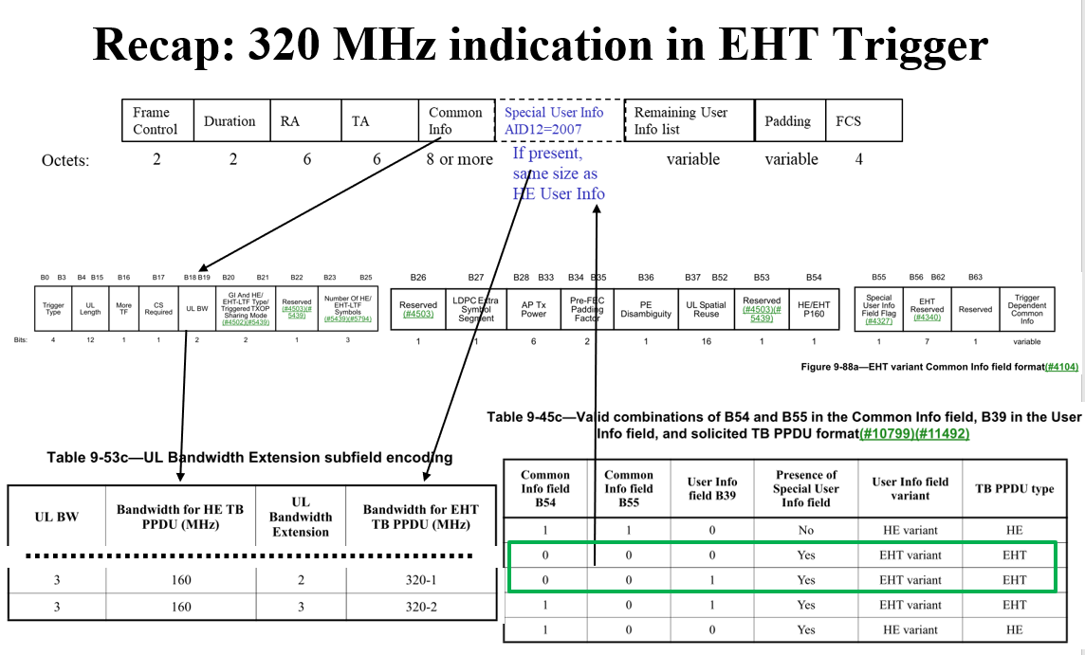
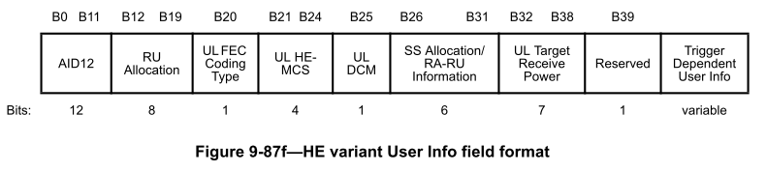
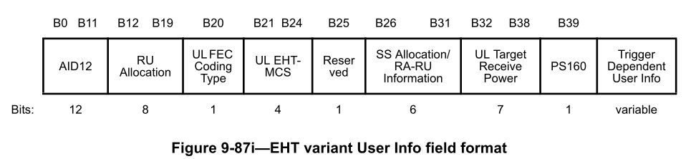
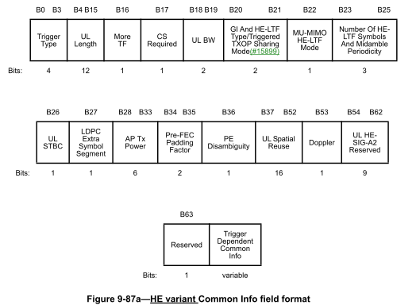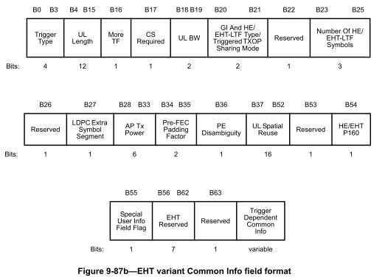
The UL Bandwidth Extension subfield in the Special User Info field together with the UL BW field in the Common Info field of a Trigger frame is used to indicate a 320 MHz Trigger frame.
- Direction: if a Trigger frame is sent in a 320 MHz PPDU, we’ll need rules for the STA to encode/decode the bandwith based on both these two subfields.
By identifying an EHT variant User Info field based on table 9-45c above, a non-AP STA can use the RU Allocation subfield and the PS160 subfield to identify an RU/MRU allocated by a 320 MHz Trigger frame.
- Direction: to identify an RU allocated by a 320 MHz Trigger frame, we’ll need rules for the STA to encode/decode a corresponding EHT variant User Info field

Proposed spec text:
TGbk editor: Please note Baseline is REVme_D3.0, IEEE 802.11az-2022, IEEE 802.11be D3.2 and the motioned text in SFD 23/0390r4 on measurement exchange.

TGbk editor: Please update 9.3.1.22 as follows (track changes enabled):

9. Frame formats

9.3 Format of individual frame types

9.3.1 Control frames

9.3.1.22 Trigger frame format

9.3.1.22.1 General
Insert the following new row into Table 9-29c and change the reserve subfield values from 8-15 to 9-15:
Table 9-29c—Trigger Type subfield encoding

Trigger Type subfield value | Trigger frame variant
8 | Ranging
9-15 | Reserved

Change the paragraph in 9.3.1.22.1 of draft 80211ax-2021 as shown below:
The User Info field is defined in Figure 9-64d (User Info field) for all Trigger frame variants, except the NFRP Trigger frame, which is defined in 9.3.1.22.9 (NDP Feedback Report Poll (NFRP) variant) and the Ranging Trigger frame which is defined in 9.3.1.22.10 (Ranging Trigger variant).

Change the Table 9-29j in 9.3.1.22.1 as follows:

Table 9-29j—UL Target Receive Power subfield in Trigger frame
UL Target Receive  Power subfield | Description
0–90 | The expected receive signal power, in units of dBm, is  Targetpwr = –110 + Fval, where Fval is the subfield value
91–126 | Reserved
127 | The STA transmits the HE/EHT TB PPDU at the STA’s maximum transmit power for the assigned MCS.  If the Trigger frame is a Sounding or Passive Sounding Ranging Trigger frame that does not assign an MCS, then the STA’s transmit power is that used for HE-MCS 0 for an HE TB PPDU or that used for EHT-MCS 0 for an EHT TB PPDU.  If the Trigger frame is a Secured Sounding Ranging Trigger frame that does not assign an MCS, the assigned MCS is assumed to be HE-MCS 6 in terms of setting the STA’s transmit power for an HE TB PPDU or to be EHT-MCS 6 for an EHT TB PPDU.  NOTE—The expected receive signal power is then the STA's maximum transmit power for the assigned MCS minus the path loss.

Change the paragraph in 9.3.1.22.1 of 80211ax-2021 as shown below:

The More TF subfield of the Common Info field indicates whether or not a subsequent Trigger frame is scheduled for transmission. The More TF subfield is set as defined in 26.8.2 (Individual TWT agreements), and 26.8.3.2 (Rules for TWT scheduling AP) and 11.21.6.4.3 (TB ranging measurement exchange).

Insert the following new clauses:

9.3.1.22.10 Ranging Trigger variant
The Ranging Trigger Subtype subfield value in the Trigger Dependent Common Info field of the Ranging Trigger frame, see Table 9-30ka (Ranging Trigger Subtype subfield encoding), signals the Ranging Trigger frame subvariants which can be one of five frame types: Poll, Sounding, Secure Sounding, Report and Passive Sounding Ranging Trigger frame.

The format of the Trigger Dependent Common Info subfield for the Poll, Sounding, Secure Sounding and Report Ranging Trigger frame, is shown in Figure 9-64la (Trigger Dependent Common Info subfield format for the subvariants of the Ranging Trigger variant). The Token field in the Trigger Dependent Common Info subfield is used in a Poll Ranging Trigger frame to match it with the partial TSF time in a following Ranging NDP Announcement frame. It is reserved in all other Ranging Trigger subvariants.

 | B0 B3 | B4 | B5 B7
 | Ranging Trigger Subtype | Reserved |  | Token
Bits: | 4 | 1 |  | 3

Figure 9-64la—Trigger Dependent Common Info subfield format for the Ranging Trigger subvariants Poll, Sounding, Secure Sounding, and Report

The format of the Trigger Dependent Common Info subfield of Ranging Trigger frame of subvariant Passive Sounding is shown in Figure 9-64lb (Trigger Dependent Common Info subfield format of Ranging Trigger frame of subvariant Passive Sounding). The Sounding Dialog Token Number subfield contains a value in the range of 0 to 63 which identifies a Measurement Sounding phase (I2RNDP and R2I NDP announced by a Sounding Trigger frame and the Ranging NDP Announcement frame, respectively), and the same value is included in the Sounding Dialog Token field of the Ranging NDP Announcement frame transmitted within the same Availability Window; see 9.3.1.19 (VHT/HE/Ranging NDP Announcement frame format).

 | B0 B3 | B4 B9 | B10 B15
 | Ranging Trigger Subtype | Reserved | Sounding Dialog Token Number
Bits: | 4 | 6 | 6

Figure 9-64lb—Trigger Dependent Common Info subfield format of the Passive Sounding Ranging Trigger frame

The value of the Ranging Trigger Subtype subfield for the Ranging Trigger frame is defined in Table 9-30ka (Ranging Trigger Subtype subfield encoding):

Table 9-30ka — Ranging Trigger Subtype subfield encoding

Ranging Trigger Subtype subfield value | Ranging Trigger frame subvariant
0 | Poll
1 | Sounding
2 | Secure Sounding
3 | Report
4 | Passive Sounding
5-15 | Reserved

The RA field, and the CS Required and UL BW subfields in the Common Info field of the Ranging Trigger frame are identical to the Basic Trigger frame described in 26.5.2 (UL MU operation), 35.5.2 (EHT UL MU operation) and 9.3.1.22 (Trigger frame format), except that the RA field in Ranging Trigger frames with only one User Info field that is not a Special User info field (see 9.3.1.22.3) may be either unicast or broadcast.

The More TF subfield of the Common Info field of the Ranging Trigger frame indicates whether a subsequent Poll Ranging Trigger is scheduled for transmission within the availability window as defined in 11.21.6.4.3 (TB ranging measurement exchange)

When a ranging Trigger frame is addressed to ISTAs which all have a TB ranging measurement exchange, see 11.21.6.4.3 (TB ranging measurement exchange), with the same RSTA’s BSSID, the TA field of the Ranging Trigger frame is set to the RSTA’s address. The TA field is set to the transmitted BSSID, if the Trigger frame is addressed to a set of ISTAs in which at least two ISTAs have a TB ranging measurement exchange with different BSSIDs in the Multiple BSSID set of the RSTA.

9.3.1.22a Subvariants of Ranging Trigger variant

9.3.1.22a.1 Poll subvariant
The format of the User Info field in the Poll Ranging Trigger frame is defined in Figure 9-64lc (User Info field format for Poll and Report Ranging Trigger).
The AID12/RSID12 subfield carries either the 12 LSBs of the AID for an associated ISTA or the 12 LSBs of the RSID for an unassociated ISTA. The UL FEC Coding Type, UL Target Receive Power subfields are identical to the corresponding subfield in the Basic Trigger frame; see 9.3.1.22 (Trigger Frame format.)

If the Poll Ranging Trigger frame is soliciting an HE TB PPDU :
- The RU Allocation, UL DCM and SS Allocation/RA-RU Information subfields are identical to the corresponding subfields in the HE variant User Infor field (9.3.1.22.4 (HE variant User Info field).
- The UL MCS subfield is identical to the UL HE MCS subfield in the HE variant User Info field.
- The PS160 subfield is reserved.
If the Poll Ranging Trigger frame is soliciting an EHT TB PPDU :
- The RU Allocation, SS Allocation/RA-RU Information and PS160 subfields are identical to the corresponding subfields in the EHT variant User Info field (9.3.1.22.5 (EHT variant User Info field)).
- The UL MCS subfield is identical to the UL EHT MCS subfield in the EHT variant User Info field.
- The UL DCM subfield is reserved.
The Trigger Dependent User Info subfield is not present in the Poll Ranging Trigger frame.

 | B0 B11 | B12 B19 | B20 | B21 B24 | B25 | B26 B31 | B32 B38 | B39
 | AID12/RSID12 | RU Allocation | UL FEC Coding Type | UL MCS | UL DCM | SS Allocation /  RA-RU  Information | UL Target Receive Power | PS160
Bits: | 12 | 8 | 1 | 4 | 1 | 6 | 7 | 1
Figure 9-64lc—User Info field format for the Poll and Report Ranging Trigger.

9.3.1.22a.2 Sounding subvariant
The format of the User Info field in the Sounding Ranging Trigger frame is defined in Figure 9-64ld (User Info field format for Sounding subvariant).

The Trigger Dependent User Info subfield is not present in the Sounding Ranging Trigger frame.

 | B0 B11 | B12 B20 | B21 B23 | B24 B25 | B26 B31 | B32 B38 | B39
 | AID12/RSID12 | Reserved | I2R Rep | Reserved | SS Allocation /  RA-RU  Information | UL Target Receive  Power | Reserved
Bits: | 12 | 9 | 3 | 2 | 6 | 7 | 1

Figure 9-64ld—User Info field format for Sounding subvariant
The AID12/RSID12 subfield is identical to the corresponding subfield in the Poll Ranging Trigger frame.

The I2R Rep subfield indicates the number of LTF repetitions in the corresponding HE TB Ranging NDP or EHT TB Ranging NDP from the STA indicated in the AID12/RSID12 subfield; the I2R Rep subfield is set to the number of LTF repetitions minus 1. The value of the I2R Rep subfield is the same in all User Info fields in a single Trigger frame. If the Sounding Ranging Trigger frame is soliciting an HE TB NDP, the SS Allocation/RA-RU Information and UL Target Receive Power subfields are identical to the corresponding subfields in the HE variant User Infor field of a Basic Trigger frame; see 9.3.1.22.4 (HE variant User Info field). If the Sounding Ranging Trigger frame is soliciting an EHT TB NDP, the SS Allocation/RA-RU Information and UL Target Receive Power subfields are identical to the corresponding subfields in the EHT variant User Infor field of a Basic Trigger frame; see 9.3.1.22.5 (EHT variant User Info field).
In both the HE variant Common Info field and the EHT variant Common Info field, the UL STBC, LDPC Extra Symbol Segment, Pre-FEC Padding Factor, and PE Disambiguity subfields are reserved.
The GI And HE-LTF Type subfield in the HE variant Common Info field is set to 1 (2x HE-LTF + 1.6 μs GI). The GI And HE/EHT-LTF Type subfield in the EHT variant Common Info field is set to 1 (2x EHT-LTF + 1.6 μs GI). The MU-MIMO HE-LTF Mode subfield in the HE variant Common Info field is set to 0 (HE single stream pilot HE-LTF mode).
The Doppler subfield in the HE variant Common Info field is set to 0.
NOTE – The UL Length subfield of a Trigger frame is computed using Equation (27-11) (see 26.5.2.2.4), which is based on the TXTIME computed in 27.4.3. In case of Sounding Ranging Trigger frame, the resulting UL Length value is equivalent to 13+6‧N_{LTF_REP}N_{LTF}, where N_{LTF-REP} is the number of LTF repetitions (given by the I2R Rep subfield value plus 1) and N_{LTF} is the number of LTF symbols (given by the Number Of LTF Symbols And Midamble Periodicity subfield).

9.3.1.22a.3 Secure sounding subvariant
The format of the User Info field in the Secure Sounding Ranging Trigger is defined in Figure 9-64le (User Info field for Secure Sounding subvariant). There is a single User Info field that is not a Special User Info field in a Secure Sounding Ranging Trigger frame.

 | B0 B11 | B12 B20 | B21 B23 | B24 B25 | B26 B31 | B32 B38 | B39 | B40 B55
 | AID12/RSID12 | Reserved | I2R Rep | Reserved | SS Allocation /  RA-RU  Information | UL Target Receive Power | Reserved | Trigger Dependent User Info (SAC)
Bits: | 12 | 9 | 3 | 2 | 6 | 7 | 1 | 16
Figure 9-64le—User Info field for Secure Sounding subvariant
The AID12/RSID12 subfield is identical to the corresponding subfield in the Poll Ranging Trigger frame.

The I2R Rep subfield is identical to the corresponding subfield in the Sounding Ranging Trigger frame.

The SS Allocation/RA-RU Information and UL Target Receive Power subfields are identical to the corresponding subfields in the Sounding Ranging Trigger frame.

The Trigger Dependent User Info subfield is present in the Secure Sounding Ranging Trigger frame. The Trigger Dependent User Info subfield carries the Sequence Authentication Code (SAC) field. The SAC subfield provides the authentication information for the LTF Sequence Generation information used for the I2R sounding associated with the measurement instance; see 11.21.6.4.5 (Secure LTF in the TB and non-TB ranging measurement exchange protocol). The length of this subfield is 16 bits.

NOTE—For measurement exchange with secure LTF, the I2R Rep is set to the RSTA Assigned I2R Rep; see 11.21.6.3.4 (Negotiation for secure LTF in the TB and non-TB ranging measurement exchange).

The HE variant Common Info field and EHT variant Common Info field are set as in the Sounding Ranging Trigger frame, except that the MU-MIMO HE-LTF Mode subfield in the HE variant Common Info field is reserved.

9.3.1.22a.4 Report subvariant
The format of the User Info field in the Report Ranging Trigger frame is defined in Figure 9-64lc (User Info field format for Poll and Report Ranging Trigger frame) and the subfields of the User Info field are identical to the corresponding subfields in the Poll Ranging Trigger frame.

The Trigger Dependent User Info subfield is not present in the Report Ranging Trigger frame.

9.3.1.22a.5 Passive sounding subvariant
The Passive Sounding Ranging Trigger frame follows the definition of the Sounding Ranging Trigger frame except that the RA field is always set to the broadcast address. There is a single User Info field that is not a Special User Info field in a Passive Sounding Ranging Trigger frame.

Straw Poll: Do you support to incorporate the proposed draft text in this document 11-23/0887 to the TGbk Draft?
Result: Yes/No/Abstain

