IEEE P802.11
Wireless LANs
LB272 CR on capability of sensing measurement reporting
Date: 2023-05-17
Author(s):
Name | Company | Address | Phone | email
Dong Wei | NXP | 6501 W. William Cannon Dr, Austin, TX |  | dong.wei@nxp.com
Abstract

This document aims to resolve the following ten LB272 CIDs related to the capability of sensing measurement reporting: 1056, 1929, 1930, 1986, 2015, 2052, 2146, 2149, 2155, and 2176.

R0: Initial version

The following ten LB272 CIDs are related to the sensing responder’s capability of sensing measurement reporting:

CID | Clause | Page | Comment | Proposed Change
1056 | 11.55.1.5.2.1 | 176.26 | Sensing which does not require measurement report should be mandatory and sensing which require measurement report should be optional. | Add mandatory for sensing without measurement report; and add optional support for sensing requiring measurement report.
1929 | 11.55.1.4 | 174.07 | "If a sensing initiator assigns in a Sensing Measurement Setup Request frame the role of sensing receiver to the sensing responder and also sets the Sensing Measurement Report Requested subfield to 1, the sensing responder shall send Sensing Measurement Report frames in sensing measurement instances that result from the sensing measurement setup". These text implies sensing responder's mandatory support of sensing  measurement report, which contradicts the motion passed on optional support of measurement report. | Shall clearly state support of sensing measurement report is optional in this subclause. For example,  the following text can be added.  Supporting sensing measurement report is optional. If the sensing responder who doesn't support sensing  measurement report is assigned a sensing receiver role and received Sensing Measurement Report Request=1  in Sensing Measurement Setup Request frame, it shall set Status Code field to REJECTED_WITH_SUGGESTED_CHANGES, and set  Sensing Measurement Report Request in Sensing Measurement Parameters to 0 when transmits  Sensing Measurement Setup Respond frame to initiator.
1930 | 11.55.1.3 | 171.58 | A responder should be allowed to indicate whether it can produce a sensing report and send the sensing report to the initiator. | Include a capability bit to allow a responder to indicate whether it is capable of providing sensing measurement report to an initiator.
1986 | 11.55.1.3 | 171.58 | For both TB and NTB variants for WLAN sensing, it is allowed to have a sensing measurement setup without requiring the responder to send back measurement reports: "If a sensing initiator assigns in a Sensing Measurement Setup Request frame the role of sensing receiver to". However, currently, a responder has no method to indicate that it cannot support sensing reports. This causes inefficiency to the sensing protocol and needs to be improved. | Please include a capability bit in the Sensing element to indicate whether a STA is capable of sending back reports. Such a capability can be used by a WLAN sensing initiator to decide whether to include these STAs as a responder while setting up a sensing measurement. In addition, please add mechanism to allow a STA to send a reason code in the sensing measurement setup response to indicate that it is rejecting the sensing measurement setup request because it does not support sending back reports.
2015 | 11.55.1.4 | 174.07 | There is no way for the sensing responder STA to indicate to the initiator that it cannot support sending the sensing reports; this way the sensing initiator STA may decide to not include this STA in the sensing measurement setup which prevents the inefficiency. Please define a procedure for the STA to indicate it's capability of sending the sensing report in the sensing element. | As in comment
2052 | 11.55.1.4 | 174.07 | Both TB and NTB variants for WLAN sensing allow to have a sensing measurment setup without requiring the responder to send back measurement reports, for example: "In non-TB sensing measurement instances, if a sensing initiator assigns in a Sensing Measurement Setup Request frame the role of sensing receiver to the sensing responder and also sets the Sensing Measurement Report Requested subfield to 0, the sensing responder shall not send Sensing Measurement Report frames in sensing measurement instances that result from the sensing measurement setup." This allows non-AP STAs without report-sending capabilities to participate in WLAN sensing. However, there is no way currently for a sensing responder to indicate that it cannot support sending measurement reports as a capability. The sensing responder can use the the "sensing measurement report requested" field to indicate the rejection reason (in the REJECTED_WITH_SUGGESTED_CHANGES case). Inclusion of a capability bit can make the setup process more efficient. | Include a capability bit in the sensing element to indicate if the STA is capable of sending back reports. Such a capability can be used by the WLAN sensing initiator for deciding which STAs to include as a responder while setting up a sensing measurement.
2146 | 9.4.2.320 | 113.09 | The optional sensing capability of transmission of sensing measurement report frame is missing in sensing element. | Add support of sensing measurement report to sensing element.
2149 | 11.55.1.2 | 170.14 | Reporting of sensing measurement results to the sensing initiator is optional. | Add "Implementation of sensing measurement reporting is optional." after the third paragraph
2155 | 11.55.1.5.2.6.1 | 183.31 | Reporting of sensing measurement results to the sensing initiator is optional. | Add "Implementation of sensing measurement reporting is optional." to the beginning of this clause
2176 | 9.4.2.320 | 113.51 | 11bf designs a new format of CSI measurements for MAC frames. This should be indicated as a capability in Sensing element, because legacy device may not be able to support such a formation of CSI values. | Indicate the capability to support sensing report frame format in the Sensing field.

Discussion:
We agree with all the above comments in principle.

First of all, CSI matrices feedback is not supported in the specs for VHT PHY, HE PHY, or EHT PHY.

Motion 60 in document 20/1874r96 (shown below) implies that transmission of Sensing Measurement Report frames by a sensing responder is optional. In Motion 97 (shown below), the term “conditionally mandatory” implies that support of transmiting Sensing Measurement Report frames is the condition for certain values of $N_{g}$ to be mandatorily supported and such a condition results from the sensing reponder’s capability of supporting transmission of Sensing Measurement Report frames.

Motion 60
Move to add the following to the TGbf SFD:
- For the case when the sensing initiator is the sensing transmitter, the reporting of sensing measurement results to the sensing initiator is optional.

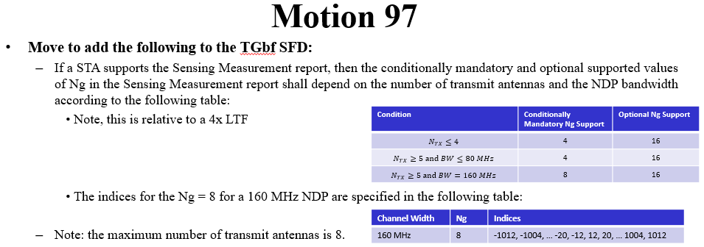

The aforementioned comments propose improved implementations of the above two passed motions.

Proposed resolution: Revised.

TGbf Editor: Please add a one-bit subfield “Reporting” to Figure 9-1002bb (Sensing field format) of D1.0.

TGbf Editor: Please add the following paragraph at the end of Clause 9.4.2.320 (Sensing element) of D1.0.
The Reporting subfield is set to 1 to indicate that the STA supports transmission of Sensing Measurement Report frames; and it is set to 0 otherwise.

TGbf Editor: Please insert the following paragraph after the third paragraph of Clause 11.55.1.2 (Dependencies) of D1.0.
Implementation of transmitting Sensing Measurement Report frames is optional.

TGbf Editor: Please revise the paragraph at P174L7-10 of Clause 11.55.1.4 (Sensing measurement setup) of D1.0 as follows.
If a sensing initiator assigns in a Sensing Measurement Setup Request frame the role of sensing receiver to
the sensing responder and also sets the Sensing Measurement Report Requested subfield to 1, and the sensing responder supports transmission of Sensing Measurement Report frames, the sensing responder shall send Sensing Measurement Report frames in sensing measurement instances that result from the sensing measurement setup.

If a sensing initiator assigns in a Sensing Measurement Request frame the role of sensing receiver to the sensing responder and also sets the Sensing Measurement Report Requested subfield to 1, and the sensing responder does not support transmission of Sensing Measurement Report frames, the sensing responder shall set Status Code field to REJECTED_WITH_SUGGESTED_CHANGES and set Sensing Measurement Report Requested subfield in Sensing Measurement Parameters to 0 when transmitting a Sensing Measurement Setup Respond frame to the sensing initiator.

SP: Do you agree to the resolutions provided in the document 11-23/0882 for the following CIDs: 1056, 1929, 1930, 1986, 2015, 2052, 2146, 2149, 2155, and 2176?

