IEEE P802.11  
Wireless LANs

|  |  |  |  |  |
| --- | --- | --- | --- | --- |
| “Proposal for a revised Annex G containing an Introduction to Frame Exchange Sequences and their Wireless Media” | | | | |
| Date: 2025-07 | | | | |
| Author(s): | | | | |
| Name | Affiliation | Address | Phone | email |
| Harry BIMS | Bims Laboratories, Inc. | Menlo Park, CA, USA. | 650 283 4174 | harrybims@me.com |

Abstract

This proposal seeks to introduce the reader to an alternative version of Annex G for describing frame exchange sequence examples, their spacio-temporal boundaries, and recommended practice based on frame exchange sequences that are specified in the 802.11-2024 document.

# A. Background

The Architecture Standing Committee has extensively debated the disposition of Annex G for many meetings. In the course of those discussions, the group has requested a proposed revision to Annex G that explains to the novice reader of the 802.11 standard, using informative text, the concept of frame exchange sequences, as the term is consistently used throughout the standard in various contexts. To this end, proposed text for Annex G is presented below for discussion.

The proposed Annex G presented below contains an informative description of frame exchange sequences, and their use in the normative text. The style of this proposed Annex G follows the style of other Annexes that provide exemplary descriptions of the normative text. In particular, consideration has been given to Annex I, Annex K.1, Annex L, Annex O.3, Annex Q, and Annex W.

The following are header primitive examples for the 802.11 standard document. Hyperlinks in the proposed text for Annex G are linked to these headers as an example of the usage of hyperlinks once the text is incorporated into the 802.11 standard.

3.1 Definitions

***[Clause text]***

4.3.10 QoS BSS

***[Clause text]***

4.3.11.11 Link measurement

*[Subclause text under 4.3.11 Wireless LAN radio measurements]*

4.3.24.5.10 Mesh path selection and forwarding

***[Clause text]***

4.3.24.5.6 Mesh coordination function (MCF)

***[Clause text]***

4.3.27.5 Overlapping BSS (OBSS) management

***[Clause text]***

4.3.31.2 Selective reception of group addressed frames

***[Clause text]***

4.10 IEEE Std 802.11 and IEEE Std 802.1X-2020

***[Clause text]***

4.10.3.3 AKM operations with a password or PSK

***[Clause text]***

4.10.3.6.2 AKM operations using FILS Shared Key authentication

***[Clause text]***

6.5.3.2 MLME-SCAN.request

***[Clause text]***

6.5.4.2 MLME-JOIN.request

***[Clause text]***

6.5.11.2 MLME-JOIN.request

***[Clause text]***

8.1 Scope of PHY services

***[Clause text]***

9.2.4.1.7 Power Management subfield

***[Clause text]***

9.2.4.5.11 Mesh Power Save Level subfield

***[Clause text]***

9.2.5.2 Setting for single and multiple protection under enhanced distributed channel access (EDCA)

***[Clause text]***

9.2.5.4 Setting for frames sent by a TXOP holder under HCCA

***[Clause text]***

9.2.5.5 Setting for frames sent by a TXOP holder under HCCA

***[Clause text]***

9.4.1.14 Block Ack Timeout Value field

***[Clause text]***

9.4.2.123 Higher Layer Stream ID element

***[Clause text]***

9.4.2.198 TWT element

***[Clause text]***

9.4.2.254.2 Quiet Time Period Setup subtype

***[Clause text]***

10.2 MAC architecture

***[Clause text]***

10.2.3 Hybrid coordination function (HCF)

***[Clause text]***

10.3 DCF

***[Clause text]***

10.3.2.1 CS mechanism

***[Clause text]***

10.3.2.4 Setting and resetting the NAV

***[Clause text]***

10.3.2.6 RTS/CTS with fragmentation

***[Clause text]***

10.3.2.9 CTS and DMG CTS procedure

***[Clause text]***

10.3.2.13.1 Acknowledgment procedure for DL MU PPDU in SU PPDU

***[Clause text]***

10.3.2.13.2 Acknowledgment procedure for DL MU PPDU in MU PPDU

***[Clause text]***

10.3.2.13.3 Acknowledgment procedure for UL MU transmission

***[Clause text]***

10.3.4.5 Control of the channel

***[Clause text]***

10.25 Block acknowledgment (block ack)

***[Clause text]***

10.25.8.4 GCR block ack BlockAckReq and BlockAck frame exchange sequences

***[Clause text]***

10.27 Protection mechanisms

***[Clause text]***

10.29.2 Reverse direction (RD) frame exchange sequence

***[Clause text]***

10.35.5.2 Rules for VHT sounding protocol sequences

***[Clause text]***

10.38.3 ATI transmission rules

***[Clause text]***

10.38.6.6.3 CDMG protected period establishment and maintenance

***[Clause text]***

10.38.12.4.3 SU-MIMO channel access procedure

***[Clause text]***

10.38.12.4.4 MU-MIMO channel access procedure

***[Clause text]***

10.42.3 Fast link adaptation

***[Clause text]***

10.47.1.2 Resource protection for S1G STAs in non-TIM mode using periodic RAW (PRAW)

***[Clause text]***

Figure 10-13



Figure 10-14



Figure 10-16

**

10.3.2.15 NAV distribution

***[Clause text]***

10.3.2.17 Response indication procedure

***[Clause text]***

10.23.2.3 EDCA TXOPs

***[Clause text]***

10.23.2.8 Multiple frame exchange sequences in an EDCA TXOP

***[Clause text]***

10.23.2.12.2 Unsolicited retry procedure

***[Clause text]***

10.23.3 HCF controlled channel access (HCCA)

***[Clause text]***

10.23.3.4 NAV operation of a TXOP under HCCA

***[Clause text]***

10.24.3.9.2 Access during an MCCAOP by mesh STAs that are not the MCCAOP owner

***[Clause text]***

10.25.8.4 GCR block ack BlockAckReq and BlockAck frame exchange sequencess

***[Clause text]***

10.33.2.2 Unidirectional implicit transmit beamforming

***[Clause text]***

10.33.2.3 Bidirectional implicit transmit beamforming

***[Clause text]***

10.33.2.4.3 Sounding exchange for calibration

***[Clause text]***

10.34 Antenna selection (ASEL)

***[Clause text]***

10.38.10 Response indication procedure

***[Clause text]***

10.41 DMG beamforming

***[Clause text]***

10.41.2.2 Initiator sector sweep (ISS)

***[Clause text]***

10.44.3 Link cooperation

***[Clause text]***

10.50 Page slicing

***[Clause text]***

Figure 10-6—RTS/CTS/data/Ack and NAV setting



Figure 10-8—RTS/CTS with fragmented MSDU



10.52 Sectorized beam operation

***[Clause text]***

10.52.4 TXOP-based sectorization operation

***[Clause text]***

10.52.5.2 Procedure

***[Subclause text for 10.52.5 Sector training operation]***

11.1.4 Acquiring synchronization, scanning

[Clause text]

11.1.4.1 General

***[Clause text]***

11.2.3.1 General

***[Clause text]***

11.2.3.11 TDLS peer power save mode

***[Clause text]***

11.2.3.16 VHT TXOP power save

***[Clause text]***

11.2.3.18 CMMG TXOP power save

***[Clause text]***

11.2.4 Power management in an IBSS

***[Clause text]***

11.2.7.2 Power management in a PBSS and DMG infrastructure BSS

***[Clause text]***

11.2.7.3 PCP power management mode

***[Clause text]***

11.2.7.4 ATIM frame usage for power management of non-AP STAs

***[Clause text]***

11.2.7.5 MU-MIMO power save

***[Clause text]***

11.2.8 ATIM frame and frame transmission in IBSS, DMG infrastructure BSS, and PBSS

***[Clause text]***

11.3.3 Frame filtering based on STA state

***[Clause text]***

11.22.3 Interworking procedures: generic advertisement service (GAS)

***[Clause text]***

Figure 12-58—FILS Shared Key authentication



13.4.2 FT initial mobility domain association in an RSN

***[Clause text]***

13.4.3 FT initial mobility domain association in a non-RSN

***[Clause text]***

13.4.4 FT initial mobility domain association over FILS in an RSN

***[Clause text]***

13.5.2 Over-the-air FT protocol authentication in an RSN

***[Clause text]***

13.5.3 Over-the-DS FT protocol in an RSN

***[Clause text]***

13.5.4 Over-the-air FT protocol in a non-RSN

***[Clause text]***

13.6.2 Over-the-air fast BSS transition with resource request

***[Clause text]***

13.6.3 Over-the-DS fast BSS transition with resource request

***[Clause text]***

14.6 Authenticated mesh peering exchange (AMPE)

***[Clause text]***

14.15.3 Mesh power management mode indications and transitions

***[Clause text]***

14.15.9.1 General

***[Subclause tex under the 14.15.9 Mesh peer service periods]***

15.1.2 Scope of DSSS PHY services

***[Clause text]***

16.1.2 Scope of HR/DSSS PHY services

***[Clause text]***

17.1.2 Scope of OFDM services

***[Clause text]***

18.1.4 Scope of ERP PHY services

***[Clause text]***

19.1.2 Scope of HT PHY services

***[Clause text]***

20.1.1 Scope of DMG PHY services

***[Clause text]***

21.1.2 Scope of VHT PHY services

***[Clause text]***

22.1.2 Scope of TVHT PHY services

***[Clause text]***

25.1.2 Scope of CMMG PHY services

***[Clause text]***

26 High-efficiency (HE) MAC specification

***[Clause text]***

26.2.4 Updating two NAVs

***[Clause text]***

26.2.6 MU-RTS Trigger/CTS frame exchange exchange procedure

***[Clause text]***

26.2.8 Multiple frame exchange sequences in an EDCA TXOP in the 6 GHz band

***[Clause text]***

26.5.3 MU cascading sequence

***[Clause text]***

27 High-efficiency (HE) PHY specification

***[Clause text]***

28 Enhanced directional multi-gigabit (EDMG) PHY specification

***[Clause text]***

O.3 Example of RD frame exchanges

***[Clause text]***

Annex Y PAD procedures

***[Clause text]***

**Annex G – Overview of Frame Exchange Sequences (revised)**

(informative)

## Introduction

Frame exchange sequences (FES) are particular sequences of Control frames, Data frames, Management frames, and Extension frames. MAC sublayer mechanisms control and restrict the operations of participating STAs, within a protection mechanism, for the duration of the frame exchange sequence. For STAs that participate in the FES, their response frames and ability to scan or go to sleep are examples of how they are controlled during the FES. For STAs that do not participate in the FES, protection mechanisms are used to control the wireless medium by restricting them from exchanging frames that will interfere with the FES. Not all frame exchanges are within the context of a frame exchange sequence.

As described in 8.1, each PHY provides protocol functions that enable these frame exchange sequences. For example, this text is repeated in the 802.11 standard for Scope of DSSS PHY services (15.1.2), Scope of HR/DSSS PHY services (16.1.2), Scope of OFDM PHY services (17.1.2), Scope of ERP PHY services (18.1.4), Scope of HT PHY services (19.1.2), Scope of DMG PHY services (20.1.1), Scope of VHT PHY services (21.1.2), Scope of TVHT PHY services (22.1.2), and Scope of CMMG PHY services (25.1.2).

During a frame exchange sequence, the sequence of frames is exchanged between STAs within a specified time duration that is communicated to STAs participating in the frame exchange sequence, and to STAs that are not participating in the frame exchange sequence. As described in 10.3.2.1 and 9.2.5.2, the single protection NAV, multiple protection NAV, and the RID are virtual CS mechanisms for frame exchange sequences, where the RID also updates the NAV of a frame exchange sequence under data rate selection rules, see 10.3.2.4 and 10.3.2.5[1]. This time duration can be updated during the frame exchange sequence to extend the time during which frames are exchanged. As described in 26.2.6, a virtual CS mechanism can be combined with the physical CS mechanism to determine the busy/idle state of the medium.

As described in 11.2.6, the completion of a frame exchange sequence can also be determined based on the address fields in received frames, the RXVECTOR in an HE MU PPDU it receives, and its PPDU classification in a received PPDU.

This annex highlights many of the clasifications of frame exchange sequences described in the 802.11 standard, their impact on STA operations, and provides links to their description in the text of the 802.11 standard.

## Overview of the basic frame exchange sequence mechanism

### General

There are a variety of frame exchange sequence variants described in the 802.11 standard. As described in 10.3, and in particular 10.3.2.15, the most basic description of a frame exchange sequence is a mechanism that simply establishes a virtual CS mechanism between STAs by distributing a NAV timer, with optional time extension to support the exchange of data frames, management frames, and their associated acknowledgment frames (see. The data and maangement frames may or may not be fragmented. As described in 10.3.2.17, an optional RID procedure distributes RID information during frame exchange sequences.

### Basic Frame Exchange Sequence with Virtual CS Mechanism

Figure 10-6 shows an example of how the virtual CS mechanism can be initialized at the start of a frame exchange sequence. An exchange of an optional RTS frame and/or CTS frame may distribute the NAV timer of the frame exchange sequence across all STAs who may attempt to transmit or receive a frame.

This NAV timer protects the transmission of subsequent data frame or management frames and their associated ACK frame exchanges.

### Fragmented Basic Frame Exchange Sequence

An example of a Fragmented Basic frame exchange sequence is shown in Figure 10-8. In this example, a single MSDU or MMPDU is transmitted from a source STA to a destination STA through the exchange of multiple PPDUs, each of which contain a fragment of the MSDU/MMPDU. Through this mechanism STAs are able to control the internal state of other participating STAs for the duration of the FES (see 10.3.2.6). Neither the NAV nor the RID are necessarily limited to a single frame exchange sequence, however a frame exchange sequence must complete on or before the NAV or RID expires.

## Impact of Frame Exchange Sequence Participation on internal operations of a STA

During a frame exchange sequence, STAs are restricted to perform certain internal operations, such as scanning, channel switching, power saving (doze/awake state), active mode, and channel measurement. As shown in Figure 10-8, the source and destination STAs participate in the FES for its entire duration, as they both rely on internal NAV timers that have been synchronized to determine when to end their FES restriction on their internal operations.

Each STA determines whether or not it is currently participating in an FES. This determination is necessary because there are at least four processes: a) scan procedure (see 6.5.3.2), synchronization procedure with a newly joined BSS (see 6.5.4.2), BSS initialization procedure (see 6.5.11.2), and the power save mechanisms (see 11.2.3.11, 11.2.3.16 (when allowed by the VHT AP during a TXOP after a BlockAck), 11.2.3.18, 11.2.4,, 11.2.7.2, 11.2.7.3, 11.2.7.4, and 11.2.7.5) within a STA that arerequired by the normative text to delay their execution if the STA is currently participating in an FES, see 11.2.3.1.

By definition, any STA that does not transmit or receive a PPDU frame transmission or control frame during an FES prior to the execution of one of these four processes, does not participate in that FES for its entire duration.

For example, though 11.1.4.1 says “details of how to optimize scanning is out of scope of this standard”, if a STA that is participating in a FES initiates its scan procedure during its participation in an FES, this will cause the STA to become unavailable to the frame exchange sequence during a time period where other STAs may attempt to exchange frames with the STA across the WM.

When a STA transmits a PPDU or control frame in the context of an FES, it becomes a participant in the FES. When a STA receives a PPDU frame transmision or a control frame transmission that addresses the STA in its destination address field, the STA also becomes a participant in the FES. Once a STA becomes a participant in an FES, there are many reasons for a STA to terminate is participation in the FES, as described in the various clauses of the normative text.

As described in 26.2.4, a STA can maintain two NAVs simultaneously, and as described in 10.38.10, a DMG STA can maintain multiple NAVs simultaneously. In addition, a VHT non-AP STA can enter a doze state during a TXOP and remain in the doze state for the rest of the TXOP (see 11.2.3.16 ).

There are several MAC layer procedures that are delayed within the awake state until the STA is no longer participating in an FES. According to 6.5.3.2, the scan process can be initiated only when a frame exchange sequence is completed. Similarly, according to 6.5.4.2, the synchronization procedure can be initiated only when a frame exchange sequence is completed, and according to 6.5.11.2, the BSS initialization procedure can be initiated only once the current frame exchange sequence is completed, and according to 9.2.4.1.7 and 9.2.4.5.11, the power management mode of a STA is initiated only after successful completion of a frame exchange sequence. Thus, these procedures can be initialized once a frame exchange sequence has completed during an ongoing TXOP, if a single protection NAV is used by the TXOP holder.

In addition, dynamic SM power save mode requires the participation of the STA in a FES to be completed before switching back from enabling multiple receive chains to single receive chain mode (see 11.2.6).

In reverse, subfields in exchanged frames can indicate the internal operational state of STAs that affect their participation and activity during a frame exchange sequence. These subfields include:

1. Power Management subfield (see 9.2.4.1.7, and 9.2.4.5.11, and 14.15.3)
2. Mesh Power Save Level subfield (see 9.2.4.5.11)
3. Block Ack Timeout Value field (see 9.4.1.14)
4. Nominal Minimum TWT Wake Duration field (see 9.4.2.198)

## The initial infrastructure BSS frame exchange sequences

In order for a STA to exchange Class 3 frames in an infrastructure BSS, a series of frame exchange sequences must be completed (see 11.1.4). One example series is the active scanning frame exchange sequence, followed by the authentication frame exchange sequence, followed by the association frame exchange sequence. (see 4.10.3.3, 4.10.3.6.2, 11.3.3, Figure 12-58, 13.4.2, 13.4.3, 13.4.4, 13.5.2, 13.5.3; 13.5.4; 13.6.2; 13.6.3).

For the infrastructure BSS, each frame exchange sequence mechanism operates within the spatial context of one or more infrastructure BSSs. As described in 10.52, these BSSs can be partitioned into sectors.

## Overview of additional frame exchange sequence classifications

In addition to this basic FES, there are more complicated varieties of an FES that involve an exchange of frames that delivers multiple MSDUs or MMPDUs across a WM, exchanges them with more than two STAs, and/or bundles multiple MSDUs or MMPDUs into a single (MU) PPDU. For these use cases, it is possible for STAs participating in the FES to prematurely end their participation, and lift their restriction on internal operations. However, once a STA has ended its participation in an FES, it cannot return to that FES.

In the IEEE 802.11 architecture, the frame exchanges of a single FES are usually limited to a single BSS. The figure below depicts the BSS components of an IEEE WLAN as though they are necessarily non-overlapping, and thus necessarily control independent WMs over which there can be independent FES communications taking place.



In this scenario, the STAs within a single BSS perform frame exchange sequences within each BSS. For example, in the figure below, the coverage area of each BSS provides a region within which frame exchange sequences can independently take place, if there is no overlap with a neighboring BSS.

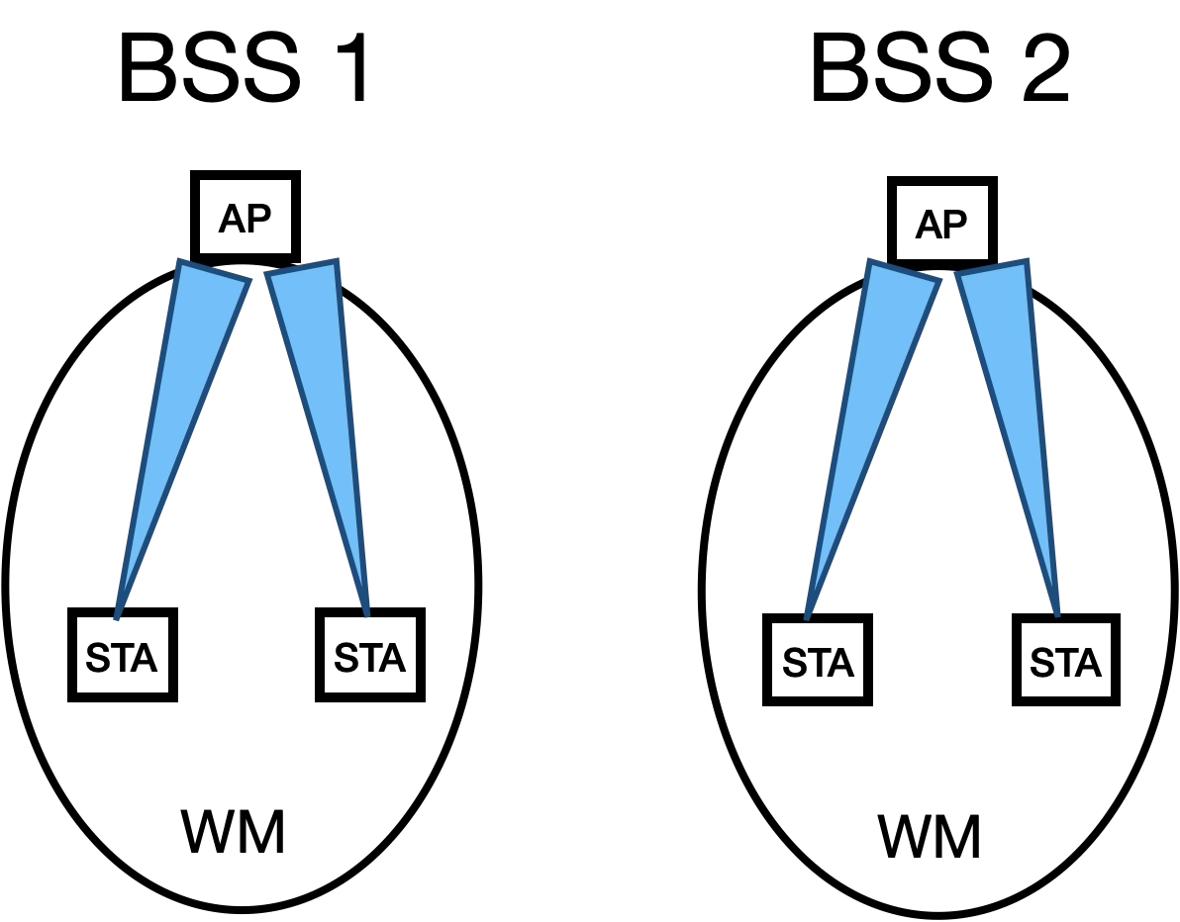

However, in many situations the coverage area of neighboring BSSs can overlap, enabling the potential for interference between their local frame exchanges when each BSS is configured to control an independent WM. As shown below, although the two STAs are exchanging frames with separate AP_STAs in separate locations, their communications can still cause interference.

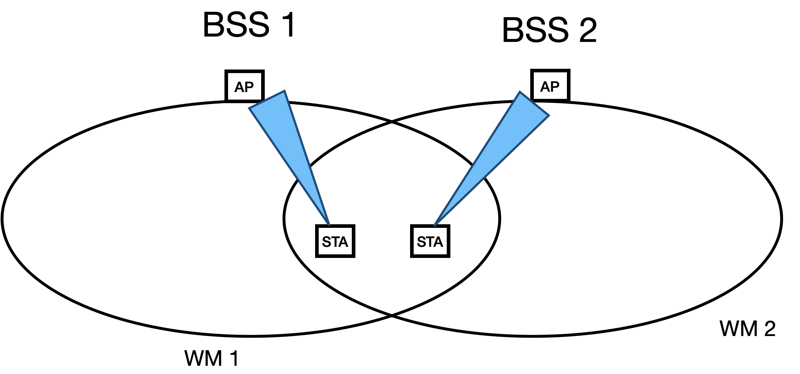

However, this overlap also allows for the exchange of frames between STAs in multiple BSSs as part of a single FES when the BSSs are configured to control a shared WM.

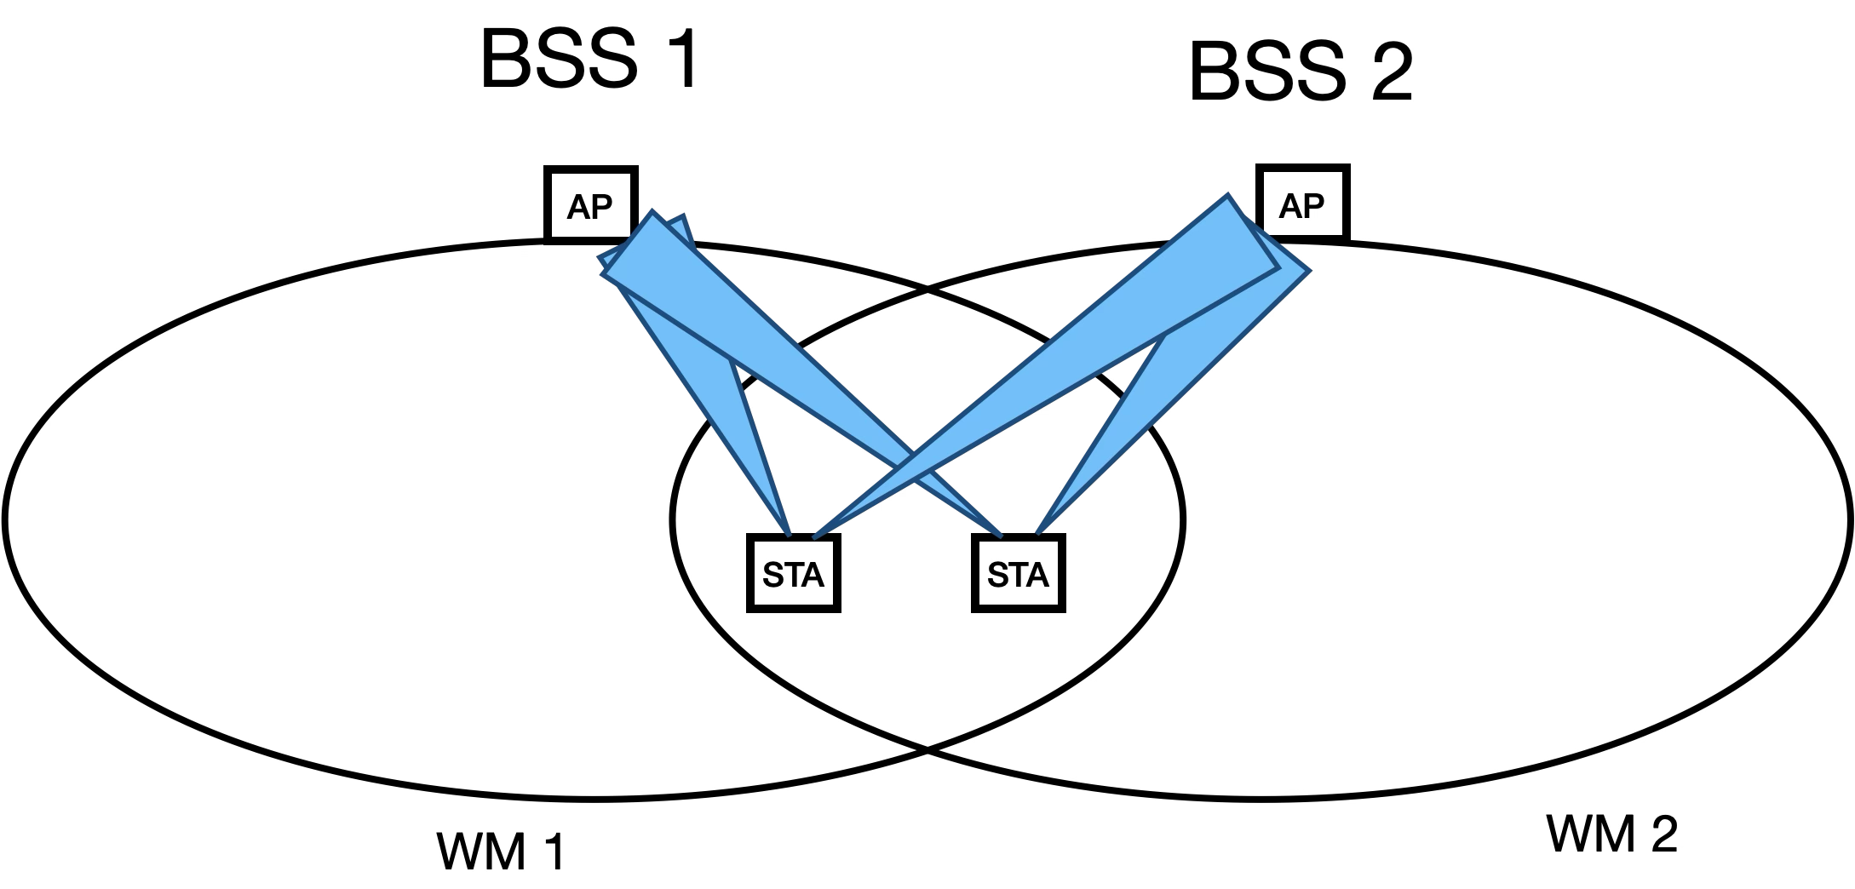

In this scenario, the neighboring BSSs can coordinate their transmissions to mitigate interference using Overlapping BSS (OBSS) management, as explained in 4.3.27.5. The architecture within which this coordination takes place is shown below.

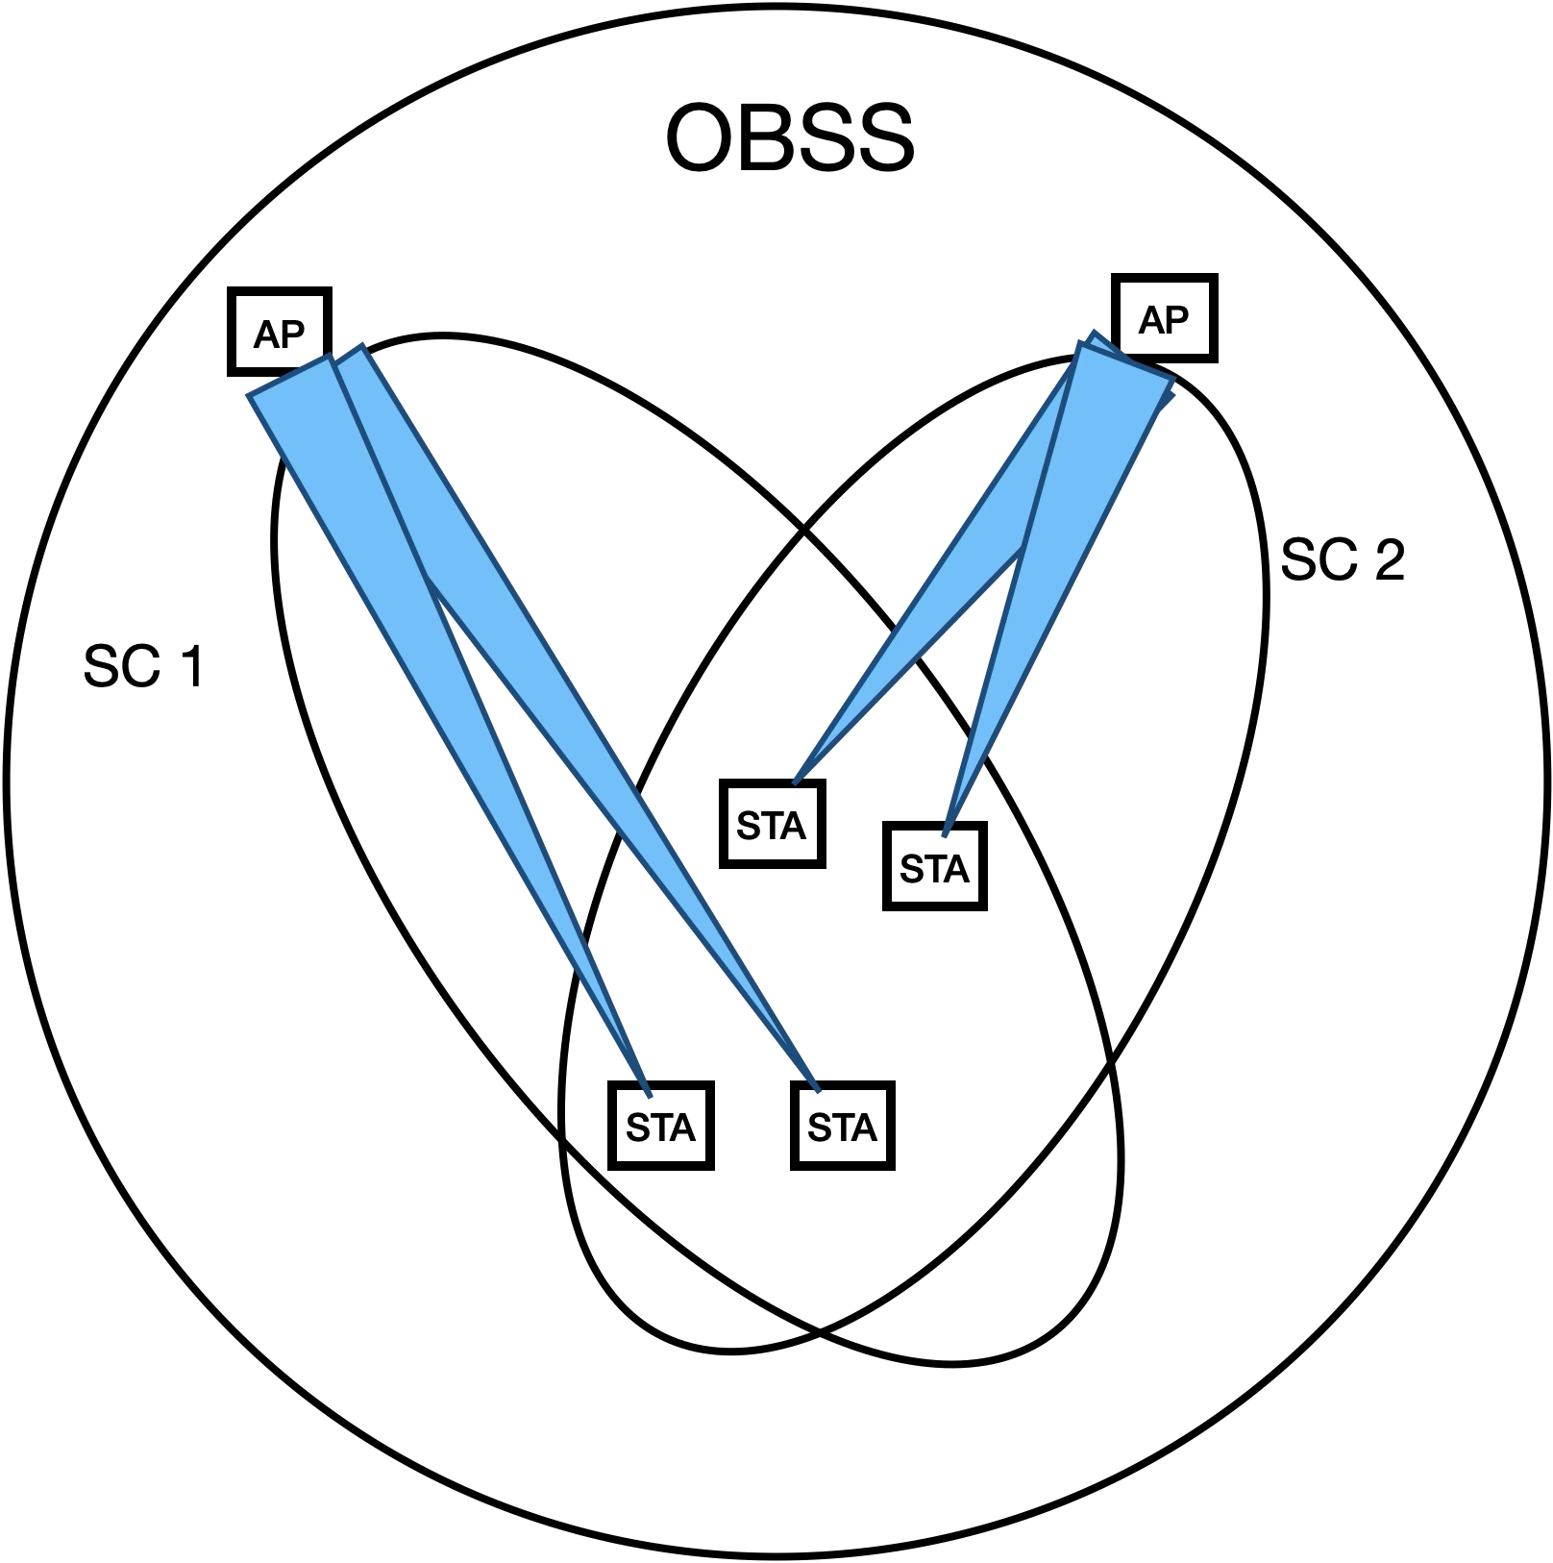

One mechanism for accomplishing this is for the AP_STAs to communicate with each other over the DS, acting as a backbone, in an architecture shown below. STAs that are in different WMs might rely on the DS to transport their MAC service tuples to peer STAs, as described in the definitions in 3.1, and shown in the figures below, when the different WMs are not colocated in the same AP. This applies to different WMs that use different frequency segments, and/or use different IEEE 802.11 PHYs, and/or use different optional sets of beamforming steering matrices.

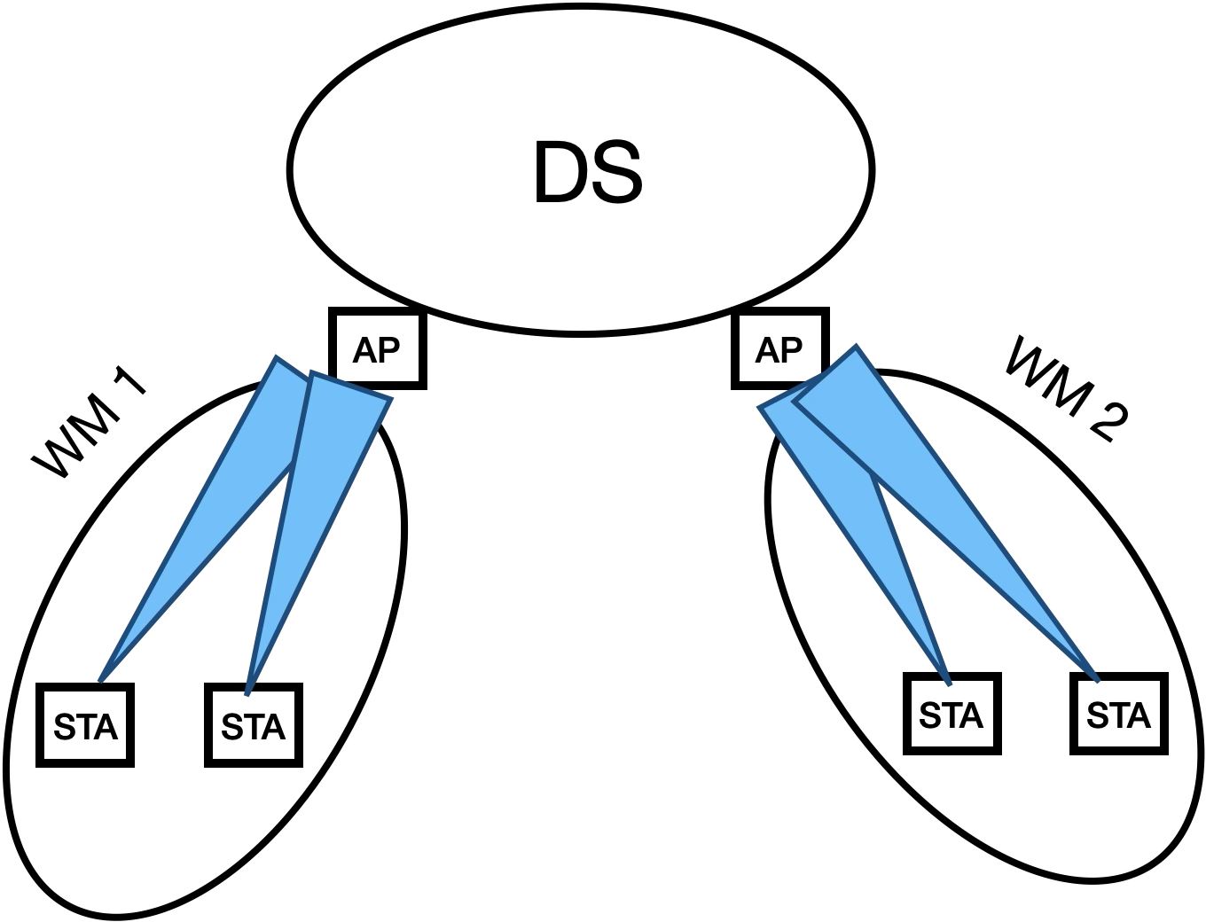



Alternatively, the AP_STAs can communicate with each other directly over their WMs, for example in a mesh BSS.

Beamforming can be used to create a spatial channel that includes an AP_STA and a plurality of non-AP STAs. A consequence of this is that non-AP STAs that communicate with an AP that uses different beams to communicate with each, can have independent frame exchange sequences, and independent awake states or active modes that are not coordinated by a NAV value.

One example of this is Figure 10-14 in which each sequence of BAR and BA/Ack can occur over separate beams in parallel. In this example, the annotated figure below shows all of the STAs are operating on their own spatial channel, created by a set of beamforming steering matrices that enables the AP_STA to communicate with the non-AP STAs in an overlapping manner. In addition, all of the STAs have synchronized to the same NAV timer within their respective WMs. However, each STA participates in a unique FES. The AP_STA participates in a single FES (AP_FES) that allows it to communicate with STA 1, STA 2, and STA 3 in a time overlapped manner. STA 1, STA 2, and STA 3, each participate in a unique FES (FES 1, FES 2, and FES 3 respectively) that allows them to communicate individually with the AP_STA, with their BA/Ack transmissions potentially isolated from the others due to beamforming. When their FES completes, each STA is allowed to prematurely lift the restriction on internal operations such as scanning, even though their NAV timer in their internal state for this FES has not expired. However, as long as the NAV timer for their internal state for this FES is still running, the STAs cannot return to exchange frames on this FES after switching to a different channel.

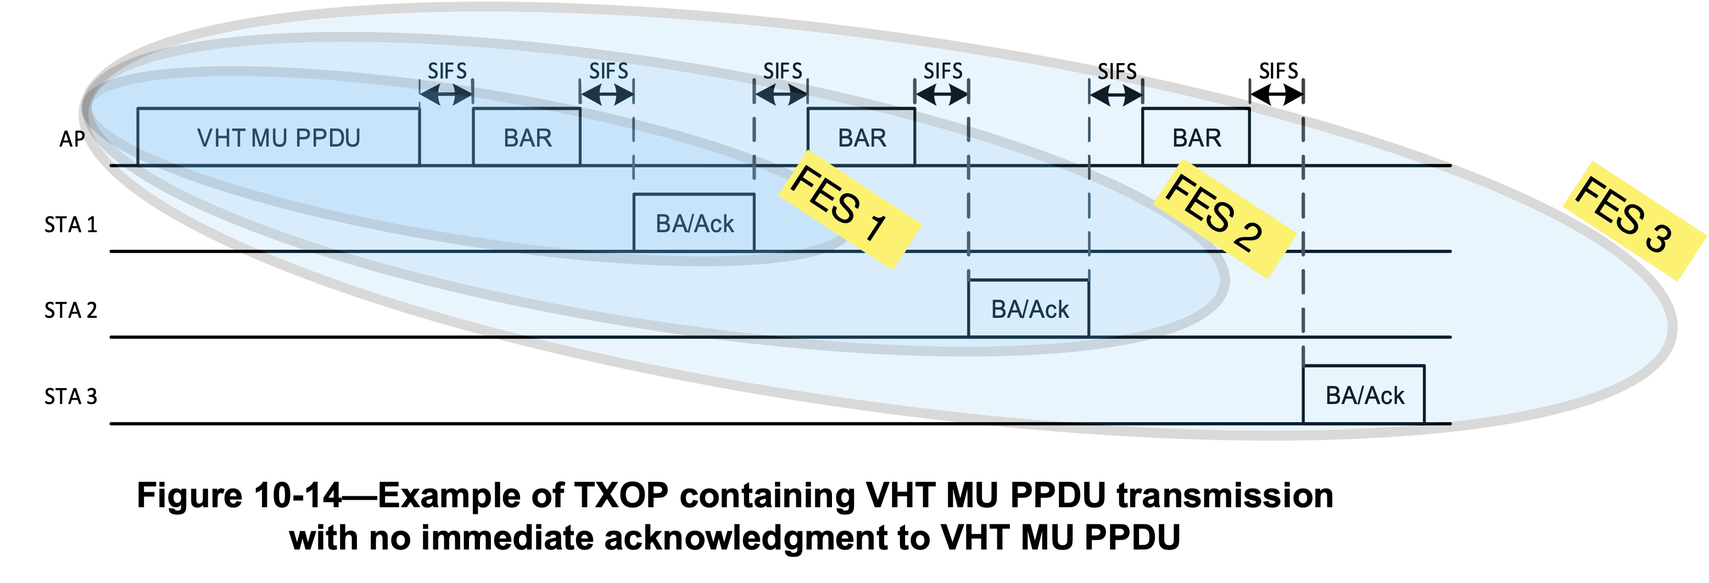

In addition to this, within a single BSS there may be optional support for more than one operating channel, where each operating channel may be configured to support independent FES communications on separate frequencies. For example, according to 4.3.24.5.10, there may be “multiple instances of a wireless medium within a mesh BSS”. In addition, as shown below there may be multiple primary and secondary channels, each with their own CCA governing the times when an FES may be transmitted over the WM of each STA.



In this scenario, the AP_STA supports multiple spatial channels within the BSS, as shown below. This allows FES communications with separate groups of STAs simultaneously, where each group of STAs operates on a separate spatial channel.

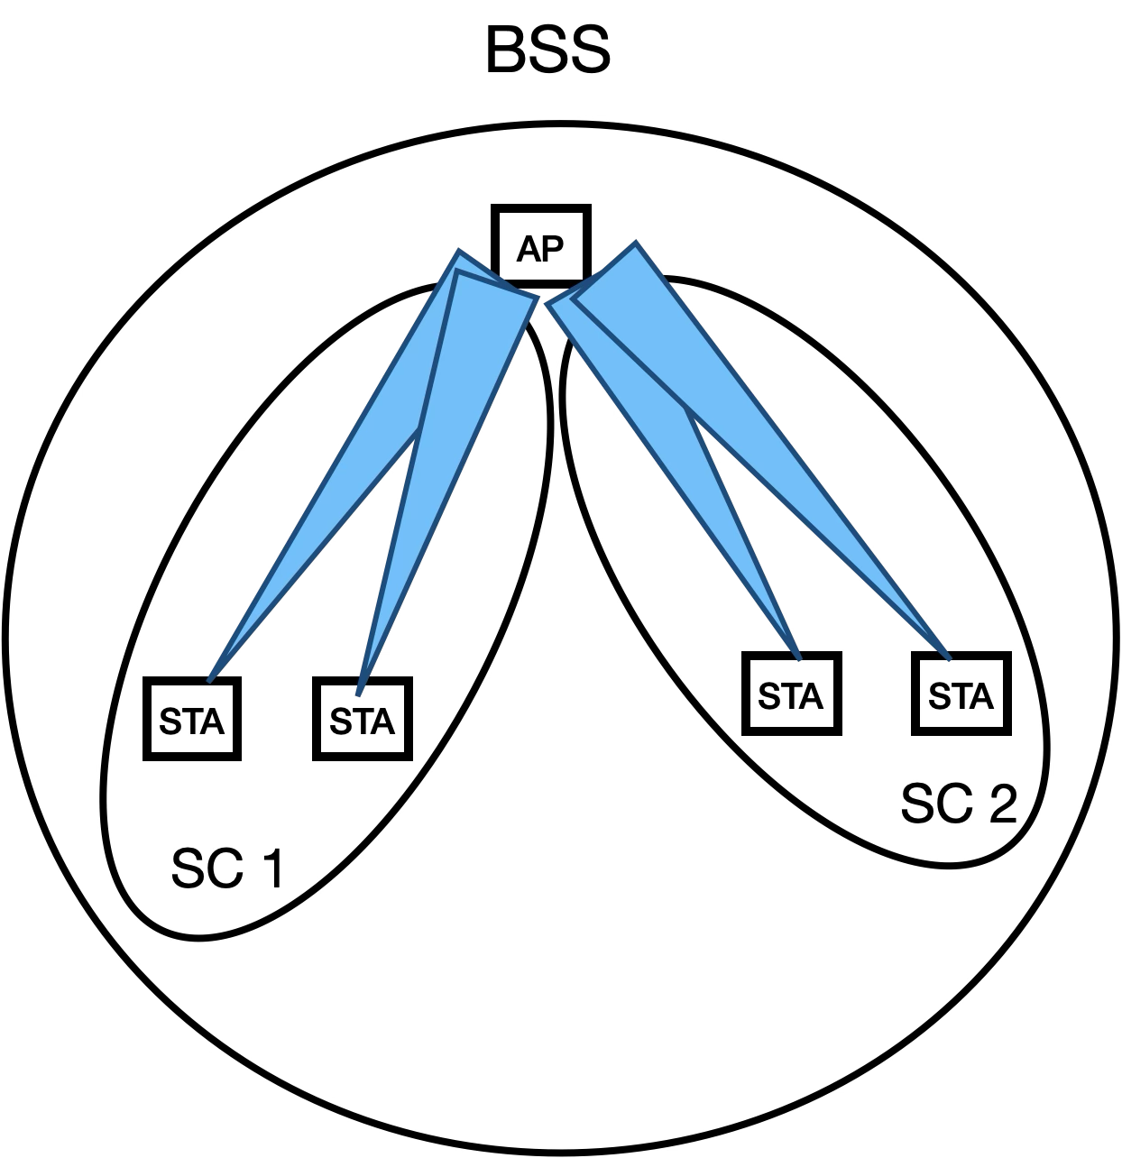

## Example Frame Exchange Sequences

Frame exchange sequences are described in a variety of contexts throughout this standard. For example, descriptions of frame exchange sequences are generally included in the normative text of multiple clauses (i.e., 4.3.10 (describing frame exchange rules are part of the core QoS facility), 4.3.11.11 (describing link measurement a frame exchange seqeunce), 10.2 and 10.3 (describing coordination functions controlling frame exchange sequences and their error states), 11.22.3 (describing a GAS frame exchange sequence), 4.3.24.5.6 and 14.6 (describing MCCA control of frame exchange sequence and AMPE frame exchange sequences), 4.10 (describing 802.1X frame exchange sequences), and Clause 26, Clause 27, and Clause 28 (each describing a different peer PHY entity). Informative text descriptions of frame exchange sequences are also described in O.3, and Annex Y.

Often, these descriptions are tailored to the specific requirements context of the clause in which they appear. For example, some frame exchange sequences are identified by a higher layer protocol (9.4.2.123), or by a peer-to-peer application (9.4.2.254.2). For some PHY scenarios, there is only one wireless channel instance, for other PHY scenarios, there may be several channel instances of the wireless medium, due to sectorization, beamforming, and MU-MIMO.

At times different peer STAs involved in a frame exchange sequence may terminate their participation in the FES, even though in accordance with 9.2.5.2, 9.2.5.4 and 9.2.5.5, each STA’s estimated time duration of the NAV that control internal states of pariticipating STA in which the FES communicates is determined by the value of the Duration/ID field in all exchanged frames (see 10.3.2.6). This is particularly true for a frame exchange sequence involving more than two STAs (such as the MU PPDU frame exchange sequence, see Figure 10-13 or Figure 10-16), where an individual STA can terminate its participation before the completion of a a group FES. This can affect the timing for when certain procedures are initiated by each STA, and can affect channel efficiency if neighboring STAs with pending transmissions are waiting for the NAV to expire, and determine that all STAs have ended their participation in the FES before the NAV has expired outside of a TXOP interval.

This Annex provides examples of frame exchange sequences that depict their usage throughout the various clauses of this standard. This Annex will not cover reference designs or recommended implementations of frame exchange sequences. The examples of frame exchange sequences that will be covered in Annex G include the following contexts:

1. Non-DMG. The frame exchange sequences implemented by this STA type require a specified IFS between basic frame exchanges to decrease the probability of non-participating STAs interrupting the frame exchange sequence. In addition, a virtual CS mechanism (10.3.2.1) is used to provide a virtual protection mechanism to all STAs.
2. HCCA and EDCA/GCR. This example is one in which HCF frame exchange sequences are implemented as part of the channel access rules defined by the HCF. Frame exchange sequences may be initiated by one or more QoS STAs or an AP in an MU cascading sequence. In this case, a TXOP responder may or may not transmit its frame within the time window of the TXOP, given the estimated time required for transmission of the response frame may be inexact. See 10.2.3, 10.23.2.3, 10.23.2.12.2, and 10.23.3. In addition, there may be multiple frame exchange sequences in the TXOP.
3. RAV mechanism. This is an additional mechanism to the virtual CS mechanism for frame exchange sequences (see 10.24.3.9.2). For example, frame exchange sequences may use mesh peer service periods in which at least one mesh STA is in light or deep sleep mode (see 14.15.9.1).
4. For grouop addressed frames, a DMS Request and Response frame exchange to set up GLK-GCR service (see 4.3.31.2).
5. Peer-to-peer application. This example is one in which a peer-to-peer application can identify individual frame exchange sequences between HE STAs (see 9.4.2.254.2).
6. Block Ack for VHT PHYs. This example is one in which a single frame exchange sequence includes multiple block acknowledgments, each from a different STA, and each preceded by either a BAR or a MU PPDU transmitted by an AP STA (see 10.3.2.13.1).
7. Restricted Access Window (RAW). This example is one in which a frame exchange sequence shall not exceed the allocated RAW slot boundary (see 10.47.1.2).
8. Fast Link Adaptation. In this example, after a Responding STA receives a Link Measurement Request, it transmits a series of PPDUs, followed by a Link Measurement Report, with additional frames subsequently transmitted by the Initiating STA (see 10.42.3).
9. GCR MU-BAR. This example is one in which a frame exchange sequence includes two types of Block Acks for the GCR group members (see 10.25.8.4).
10. MU cascading sequence. In this example, multiple STAs tansmit an HE TB PPDU to an AP_STA simultaneously, all of which are acknowledged in a single HE MU PPDU (see 26.5.3).
11. RD frame exchanges. This example is shown in the informative text of clause O.3.
12. Bidirectional Implicit transmit beamforming. This example is one in which a transmit beamforming frame exchange sequence is initiated by an unsteered PPDU that includes a training request (see 10.33.2.3).
13. SU-MIMO and MU-MIMO channel access. This example is one in which frame exchange sequences use MIMO channel access to exchange frames (see 11.2.8).
14. TXOP-based sectorization operation. This example is one in which spatially orthogonal frame exchange sequences are transmitted until the expiry of the SO timer without resetting the NAV (see 10.52.4).
15. Sector training. This example is one in which an AP transmits a sector training announcement, followed by NDP CTS frames, followed by sector ID feedback (see 10.52.5.2).

## Frame Exchange Sequence Classifications

The following table depicts the STA Types that are described as part of the normative description of each FES category. Depending on its capability as described in the normative text, a STA Type that is not described as part of the normative description of a FES Group, might nonetheless support the FES Group. In addition, the FES Groups may not be mutually exclusive. For example, an RTS/CTS protection mechanism used to begin a frame exchange within an EDCA-based TXOP, while the countdown of the NAV timer for the TXOP spans more than one frame exchange sequence, and the TXOP holder determines that start and stop of individual frame exchange sequences within the TXOP (10.23.2.3, 10.23.2.8, 10.23.3.4, 10.50. 26.2.8).

| **FES Classification** | **STA Types the standard describes using an FES Classification[2]** | | | | | | | | | | |
| --- | --- | --- | --- | --- | --- | --- | --- | --- | --- | --- | --- |
| **Non-DMG** | **DMG** | **CDMG** | **CMMG** | **GLK** | **EDMG** | **HE** | **S1G** | **VHT** | **HT** | **EHT** |
| Fragmented Basic (10.3.4.5) | X | X | X | X | X | X | X | X | X | X | X |
| Basic or Fragmented Basic w/ protection mechanism (10.3.2.6, 10.3.2.9, 10.27) | X  (RTS/ CTS) | X  (RTS/ DMG CTS) |  | X |  | X | X | X | X | X |  |
| Reverse Direction (10.29.2) |  | X |  |  |  | X |  | X |  | X |  |
| Block acknowledgment (10.25) |  | X |  |  | X | X | X | X |  | X |  |
| MU w/ auto 1st ACK (10.3.2.13.1) |  |  |  |  | X | X | X |  | X |  |  |
| MU w/ BAR for 1st ACK (10.3.2.13.1) |  |  |  |  | X | X | X |  | X |  |  |
| MU for A-MPDUs (10.3.2.13.1) |  |  |  |  |  | X |  |  |  |  |  |
| A-MPDU w/ UL OFDMA (10.3.2.13.2) |  |  |  |  |  |  | X |  |  |  |  |
| Triggered MU w/ DL MU OFDMA (10.3.2.13.3) |  |  |  |  |  |  | X |  | X | X |  |
| Triggered MU w/ DL Multi-STA Block Ack (10.3.2.13.3) |  |  |  |  |  |  | X |  | X |  |  |
| Triggered MU w/ duplicate DL Multi-STA Block Ack (10.3.2.13.3) |  |  |  |  |  |  | X |  | X |  |  |
| Multiple PPDUs before BAR (10.25.8.4) |  |  |  |  |  |  | X |  |  |  |  |
| Multiple PPDUs before MU-BAR Trigger (10.25.8.4) |  |  |  |  |  |  | X |  |  |  |  |
| Unidirectional implicit transmit beamforming (10.33.2.2) |  |  |  |  |  |  |  |  |  | X |  |
| Bidirectional updating of reciprocal beamforming steering matrices (10.33.2.3) |  |  |  |  |  |  |  |  |  | X |  |
| Calibration w/ SIFS (10.33.2.4.3) |  |  |  |  |  |  |  |  |  | X |  |
| Trasmit/Receive Antenna Selection (ASEL) (10.34) | X |  | X | X | X | X |  | X |  | X | X |
| Single VHT Beamformee (10.35.5.2) |  |  |  |  |  |  |  | X | X |  |  |
| Multiple VHT Beamformees (10.35.5.2) |  |  |  |  |  |  |  | X | X |  |  |
| ATI (10.38.3) |  | X |  | X |  |  |  |  |  |  |  |
| Multi-channel CDMG (10.38.6.6.3) |  |  | X |  |  |  |  |  |  |  |  |
| SU-MIMO w/ RTS/CTS (10.38.12.4.3, 10.38.12.4.4) |  |  |  |  |  | X |  |  |  |  |  |
| MU-MIMO w/ optional RTS/CTS (10.38.12.4.4, 26.5.3) |  |  |  |  |  | X | X |  |  |  |  |
| MU Cascading (26.5.3) |  |  |  |  |  | X | X |  |  |  |  |
| Single Sector Sweep (10.41.2.2) |  | X |  |  |  | X |  |  |  |  |  |
| Sector Sweep (10.41) |  | X |  |  |  | X |  |  |  |  |  |
| Relay setup (10.44.3) |  | X | X |  |  |  |  |  |  |  |  |
| MU followed by Doze (11.2.8) | X | X |  |  |  |  |  |  |  |  |  |
| Hybrd Omni/Spatial (10.52.4) |  |  |  |  |  |  |  | X |  |  |  |
| Protected RAW (10.47.1.2) |  |  |  |  |  |  |  | X |  |  |  |

### Reverse Direction

This frame exchange sequence classification comprises a TXOP holder that exchanges a PPDU, followed by an RD responder exchanging one or more PPDUs.

### Block Acknowledgement

This frame exchange sequence comprises the exchange of blocks of QoS Data frames exchanged by an AP, followed by a Block Ack Request exchanged by that AP, and a Block Ack frame exchanged in response by the participating STA.

### MU w/ auto 1st ACK

This frame exchange sequence classification comprises the exchange of a VHT MU PPDU frame from an AP, followed by a Block Ack, followed by a repeated series of a Block Ack Request frame exchanged by an AP, followed by a Block Ack frame exchanged by a participating STA.

### MU w/ BAR for 1st ACK

This frame exchange sequence classification comprises the exchange of a VHT MU PPDU frame from an AP, followed by a repeated series where a Block Ack Request frame is exchanged from an AP, followed by a Block Ack frame exchanged from a participating STA.

### MU for A-MPDUs

This frame exchange sequence classification comprises the simultaneous exchange of multiple A from an AP, followed by a series of Block ACK frame exchanges from participating STAs.

### A-MPDU w/ UL OFDMA

This frame exchange sequence classification comprises the exchange of an HE MU PPDU containing multiple A-MPDU with triggering frames from an AP, followed by the exchange of multiple Block Ack frames transmitted simultaneously as an uplink OFDMA Block Ack from participating STAs.

### Triggered MU w/ DL MU OFDMA

This frame exchange sequence classification comprises the simultaneous exchange of multiple HE TB PPDUs from an AP, followed by the exchange of multiple Block Ack frames transmitted simultaneously as an uplink OFDMA Block Ack from participating STAs.

### Triggered MU w/ DL Multi-STA Block Ack

This frame exchange sequence classification comprises the simultaneous exchange of multiple HE TB PPDUs from an AP, followed by the exchange of a Multi-STA Block Ack frame from participating STAs.

### Triggered MU w/ duplicate DL Multi-STA Block Ack

This frame exchange sequence classification comprises the simultaneous exchange of multiple HE TB PPDUs from an AP, followed by the exchange of a Multi-STA Block Ack frame from participating STAs.

### Multiple PPDUs before BAR

This frame exchange sequence classification comprises a series of Data frames exchanged by an AP, followed by a repeated series where a Block Ack Request frame is exchanged by that AP, followed by a Block Ack frame from a participating STA.

### Multiple PPDUs before MU- BAR Trigger

This frame exchange sequence classification comprises a series of Data frames exchanged by an AP, followed by a repeated series where a GCR MU-BAR Trigger frame is exchanged by that AP, followed by a Block Ack frame from a participating STA. After the repeated series, further Data frames are exchanged by the AP.

### Updating Reciprocal Beamforming Steering Matrix

This frame exchange sequence classification comprises an unsteered TRQ frame, followed by an unsteered Sounding PPDU, followed by a steered HT Data frame, followed by an unsteered Sounding PPDU without an IFS restriction.

### Bidirectional Updating of Reciprocal Beamforming Steering Matrix

This frame exchange sequence classification comprises an unsteered TRQ frame, followed by an unsteered Sounding PPDU, followed by a steered HT Data frame, followed by a steered Sounding PPDU exchanged in series without an IFS restriction.

### Calibration w/ SIFS

This frame exchange sequence classification comprises a calibration start frame, followed by a calibration sound frame, followed by a calibration cocmplete frame, followed by an Ack frame exchanged in series without an IFS restriction.

### Transmit/Receive Antenna Selection

This frame exchange sequence classification starts with a calibration start frame, followed by a calibration sound frame. Subsequently, one variant comprises a calibration cocmplete frame, followed by an Ack frame exchanged in series without an IFS restriction; a second variation comprises an NDP frame; and a third variation comprises an NDP frame followed by an NDP frame.

### Single VHT Beamformee

This frame exchange sequence classification comprises a VHT NDP Announcement frame, followed by an NDP frame, followed by a VHT Compressed Beamforming frame, exchanged with a SIFS interval spacing.

### Multiple VHT Beamformee

This frame exchange sequence classification comprises a VHT NDP Announcement frame, followed by an NDP frame, followed by a VHT Compressed Beamforming frame, followed by a repeated series where a Beamforming Report Poll frame is exchanged followed by a VHT Compressed Beamforming frame.

### ATI

This frame exchange sequence classification comprises a repeated series of a Request frame followed by either an ACK frame or a Response frame.

### Multi-channel CDMG

This frame exchange sequence classification comprises a series of a RTS frame followed by a DMG CTS frame exchanged on each of two channel frequencies before a Data frame is exchanged.

### SU-MIMO w/ RTS/CTS

In the first variant, a frame exchange sequence classification comprises an RTS frame followed by a CT frame, followed by a DMG CTS frame followed by a CT frame, followed by the exchange of one or more SU PPDU frames. In the second variant, a frame exchange sequence comprises a CTS-to-self frame followed by a CT frame, followed by the exchange of one or more SU PPDU frames.

### MU-MIMO w/ optional RTS/CTS

In the first variant, this frame exchange sequence classification comprises multiple RTS frames exchanged simulatneously followed by a CT frame, followed by multiple DMG CTS frames exchanged by participating STAs, followed by the exchange of one or more MU PPDU frames.

In the second variant, this frame exchange sequence classification comprises multiple CTS-to-self frames exchanged simulatneously followed by multiple CT frames exchanged simultaneously, followed by the exchange of one or more MU PPDU frames.

### MU Cascading

This frame exchange sequence classification comprises a repeated series where an HE MU PPDU exchanged from an AP, followed by multiple HE TB PPDUs exchanged from participating STAs; followed by a Multi-STA Block Ack frame exchanged from the AP.

### Single Sector Sweep

This frame exchange sequence classification comprises a series of Transmit Sector Sweep frames exchanged by an Initiator, followed by a series of Receive Sector Sweep frames exchanged by a Responder, followed by a Sector Sweep Feedback frame exchanged by an Initiator, followed by an SSW-Ack frame exchanged by the Responder.

### Single Sector Sweep

In the first variant, this frame exchange sequence classification comprises a series of Transmit Sector Sweep frames exchanged by an Initiator, followed by a series of Receive Sector Sweep frames exchanged by a Responder, followed by a Sector Sweep Feedback frame exchanged by that Initiator, followed by an SSW-Ack frame exchanged by the Responder.

In the second variant, this frame exchange sequence classification comprises a series of Transmit Sector Sweep frames exchanged by an Initiator, followed by a Transmit Sector Sweep frame exchanged by a Responder, followed by a Sector Sweep Feedback frame exchanged by an Initiator, followed by an SSW-Ack frame exchanged by the Responder.

### Single Sector Sweep

In the first variant, this frame exchange sequence classification comprises a series of Short SSW frames exchanged by an Initiator, followed by a series of BRP frames exchanged by an Initiator and participating Responders.

In the second variant, this frame exchange sequence classification comprises a series of MIMO BF Setup frames exchanged by an Initiator, followed by a series of BRP training frames exchanged by that Initiator, followed by a repeated series where a MIMO BF-Poll frame is exchanged by the Initiator followed by a MIMO BF Feedback frame.

In the third variant, this frame exchange sequence classification comprises a series of MIMO BF Setup frames exchanged by an Initiator, followed by a series where a MIMO BF Poll frame is exchanged by that Initiator followed by a series of BRP frames exchanged by a Responder.

### Point-to-Multipoint

This frame exchange sequence classification comprises a pair of TPA Request frames transmitted by a Destination REDS, followed by a TPA Response frame from an RDS, followed by a TPA Response frame and TPA Request frame from a source, followed by a TPA Response frame from the RDS, followed by a TPA Request frame exchanged by the Destination REDS followed by a TPA Response frame exchanged by the RDS.

### MU followed by Doze state

This frame exchange sequence classification comprises multiple A-MPDU frames exchanged simultaneously, followed by a series of Block Ack frames exchanged sequentially by participating EDMG STAs.

### MU followed by Doze state

This frame exchange sequence classification comprises multiple A-MPDU frames exchanged simultaneously, followed by a series of Block Ack frames exchanged sequentially by participating EDMG STAs, where each EDMG STA enters the Doze state after exchanging their Block Ack frame.

### Hybrid Omni/Spatial

In the first variant of this frame exchange sequence classification comprises a CTS-to-self frame exchanged from an AP, followed by an Omnidirectional portion of the frame exchange sequence, followed by a Sectorized Beam portion of the frame exchange sequence.

In the second variant, this frame exchange sequence classification comprises a packet frame exchanged from an AP, followed by an Ack or Response frame exchanged by a participating STA in an omnidirectional portion, followed by long format or short format frames exchanged from the AP, followed by an Ack frame exchanged by the participating STA.

In the third variant, this frame exchange sequence classification comprises an RTS frame exchanged from an AP, followed by a CTS frame exchanged by a participating STA in an omnidirectional portion, followed by long format or short format frames exchanged from the AP, followed by an Ack frame exchanged by the participating STA.

In the fourth variant, this frame exchange sequence classification comprises a PS-Poll/Trigger/Other frame exchanged from a participating STA followed by a short format frame exchanged from an AP in an omnidirectional portion, followed by a long format or short format frame exchanged by the AP.

### Protected RAW

This frame exchange sequence classification comprises a repeated series where a PRAW frame is exchanged from an AP while STA 1 is not allowed to access its WM, while STA 2 is allowed to exchange a TWT scheduled frame.

1. UUnder these rules, the RID is updated when a S1G PPDU is received, except when a non-zero Duration/ID field is received that sets the NAV. Thus, different S1G STAs can have different perspectives on the ending of the FES depending on whether their RID counter was updated, or their NAV was reset.
2. STA Types not identified in the table may be conditionally capable of certain FES Classifications depending on its operational state.