IEEE P802.11  
Wireless LANs

|  |  |  |  |  |
| --- | --- | --- | --- | --- |
| “Proposal for a revised Annex G containing an Introduction to Frame Exchange Sequences and their Wireless Media” | | | | |
| Date: 2025-05 | | | | |
| Author(s): | | | | |
| Name | Affiliation | Address | Phone | email |
| Harry BIMS | Bims Laboratories, Inc. | Menlo Park, CA, USA. | 650 283 4174 | harrybims@me.com |

Abstract

This proposal seeks to introduce the reader to an alternative version of Annex G for describing frame exchange sequence examples, their spacio-temporal boundaries, and recommended practice based on frame exchange sequences that are specified in the P802.11-REVme/D7.0 document.

# A. Background

The Architecture Standing Committee has extensively debated the disposition of Annex G for many meetings. In the course of those discussions, the group has requested a proposed revision to Annex G that explains to the novice reader of the 802.11 standard, using informative text, the concept of frame exchange sequences, as the term is consistently used throughout the standard in various contexts. To this end, proposed text for Annex G is presented below for discussion.

The proposed Annex G presented below contains an informative description of frame exchange sequences, and their use in the normative text. The style of this proposed Annex G follows the style of other Annexes that provide exemplary descriptions of the normative text. In particular, consideration has been given to Annex I, Annex K.1, Annex L, Annex O.3, Annex Q, and Annex W.

**Annex G – Overview of Frame Exchange Sequences (revised)**

(informative)

## Impact of NAV, Awake State, and RID on Frame Exchange Sequence Participation

According to 10.3.2.1, the NAV timer and RID counters do not control the wireless medium. Rather the NAV, merely “maintains a prediction of future traffic on the medium based on duration information that is announced in RTS/CTS frames by non-DMG STAs, in MU-RTS Trigger/CTS frames by HE STAs as defined in 26.2.6 MU-RTS Trigger/CTS frame exchange exchange procedure), and in RTS/DMG CTS frames by DMG STAs prior to the actual exchange of data” and a virtual CS mechanism is formed by combining “the NAV state, and in S1G STAs also the RID state, and the STA’s transmitter status with physical CS to determine the busy/idle state of the medium.”

For any given frame exchange sequence (FES), the STAs participating in the FES use the NAV to remain in the awake state. However, there can be different understandings among the peer STAs about when they are allowed to transition from the awake state to the doze state. This can affect the timing for when certain procedures within a given STA that cannot be initiated when an ongoing awake state (or active mode) is required, can be initiated.

For example, as described in 10.3.2.1 and 9.2.5.2 for S1G STAs, there can be two types of virtual CS mechanisms provided by S1G MACs during a frame exchange sequence; 1) the single protection or multiple protection NAV (which is used to update the NAV under data rate selection rules, see 10.3.2.4), or 2) the response indication deferral (RID) (which is used to update the NAV after the RID is updated, see 10.3.2.4, and 10.3.2.5). The multiple protection NAV indicates to all STAs participating in the FES they are allowed to transition to the doze state only after the end of the TXOP, whereas according to 10.49.2, a non-AP STA may transition to the doze state if the More Data field in a frame sent by the AP is equal to 0 prior to the end of the TXOP.

There are several MAC layer procedures that are delayed within the awake state until the STA is no longer participating in an FES. According to 6.5.3.2.4, the scan process can be initiated only when a frame exchange sequence is completed. Similarly, according to 6.5.4.2.4, the synchronization procedure can be initiated only when a frame exchange sequence is completed, and according to 6.5.11.2.4, the BSS initialization procedure can be initiated only once the current frame exchange sequence is completed, and according to 9.2.4.1.7 and 9.2.4.5.11, the power management mode of a STA is initiated only after successful completion of a frame exchange sequence. Thus, these procedures can be initialized once a frame exchange sequence has completed during an ongoing TXOP, if a single protection NAV is used by the TXOP holder.

As described in 11.2.6, the completion of a frame exchange sequence can be determined through multiple possibilities, including a deteremination made by the CS mechanism:

“The STA can determine the end of the frame exchange sequence through any of the following:

* It receives an individually addressed frame addressed to another STA.
* It receives a frame with a TA that differs from the TA of the frame that started the TXOP.

. . .

* The CS mechanism (see 10.3.2.1 (CS mechanism) indicates that the medium is idle at the TxPIFS slot boundary (defined in 10.3.7 (DCF timing relations)).”

This nuance is not currently captured in the normative text, and should be explained to the reader in Annex G where appropriate.

# In addition, according to 10.3.2.5, the RID is updated when a S1G PPDU is received, except when a non-zero Duration/ID field is received that sets the NAV. Thus, different S1G STAs can have different perspectives on the ending of the FES depending on whether their RID counter was updated, or their NAV was reset.

In addition, indications that maintain overlapping control of frame exchange sequences in their wireless medium are also impacted by these boundaries. Some of the affected indications include:

1. Power Management subfield
2. Mesh Power Save Level subfield
3. Block Ack Timeout Value field
4. Nominal Minimum TWT Wake Duration field

## Impact of Frame Exchange Sequence Participation on internal operations of a STA

During a frame exchange sequence, STAs are restricted to perform certain internal operations, such as scanning, channel switching, power saving, and channel measurement. In this above figure, the source and destination STAs participate in the FES for its entire duration, as they both rely on internal NAV timers that have been synchronized to determine when to end their FES communications.

Each STA determines whether or not it is currently participating in an FES. This determination is necessary because there are at least four processes: a) scan procedure (see 6.5.3.2.4), synchronization procedure with a newly joined BSS (see 6.5.4.2.4), BSS initialization procedure (see 6.5.11.2.4), and the power save mechanisms (see 11.2.3.11, 11.2.3.16 (when allowed by the VHT AP during a TXOP after a BlockAck), 11.2.3.18, 11.2.4.2, 11.2.4.4, 11.2.7.1, 11.2.7.2.2, 11.2.7.2.3, 11.2.7.3.3, 11.2.7.4, and 11.2.7.5) within a STA that arerequired by the normative text to delay their execution if the STA is currently participating in an FES, see 11.2.3.1.

For example, though the normative text at 11.1.4.1 says “details of how to optimize scanning is out of scope of this standard”, if a STA that is participating in a FES initiates its scan procedure during its participation in an FES will cause the STA to become unavailable during a time period where other STAs may attempt to exchange frames with the STA across the WM. The normative text expressly requires that the BSS initialization procedure must delay until the current frame exchange sequence is complete.

By definition, any STA that does not transmit or receive a PPDU frame transmission or control frame during an FES prior to the execution of one of these four processes, does not participate in that FES for its entire duration.

When a STA transmits a PPDU or control frame in the context of an FES, it becomes a participant in the FES. When a STA receives a PPDU frame transmision or a control frame transmission that addresses the STA in its destination address field, the STA also becomes a participant in the FES. Once a STA becomes a participant in an FES, there are many reasons for a STA to terminate is participation in the FES, as described in the various clauses of the normative text.

In addition, at least the dynamic SM power save mode requires the participation of the STA in a FES to be completed before switching back from enabling multiple receive chains to single receive chain mode (see 11.2.6).

## Overview of a Wireless Medium (WM)

As defined by the standard a wireless medium is “the medium used to implement the transfer of protocol data units (PDUs) between peer physical layer (PHY) entities of a wireless local area network (LAN).” Each STA has such a wireless medium that is used by its internal PHY entities to effectuate frame exchanges in a frame exchange sequence. Thus, in each frame exchange a frame is transmitted through the sending STA’s WM, and received by potentially one or more STAs through their respective WMs. When spatial multiplexing is used, frames are exchanged over one or more spatial dimensions associated with a spatial stream. This spatial stream utilizes a beamforming steering matrix to map the frame exchange into a non-exclusive portion of the STA’s WM called a spatial channel.

An instance of the WM connected to each STA is essentially identified in the normative text by three factors:

a) the frequency segment(s) within a radio frequency band used for contiguous or non-contiguous transmission of frames (see 3.1). For EDMG the frequency segment(s) occupy a bandwidth up to 2.16 GHz (see 10.38.12); and

b) the type of IEEE 802.11 PHY used for frame exchanges between peer STAs (see 4.6), even if they are part of a colocated access point set, and

The optional set of beamforming steering matrices used for direct communication of frame exchanges between peer STAs operating as a beamformer/beamformee pair (see 3.1) identify a non-exclusive portion of the WM that is mapped to a spatial stream. See for example, the DMG PHY (see Clause 20) and EDMG PHY (see Clause 28).

As shown in the figure below, a single AP along with a subset of its associated STAs in a BSS can form a WM that is a communication channel for the exchange of frames between two or more devices.

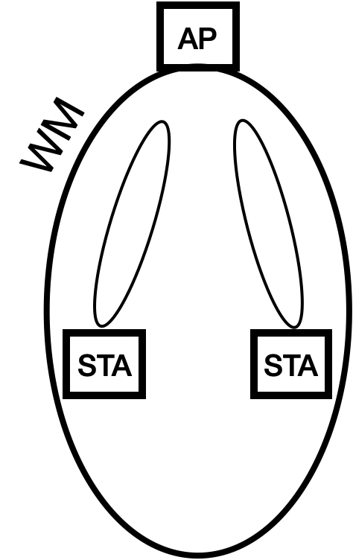

In this context there are 3 WMs. The area of WM of the AP encompasses the locations of the two STAs. Each STA, in turn has its own WM, within which beam steering can be applied to exchange frames with the AP. When a single MPDU is transmitted as a frame exchange, the one or more peer STAs that are addressed using a unicast or multicast address might use their own beamforming steering matrices to receive the MPDU, and the STA that transmitted the MPDU might use its own beamforming steering matrix to transmit the MPDU.

Further, when an A-MPDU is exchanged, the one or more associated STAs that are addressed by the MPDUs contained in this frame might use their own beamforming steering matrix mappings to receive the A-MPDU, and the AP that transmitted the A-MPDU might use its own beamforming steering matrix mapping to multicast the A-MPDU to all of the STAs in the WM. An acknowledgement frame from each STA that received at least one MPDU is then transmitted to the AP as a Block Ack.

The AP can handle multiple mappings within its WM in parallel by sectorizing the BSS according to operating channel or spatially, as shown in the figure below.

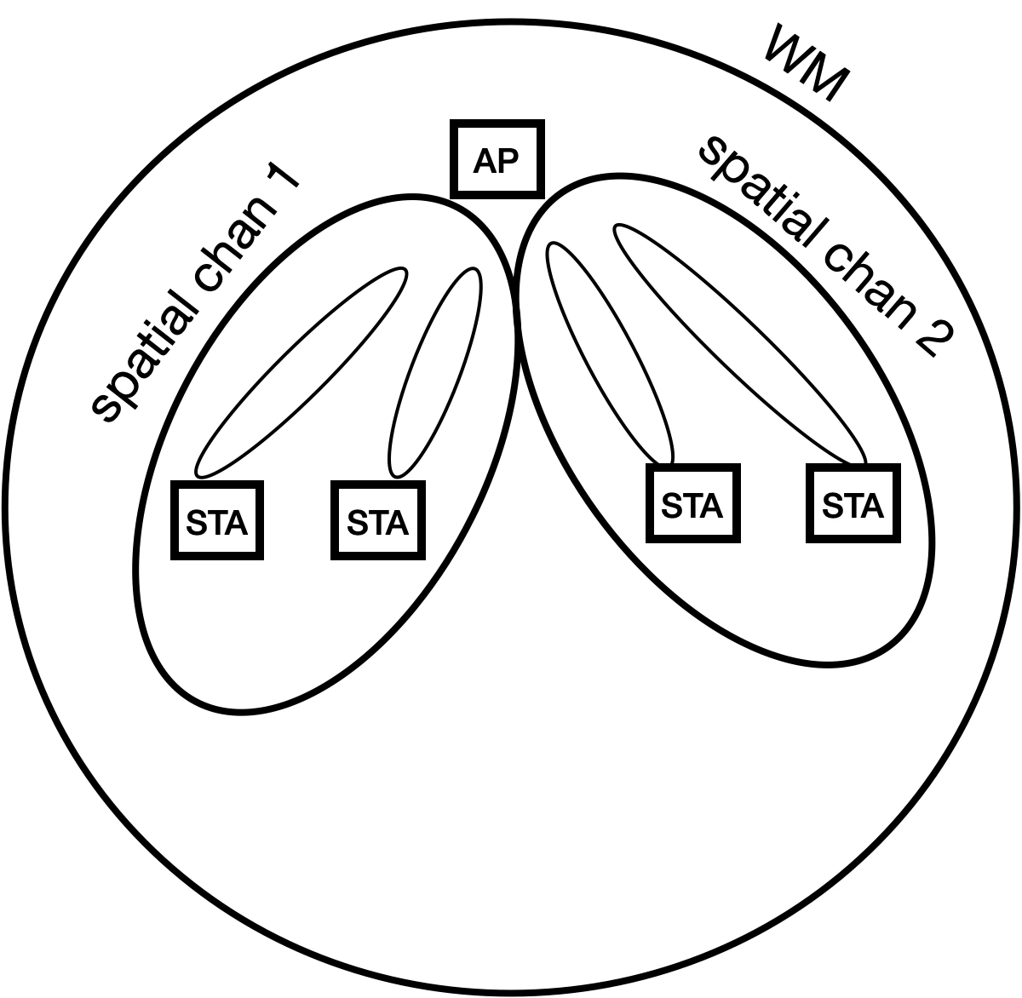

In addition, the AP may use a different beamforming steering matrix for each associated STA in the WM, as described in this standard, as shown in the figure below for the DMG STA:



## Basic frame exchange sequence classifications

### General

The frame exchange sequence (FES) is composed of a sequence of IEEE 802.11 frames that are exchanged between two or more PHY layer entities in different STAs, through the WM of each STA. As described in 8.1, data is transmitted and received between two or more STAs through a WM that is between them. This text is repeated in this standard for DSSS PHY services (15.1.2), HR/DSSS PHY services (16.1.2), OFDM PHY services (17.1.2), ERP PHY services (18.1.4), HT PHY services (19.1.2), DMG PHY services (20.1.1), VHT PHY services (21.1.2), TVHT PHY services (22.1.2), and CMMG PHY services (25.1.2). As we will show later, there is more than one such WM between two or more STAs, and each frame exchange occurs over the WMs of all STAs participating in the frame exchange sequence simultaneously.

### Basic Frame Exchange Sequence with Virtual CS Mechanism

Figure 10-6 is repeated below, and shows an example of a basic frame exchange sequence classification that can be used in all circumstances where a frame exchange sequence can occur. In this example, the data frame exchange and its subsequent ACK frame exchange are protected by a NAV timer that is distributed to all STAs capable of receiving the RTS frame, the CTS frame and/or the Data frame.



### Fragmented Basic

The Fragmented Basic frame exchange sequence classification is shown in 10-24 below, which shows a basic frame exchange sequence that delivers a single MSDU or MMPDU from a source to a destination through the exchange of multiple PPDUs, each of which contain a fragment of the MSDU/MMPDU.



In this classification, the time period in between each frame transmission is a SIFS interval, which under most circumstances prevents the STAs from losing access to their WM if other STAs not participating in the FES have not updated their NAV timer based on the NAV field in the frame headers in the fragment frames. The STAs that participate in an FES maintain control of their WMs through their transport of the network allocation vector (NAV) value in the Duration/ID field and/or for an S1G STA, a response indication deferral RID counter in frame headers. Through this mechanism STAs are able to control the internal state of other participating STAs for the duration of the FES. Neither the NAV nor the RID are necessarily limited to a single frame exchange sequence, however a frame exchange sequence must complete on or before the NAV or RID expires.

The first two mechanisms are limited by the original TXOP boundaries and apply to both STAs and APs.  The TXOP limits are determined by the AP by signalling in the beacon. The last mechanism allows multiple STAs to manage the medium, where control is not limited to a single TXOP limit.

### Basic or Fragmented Basic w/ protection mechanism

This frame exchange sequence classification adds a protection mechanism, such as the exchange of an RTS frame followed by the exchange of a CTS frame, preceding the basic or fragmented basic frame exchange.

## Overview of additional frame exchange sequence classifications

In addition to this basic FES, there are more complicated varieties of an FES that involve an exchange of frames that delivers multiple MSDUs or MMPDUs across a WM, exchanges them with more than two STAs, and/or bundles multiple MSDUs or MMPDUs into a single (MU) PPDU. For these use cases, it is possible for STAs participating in the FES to prematurely end their participation, and lift their restriction on internal operations. However, once a STA has ended its participation in an FES, it cannot return to that FES.

In the IEEE 802.11 architecture, the frame exchanges of a single FES are usually limited to a single BSS. The figure below depicts the BSS components of an IEEE WLAN as though they are necessarily non-overlapping, and thus necessarily control independent WMs over which there can be independent FES communications taking place.



In this scenario, the STAs within a single BSS perform frame exchange sequences within each BSS. For example, in the figure below, the coverage area of each BSS provides a region within which frame exchange sequences can independently take place, if there is no overlap with a neighboring BSS.

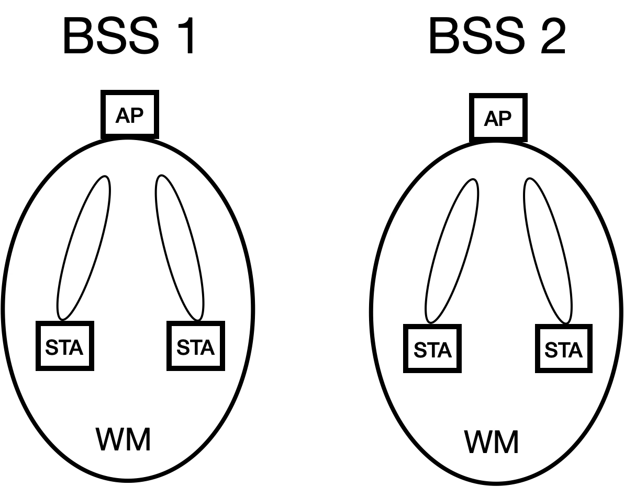

However, in many situations the coverage area of neighboring BSSs can overlap, enabling the potential for interference between their local frame exchanges when each BSS is configured to control an independent WM. As shown below, although the two STAs are exchanging frames with separate AP_STAs in separate locations, their communications can still cause interference.

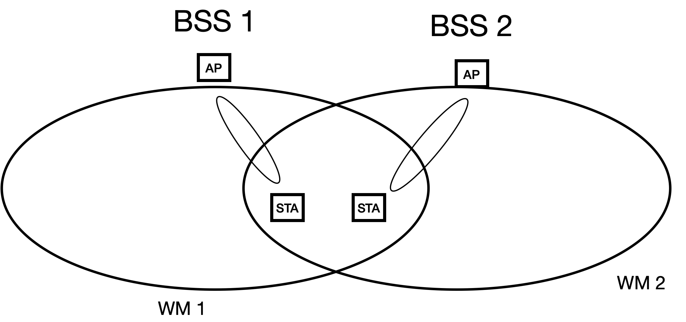

However, this overlap also allows for the exchange of frames between STAs in multiple BSSs as part of a single FES when the BSSs are configured to control a shared WM.

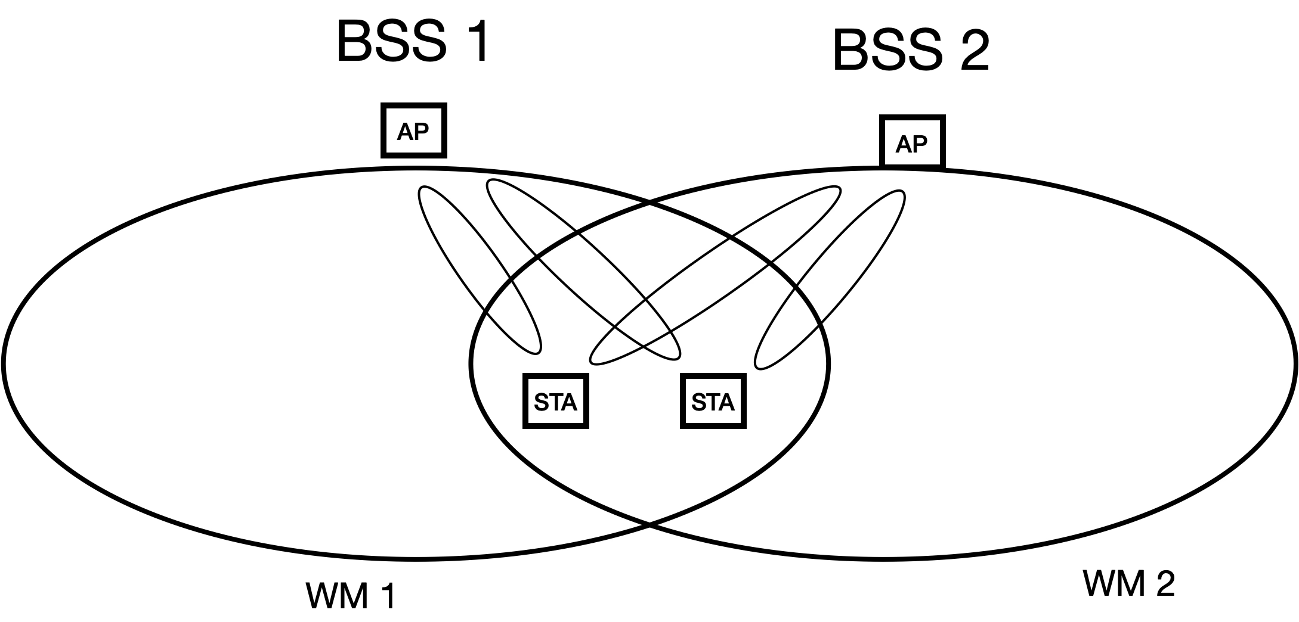

In this scenario, the neighboring BSSs can coordinate their transmissions to mitigate interference using Overlapping BSS (OBSS) management, as explained in 4.3.27.5. The architecture within which this coordination takes place is shown below.

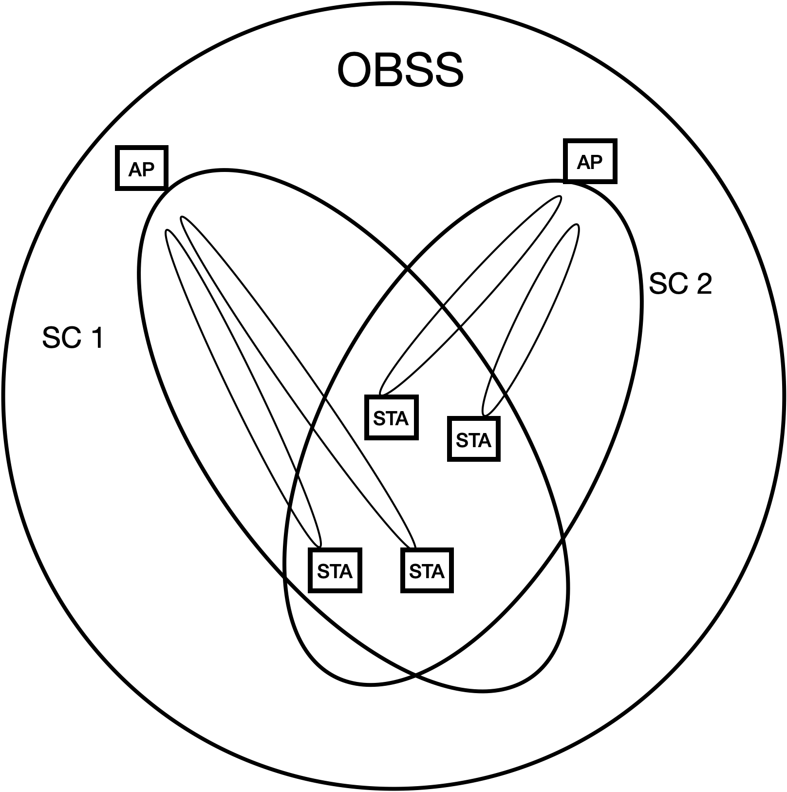

One mechanism for accomplishing this is for the AP_STAs to communicate with each other over the DS, acting as a backbone, in an architecture shown below. STAs that are in different WMs might rely on the DS to transport their MAC service tuples to peer STAs, as described in the definitions in 3.1, and shown in the figures below, when the different WMs are not colocated in the same AP. This applies to different WMs that use different frequency segments, and/or use different IEEE 802.11 PHYs, and/or use different optional sets of beamforming steering matrices.

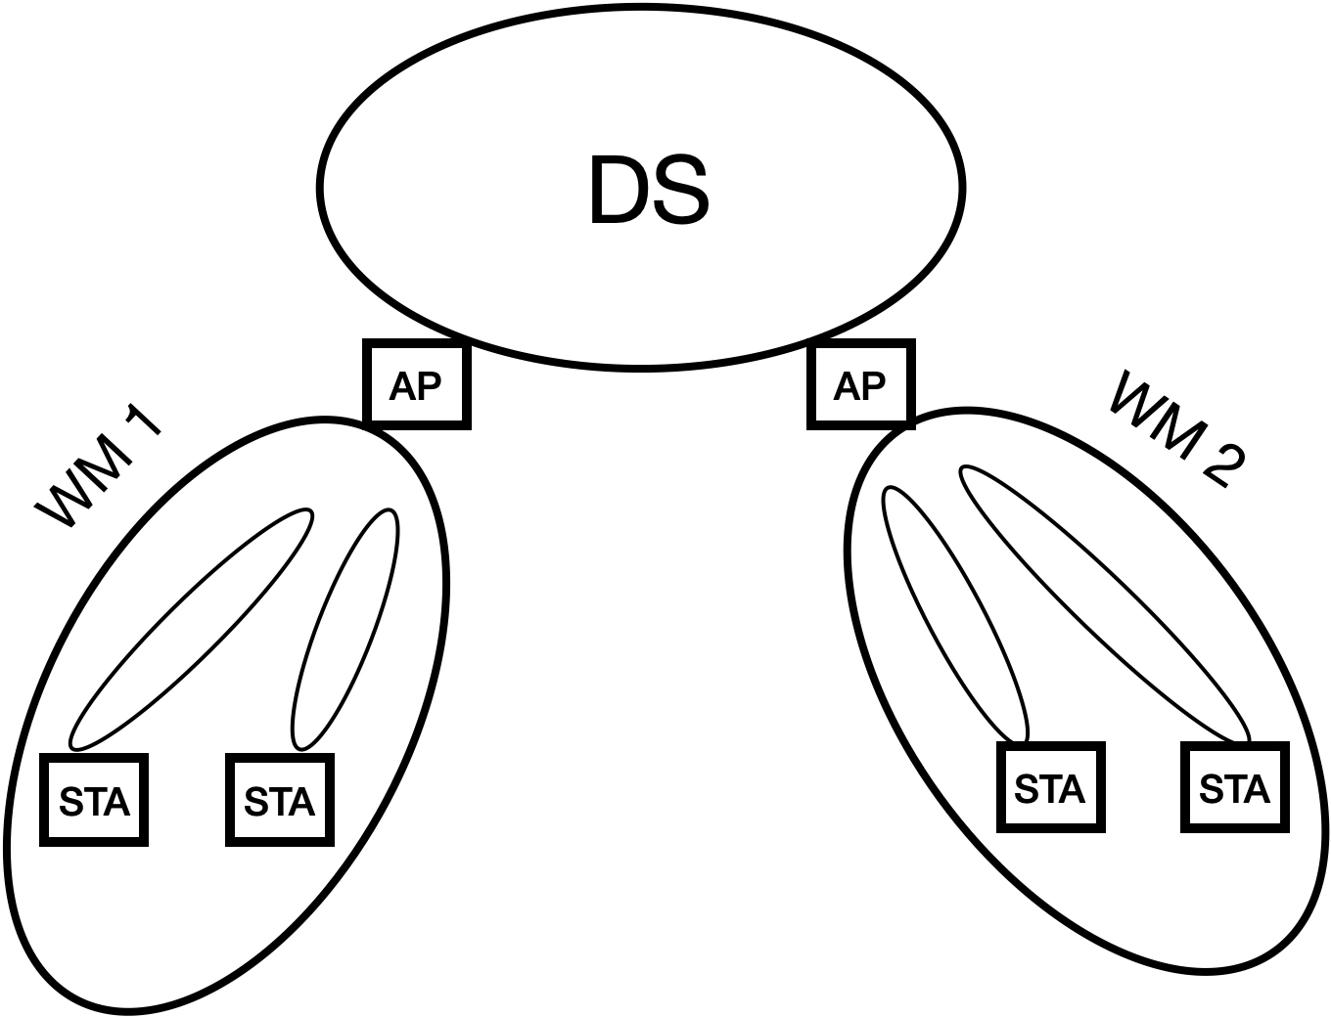



Alternatively, the AP_STAs can communicate with each other directly over their WMs, for example in a mesh BSS.

Beamforming can be used to create a spatial channel that includes an AP_STA and a plurality of non-AP STAs. A consequence of this is that non-AP STAs that communicate with an AP that uses different beams to communicate with each, can have independent frame exchange sequences, and independent awake states or active modes that are not coordinated by a NAV value.

One example of this is Figure 10-14 of 10.3.2.13.1 in which each sequence of BAR and BA/Ack can occur over separate beams in parallel. In this example, the annotated figure below shows all of the STAs are operating on their own spatial channel, created by a set of beamforming steering matrices that enables the AP_STA to communicate with the non-AP STAs in an overlapping manner. In addition, all of the STAs have synchronized to the same NAV timer within their respective WMs. However, each STA participates in a unique FES. The AP_STA participates in a single FES (AP_FES) that allows it to communicate with STA 1, STA 2, and STA 3 in a time overlapped manner. STA 1, STA 2, and STA 3, each participate in a unique FES (FES 1, FES 2, and FES 3 respectively) that allows them to communicate individually with the AP_STA, with their BA/Ack transmissions potentially isolated from the others due to beamforming. When their FES completes, each STA is allowed to prematurely lift the restriction on internal operations such as scanning, even though their NAV timer in their internal state for this FES has not expired. However, as long as the NAV timer for their internal state for this FES is still running, the STAs cannot return to exchange frames on this FES after switching to a different channel.

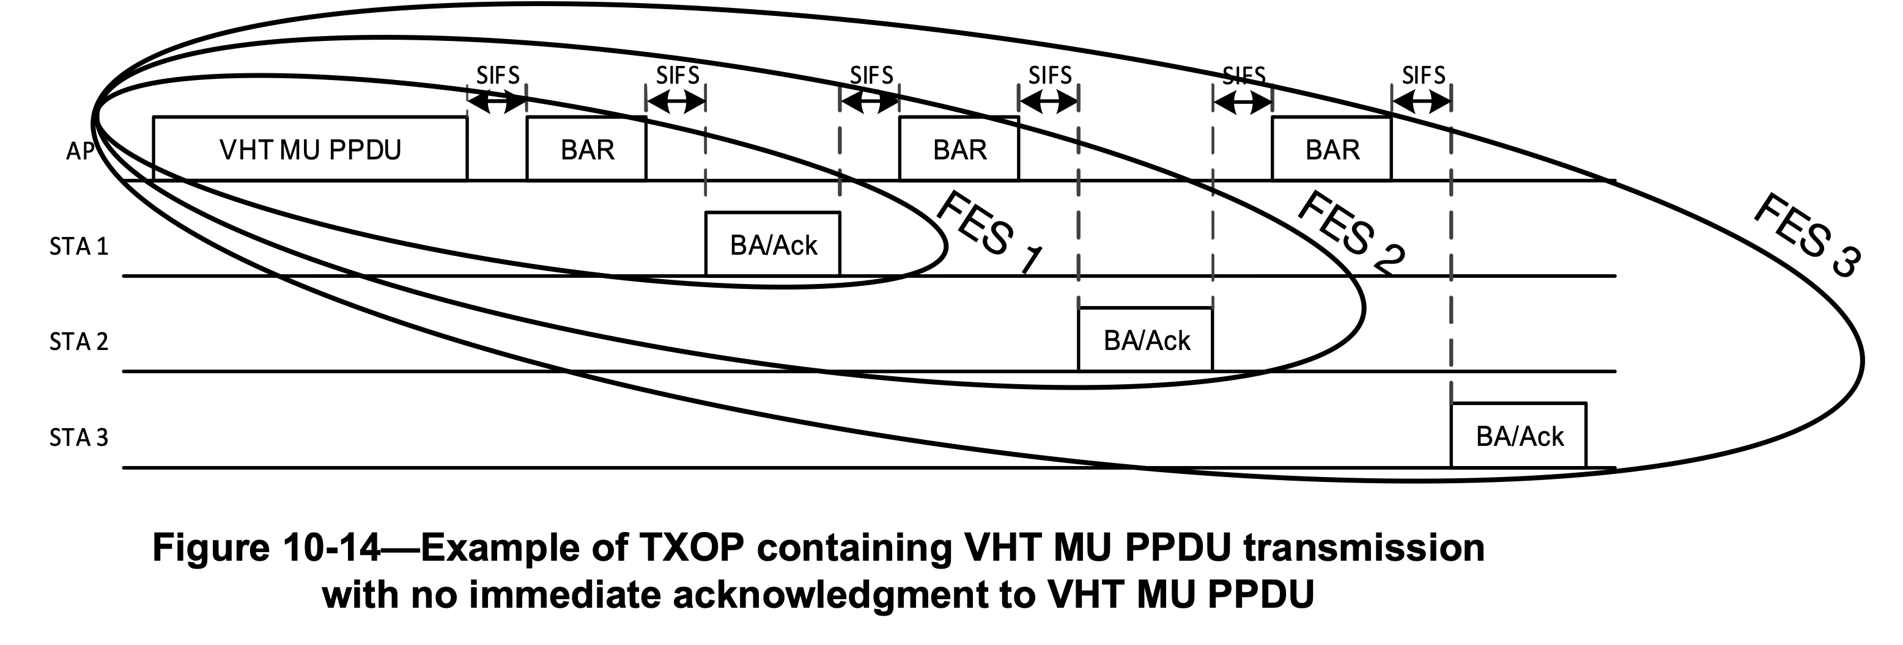

In addition to this, within a single BSS there may be optional support for more than one operating channel, where each operating channel may be configured to support independent FES communications on separate frequencies. For example, according to 4.3.24.5.10, there may be “multiple instances of a wireless medium within a mesh BSS”. In addition, as shown below there may be multiple primary and secondary channels, each with their own CCA governing the times when an FES may be transmitted over the WM of each STA.



In this scenario, the AP_STA supports multiple spatial channels within the BSS, as shown below. This allows FES communications with separate groups of STAs simultaneously, where each group of STAs operates on a separate spatial channel.

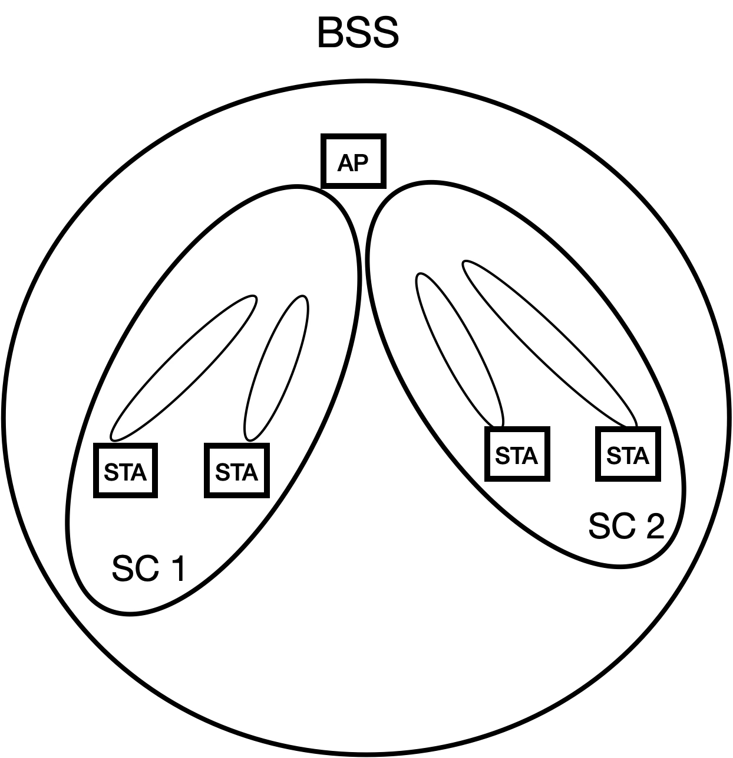

## Example Frame Exchange Sequences

Frame exchange sequences are described in a variety of contexts throughout this standard. For example, descriptions of frame exchange sequences are generally included in the normative text of multiple clauses (i.e., 4.3.10 (describing frame exchange rules are part of the core QoS facility), 4.3.11.11 (describing link measurement a frame exchange seqeunce), Clause 10 (describing different STA Types), Clause 11 (describing a GAS frame exchange sequence), 4.3.24.5.6 and 14.6 (describing AMPE and MCCA), 4.10 (describing 802.1X frame exchange sequences), 6.3 and Clauses 26 through 28 (each describing a different peer PHY entity). Informative text descriptions of frame exchange sequences are also described in Annex O (RD frame exchanges), and Annex Y (PAD procedures). The first description of a frame exchange sequence appears in 4.10.3.3, Figure 4-34.

Often, these descriptions are tailored to the specific requirements context of the clause in which they appear. For example, some frame exchange sequences are identified by a higher layer protocol (9.4.2.123), or by a peer-to-peer application (9.4.2.254). For some PHY scenarios, there is only one wireless channel instance, for other PHY scenarios, there may be several channel instances of the wireless medium, due to sectorization, beamforming, and MU-MIMO.

At times different peer STAs involved in a frame exchange sequence may terminate their participation in the FES, even though in accordance with 9.2.5.2, 9.2.5.4 and 9.2.5.5, each STA’s estimated time duration of the NAV that control internal states of pariticipating STA in which the FES communicates is determined by the value of the Duration/ID field in all exchanged frames. See 10.3.2.6. This is particularly true for a frame exchange sequence involving more than two STAs (such as the MU PPDU frame exchange sequence, see Figure 10-13 or Figure 10-16), where an individual STA can terminate its participation before the completion of a a group FES. This can affect the timing for when certain procedures are initiated by each STA, and can affect channel efficiency if neighboring STAs with pending transmissions are waiting for the NAV to expire, and determine that all STAs have ended their participation in the FES before the NAV has expired outside of a TXOP interval.

This Annex provides examples of frame exchange sequences that depict their usage throughout the various clauses of this standard. This Annex will not cover reference designs or recommended implementations of frame exchange sequences. The examples of frame exchange sequences that will be covered in Annex G include the following contexts:

1. Non-DMG. The frame exchange sequences implemented by this STA type require a specified IFS between basic frame exchanges to decrease the probability of non-participating STAs interrupting the frame exchange sequence. In addition, a virtual CS mechanism (10.3.2.1) is used to provide a virtual protection mechanism to all STAs.
2. HCCA and EDCA/GCR. This example is one in which HCF frame exchange sequences are implemented as part of the channel access rules defined by the HCF. Frame exchange sequences may be initiated by one or more QoS STAs or an AP in an MU cascading sequence. In this case, a TXOP responder may or may not transmit its frame within the time window of the TXOP, given the estimated time required for transmission of the response frame may be inexact. See 10.2.3, 10.23.2.3, 10.23.2.12.2, and 10.23.3. In addition, there may be multiple frame exchange sequences in the TXOP. Frame exchange sequences are also allowed outside the context of a TXOP. For example, during
3. MCCA. This example is one in which the efficiency of frame exchange sequences is optimized in a mesh BSS. (see 10.24.3.9). For example, frame exchange sequences may use mesh peer service periods in which at least one mesh STA is in light or deep sleep mode. See 14.15.9.1.
4. For grouop addressed frames, a DMS Request and Response frame exchange to set up GLK-GCR service. See 4.3.31.2.
5. Peer-to-peer application. This example is one in which a peer-to-peer application can identify individual frame exchange sequences between HE STAs. See 9.4.2.254.
6. Block Ack for VHT PHYs. This example is one in which a single frame exchange sequence includes multiple block acknowledgments, each from a different STA, and each preceded by either a BAR or a MU PPDU transmitted by an AP STA. See 10.3.2.13.1.
7. Restricted Access Window (RAW). This example is one in which a frame exchange sequence shall not exceed the allocated RAW slot boundary. See 10.47.1.2.
8. Fast Link Adaptation. In this example, after a Responding STA receives a Link Measurement Request, it transmits a series of PPDUs, followed by a Link Measurement Report, with additional frames subsequently transmitted by the Initiating STA. See 10.42.3.
9. GCR MU-BAR. This example is one in which a frame exchange sequence includes two types of Block Acks for the GCR group members. See 10.25.8.4.
10. MU cascading sequence. In this example, multiple STAs tansmit an HE TB PPDU to an AP_STA simultaneously, all of which are acknowledged in a single HE MU PPDU. See 26.5.3.
11. RD frame exchanges. This example is shown in the informative text of clause O.3.
12. Bidirectional Implicit transmit beamforming. This example is one in which a transmit beamforming frame exchange sequence is initiated by an unsteered PPDU that includes a training request. See 10.33.2.3.
13. SU-MIMO and MU-MIMO channel access. This example is one in which frame exchange sequences use MIMO channel access to exchange frames. See 11.2.8.
14. TXOP-based sectorization operation. This example is one in which spatially orthogonal frame exchange sequences are transmitted until the expiry of the SO timer without resetting the NAV. See 10.52.4.
15. Sector training. This example is one in which an AP transmits a sector training announcement, followed by NDP CTS frames, followed by sector ID feedback. See 10.52.5.2.

## Frame Exchange Sequence Classifications

The following table depicts the STA Types that are described as part of the normative description of each FES category. Depending on its capability as described in the normative text, a STA Type that is not described as part of the normative description of a FES Group, might nonetheless support the FES Group. In addition, the FES Groups may not be mutually exclusive. For example, an RTS/CTS protection mechanism used to begin a frame exchange within an EDCA-based TXOP, while the countdown of the NAV timer for the TXOP spans more than one frame exchange sequence, and the TXOP holder determines that start and stop of individual frame exchange sequences within the TXOP (10.23.2.3, 10.23.2.8, 10.23.3.4, 10.50. 26.2.8).

| **FES Classification** | **STA Types the standard describes using an FES Classification[1]** | | | | | | | | | | |
| --- | --- | --- | --- | --- | --- | --- | --- | --- | --- | --- | --- |
| **Non-DMG** | **DMG** | **CDMG** | **CMMG** | **GLK** | **EDMG** | **HE** | **S1G** | **VHT** | **HT** | **EHT** |
| Basic w/ virtual CS mechanism (10.3.2.1, 10.3.2.3, 10.3.2.4, 10.3.2.5, 10.3.2.15, 10.3.2.17) | X |  |  |  |  |  |  |  |  |  |  |
| Fragmented Basic (10.3.4.5) | X | X | X | X | X | X | X | X | X | X | X |
| Basic or Fragmented Basic w/ protection mechanism (10.3.2.6, 10.3.2.9, 10.27) | X  (RTS/ CTS) | X  (RTS/ DMG CTS) |  | X |  | X | X | X | X | X |  |
| Reverse Direction (10.29.2) |  | X |  |  |  | X |  | X |  | X |  |
| Block acknowledgment (10.25) |  | X |  |  | X | X | X | X |  | X |  |
| MU w/ auto 1st ACK (10.3.2.13.1) |  |  |  |  | X | X | X |  | X |  |  |
| MU w/ BAR for 1st ACK (10.3.2.13.1) |  |  |  |  | X | X | X |  | X |  |  |
| MU for A-MPDUs (10.3.2.13.1) |  |  |  |  |  | X |  |  |  |  |  |
| A-MPDU w/ UL OFDMA (10.3.2.13.2) |  |  |  |  |  |  | X |  |  |  |  |
| Triggered MU w/ DL MU OFDMA (10.3.2.13.3) |  |  |  |  |  |  | X |  | X | X |  |
| Triggered MU w/ DL Multi-STA Block Ack (10.3.2.13.3) |  |  |  |  |  |  | X |  | X |  |  |
| Triggered MU w/ duplicate DL Multi-STA Block Ack (10.3.2.13.3) |  |  |  |  |  |  | X |  | X |  |  |
| Multiple PPDUs before BAR (10.25.8.4) |  |  |  |  |  |  | X |  |  |  |  |
| Multiple PPDUs before MU-BAR Trigger (10.25.8.4) |  |  |  |  |  |  | X |  |  |  |  |
| Updating Reciprocal Beamforming Steering Matrix (10.33.2.2) |  |  |  |  |  |  |  |  |  | X |  |
| Bidirectional updating of reciprocal beamforming steering matrices (10.33.2.3) |  |  |  |  |  |  |  |  |  | X |  |
| Calibration w/ SIFS (10.33.2.4.3) |  |  |  |  |  |  |  |  |  | X |  |
| Trasmit/Receive Antenna Selection (ASEL) (10.34) | X |  | X | X | X | X |  | X |  | X | X |
| Single VHT Beamformee (10.35.5.2) |  |  |  |  |  |  |  | X | X |  |  |
| Multiple VHT Beamformees (10.35.5.2) |  |  |  |  |  |  |  | X | X |  |  |
| ATI (10.38.3) |  | X |  | X |  |  |  |  |  |  |  |
| Multi-channel CDMG (10.38.6.6.3) |  |  | X |  |  |  |  |  |  |  |  |
| SU-MIMO w/ RTS/CTS (10.38.12.4.3, 10.38.12.4.4) |  |  |  |  |  | X |  |  |  |  |  |
| MU-MIMO w/ optional RTS/CTS (10.38.12.4.4, 26.5.3) |  |  |  |  |  | X | X |  |  |  |  |
| MU Cascading (26.5.3) |  |  |  |  |  | X | X |  |  |  |  |
| Single Sector Sweep (10.41.2.2) |  | X |  |  |  | X |  |  |  |  |  |
| Multiple Sector Sweep (10.41.10.2.3.2) |  | X |  |  |  | X |  |  |  |  |  |
| Point-to-multipoint (10.44.3.1) |  | X | X |  |  |  |  |  |  |  |  |
| MU followed by Doze (11.2.8) | X | X |  |  |  |  |  |  |  |  |  |
| Hybrd Omni/Spatial (10.52.4) |  |  |  |  |  |  |  | X |  |  |  |
| Protected RAW (10.47.1.2) |  |  |  |  |  |  |  | X |  |  |  |

### Reverse Direction

This frame exchange sequence classification comprises a TXOP holder that exchanges a PPDU, followed by an RD responder exchanging one or more PPDUs.

### Block Acknowledgement

This frame exchange sequence comprises the exchange of blocks of QoS Data frames exchanged by an AP, followed by a Block Ack Request exchanged by that AP, and a Block Ack frame exchanged in response by the participating STA.

### MU w/ auto 1st ACK

This frame exchange sequence classification comprises the exchange of a VHT MU PPDU frame from an AP, followed by a Block Ack, followed by a repeated series of a Block Ack Request frame exchanged by an AP, followed by a Block Ack frame exchanged by a participating STA.

### MU w/ BAR for 1st ACK

This frame exchange sequence classification comprises the exchange of a VHT MU PPDU frame from an AP, followed by a repeated series where a Block Ack Request frame is exchanged from an AP, followed by a Block Ack frame exchanged from a participating STA.

### MU for A-MPDUs

This frame exchange sequence classification comprises the simultaneous exchange of multiple A from an AP, followed by a series of Block ACK frame exchanges from participating STAs.

### A-MPDU w/ UL OFDMA

This frame exchange sequence classification comprises the exchange of an HE MU PPDU containing multiple A-MPDU with triggering frames from an AP, followed by the exchange of multiple Block Ack frames transmitted simultaneously as an uplink OFDMA Block Ack from participating STAs.

### Triggered MU w/ DL MU OFDMA

This frame exchange sequence classification comprises the simultaneous exchange of multiple HE TB PPDUs from an AP, followed by the exchange of multiple Block Ack frames transmitted simultaneously as an uplink OFDMA Block Ack from participating STAs.

### Triggered MU w/ DL Multi-STA Block Ack

This frame exchange sequence classification comprises the simultaneous exchange of multiple HE TB PPDUs from an AP, followed by the exchange of a Multi-STA Block Ack frame from participating STAs.

### Triggered MU w/ duplicate DL Multi-STA Block Ack

This frame exchange sequence classification comprises the simultaneous exchange of multiple HE TB PPDUs from an AP, followed by the exchange of a Multi-STA Block Ack frame from participating STAs.

### Multiple PPDUs before BAR

This frame exchange sequence classification comprises a series of Data frames exchanged by an AP, followed by a repeated series where a Block Ack Request frame is exchanged by that AP, followed by a Block Ack frame from a participating STA.

### Multiple PPDUs before MU- BAR Trigger

This frame exchange sequence classification comprises a series of Data frames exchanged by an AP, followed by a repeated series where a GCR MU-BAR Trigger frame is exchanged by that AP, followed by a Block Ack frame from a participating STA. After the repeated series, further Data frames are exchanged by the AP.

### Updating Reciprocal Beamforming Steering Matrix

This frame exchange sequence classification comprises an unsteered TRQ frame, followed by an unsteered Sounding PPDU, followed by a steered HT Data frame, followed by an unsteered Sounding PPDU without an IFS restriction.

### Bidirectional Updating of Reciprocal Beamforming Steering Matrix

This frame exchange sequence classification comprises an unsteered TRQ frame, followed by an unsteered Sounding PPDU, followed by a steered HT Data frame, followed by a steered Sounding PPDU exchanged in series without an IFS restriction.

### Calibration w/ SIFS

This frame exchange sequence classification comprises a calibration start frame, followed by a calibration sound frame, followed by a calibration cocmplete frame, followed by an Ack frame exchanged in series without an IFS restriction.

### Transmit/Receive Antenna Selection

This frame exchange sequence classification starts with a calibration start frame, followed by a calibration sound frame. Subsequently, one variant comprises a calibration cocmplete frame, followed by an Ack frame exchanged in series without an IFS restriction; a second variation comprises an NDP frame; and a third variation comprises an NDP frame followed by an NDP frame.

### Single VHT Beamformee

This frame exchange sequence classification comprises a VHT NDP Announcement frame, followed by an NDP frame, followed by a VHT Compressed Beamforming frame, exchanged with a SIFS interval spacing.

### Multiple VHT Beamformee

This frame exchange sequence classification comprises a VHT NDP Announcement frame, followed by an NDP frame, followed by a VHT Compressed Beamforming frame, followed by a repeated series where a Beamforming Report Poll frame is exchanged followed by a VHT Compressed Beamforming frame.

### ATI

This frame exchange sequence classification comprises a repeated series of a Request frame followed by either an ACK frame or a Response frame.

### Multi-channel CDMG

This frame exchange sequence classification comprises a series of a RTS frame followed by a DMG CTS frame exchanged on each of two channel frequencies before a Data frame is exchanged.

### SU-MIMO w/ RTS/CTS

In the first variant, a frame exchange sequence classification comprises an RTS frame followed by a CT frame, followed by a DMG CTS frame followed by a CT frame, followed by the exchange of one or more SU PPDU frames. In the second variant, a frame exchange sequence comprises a CTS-to-self frame followed by a CT frame, followed by the exchange of one or more SU PPDU frames.

### MU-MIMO w/ optional RTS/CTS

In the first variant, this frame exchange sequence classification comprises multiple RTS frames exchanged simulatneously followed by a CT frame, followed by multiple DMG CTS frames exchanged by participating STAs, followed by the exchange of one or more MU PPDU frames.

In the second variant, this frame exchange sequence classification comprises multiple CTS-to-self frames exchanged simulatneously followed by multiple CT frames exchanged simultaneously, followed by the exchange of one or more MU PPDU frames.

### MU Cascading

This frame exchange sequence classification comprises a repeated series where an HE MU PPDU exchanged from an AP, followed by multiple HE TB PPDUs exchanged from participating STAs; followed by a Multi-STA Block Ack frame exchanged from the AP.

### Single Sector Sweep

This frame exchange sequence classification comprises a series of Transmit Sector Sweep frames exchanged by an Initiator, followed by a series of Receive Sector Sweep frames exchanged by a Responder, followed by a Sector Sweep Feedback frame exchanged by an Initiator, followed by an SSW-Ack frame exchanged by the Responder.

### Single Sector Sweep

In the first variant, this frame exchange sequence classification comprises a series of Transmit Sector Sweep frames exchanged by an Initiator, followed by a series of Receive Sector Sweep frames exchanged by a Responder, followed by a Sector Sweep Feedback frame exchanged by that Initiator, followed by an SSW-Ack frame exchanged by the Responder.

In the second variant, this frame exchange sequence classification comprises a series of Transmit Sector Sweep frames exchanged by an Initiator, followed by a Transmit Sector Sweep frame exchanged by a Responder, followed by a Sector Sweep Feedback frame exchanged by an Initiator, followed by an SSW-Ack frame exchanged by the Responder.

### Single Sector Sweep

In the first variant, this frame exchange sequence classification comprises a series of Short SSW frames exchanged by an Initiator, followed by a series of BRP frames exchanged by an Initiator and participating Responders.

In the second variant, this frame exchange sequence classification comprises a series of MIMO BF Setup frames exchanged by an Initiator, followed by a series of BRP training frames exchanged by that Initiator, followed by a repeated series where a MIMO BF-Poll frame is exchanged by the Initiator followed by a MIMO BF Feedback frame.

In the third variant, this frame exchange sequence classification comprises a series of MIMO BF Setup frames exchanged by an Initiator, followed by a series where a MIMO BF Poll frame is exchanged by that Initiator followed by a series of BRP frames exchanged by a Responder.

### Point-to-Multipoint

This frame exchange sequence classification comprises a pair of TPA Request frames transmitted by a Destination REDS, followed by a TPA Response frame from an RDS, followed by a TPA Response frame and TPA Request frame from a source, followed by a TPA Response frame from the RDS, followed by a TPA Request frame exchanged by the Destination REDS followed by a TPA Response frame exchanged by the RDS.

### MU followed by Doze state

This frame exchange sequence classification comprises multiple A-MPDU frames exchanged simultaneously, followed by a series of Block Ack frames exchanged sequentially by participating EDMG STAs.

### MU followed by Doze state

This frame exchange sequence classification comprises multiple A-MPDU frames exchanged simultaneously, followed by a series of Block Ack frames exchanged sequentially by participating EDMG STAs, where each EDMG STA enters the Doze state after exchanging their Block Ack frame.

### Hybrid Omni/Spatial

In the first variant of this frame exchange sequence classification comprises a CTS-to-self frame exchanged from an AP, followed by an Omnidirectional portion of the frame exchange sequence, followed by a Sectorized Beam portion of the frame exchange sequence.

In the second variant, this frame exchange sequence classification comprises a packet frame exchanged from an AP, followed by an Ack or Response frame exchanged by a participating STA in an omnidirectional portion, followed by long format or short format frames exchanged from the AP, followed by an Ack frame exchanged by the participating STA.

In the third variant, this frame exchange sequence classification comprises an RTS frame exchanged from an AP, followed by a CTS frame exchanged by a participating STA in an omnidirectional portion, followed by long format or short format frames exchanged from the AP, followed by an Ack frame exchanged by the participating STA.

In the fourth variant, this frame exchange sequence classification comprises a PS-Poll/Trigger/Other frame exchanged from a participating STA followed by a short format frame exchanged from an AP in an omnidirectional portion, followed by a long format or short format frame exchanged by the AP.

### Protected RAW

This frame exchange sequence classification comprises a repeated series where a PRAW frame is exchanged from an AP while STA 1 is not allowed to access its WM, while STA 2 is allowed to exchange a TWT scheduled frame.

1. STA Types not identified in the table may be conditionally capable of certain FES Classifications depending on its operational state.