IEEE P802.11  
Wireless LANs

|  |  |  |  |  |
| --- | --- | --- | --- | --- |
| “Proposal for a revised Annex G containing an Introduction to Frame Exchange Sequences and their Wireless Medium” | | | | |
| Date: 2025-01 | | | | |
| Author(s): | | | | |
| Name | Affiliation | Address | Phone | email |
| Harry BIMS | Bims Laboratories, Inc. | Menlo Park, CA, USA. | 650 283 4174 | harrybims@me.com |

Abstract

This proposal seeks to introduce the reader to an alternative version of Annex G for describing frame exchange sequence examples, their temporal boundaries, and recommended practice based on frame exchange sequences that are specified in the P802.11-REVme/D5.0 document.

# A. Background

The Architecture Standing Committee has extensively debated the disposition of Annex G for many meetings. In the course of those discussions, the group has requested a proposed revision to Annex G that explains to the novice reader of the 802.11 standard, using informative text, the concept of frame exchange sequences, as the term is consistently used throughout the standard in various contexts. To this end, proposed text for Annex G is presented below for discussion. We may want to consider as part of the discussion the prospect of moving the informative text in clause O.3 (Example of RD frame exchanges) to Annex G, as it appears to be out of place in its current location.

The proposed Annex G presented below contains an informative description of frame exchange sequences, and their use in the normative text. The style of this proposed Annex G follows the style of other Annexes that provide exemplary descriptions of the normative text. In particular, consideration has been given to Annex I, Annex K.1, Annex L, Annex O.3, Annex Q, and Annex W.

**Annex G (revised)**

(informative)

# Overview of a basic frame exchange sequence

The frame exchange sequence (FES) is composed of a sequence of IEEE 802.11 frames that are transmitted, or exchanged, over a wireless medium (WM). In general, as described in 8.1, data is transmitted and received between two or more STAs within the scope of a WM. This scope is repeated in this standard for DSSS PHY services (15.1.2), HR/DSSS PHY services (16.1.2), OFDM PHY services (17.1.2), ERP PHY services (18.1.4), HT PHY services (19.1.2), DMG PHY services (20.1.1), VHT PHY services (21.1.2), TVHT PHY services (22.1.2), and CMMG PHY services (25.1.2).

For example, the figure below shows a basic frame exchange sequence that delivers a single MSDU or MMPDU from a source to a destination through the exchange of multiple PPDUs, each of which contain a fragment of the MSDU/MMPDU.



In this example, the time period in between each frame transmission is a SIFS interval, which under most circumstances prevents the STAs from losing control of a WM to other STAs whose NAV timer may not have been updated by the FES frame headers. The STAs that participate in an FES maintain control of the WM through their transport of the network allocation vector (NAV) and/or response indication deferral RID in each frame header, which reserves the WM for a period of time. This reservation request is either a NAV value in the Duration/ID field, or for an S1G STA, can also include a RID. Neither the NAV nor the RID are necessarily limited to a single frame exchange sequence, however a frame exchange sequence must complete on or before the NAV or RID expires.

For example, the following are mechanisms related to frame exchange sequences:

1. TXOP error continuation.  A STA owning a TXOP that misses a response can recover by transmission after a PIFS, and can transmit to another STA.

2.       RDG.  Effectively transfers ownership of the balance of the current TXOP to another STA.  But that “balance” is constrained in that other STA can only talk to the original STA.

3.       HCCA.   This is a polled mechanism where the HC grants a sequence of TXOPs to other STAs.  The HC remains in control of who owns a TXOP, and the duration of that TXOP.

The first two mechanisms are limited by the original TXOP boundaries and apply to both STAs and APs.  The TXOP limits are determined by the AP by signalling in the beacon. The last mechanism allows multiple STAs to manage the medium, where control is not limited to a single TXOP limit.

# Impact of NAV, Awake State, and RID on Frame Exchange Sequence Participation

According to 10.3.2.1, the NAV does not control the wireless medium, rather it merely “maintains a prediction of future traffic on the medium based on duration information that is announced in RTS/CTS frames by non-DMG STAs, in MU-RTS Trigger/CTS frames by HE STAs as defined in 26.2.6 (MU-RTS Trigger/CTS frame exchange exchange procedure, and in RTS/DMG CTS frames by DMG STAs prior to the actual exchange of data.” For any given frame exchange sequence (FES), the STAs participating in the FES use the NAV to remain in the awake state. However, there can be different understandings among the peer STAs about when they are allowed to transition from the awake state to the doze state. This can affect the timing for when certain procedures within a given STA that cannot be initiated when an ongoing awake state (or active mode) is required, can be initiated.

For example, as described in 10.3.2.1 and 9.2.5.2 for S1G STAs, there can be two virtual CS mechanisms provided by S1G MACs during a frame exchange sequence; 1) the single protection or multiple protection NAV (which is used to update the NAV under data rate selection rules, see 10.3.2.4), or 2) the response indication deferral (RID) (which is used to update the NAV after the RID is updated, see 10.3.2.4, and 10.3.2.5). The multiple protection NAV indicates to all STAs participating in the FES they are allowed to transition to the doze state only after the end of the TXOP, whereas according to 10.49.2, a non-AP STA may transition to the doze state if the More Data field in a frame sent by the AP is equal to 0 prior to the end of the TXOP.

There are several MAC layer procedures that are delayed within the awake state until the STA is no longer participating in an FES. According to 6.5.3.2.4, the scan process can be initiated only when a frame exchange sequence is completed. Similarly, according to 6.5.4.2.4, the synchronization procedure can be initiated only when a frame exchange sequence is completed, and according to 6.5.11.2.4, the BSS initialization procedure can be initiated only once the current frame exchange sequence is completed, and according to 9.2.4.1.7 and 9.2.4.5.11, the power management mode of a STA is initiated only after successful completion of a frame exchange sequence. Thus, these procedures can be initialized once a frame exchange sequence has completed during an ongoing TXOP, if a single protection NAV is used by the TXOP holder.

As described in 11.2.6, the completion of a frame exchange sequence can be determined through multiple possibilities, including a deteremination made by the CS mechanism:

“The STA can determine the end of the frame exchange sequence through any of the following:

* It receives an individually addressed frame addressed to another STA.
* It receives a frame with a TA that differs from the TA of the frame that started the TXOP.

. . .

* The CS mechanism (see 10.3.2.1 (CS mechanism) indicates that the medium is idle at the TxPIFS slot boundary (defined in 10.3.7 (DCF timing relations)).”

This nuance is not currently captured in the normative text, and should be explained to the reader in Annex G where appropriate.

# In addition, according to 10.3.2.5, the RID is updated when a S1G PPDU is received, except when a non-zero Duration/ID field is received that sets the NAV. Thus, different S1G STAs can have different perspectives on the ending of the FES depending on whether their RID counter was updated, or their NAV was reset.

In addition, indications that maintain overlapping control of frame exchange sequences in their wireless medium are also impacted by these boundaries. Some of the affected indications include:

1. Power Management subfield
2. Mesh Power Save Level subfield
3. Block Ack Timeout Value field
4. Nominal Minimum TWT Wake Duration field

# Impact of Frame Exchange Sequence Participation on internal operations of a STA

During a frame exchange sequence, STAs are restricted to perform certain internal operations, such as scanning, channel switching, power saving, and channel measurement. In this above figure, the source and destination STAs participate in the FES for its entire duration, as they both rely on internal NAV timers that have been synchronized to determine when to end their FES communications.

Each STA in a WM determines whether or not it is currently participating in an FES. This determination is necessary because there are at least four processes: a) scan procedure (see 6.5.3.2.4), synchronization procedure with a newly joined BSS (see 6.5.4.2.4), BSS initialization procedure (see 6.5.11.2.4), and the power save mechanisms (see 11.2.3.11, 11.2.3.16 (when allowed by the VHT AP during a TXOP after a BlockAck), 11.2.3.18, 11.2.4.2, 11.2.4.4, 11.2.7.1, 11.2.7.2.2, 11.2.7.2.3, 11.2.7.3.3, 11.2.7.4, and 11.2.7.5) within a STA that arerequired by the normative text to delay their execution if the STA is currently participating in an FES, see 11.2.3.1.

For example, though the normative text at 11.1.4.1 says “details of how to optimize scanning is out of scope of this standard”, if a STA that is participating in a FES initiates its scan procedure during its participation in an FES will cause the STA to become unavailable during a time period where other STAs may attempt to exchange frames with the STA across the WM. The normative text expressly requires that the BSS initialization procedure must delay until the current frame exchange sequence is complete.

By definition, any STA that does not transmit or receive a PPDU frame transmission or control frame during an FES prior to the execution of one of these four processes, does not participate in that FES for its entire duration.

When a STA transmits a PPDU or control frame in the context of an FES, it becomes a participant in the FES. When a STA receives a PPDU frame transmision or a control frame transmission that addresses the STA in its destination address field, the STA also becomes a participant in the FES. Once a STA becomes a participant in an FES, there are many reasons for a STA to terminate is participation in the FES, as described in the various clauses of the normative text.

In addition, at least the dynamic SM power save mode requires the participation of the STA in a FES to be completed before switching back from enabling multiple receive chains to single receive chain mode (see 11.2.6).

# Overview of a Wireless Medium (WM)

An instance of the WM is essentially identified in the normative text by three factors:

a) the frequency segment(s) within a radio frequency band used for contiguous or non-contiguous transmission of frames (see 3.1). For EDMG the frequency segment(s) occupy a bandwidth up to 2.16 GHz (see 10.38.12);

b) the type of IEEE 802.11 PHY used for frame exchanges between peer STAs (see 4.6), even if they are part of a colocated access point set, and

c) the optional set of beamforming steering matrices used for direct communication of frame exchanges between peer STAs operating as a beamformer/beamformee pair (see 3.1). See for example, the DMG PHY (see Clause 20) and EDMG PHY (see Clause 28).

As shown in the figure below, a single AP along with a subset of its associated STAs in a BSS can form a WM.

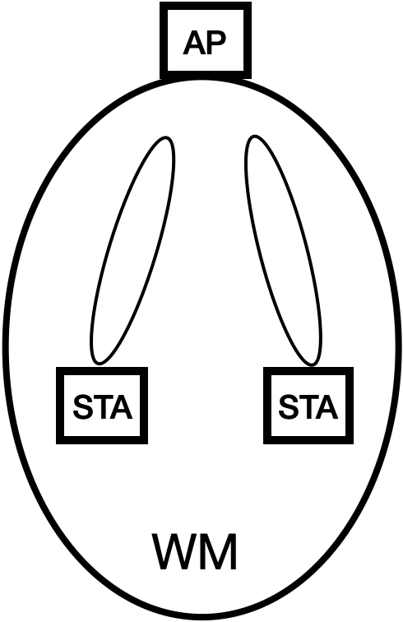

In the context of this WM, when a single MPDU is transmitted as a frame exchange, the one or more peer STAs that are addressed using a unicast or multicast address might use their own beamforming steering matrices to receive the MPDU, and the STA that transmitted the MPDU might use its own beamforming steering matrix to transmit the MPDU.

Further, when an A-MPDU is exchanged, the one or more associated STAs that are addressed by the MPDUs contained in this frame might use their own beamforming steering matrices to receive the A-MPDU, and the AP that transmitted the A-MPDU might use its own beamforming steering matrix to multicast the A-MPDU to all of the STAs in the WM. An acknowledgement frame from each STA that received at least one MPDU is then transmitted to the AP as a Block Ack.

The AP can manage multiple such WMs in parallel by sectorizing the BSS by operating channel or spatially, as shown in the figure below.

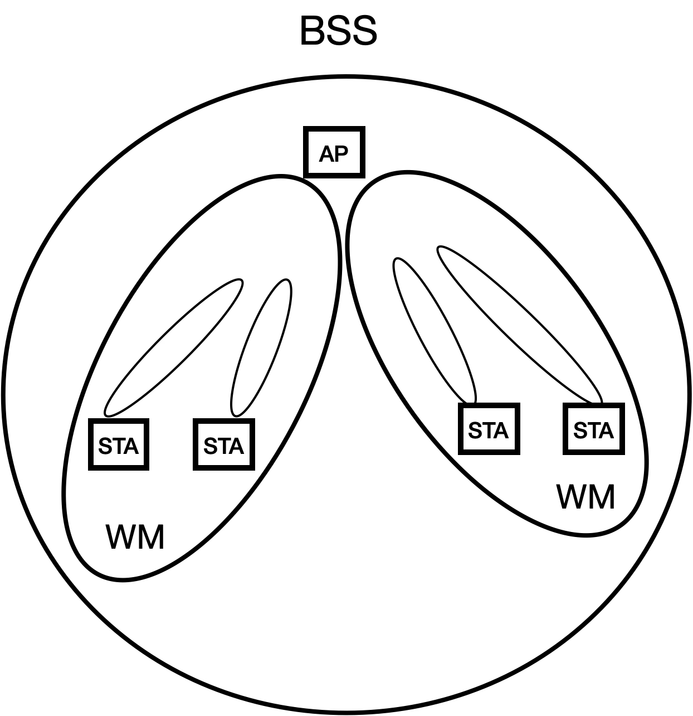

In addition, the AP may use a different beamforming steering matrix for each associated STA in the WM, as described in this standard, as shown in the figure below for the DMG STA:



# Overview of more complex frame exchange sequences

In addition to this basic FES, there are more complicated varieties of an FES that involve an exchange of frames that delivers multiple MSDUs or MMPDUs across a WM, exchanges them with more than two STAs, and/or bundles multiple MSDUs or MMPDUs into a single (MU) PPDU. For these use cases, it is possible for STAs participating in the FES to prematurely end their participation, and lift their restriction on internal operations. However, once a STA has ended its participation in an FES, it cannot return to that FES.

In the IEEE 802.11 architecture, the frame exchanges of a single FES are usually limited to a single BSS. The figure below depicts the BSS components of an IEEE WLAN as though they are necessarily non-overlapping, and thus necessarily control independent WMs over which there can be independent FES communications taking place.



In this scenario, the STAs within a single BSS perform frame exchange sequences within each BSS. For example, in the figure below, each infrastructure BSS provides a regional boundary within which frame exchange sequences independently take place.

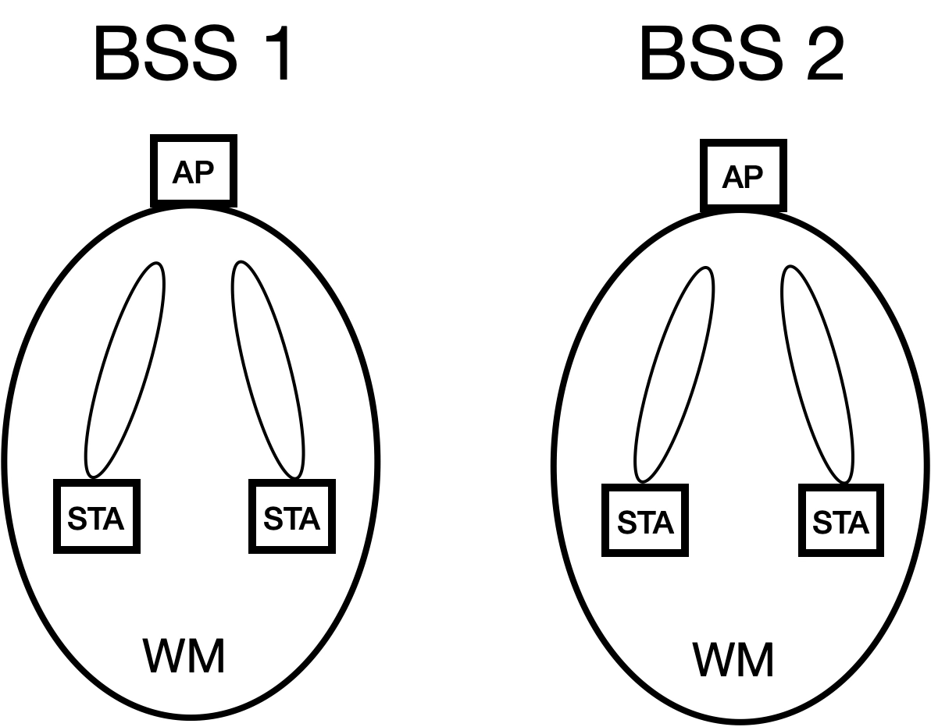

However, in many situations the coverage area of neighboring BSSs can overlap, enabling the potential for interference between their local frame exchanges when each BSS is configured to control an independent WM. As shown below, although the two STAs are exchanging frames with separate AP_STAs in separate locations, their communications can still cause interference.

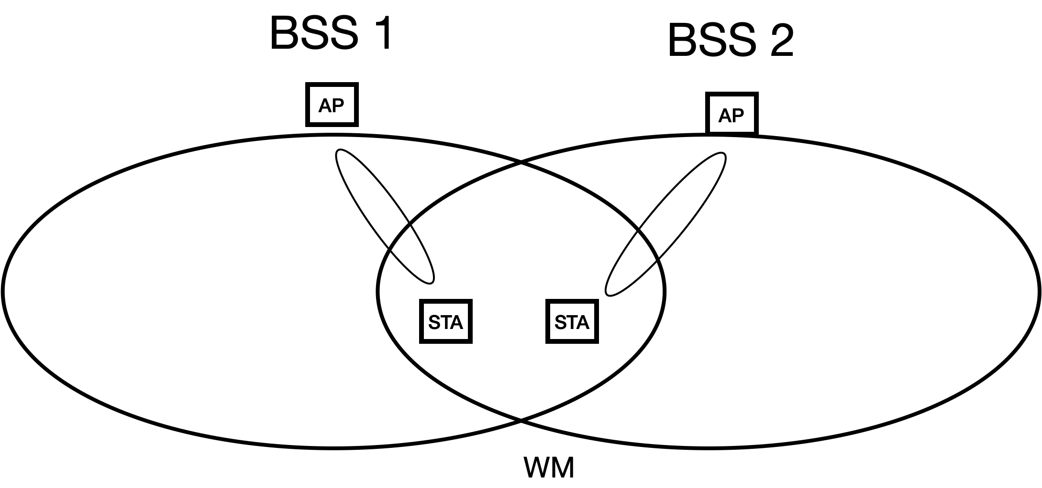

However, this overlap also allows for the exchange of frames between STAs in multiple BSSs as part of a single FES when the BSSs are configured to control a shared WM.

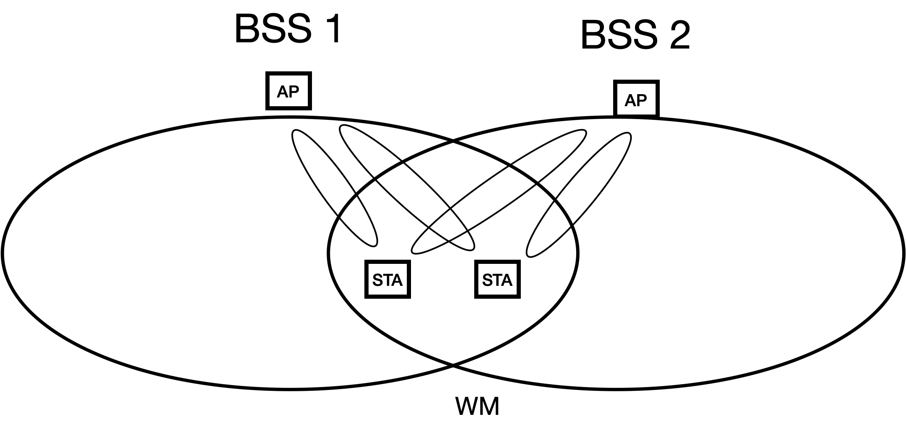

In this scenario, the neighboring BSSs can coordinate their transmissions to mitigate interference using Overlapping BSS (OBSS) management, as explained in 4.3.27.5. The architecture within which this coordination takes place is shown below.

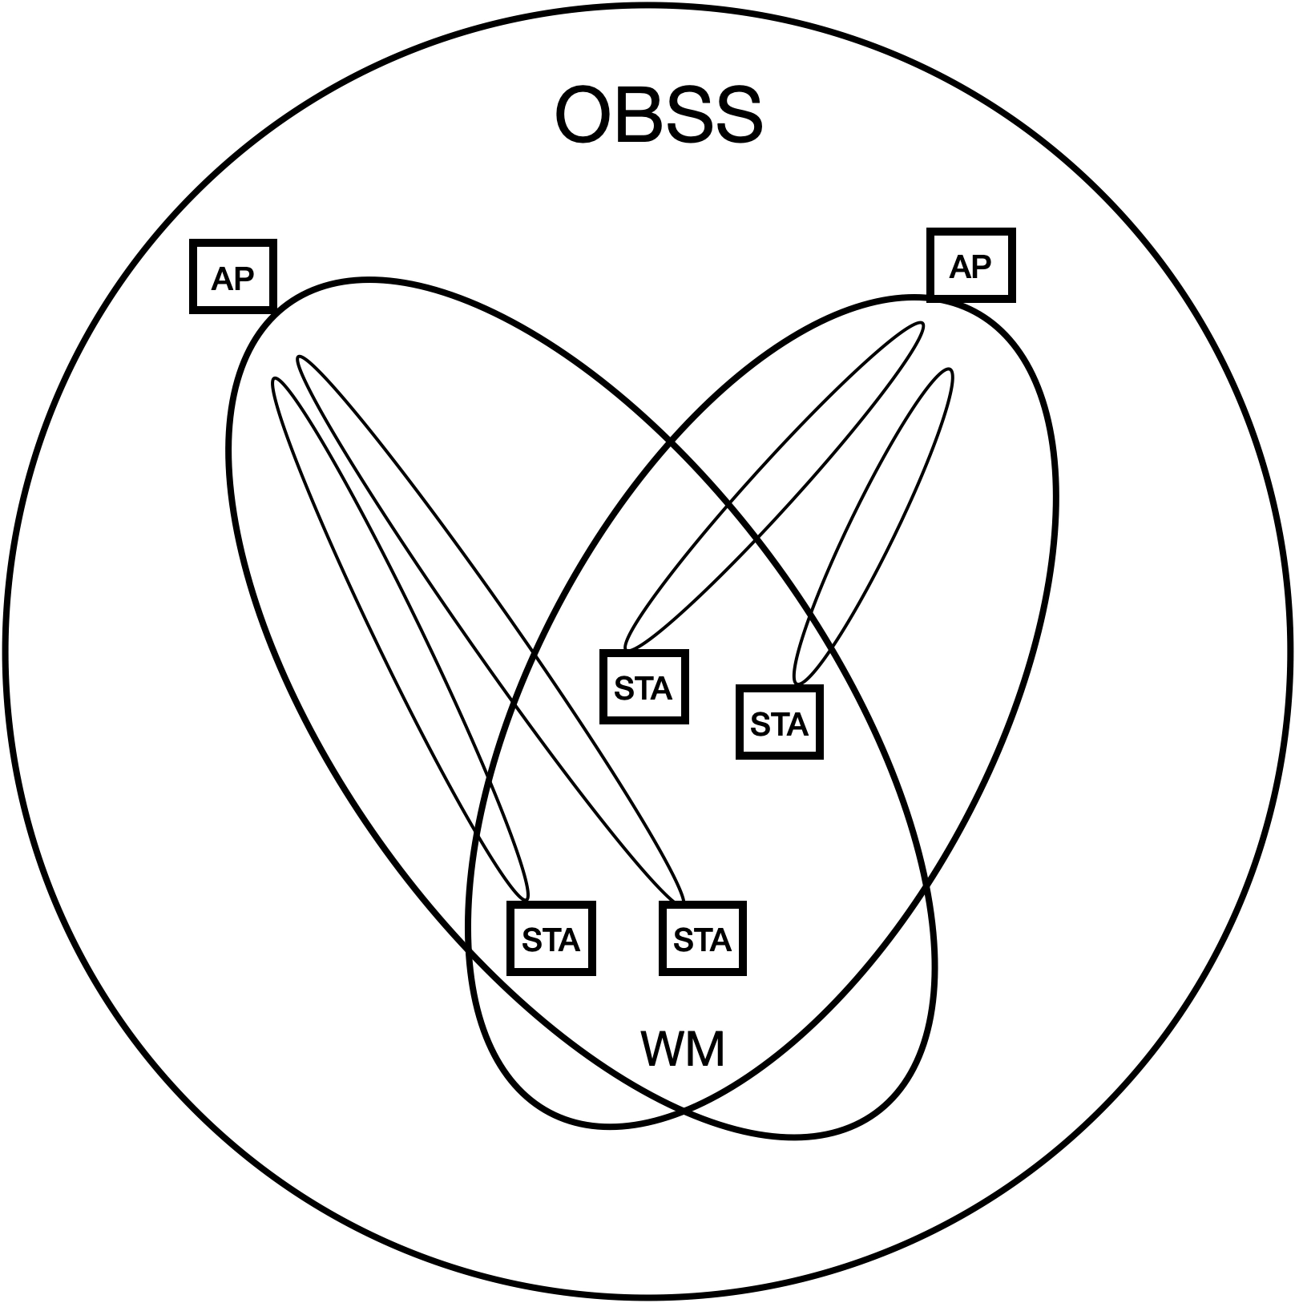

One mechanism for accomplishing this is for the AP_STAs to communicate with each other over the DS, acting as a backbone, in an architecture shown below. STAs that are in different WMs might rely on the DS to transport their MAC service tuples to peer STAs, as described in the definitions in 3.1, and shown in the figures below, when the different WMs are not colocated in the same AP. This applies to different WMs that use different frequency segments, and/or use different IEEE 802.11 PHYs, and/or use different optional sets of beamforming steering matrices.

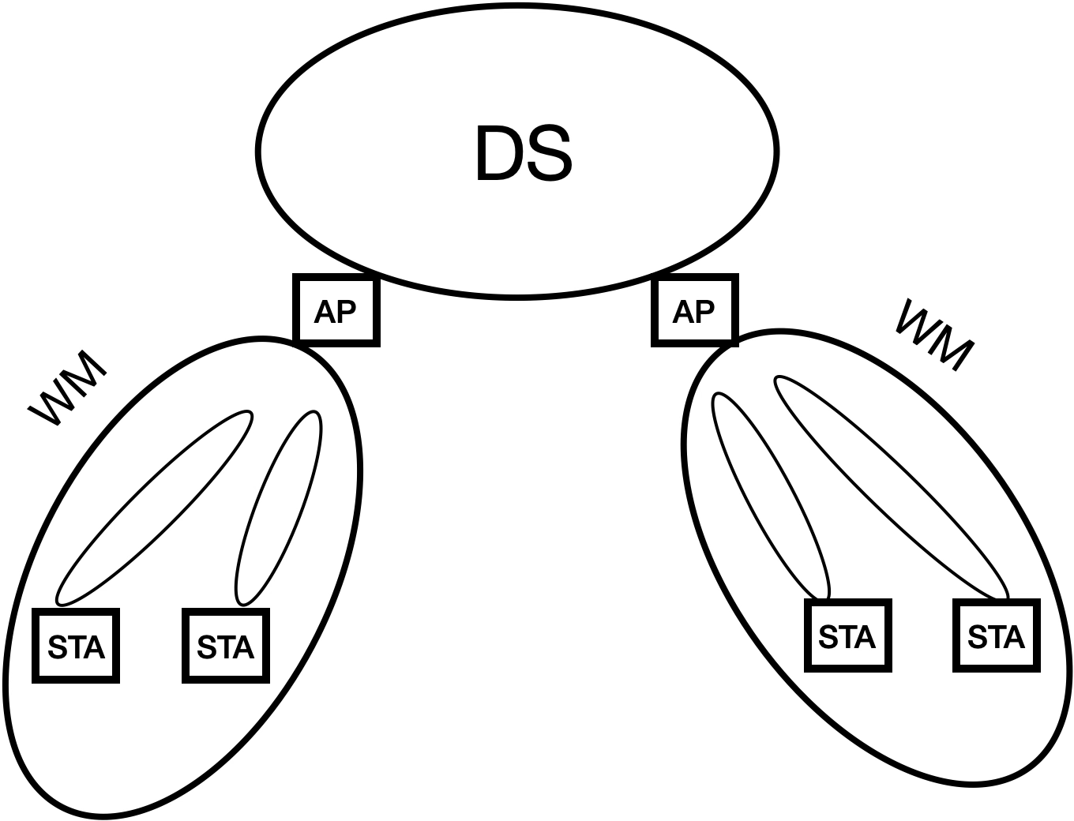



Alternatively, the AP_STAs can communicate with each other over a WM, for example in a mesh BSS.

Beamforming can be used to create a wireless medium that includes an AP_STA and a plurality of non-AP STAs. A consequence of this is that non-AP STAs that communicate with an AP that uses different beams to communicate with each, can have independent frame exchange sequences, and independent awake states or active modes that are not coordinated by a NAV value.

One example of this is Figure 10-14 of 10.3.2.13.1 in which each sequence of BAR and BA/Ack can occur over separate beams in parallel. In this example, the annotated figure below shows all of the STAs are operating on the same WM, created by a set of beamforming steering matrices that enables the AP_STA to communicate with the non-AP STAs in an overlapping manner. In addition, all of the STAs have synchronized to the same NAV timer. However, each STA participates in a unique FES. The AP_STA participates in a single FES (AP_FES) that allows it to communicate with STA 1, STA 2, and STA 3 in a time overlapped manner. STA 1, STA 2, and STA 3, each participate in a unique FES (FES 1, FES 2, and FES 3 respectively) that allows them to communicate individually with the AP_STA, with their BA/Ack transmissions potentially isolated from the others due to beamforming. When their FES completes, each STA is allowed to prematurely lift the restriction on internal operations such as scanning, even though their NAV timer for this WM has not expired. However, as long as the NAV timer for this WM is still running, the STAs cannot return to exchange frames on this WM after switching to a different WM.

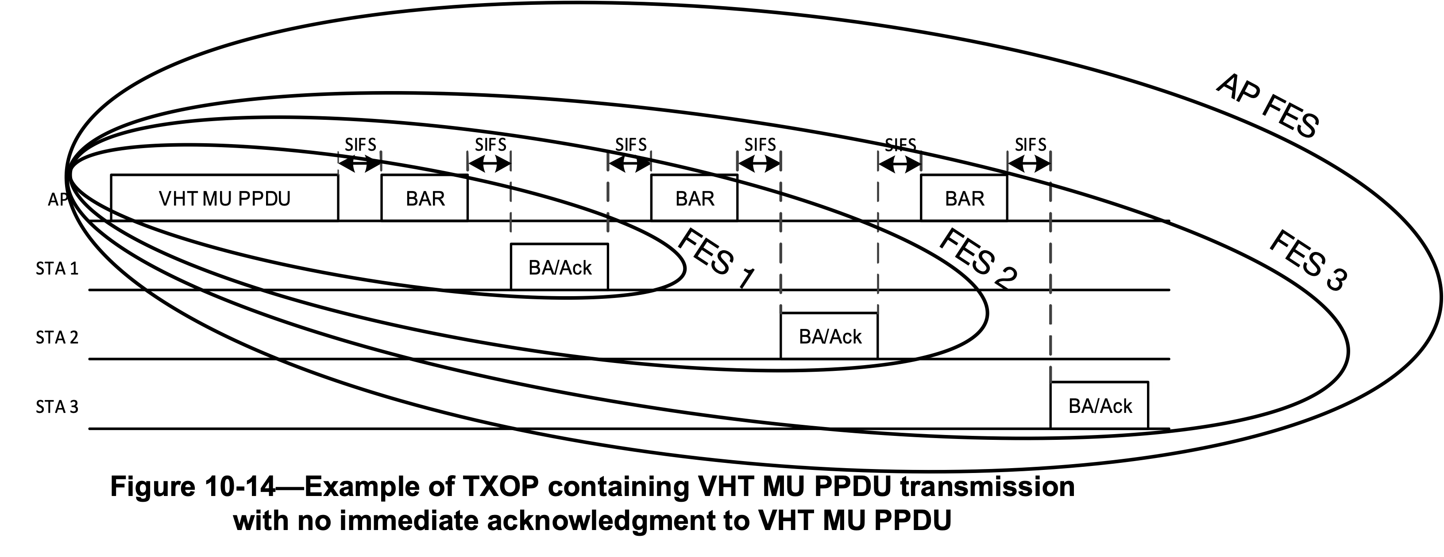

In addition to this, within a single BSS there may be optional support for more than one operating channel, where each operating channel may be configured as a separate WM that supports independent FES communications on separate frequencies. For example, according to 4.3.24.5.10, there may be “multiple instances of a wireless medium within a mesh BSS”. In addition, as shown below there may be multiple primary and secondary channels, each with their own CCA governing the times when an FES may be transmitted over the WM.



In this scenario, the AP_STA supports multiple WMs within the BSS, as shown below. This allows FES communications with separate groups of STAs simultaneously, where each group of STAs operates on a separate WM.



# Examples of Frame Exchange Sequences

## Introduction

Frame exchange sequences are described in a variety of contexts throughout this standard. For example, descriptions of frame exchange sequences are generally included in the normative text of multiple clauses (i.e., 4.3.10 (describing frame exchange rules are part of the core QoS facility), 4.3.11.11 (describing link measurement a frame exchange seqeunce), Clause 10 (describing different STA Types), Clause 11 (describing a GAS frame exchange sequence), 4.3.24.5.6 and 14.6 (describing AMPE and MCCA), 4.10 (describing 802.1X frame exchange sequences), 6.3 and Clauses 26 through 28 (each describing a different peer PHY entity). Informative text descriptions of frame exchange sequences are also described in Annex O (RD frame exchanges), and Annex Y (PAD procedures). The first description of a frame exchange sequence appears in 4.10.3.3, Figure 4-34.

Often, these descriptions are tailored to the specific requirements context of the clause in which they appear. For example, some frame exchange sequences are identified by a higher layer protocol (9.4.2.123), or by a peer-to-peer application (9.4.2.254). For some PHY scenarios, there is only one wireless channel instance, for other PHY scenarios, there may be several channel instances of the wireless medium, due to sectorization, beamforming, and MU-MIMO.

At times different peer STAs involved in a frame exchange sequence may terminate their participation in the FES, even though in accordance with 9.2.5.2, 9.2.5.4 and 9.2.5.5, each STA’s estimated time duration of the NAV that controls the WM in which the FES communicates is determined by the value of the Duration/ID field in all exchanged frames. See 10.3.2.6. This is particularly true for a frame exchange sequence involving more than two STAs (such as the MU PPDU frame exchange sequence, see Figure 10-13 or Figure 10-16), where an individual STA can terminate its participation before the completion of a a group FES. This can affect the timing for when certain procedures are initiated by each STA, and can affect channel efficiency if neighboring STAs with pending transmissions are waiting for the NAV to expire, and determine that all STAs have ended their participation in the FES before the NAV has expired outside of a TXOP interval.

This Annex provides examples of frame exchange sequences that depict their usage throughout the various clauses of this standard. This Annex will not cover reference designs or recommended implementations of frame exchange sequences. The examples of frame exchange sequences that will be covered in Annex G include the following contexts:

1. DCF. This example is one in which a minimum specified duration exists between basic frame exchange sequences to gain control of a wireless medium for the duration of a contention-based access period protected by a NAV.
2. HCCA and EDCA/GCR. This example is one in which HCF frame exchange sequences are implemented as part of the channel access rules defined by the HCF. Frame exchange sequences may be initiated by one or more QoS STAs or an AP in an MU cascading sequence. In this case, a TXOP responder may or may not transmit its frame within the time window of the TXOP, given the estimated time required for transmission of the response frame may be inexact. See 10.2.3, 10.23.2.3, 10.23.2.12.2, and 10.23.3. In addition, there may be multiple frame exchange sequences in the TXOP. Frame exchange sequences are also allowed outside the context of a TXOP. For example, during
3. MCCA. This example is one in which the efficiency of frame exchange sequences is optimized in a mesh BSS. (see 10.24.3.9). For example, frame exchange sequences may use mesh peer service periods in which at least one mesh STA is in light or deep sleep mode. See 14.15.9.1.
4. For grouop addressed frames, a DMS Request and Response frame exchange to set up GLK-GCR service. See 4.3.31.2.
5. Peer-to-peer application. This example is one in which a peer-to-peer application can identify individual frame exchange sequences between HE STAs. See 9.4.2.254.
6. Block Ack for VHT PHYs. This example is one in which a single frame exchange sequence includes multiple block acknowledgments, each from a different STA, and each preceded by either a BAR or a MU PPDU transmitted by an AP STA. See 10.3.2.13.1.
7. Restricted Access Window (RAW). This example is one in which a frame exchange sequence shall not exceed the allocated RAW slot boundary. See 10.47.1.2.
8. Fast Link Adaptation. In this example, after a Responding STA receives a Link Measurement Request, it transmits a series of PPDUs, followed by a Link Measurement Report, with additional frames subsequently transmitted by the Initiating STA. See 10.42.3.
9. GCR MU-BAR. This example is one in which a frame exchange sequence includes two types of Block Acks for the GCR group members. See 10.25.8.4.
10. MU cascading sequence. In this example, multiple STAs tansmit an HE TB PPDU to an AP_STA simultaneously, all of which are acknowledged in a single HE MU PPDU. See 26.5.3.
11. RD frame exchanges. This example is shown in the informative text of clause O.3.
12. Bidirectional Implicit transmit beamforming. This example is one in which a transmit beamforming frame exchange sequence is initiated by an unsteered PPDU that includes a training request. See 10.33.2.3.
13. SU-MIMO and MU-MIMO channel access. This example is one in which frame exchange sequences use MIMO channel access to exchange frames. See 11.2.8.
14. TXOP-based sectorization operation. This example is one in which spatially orthogonal frame exchange sequences are transmitted until the expiry of the SO timer without resetting the NAV. See 10.52.4.
15. Sector training. This example is one in which an AP transmits a sector training announcement, followed by NDP CTS frames, followed by sector ID feedback. See 10.52.5.2.

Suggested categories for these frame exchange sequences that will be used for the purpose of examples in this Annex are described below:

1. contention-based access periods (including RTS/CTS) generally the DCF and contention-based HCF

The remaining categories are for protection mechanism-based access periods.

1. Frame aggregation
2. Block acknowledgment
3. Service period)
4. Reverse Direction (see 10.29.1)
5. Beamforming on single spatial stream
6. Point-to-multipoint frame exchanges between an AP STA (the point STA sending a multicast frame) and each of its multipoint STAs (that respond with unicast frames).
7. The abovementioned frame exchange sequences exchange frames within a single wireless medium. Below are for frame exchange sequences that exchange frames across multiple wireless media.

The following table depicts the STA Types that are described as part of the normative description of each FES category. Depending on its capability as described in the normative text, a STA Type that is not described as part of the normative description of a FES Group, might nonetheless support the FES Group. In addition, the FES Groups may not be mutually exclusive. For example, an RTS/CTS protection mechanism used to begin a frame exchange within an EDCA-based TXOP, while the countdown of the NAV timer for the TXOP spans more than one frame exchange sequence, and the TXOP holder determines that start and stop of individual frame exchange sequences within the TXOP (10.23.2.3, 10.23.2.8, 10.23.3.4, 10.50. 26.2.8).

| **FES Grouping** | **STA Types referenced in the FES Group normative descriptions (non-referenced STA Types might be capable of certain FES Groups)** | | | | | | | | | |
| --- | --- | --- | --- | --- | --- | --- | --- | --- | --- | --- |
| **DCF** | **DMG** | **CDMG** | **CMMG** | **GLK** | **EDMG** | **HE** | **S1G** | **VHT** | **HT** |
| Contention-based access period (NAV) | X |  |  |  |  |  |  |  |  |  |
| Protection mechanism-based access period (10.27) | X  (RTS/ CTS) | X  (DMG CTS) |  |  |  | X | X |  | X | X |
| TXOP holder-based access period within a TXOP (10.23.2.8, 10.29.2, 10.50) (EDCA/HCCA/ Reverse Direction) |  | X | X | X |  | X | X | X | X | X |
| Scheduled access period (10.39.6) |  |  |  |  |  | X |  |  |  |  |
| Block acknowledgment (10.25) |  | X | X | X |  |  | X | X |  | X |
| Service period w/ dynamic truncation (Reverse Direction) (10.39) |  | X | X | X |  |  |  |  |  | X |
| Beamforming on single spatial stream (10.33, 10.34, 10.42.1) |  | X | X | X |  | X |  |  | X | X |
| Multi-user MIMO (10.42.10.2, 26.5.3) |  |  |  |  |  | X | X |  |  |  |
| MIMO and spatial sharing across multiple wireless media (10.39.12.4, 10.42.10.2.2) |  | X | X | X |  | X |  |  |  |  |
| Simultaneous Multiband (11.31) |  | X | X |  |  |  |  |  |  |  |
| Transparent Fast Session Transfer |  | X |  | X |  |  |  |  |  |  |
| Traffic Wake Time and Quiet Time Period (10.47) |  |  |  |  |  |  | X |  |  |  |

## Example 1—HE and VHT STA Frame Exchange Sequences with MU acknowledgments

The HE STA and VHT STA are capable of frame exchange sequences that contain multi-user acknowledgments, as described in Clause 10.3.2.13.

### Termination of the frame exchange sequence time interval

For any given multi-user frame exchange sequence (FES), there can be different peer STAs can terminate their participation at different times prior to when the FES terminates. For this example, there are two perspectives:

Persepctive #1: The STA that initiates the FES (STA #1, also called the TXOP holder) identifies the end of the FES as the end of a PIFS interval following the last transmission during the FES. The timing for the end of the last transmission of the FES is either pre-determined by the particular FES (e.g., an RTS / CTS exchange) or is scheduled by STA #1 for the current FES (when it schedules BAR frames).

Perspective #2: A peer STA to STA #1 (STA #2) identifies the end of the FES as the end of a PIFS interval following the last frame transmission it is destined to receive during the FES. This understanding may differ from STA #1. For example, if STA #1 transmits PPDUs to four different STAs (STA #2 through STA #5) during a single FES, and STA #2’s CCA function indicates the medium is idle while the BlockAcks from STA #3 through #5 are transnmitted, then STA #2 may declare the end of its participation in the frame exchange sequence a PIFS interval after its BlockAck transmission. Note, however, that the NAV protection signaled by STA #1 still prevents STA #2 from initiating any transmission until STA #5 has transmitted, regardless of CCA sensing. If STA #2’s CCA function indicates the medium is busy when the BlockAcks from STA #3 through #5 are transmitted, then STA #2 will immediately terminate its FES with STA #1 if it can decode the PPDU, per the normative text. See §11.2.6:

“The STA can determine the end of the frame exchange sequence through any of the following:

* It receives an individually addressed frame addressed to another STA.
* It receives a frame with a TA that differs from the TA of the frame that started the TXOP.

. . .

* The CS mechanism (see 10.3.2.1 (CS mechanism) indicates that the medium is idle at the TxPIFS slot boundary (defined in 10.3.7 (DCF timing relations)).”

These differences in perspective allow for the possibility that a non-TXOP holder may engage scanning, power save, and/or power management mechanisms while the TXOP holder is waiting for BlockAck frames from other non-TXOP holders. This behavior may or may not impact the delivery of re-transmissions from the TXOP holder.

## Example 2—RD frame exchange sequences

***[Editor instruction to copy the text in O.3]***