IEEE P802.11
Wireless LANs
LB 271 comment resolution for CID 17704
Date: 2023-05-13
Author(s):
Name | Affiliation | Address | Phone | email
Kanke Wu | Qualcomm Inc |  |  | kankew@qti.qualcomm.com
Bin Tian | Qualcomm Inc

Abstract
This submission proposes resolutions for the following comments from LB271 in P802.11be D3.0:
17704

This proposed text changes in this document are based on TGbe Draft 3.0

Revisions:

- Rev 0: Initial version of the document.

CID 17704
CID | Clause | Page.Line | Comment | Proposed Change | Resolutions
17704 | 9.4.2.313.3 | 280.30 | What is our bit ordering convention? There are instances of LSb first and MSb first (e.g., B3-B4 versus B2-B1) | Apply a consistent style guide to bit ordering, following the style guide if defined else choosing a style and updating the style guide if not. | Rejected  In the current spec, both “B1-B2” and “B2-B1” exists.  After checking with the editor, “B1-B2” is preferred format, and is currently used in the table.

Discussion
Currently, both “B1-B2” and “B2-B1” exists in spec text:
Examples using “B1-B2”
P280
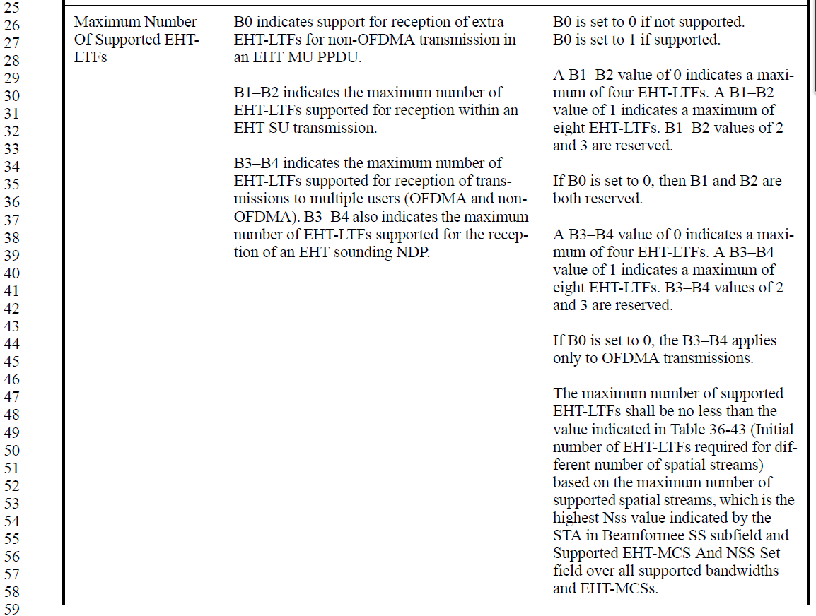

P245
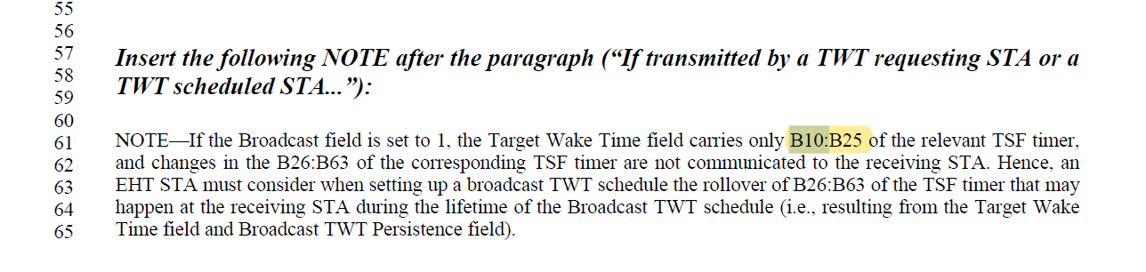
Example using “B2-B1”
P157
