IEEE P802.11
Wireless LANs
LB272-DMG-Sensing-Instance-CIDs
Date: 2023-05-15
Author(s):
Name | Affiliation | Address | Phone | email
Pu (Perry) Wang | MERL |  |  | pwang@merl.com
Abstract
This document proposes resolution to several LB272 DMG related CIDs.
The list of CIDs is: 1016, 1017, 1048, 1205, 1300, 1301, 2009, 2010, 2011, 2012, 2013, 2075, 2078, 2080, 2082, 2083, 2084, 2085, 2086, 2087, 2088, 2089, 2097, and 2119.

CID | Section | Page  Line | Comment | Proposed Change | Resolution
2075 | 11.55.3.6.3 | P210  L48 | ... instances of the same measurement setup. | As in comment. | Accepted
Proposed changes (11.55.3.6.3 Bistatic DMG sensing instance)
DMG sensing instances of measurement whose Sensing Type subfield is set to bistatic are bistatic DMG sensing instances. Only a single transmitting STA and a single receiving STA participate in a bistatic DMG sensing instance. The roles of the sensing initiator (sensing transmitter or sensing receiver) and sensing responder are set by the RX Initiator subfield of the Measurement Setup Control field within the DMG Sensing Measurement Setup element sent by the sensing initiator. These roles apply to all DMG sensing instances of the same measurement setup.

CID | Section | Page  Line | Comment | Proposed Change | Resolution
2009 | 11.55.3.6.3 | P211  L27 | Please remove the single "(" before "indicating" | As in comment | Revised
2078 | 11.55.3.6.3 | P211  L27 | the right bracket ')' is missed. | As in comment. | Accepted
Proposed changes (11.55.3.6.3 Bistatic DMG sensing instance)
The sensing responder shall start transmitting using this beam (indicating it in the same field in the first BRP frame it transmits).

CID | Section | Page  Line | Comment | Proposed Change | Resolution
2097 | 11.55.3.6.3 | P211  L52 | The 'Report Delay = 0' in the first sensing instance in Figure 11-74p. It should be 'Report Delay = 1'. | As in comment. | Revised
1048 | 11.55.3.6.3 | P211  L44 | inconsistent Report Delay codes in the text and Figure 11-74p for the first instance. Based on Report Delay code specificaiton in Table 9-401z, "no report in this instance" shoud be Report Delay =0. | In line 44 page 211, change "Report Delay =1" to "Report Delay =0". | Revised
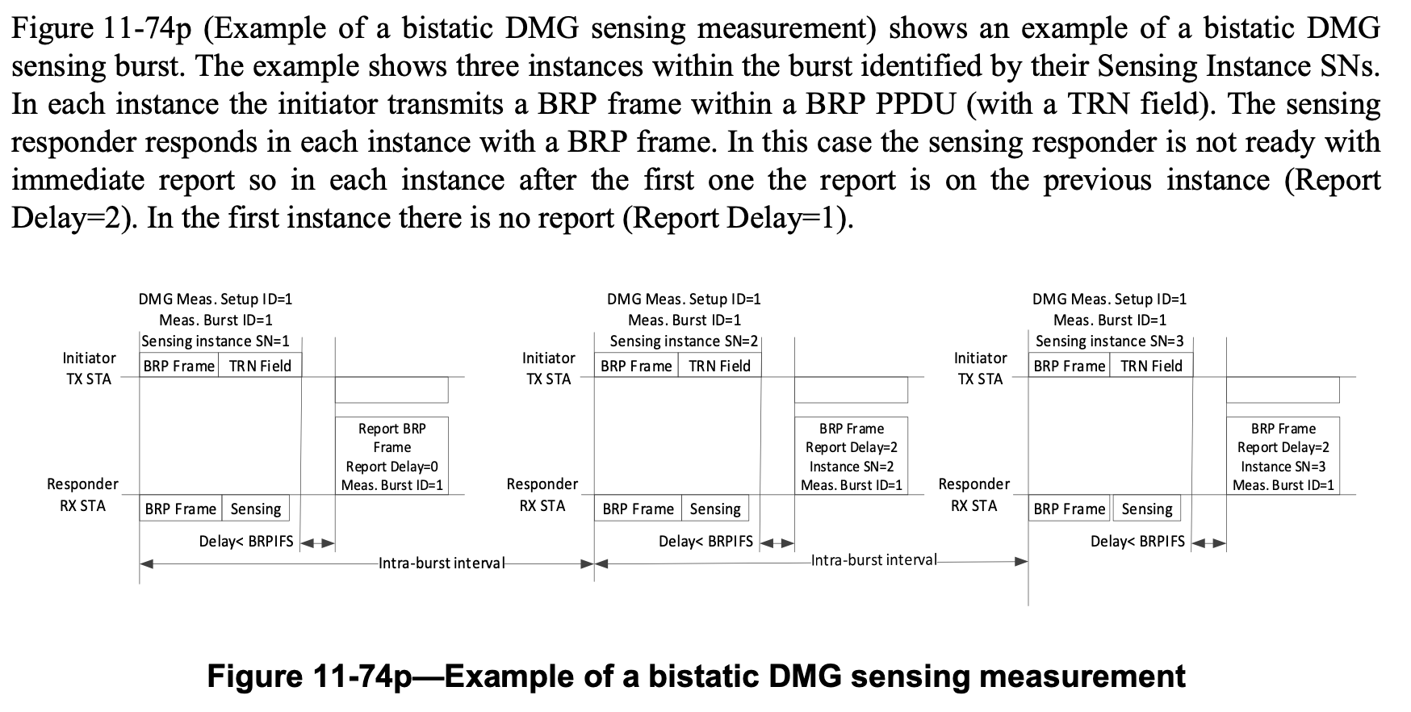
Discussion:
According to the definition of Report Delay code specification in Table 9-410z, the Report Delay code for no report in the first instance should be Report Delay = 1.
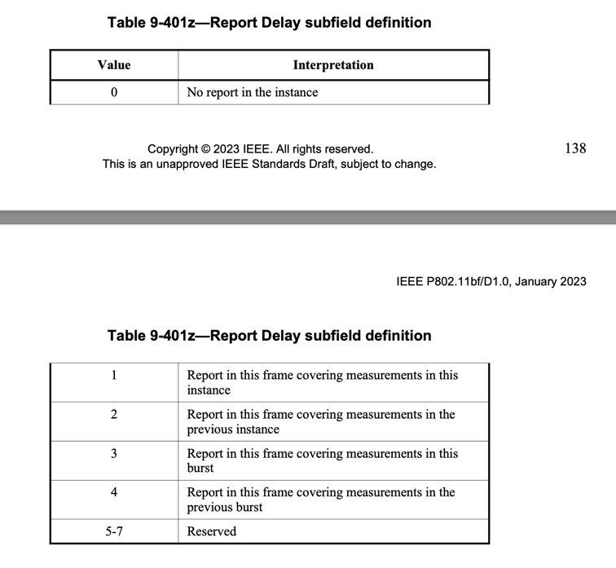

Proposed changes:
Update “Report BRP Frame Report Delay=01” in Figure 11-74p.

CID | Section | Page  Line | Comment | Proposed Change | Resolution
1300 | 11.55.3.6.4 | P212  L9 | The 'DMG Measurement Setup Request frame' is not correct. | Replace it with the 'DMG Sensing Request frame' | Accepted
2080 | 11.55.3.6.4 | P212  L9 | It should be 'DMG Sensing Request frame' instead of 'DMG Measurement Setup Request frame'. | As in comment. | Accepted
1301 | 11.55.3.6.4 | P212  L13 | The ' SIF' is a typo. | Replace it with the 'SIFS'. | Accepted
2010 | 11.55.3.6.4 | P212  L13 | Please replace "SIF" with "SIFS". | As in comment | Accepted
2082 | 11.55.3.6.4 | P212  L13 | It should be 'SIFS'. | As in comment. | Accepted

Proposed changes (11.55.3.6.4 Coordinated bistatic DMG sensing instance):
In the coordinated bistatic DMG sensing instance, the following rules shall apply:
- Number of sensing responders in each coordinated bistatic DMG sensing instance of the same DMG Measurement Setup ID may be different.
- The sensing initiator shall send a DMG Measurement Setup Sensing Request frame to each sensing responder it invites to participate in the sensing instance.
- The sensing responder shall respond with a DMG Sensing Response frame to the sensing initiator within a SIF SIFS
- The sensing responder that responded to the sensing initiator shall remain active to receive the BRP PPDU
- The order of sounding is indicated in the STA ID field within the DMG Sensing Measurement Setup Request frame
CID | Section | Page  Line | Comment | Proposed Change | Resolution
1016 | 11.55.3.6.5.2 | P212  L61 | "a SIFS" at this place in the sentence sounds like it describes or gives context to sensing PPDU instead of a timing related action. | The sensing initiator shall start the transmission of EDMG multistatic sensing PPDUs after receiving the response from the last sensing responder plus a SIFS. | Rejected
1017 | 11.55.3.6.5.3 | P213  L15 | "a SIFS" at this place in the sentence sounds like it describes or gives context to sensing responders instead of a timing related action. | The sensing initiator sends a DMG Sensing Poll frame to each of the sensing responders after the  transmission of the last PPDU plus a SIFS. | Rejected

Discussion (11.55.3.6.5 Multistatic EDMG sensing instance)
This is an editorial comment. The commentor is concerned that the focus of the sentence is more about the subject, not the timing-related action. However, the original sentence appears to be more concise and accurate. For instance, in the proposed change, it can be “immediately after” or “some time after” the transmission of the last PPDU plus a SIFS.
Similar sentences have been used in 802.11ay:
In the MIMO phase…, the responder shall send a MIMO BF Setup frame a SIFS following the reception of the MIMO BF Setup frame from the initiator.
CID | Section | Page  Line | Comment | Proposed Change | Resolution
2083 | 11.55.3.6.5.1 | P212  L31 | It should be 'DMG Sensing Response frames response to the DMG Sensing Request frames'. | As in comment. | Revised

Proposed changes (11.55.3.6.5 Multistatic EDMG sensing instance)
11.55.3.6.5.1 Initiation
A multistatic EDMG sensing instance between a sensing initiator in the sensing transmitter role and two or more sensing responders is initiated by several DMG Sensing Measurement Setup Request frames and DMG Sensing Response frames respond responses to the DMG Sensing Requests frames.

CID | Section | Page  Line | Comment | Proposed Change | Resolution
2119 | 11.55.3.6.5.1 | P212  L45 | The symbol: #N is confusing | change to N^th | Revised
2084 | 11.55.3.6.5.1 | P212  L37 | It should be 'The DMG Measurement Setup ID, Measurement Burst ID and Sensing Instance SN subfields shall have the same value in all DMG Sensing Request frames'. | As in comment. | Accepted

Proposed changes (11.55.3.6.5 Multistatic EDMG sensing instance):
The sensing initiator initiates the multistatic EDMG sensing instance by sending DMG Sensing Measurement Setup Request frames to each of the intended sensing responders. The DMG Measurement Setup ID, Measurement Burst ID and the Sensing Instance SN subfields shall have the same value in all DMG Sensing Measurement Setup Request frames. The sensing initiator shall set the STA ID subfield to a value between 0 and 7 indicating the index of the sensing responder sync subfield in the sync field of the EDMG multistatic sensing PPDUs. EDMG multistatic sensing PPDUs shall be addressed to the sensing responder that is assigned the value of 0 in the STA ID. The sensing initiator sets the First Beam Index field to a value that indicates the first beam that is used for transmission in the TRN field of the first EDMG multistatic sensing PPDU. The other beams used in the Multistatic Sensing PPDUs are the following beams in the Tx Beam List subelement. The sensing initiator sets the Start of #N the Nth PPDU subfields to the time, in microseconds, from the end of the DMG Sensing Request to the beginning of the Nth EDMG multistatic sensing PPDU in the multistatic EDMG sensing instance.

CID | Section | Page  Line | Comment | Proposed Change | Resolution
2085 | 11.55.3.6.5.1 | P212  L50 | It should be 'A STA that receives ...'. | As in comment. | Accepted

Proposed changes (11.55.3.6.5 Multistatic EDMG sensing instance):
A STA that receivers receives a DMG Sensing Request frame shall respond after SIFS with a DMG Sensing Response frame. The sensing responder shall remain active to receive all the EDMG multistatic sensing PPDUs in the multistatic EDMG sensing instance and poll frame.

CID | Section | Page  Line | Comment | Proposed Change | Resolution
2011 | 11.55.3.6.5.3 | P213  L22 | The last paragraph and Figure 11-74q are not specific to subclause 11.5.36.5.3. Please insert a new subclause "11.553.6.5.4 EDMG multistatic measurement instance" | As in comment | Revised
2012 | 11.55.3.6.5.3 | P213L47 | Please correct typo "EMDG" in caption of Figure 11-74q | As in comment | Accepted
2086 | 11.55.3.6.5.3 | P213  L46 | In Figure 11-74q, the title should be 'EDMG'. | As in comment. | Accepted
2013 | 11.55.3.6.5.3 | P213  L36 | Figure 11-74q needs to be revised so that it is aligned with the preceeding paragraph. For example, replace "RQ", "RSP", "Report RQ" with "DMG Sensing Request", "DMG Sensing Response", "DMG Sensing Poll". | As in comment | Revised

Discussion (11.55.3.6.5 Multistatic EDMG sensing instance):
In the subclause 11.55.3.6.5.3 Reporting, the last paragraph and Figure 11-74q are about an example of Multistatic EDMG sensing instance, illustrating the initiation, sounding, and reporting phases. The commentor suggested to add a new subclause that is specific to this paragraph and Figure 11-74q.

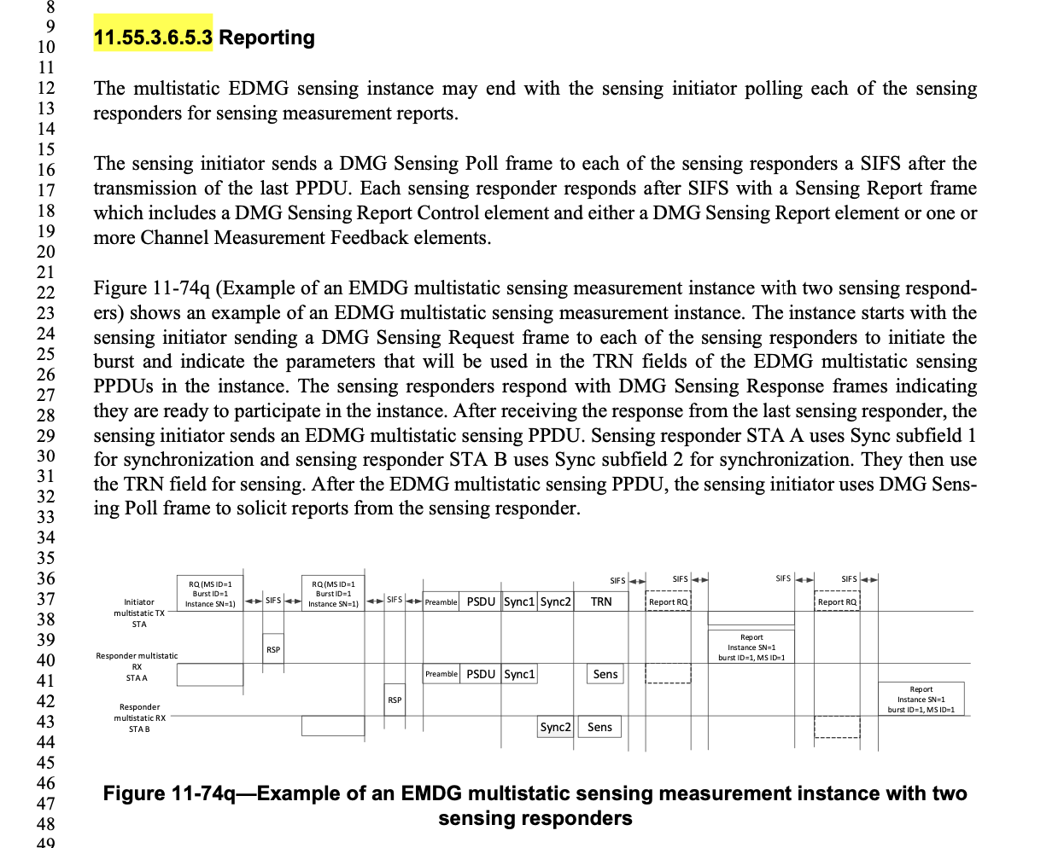

Proposed change:

11.553.6.5.4 An Example of An EDMG multistatic sensing measurement instance

Figure 11-74q (Example of an EMDG EDMG multistatic sensing measurement instance with two sensing responders) shows an example of an EDMG multistatic sensing measurement instance. The instance starts with the sensing initiator sending a DMG Sensing Request frame (RQ) to each of the sensing responders to initiate the burst and indicate the parameters that will be used in the TRN fields of the EDMG multistatic sensing PPDUs in the instance. The sensing responders respond with DMG Sensing Response frames (RSP) indicating they are ready to participate in the instance. After receiving the response from the last sensing responder, the sensing initiator sends an EDMG multistatic sensing PPDU. Sensing responder STA A uses Sync subfield 1 for synchronization and sensing responder STA B uses Sync subfield 2 for synchronization. They then use the TRN field for sensing. After the EDMG multistatic sensing PPDU, the sensing initiator uses DMG Sensing Poll frame (Report RQ) to solicit reports from the sensing responder.
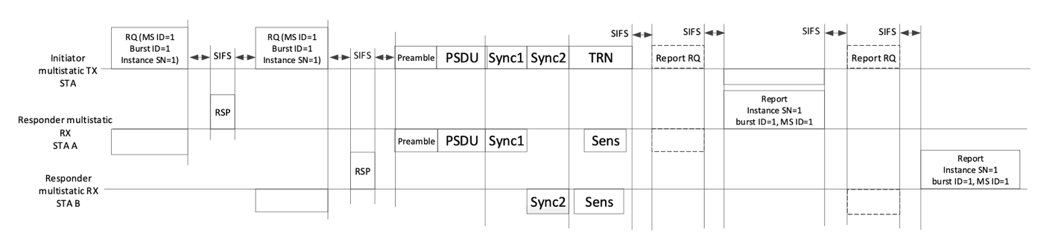
Figure 11-74q—Example of an EMDG (EDMG) multistatic sensing measurement instance with two sensing responders.

CID | Section | Page  Line | Comment | Proposed Change | Resolution
2087 | 11.55.3.8 | P214  L57 | It should be '11.55.3.4 DMG sensing measurement setup' | As in comment. | Accepted

Proposed changes (11.55.3.8 DMG sensing measurement setup termination):
For the implicit DMG sensing measurement setup termination of the measurement setup, the sensing initiator and the sensing responder shall use the DMG sensing procedure expiry timer. The DMG sensing procedure expiry timer maintains the DMG measurement setup identified with the DMG Measurement Setup ID between the sensing initiator and the sensing responder. The DMG sensing procedure expiry timer shall be set to the dot11DMGSensingProcedureExpiry value at
— the success of the procedure specified in 11.55.3.3 (DMG sensing session setup) 11.55.3.4 (DMG sensing measurement setup);
— the exchange of DMG Sensing Request and DMG Sensing Response frames is completed in the coordinated DMG sensing instance (see 11.55.3.6.2 (Coordinated monostatic DMG sensing instance), 11.55.3.6.4 (Coordinated bistatic DMG sensing instance), and 11.55.3.6.5 (Multistatic EDMG sensing instance)); or
— the exchange of the BRP frames is completed in the Bistatic DMG sensing instance (see 11.55.3.6.3 (Bistatic DMG sensing instance)).

CID | Section | Page  Line | Comment | Proposed Change | Resolution
1205 | 11.55.4.2 | P217  L45 | change an  DMG-MLME-SENSMSMTSETUP.request to a DMG-MLME-SENSMSMTSETUP.request | change an  DMG-MLME-SENSMSMTSETUP.request to a DMG-MLME-SENSMSMTSETUP.request | Accept

Proposed changes (11.55.4.2 DMG SBP Setup)
If the Sensing Responder subfield within the DMG SBP Parameters of the corresponding MLME-DMG- SBP.indication primitive is set to 0, the SBP responder shall not use a DMG sensing procedure initiated with the issue of an MLME-DMG-SENSMSMTSETUP.request primitive with PeerSTAAddress parameter equal to the SBP initiator’s MAC address to satisfy the DMG SBP request. Otherwise, if the Sensing Responder subfield is set to 1, the SBP responder shall use a DMG sensing procedure initiated with the issue of an a DMG-MLME-SENSMSMTSETUP.request primitive with PeerSTAAddress parameter equal to the SBP initiator’s MAC address to satisfy the DMG SBP request.

CID | Section | Page  Line | Comment | Proposed Change | Resolution
2088 | 11.55.4.2 | P218  L43 | WLAN' should be removed in the first row of the NOTE. | As in comment. | Accepted

Proposed changes (DMG SBP Setup):
NOTE—The method used by an SBP responder to select DMG STAs to include in the DMG WLAN sensing procedure used in response to an MLME-DMG-SBP.request primitive in which the DMG Preferred Responder List subfield within the DMG SBP Parameters is equal to 0 or in which the DMG Preferred Responder List subfield and the DMG Mandatory Preferred Responder subfield within the DMG SBP Parameters are set to 1 and 0, respectively, is implementation dependent.

CID | Section | Page  Line | Comment | Proposed Change | Resolution
2089 | 11.55.4.3 | P219  L15 | ..., the SBP responder shall transmit all frames prepared...' | As in comment. | Accepted

Proposed changes (DMG SBP Setup):
At the time scheduled to deliver the DMG SBP report frame(s), the SBP responder shall delete transmit all frames prepared for delivery at the preceding scheduled time.

Straw Poll:
Do you agree with the proposed resolutions for CIDs 1016, 1017, 1048, 1205, 1300, 1301, 2009, 2010, 2011, 2012, 2013, 2075, 2078, 2080, 2082, 2083, 2084, 2085, 2086, 2087, 2088, 2089, 2097, and 2119 in revision 1 of this document?
Y/N/A

