IEEE P802.11
Wireless LANs
CR for LB273 CID 4381 and 4382
Date: 2023-05-15
Author(s):
Name | Affiliation | Address | Phone | email
Rui Yang | InterDigital |  |  | rui.yang@interdigital.com
Abstract

This submission present proposed resolutions for the following 2 CIDs:
4381 and 4382

The proposed changes are based on 802.11REVme_D3.0.

Revision history:

r0 – initial version

CID | Clause | P.L | Comment | Proposed Change | Resolution
4381 | 9.3.1.19 | 660.38 | Saying "A subchannel lies within a bandwidth" doesn't make sense, but "a subchannel lies within a channel" does. Suggest replace "BSS bandwidth" by "BSS channel", which has been used in D3.0, e.g., the title of subclause 10.45.3 is "BSS channel selection methods". | Change the sentence to "The lowest numbered bit of the Disallowed Subchannel Bitmap subfield corresponds to the 20 MHz subchannel that lies within the BSS channel and that has the lowest frequency of the set of all 20 MHz subchannels within the BSS channel." | ACCEPTED
4382 | 11.7.5 | 2481.43 | Saying "channels within a bandwidth" doesn't make sense. Suggest replace "the bandwidth of the BSS" to "BSS channel". | Change the sentence to "... or for all 20 MHz channels within the BSS channel ..." | REVISED  Agree with commentor’s resolution. In addition, two “for” statements connected by “or” do not have the same meaning: one is bandwidth; the other is channel. Both should be about the channel.  TGm editor: please incorporate changes shown in 11-23/0861r0 under the tag 4382.

Discussion
The complete paragraph about CID 4381:
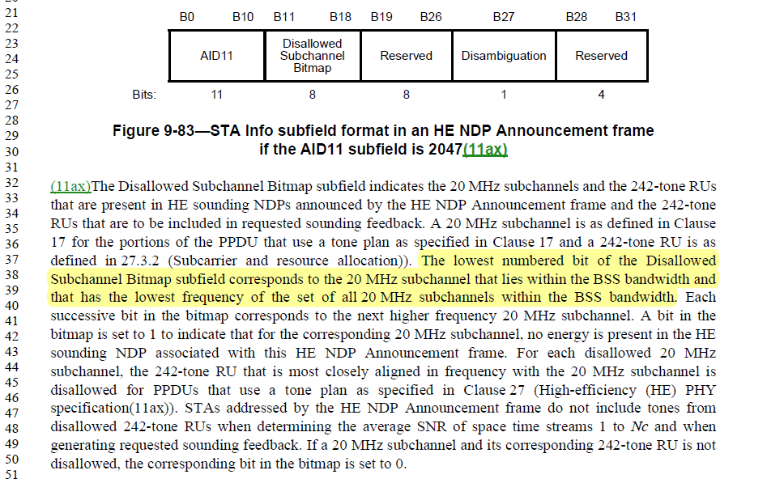

The complete paragraph about CID 4382:
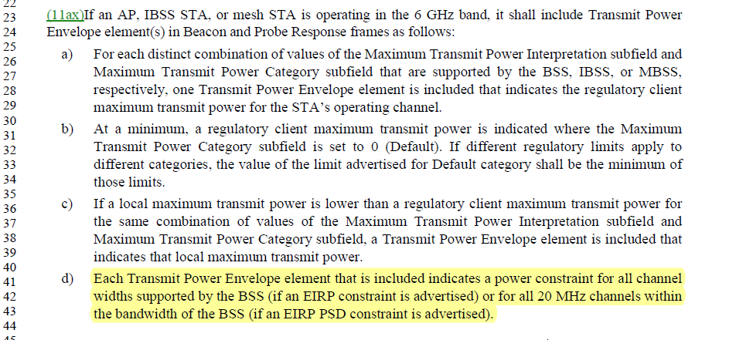
In both cases, the intention of the sentences is to make sure that the “subchannels” or “channels” reside within the channel of a BSS (or the BSS channel). It is illogical to say that a subchannel resides within a bandwidth which is just the width measure of a channel or a band.
End of Discussion

TGm editor: please make the following change in subclause 9.3.1.19, P660L38:
The lowest numbered bit of the Disallowed Subchannel Bitmap subfield corresponds to the 20 MHz subchannel that lies within the BSS channel and that has the lowest frequency of the set of all 20 MHz subchannels within the BSS channel. (#4381)

TGm editor: please make the following change in subclause 11.7.5, P2481L43:
- Each Transmit Power Envelope element that is included indicates a power constraint for all channels with widths supported by the BSS (if an EIRP constraint is advertised) or for all 20 MHz channels within the BSS channel (if an EIRP PSD constraint is advertised). (#4382)

