IEEE P802.11  
Wireless LANs

|  |  |  |  |  |
| --- | --- | --- | --- | --- |
| Liaison statement from Wireless Broadband Alliance re: QOS | | | | |
| Date: 2023-05-18 | | | | |
| Author(s): | | | | |
| Name | Affiliation | Address | Phone | email |
| Dorothy Stanley | Hewlett Packard Enterprise | 3333 Scott Blvd. Santa Clara, CA 95054 | +1 630-363-1389 | [dstanley@ieee.org](mailto:dstanley@ieee.org) |
|  |  |  |  |  |

Abstract

This document contains a liaison received from the Wireless Broadband Alliance (WBA) related to Quality of Service use cases and operation. The received liaison is embedded below and copied on the following pages. Please see the specific requests in the liaison. The white paper is also embedded below.

 

R1: Includes a word version of the whitepaper in the body text.

|  |  |  |  |
| --- | --- | --- | --- |
| **Date** | 3rd May, 2023 | **Meeting Time** | **Wednesday**  9am PT, 6pm CET |
| **WG / Project** | WBA E2E Wi-Fi QoS | | |
| **To** | IEEE 802.11 Working Group | | |
| **Project Leads** | Ganesh Venkatesan (Intel Corp), Mehmet Sukru Kuran (Airties),  Enis Akay (Meta), Elif Salik (Lifemote) | | |
| **Topic** | Optimizing QoS over the Wi-Fi Link | | |

Dear IEEE 802.11 Working Group Chair,

The WBA Members formed a technical activity in early 2022 called E2E Wi-Fi QoS, focused on identifying issues causing QoS degradation for QoS-sensitive applications in various topologies, recommending QoS mechanisms and corresponding configurations to deploy and conduct trials to demonstrate the efficacy of the QoS mechanisms in maintaining QoS for QoS-sensitive applications.

In the first phase of this effort, the focus is limited to Wi-Fi link(s) and the use of QoS mechanisms defined in IEEE 802.11-2020 and Wi-Fi Alliance QoS Management Releases 1 and 2 over the Wi-Fi link(s).

The group has recently finished a whitepaper that addresses Residential Use Cases, Enterprise Use Cases, Gaming Use Cases.

Considering this, the group leadership would like to formally liaise with IEEE 802.11 the final draft that will be published later to the WBA Members in June 2023.

The program meetings will carry on now with live trials, where the technology is tested and applied to real practical scenarios in Residential and Enterprise networks. A report summarizing the outcome of these trials will be published at the end of the trials.

Specific requests:

* WBA invites IEEE 802.11 WG members to provide opportune feedback on the document, as well as any other areas that WBA should in future phases of this work.
* WBA invites IEEE 802.11 WG members to be involved in the ongoing trials that will take place during the second half of 2023:
  + With technical or business interest in this topic
  + With focus on QoS-sensitive Application Development or support for QoS mechanisms natively in Operating Systems
* WBA E2E QoS leadership would like to present an overview of this effort to IEEE 802.11 WG in a future IEEE 802.11 session (May 2023 Interim or July 2023 Plenary).

Yours sincerely,  
The WBA E2E Wi-Fi QoS Chairs

**Upcoming WBA events:**

* Wireless Global Congress & Working Sessions – 19th to 22nd June 2023
* For more information, consult <https://www.wirelessglobalcongress.com/>

**References:**

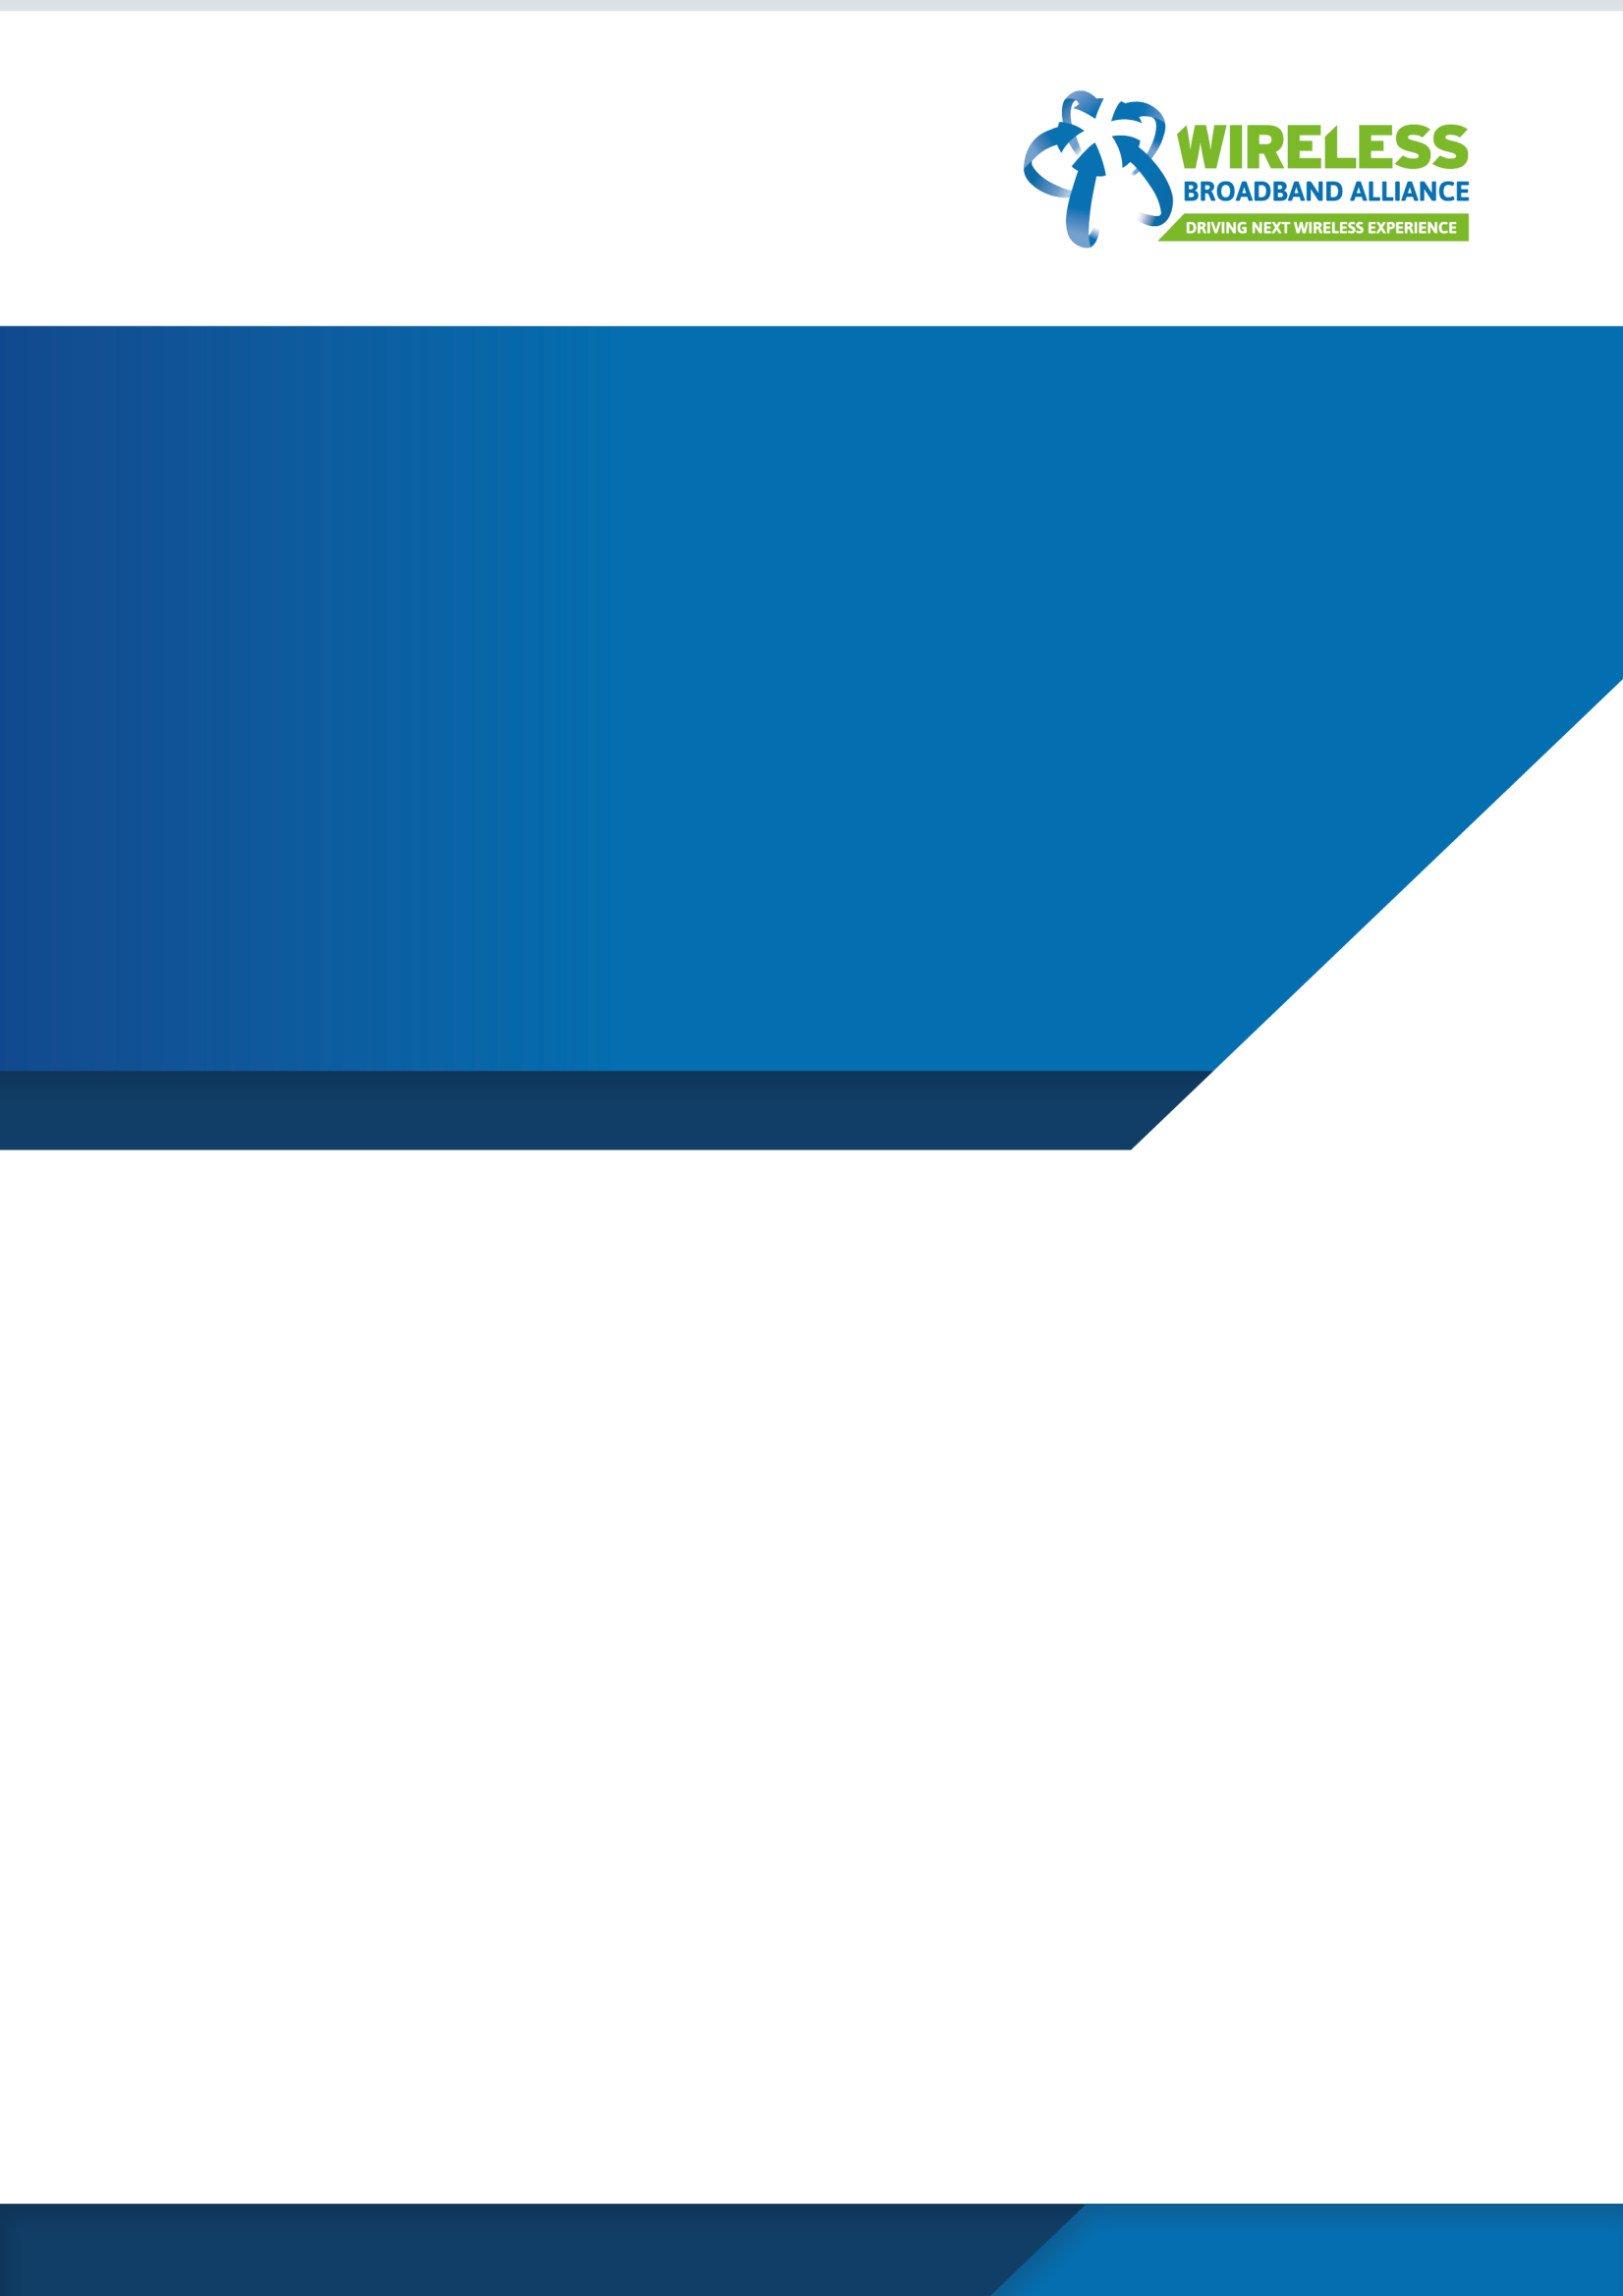

**E2E QoS Improvement**

**Optimizing QoS Over Wi**

**-**

**Fi Links**

**Source:**

**Author(s):**

**Issue Date:**

**Version:**

**Document Status:**

Wireless Broadband Alliance

E2E Wi

-

Fi QoS Group

May

202

3

1.

0

Draft

**About the Wireless Broadband Alliance**

Wireless Broadband Alliance (WBA) is the global organization that connects people with the latest Wi-Fi initiatives. Founded in 2003, the vision of the Wireless Broadband Alliance (WBA) is to drive seamless, interoperable service experiences via Wi-Fi within the global wireless ecosystem. WBA’s mission is to enable collaboration between service providers, technology companies, cities, regulators and organizations to achieve that vision. WBA’s membership is comprised of major operators, identity providers and leading technology companies across the Wi-Fi ecosystem with the shared vision.

WBA undertakes programs and activities to address business and technical issues, as well as opportunities, for member companies. WBA work areas include standards development, industry guidelines, trials, certification and advocacy. Its key programs include NextGen Wi-Fi, OpenRoaming, 5G, IoT, Testing & Interoperability and Policy & Regulatory Affairs, with memberled Work Groups dedicated to resolving standards and technical issues to promote end-to-end services and accelerate business opportunities.

The WBA Board includes Airties, AT&T, BAI Communications, Boingo Wireless, Broadcom, BT, Cisco Systems, Comcast, Deutsche Telekom AG, Intel, Reliance Jio, Turk Telekom and Viasat. For the complete list of current WBA members, **click here**.

**Follow Wireless Broadband Alliance:**

[**www.twitter.com/wballiance**](http://www.twitter.com/wballiance) [**http://www.facebook.com/WirelessBroadbandAlliance**](http://www.facebook.com/WirelessBroadbandAlliance) [**https://www.linkedin.com/company/wireless-broadband-alliance**](https://www.linkedin.com/company/wireless-broadband-alliance)

**Undertakings and Limitation of Liability**

This Document and all the information contained in this Document is provided on an ‘as is’ basis without warranty of any kind, either expressed or implied, including, but not limited to, the implied warranties of merchantability, fitness for particular purpose, or non-infringement.

In addition, the WBA (and all other organizations who may have contributed to this document) makes no representations or warranties about the accuracy, completeness, or suitability for any purpose of the information. The information may contain technical inaccuracies or typographical errors. All liabilities of the WBA (and all other organizations who may have contributed to this document) howsoever arising for any such inaccuracies, errors, incompleteness, suitability, merchantability, fitness, and non-infringement are expressly excluded to the fullest extent permitted by law. None of the contributors make any representation or offer to license any of their intellectual property rights to the other, or to any third party. Nothing in this information or communication shall be relied on by any recipient.

The WBA also disclaims any responsibility for identifying the existence of or for evaluating the applicability of any claimed copyrights, patents, patent applications, or other intellectual property rights, and will take no position on the validity or scope of any such rights. The WBA takes no position regarding the validity or scope of any intellectual property or other rights that might be claimed to pertain to the implementation or use of the technology described in this document or the extent to which any license under such rights might or might not be available; nor does it represent that it has made any effort to identify any such rights.

Neither the WBA nor any of the other organizations who may have contributed to this document will be liable for loss or damage arising out of or in connection with the use of this information. This is a comprehensive limitation of liability that applies to all damages of any kind, including (without limitation) compensatory, direct, indirect, or consequential damages, loss of data, income or profit, loss of or damage to property and claims of third parties.

**Table of Contents**

1. OVERVIEW 1

2. USE CASES 2

2.1. USE CASE STRUCTURE 2

2.2. RESIDENTIAL USE CASES 3

2.2.1. Teleconferencing (Work from Home) 3

2.2.2. Video on Demand 4

2.2.3. Real-time Audio / Video Streaming to subscribers 5

2.2.4. Real-time Audio / Video Publishing 6

2.2.5. Internet / Cloud Gaming 7

2.3. GAMING USE CASES 8

2.3.1. Networked full-featured gaming consoles 8

2.3.2. Minimally resourced gaming consoles networked to a fully resourced gaming server at the venue 9

2.4. ENTERPRISE USE CASES 10

2.4.1. Audio / Video / Data Conferencing 10

2.4.2. Stadium Use Cases 11

2.4.3. Airport / Subway Use Cases 12

2.5. OTHER USE CASES FOR CONSIDERATION IN FUTURE PHASE(S) 12

3. TOOLS AND MECHANISMS TO MITIGATE THE COMMON CAUSES 13

3.1. WFA QOS MANAGEMENT SPECIFICATION 13

3.1.1. DSCP-to-UP Mapping 13

3.1.2. MSCS and SCS mechanisms 14

3.2. QUEUE MANAGEMENT MECHANISMS 15

3.3. ASSURED SERVICE VIA OFDMA AND QOS CHARACTERISTICS 16

4. PLANNED TRIALS 16

THE FOLLOWING TRIALS ARE BEING PREPARED TO DEMONSTRATE THE TOOLS AND MECHANISMS IN REAL ACTION, LOOKING TO OBSERVE AND REPORT GAINS IN TERMS OF END-PERFORMANCE 16

4.1. TEST EQUIPMENT 16

4.2. TEST SETUP 17

5. CONCLUSION 17

**Tables**

Table 1: User Priority (UP) to Access Category (AC) mapping in WMM ......................................................................... 13

Table 2: Default DSCP tag to User priority mapping in WFA QoS Specification ............................................................. 14

**Figures**

Figure 1: Teleconference between users ......................................................................................................................... 3

Figure 2:Video on Demand (VOD) from media centre to subscribers .............................................................................. 4

Figure 3: Real-Time Audio/Video Streaming to Subscribers ............................................................................................ 5

Figure 4: Real-time publication of Audio/Video Content ................................................................................................. 6

[Figure 5: Internet/Cloud Gaming (latency bound) ........................................................................................................... 7](https://d.docs.live.net/d2043977d025895b/Attachments/%C1rea%20de%20Trabalho/Optimizing%20E2E%20QoS%20Whitepaper%20V1.0.0%20vPM-MSK%20REVISION.docx#_Toc134107705)

Figure 6: Typical Test Setup ............................................................................................................................................ 17

# Overview

Today’s networks are responsible to carry a lot of information some of which require special treatment by the network for the performance of the corresponding application to be acceptable. A variety of standard Quality-of-Service (QoS) mechanisms (some operating the in media dependent Internet Protocol Suite (IPS) layer-2 and others in media-independent IPS layer-3) are available to choose depending on the requirements of the application to sustain acceptable performance for the lifetime of the application process(es).

Recognizing the range of applications and their QoS requirements, WBA has taken a phased approach to partition the problem space to

* Identify representative Use Cases
* Establish QoS requirements and corresponding Key Performance Indices (KPIs)
* Recommend a choice of standard QoS mechanisms to deploy with the goal of providing the required QoS for QoS-sensitive applications while co-existing with other non-QoS-sensitive applications in the same network
* Execute trials on one or more networks with and without the recommended standard QoS mechanisms, demonstrating QoS improvement for the relevant applications
* In some cases, identify potential requirements for enhancements to existing or for new standard QoS mechanisms
* Enhancements to existing or new standard QoS mechanisms when defined may get included in the scope of a subsequent WBA QoS effort.

In this phase of the WBA E2E Wi-Fi QoS, the focus is limited to optimizing the Wi-Fi link using Wi-Fi Alliance (WFA) QoS Mechanisms, for the following Use Cases:

* Residential use cases
* Gaming use cases
* Enterprise use cases

Use cases with corresponding QoS KPIs are described in Section-2.

Section-3 provides an overview of common QoS issues with the identified Use Cases.

Section-4 is a description of standard QoS mechanisms that can be used individually or as a combination to mitigate the QoS issues identified in Section-3.

Section-5 is a high-level description of the network(s) along with some tools we intend to deploy to assess the QoS improvement that can be achieved with the standard QoS mechanisms.

# Use Cases

In all the Use Cases described in this document it is assumed that some choices were made in the configuration of the Wi-Fi network. This includes the choice of the operating band (2.4GHz, 5GHz or 6GHz), the operating channel (less interference, less QoS activity, etc.). The process used to make these choices is outside the scope of this work, and hence is not addressed in this document. In some cases, depending on the capabilities of the Wi-Fi components in the network, there may be some additional options available to steer the operation of the network to a channel that has less interference or less QoS activity.

In addition, given a configuration (which includes the capabilities of the Wi-Fi Access Point (AP) and the associated devices / stations (STAs)), there is a limited capacity in the network. In most instances, improving QoS selectively for a set of streams in the network is a trade-off, i.e., it is achieved at the cost of sacrificing some capacity and potentially some degradation in the performance of lower priority applications (e.g., a file download may take a little longer). The focus of this document is to outline Use Cases where Wi-Fi links with QoS Mechanisms appropriately configured can preserve QoS / QoE for the applications that require it. With limited capacity in the network, there will be a limit to how many QoS / QoE sensitive applications can be concurrently supported. Scaling beyond this may require upgrading to a higher capacity (AP / STAs supporting higher rate Wi-Fi protocols and/or moving from a single-AP Basic Service Set (BSS) to a Mesh / multi-AP (Extended Service Set - ESS) deployment).

## Use Case Structure

Use Cases are described in this document with the following structure:

A general description of the Use Case is followed by a diagrammatic depiction of the Use Case. Metrics that quantify QoS and QoE are then enumerated followed by ‘Key Performance Indicators (KPIs)’ at the network level. Potential issues that typically cause QoS / QoE degradation and how best to minimize or eliminate the issues are listed in the ‘Mitigation Strategies’ part of the Use Case. Finally, if applicable, variants of the Use Case are listed.

## Residential Use Cases

### Teleconferencing (Work from Home)

**Description:** Establish an audio-visual [video / data] session using a professional conferencing application (e.g., Webex, GoToMeeting, Microsoft Teams, etc.) with 2 or more participants; participants actively interact with each other.

Teleconference Media

Center

Users (Mobile)

Users (Laptop)

Users (Laptop)

Users (Desktop)

#### Figure 1: Teleconference between users

**QoE:**

* Uninterrupted audio and reasonably responsive data sharing,
* Video performance may be sub-optimal (and in some cases disabled if the number of participants is large)

**KPI:**

##### Layer-2

* Audio / video packets lost
* Audio / video latency / jitter

##### Application layer

* E2E Audio / video latency / jitter
* Audible audio artifacts (clicks due to lost / late samples), loss of audio
* Video freeze, artifacts

**Mitigation Strategies:** E2E prioritization of audio / video / data streams (QoS tags) over other data traffic in the network, prioritization over the wireless link, appropriate wireless channel selection

**Use Case Variants:**

* 1. family conferences (using consumer conferencing tools like Zoom, WhatsApp, etc.,)
  2. Webcast (one speaker / presenter and multiple listeners; participants do not interact)

### Video on Demand

**Description:** Watching a non-real time streaming stored content from a network-based media-server (within the Local Area Network (LAN), from the cloud / internet), (e.g., YouTube, Netflix) published by a streamer. May be delivered to multiple renderers within the home.

Subscribers (Smart TV, STB) Subscribers (Laptop)

VoD Media Center

#### Figure 2:Video on Demand (VOD) from media centre to subscribers

**QoE:** Uninterrupted and smooth (no perceptible audio / video artifacts) streaming of audio and video. Resolution may change occasionally. Initial short buffering phases may be acceptable.

**KPI:**

##### Layer-2

* Audio/video packets lost
* Audio / video jitter

##### Application layer

* Buffer level in-relation to zero buffer (occasionally reaching zero and / or staying at zero are problematic cases)
* Audible audio artifacts (clicks due to lost / late samples), loss of audio
* Video freeze, artifacts
* Video resolution

**Mitigation Strategies:** E2E prioritization of audio / video streams (QoS tags), appropriate wireless channel selection.

**Use Case Variants:** ISP specific VoD services

### Real-time Audio / Video Streaming to subscribers

**Description:** Watching a real-time streaming stored content from a network-based media-server (within the Local Area Network (LAN), from the cloud/internet), (e.g., Twitch, YouTube Live) may be delivered to multiple renderers within the home. The user(s) may be participating in real-time in a chat board related to the program being streamed / watched.

Media Center Users Streamer (Publisher) (Subscribers)

#### Figure 3: Real-Time Audio/Video Streaming to Subscribers

**QoE:** Uninterrupted smooth (no perceptible audio / video artifacts) streaming of audio and video. Delay to the publisher should be close to publisher’s base-line delay value. Chat messages should be published in real-time and should be in sync with the context of the streamed content.

**KPI:**

##### Layer-2

* Audio / video / data packets lost
* Audio / video / data latency / jitter

##### Application layer

* E2E Audio / video latency / jitter
* Audible audio artifacts (clicks due to lost/late samples), loss of audio
* Video freeze, artifacts
* Video resolution

**Mitigation Strategies**: E2E prioritization of audio / video / chat-specific data streams (QoS tags), appropriate wireless channel selection. In some cases, mechanisms to keep the streams synchronized with each other.

##### Use Case Variants: N/A

### Real-time Audio / Video Publishing

**Description:** Publishing a real time streaming stored content to a network-based media-server (either within the Local Area Network (LAN), or over the cloud / internet) to be pushed to the subscribers. High Resolution video stream and higher frame rates as opposed to the video streams in Work from home conferencing scenario.

*(It might be considered as a variant of teleconference scenario.)*

Media Center Users Streamer (Publisher) (Subscribers)

#### Figure 4: Real-time publication of Audio/Video Content

**QoE:** Uninterrupted uplink performance. Delay / Jitter to Media server is acceptable. Chat messages to the publisher from the audience may not be received in real-time, but the delay should be acceptable.

**KPI:**

##### Layer-2

* Audio / video packets lost (Uplink)
* Audio / video latency / jitter (Uplink)

##### Application layer

* Publisher to Server audio/video latency / jitter
* Server to Subscribers audio/video latency / jitter
* Publisher to Server throughput

**Mitigation Strategies:** Guaranteed or prioritized resource allocation over the wireless link, E2E prioritization of audio / video / data streams (QoS tags), appropriate wireless channel selection. Asymmetrical bandwidth allocation, especially in the backbone. Deployment of active queue management (AQM) or priority queuing mechanisms to combat Bufferbloat in the upstream WAN queue.

##### Use Case Variants: N/A

### Internet / Cloud Gaming

**Description:** Video game hosted in internet rendered to a single user within the home (e.g., GeForce Now, Xbox Cloud Gaming), e.g., Modern multiplayer action games – Battlefield series, Fortnite, modern single player action games – Cyberpunk 2077, Facebook [**Wild Hunt**.](https://www.facebook.com/wildhuntapp/)

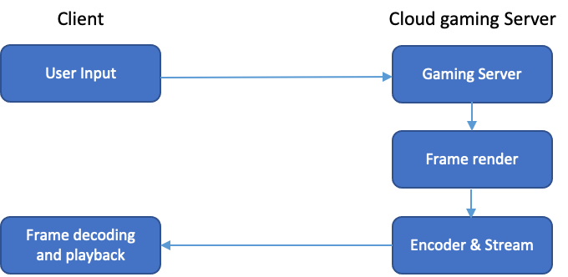

*Figure 5: Internet/Cloud Gaming (latency bound)*

**QoE:** Smooth (no perceptible video artifacts) frame rendering and unnoticeable response for a user generated input command.

1. **Freeze Count:** Freeze is defined if two consecutive rendered frames are not received by the client within a defined time interval. Exact value is varied from game to game typically between 100ms to 500ms (e.g., Facebook Wild Hunt uses 180ms threshold). Number of freezes within a period is Freeze Count.
2. **Motion to Photon latency:** It is the time interval between the instance when a player takes an action (click to fire a shot) and the instance at which the frame corresponding to the player action is fully displayed on the player’s screen (e.g., Bullet fired).

**KPI:**

##### Layer-2 / 3

* Packets lost
* Latency / jitter
* Throughput

##### Application layer

* Freeze count
* Input based E2E latency

**Mitigation Strategies:** Video Game Traffic prioritization over Wi-Fi link between end user and Wi-Fi router. Maintain and honor QoS tags in ISPs core network. Wireless channel selection Deployment of AQM or priority queuing mechanisms to combat Bufferbloat in the downstream WAN queue to combat Bufferbloat.

**Use Case Variants:** N/A

## Gaming Use Cases

Networked gaming at a specific venue is a common use case. This is different from the Internet / Cloud Gaming Use Case described earlier as the network in this case is a Local Area Network (LAN) as opposed to the Internet. The gamers are all located within the LAN and are playing a competitive game where timely response to input(s) from the gamer(s) and timely update to the audio / visual representation of the game for each individual user are critical for optimal gaming experience and to render the game fair from the perspective of network performance.

There are two variants of this Use Case.

### Networked full-featured gaming consoles

Each gamer has a gaming console which is fully featured in terms of computing, memory, and display resources. The network only provides a means for keeping the game coordinated in terms of individual player action(s) and the combined outcome of the action(s) by all the players – the combined outcome being a synchronized audio-visual output resulting from the players’ action(s).

From a QoS perspective the network in this case needs to provide appropriate prioritization for the payloads carrying individual player action(s) and the corresponding change to the game in order to keep the combined outcome synchronized across all the networked gaming consoles. The typical gaming payload in the case is small but requires no loss or ultra-low latency to maintain the gaming experience.

**QoE**: the audio-visual output at all the networked gaming consoles remain the same (perfectly synchronized) and the response to an individual player’s action is reflected seamlessly across all the gaming consoles.

**KPI:** Packet loss, response time to an individual player’s action, lag in the synchronization of the audiovisual output across the networked gaming consoles, worst-case and average end-to-end latency for individual player’s action payload (and what part of it is contributed by the network)

### Minimally resourced gaming consoles networked to a fully resourced gaming server at the venue

The main difference in this case is that the individual gaming consoles are minimally resourced – i.e., high-end audio / video codecs with enough compute / memory resources to provide the best audiovisual display of the game to each individual user and the corresponding controller to capture the individual user action(s). The uplink network requirements are the same as that of the Networked fullfeatured gaming consoles case while the downlink is compressed content representing the combined outcome of all action(s) by all the players.

Note that the downlink stream can be multicast since the combined outcome is the same and by doing that some of the synchronization issues in the previous use case may be mitigated.

Some variants of this use case may require additional processing. For instance, during the time taken to send the individual gamer action(s) to the game controller, integrate the actions from all the users, generate a combined outcome, encode / compress the combined outcome, send it downlink, decode / decompress the combined outcome and render it, the users may have performed some actions which may need each individual gaming console to perform some compensation to reflect the outcome of the ‘vestigial’ action(s). This may not apply to all gaming applications, but it does it brings back the synchronization of combined outcome problem despite the multicast advantage and may require additional downlink traffic (expedited) for ‘vestigeal’ actions(s) from other gamer(s) and additional resource requirements (memory and / or compute) to perform timely compensation.

**QoE**: the audio-visual output at all the networked gaming consoles remains the same (perfectly synchronized) and the response to an individual player’s action is reflected seamlessly across all the gaming consoles. Effects due to poor compensation (motion sickness, etc.)

**KPI**: Packet loss, response time to an individual player’s action, lag in the synchronization of the audiovisual output across the networked gaming consoles, worst-case and average end-to-end latency for individual player’s action payload (and what part of it is contributed by the network)

## Enterprise Use Cases

In Enterprise scenarios the network is engineered to have enough capacity to meet the enterprise needs. Specifically in the context of the wireless, interference due to overlapping BSS, etc., is managed and is either non-existent or minimal. Enterprise policies may include policing the network use, identifying misconfigurations proactively and eliminating potential bottlenecks. Network policies are also updated as need (e.g., new applications become available, etc.)

Enabling the best QoS for business-critical applications takes precedence over all other network activities. To achieve this several mechanisms are typically used and most of these depend on

* mandating a specific application for business use,
* [deep] packet inspection by the network to monitor the traffic and prioritize pertinent ones over others; and
* in cases where the network activity is limited to being within the enterprise network ensure that the prioritization is maintain end-to-end for optimal QoS.

### Audio / Video / Data Conferencing

Conference calls within the Enterprise enables collaboration without perturbing the participants’ schedules too much (eliminates time for the participants to travel to the meeting location, allows for participants to multi-task, etc.). However, for the conference call to be productive, the quality of voice, data and video should be perfect, so that the discussions, debates, and outcomes are equivalent to what it would have been if the participants met face-to-face.

Mandating a specific conferencing application configured specifically for the Enterprise enables assignment of appropriate priority to the payload corresponding to the application, to maintain required latency bounds, eliminate or minimize packet loss and avoid congestion due to other activities in the Enterprise network.

In some scenarios, the Enterprise conferencing may include participants from organizations outside the Enterprise resulting in not being able to use the Enterprise Conferencing application (e.g., Standards meeting involving members from various companies using an application mandated by the Standards Organization, conferencing between two or more collaborating parties that use different conferencing tools, etc.). In these cases, within the Enterprise (that participates in the inter-party conference using a conferencing tool that is not the preferred tool within the Enterprise) can improve QoS for the conference by performing deep packet inspection (DPI) to classify the packets as pertinent to the conference and prioritize them over others within the Enterprise network.

In the Enterprise, there is also a need for prioritizing certain applications over others based on the timeof-day. For instance, business-critical conferences are a priority during business hours but personal conferences by employees after business hours should be prioritized (as a reward for employees choosing to stay after hours and work).

**QoE:**

Audio: noisy, choppy, or inaudible versus clear

Video: optional and resolution is adaptable to network conditions; Frozen, or noisy video is not acceptable. If network resources are insufficient, it would be best to notify the user and turn video off.

Data: Data is very critical as most conference use data as an aid to assist in the discussions / debates and in some case the shared data is used to record the consensus / agreements. Conference Data should consistently be synchronized across all the participants to keep the discussions/debates coherent.

**KPI:** Latency, Packet Loss, enterprise-application-specific statistics (e.g., jitter, delay, etc.)

**Mitigation Strategies:** Mandate specific applications where possible to allow for prioritization without the need for [deep] packet inspection; Explicit setup of QoS either by the application or by some middleware at or above OSI layer-3 with the corresponding payload uniquely tagged. For Endto-End QoS this tag needs to be preserved across all the nodes from the source to the renderer(s).

### Stadium Use Cases

Prior to the start of the event, queries to locate parking spots, locate the entrance closest to assigned seats and to locate the seats within the stadium should be prioritized to provide timely guidance to the spectator(s). At the end of the event, the prioritization to this service should be restored to provide guidance to the spectators to guide them to their preferred exits from the arena.

**QOE**: quick response to queries on directions to assigned seats, directions to facilities within the arena, etc. Note that the system should be able to handle multiple simultaneous requests with the same response time (for each).

**KPI:** accuracy of the navigation, response time, number of simultaneous requests

**D**uring the event, traffic from the selected venue camera to the spectator’s personal device showing the perspective from the camera (e.g., the camera focused on a specific performer, or a camera focused on a specific area (e.g., the Basketball Hoop) in the arena, etc.). The video feed from the camera should have no or minimal artifacts. There may be variations of this service depending on what the specific spectator’s subscription to the event is.

**QoE:** responsiveness to switching between cameras and receiving the corresponding feed, video quality and consistence of video quality

**KPI:** Packet loss, latency, jitter

### Airport / Subway Use Cases

When passengers get out of their plane or train, queries to guide them to appropriate connecting gates/platforms or to the appropriate destination (baggage claim, customs, etc.). The number of such queries would spike when the aircraft/train arrives, and the network should be able to handle all the queries in parallel and provide timely response to all the queries.

**QOE:** quick response to queries on directions to the chosen destination, directions to restaurants, restrooms, etc., within the area. Note that the system should be able to handle multiple simultaneous requests with the same response time (for each).

**KPI:** accuracy of the navigation, response time, number of simultaneous requests

While passengers are waiting for their flight or train, they may entertain themselves by streaming content – podcasts, music, or audio/video content. The Airport / Subway enterprise network should provide acceptable QoS. Note that the QoS may in some cases be dependent on the level-of-service the user has subscription for (e.g., free streaming versus a paid streaming service).

**QoE:** responsive display of guides/catalogues, audio/video streaming with minimal drops/freezes

**KPI:** Packet loss, latency, jitter (note the streaming performance in this case can be managed with buffering with the caveat that delay in the start of streaming is acceptable – specifically for the free streaming service).

## Other Use Cases for consideration in future phase(s)

During the work, multiple other Use Cases have been discussed and considered, but due to preliminary filtering and prioritization, the team has decided to postpone them to a later phase and release of this work.

Examples of the Use Cases mentioned are AR / VR Gaming and Industrial Networks.

Future other use cases will also be included and suggestions from the members are welcome.

# Tools and Mechanisms to mitigate the common causes

The most well-known mechanism to mitigate performance losses in real-time applications is the Enhanced Distributed Channel Access (EDCA); standardized in IEEE 802.11e and specified under WFA’s Wi-Fi Multimedia (WMM). In EDCA, a traffic is given an access category (AC) defining its channel access parameters. These AC specific channel access parameters give priority to traffics with higher priority over traffics with lower priority; both between different competing Wi-Fi devices and within the same Wi-Fi device. WMM defines four ACs in descending priority: AC_VO (Voice), AC_VI (Video), AC_BE (Best Effort), and AC_BK (Background). WMM also defines how the 802.1Q user priorities (UPs) are mapped into the ACs (Table 1). However, it does not specify how higher-level packet tags (i.e., Differentiated Services Code Point (DSCP) tags) shall be mapped into the UPs.

|  |  |
| --- | --- |
| **User Priority (UP)** | **Access Category (AC)** |
| **7, 6** | AC_VO |
| **5, 4** | AC_VI |
| **3, 0** | AC_BE |
| **1** | AC_BK |

**Table 1: User Priority (UP) to Access Category (AC) mapping in WMM**

## WFA QoS Management Specification

The EDCA mechanism depends on the correct usage of DSCP tags as well as a proper mapping between them and the Ups. The recently ratified WFA QoS Management specification defines several features for these two issues and aims to connect the whole application layer to link layer traffic tagging pipeline.

### DSCP-to-UP Mapping

WFA QoS Management specification defines a default mapping scheme between the DSCP tags and Ups based on the previous RFC 8325 documentation (Table 2). A second feature is also added to allow an AP to supersede this mapping with a network specific mapping table via the exchange of a special set of management frames. Both the default and the network specific mappings are applied to both the downlink (from AP to STA) and uplink (from STA to UP) traffics.

|  |  |
| --- | --- |
| **DSCP value** | **User Priority (UP)** |
| **111000, 110000** | 7 or 0 |
| **101110, 101100** | 6 |
| **101000** | 5 |
| **100010, 100100, 100110,**  **100000, 011010, 011100, 011110, 011000** | 4 |
| **010010, 010100, 010110** | 3 |
| **010000, 001010, 001100, 001110, 000000** | 0 |
| **001000** | 1 |

**Table 2: Default DSCP tag to User priority mapping in WFA QoS Specification**

### MSCS and SCS mechanisms

EDCA mechanism coupled with DSCP-to-UP mapping provides a good improvement in the Wi-Fi link QoS for real-time applications. However, often DSCP tags are not set by the applications or even if set, are overwritten as 000000 in the backbone networks forcing the traffic to use the incorrect default AC_BK in the downlink last mile Wi-Fi link. WFA QoS specification offers two mechanisms: Mirrored Stream Classification Service (MSCS) and Stream Classification Service (SCS) to learn the correct UP value of any given traffic stream with the assistance of the application in the STA-side to reduce its E2E latency and jitter.

#### MSCS mechanisms

MSCS is a simple mechanism that is initiated by the STA. STA sends an MSCS request message to its AP with a set of UPs called the MSCS context. Afterwards, the AP monitors all uplink traffic with a UP value within the MSCS context and creates an entry for each such stream (i.e., source IP, destination IP, source port, and destination port) with its UP value. Whenever a downlink stream arrives to the AP whose IP and port addresses are the reverse of any entry, the AP applies the UP value of that entry to all frames belonging to this reverse stream. This downlink UP marking is done before the EDCA mechanism so that the correct AC is used in the downlink stream.

MSCS is designed for streams whose uplink and downlink traffics have mirrored IP and port address values. It requires the AP to monitor uplink side traffic and keep a dynamic stream entry table for UP marking.

#### SCS mechanisms

SCS is a more generalized version of the MSCS mechanism added in the WFA QoS Specification Release 2 (R2). An SCS request, specifies a downlink stream by its IP and port addresses as well as Transport Layer (layer-4) protocols (i.e., TCP, UDP) and requests the AP to mark frames belonging to this downlink stream with a particular UP value before the EDCA mechanism. The STA can request markings for multiple streams each specified by its IP and port address and the requested UP value.

SCS works for streams whose uplink and downlink traffics, in terms of IP and port address values, are mirrored or not. Unlike MSCS, this mechanism moves the responsibility of identifying IP and port addresses of downlink streams to the STA. Therefore, requiring more complicated STA-side implementation for its increased flexibility in downlink UP marking.

#### STA-side MSCS/SCS Triggering mechanisms

In both MSCS and SCS mechanisms, it is the responsibility of the application in the STA side to trigger the MSCS/SCS messaging so that the AP acts accordingly. This can be achieved by the application triggering the Wi-Fi network driver for sending these request frames with the appropriate addressing information (i.e., IP addresses and port addresses). However, the WFA QoS standard does not include any such standardized framework for the applications to trigger the Wi-Fi network driver.

As such, in order these mechanisms to be utilized, propriety solution must be added to both operating systems and applications so that

* The application decides to trigger the MSCS / SCS mechanism for its traffic to improve its QoS / QoE.
* The operating system should have a framework for an application to trigger the MSCS / SCS mechanism.
* The application should utilize this framework and trigger the MSCS / SCS mechanism according to its priority level.

Aside from these general suggestions, the design and implementation requirements of such a operating system level MSCS / SCS triggering mechanism is out of scope of this document and shall be left out intentionally for operating system and application developers.

## Queue Management Mechanisms

Another network component having a profound effect over the performance of real-time applications is the queue management mechanisms governing the Wi-Fi devices. An inappropriate queue mechanism can lead to performance issues such as increased delay and jitter both in the downlink and the uplink direction. In the downlink direction, the Wi-Fi queues of the AP (i.e., one for each AC); in the uplink direction the Wi-Fi queues of the STAs (i.e., one for each AC for each STA) as well as the backbone queue of the AP are the critical components in this issue. Additionally, when a Wi-Fi mesh network (WMN also known as WFA EasyMesh) is considered, the queues managing the Wi-Fi mesh links also play a significant role.

In the recent literature, the classical active queue management (AQM) mechanisms are shown to be incomplete to address critical queuing problems namely the “Bufferbloat” scenarios [Nichols2012_Controlling]. As such, various dynamic AQM mechanisms, priority queueing mechanisms [Jorgensen2015_AQM], and more recently more comprehensive mechanisms (i.e., CAKE) have been developed that also consider various link layer aspects including home network and Wi-Fi protocol specific issues [Jorgensen2018_CAKE]. However, currently there are no standards for the selection of the queue mechanism in Wi-Fi devices and their selection is left to propriety solutions.

## Assured Service via OFDMA and QoS Characteristics

The core channel access mechanism of Wi-Fi, the Distributed Control Function (DCF) as well as IEEE 802.11’s EDCA are at their core random-access mechanisms. Therefore, neither mechanism can deliver an assured service as required by some higher-layer QoS definitions (e.g., the Assured Forwarding (AF) class). The Orthogonal Frequency Division Multiple Access (OFDMA) mechanism introduced in Wi-Fi 6 is a scheduled access mechanism and can be tuned to provide guaranteed service to particular traffics both in the downlink and the uplink directions.

Additionally, the upcoming IEEE 802.11be standard (i.e., Wi-Fi 7) is expected to introduce the QoS characteristics mechanism replacing the old Traffic Specification (TSPEC). Combined, these two mechanisms can be tuned to give assured services to traffics. However, as with the previous item currently there are no standards on an OFDMA scheduler which should be designed in conjunction with the queue management mechanism.

# Planned Trials

# The following trials are being prepared to demonstrate the tools and mechanisms in real action, looking to observe and report gains in terms of end-performance.

## Test Equipment

1. WFA QoS R2 Capable Wi-Fi Client(s)
2. WFA QoS R2 Capable Wi-Fi Access Point(s)
3. WFA QoS R2 Capable Application(s)
4. Static QoS Capable Traffic Generator to saturate Wi-Fi & Uplink – (Ex: [**Flent**)](https://flent.org/)
5. Tool to initiate multiple Wi-Fi connections (ex: IxVeriWave)
6. ITU-T SG12 Recommendation based tools to assess Objective MOS scores

## Test Setup

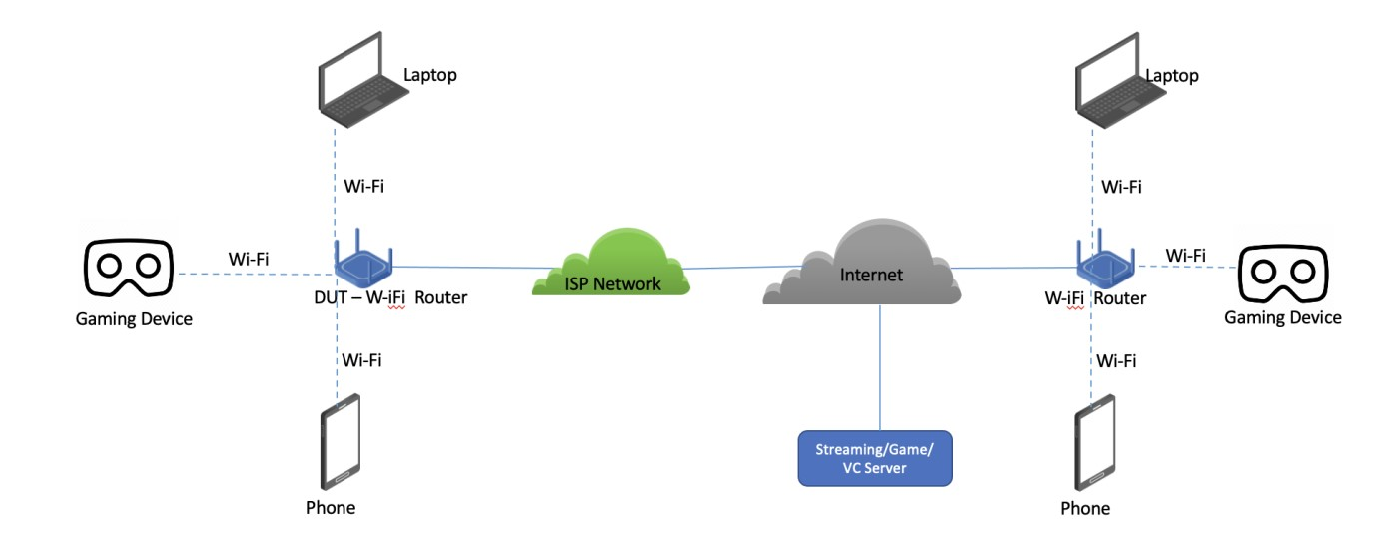

#### Figure 6: Typical Test Setup

* Verify latency and throughput for QoS traffic improvement using the use cases described in previous sections while Wi-Fi link gets saturated with Best Effort traffic in 2.4GHz, 5GHz & 6GHz environments.
* Facilitate QoS enforcement extension for ISPs using DSCP Per-Hop Behavior (PHB) in rest of the Access and core network, possibly extend further at internet exchanges.

# Conclusion

This document enumerates a set of use cases where Wi-Fi links are configured to prioritize QoS traffic using mechanisms defined in Wi-Fi Alliance QoS Management Technical Specification [4]. In the trials we intend to use recommendations from ITU-T SG12 standards to assess Objective MOS scores to assess the benefits of the QoS Mechanisms in maintaining QoS for the application stream(s). WBA will publish a report at the end of Phase-1 summarizing Trial Networks, Applications deployed in the network and the corresponding QoS performance with one or more relevant QoS Mechanism(s). The report will also provide a set of recommendations to Network / Service Providers to configure the WiFi Network (including QoS Mechanisms to enable) and tools to monitor QoS. The report will not address policing the network for appropriate use of the QoS Mechanisms (for instance, if an application requests setup of QoS, any technique to monitor to the application traffic and ascertain if it really needs QoS is outside the scope of the report).

**Future work will include**

* Extending the topology to Wi-Fi Mesh (Wi-Fi Alliance EasyMesh)
* Extending the QoS Management to non-Wi-Fi links to preserve end-to-end QoS
* Enabling new QoS Management mechanisms defined in ongoing work in IEEE802.11 Working Group and/or in Wi-Fi Alliance QoS Management TG)

**References**

1. **A Measurement Study on Achieving Imperceptible Latency in Mobile Cloud Gaming** - [**https://users.aalto.fi/~siekkine/pub/kamarainen17mmsys.pdf**](https://users.aalto.fi/~siekkine/pub/kamarainen17mmsys.pdf)
2. **WFA Whitepaper**: [**https://www.wi-fi.org/file/wi-fi-certified-qos-management-technologyoverview-2021**](https://www.wi-fi.org/file/wi-fi-certified-qos-management-technology-overview-2021)
3. **IEEE802.11-2020:** [**https://www.techstreet.com/ieee/standards/ieee-802-112020?product_id=2009234**](https://www.techstreet.com/ieee/standards/ieee-802-11-2020?product_id=2009234)
4. **WFA QoS Management Technical Specification:** [**https://www.wi-fi.org/file-member/wi-fiqos-management-specification-v20**](https://www.wi-fi.org/file-member/wi-fi-qos-management-specification-v20)
5. T.Hoiland-Jorgensen, P. Hurtig, and A. Brunstrom, “The Good, the Bad and the Wi-Fi: Modern AQMs in a residential setting,” Elsevier Computer networks, vol.89, pp 90 – 106, 2015.
6. T.Hoiland-Jorgensen, D. Taht, and J. Morton, “Piece of CAKE: A Comprehensive Queue Management Solution for Home Gateways,”*2018 IEEE International Symposium on Local and Metropolitan Area Networks (LANMAN)*, 2018, pp. 37-42
7. K. Nichols and V. Jacobson, “Controlling queue delay,” Communications of the ACM, vol. 55, no. 7, p. 42–50, July 2012.

**Appendix**

**Heading - Appendix A: Demonstrating the QoS/QoE over a Wi-Fi link using SCS**

1. Introduction

Enabling QoS Management for streams corresponding to applications that have Quality of Experience criteria facilitates prioritization of the corresponding payload over other compering traffic in the network. A proof-of-concept implementation of the WFA QoS Management R2 feature, SCS in an Airties AP along with an Intel reference STA implementation is used to demonstrate this.

1. **Test Setup**

The test setup is shown below. The Cloud Gaming User (User1) has graphics (and memory) supporting smooth rendition of 1080p video at 30 frames per second. The wireless link to Cloud Gaming User (User1) is calibrated first to estimate the amount best effort traffic required to interfere and cause QoE issues to the cloud gaming application. This calibration is done as follows:

* 1. Start the cloud gaming application and ensure that the rendered audio/video is of acceptable quality (no QoE issues). Note that no QoS Management mechanisms are enabled at the AP

(labeled Wi-Fi Enabled Home GW (GW1))

* 1. Start interfering Best Effort traffic at the BE traffic Generators/Applications. If needed start corresponding services at the AP as well.
  2. Check if QoE of the cloud gaming application gets impacted. If not, keep increasing the Best Effort load in step (b). When the QoE of the cloud gaming application is observed to suffer, note the corresponding Best Effort load. This ends the calibration step.
  3. Collect cloud gaming application specific key performance indices (latency, packet loss, jitter, frame rates, frame resolutions, etc.). This is the test data when QoS Mechanism is not enabled.
  4. Following the calibration, enable SCS at both the Wireless Test STA and the Wi-Fi enabled Home GW (GW1).
  5. Collect cloud gaming application specific key performance indices (latency, packet loss, jitter, frame rates, frame resolutions, etc.). This is the test data when QoS Mechanism is enabled

Internet

Cloud Gaming

Servers

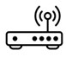

**Cloud Gaming**

**WiFi User**

**User**

**(**

**1**

**)**

WiFi enabled

Home GW

(

GW

1

)

WiFi connection

Cable connection



WiFi User (User

3

)



WiFi User (User

4

)



WiFi User (User

2

)

1. **Test Results**

Here is a compilation of data collected in steps (d) and (f) above. The test results were captured over three iterations. The Gaming Application defines a performance index Q-Score which ranges in the value 1 through 100. 100 indicates perfect QoE and 1 indicates unacceptable QoE,

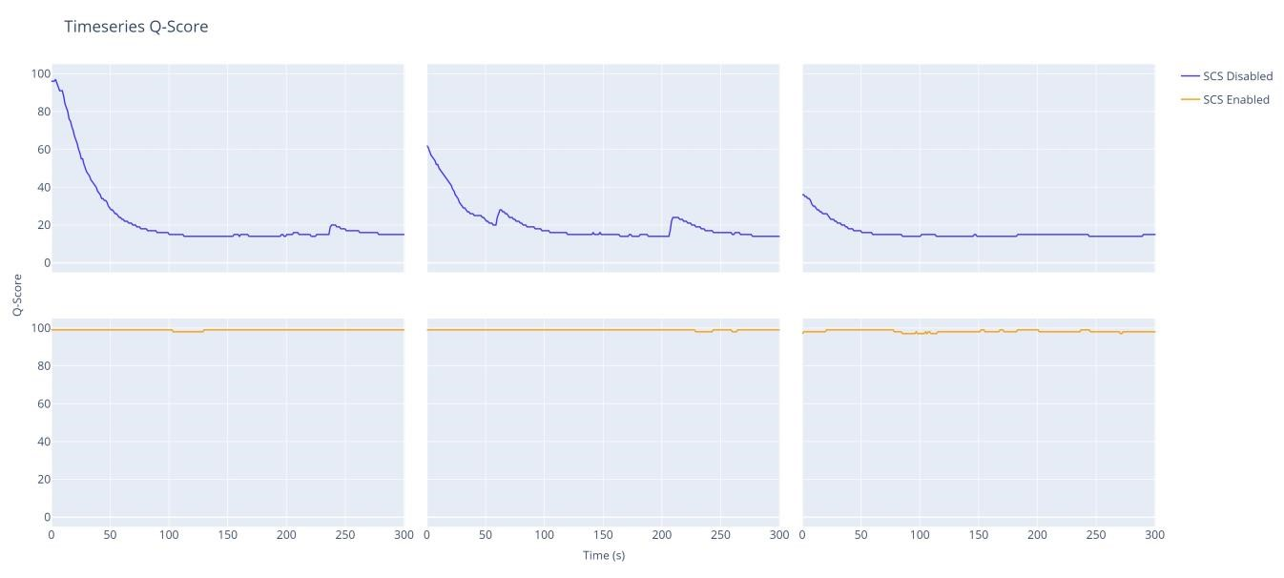

**Round Trip Delay CDF**

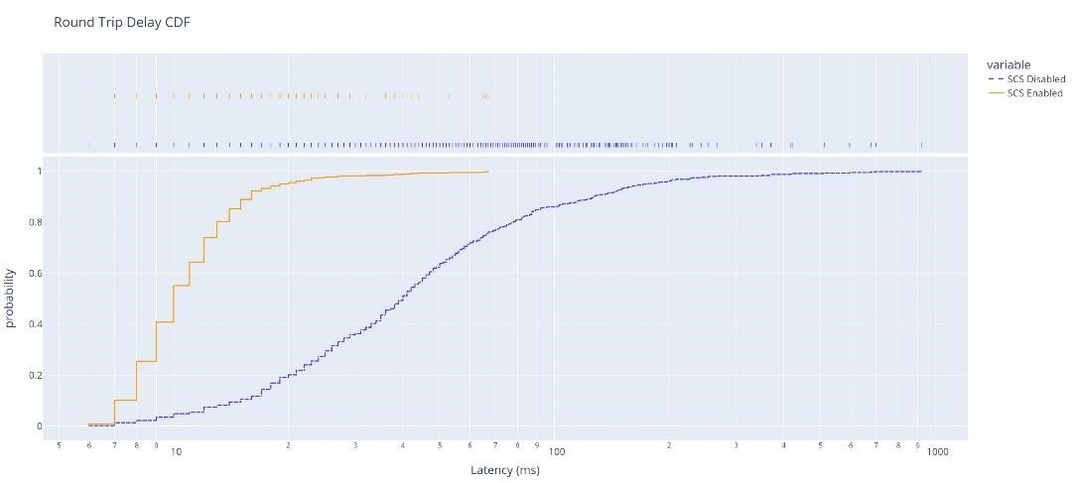

**Jitter CDF:**

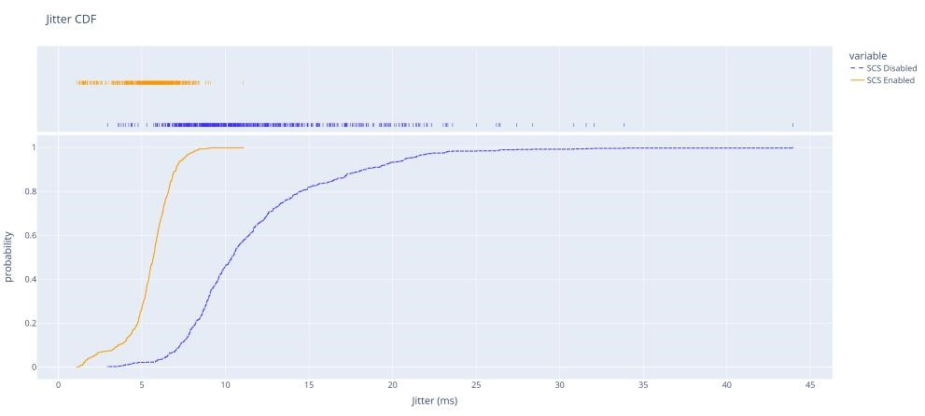

**Bitrate for the Cloud Gaming Application Stream(s)**

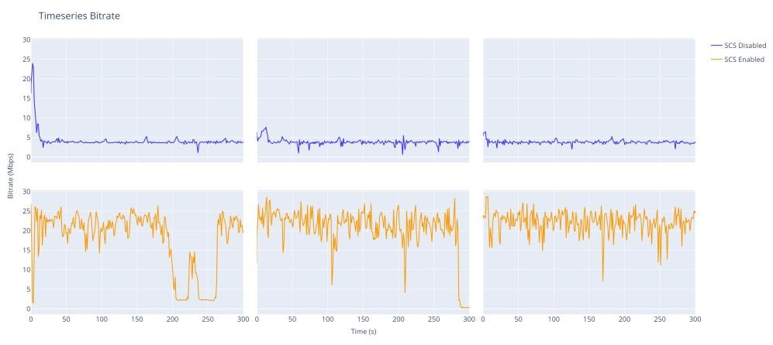

**Gaming Video Snapshot – with and without SCS enabled:**

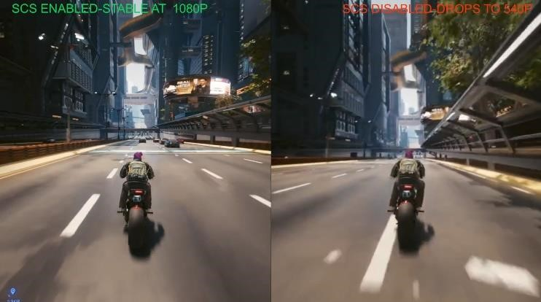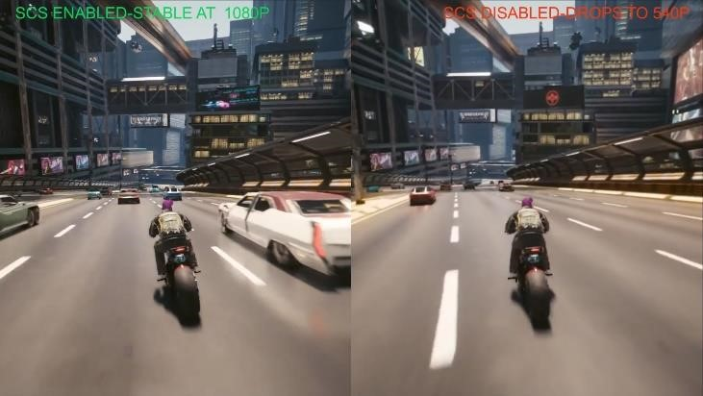

1. **Summary**

As shown in the Test Results sub-clause, the cloud gaming experience is not impacted by the interfering Best Effort traffic load when SCS is enabled for the streams corresponding to the cloud gaming application. This is the benefit WFA QoS Mechanism(s) facilitate.

* 1. We invite network providers to help setup more realistic test scenarios (e.g., use of real besteffort load that is common, use of mesh deployments for residential Use Cases, etc.) to demonstrate the efficacy of WFA QoS Mechanisms in the Use Cases described in this document.
  2. Enabling QoS Mechanisms require support in the application, operating system or in some middleware that resides between the application and the wireless stack. We invite OS vendors and application developers to collaborate with us on this effort.





For

other publications please visit:

**wballiance.com/resources/wb**

[**a**](http://wballiance.com/resources/wba-white-papers)

[**-**](http://wballiance.com/resources/wba-white-papers)

**whit**

[**e**](http://wballiance.com/resources/wba-white-papers)

[**-**](http://wballiance.com/resources/wba-white-papers)

**paper**

[**s**](http://wballiance.com/resources/wba-white-papers)

To participate in future projects, please

contact:

**pmo@wballiance.com**

Wireless

Broadband Alliance © 202

3



**Participant List**

|  |  |  |
| --- | --- | --- |
| **NAME** | **COMPANY** | **ROLE** |
| **Ganesh Venkatesan** | Intel | Project Leader |
| **Mehmet Şükrü Kuran** | Airties | Project Co-Leader |
| **Govi Reddy** | Meta | Project Co-Leader |
| **Enis Akay** | Meta | Project Co-Leader |
| **Irfan Acar** | Airties | Project Participant |
| **Furkan Canbal** | Airties | Project Participant |
| **Bahadir Ozgun** | Airties | Project Participant |
| **Jim Sturges** | AT&T | Project Participant |
| **Jessie Manik** | Bell Mobility | Project Participant |
| **Thomas Derham** | Broadcom | Project Participant |
| **Tim Twell** | BT | Project Participant |
| **Greg White** | CableLabs | Project Participant |
| **Martin Casey** | Calix | Project Participant |
| **Lingaraj Holiyappanavar** | Calix | Project Participant |
| **Loay Kreishan** | Charter | Project Participant |
| **Jerome Henry** | Cisco | Project Participant |
| **Mark Grayson** | Cisco | Project Participant |
| **Sri Gundavelli** | Cisco | Project Participant |
| **Teddy El-Rashidi** | Comcast | Project Participant |
| **Mark Hamilton** | CommScope | Project Participant |
| **Kurt Lumbatis** | CommScope | Project Participant |
| **Harpreet Narula** | Dell | Project Participant |
| **Necati Canpolat** | Intel | Project Participant |
| **Roya Doostnejad** | Intel | Project Participant |
| **Ravi Sinha** | Reliance JIO | Project Participant |





For

other publications please visit:

**wballiance.com/resources/wb**

[**a**](http://wballiance.com/resources/wba-white-papers)

[**-**](http://wballiance.com/resources/wba-white-papers)

**whit**

[**e**](http://wballiance.com/resources/wba-white-papers)

[**-**](http://wballiance.com/resources/wba-white-papers)

**paper**

[**s**](http://wballiance.com/resources/wba-white-papers)

To participate in future projects, please

contact:

**pmo@wballiance.com**

Wireless

Broadband Alliance © 202

3



|  |  |  |
| --- | --- | --- |
| **Tim Colleran** | LEVL | Project Participant |
| **Elif Salik** | Lifemote | Project Participant |
| **Yonggang Fang** | MediaTek | Project Participant |
| **Eran Dor** | Meta | Project Participant |
| **Marcel Chenier** | NetExperience | Project Participant |
| **Juan Castro** | Nokia | Project Participant |
| **Dennis Edwards** | Nokia | Project Participant |
| **Max Riegel** | Nokia | Project Participant |
| **Randy Sharpe** | Nokia | Project Participant |
| **Jean-Michel Bonnamy** | Orange | Project Participant |
| **George Hart** | Rogers | Project Participant |
| **Ryan Blossom** | Single Digits | Project Participant |
| **Michael Sym** | Single Digits | Project Participant |
| **Manu Geetha** | Zebra Technologies | Project Participant |
| **Adrian Sandu** | Zebra Technologies | Project Participant |
| **Pedro Mouta** | WBA | Project Participant |