IEEE P802.11
Wireless LANs
Discussion and Proposed Modifications to Annex C
Date: 2023-06-01
Author(s):
Name | Affiliation | Address | Phone | email
Claudio da Silva | Meta Platforms |  |  | claudiodasilva@meta.com
Abstract
This submission examines MIB concepts and recommends modifications to Annex C.

Discussion
- MIB = Management Information Base
- Informal description:
  - Database used for managing the entities in a communication network
  - Collection of management information available on an entity
- References
  - 09/0533r1, Recomendation-re-MIB-types-and-usage
  - 15/0355r13, MIB TruthValue usage patterns

From 09/0533r1,
- Purpose is to manage STAs and entities within STAs to allow proper and useful interoperation in a wireless network
- Such management is provided by interaction between entities to provide status and exert control
  - MIB attributes (a.k.a. “objects” or “variables”) provide an implicit interface between entities through read (“GET”) and write (“SET”) operations.

- Types of MIB attributes
  - Capability: Static, initialized by entity as part of instantiation, read by other entities.
    - dot11XxxImplemented, dot11RadioMeasurementCapable, dot11ChannelAgilityPresent, dot11FTResourceRequestSupported, dot11ExtendedChannelSwitchEnabled
  - Status: Dynamic, written by the entity to expose current conditions to reading entities.
    - dot11XxxCount, dot11RadioMeasurementEnabled
  - Control: Dynamic, written by another entity to control the applicable entity’s manageable behaviors.
    - dot11RTSThreshold, dot11ShortRetryLimit, dot11LongRetryLimit, dot11FragmentationThreshold, dot11PrivacyInvoked

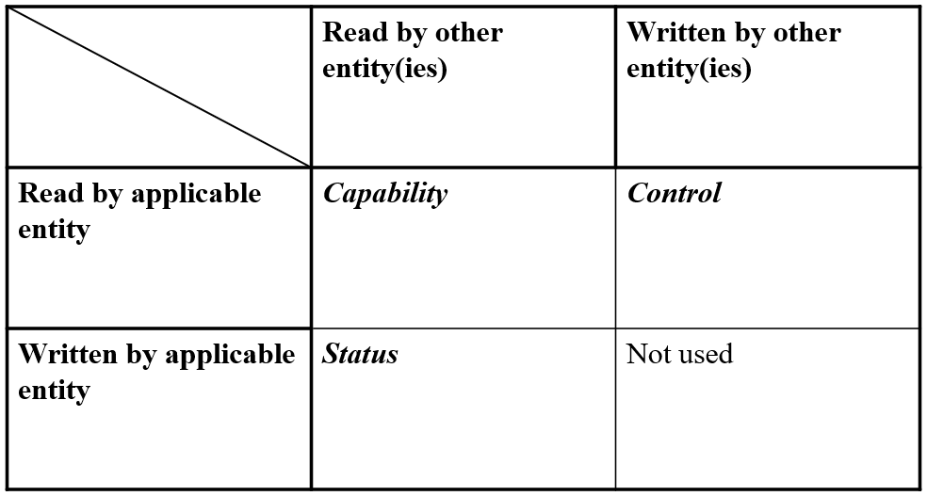

- MIB attributes are not local variables
  - Attributes accessed solely within the entity do not provide any management function
  - Local variables are those that are not exposed outside an entity, for read or write
  - Some example local variables – NAV, used_time, admitted_time, aXxxXxx (e.g. aSlotTime), CW, SSRC, SLRC
  - Local variables should not be part of the MIB
  - Some local variables could be used solely within the Standard’s text, if useful to clarify conforming behaviors, and don’t need formal definition

Discussion (cont.)
- In P802.11bf D1.0’s Annex C:
  - These definitions listed above must be removed from Annex C.

- And in Table 11-29a we have:
  - “Sensing Frame Exchange Timeout value” is correctly defined as a local variable (and does not appear in Annex C).
  - The other three could be defined as a status MIB attribute, or not.
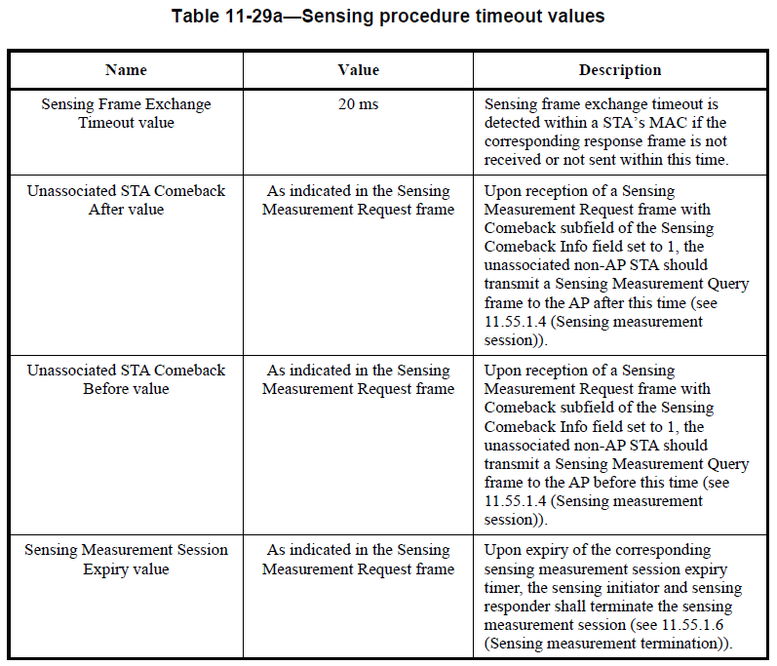

Discussion (cont.)

Example:

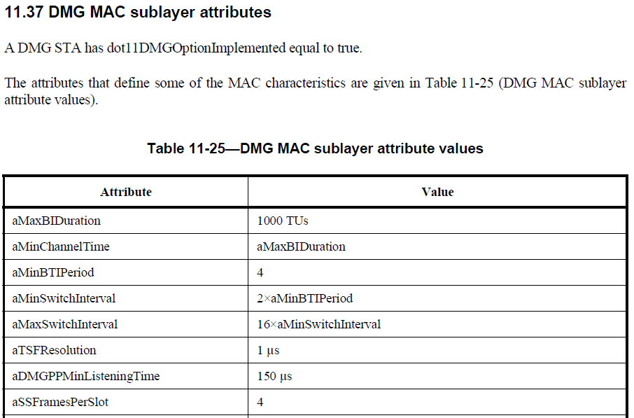

Discussion (cont.)

In 05/25, TGbf supported the acceptance of the three comments below. The changes proposed in what follows (also marked in blue) the structure/wording of the three proposed changes below.

CID | Comment | Proposed Change
1966 | If the timeouts are recommended values (which seems more appropriate than completely optional) then use the verb "should" | Change to "A sensing STA should used the timeouts defined in Table 11-29a." (In another comment I suggested we adopt the term "sensing STA" for the generic sensing participant. If we don't do this substitute the appropriate generic term)

CID | Comment | Proposed Change
1969 | The normative requirement for each of these timeout values has already been established with the statement at 167.56 so the descriptions in the table should be exactly that; just a description of what the timeout value represents. | Change to "For an unassociated non-AP STA, the minimum time between the reception of a Sensing Measurement Setup Request frame with Comeback subfield equal to 1and the transmission of the corresponding Sensing Measurement Setup Query frame."

CID | Comment | Proposed Change
1970 | The normative requirement for each of these timeout values has already been established with the statement at 167.56 so the descriptions in the table should be exactly that; just a description of what the timeout value represents. | Change to "For an unassocaited non-AP STA, the maximum time between the reception of a Sensing Measurement Request frame with the Sensing Comeback Info field equal to 1 and the sending of the corresponding Sensing Measurement Setup Query frame."

Sensing Procedure
Modifications: TGbf editor:
- Change the title of 11.55.1.2 to “Dependencies and timing-related parameters”.
- Add the following at the end of 11.55.1.2

Table X1 defines timing-related parameters associated with the sensing procedure.
A sensing STA should use the timing-related parameters defined in Table X1.

Table X1—Sensing procedure timing-related parameters
Parameter | Value | Description
aSensingFrameExchangeExpiry | 20 ms | Sensing frame exchange timeout is detected within a STA’s MAC if the corresponding response frame is not received or not sent within this time.  The maximum time interval between the reception of a Sensing Measurement Request frame and the transmission of the corresponding Sensing Measurement Response frame, or the reception of a Sensing Measurement Query frame and the sensing of the corresponding Sensing Measurement Request frame.
aSensingSessionExpiry  aMeasurementSessionExpiry | Set to the value indicated in derived from the Measurement Session Expiry Exponent field of the Sensing Measurement Request frame that established the sensing session | Upon expiry of the corresponding sensing measurement session expiry timer, the sensing initiator and sensing responder shall terminate the sensing measurement session (see 11.55.1.6 (Sensing measurement termination)).  The maximum duration for the established sensing measurement session.
aSensingComebackAfter | Set to the value indicated in derived from the Unassociated STA Comeback After field of the associated Sensing Measurement Request frame | Upon reception of a Sensing Measurement Request frame with Comeback field of the Sensing Comeback Info field set to 1, the unassociated non-AP STA should transmit a Sensing Measurement Query frame to the AP after this time (see 11.55.1.4 (Sensing measurement session)).  For an unassociated non-AP STA, the minimum time between the reception of a Sensing Measurement Setup Request frame with Comeback subfield within the Sensing Comeback Info field equal to 1 and the transmission of the corresponding Sensing Measurement Setup Query frame(#1969).
aSensingComebackBefore | Set to the value indicated in derived from the Unassociated STA Comeback Before Exponent field of the associated Sensing Measurement Request frame | Upon reception of a Sensing Measurement Request frame with Comeback field of the Sensing Comeback Info field set to 1, the unassociated non-AP STA should transmit a Sensing Measurement Query frame to the AP before this time (see 11.55.1.4 (Sensing measurement session)).  For an unassociated non-AP STA, the maximum time between the reception of a Sensing Measurement Request frame with the Comeback field within the Sensing Comeback Info field equal to 1 and the sending transmission of the corresponding Sensing Measurement Setup Query frame(#1970).

TGbf editor:
- Delete Table 11-29a.
- Replace references to “Sensing Measurement Session Expiry value”, “Unassociated STA Comeback After value”, and “Unassociated STA Comeback Before value” with aMeasurementSessionExpiry, aSensingComebackAfter, and aSensingComebackBefore, respectively.

Sensing Procedure (Cont.)
Modifications: TGbf editor:
- Delete the dot11SENSReportSegmentSize entry from Annex C.
- Change 11.55.1.5.3.4 as indicated below:

11.55.1.5.3.4 Rules for generating segmented sensing measurement reports
If a Sensing Measurement Report information exceeds dot11SENSReportSegmentSize aSensingReportSegmentSize, then the Sensing Measurement Report information shall be divided into up to 32 report segments.

aSensingReportSegmentSize shall be 3 750 octets.

Each report segment shall be included in a separate Sensing Measurement Report Container and shall contain successive portions of the Sensing Measurement Report information. The Sensing Measurement Report Control field shall be included in the Sensing Measurement Report Container that carries the first report segment and the Report Control Present field in the Segmentation Control field shall be set to 1(#1154). The Sensing Measurement Report Control field shall not be included in a Sensing Measurement Report Container that does not carry the first report segment and the Report Control Present field in the Segmentation Control field shall be set to 0(#1154). Each report segment shall be of equal length, the length of each report segment being equal to dot11SENSReportSegmentSize aSensingReportSegmentSize, except the last report segment that may be smaller.

Each report segment is identified by the value of the Remaining Report Segments field and the First Report Segment field in the Sensing Measurement Report Control field as defined in Table 9-127f (Segmentation Control field). The other non-reserved fields of the Segmentation Control field shall be the same for all report segments. All report segments shall be sent in a single A-MPDU contained in a PPDU and shall be included in the A-MPDU in the descending order of the values of the Remaining Report Segments field.

Note: Clause 12 example: “This authentication result shall be of fixed length of 128 octets”

SBP Procedure
Discussion:
- In addition to the dot11SBPSetupExpiry attribute, a second timing-related parameter is defined for SBP: SBP Procedure Expiry Exponent.

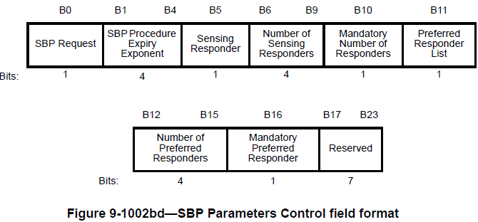

Note: There is no normative text for this field in Clause 11.

Modifications: TGbf editor:
- Add the following at the end of 11.55.2.1 (General)

Table X2 defines timing-related parameters associated with the SBP procedure.
A STA that supports SBP should use the timing-related parameters defined in Table X2.

Table X2—SBP procedure timing-related parameters
Attribute | Value | Description
aSBPSetupExpiry | 100 ms | This parameter indicates the time limit the SBP responder shall send an SBP Response frame after receiving an SBP Request.  The maximum time interval between the reception of an SBP Request frame and the transmission of the corresponding SBP Response frame.
aSBPProcedureExpiry | Indicated in Set to the value derived from the SBP Procedure Expiry Exponent field within an SBP Request frame | This parameter indicates the time after which the SBP procedure is terminated if there are no frame exchange sequences.  The time limit for which an SBP procedure remains active if no frames are exchanged between its SBP initiator and SBP responder.

TGbf editor:
- Replace dot11SBPSetupExpiry with aSBPSetupExpiry through the draft.
- Delete the dot11SBPSetupExpiry entry from Annex C.

DMG Sensing Procedure

TGbf editor:
- Change the title of 11.55.3.2 to “Dependencies and timing-related parameters”.
- Add the following at the end of 11.55.3.2

Table X3 defines a timing-related parameter associated with the DMG sensing procedure.
A STA that supports DMG sensing use the timing-related parameters defined in Table X3.

Table X3—DMG sensing procedure timing-related parameter
Parameter | Value | Description
aDMGSensingProcedureExpiry | 10 s | This parameter indicates the time limit the sensing initiator and sensing responder terminate the DMG sensing measurement session if no handshake happens during the established DMG sensing measurement session.  The time limit for which a DMG sensing measurement session remains active if no frames are exchanged between its sensing initiator and sensing responder.

TGbf editor:
- Replace dot11DMGSensingProcedureExpiry with aDMGSensingProcedureExpiry through the draft.
- Delete the dot11DMGSensingProcedureExpiry entry from Annex C.

DMG SBP Procedure

TGbf editor:
- Add the following at the end of 11.55.4.1 (General)

Table X4 defines timing-related parameters associated with the DMG SBP procedure.
A DMG STA that supports DMG SBP procedure should use the timing-related parameters defined in Table X4.

Table X4—DMG SBP procedure timing-related parameters
Parameters | Value | Description
aDMGSBPSetupExpiry | 200 ms | This parameter indicates the time limit the SBP responder shall send a DMG SBP Response frame after receiving a DMG SBP Request.  The maximum time interval between the reception of a DMG SBP Request frame and the transmission of the corresponding DMG SBP Response frame.
aDMGSBPProcedureExpiry | 10 s | This attribute indicates the time limit the DMG SBP initiator and the DMG SBP responder terminate the DMG SBP procedure if no SBP reporting happens within the time.  The time limit for which a DMG SBP procedure remains active if no frames are exchanged between its SBP initiator and SBP responder.

TGbf editor:
- Replace dot11DMGSBPSetupExpiry with aDMGSBPSetupExpiry through the draft.
- Replace dot11DMGSBPProcedureExpiry with aDMGSBPProcedureExpiry through the draft.
- Delete the dot11DMGSBPSetupExpiry and dot11DMGSBPProcedureExpiry entries from Annex C.

